On-screen text: hdwrneavbwm

Channel Islands National Marine Sanctuary Deep Coral Gardens Expedition

Brand new article

Channel Islands National Marine Sanctuary Deep Coral Gardens Expedition

Brand new article

Section 1
Task: Transcribe, word for word, only the on-screen text described below.
Look for: This ROV video from the Gull Island Reserve (Channel Islands) has a telemetry overlay. At each notable sighting (corals, groups of rockfish, the sixgill shark, the abandoned net), give the timestamp and transcribe the overlay verbatim: date, time, depth (D), altitude (A), range (R), heading, pitch and roll, and water temperature. Then summarise the depth and temperature range across the video and flag any value you could not read.
Result
Corals
[0:00:09]
06-08-2019
16:14:42:08
D: 70.8 m
A: 1.4 m
R: 1.9 m
P: -9.6°
R: 8.0°
10.3°C
[0:00:11]
C: -0.9
P: -8.1°
R: 8.6°
D: 70.9 m
R: 1.8 m
278
A: 1.4 m
06-08-2019
16:14:44:10
10.3°C
[0:00:13]
C: -0.9
P: -8.2°
R: 8.2°
D: 70.9 m
R: 1.6 m
277
A: 1.5 m
06-08-2019
16:14:46:10
10.4°C
[0:00:15]
C: 3.9
P: -9.2°
R: 6.7°
D: 80.7 m
R: 2.7 m
324
A: 1.2 m
06-07-2019
17:03:32:15
9.6°C
[0:00:17]
C: 3.9
P: -6.1°
R: 7.6°
D: 80.8 m
R: 2.2 m
325
A: 1.5 m
06-07-2019
17:03:34:15
9.6°C
[0:00:19]
C: 3.9
P: -6.0°
R: 7.5°
D: 80.8 m
R: 2.0 m
324
A: 1.4 m
06-07-2019
17:03:36:15
9.6°C
[0:00:21]
C: 3.9
P: -5.1°
R: 8.0°
D: 80.7 m
R: 2.2 m
323
A: 1.4 m
06-07-2019
17:03:38:15
9.6°C
Groups of rockfish
[0:00:23], [0:00:38], [0:00:40], [0:00:42], [0:00:44], [0:00:46], [0:00:48]
No readable telemetry overlay.
Sixgill shark
[0:00:50], [0:00:52], [0:00:57], [0:00:57], [0:00:59], [0:01:01], [0:01:03], [0:01:05]
No readable telemetry overlay.
Abandoned net
[0:00:25], [0:00:27], [0:00:29], [0:00:31], [0:00:33], [0:00:35], [0:00:37], [0:00:38]
No readable telemetry overlay.
Summary of depth and temperature range:
Depths (coral sightings): 70.8–80.8 m
Temperatures (coral sightings): 9.6–10.4°C
All values for depth and temperature are readable.
Findings
[0:00:00]
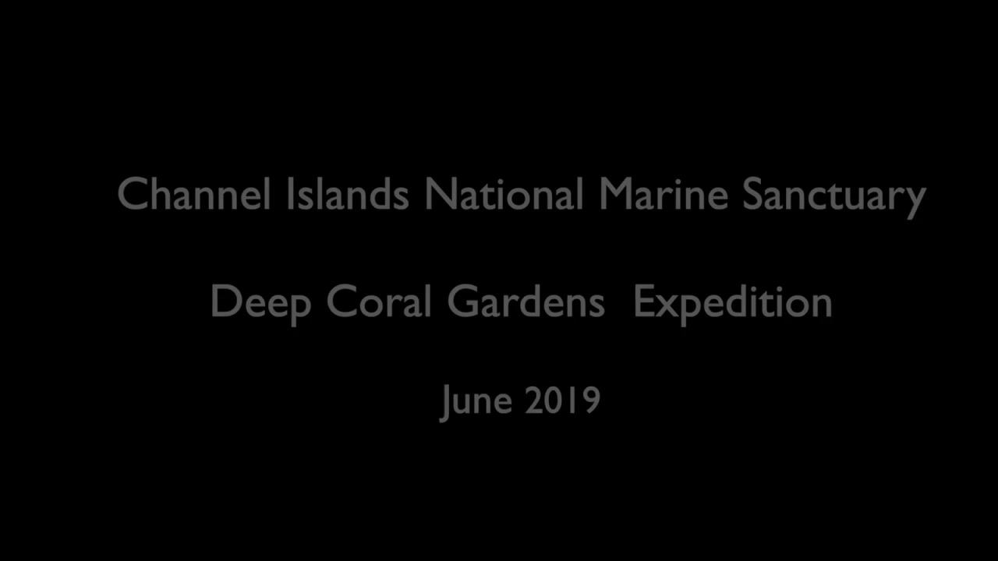
Channel Islands National Marine Sanctuary
Deep Coral Gardens Expedition
June 2019
[0:00:09]
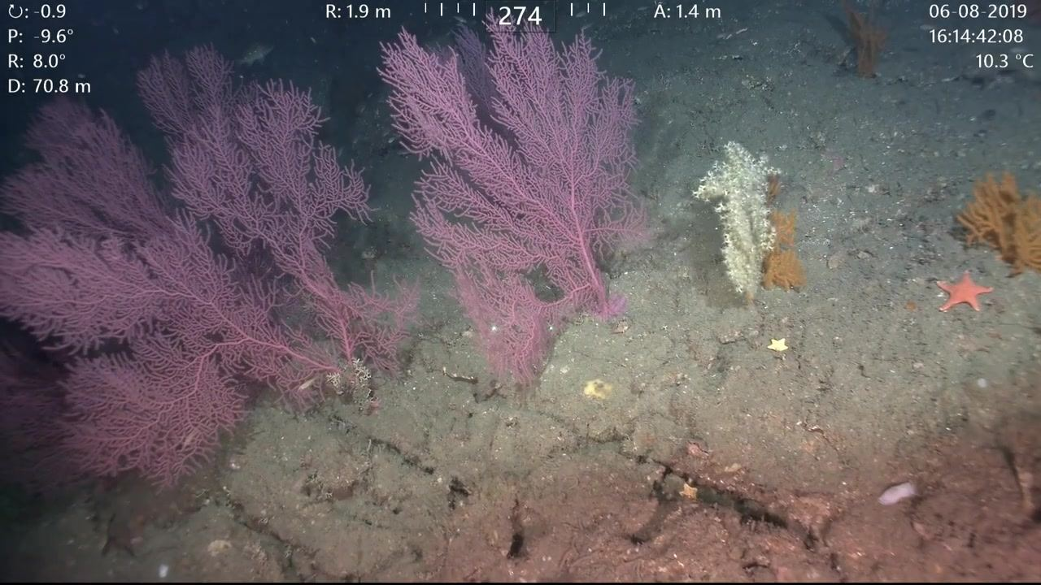
06-08-2019
16:14:42:08
D: 70.8 m
A: 1.4 m
R: 1.9 m
P: -9.6°
R: 8.0°
10.3°C
[0:00:11]
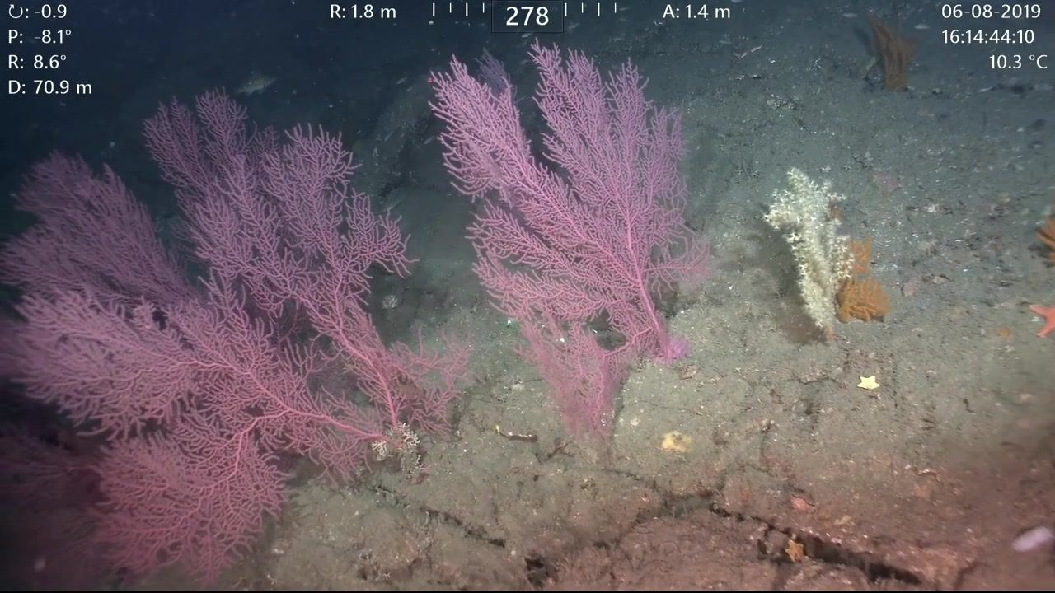
C: -0.9
P: -8.1°
R: 8.6°
D: 70.9 m
R: 1.8 m
278
A: 1.4 m
06-08-2019
16:14:44:10
10.3°C
[0:00:13]
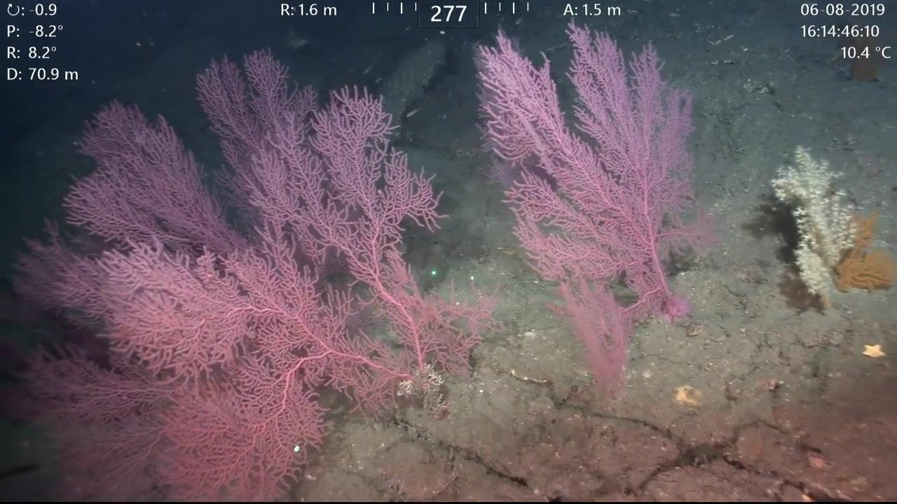
C: -0.9
P: -8.2°
R: 8.2°
D: 70.9 m
R: 1.6 m
277
A: 1.5 m
06-08-2019
16:14:46:10
10.4°C
[0:00:15]
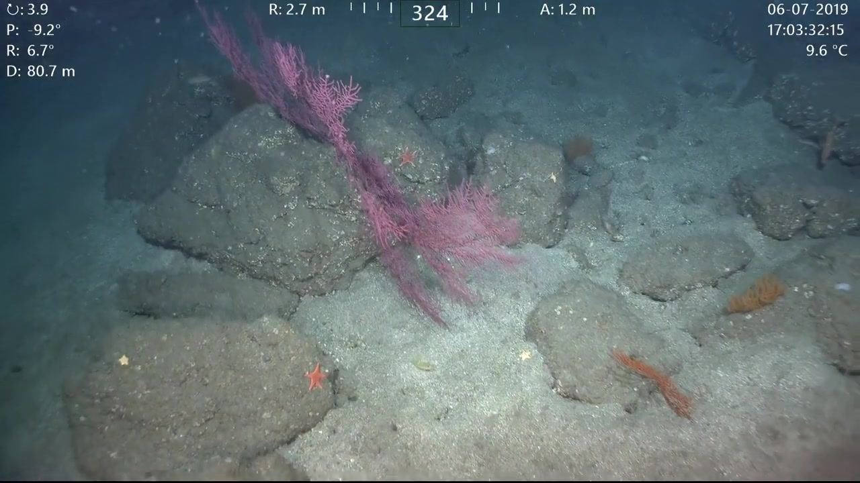
C: 3.9
P: -9.2°
R: 6.7°
D: 80.7 m
R: 2.7 m
324
A: 1.2 m
06-07-2019
17:03:32:15
9.6°C
[0:00:17]
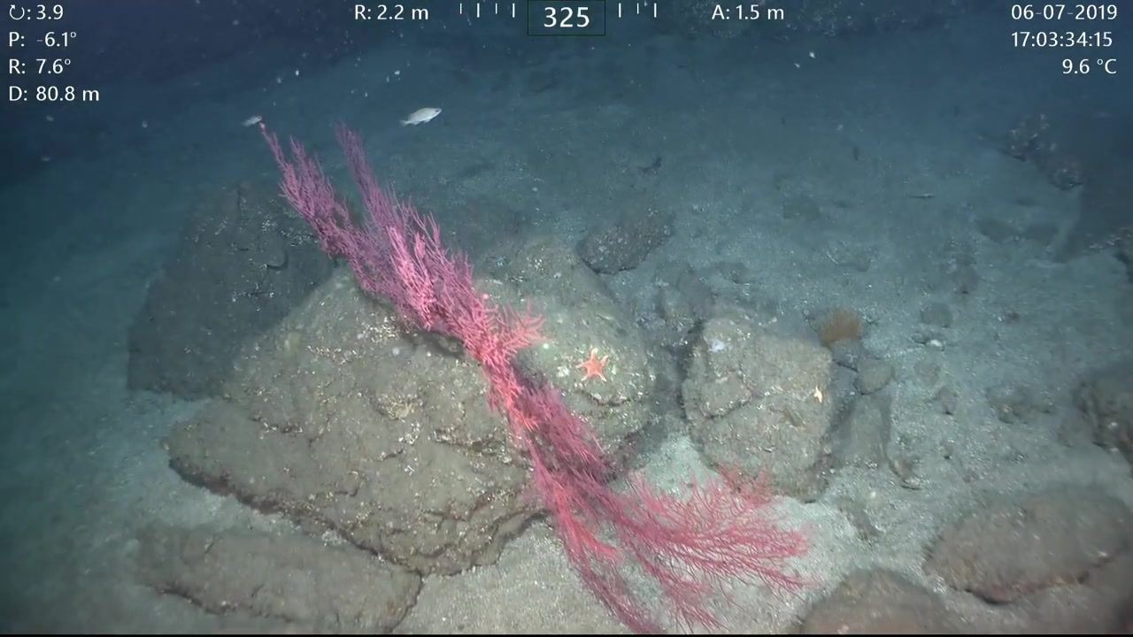
C: 3.9
P: -6.1°
R: 7.6°
D: 80.8 m
R: 2.2 m
325
A: 1.5 m
06-07-2019
17:03:34:15
9.6°C
[0:00:19]
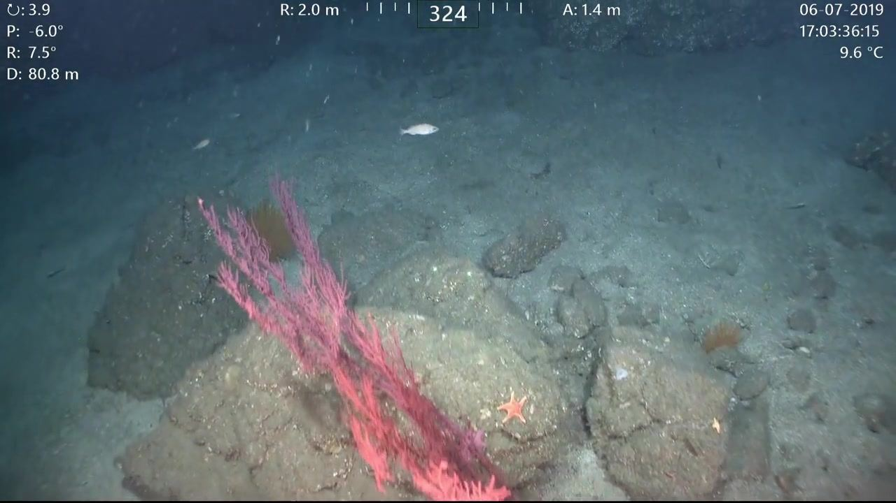
C: 3.9
P: -6.0°
R: 7.5°
D: 80.8 m
R: 2.0 m
324
A: 1.4 m
06-07-2019
17:03:36:15
9.6°C
[0:00:21]
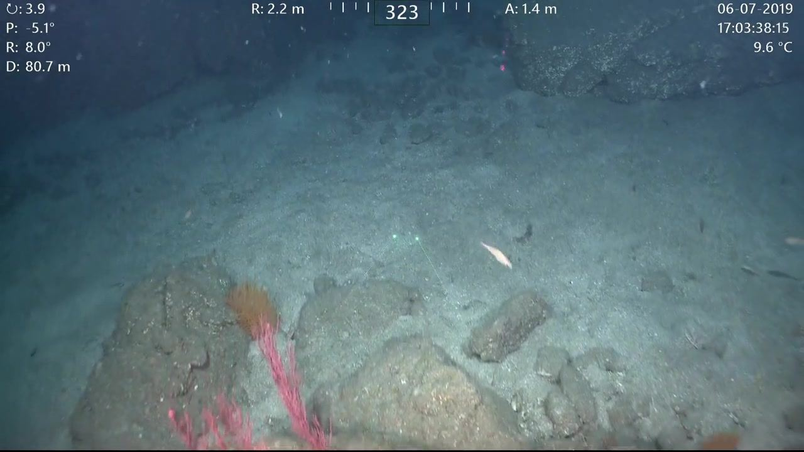
C: 3.9
P: -5.1°
R: 8.0°
D: 80.7 m
R: 2.2 m
323
A: 1.4 m
06-07-2019
17:03:38:15
9.6°C
[0:00:23]
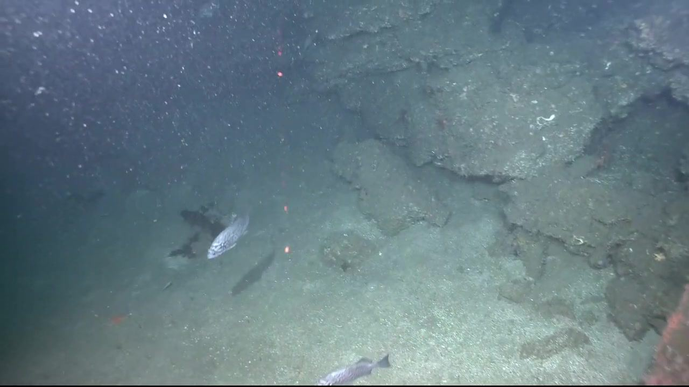
[0:00:25]
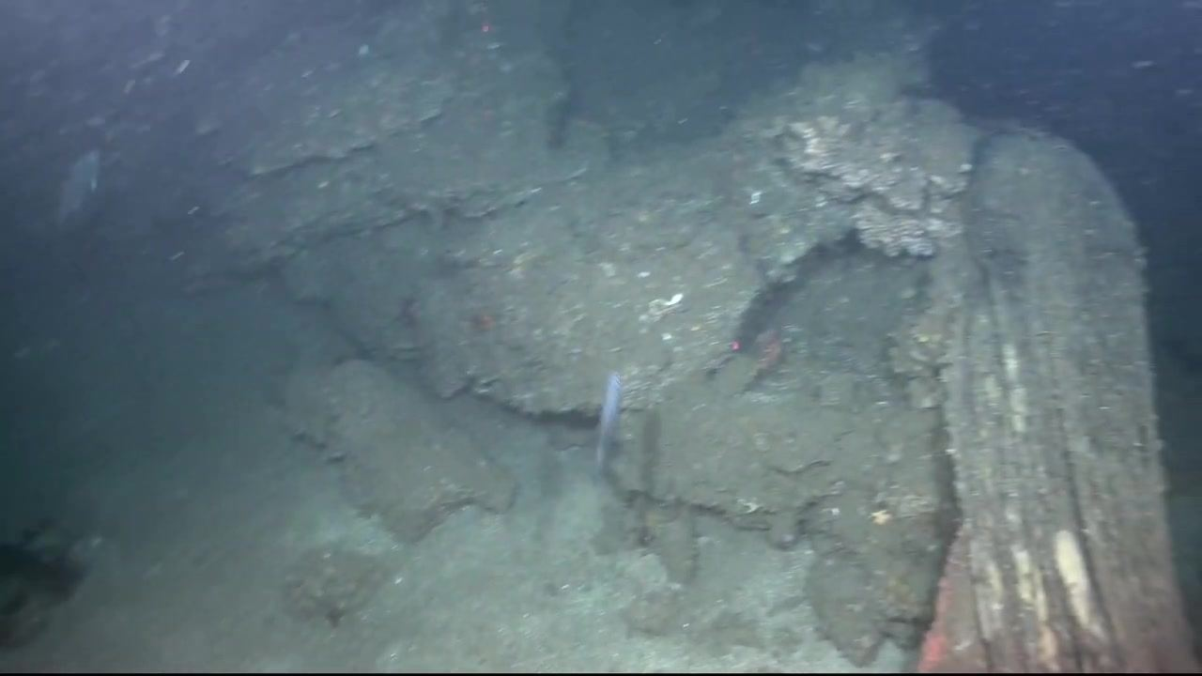
[0:00:27]
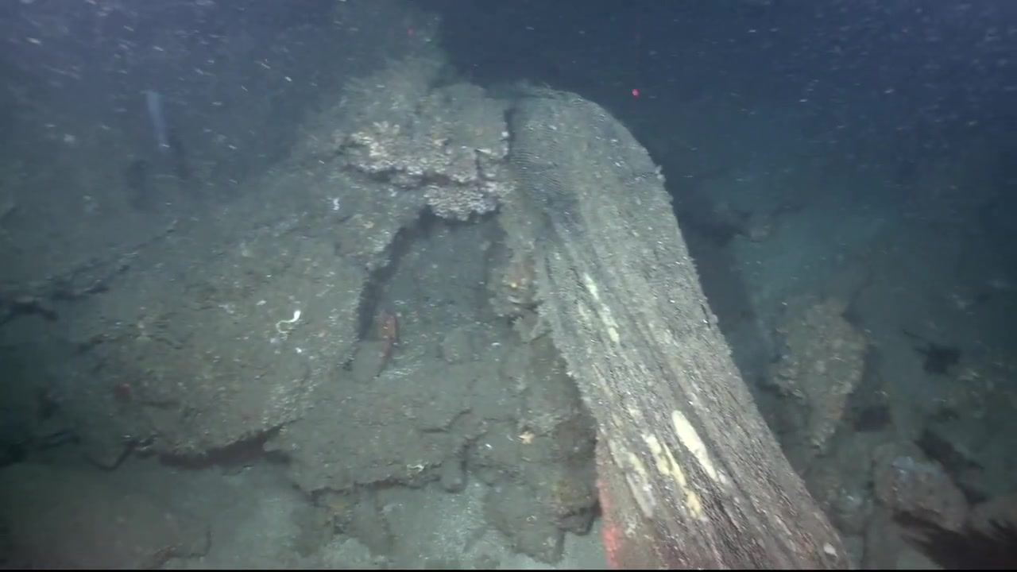
[0:00:29]
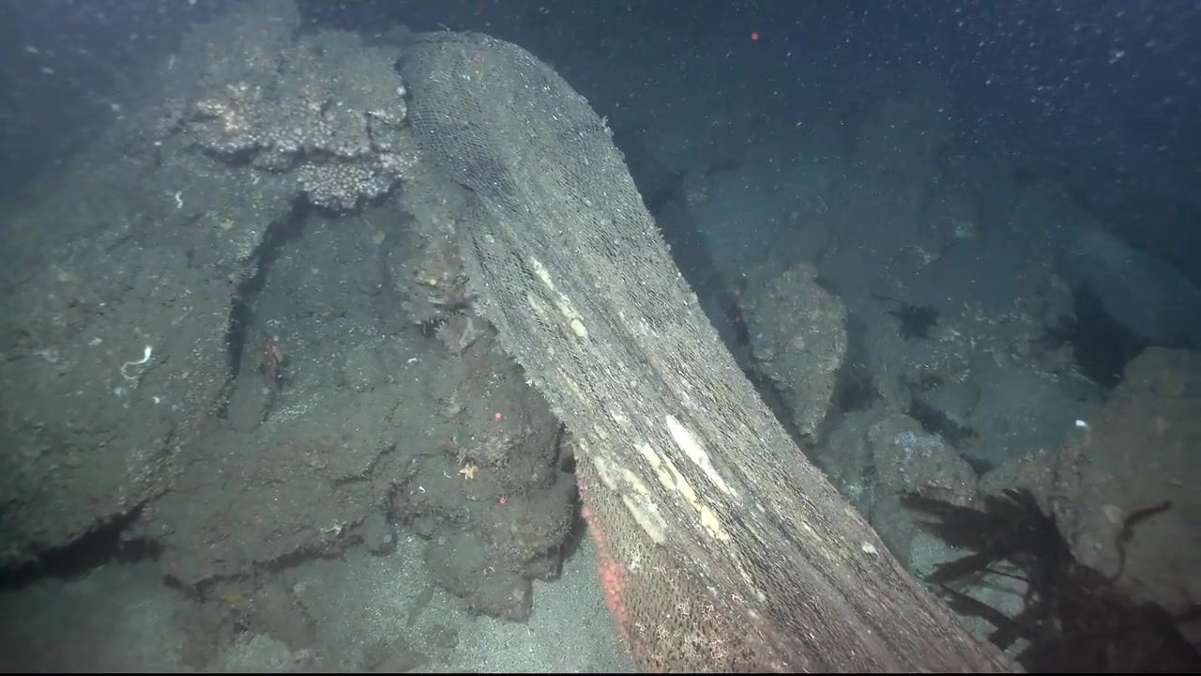
[0:00:31]
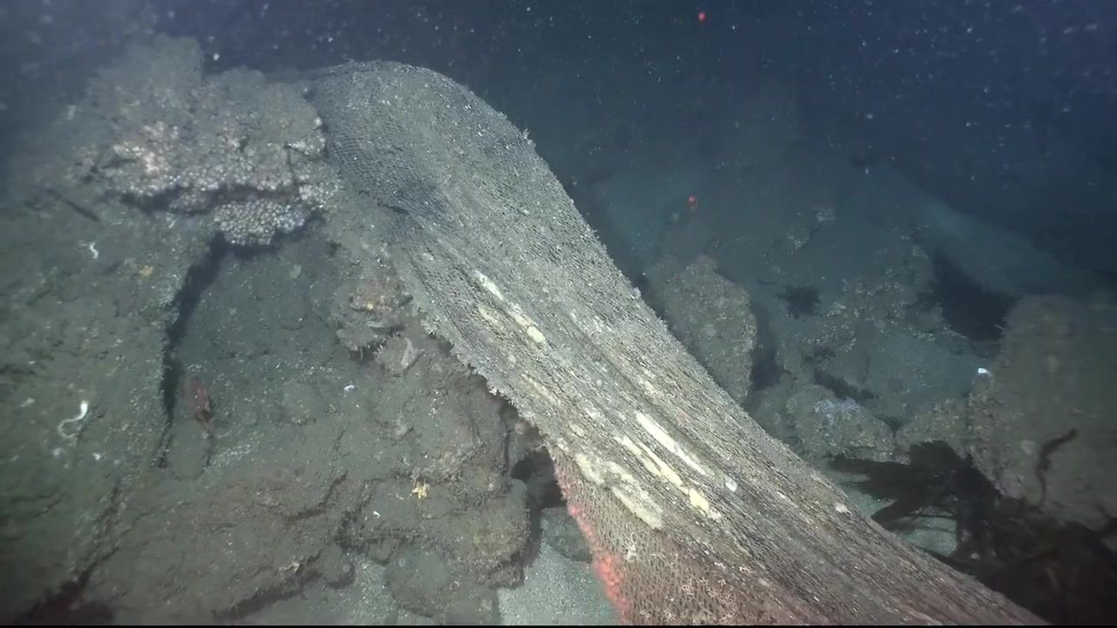
[0:00:33]
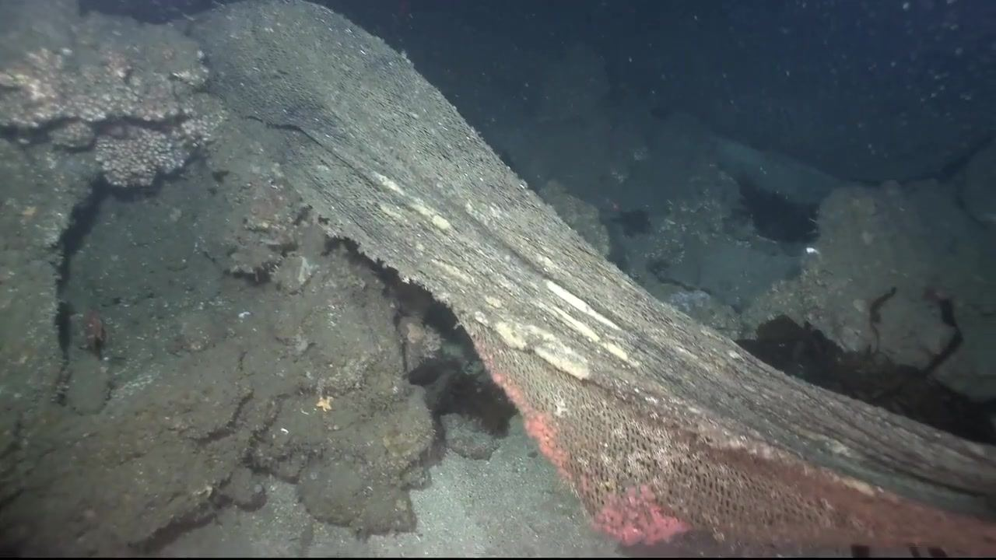
[0:00:35]
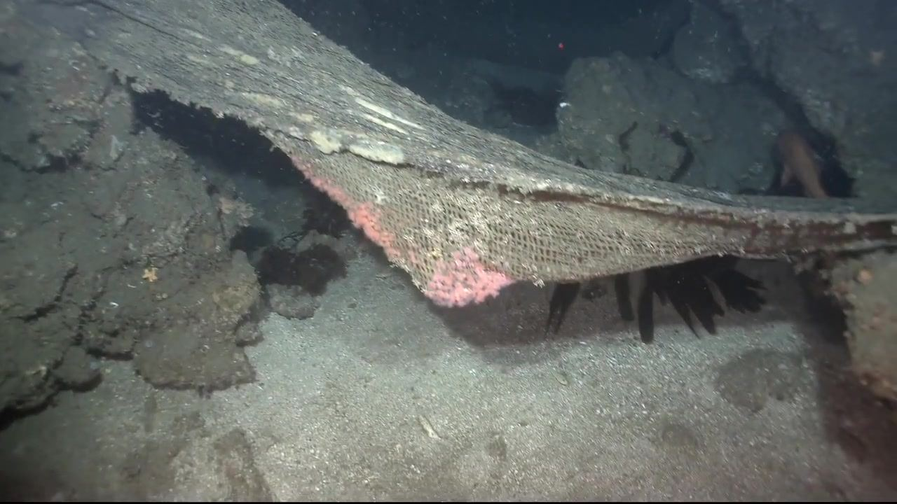
[0:00:37]
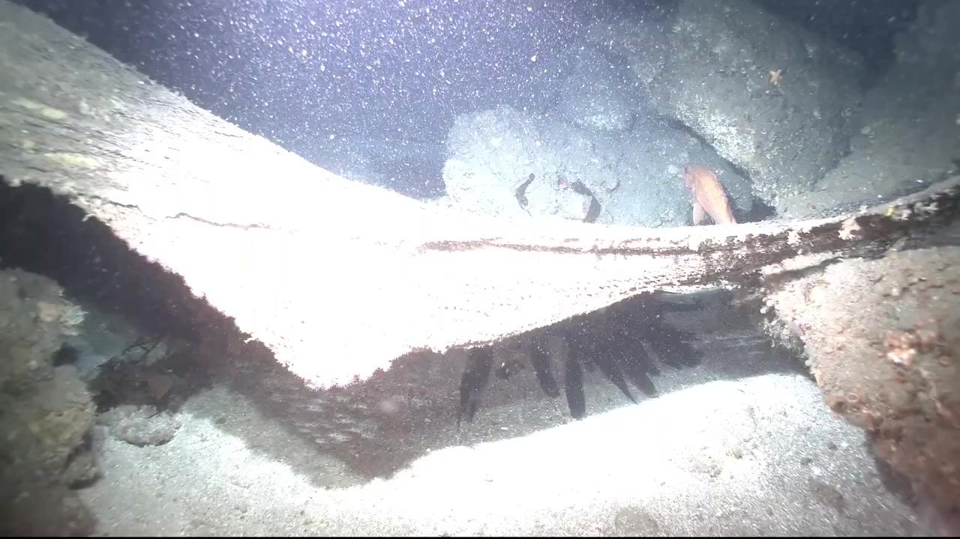
[0:00:38]
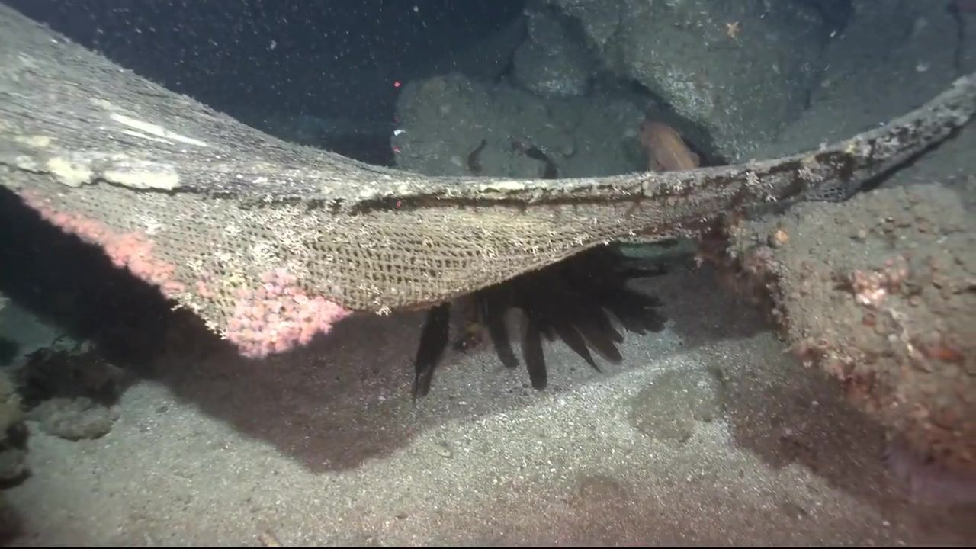
[0:00:38]
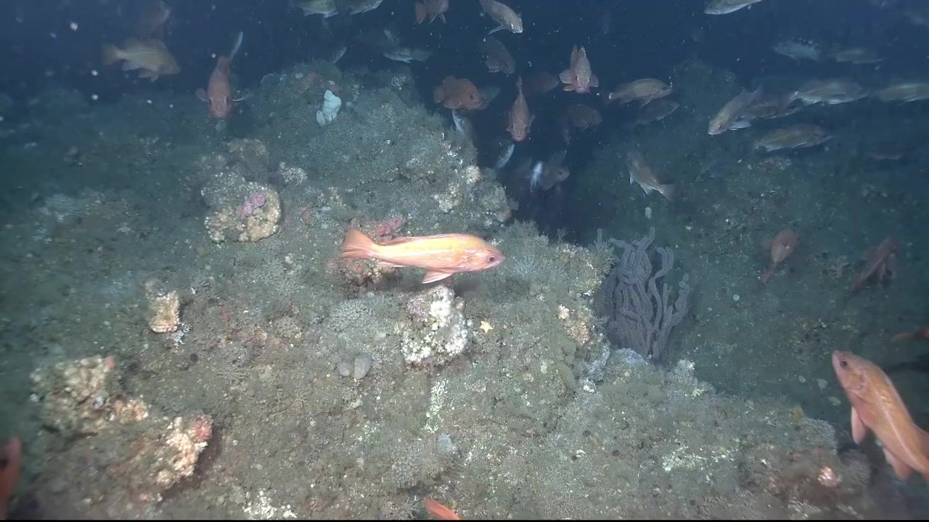
[0:00:40]
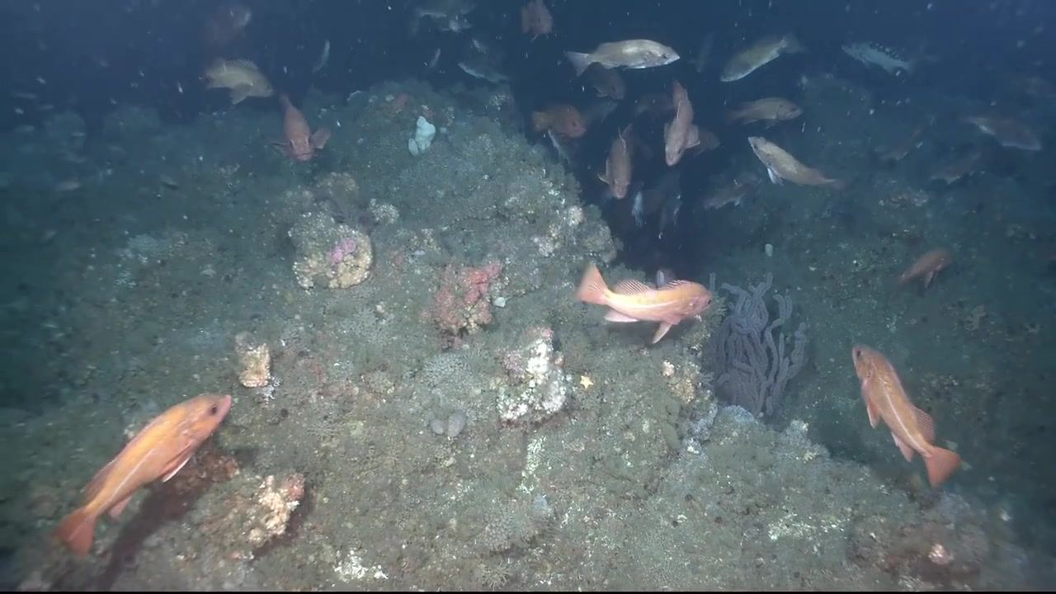
[0:00:42]
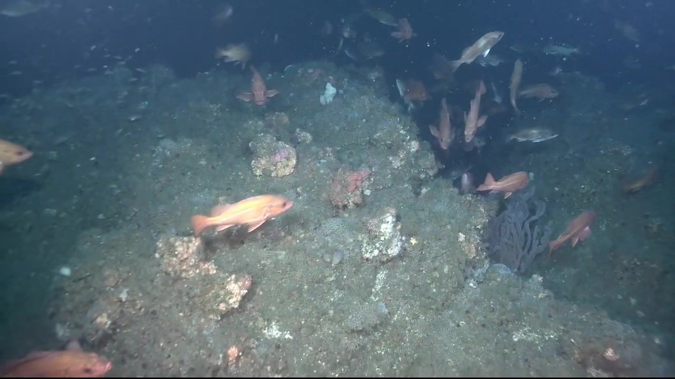
[0:00:44]
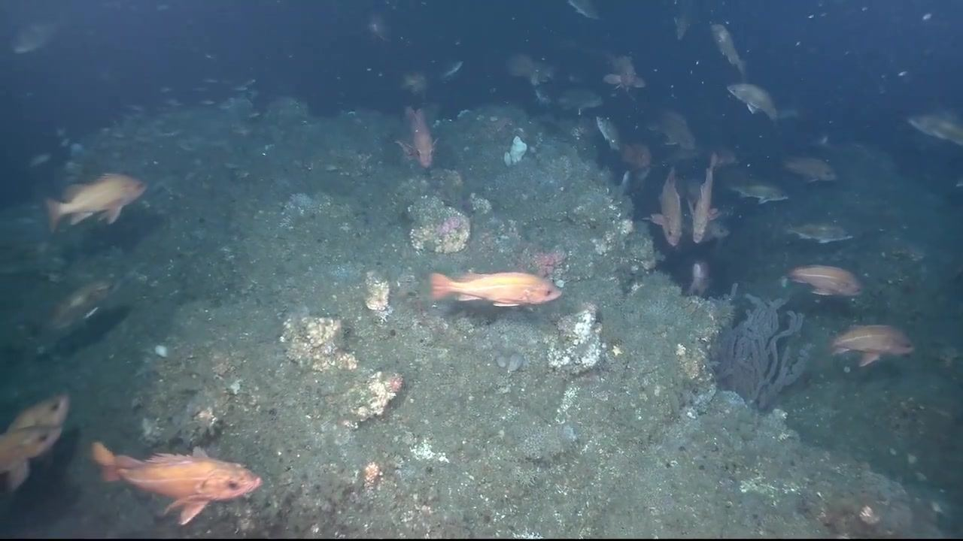
[0:00:46]
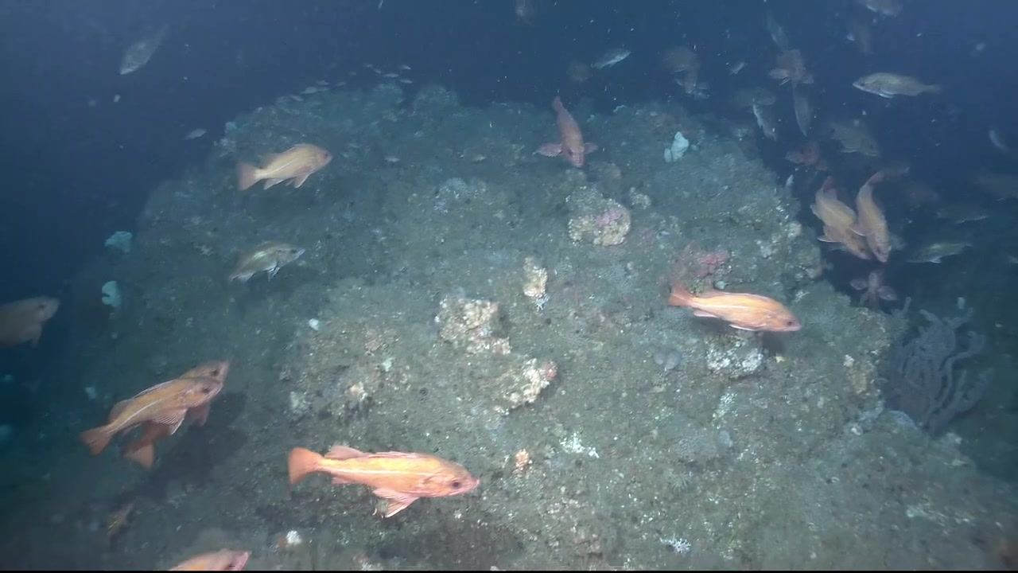
[0:00:48]
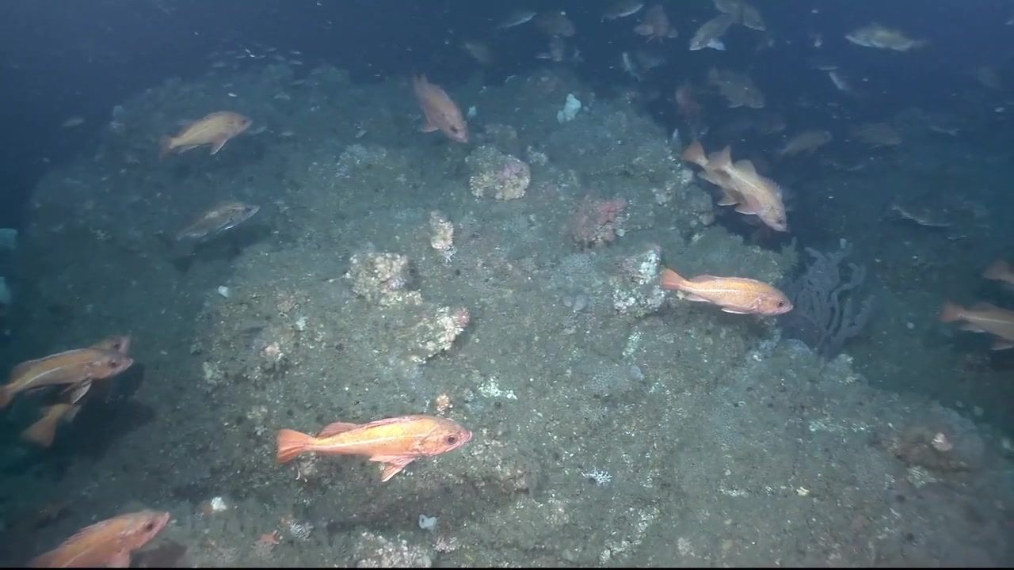
[0:00:50]
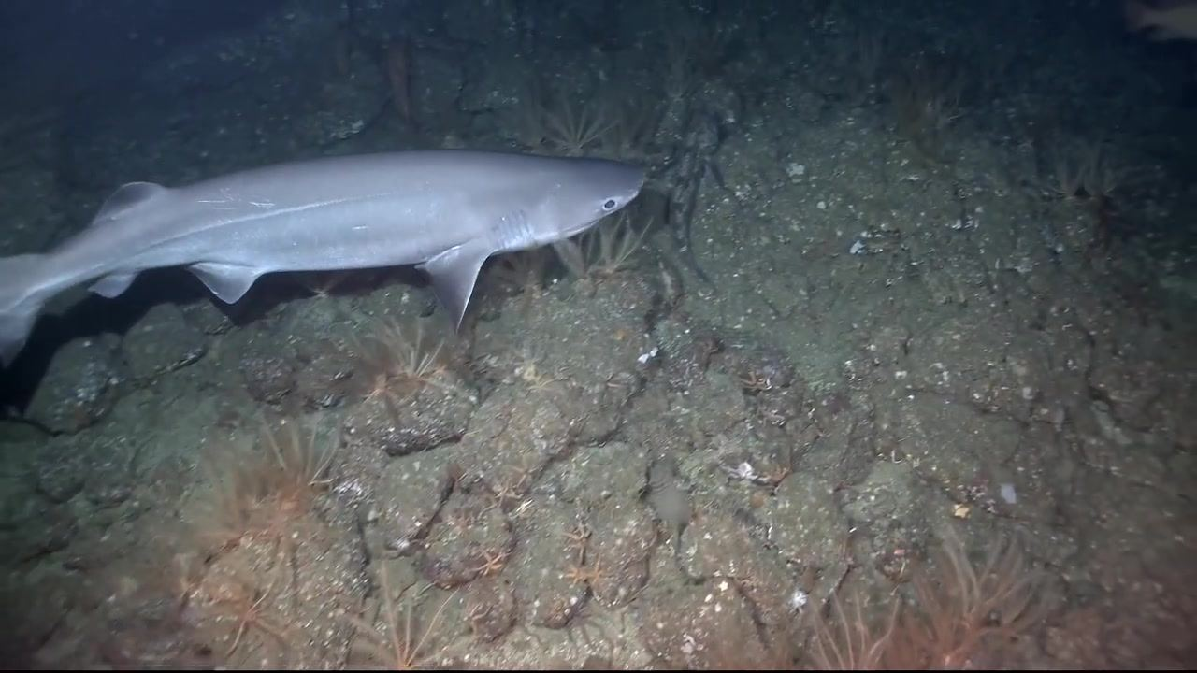
[0:00:52]
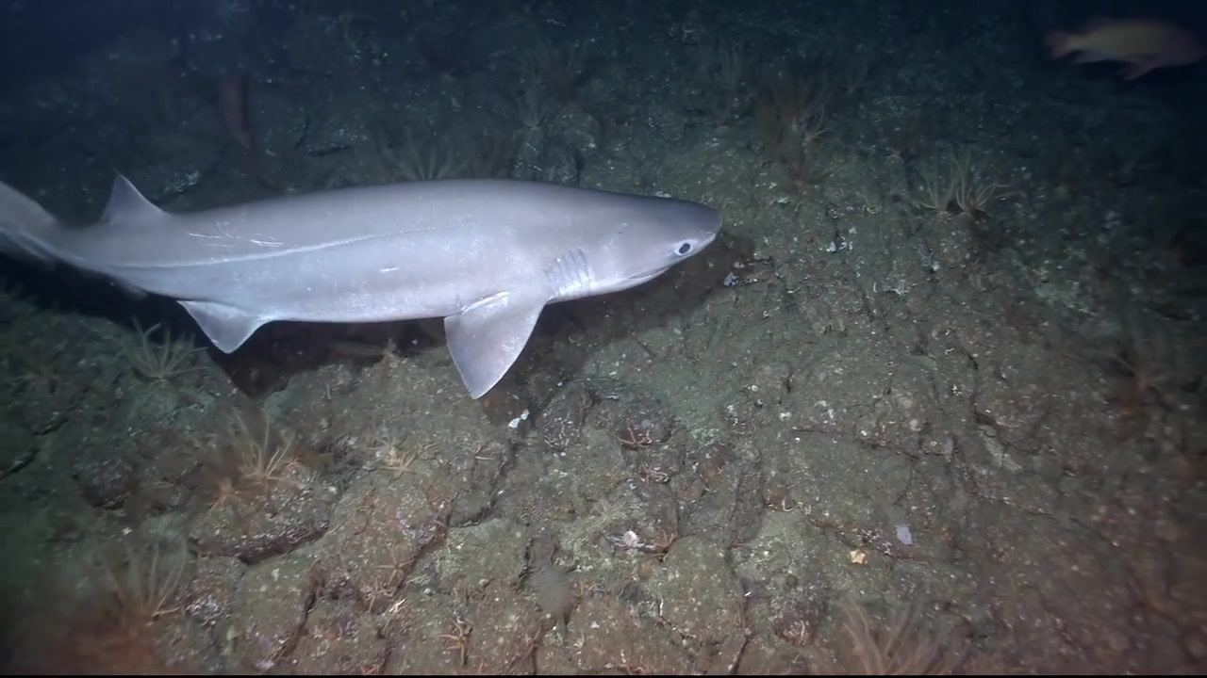
[0:00:57]
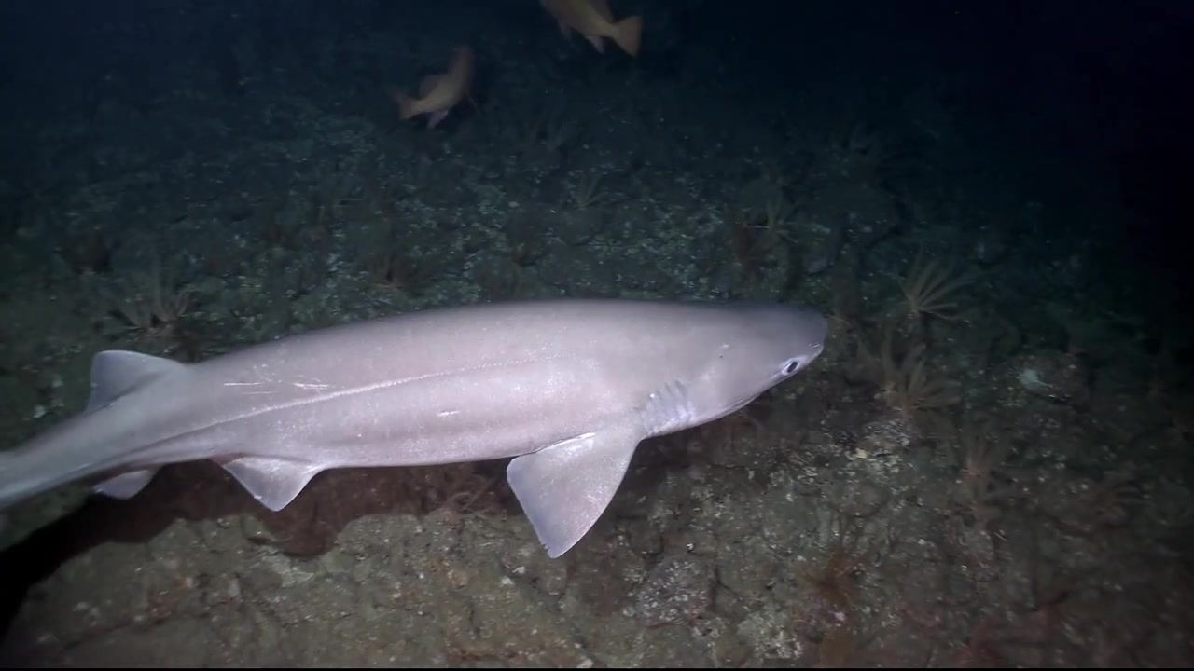
[0:00:57]
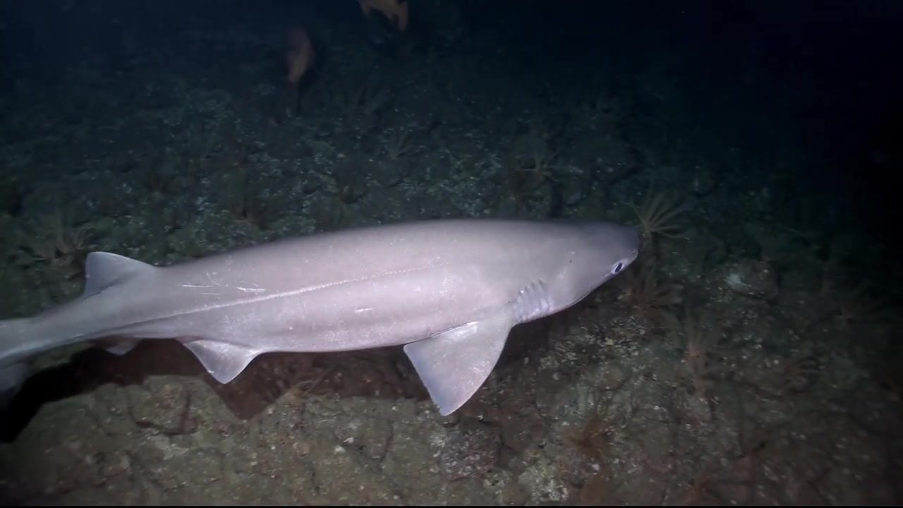
[0:00:59]
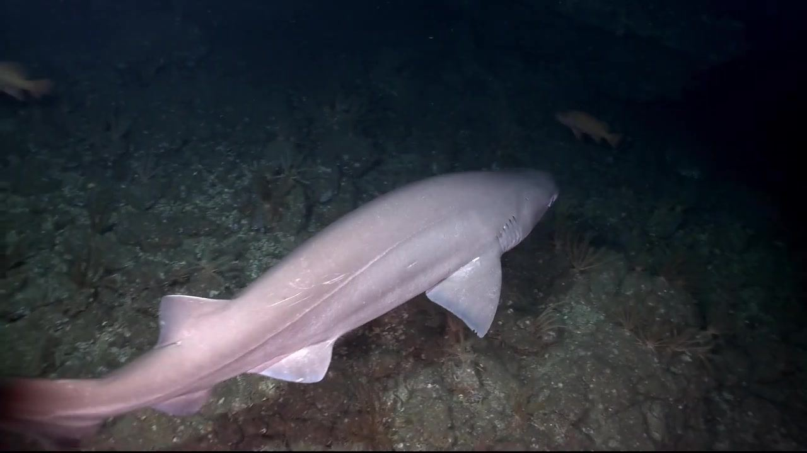
[0:01:01]
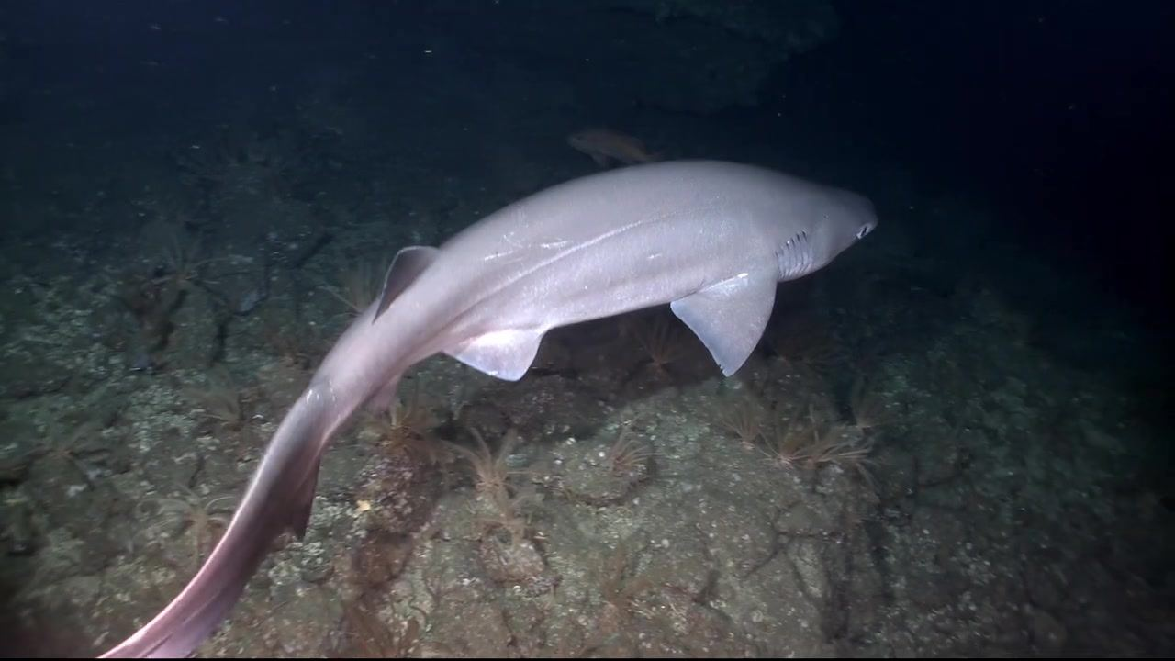
[0:01:03]
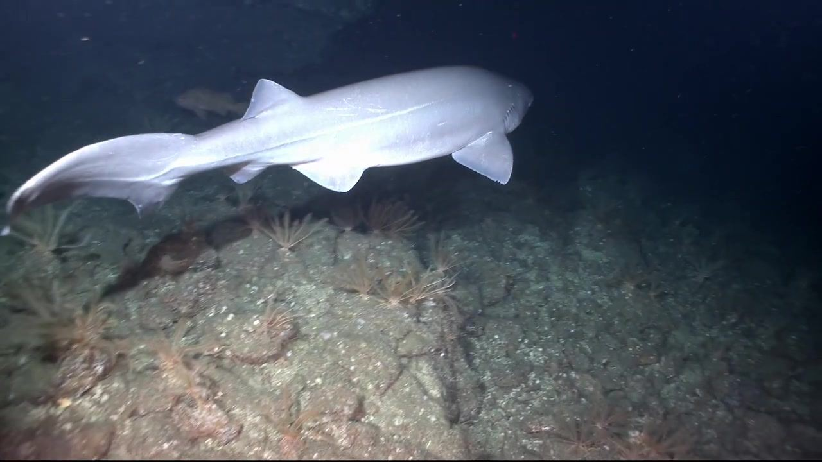
[0:01:05]
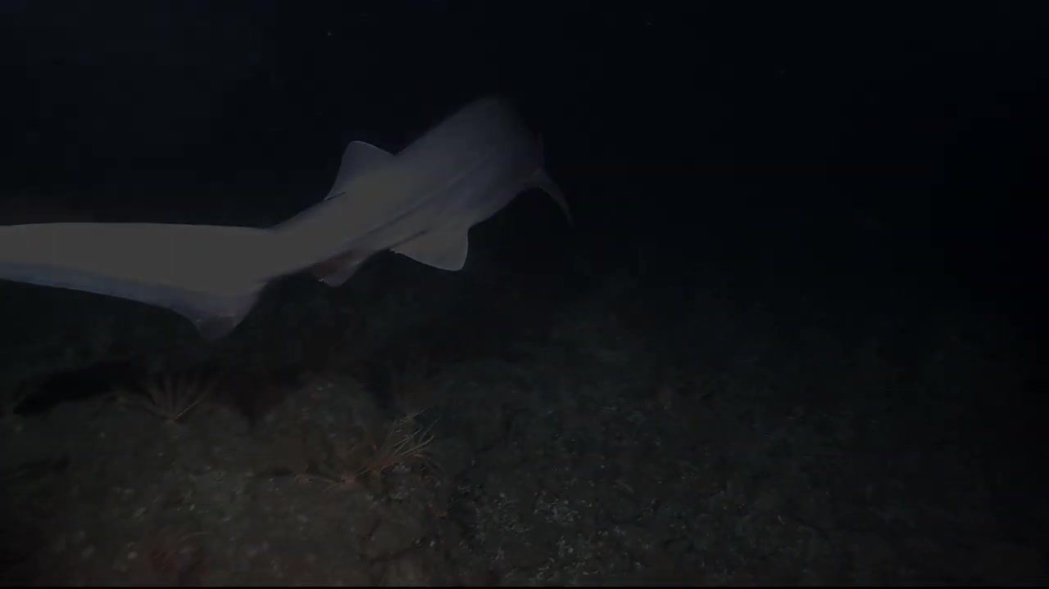
[0:01:05]

[0:01:09]
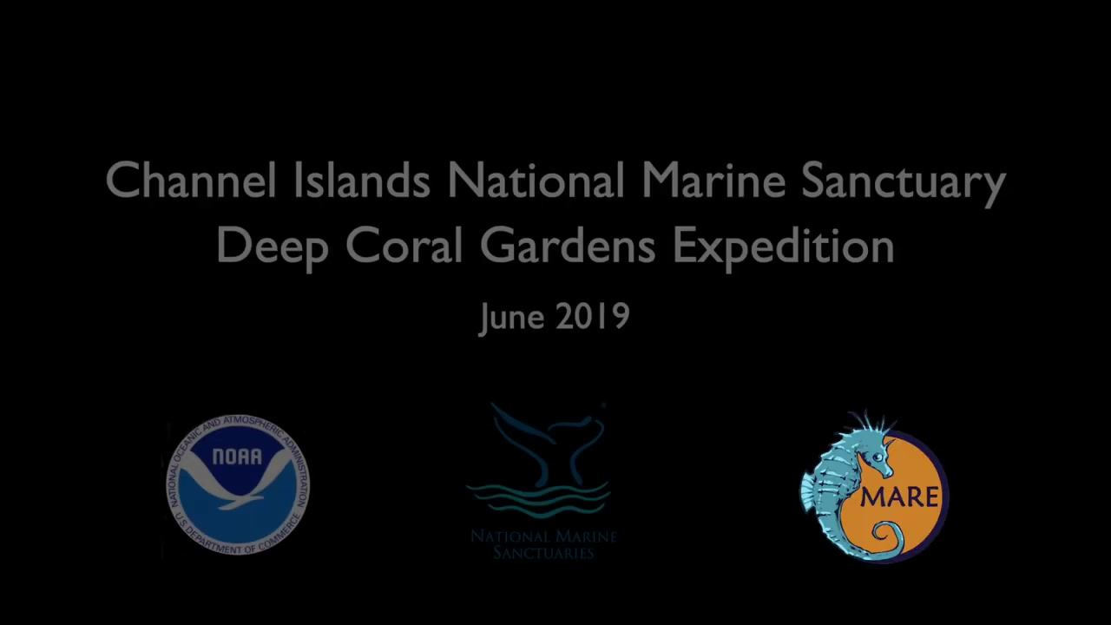
Channel Islands National Marine Sanctuary
Deep Coral Gardens Expedition
June 2019
[Image: NOAA logo]
[Image: National Marine Sanctuaries logo]
[Image: MARE logo]
[0:01:10]
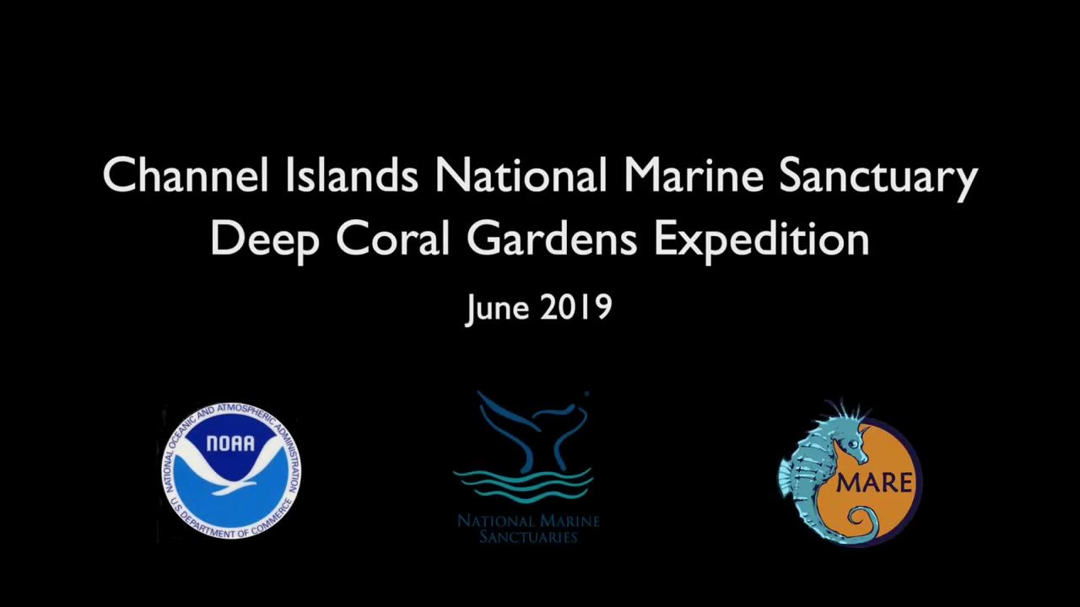
Channel Islands National Marine Sanctuary
Deep Coral Gardens Expedition
June 2019
[Image: NOAA logo]
[Image: National Marine Sanctuaries logo]
[Image: MARE logo]
[0:01:13]
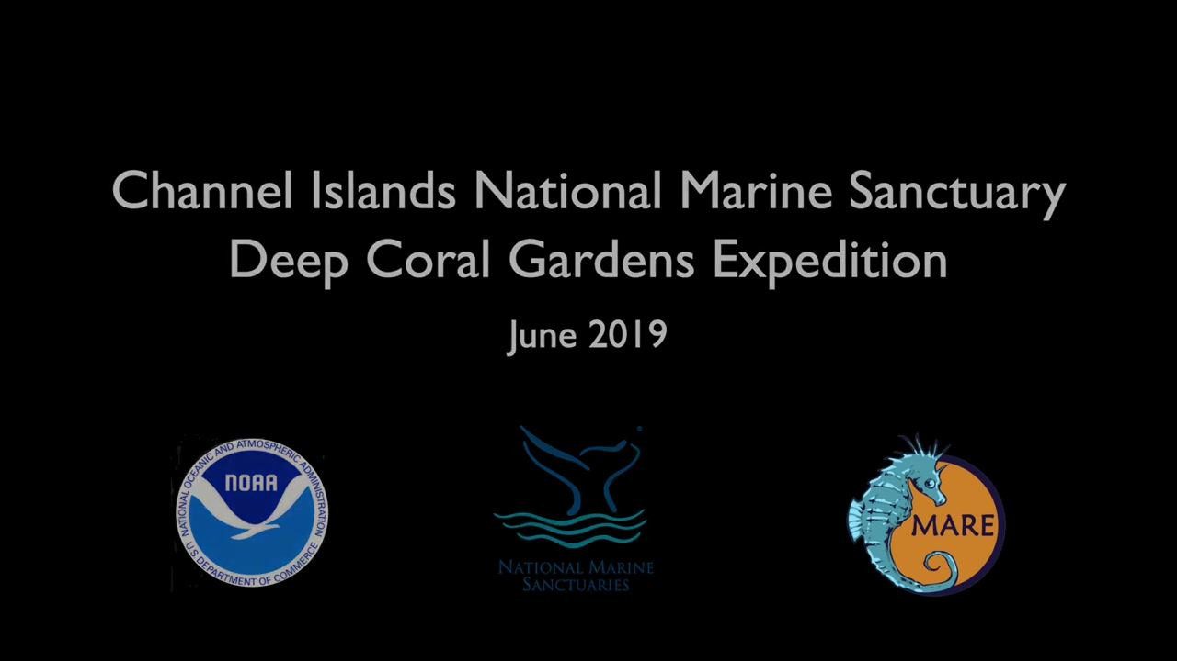
Channel Islands National Marine Sanctuary
Deep Coral Gardens Expedition
June 2019
[Image: NOAA logo]
[Image: National Marine Sanctuaries logo]
[Image: MARE logo]

