Question: ke6xx8fhohm

Table of contents
Artemis II Mission Animation Segment Breakdown
Artemis II Mission Animation Segment Breakdown
Section 1

Artemis II Mission Animation Segment Breakdown

Brand new article

Artemis II Mission Animation Segment Breakdown

Brand new article

Section 1
Task: Answer the question below from what the recording shows and says.
Look for: Extract a representative frame for each distinct segment of this NASA mission animation (crew walkout, launch, separations, translunar injection, lunar flyby, re-entry, parachutes, splashdown). For each segment give the timestamp of the clearest frame and a one-line caption suitable for alt text.
Result
Crew walkout
[0:00:02]
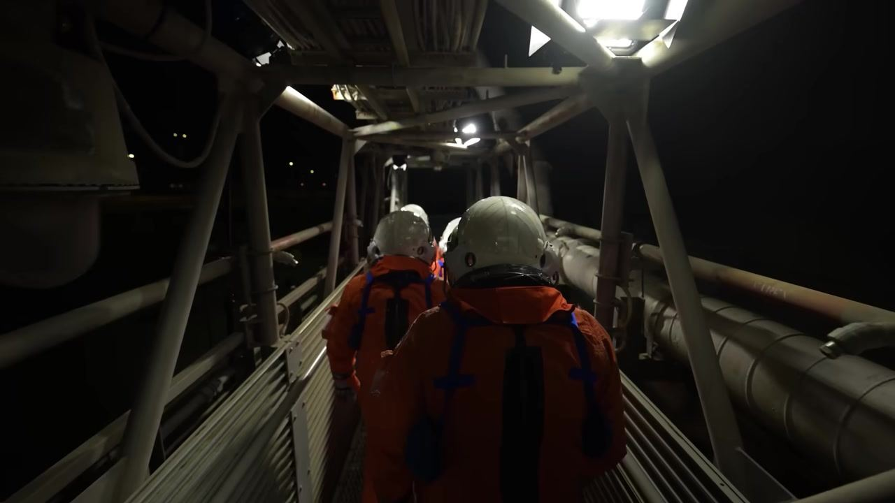
Alt: Four astronauts in orange suits walk down a launch tower walkway at night.
Launch
[0:01:19]
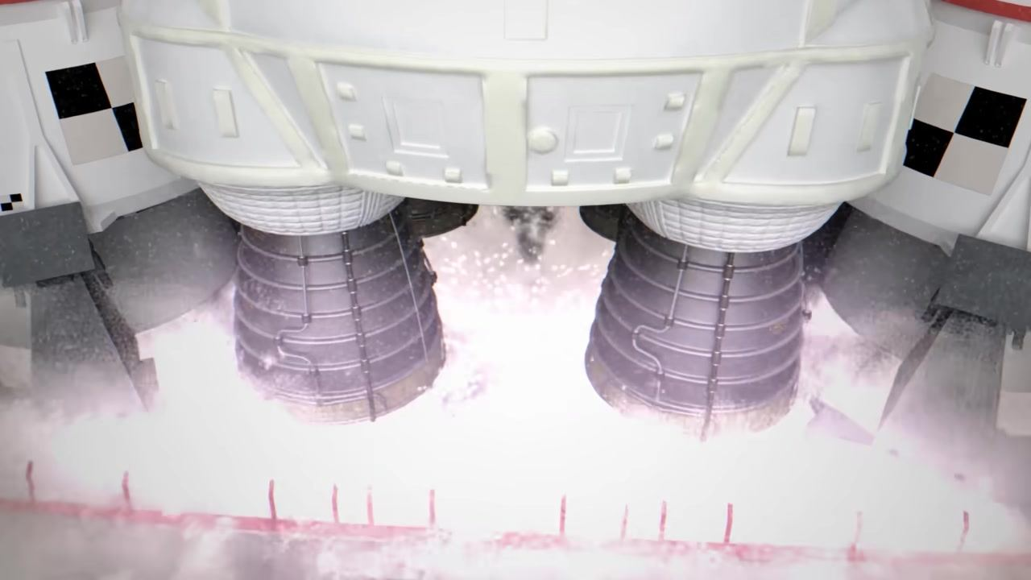
Alt: View of the SLS engines and boosters firing, with intense exhaust and flames as the rocket lifts off.
Separations
[0:01:58]
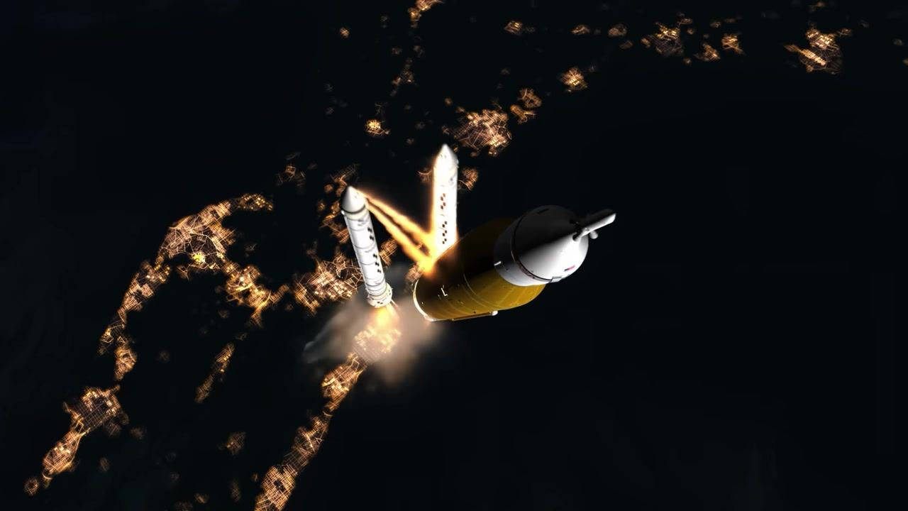
Alt: Solid rocket boosters separating from the core stage, flames trailing, above city lights at night.
Translunar injection
[0:04:17]
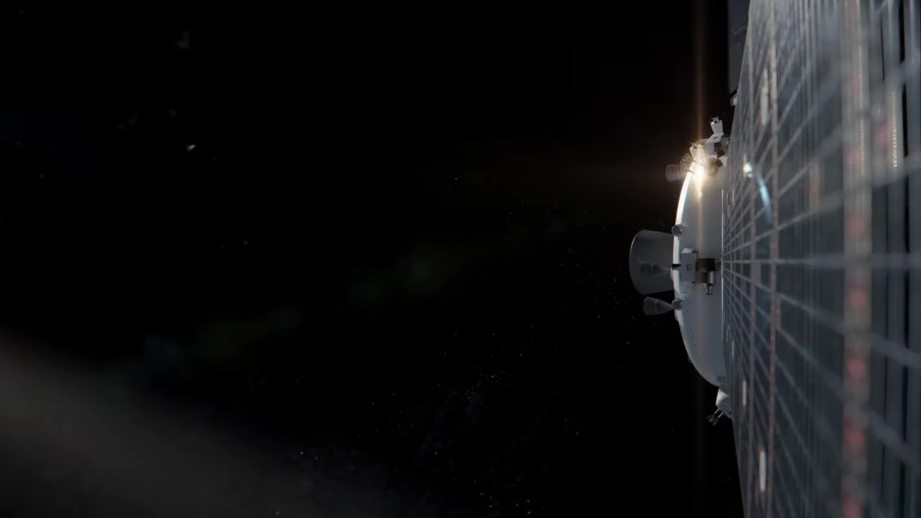
Alt: Orion spacecraft in deep space with solar panel visible, faint engine glow marks the start of the Translunar Injection burn.
Lunar flyby
[0:04:56]
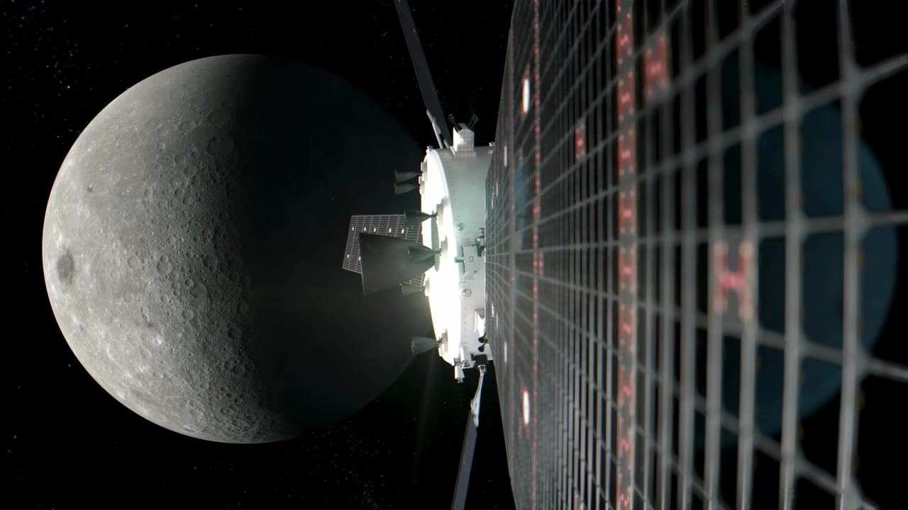
Alt: Orion spacecraft with solar panels, close flyby of the Moon's far side.
Re-entry
[0:06:14]
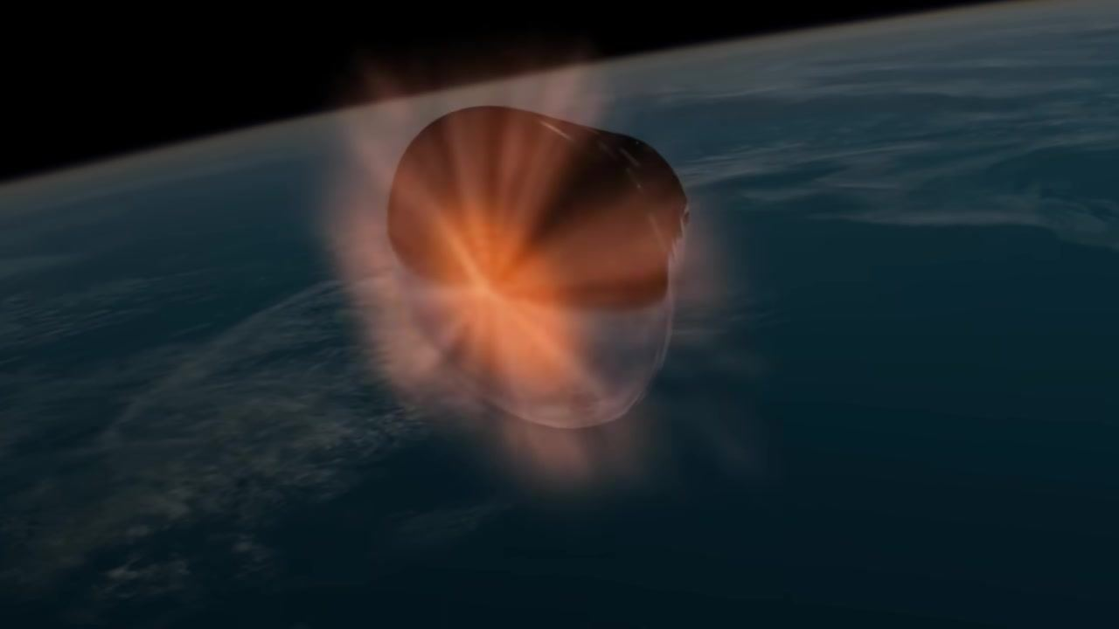
Alt: Orion capsule surrounded by plasma and heat as it descends through the atmosphere.
Parachutes
[0:06:48]
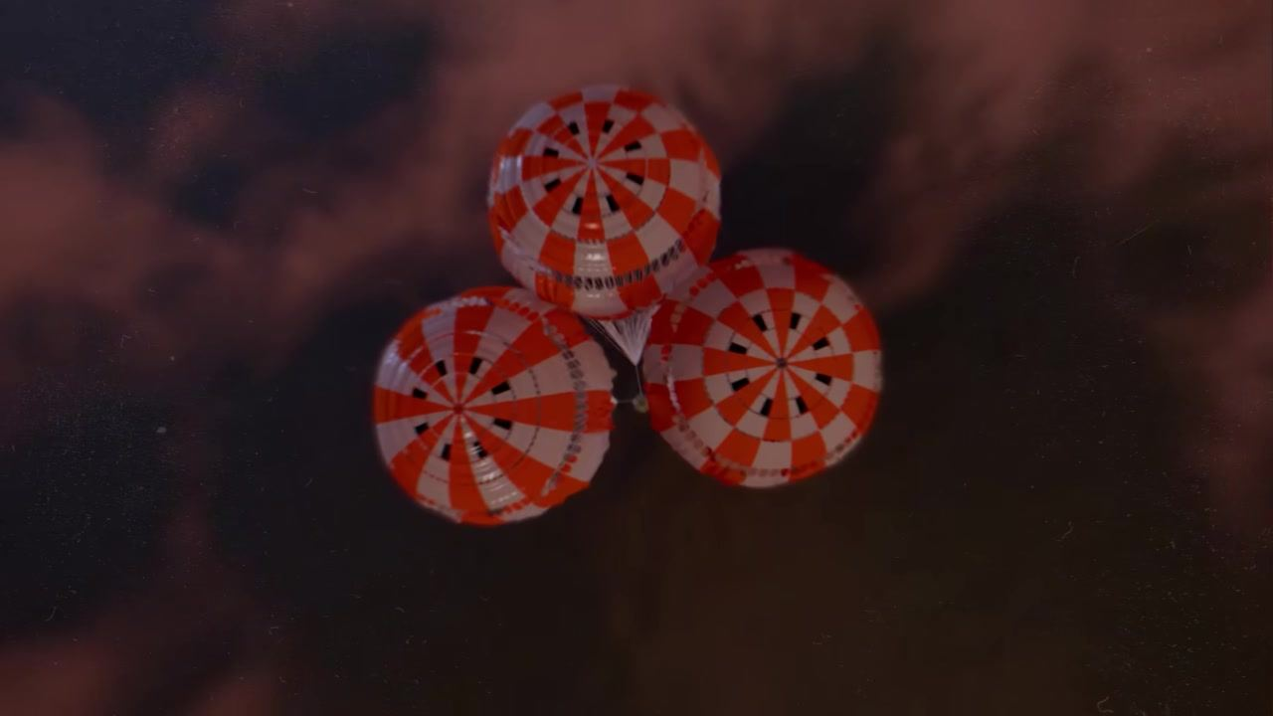
Alt: Three fully inflated orange-and-white main parachutes, viewed from below, reddish clouds in background.
Splashdown
[0:07:05]
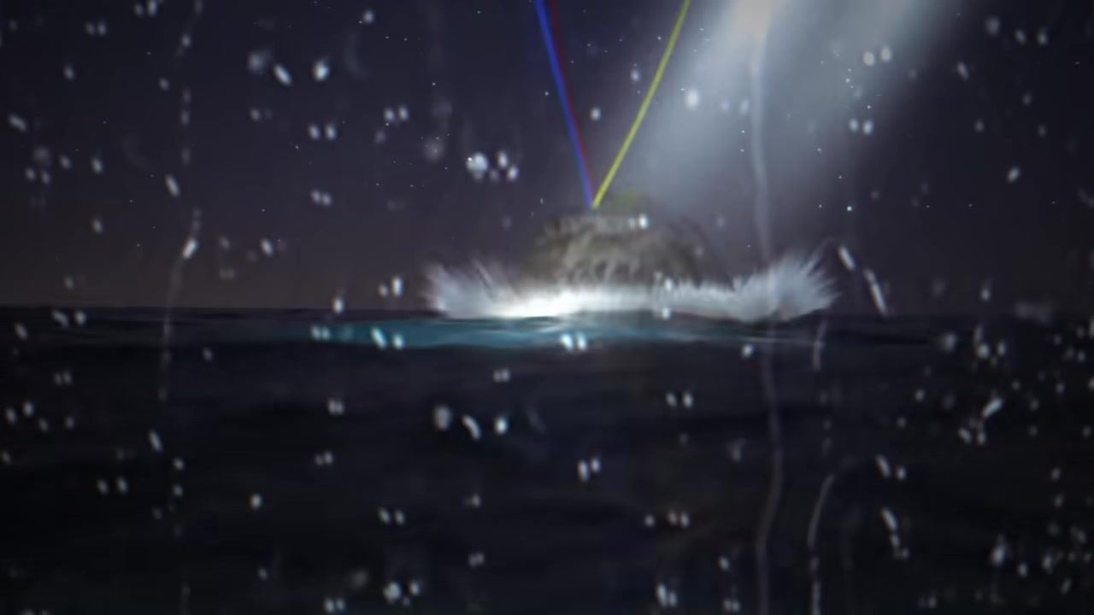
Alt: Capsule splashing into ocean at night, water spray and droplets, searchlight beam, colored parachute lines visible.
Findings
[0:00:02]
Caption: Four astronauts in orange suits walk down a launch tower walkway at night.
[0:00:04]
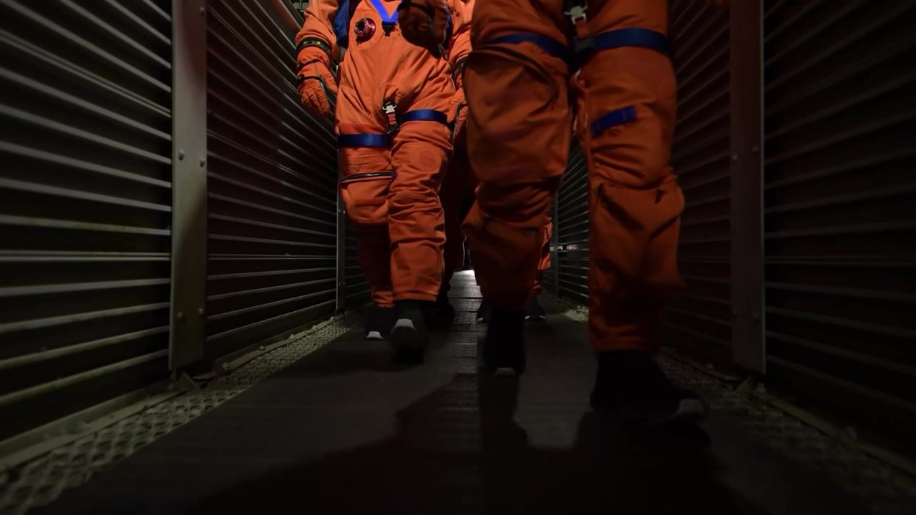
Caption: Close-up of astronauts' legs as they walk in orange suits along a grated corridor.
[0:00:06]
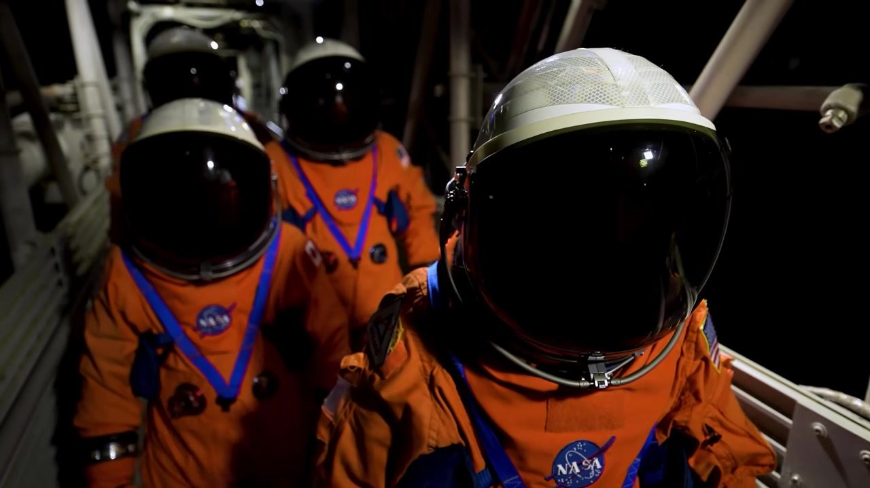
Caption: Four astronauts in full NASA suits and helmets stand together in a launch walkway.
[0:00:08]
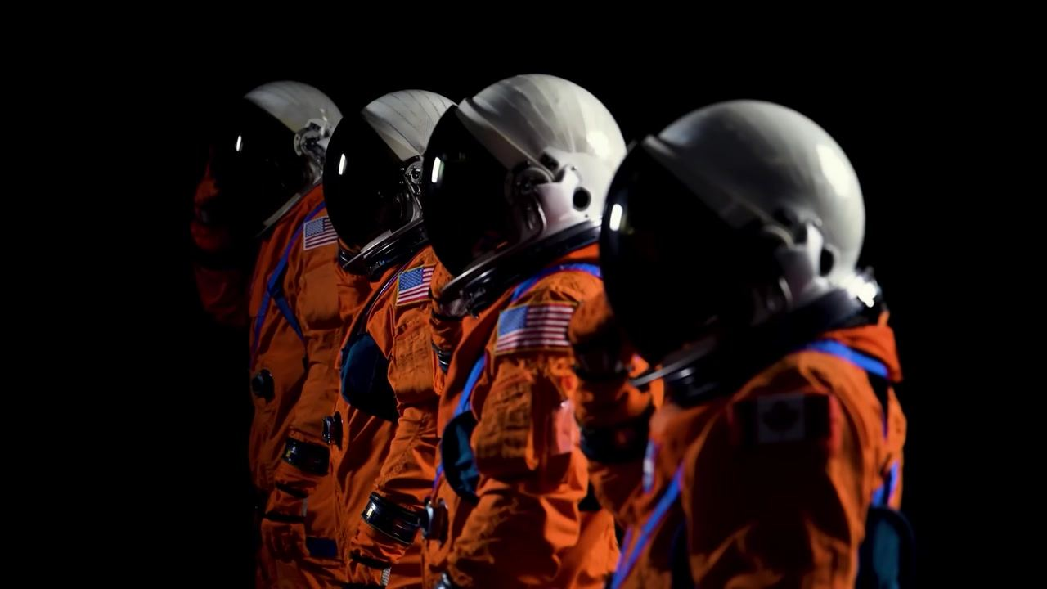
Caption: Side view of four suited astronauts standing in a row, flags visible on their arms.
[0:00:16]
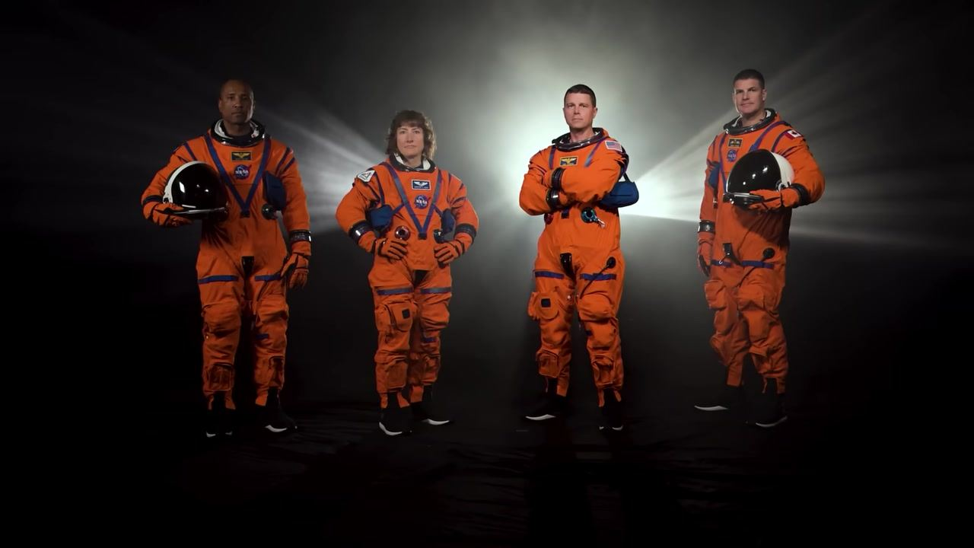
Caption: The Artemis II crew stands together in orange suits, two holding helmets, with bright backlighting.
[0:00:18]
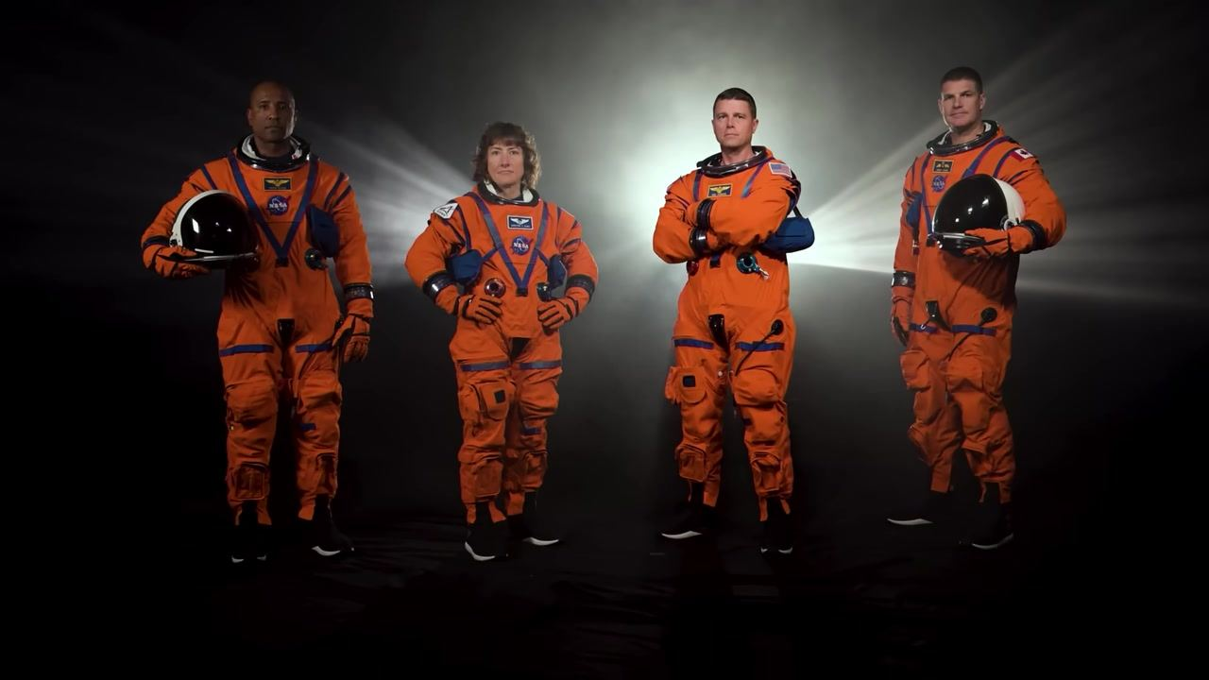
Caption: The Artemis II crew stands in orange suits with dramatic backlighting, two holding helmets.
[0:00:20]
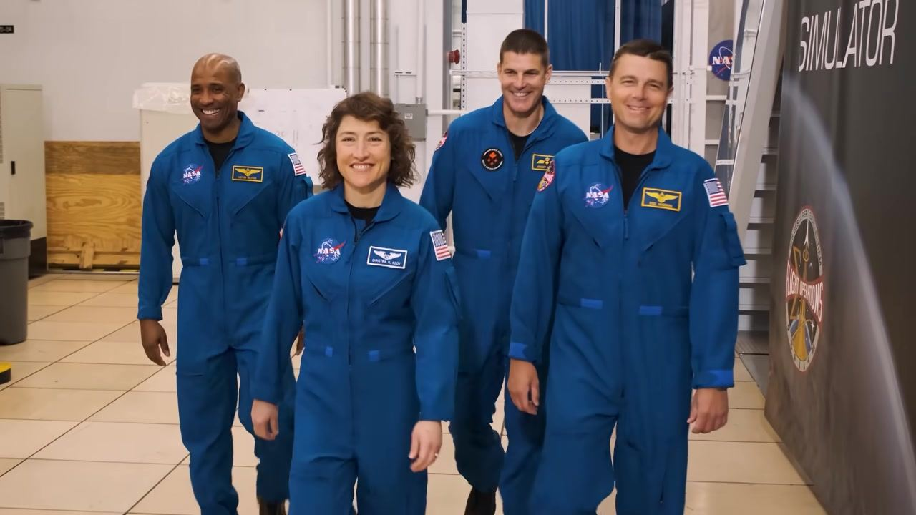
Caption: The Artemis II crew walks together in blue NASA flight suits, smiling inside a training facility.
[0:00:22]

Caption: An astronaut in a blue suit touches a large red and white NASA logo, with crew members in the background.
[0:00:24]
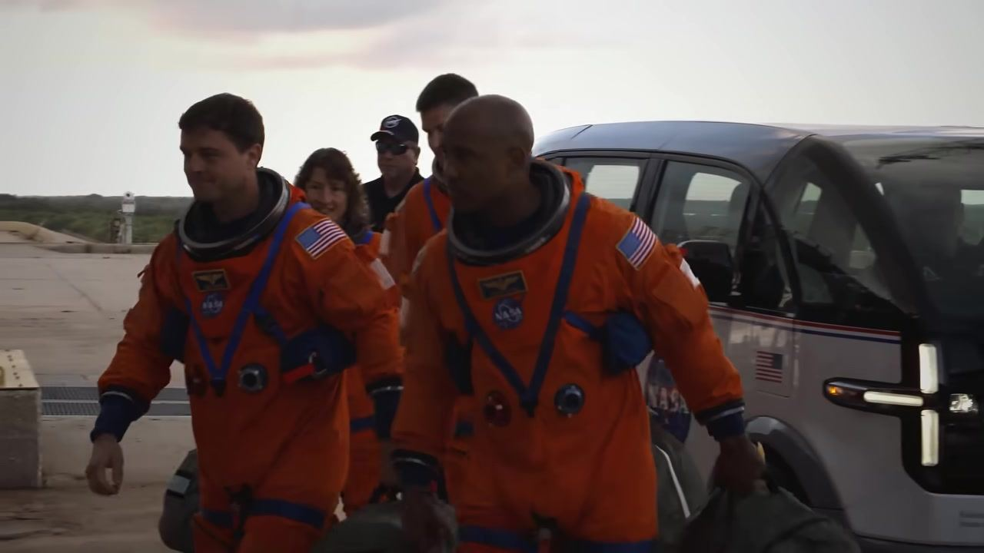
Caption: The Artemis II crew exits a NASA van at the launch pad, carrying their gear bags.
[0:00:26]
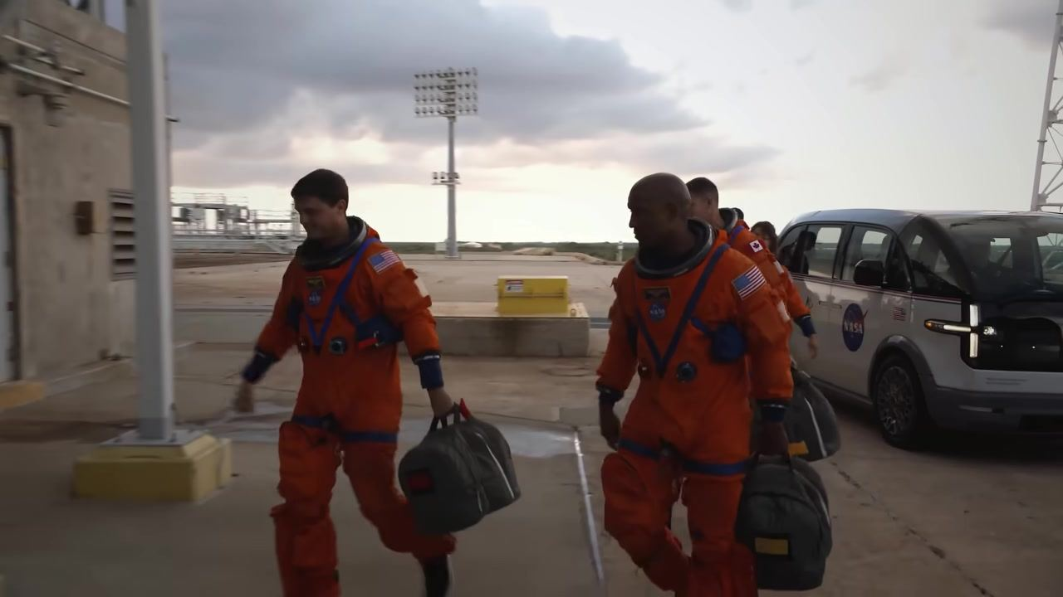
Caption: The Artemis II crew walks toward the launch pad building at dawn, carrying their bags.
[0:00:28]
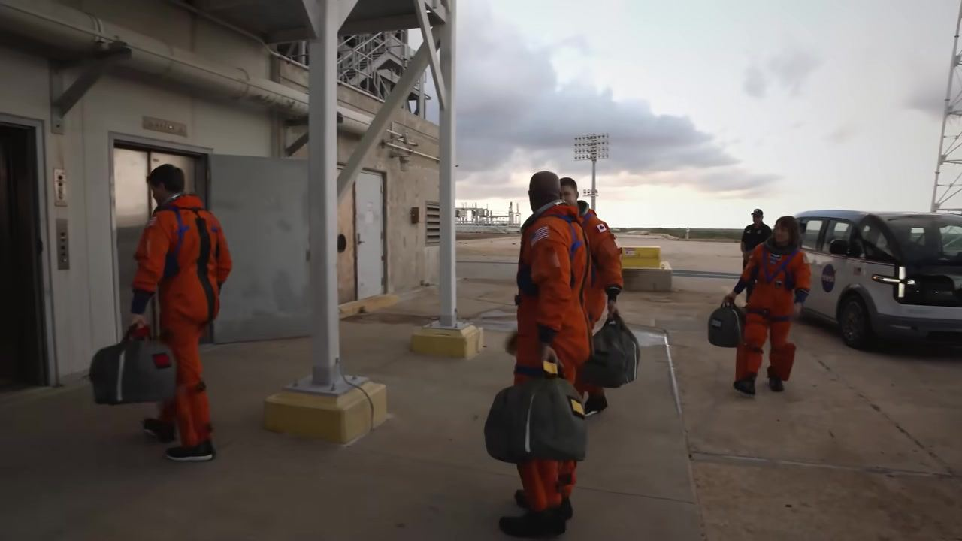
Caption: One Artemis II astronaut enters the launch pad building as the others approach, NASA van behind them.
[0:00:30]
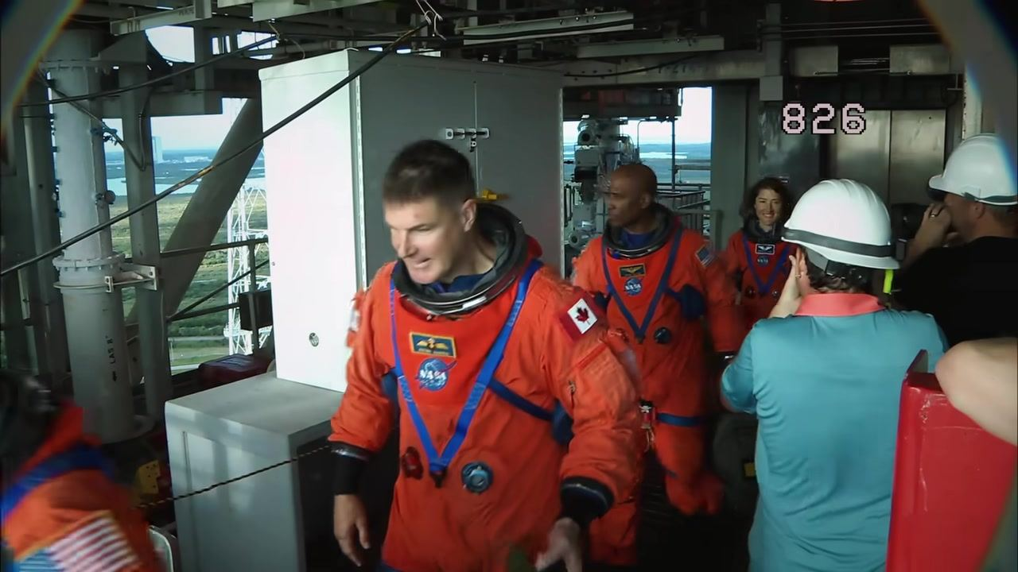
Caption: The Artemis II crew is greeted by ground personnel at the launch tower, with the number 826 visible.
[0:00:32]
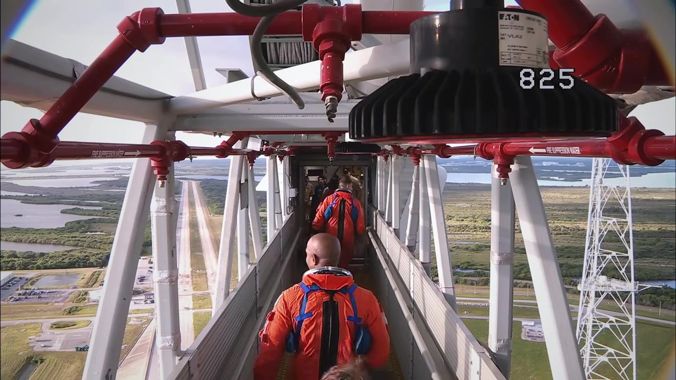
Caption: The Artemis II crew walks down the elevated launch tower walkway, landscape visible below, number 825 on screen.
[0:00:34]
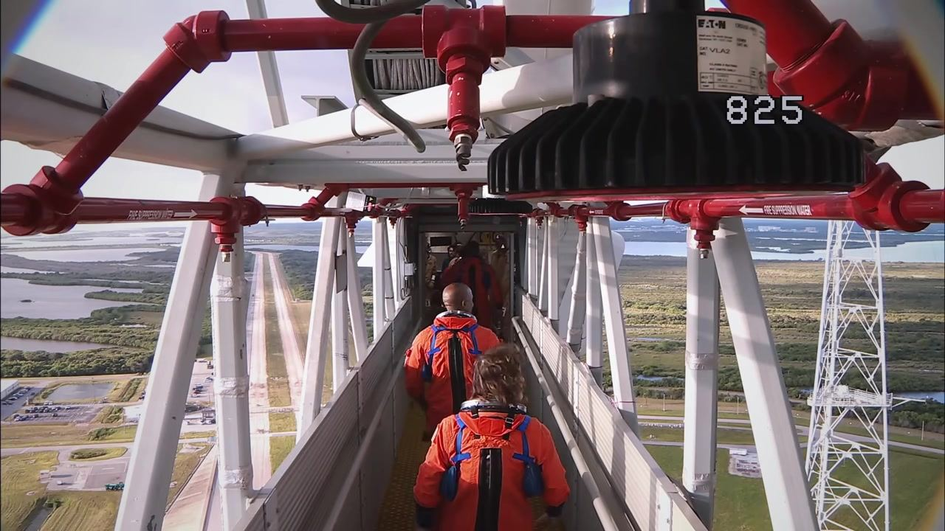
Caption: The Artemis II crew continues down the launch tower walkway, with the launch pad and landscape in view, number 825.
[0:00:36]
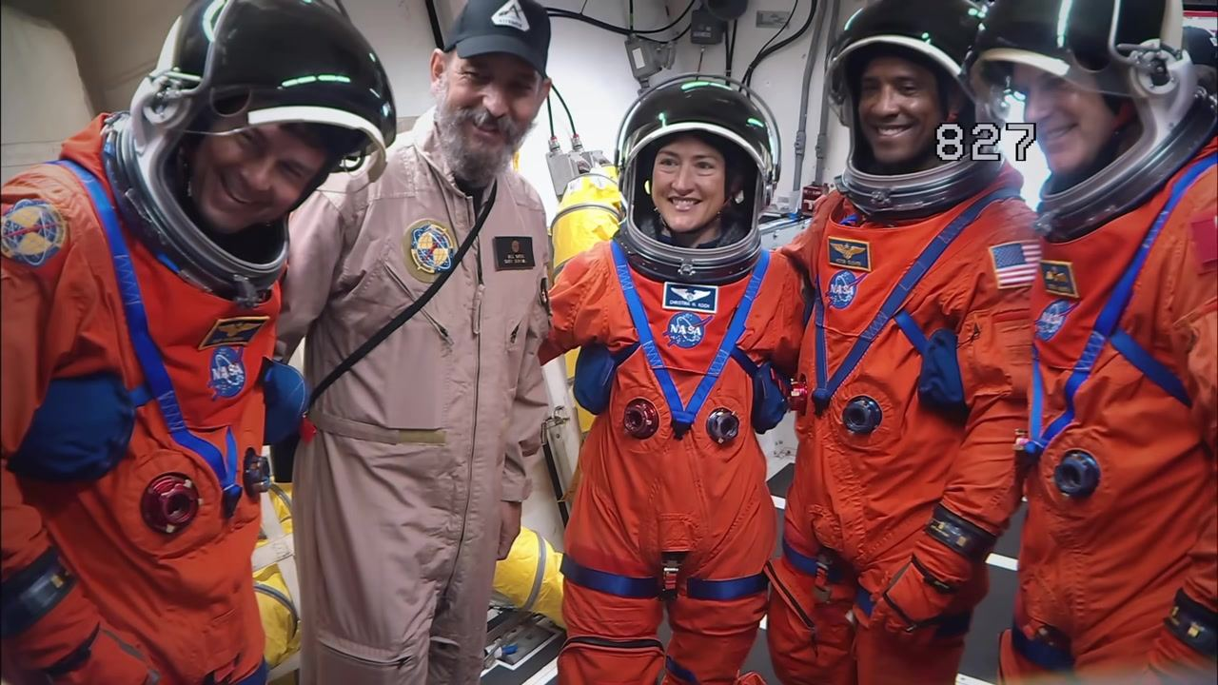
Caption: The Artemis II crew, suited and helmeted, smiles with a technician inside the spacecraft area, number 827 on screen.
[0:00:43]
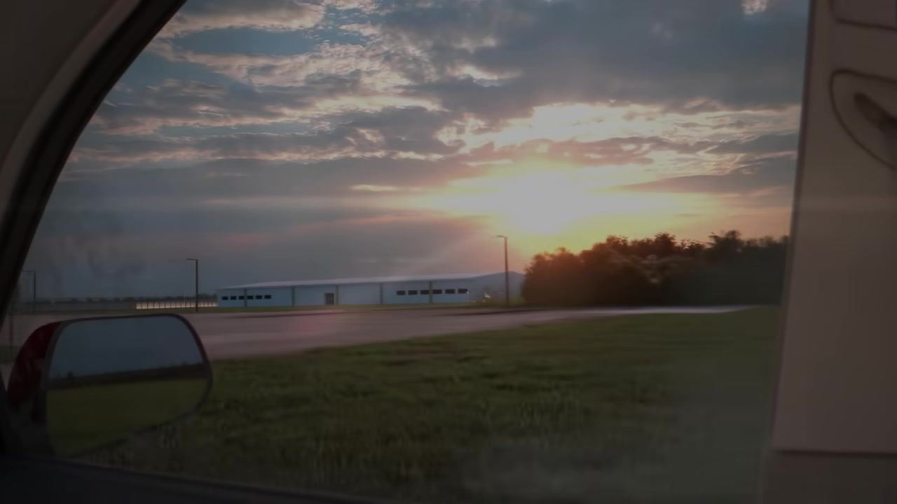
Caption: Sunrise over a NASA facility as seen through the window of a crew transport vehicle.
[0:00:50]
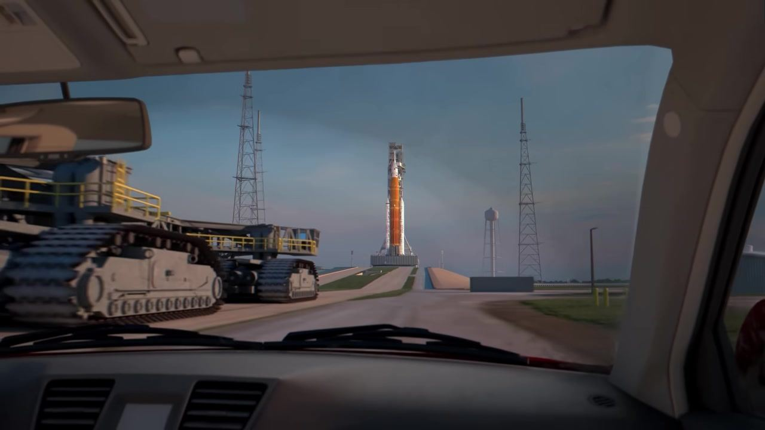
Caption: View from inside a vehicle approaching the SLS rocket on the launch pad, with the crawler-transporter to the left.
[0:00:56]
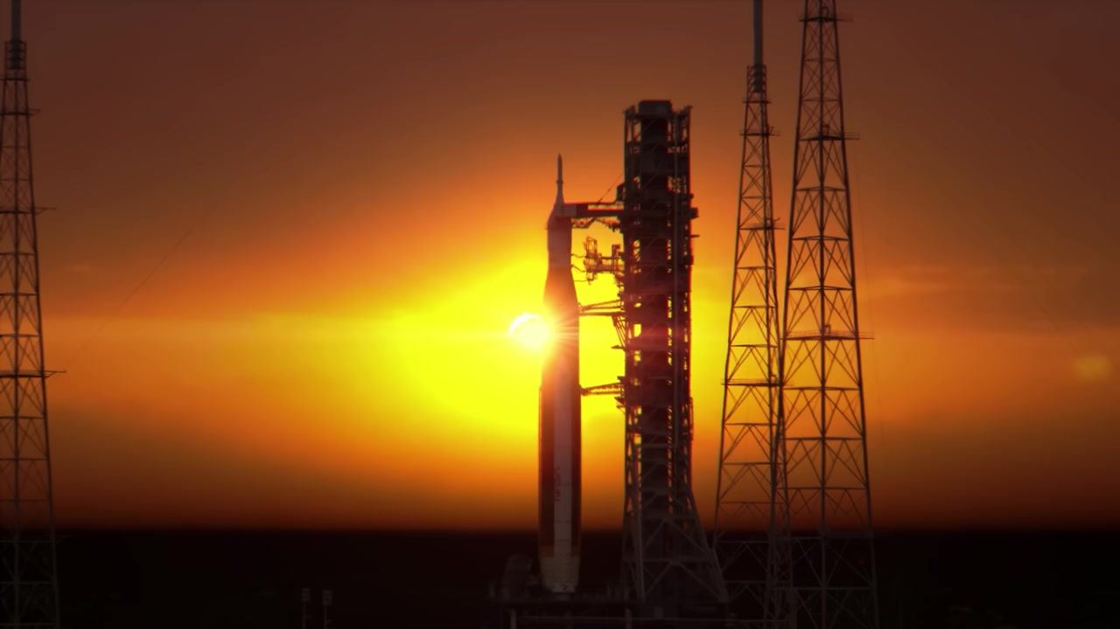
Caption: SLS rocket and launch tower silhouetted by the rising sun at the launch pad.
[0:01:01]
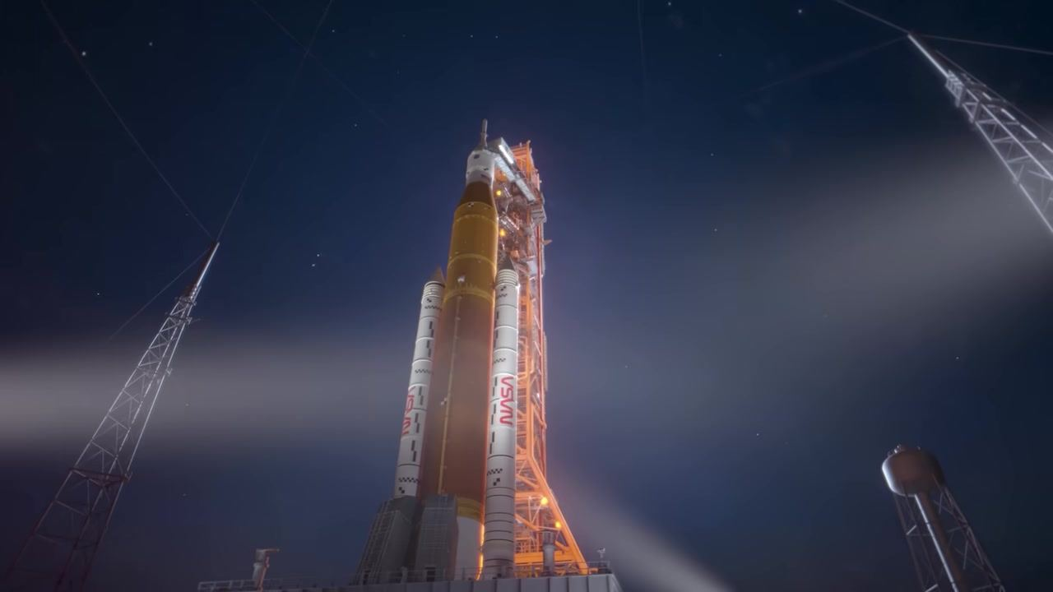
Caption: SLS rocket on the launch pad at night, illuminated by spotlights with stars in the sky.
[0:01:05]
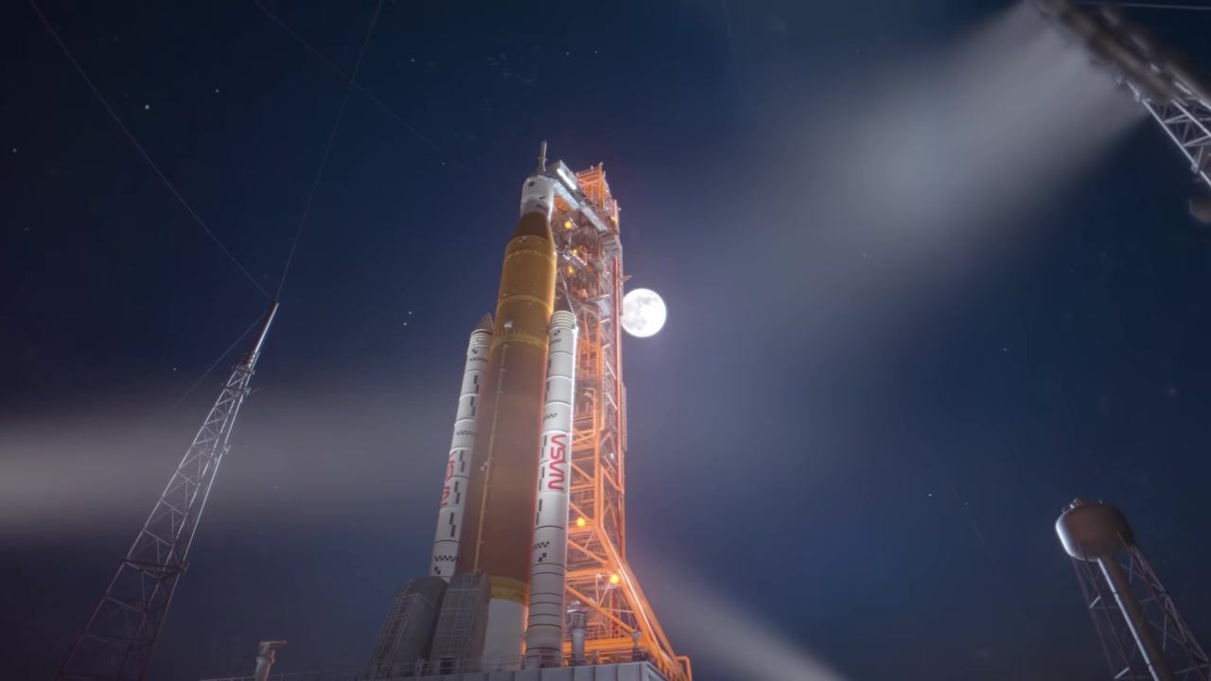
Caption: SLS rocket on the launch pad at night with the full moon visible behind the tower.
[0:01:10]
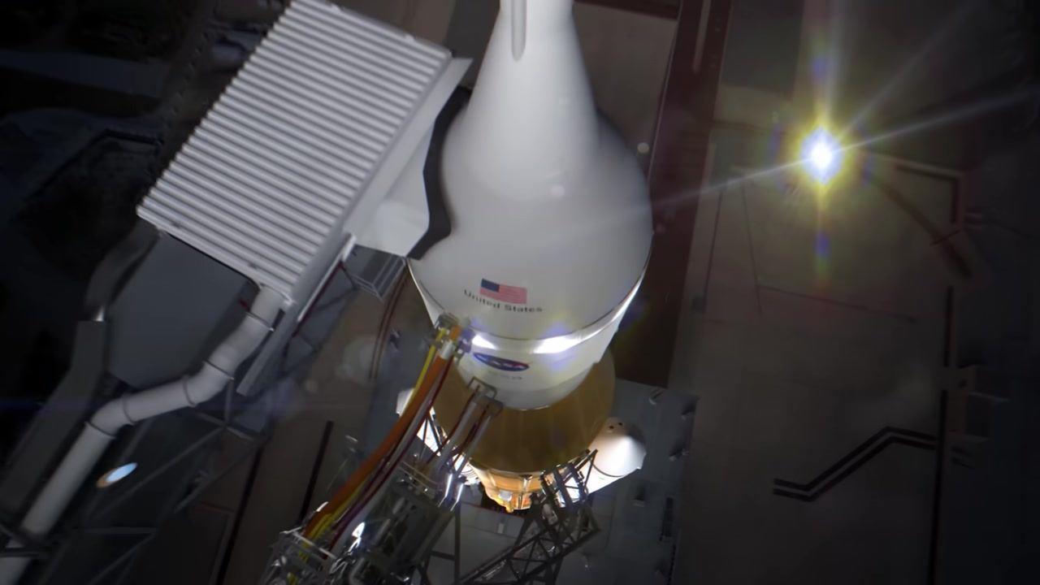
Caption: Overhead view of the Orion capsule atop the SLS rocket on the launch pad, with umbilical connections attached.
[0:01:12]
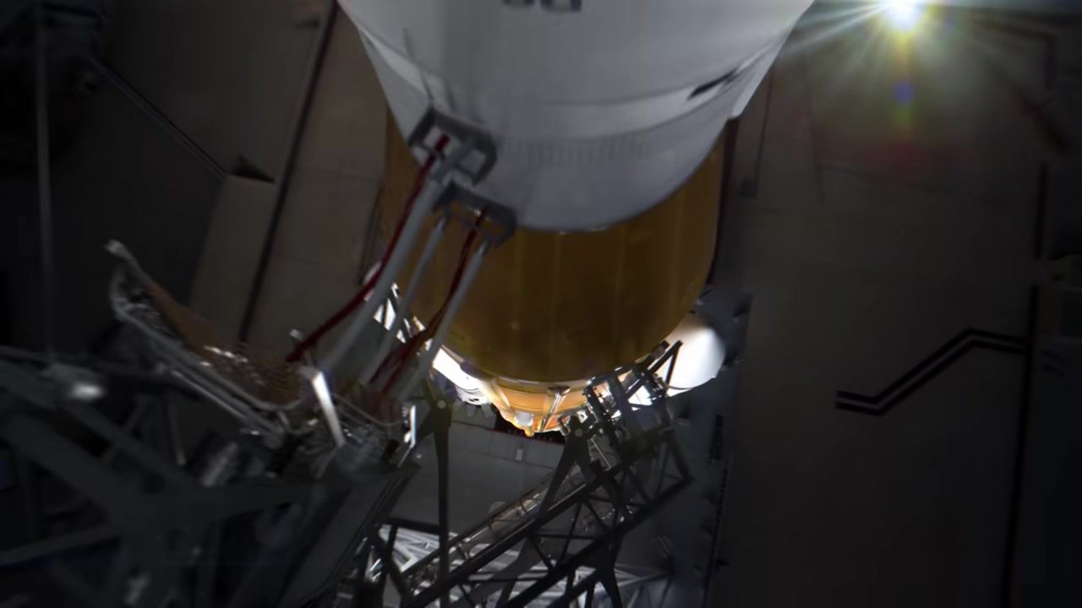
Caption: Close overhead view of the SLS core stage and umbilical arm, with the United States flag and NASA logo visible.
[0:01:12]
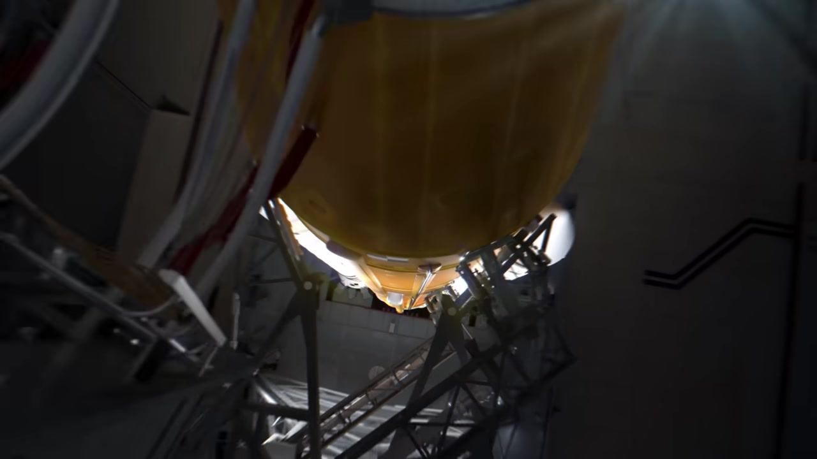
Caption: View looking down the SLS core stage as the umbilical arm begins to retract before launch.
[0:01:13]
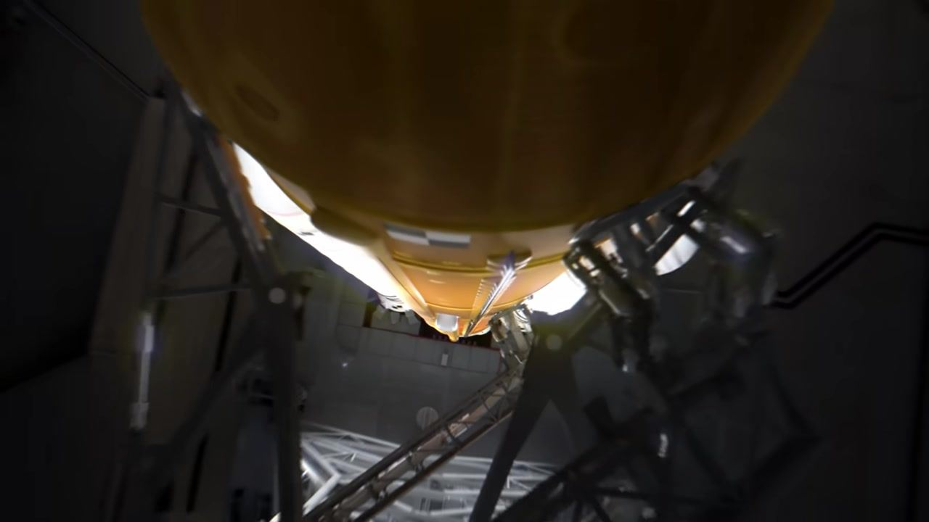
Caption: View down the SLS core stage with the umbilical arm nearly clear of the rocket.
[0:01:13]
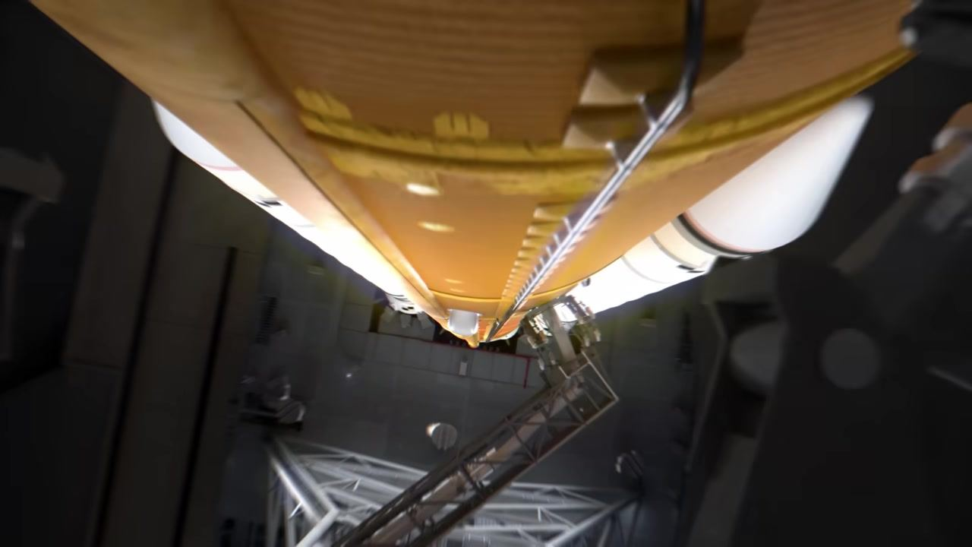
Caption: View down the SLS core stage with the umbilical arm fully retracted, seconds before engine ignition.
[0:01:15]
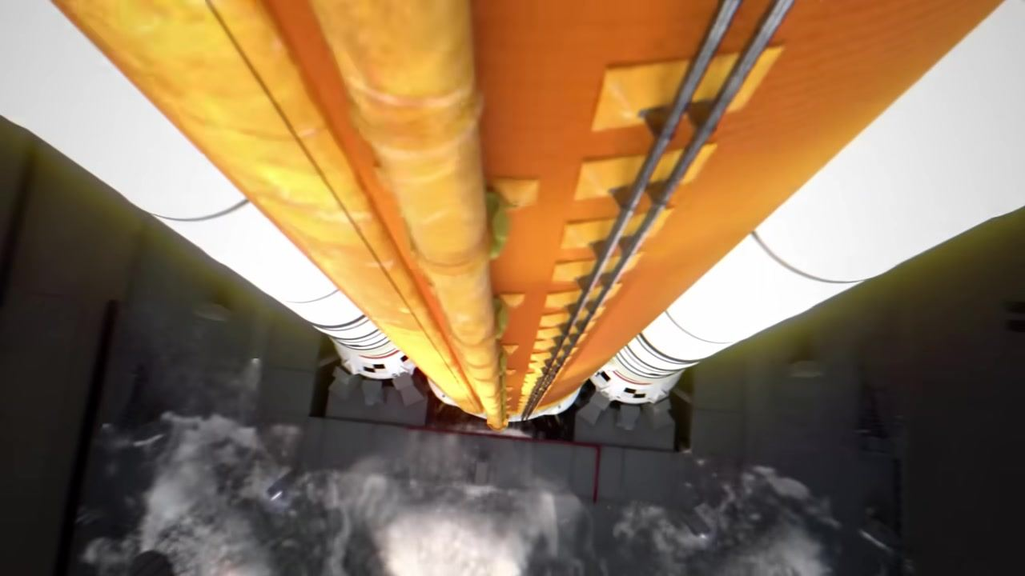
Caption: View down the SLS core stage as the engines ignite, with exhaust and steam billowing at the base.
[0:01:17]
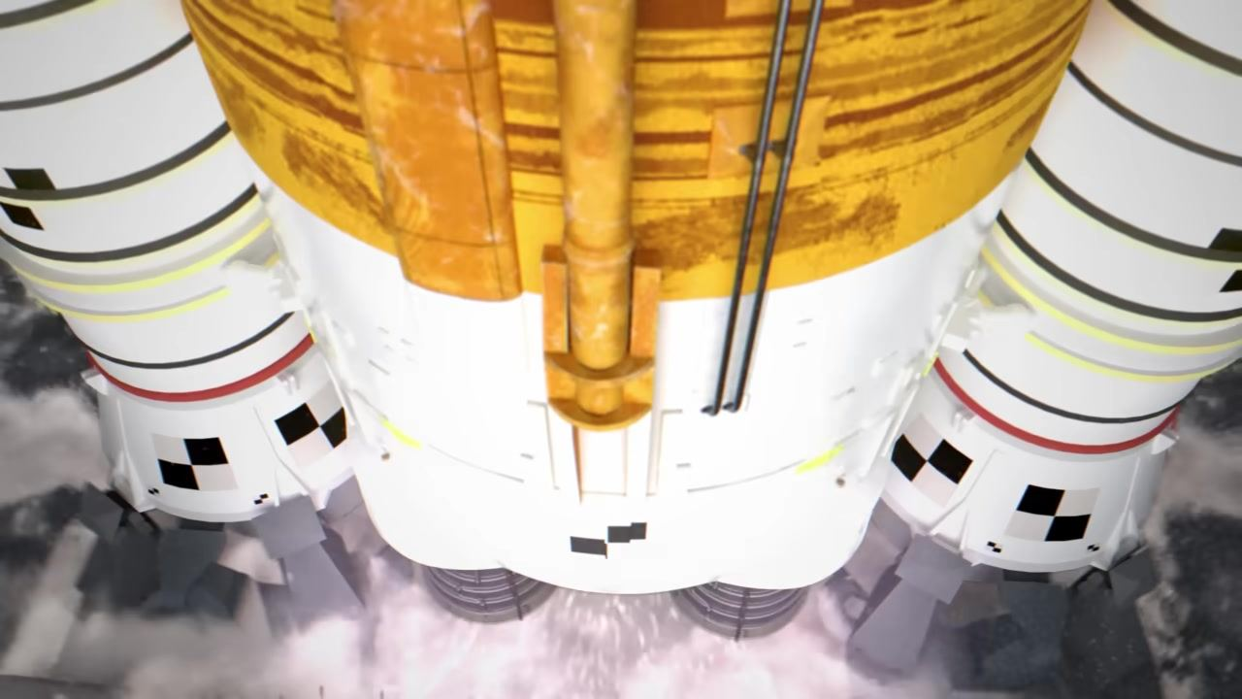
Caption: Close-up of the SLS core stage and solid rocket boosters at ignition, with flames and smoke billowing at the base.
[0:01:19]
Caption: View of the SLS engines and boosters firing, with intense exhaust and flames as the rocket lifts off.
[0:01:20]
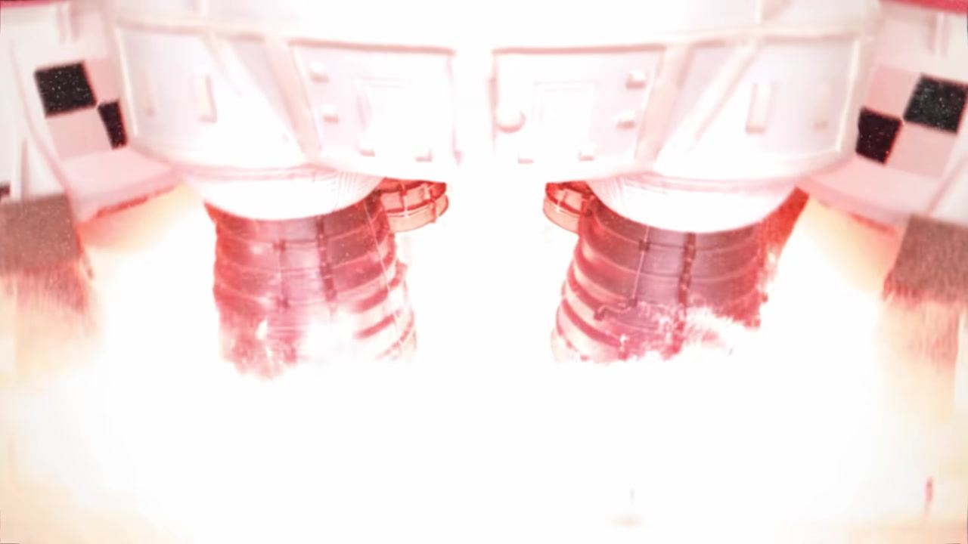
Caption: SLS engines and boosters firing, with a bright exhaust plume filling the frame during liftoff.
[0:01:22]
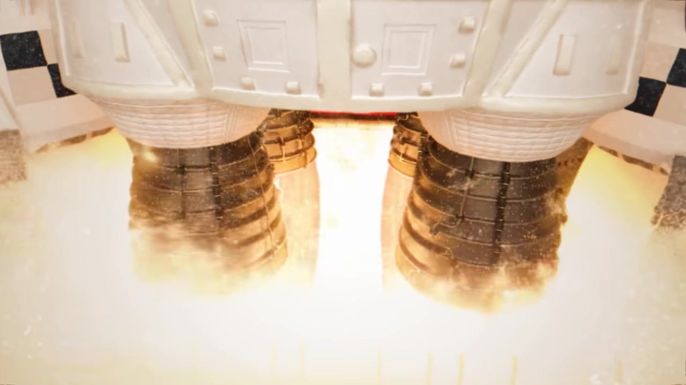
Caption: SLS engines and boosters firing, with a yellow-orange exhaust plume as the rocket ascends.
[0:01:24]
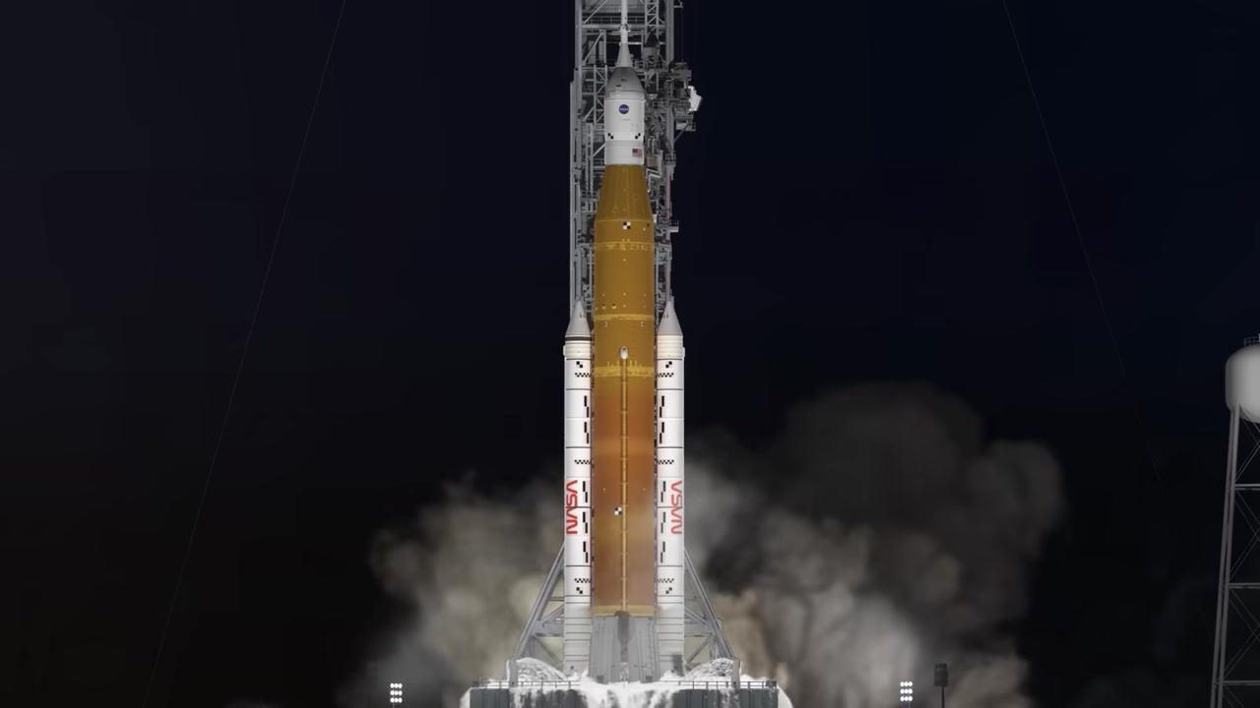
Caption: Full view of the SLS rocket on the launch pad at night, engines firing with smoke and steam at the base.
[0:01:26]
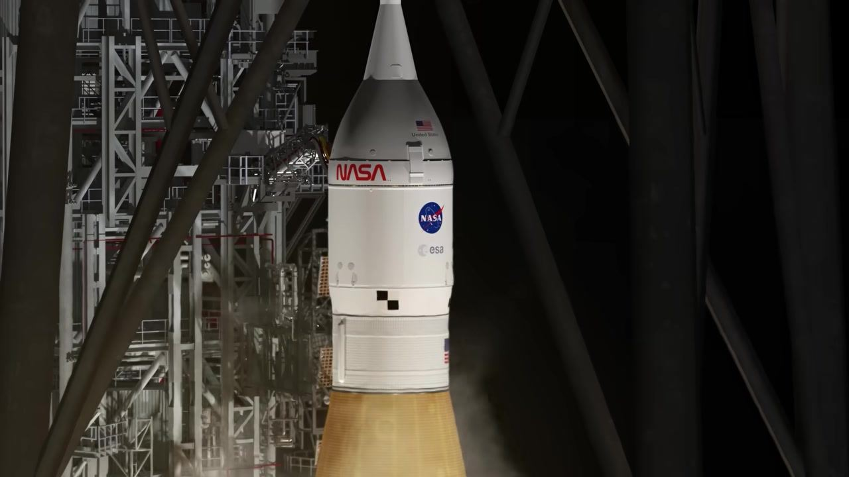
Caption: Orion capsule and SLS core stage lifting off, with the launch pad structure in the background.
[0:01:28]
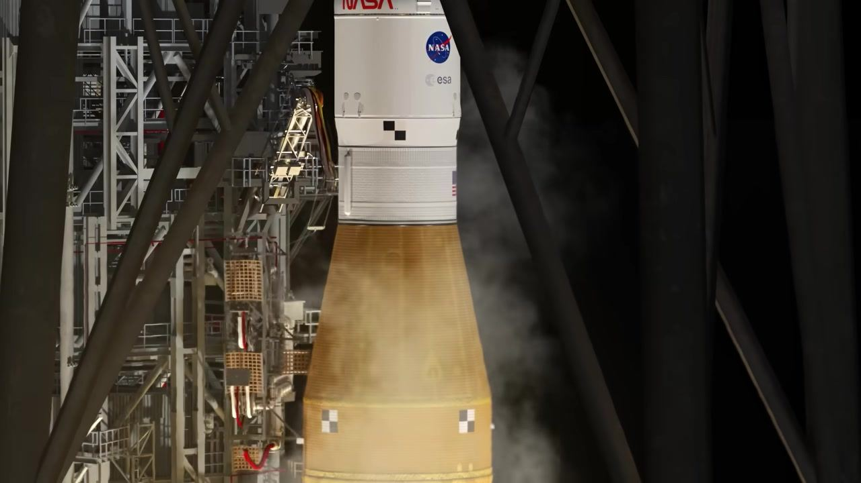
Caption: SLS core stage and Orion capsule rising past the pad structure, with exhaust visible below.
[0:01:30]
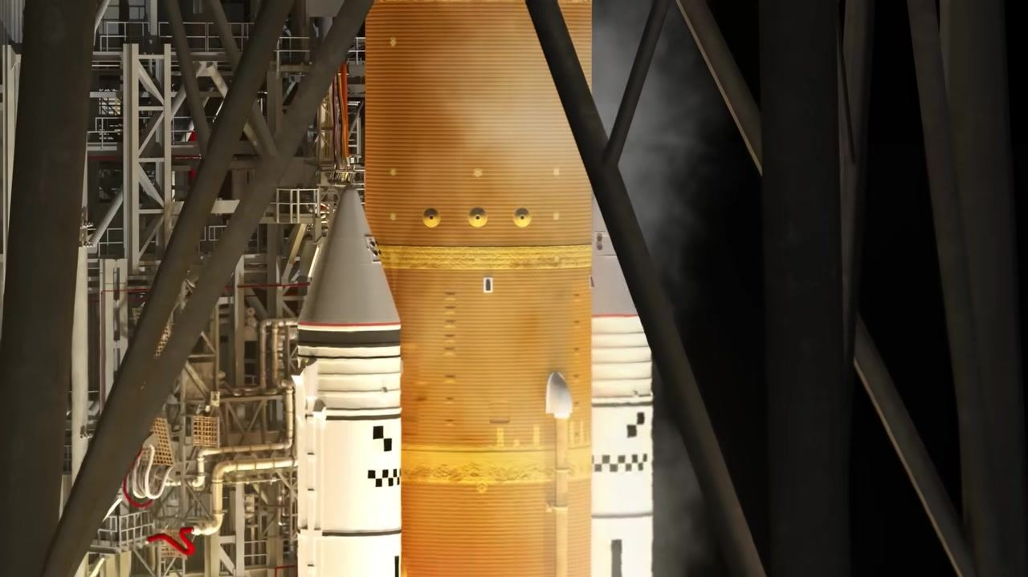
Caption: Midsection of the SLS core stage and a solid rocket booster, with the pad structure behind as the rocket ascends.
[0:01:32]
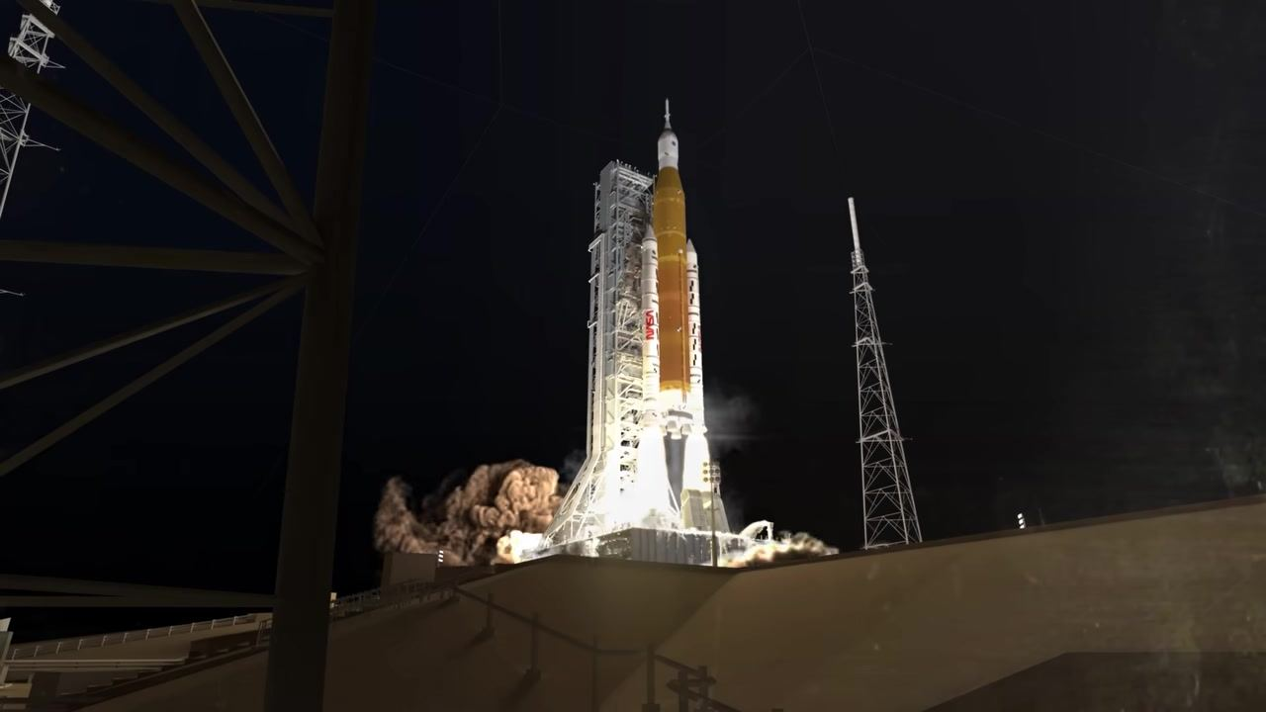
Caption: Wide view of the SLS rocket lifting off the pad at night, with flames and smoke at the base.
[0:01:34]
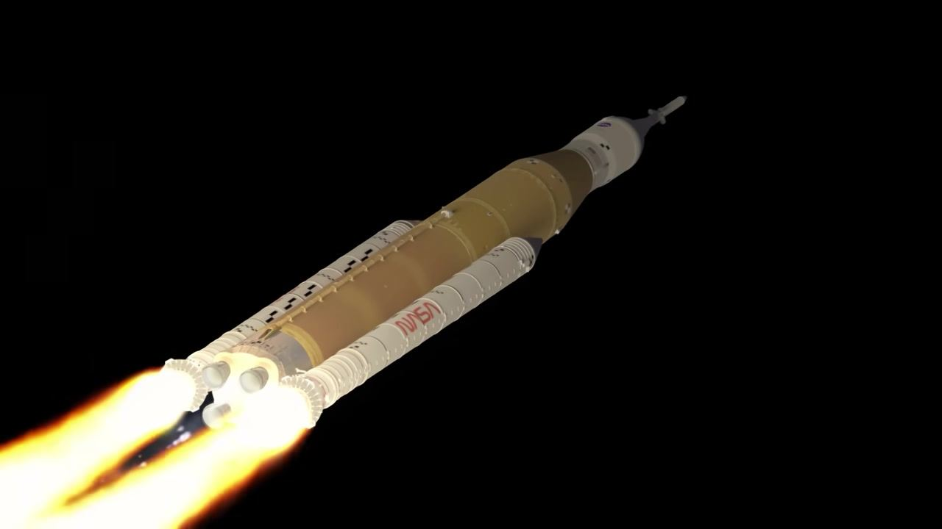
Caption: SLS rocket ascending into the dark sky, with engines and boosters firing brightly.
[0:01:36]
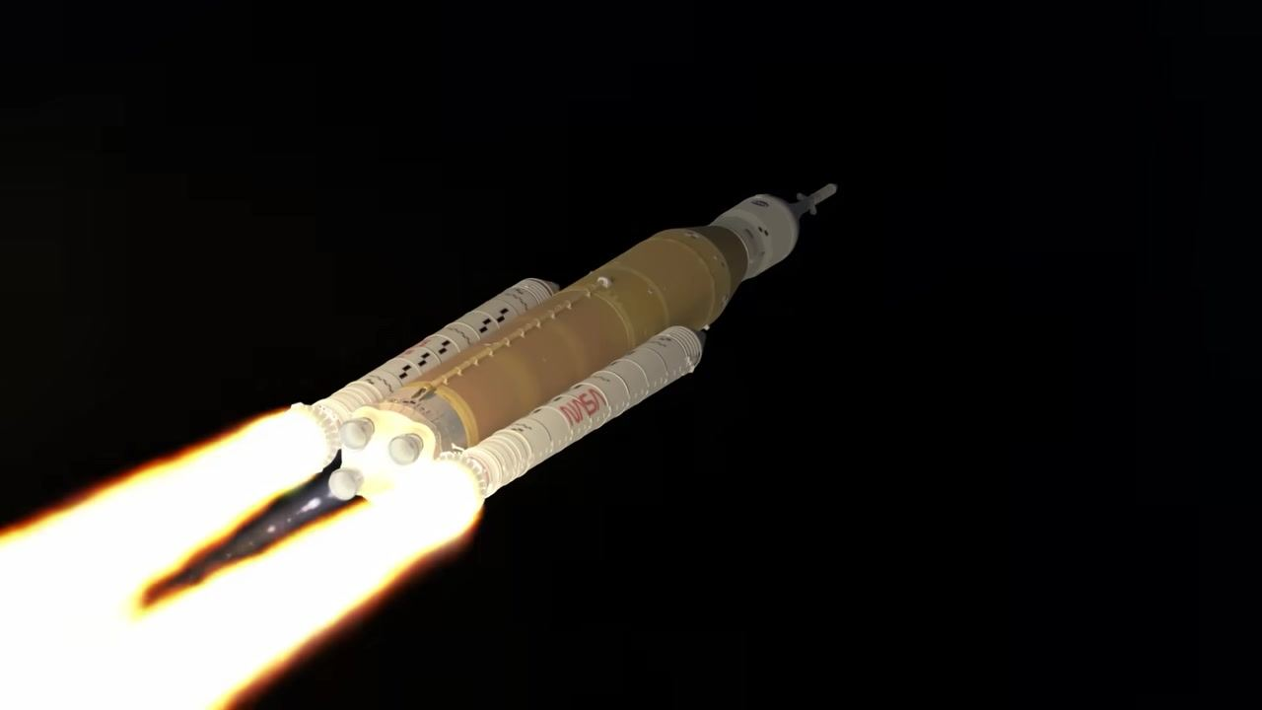
Caption: SLS rocket with solid rocket boosters and core stage firing, ascending against a black sky.
[0:01:44]
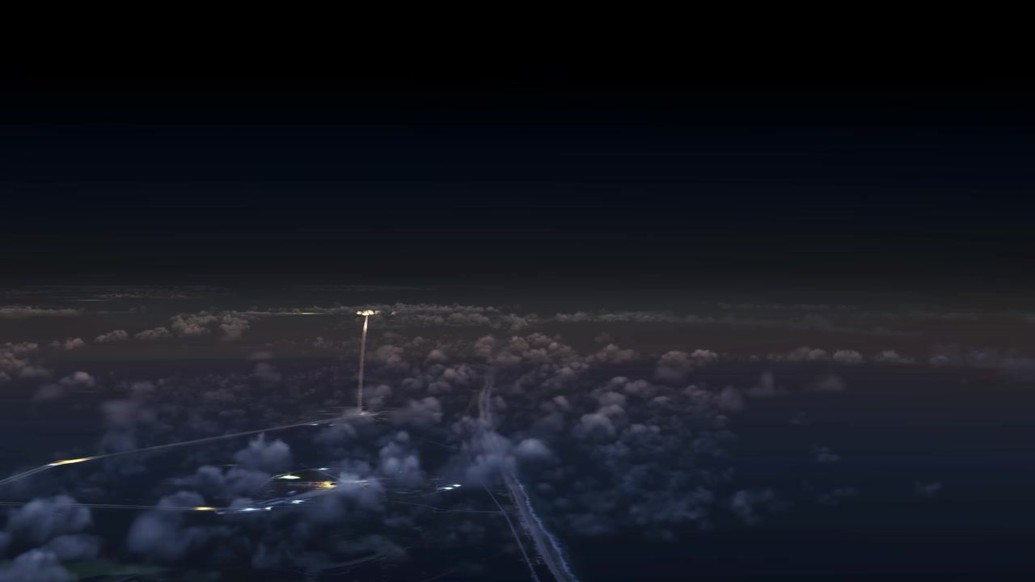
Caption: Distant view of the rocket ascending through clouds, with a bright exhaust trail visible at night.
[0:01:45]
Caption: Rocket higher in the sky, exhaust trail arcing above the clouds in a night scene.
[0:01:47]
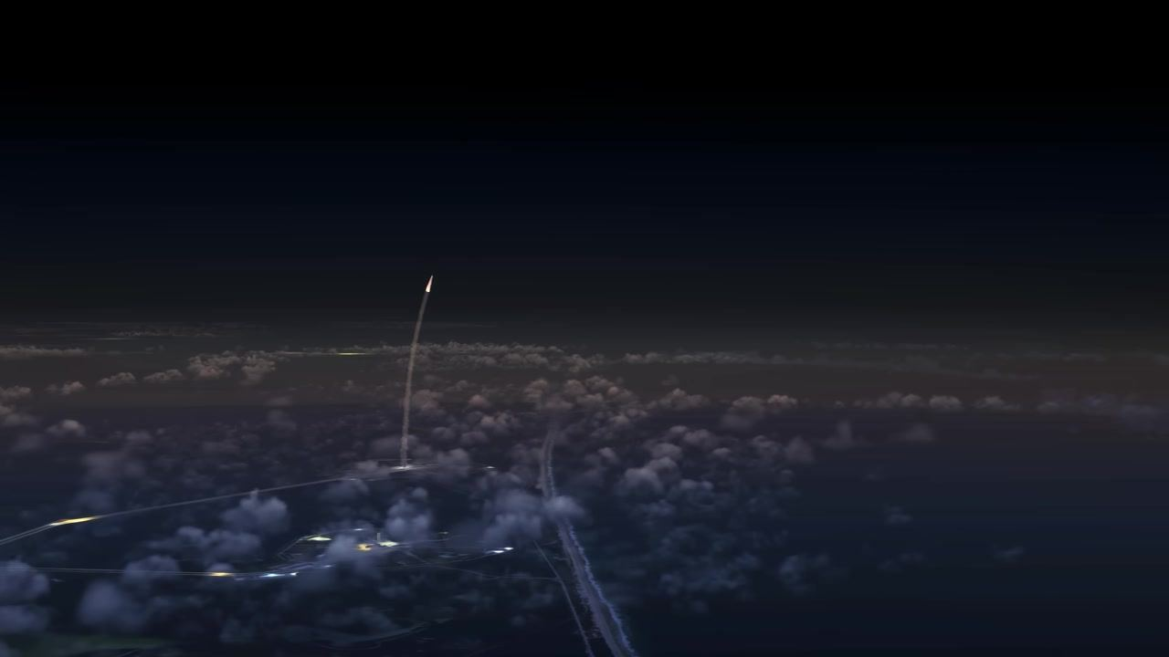
Caption: Rocket and exhaust trail curving upward above the clouds, set against the night sky.
[0:01:48]
Caption: Rocket further along its curved exhaust trail, above the clouds at night.
[0:01:50]
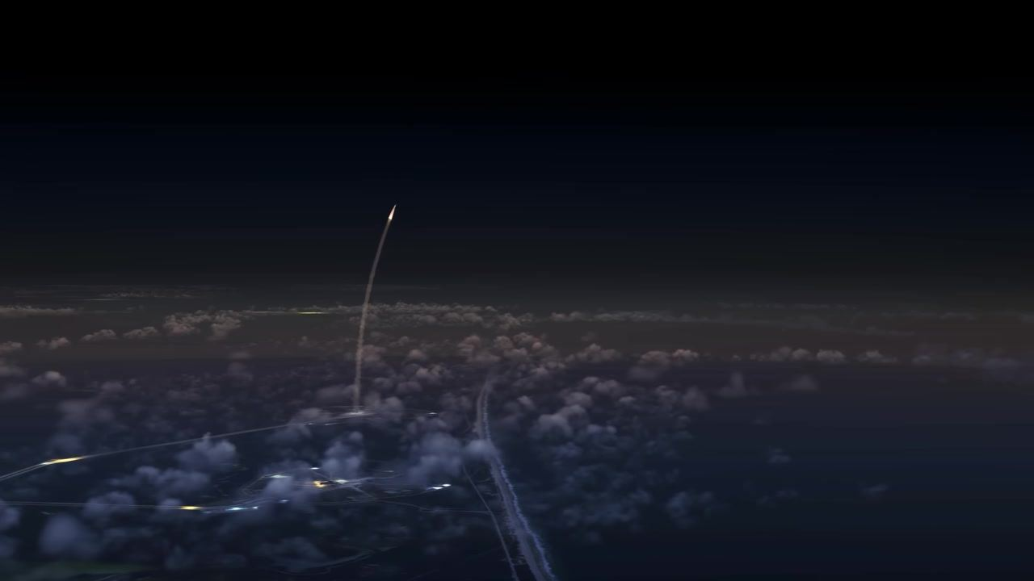
Caption: Rocket near the top of the frame, with a long exhaust trail over the clouds in the night sky.
[0:01:57]
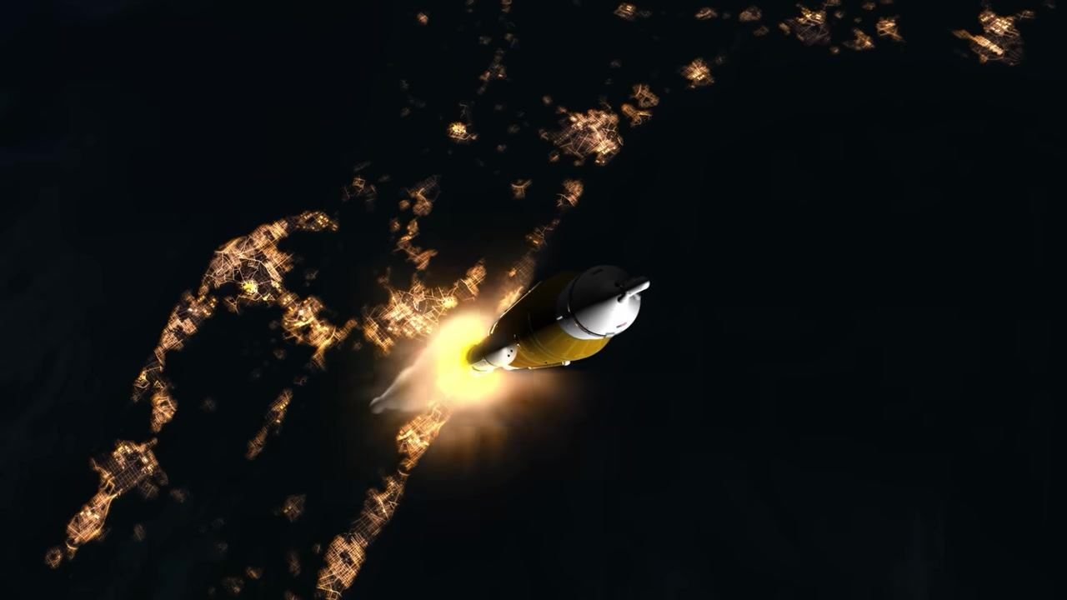
Caption: Rocket above Earth at night with city lights below, core stage and boosters visible, bright engine plume.
[0:01:58]
Caption: Solid rocket boosters separating from the core stage, flames trailing, above city lights at night.
[0:01:59]
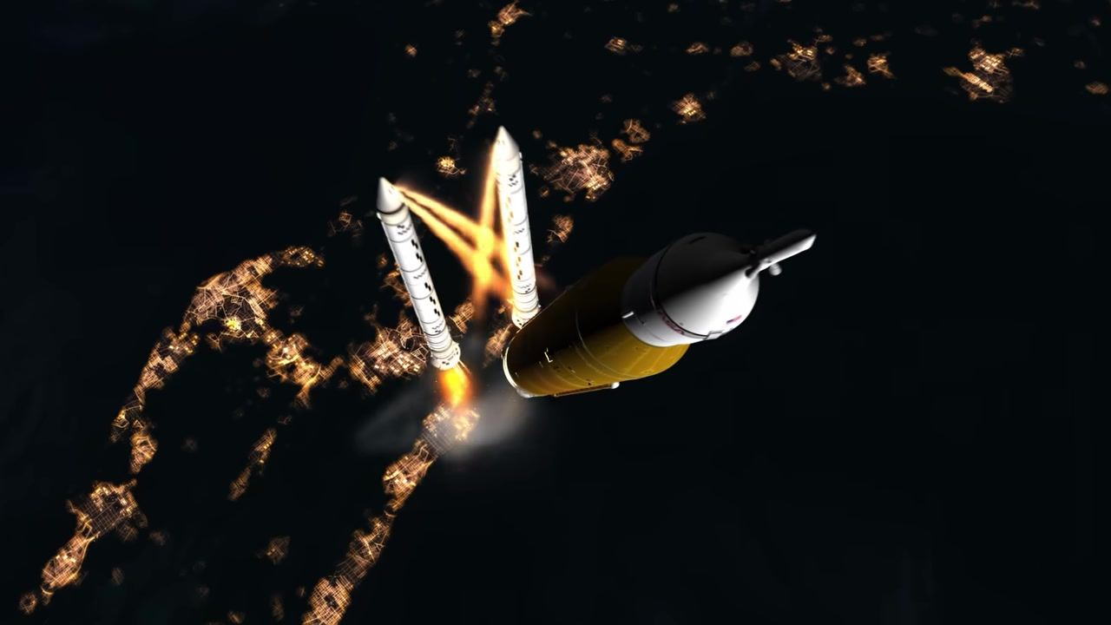
Caption: Boosters moving away from the core stage, separation complete, rocket continues upward above the lit Earth.
[0:01:59]
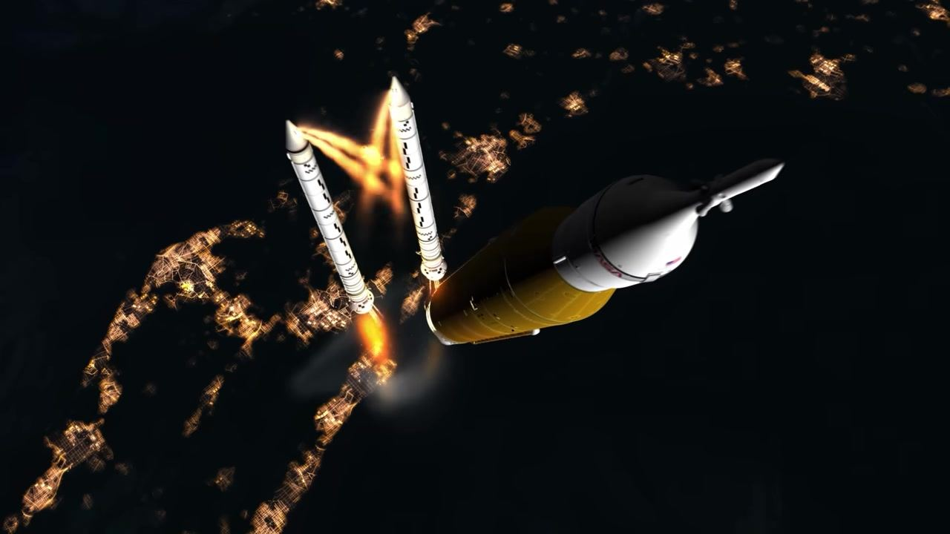
Caption: Boosters drifting farther from the core stage as the rocket ascends, city lights on Earth below.
[0:02:00]
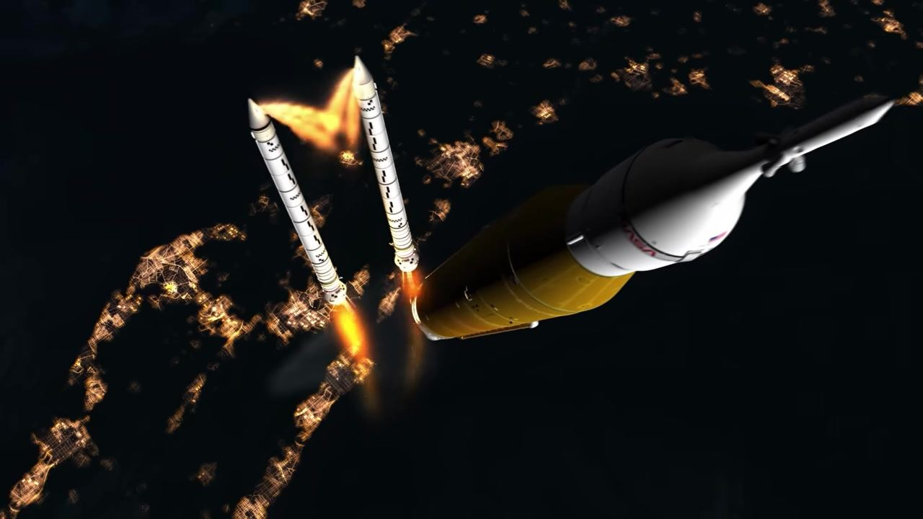
Caption: Solid rocket boosters farther from the core stage as the rocket continues upward, city lights on Earth below.
[0:02:00]
Caption: Two solid rocket boosters separate from the core stage as the rocket ascends over the night side of Earth.
[0:02:07]
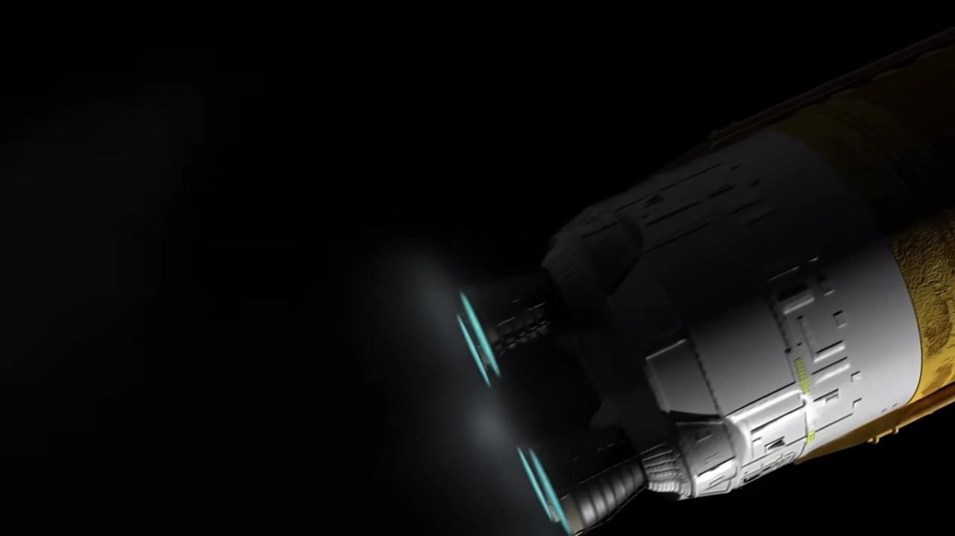
Caption: The core stage continues to propel the spacecraft with its four RS-25 engines, now alone in space.
[0:02:10]
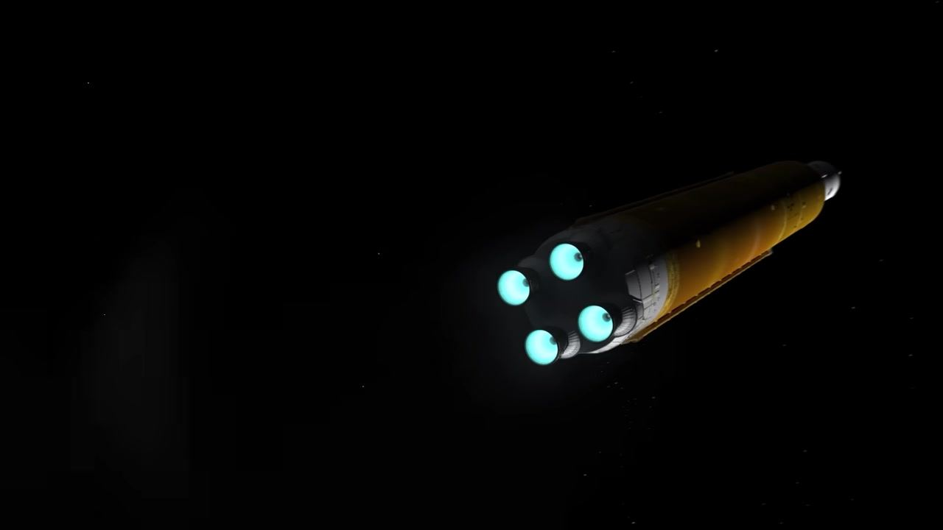
Caption: The core stage and its engines push the spacecraft further into deep space, surrounded by darkness.
[0:02:14]
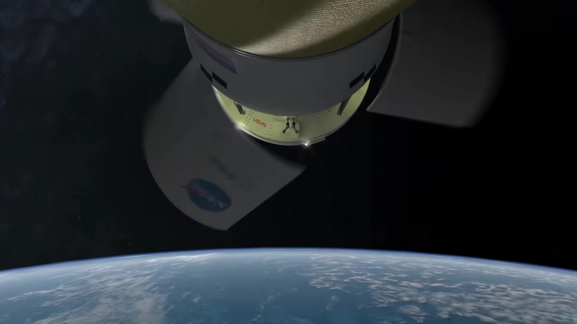
Caption: The protective fairings around Orion's service module are ejected, exposing its solar arrays above Earth.
[0:02:21]
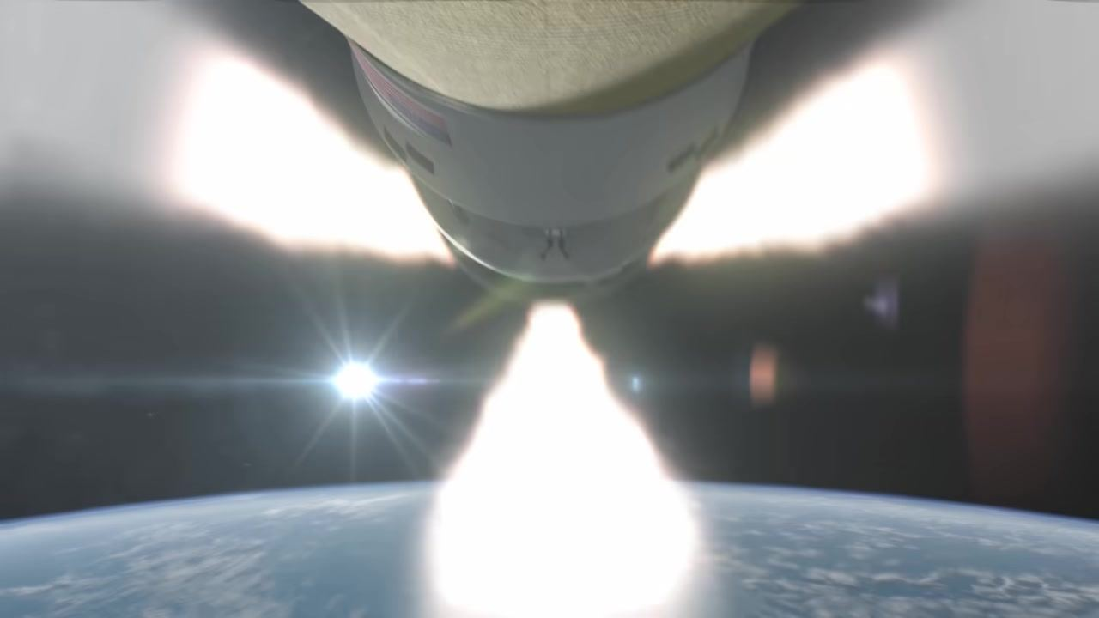
Caption: The launch abort system is jettisoned from Orion with a bright plume as the spacecraft orbits above Earth.
[0:02:27]
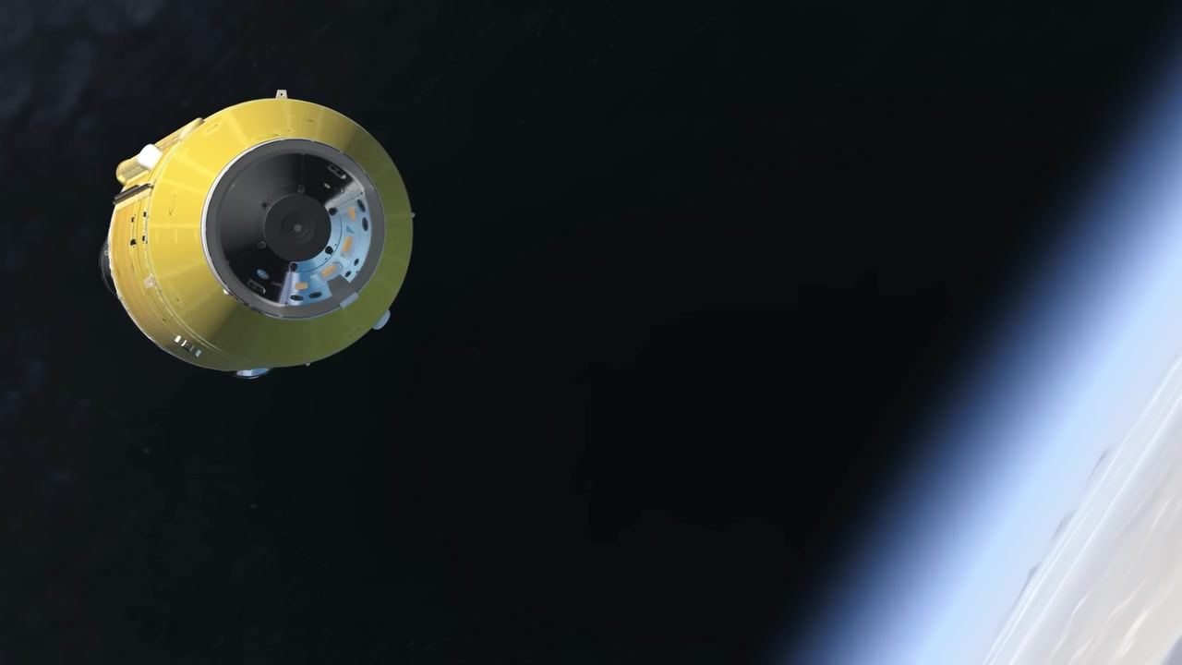
Caption: The Interim Cryogenic Propulsion Stage (ICPS) floats in orbit after separating from the core stage, with Earth's limb in the background.
[0:02:32]
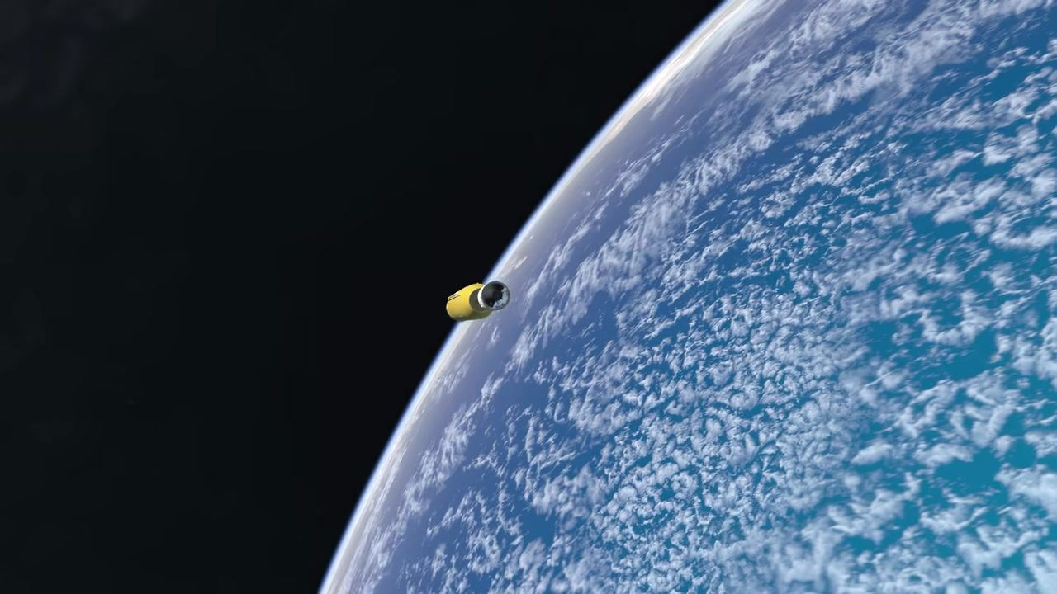
Caption: The Interim Cryogenic Propulsion Stage (ICPS) drifts away in orbit, with the curvature of Earth and cloud cover below.
[0:02:34]
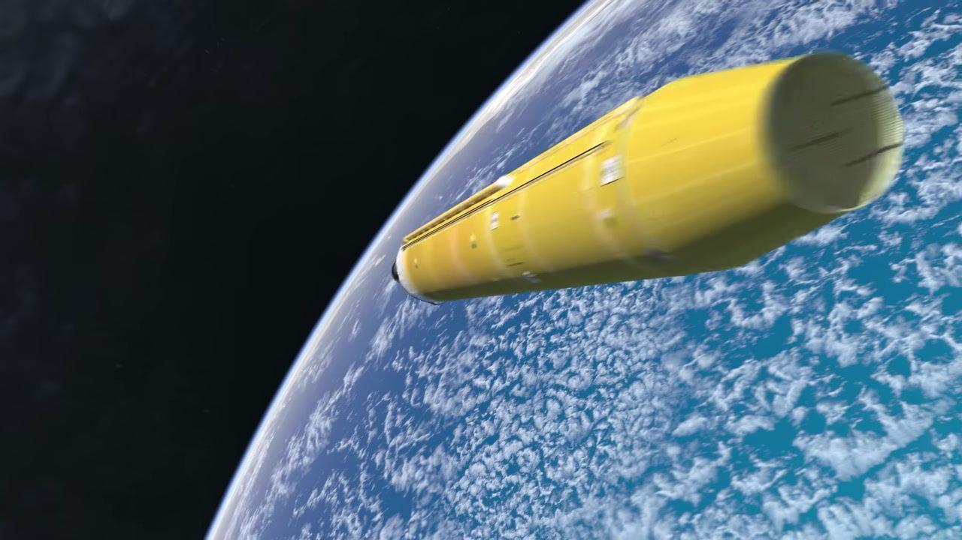
Caption: The SLS core stage floats in space above the blue Earth after separation.
[0:02:38]
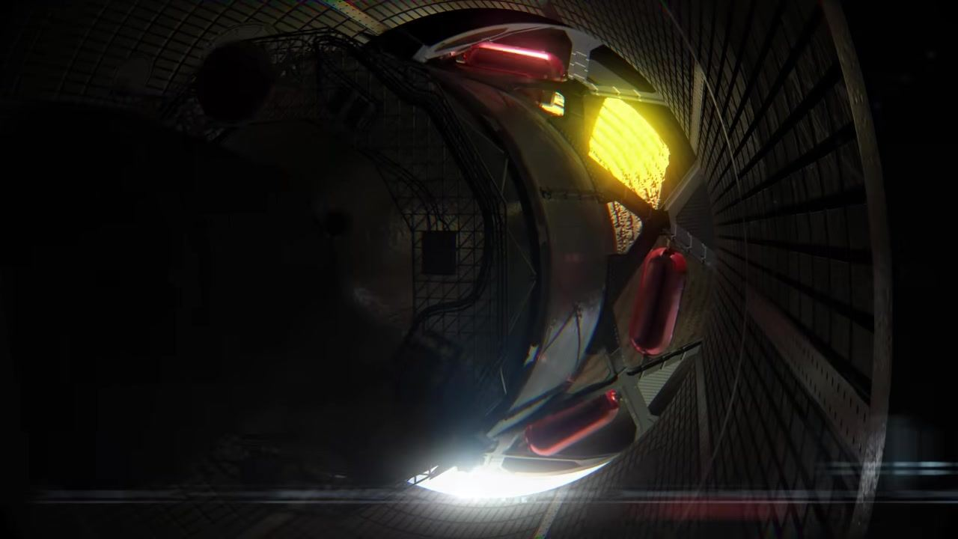
Caption: A dimly lit view inside the stage adapter reveals part of the Orion spacecraft and a faint yellow glow.
[0:02:40]
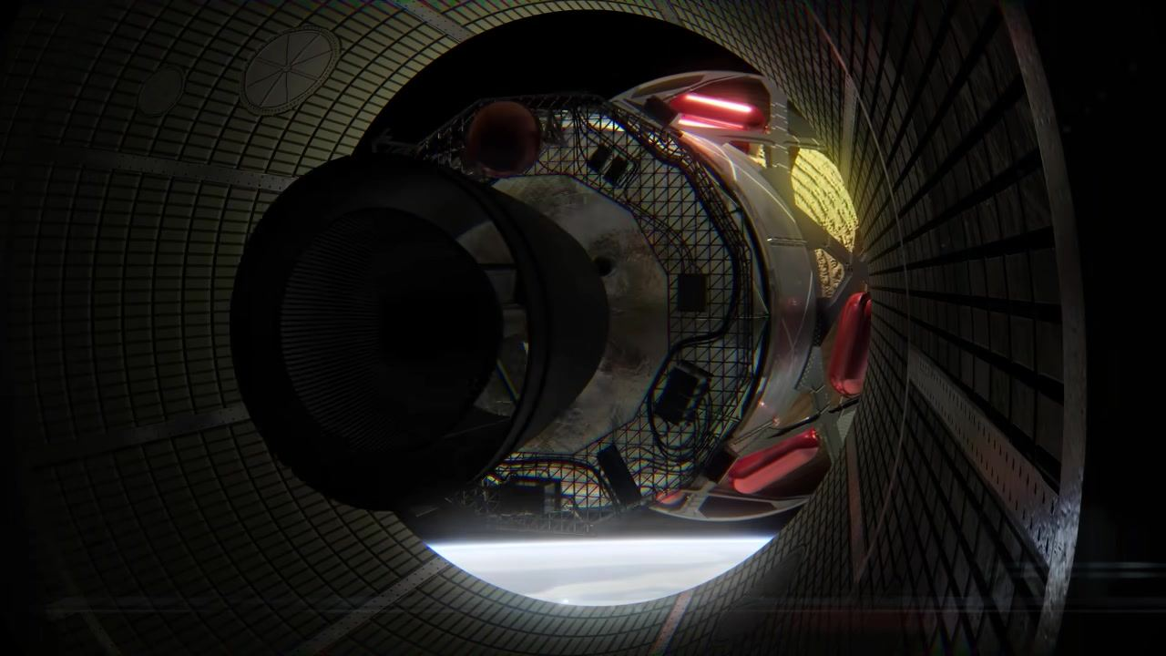
Caption: The Orion spacecraft is seen inside the adapter, with illuminated tanks and structural elements, and Earth visible below.
[0:02:42]
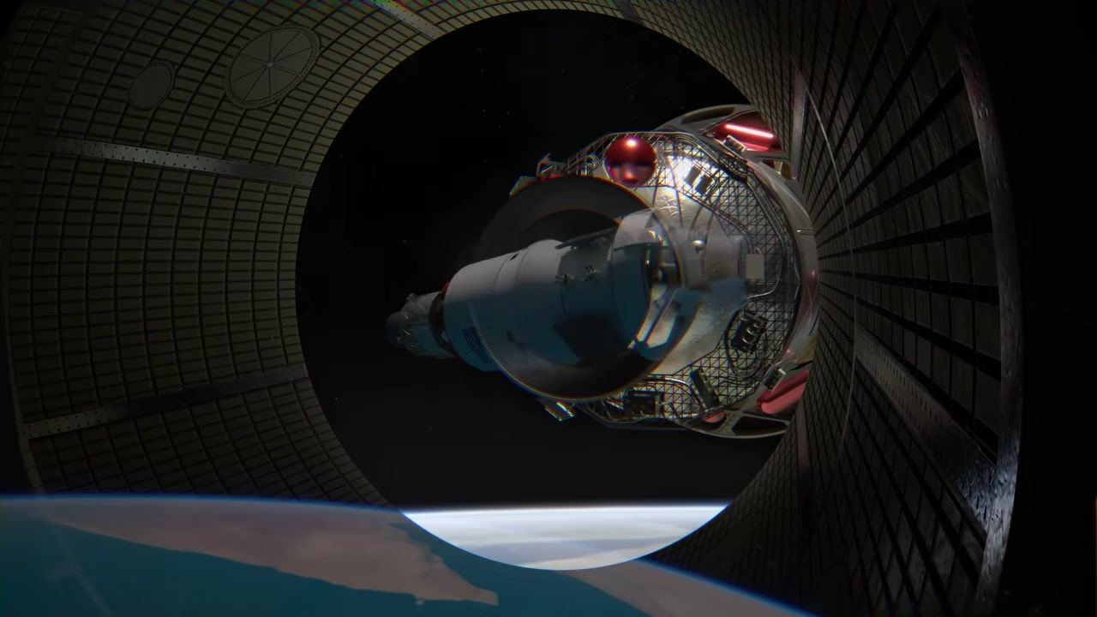
Caption: Orion emerges from the adapter, with its service module and American flag visible as Earth appears below.
[0:02:44]
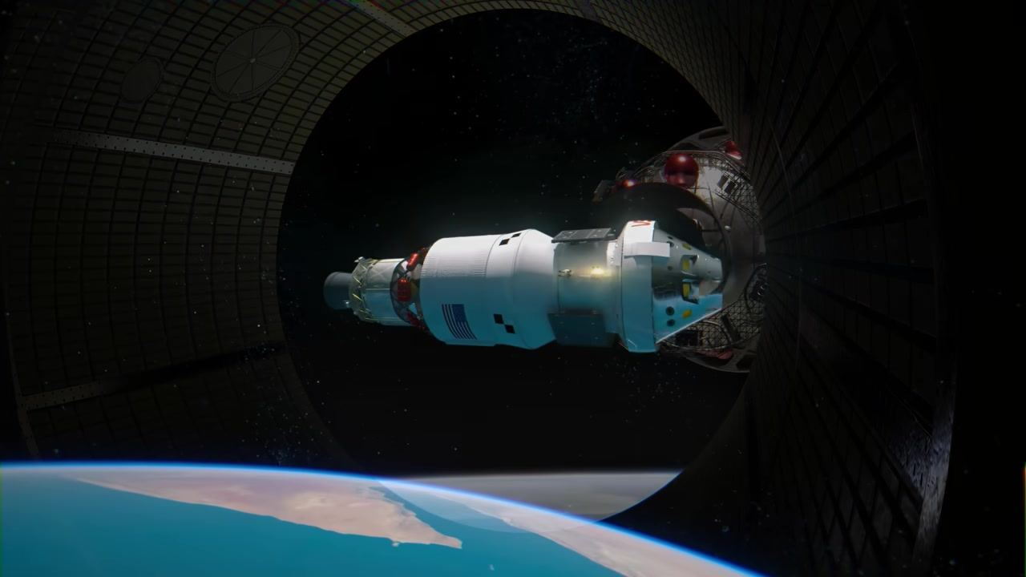
Caption: The Orion spacecraft floats freely in space above Earth, fully separated from the adapter.
[0:02:54]
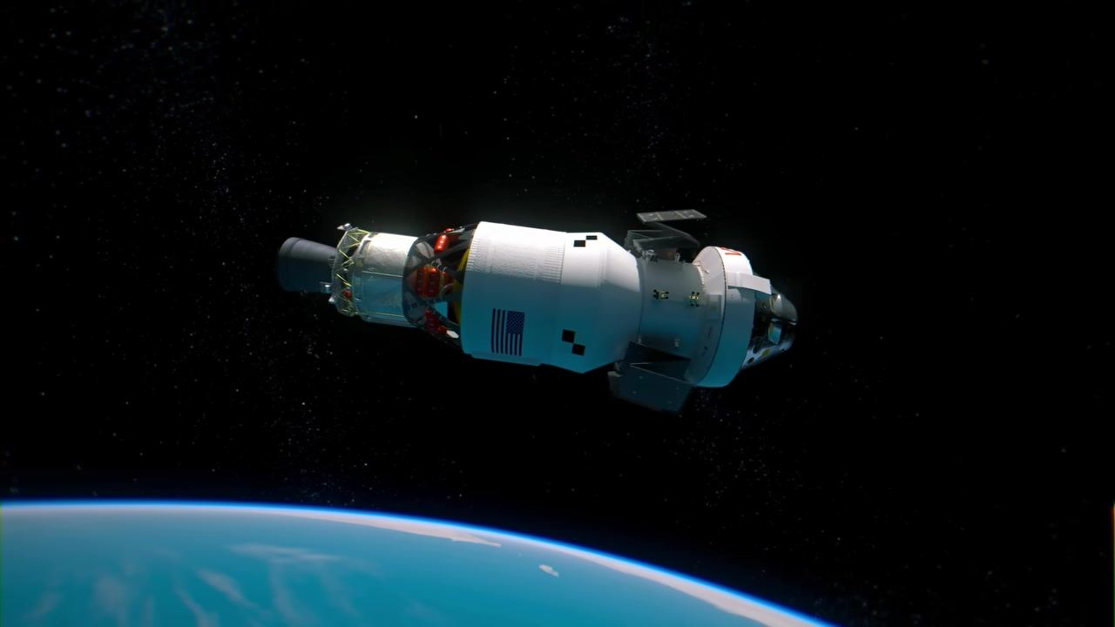
Caption: The Orion spacecraft begins deploying its solar arrays in orbit above Earth, with one array partially extended.
[0:02:54]
Caption: The Orion spacecraft continues deploying its solar arrays in orbit above Earth, with two arrays now partially extended.
[0:02:55]
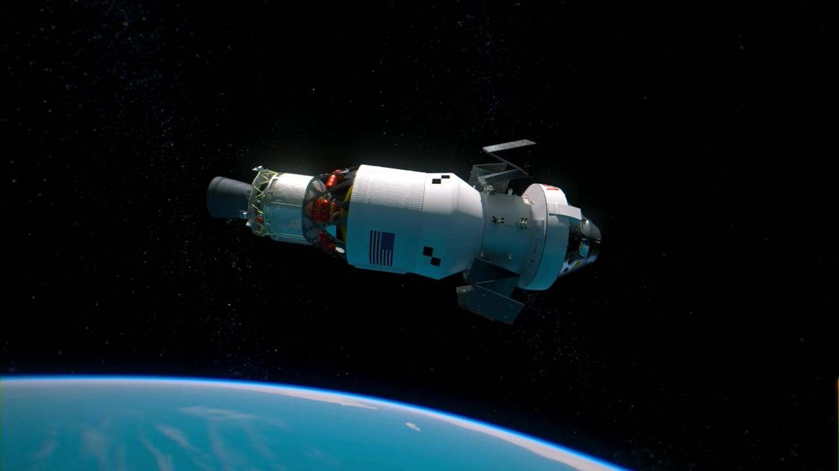
Caption: The Orion spacecraft's solar arrays extend further as it orbits above the blue curve of Earth.
[0:02:56]
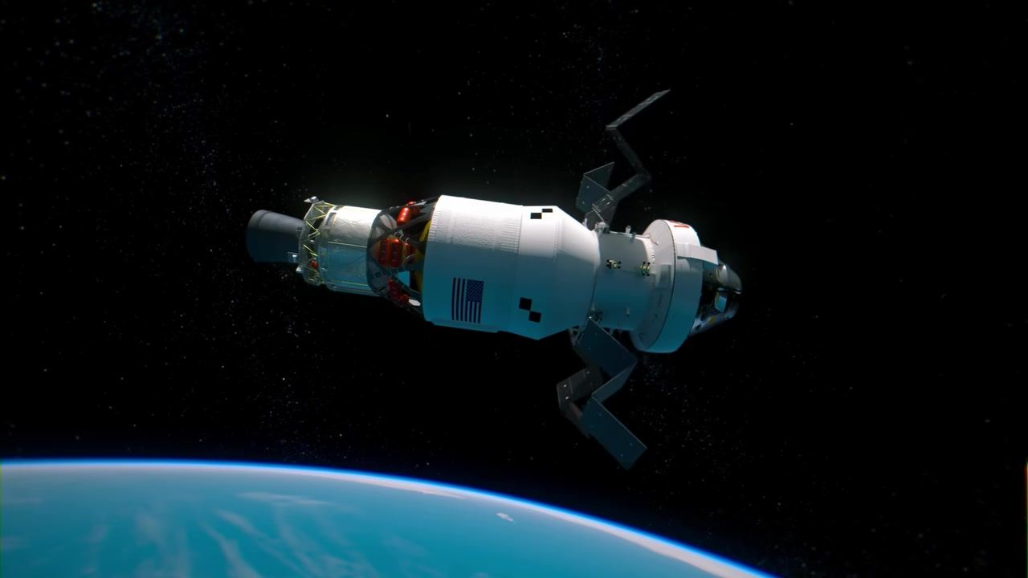
Caption: Three of Orion's solar arrays are now partially deployed as the spacecraft prepares for its next maneuver.
[0:02:56]
Caption: The Orion spacecraft's solar arrays are nearly fully deployed, with three arrays clearly visible against the backdrop of space.
[0:02:57]
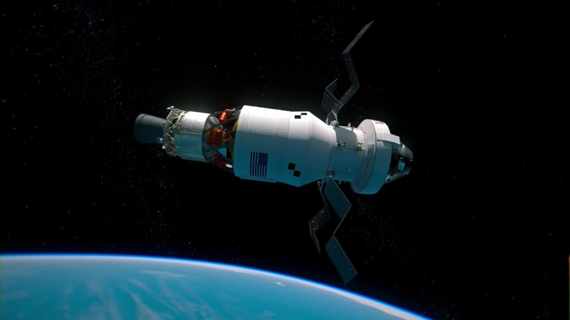
Caption: All four solar arrays on Orion are now deployed as the spacecraft orbits above Earth.
[0:02:57]
Caption: The Orion spacecraft is shown with all four solar arrays fully extended, ready for the journey to the Moon.
[0:02:58]
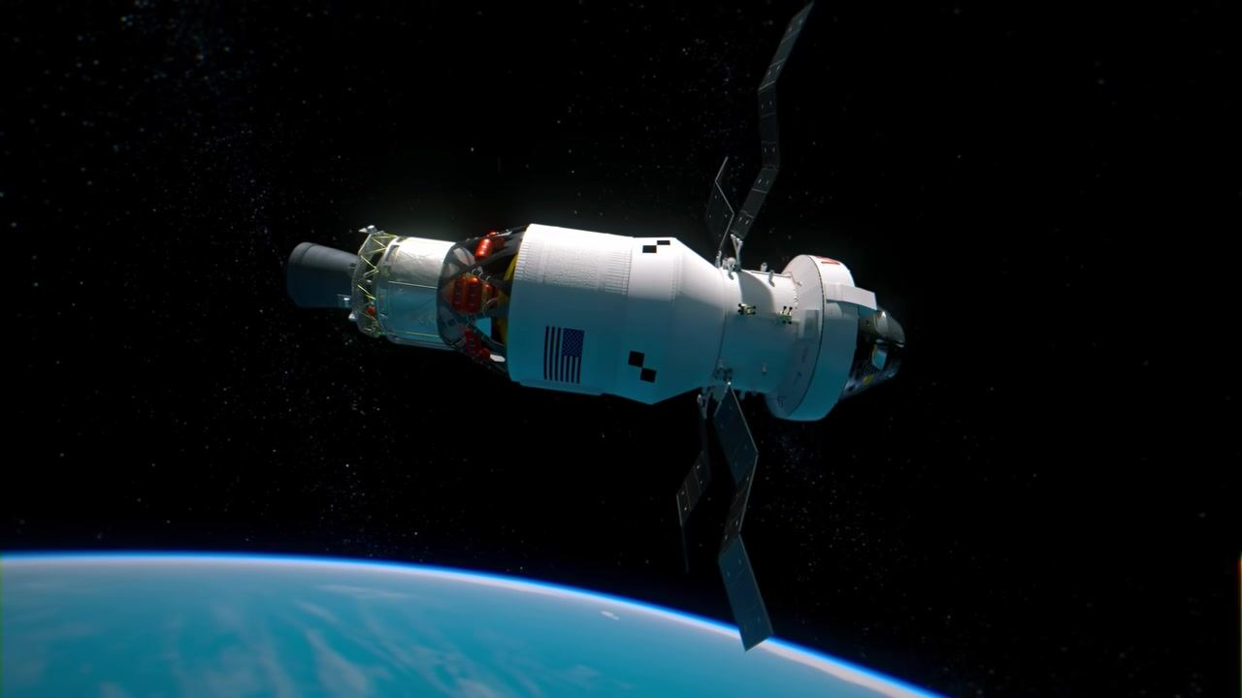
Caption: Orion, with its solar arrays fully extended, orbits above the Earth in preparation for the next phase of the mission.
[0:02:58]
Caption: The Orion spacecraft drifts above Earth with its solar arrays fully deployed, marking the completion of array deployment.
[0:02:59]
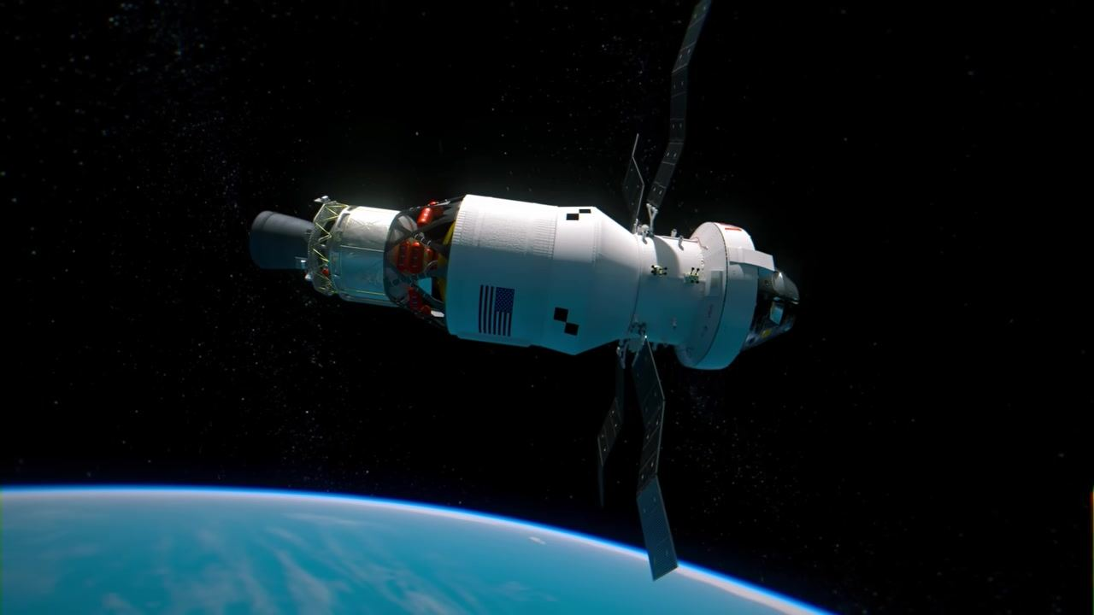
Caption: Orion, with all solar arrays fully extended, is poised above the blue curve of Earth, ready for translunar injection.
[0:03:03]
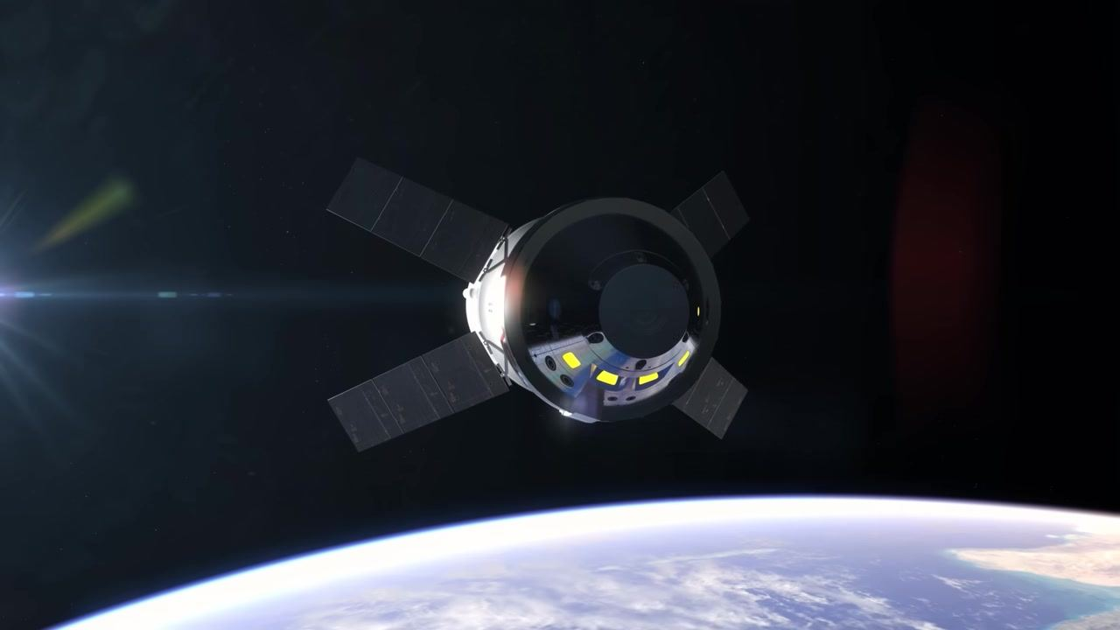
Caption: The Orion spacecraft and ICPS upper stage are shown in orbit above Earth, illuminated by sunlight from the left.
[0:03:08]
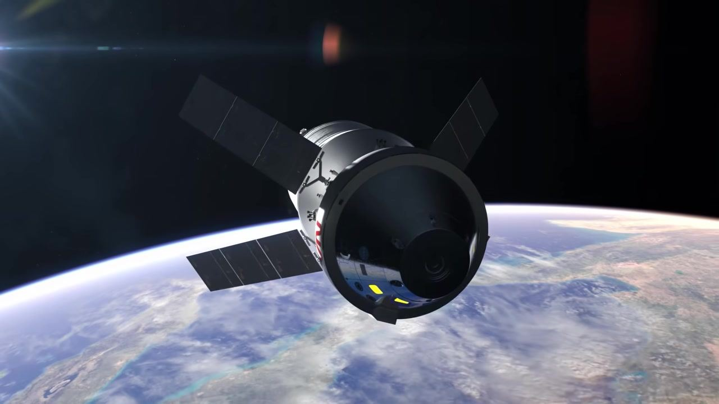
Caption: Orion orbits above Earth with its solar arrays extended, now separated from the ICPS upper stage.
[0:03:09]
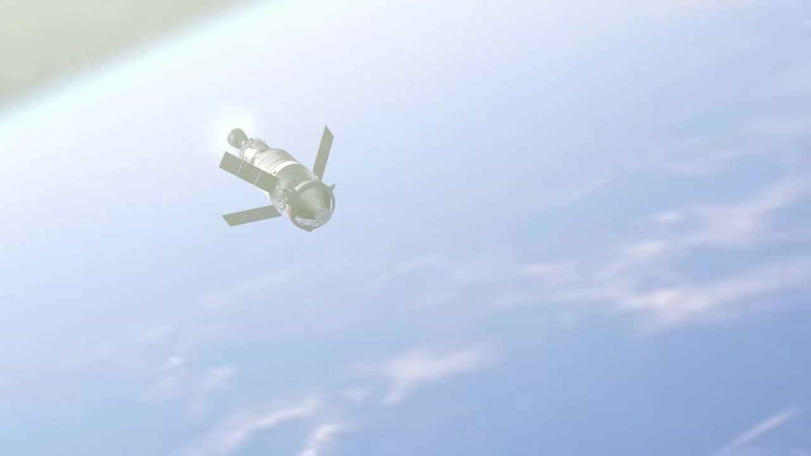
Caption: The Orion spacecraft drifts above the bright blue Earth, viewed from a distance after separation from the upper stage.
[0:03:09]
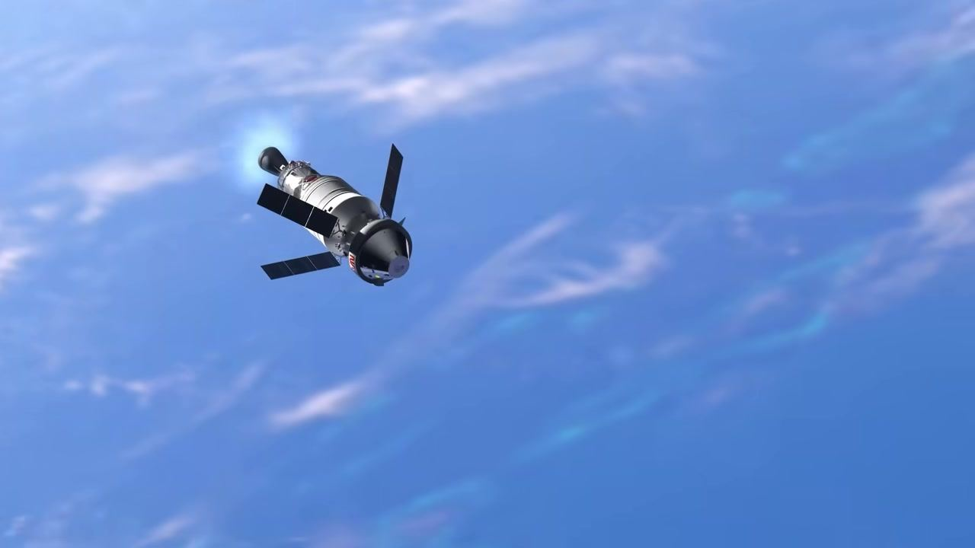
Caption: The Orion spacecraft and ICPS upper stage fire their engine in orbit above Earth, with solar arrays extended.
[0:03:10]
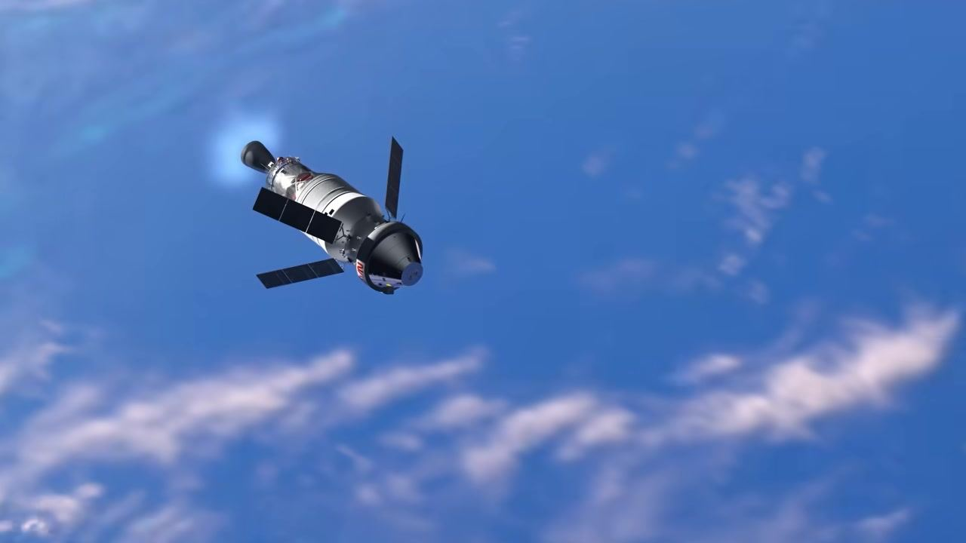
Caption: Orion and the ICPS upper stage continue their engine burn above the blue Earth, solar arrays clearly visible.
[0:03:10]
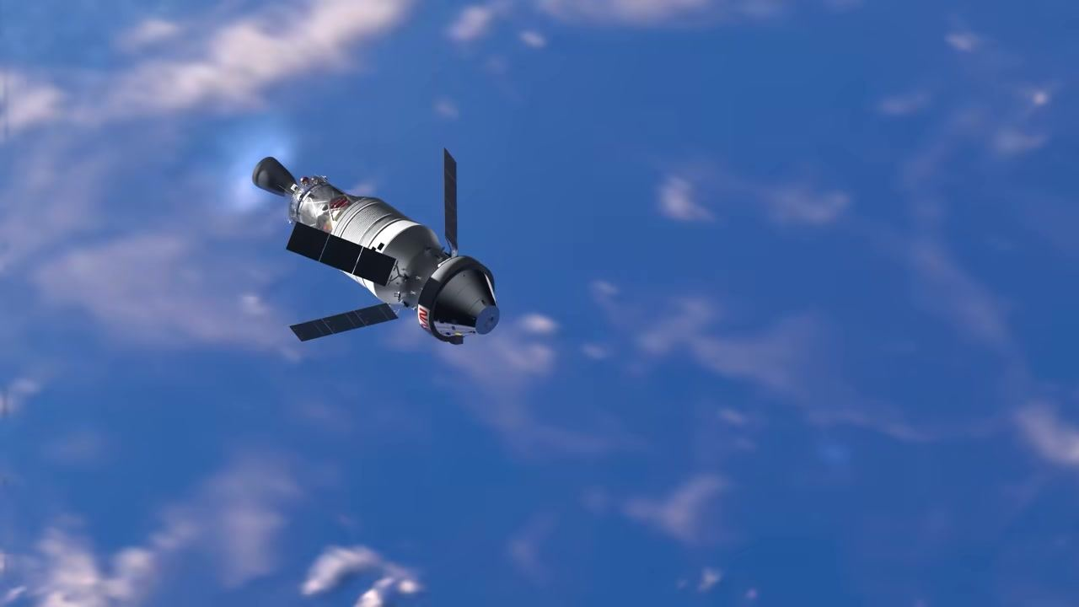
Caption: The Orion spacecraft and ICPS upper stage, with a visible engine plume, drift above Earth with solar arrays extended.
[0:03:11]
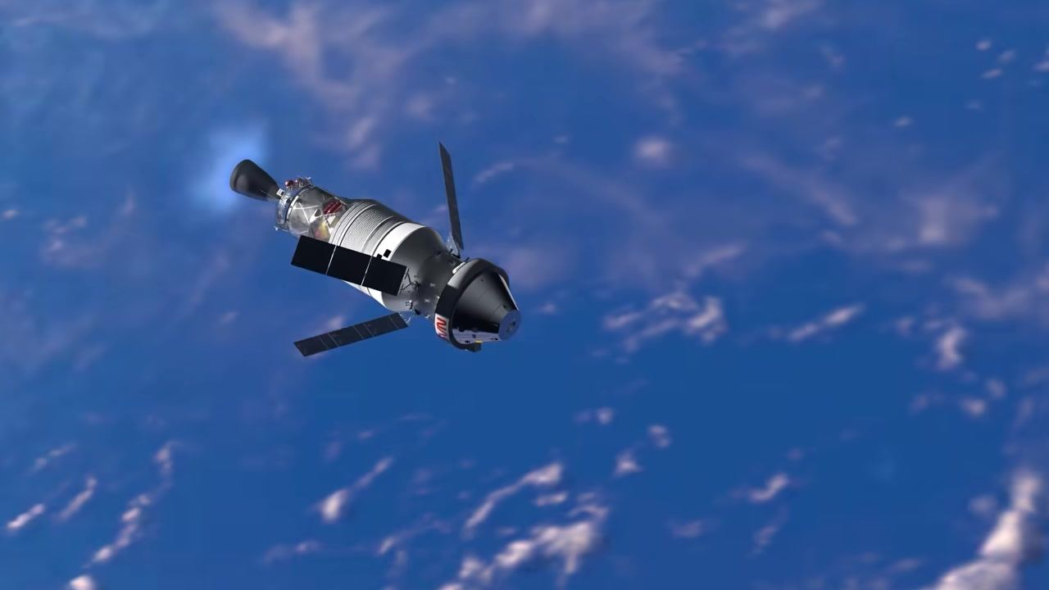
Caption: Orion and the ICPS upper stage fire their engine above the clouds on Earth, solar arrays extended.
[0:03:11]
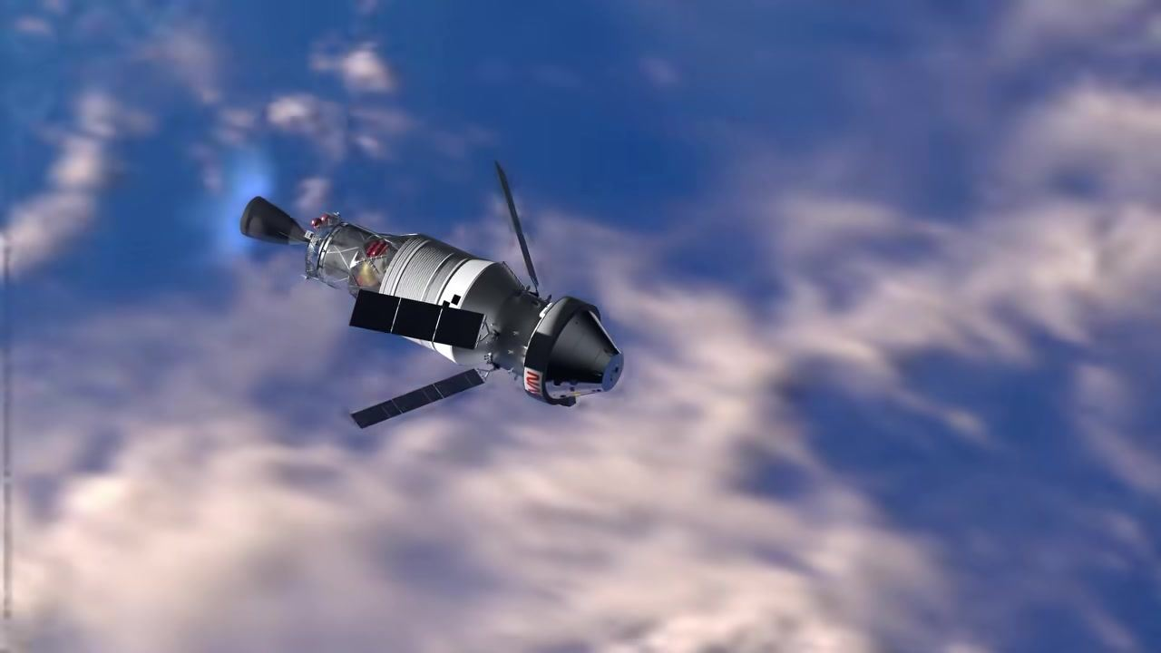
Caption: The Orion spacecraft and ICPS upper stage continue their engine burn above Earth, with clouds below and solar arrays extended.
[0:03:12]
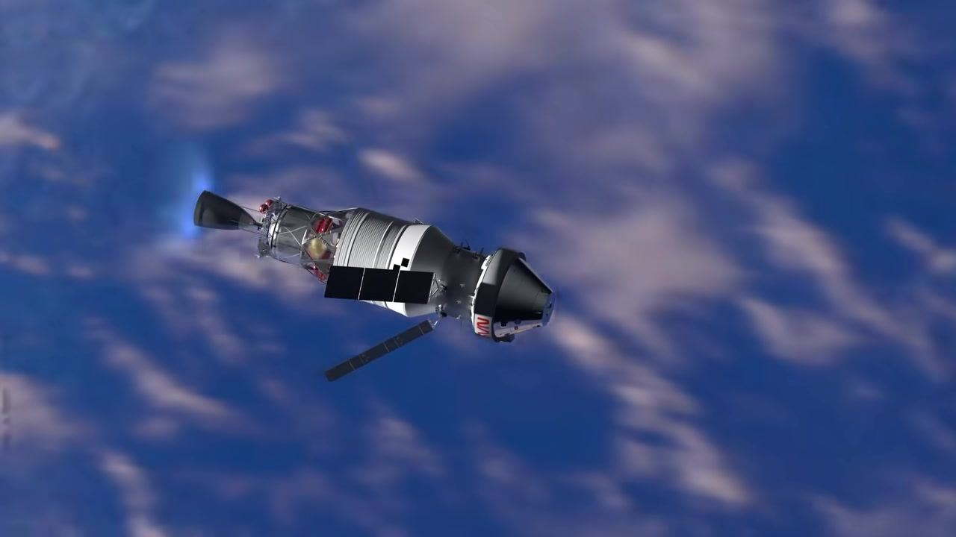
Caption: Orion and the ICPS upper stage, with engine firing and solar arrays extended, are seen above Earth.
[0:03:12]
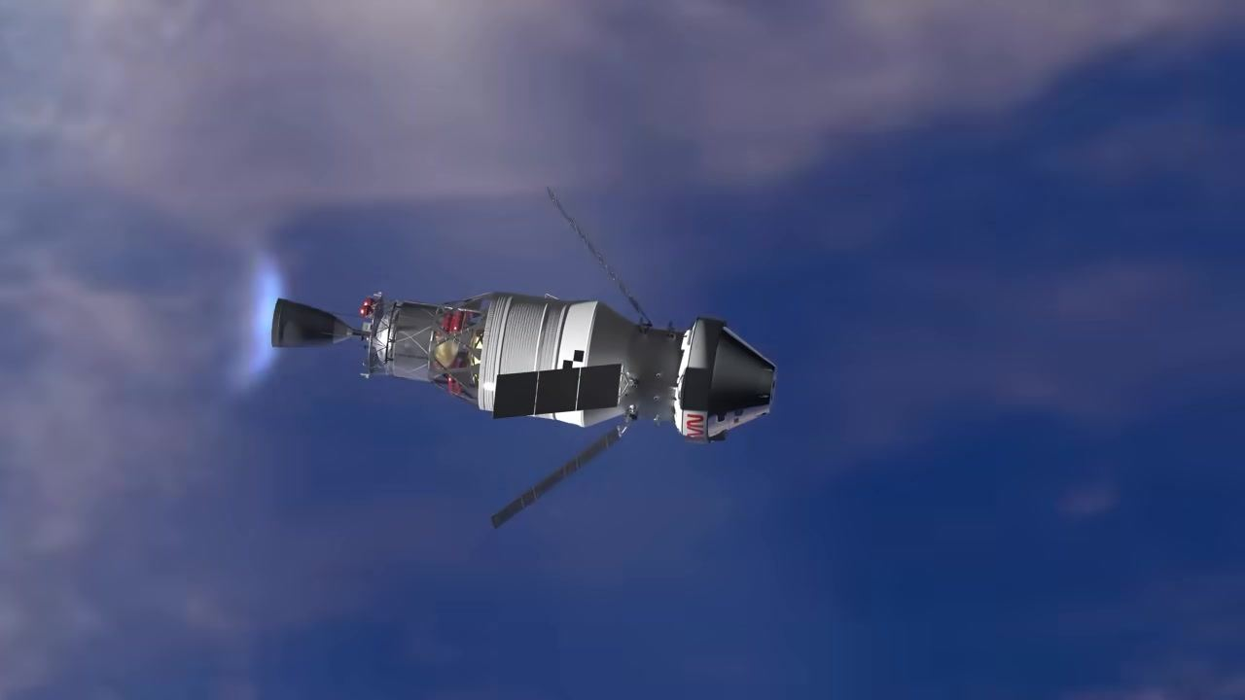
Caption: The Orion spacecraft and ICPS upper stage, with engine burning and solar arrays extended, travel above Earth.
[0:03:13]
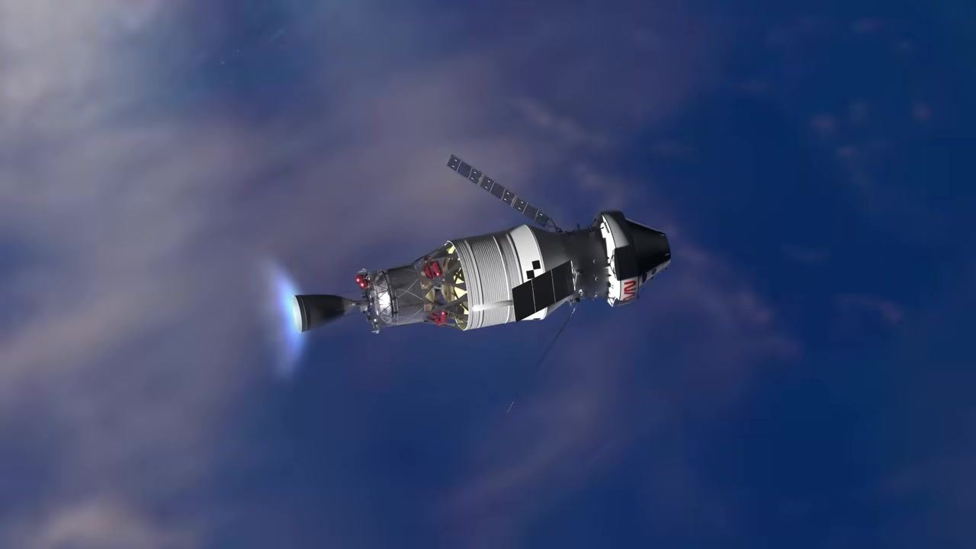
Caption: Orion and the ICPS upper stage, with a prominent engine plume and solar arrays extended, fly above Earth.
[0:03:14]
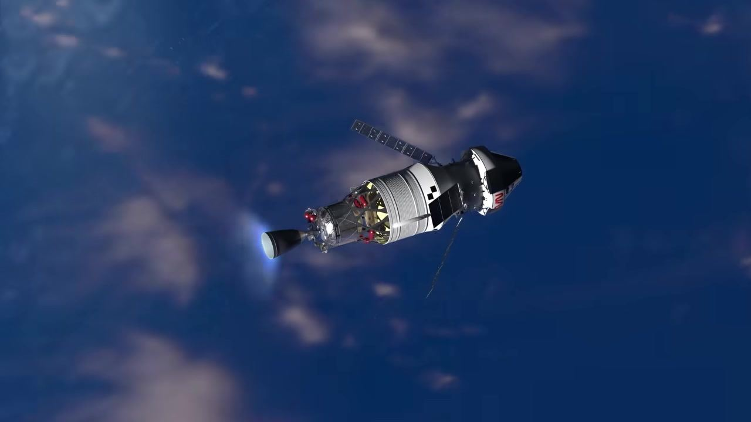
Caption: The Orion spacecraft and ICPS upper stage, with engine firing and solar arrays extended, are seen above Earth.
[0:03:14]
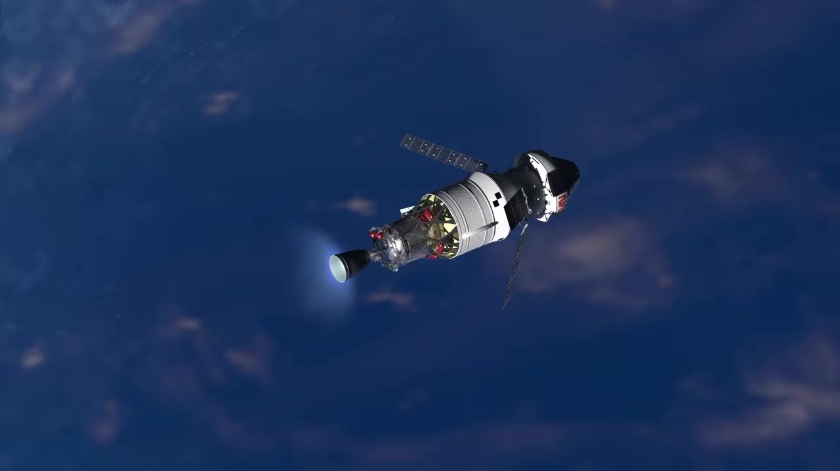
Caption: The Orion spacecraft and ICPS upper stage, with engine burning and solar arrays extended, continue their journey above Earth.
[0:03:16]
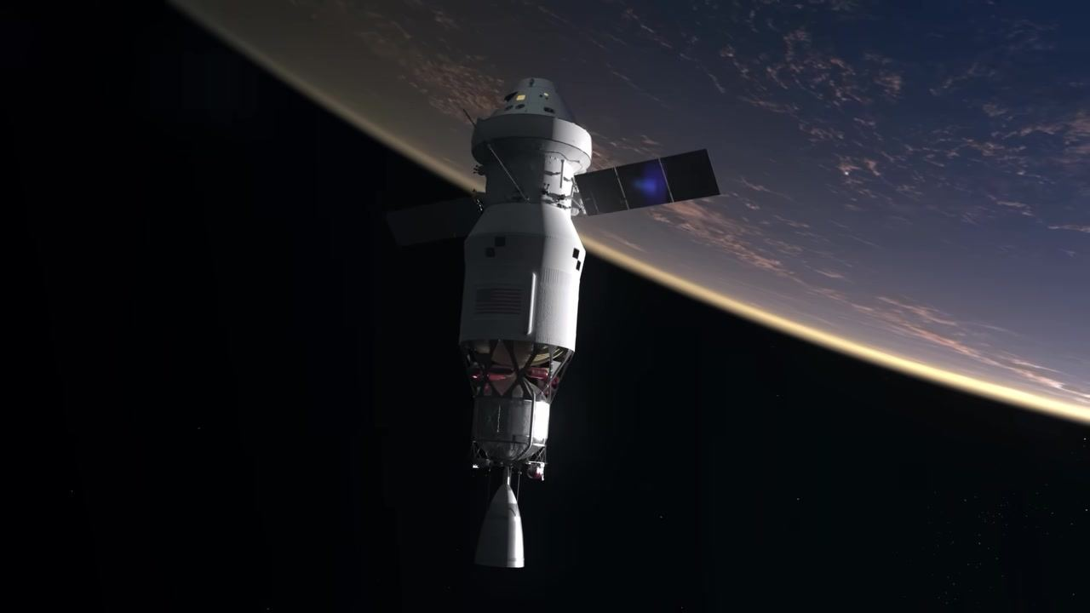
Caption: The Orion spacecraft and ICPS upper stage drift in orbit above Earth with solar arrays extended and engine off.
[0:03:18]
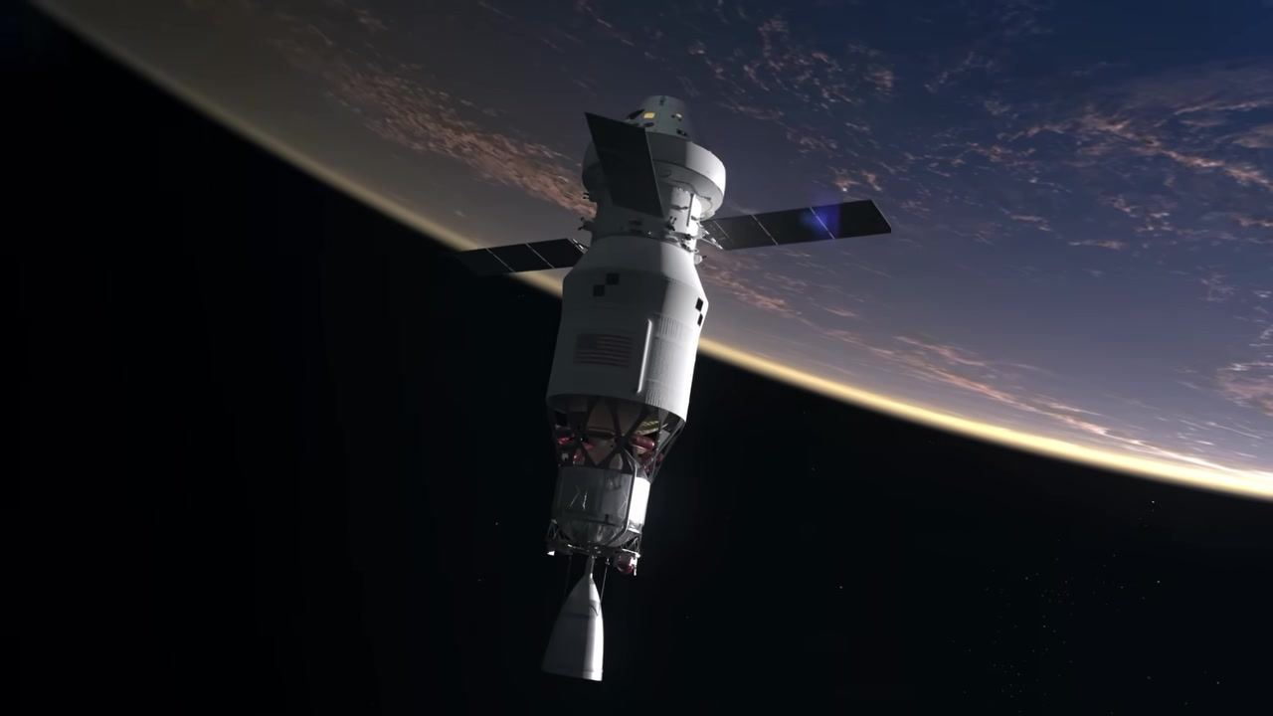
Caption: Orion and the ICPS upper stage float together in high Earth orbit, solar arrays extended, with Earth in the background.
[0:03:20]
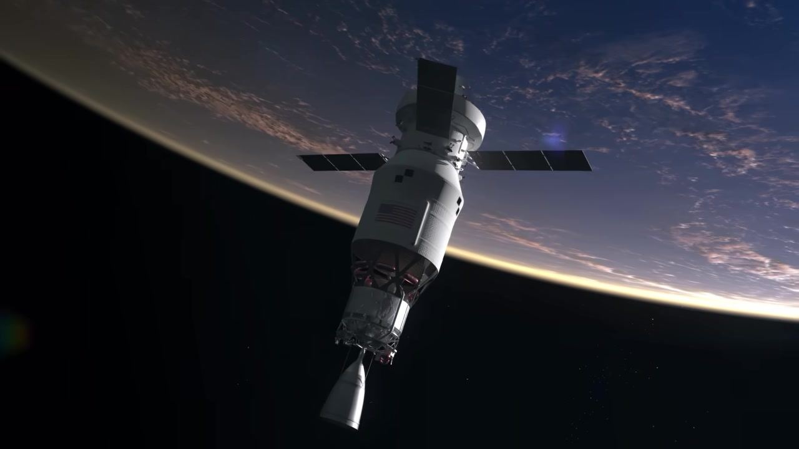
Caption: The Orion spacecraft and ICPS upper stage remain connected in orbit above Earth, solar arrays extended.
[0:03:22]
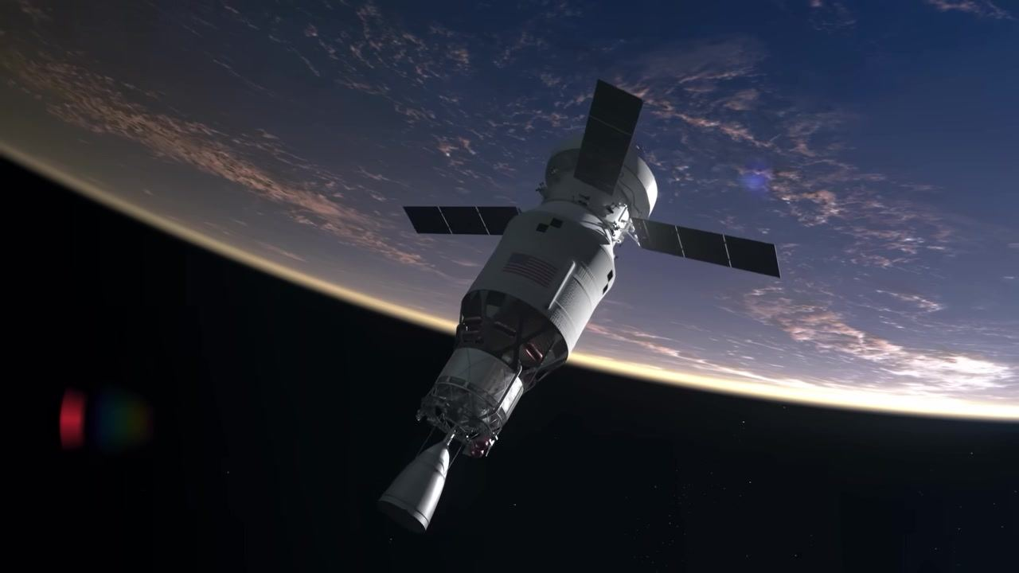
Caption: Orion and the ICPS upper stage, with solar arrays extended, continue to drift in high Earth orbit above the planet.
[0:03:24]
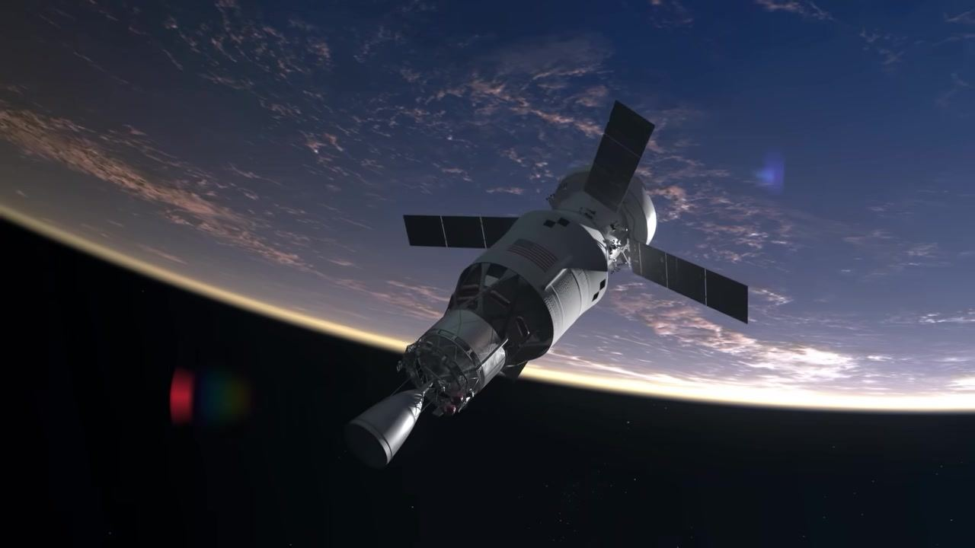
Caption: The Orion spacecraft and ICPS upper stage, solar arrays extended, are seen in orbit above the curved horizon of Earth.
[0:03:26]
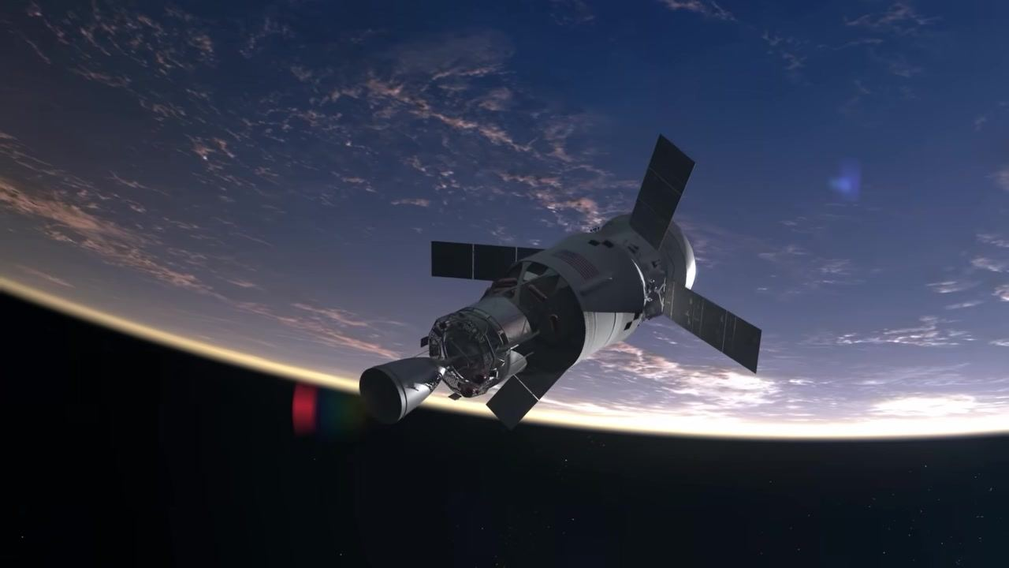
Caption: Orion and the ICPS upper stage, with solar arrays extended, float above Earth as the sun rises over the horizon.
[0:03:28]
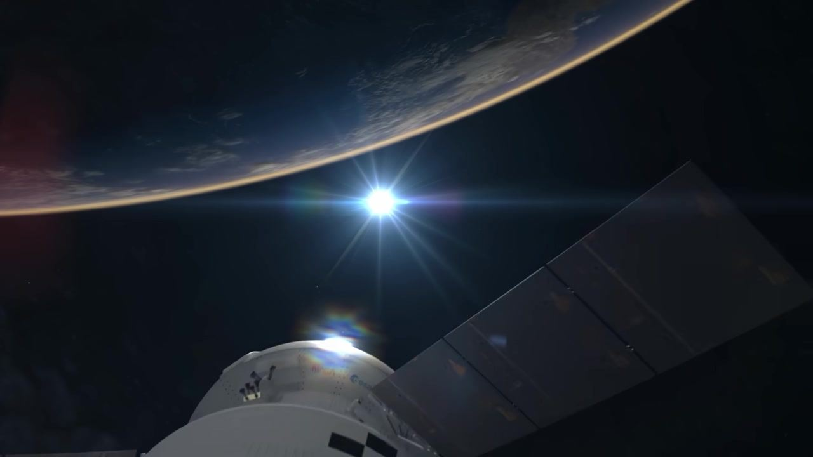
Caption: Close-up of Orion and the ICPS upper stage with solar arrays extended, the sun and Earth visible in the background.
[0:03:30]
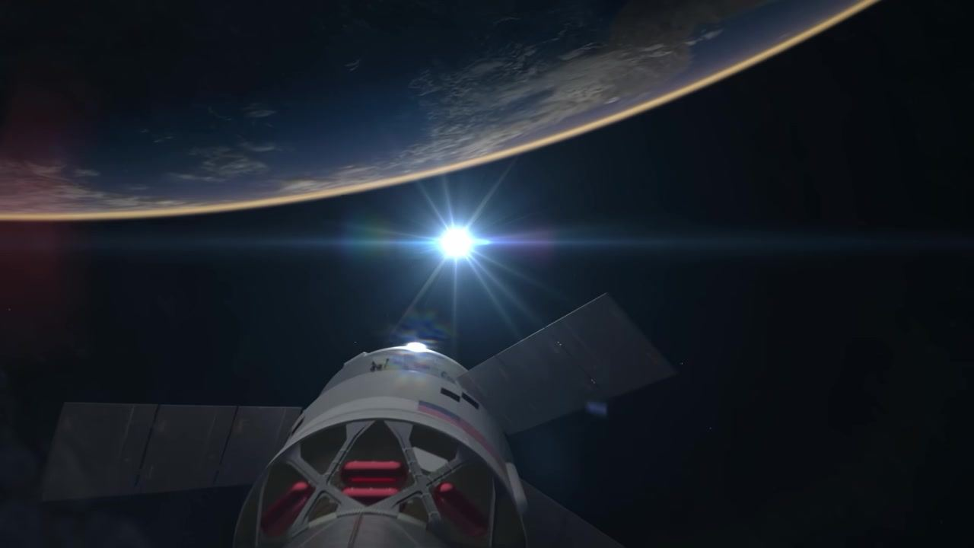
Caption: Rear view of Orion and the ICPS upper stage, solar arrays extended, with the sun shining above Earth's horizon.
[0:03:32]
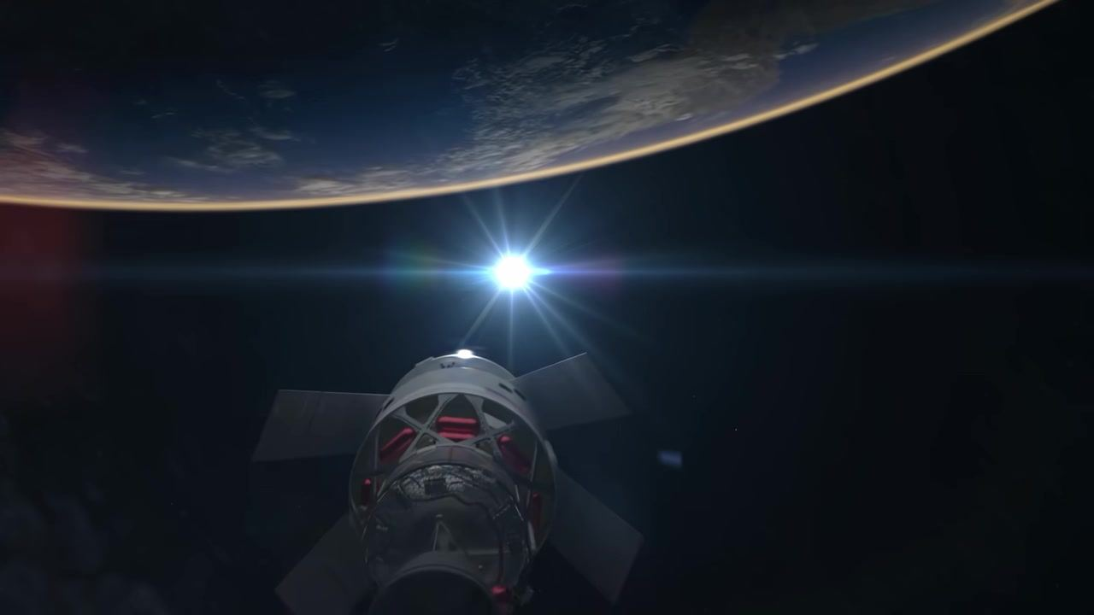
Caption: The Orion spacecraft and ICPS upper stage, seen from behind, float in orbit with the sun and Earth in the background.
[0:03:34]
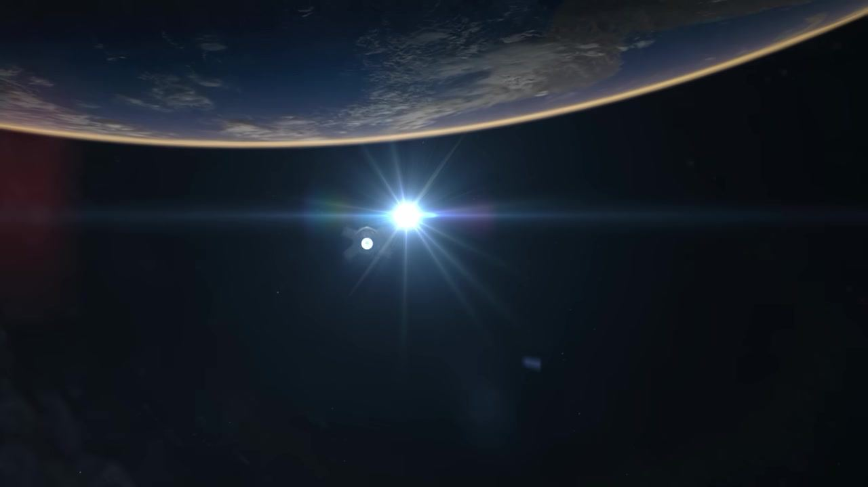
Caption: Distant view of Orion and the ICPS upper stage silhouetted against the sun and the curved Earth.
[0:03:40]
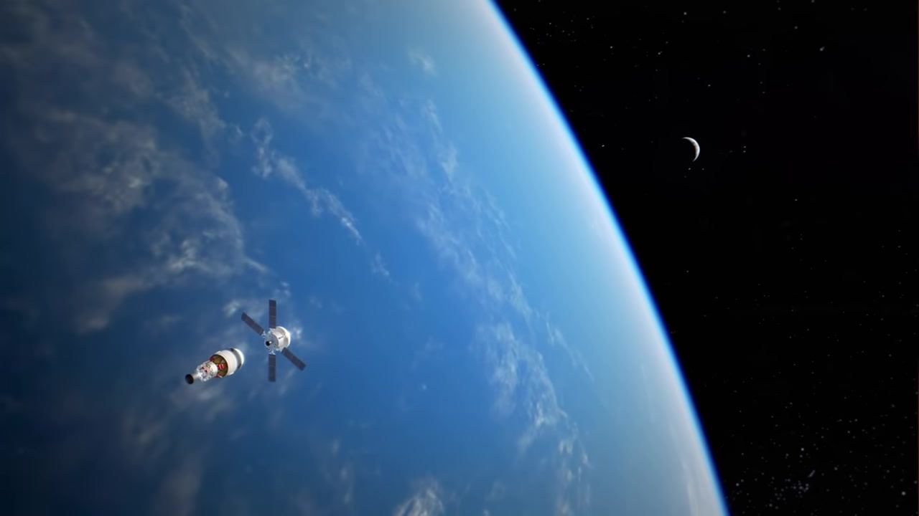
Caption: The Orion spacecraft and ICPS upper stage are seen separated in orbit above Earth, with a crescent Moon in the background.
[0:03:42]
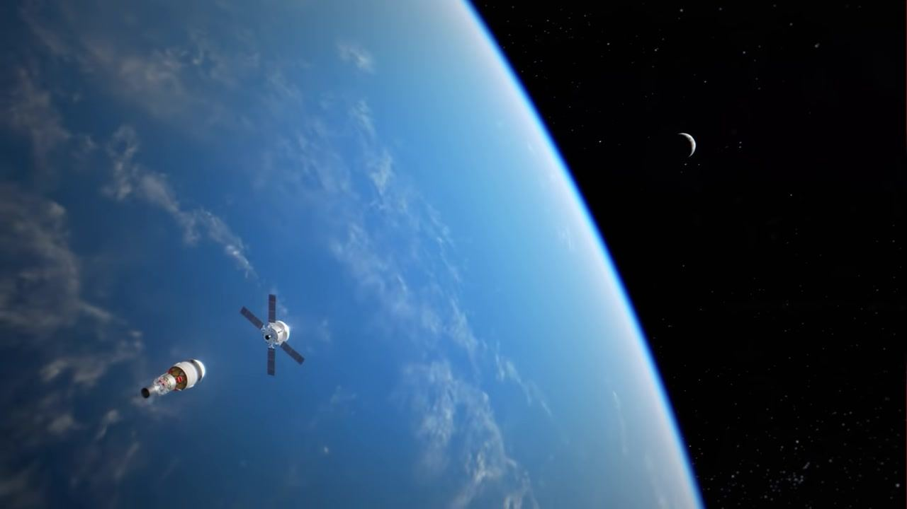
Caption: Orion and the ICPS upper stage drift apart in high Earth orbit, the crescent Moon visible in the distance.
[0:03:44]
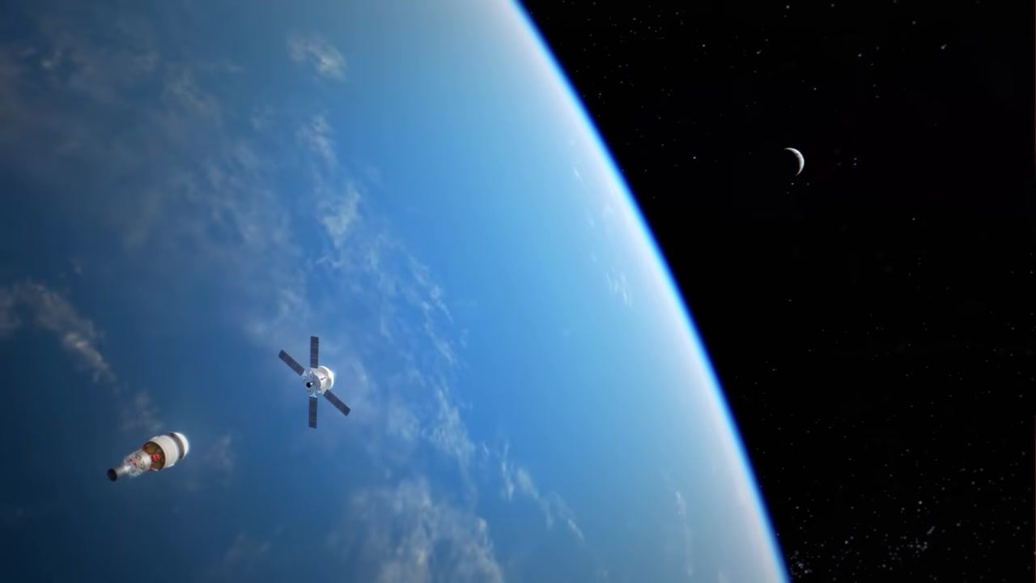
Caption: The Orion spacecraft and ICPS upper stage, now separated, float above Earth with the crescent Moon in the background.
[0:03:46]
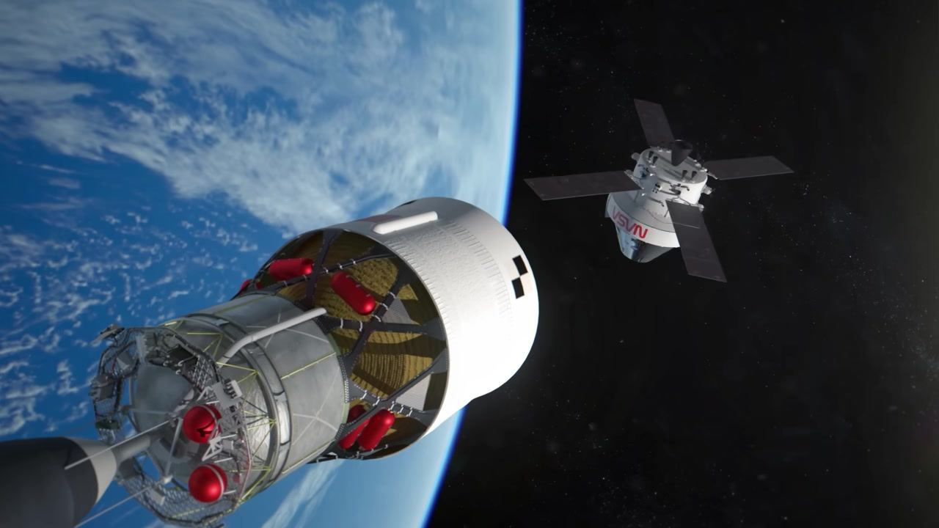
Caption: Close-up view of the separated Orion spacecraft and ICPS upper stage in orbit above Earth, with the NASA logo visible on Orion.
[0:03:48]
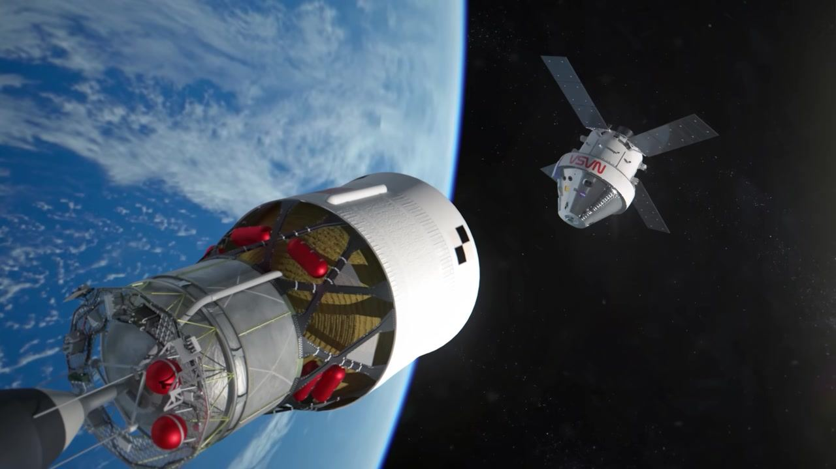
Caption: The Orion spacecraft and ICPS upper stage continue to drift apart in orbit above Earth, with the NASA logo visible on Orion.
[0:03:50]
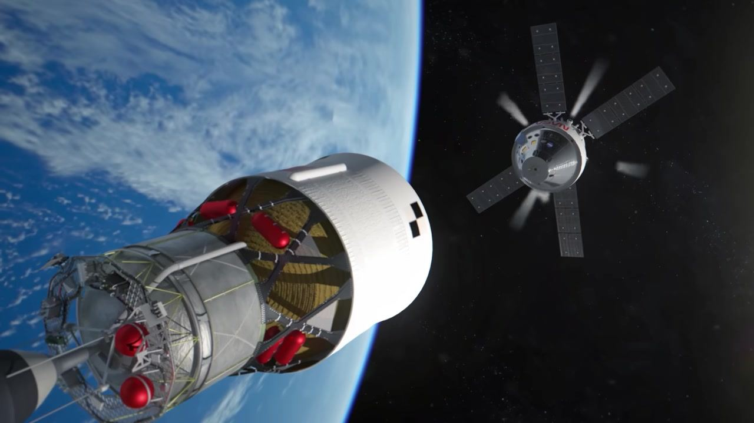
Caption: Orion moves farther away from the ICPS upper stage as both spacecraft orbit above Earth.
[0:03:52]
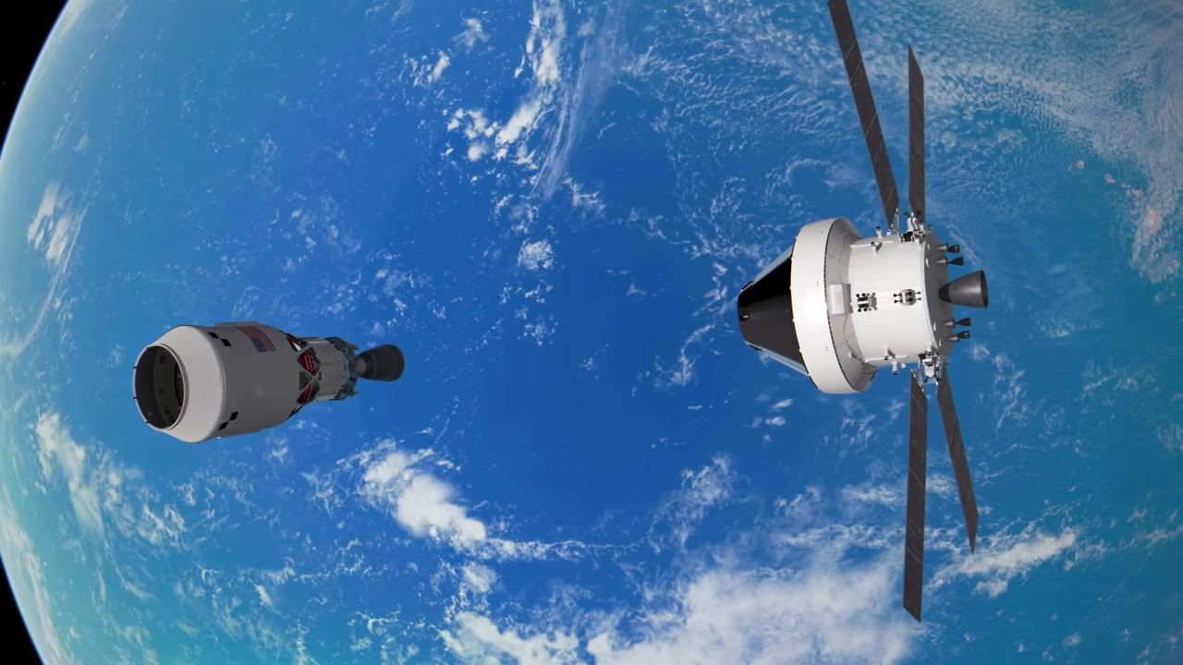
Caption: A top-down view of the separated Orion spacecraft and ICPS upper stage above the blue Earth.
[0:03:54]
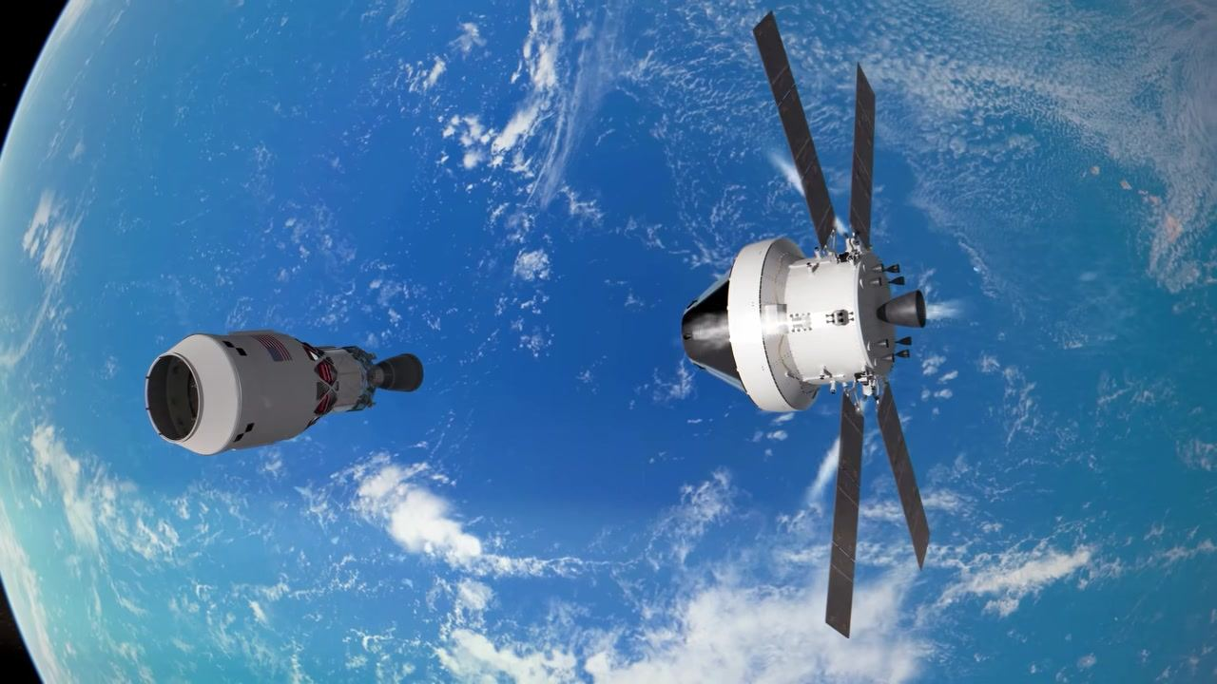
Caption: Orion fires its thrusters as it maneuvers away from the ICPS upper stage in orbit above Earth.
[0:03:56]
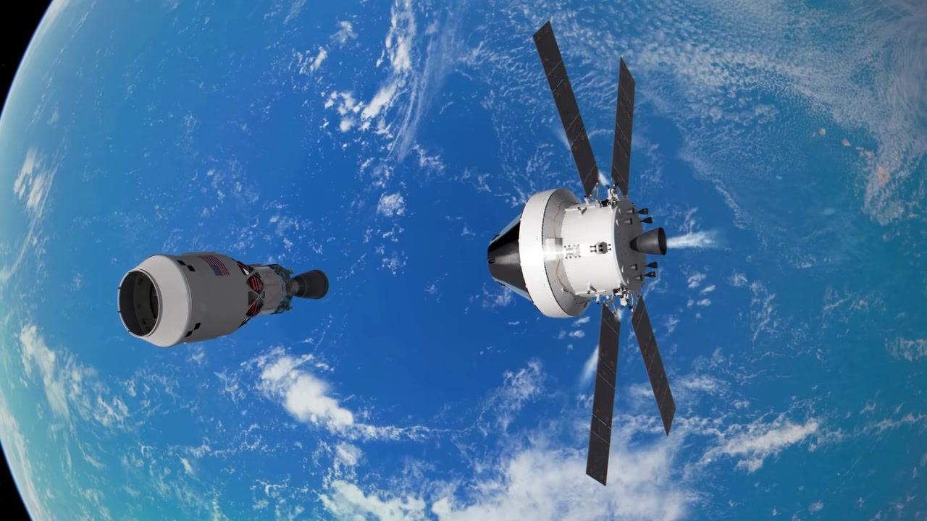
Caption: Orion continues its thruster burn, increasing distance from the ICPS upper stage above Earth.
[0:03:58]
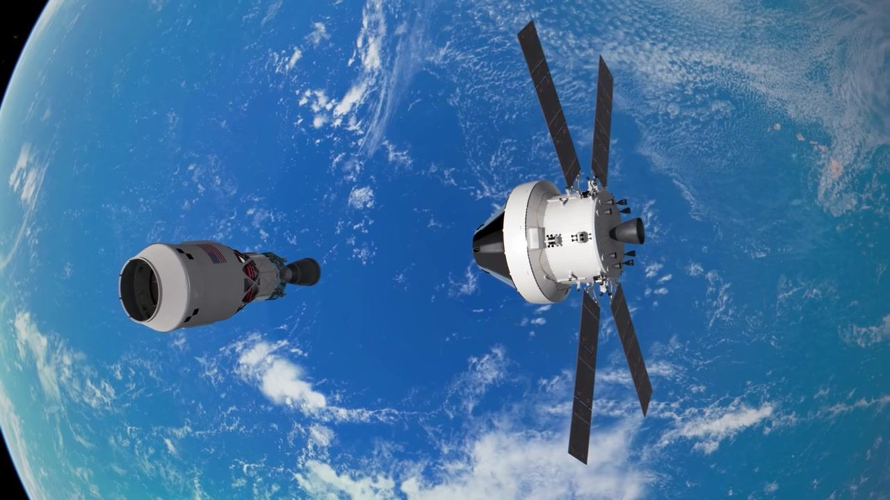
Caption: Orion is now farther from the ICPS upper stage, both spacecraft still visible above the Earth.
[0:03:59]
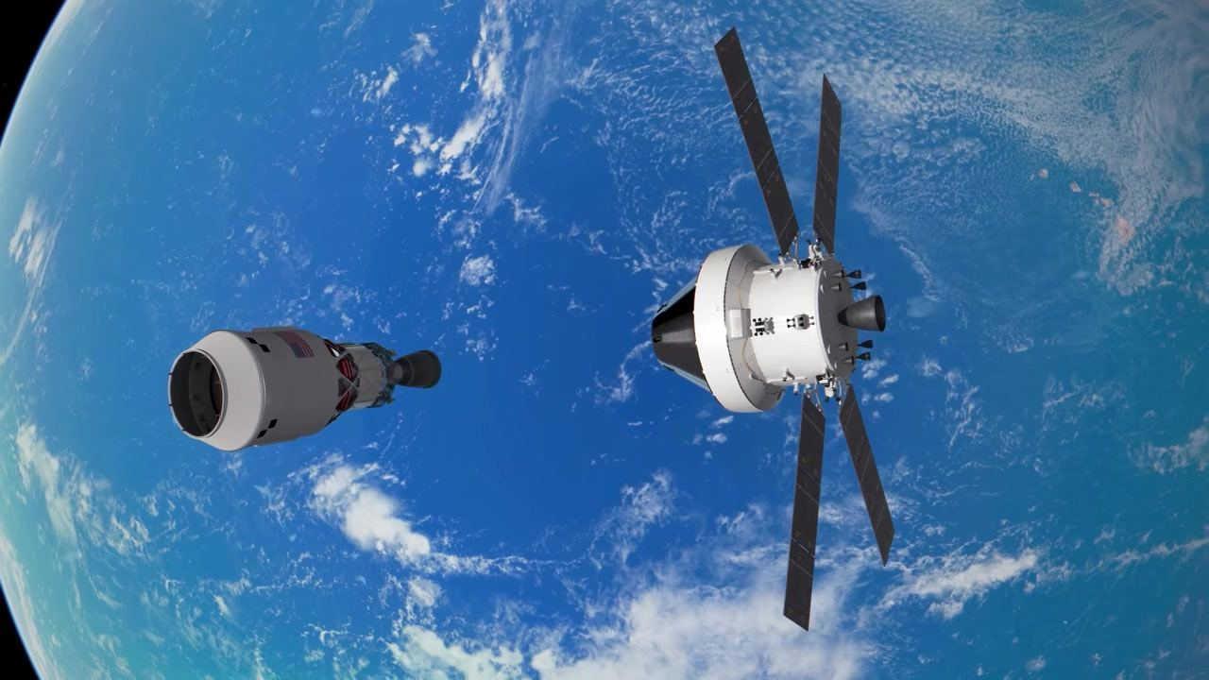
Caption: Orion reaches maximum visible distance from the ICPS upper stage in orbit above Earth.
[0:04:00]
Caption: Orion and its upper stage separate in orbit above Earth, with solar panels deployed.
[0:04:15]
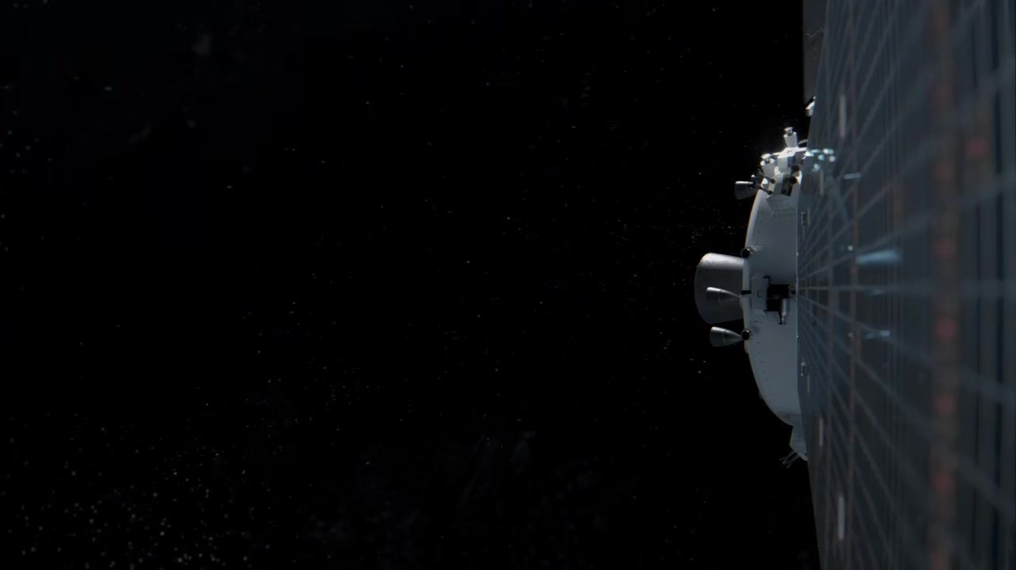
Caption: Orion spacecraft alone in deep space after separation, with one solar panel in view.
[0:04:17]
Caption: Orion spacecraft in deep space with solar panel visible, faint engine glow marks the start of the Translunar Injection burn.
[0:04:20]
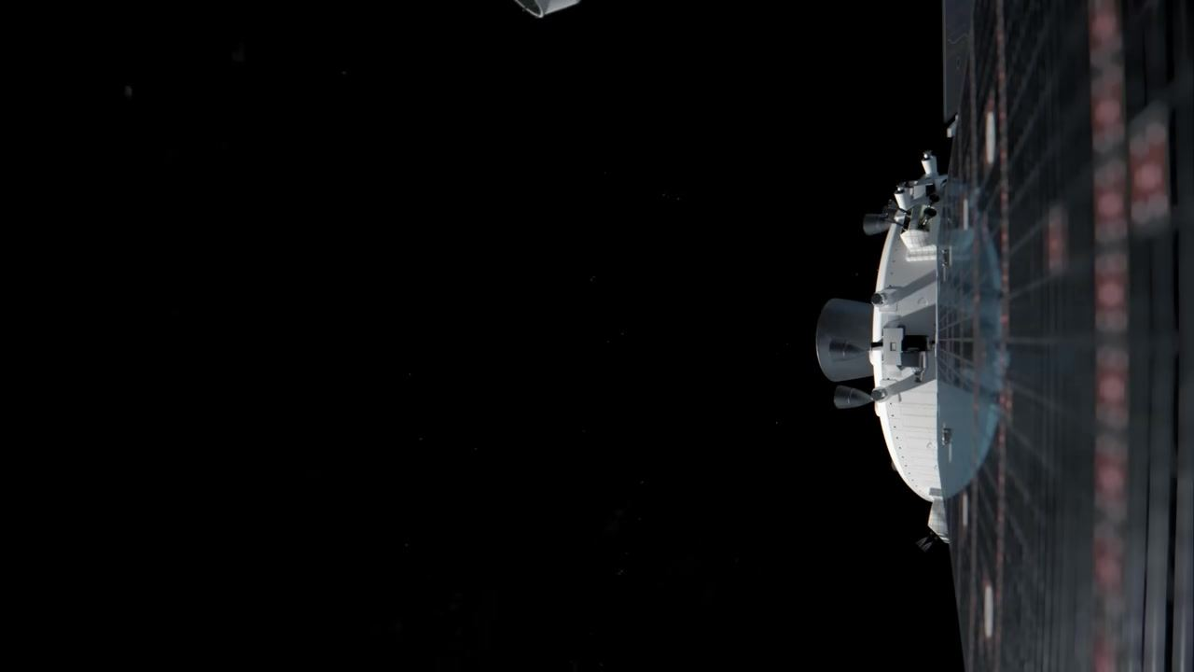
Caption: Orion spacecraft with solar panel at right as the upper stage begins to drift away after separation.
[0:04:21]
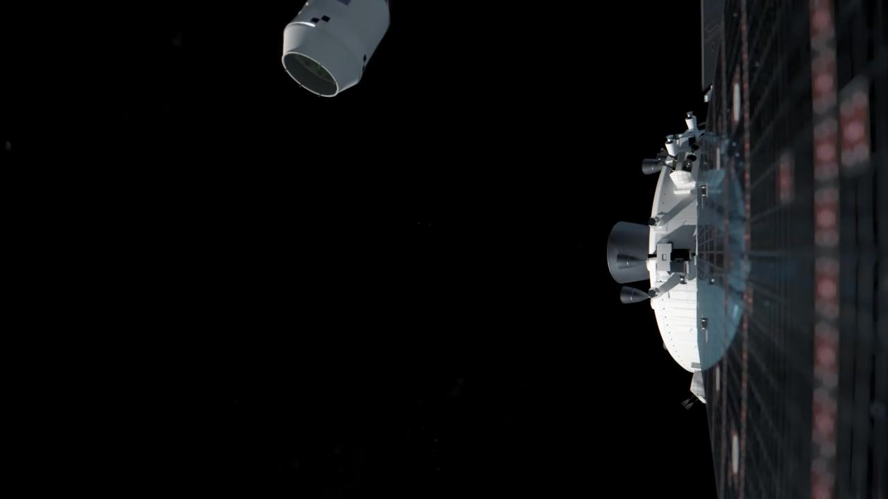
Caption: Orion spacecraft with solar panel at right, upper stage moving farther away after separation.
[0:04:23]
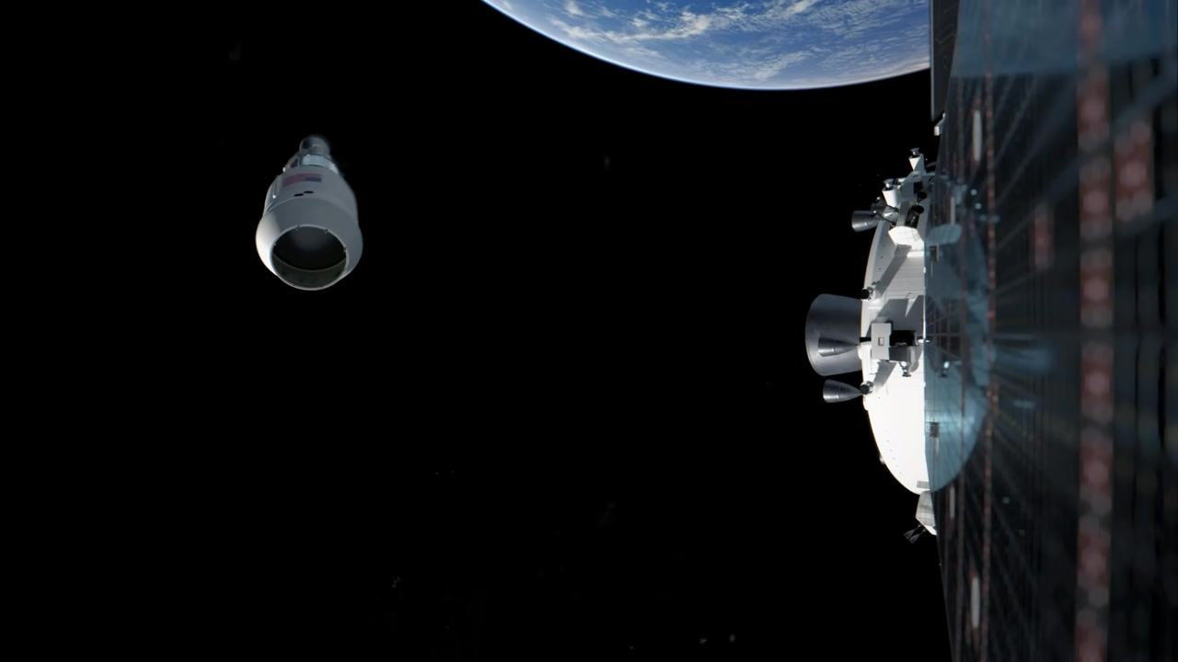
Caption: Orion spacecraft and upper stage separated in orbit, with Earth visible above.
[0:04:25]
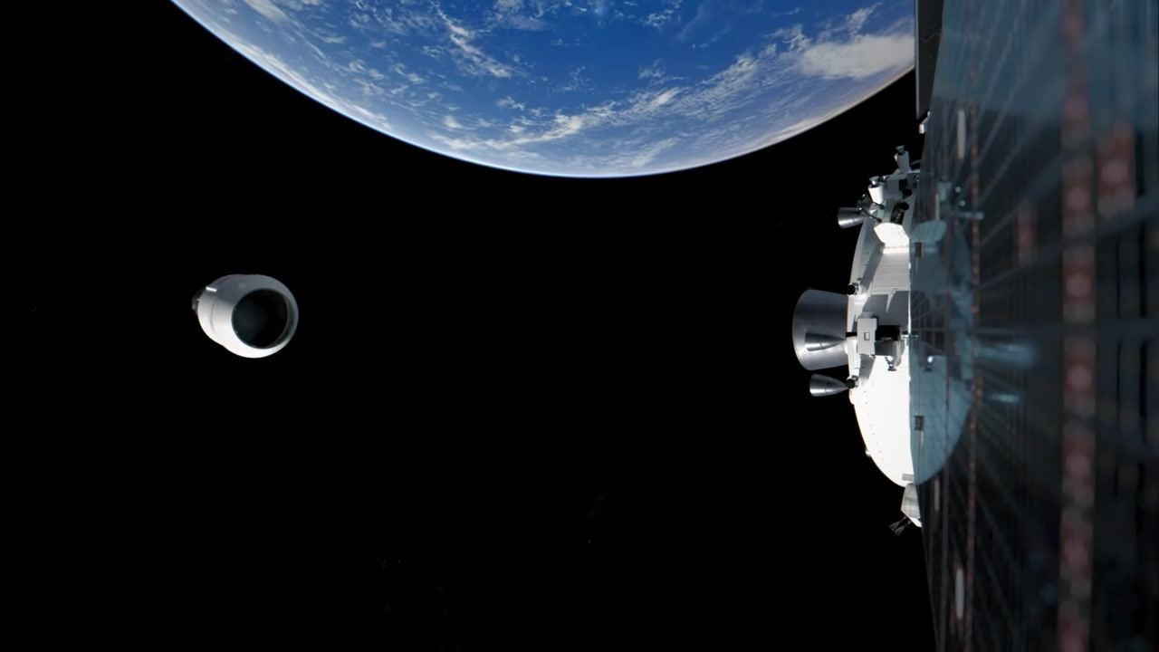
Caption: Orion spacecraft and upper stage drifting farther apart, with Earth in the background.
[0:04:26]
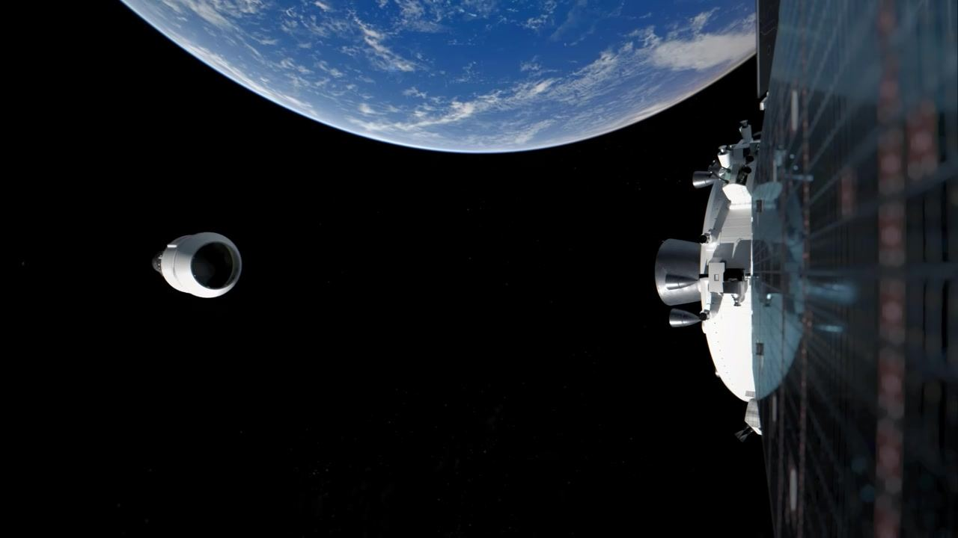
Caption: Orion spacecraft and upper stage widely separated in orbit, with Earth in the background.
[0:04:28]
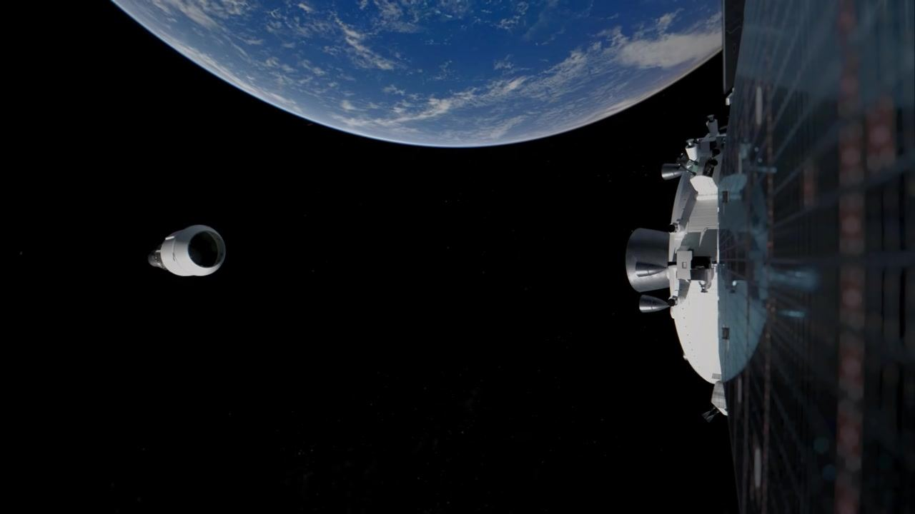
Caption: Orion spacecraft and upper stage widely separated with Earth above and solar panel at right, marking the end of upper stage separation.
[0:04:36]
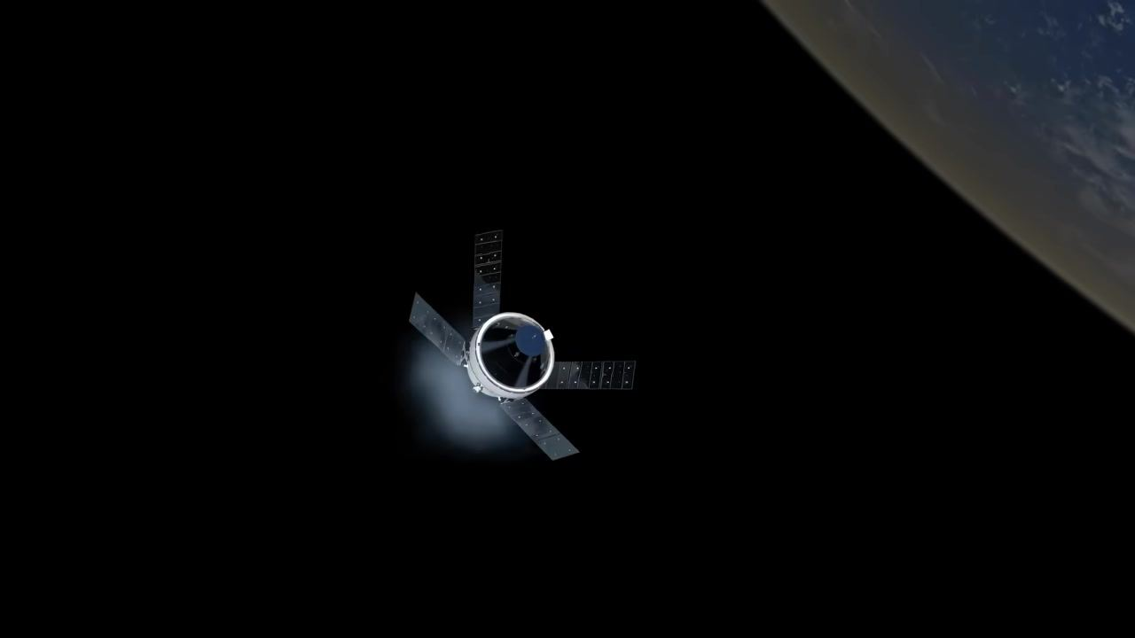
Caption: Orion spacecraft with solar panels firing its engine, beginning the journey away from Earth.
[0:04:37]
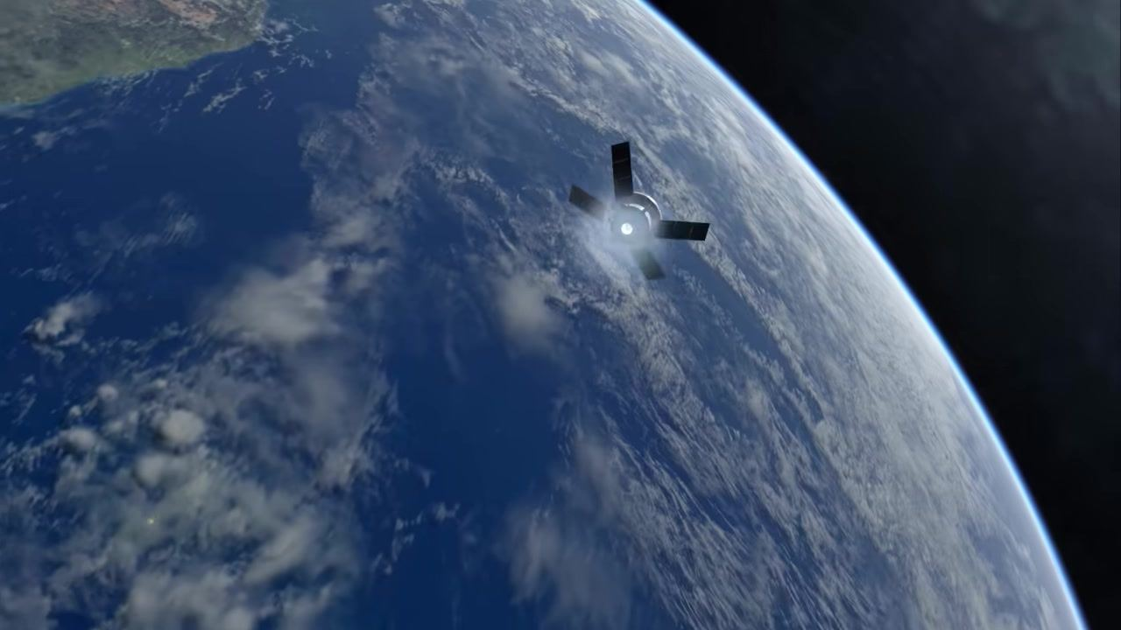
Caption: Orion spacecraft with solar panels firing its engine, seen from above with Earth below.
[0:04:39]
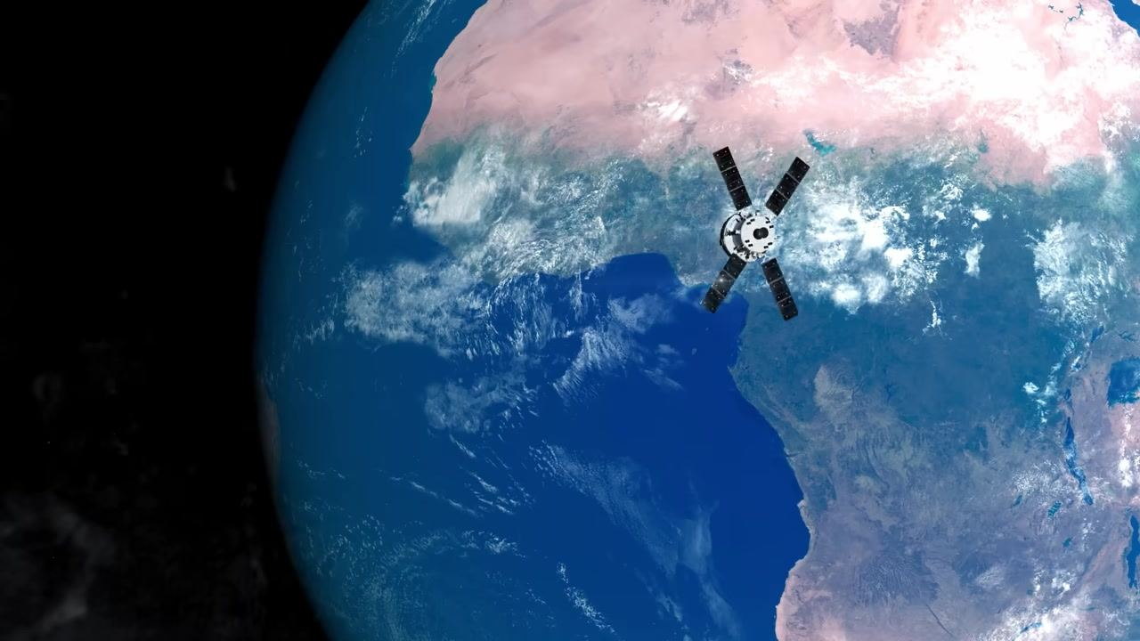
Caption: View of Earth from space with Africa visible, no spacecraft in view.
[0:04:43]
Caption: Orion spacecraft with solar panels seen distantly above Earth, with Africa visible below.
[0:04:44]
Caption: Orion spacecraft with solar panels, closer above Earth with Africa visible below.
[0:04:45]
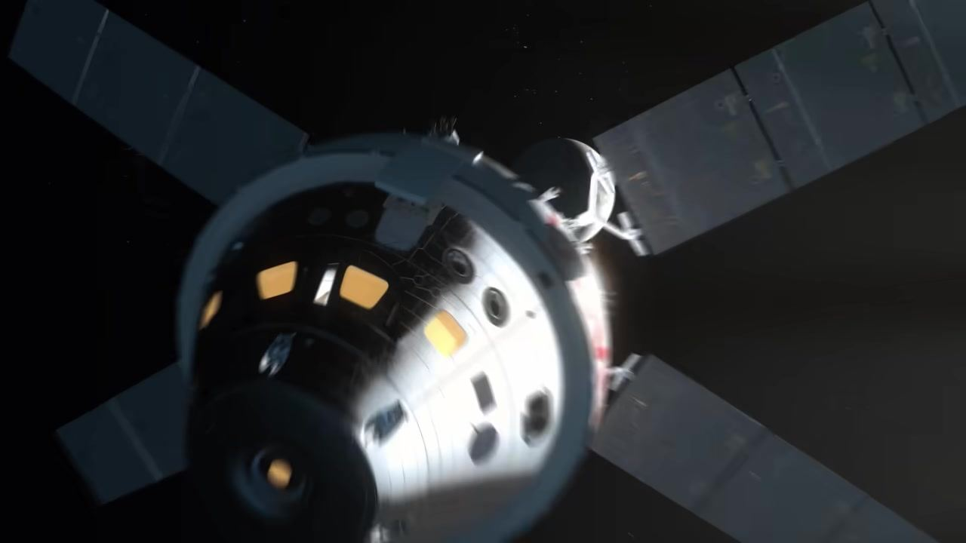
Caption: Close-up of Orion spacecraft with solar panels extended in space.
[0:04:46]
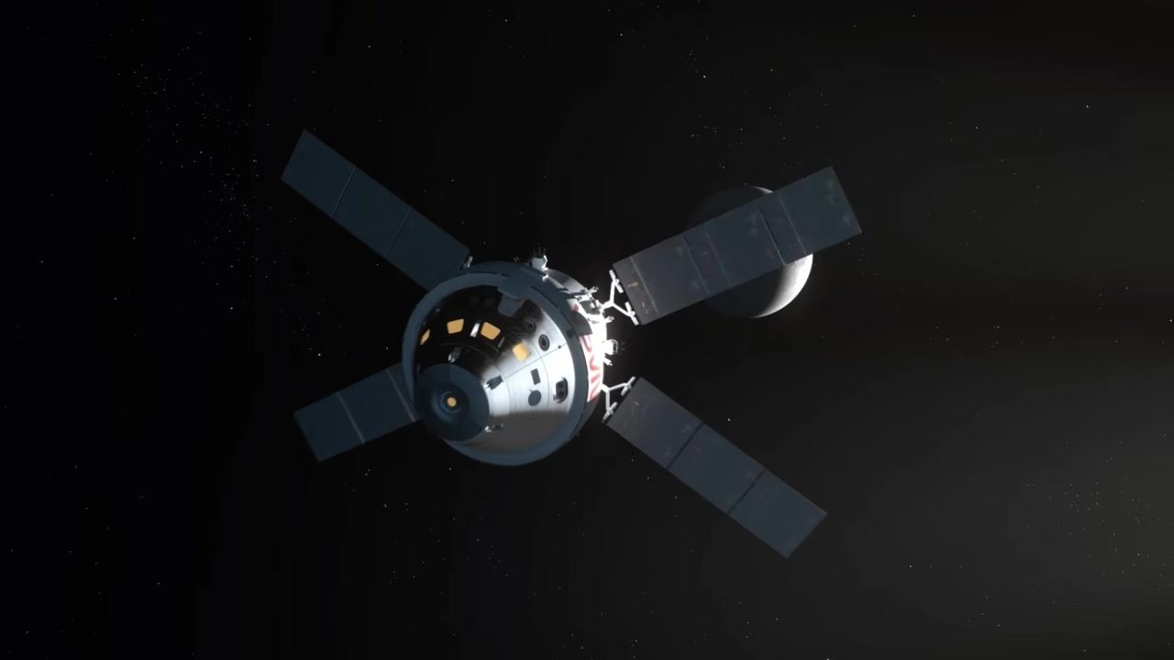
Caption: Orion spacecraft with solar panels seen from above, with the Moon in the background.
[0:04:47]
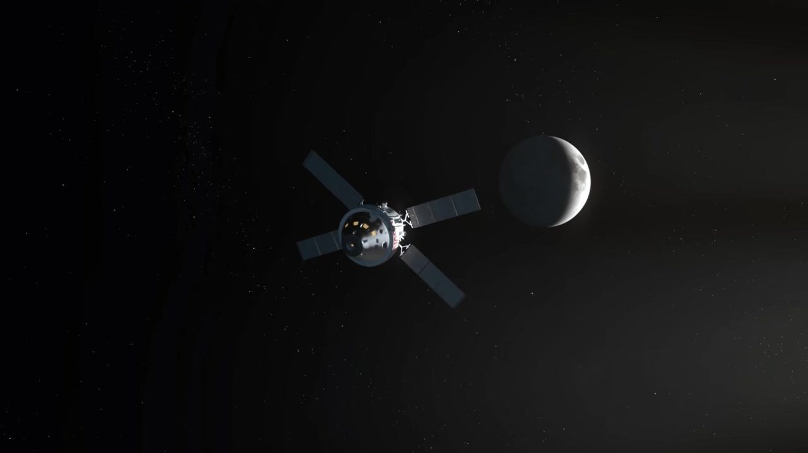
Caption: Orion spacecraft with solar panels approaching the Moon, seen from a distance.
[0:04:48]
Caption: Orion spacecraft with solar panels farther from the Moon, seen from a greater distance.
[0:04:49]
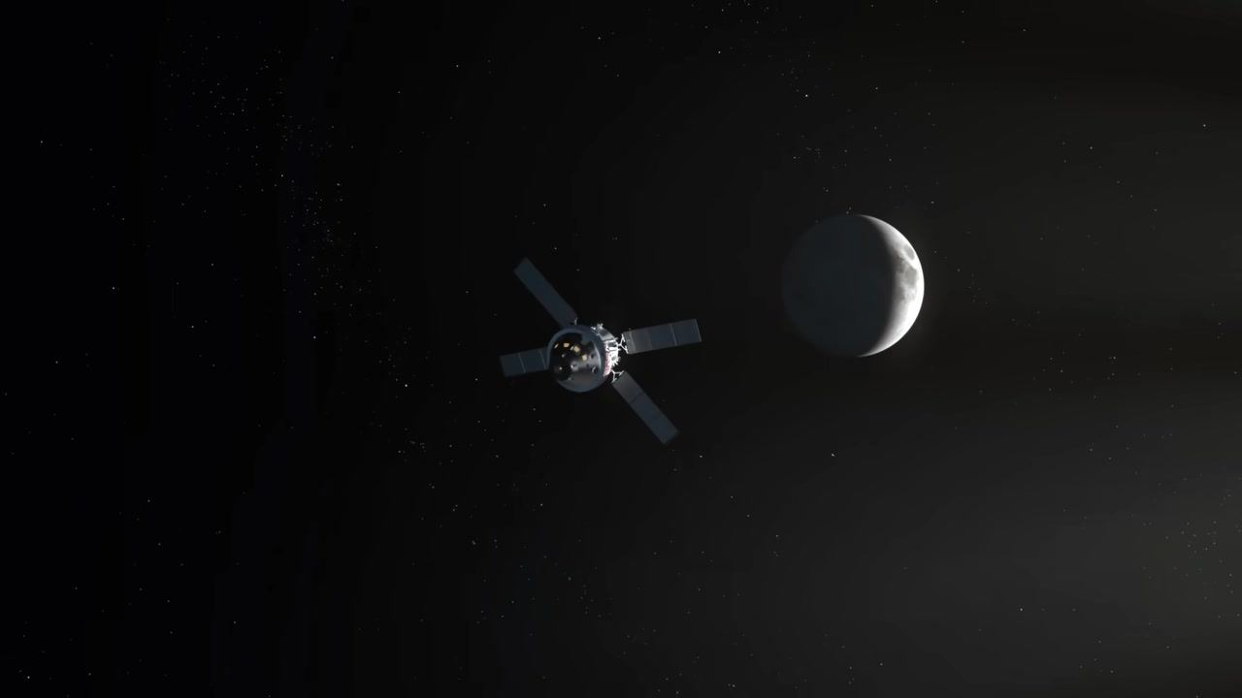
Caption: Orion spacecraft with solar panels receding from the Moon, seen from even farther away.
[0:04:51]
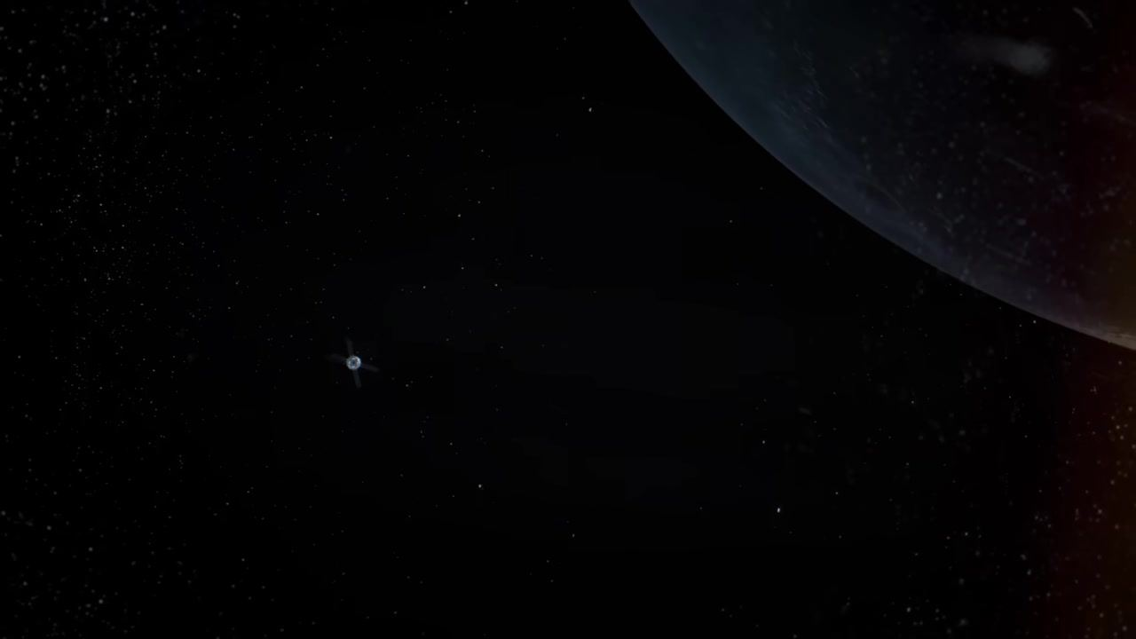
Caption: Orion spacecraft with solar panels seen from behind, with Earth at upper right.
[0:04:52]
Caption: Orion spacecraft with solar panels very distant from Earth, seen from behind.
[0:04:53]
Caption: Orion spacecraft with solar panels extremely distant from Earth, seen from behind.
[0:04:54]
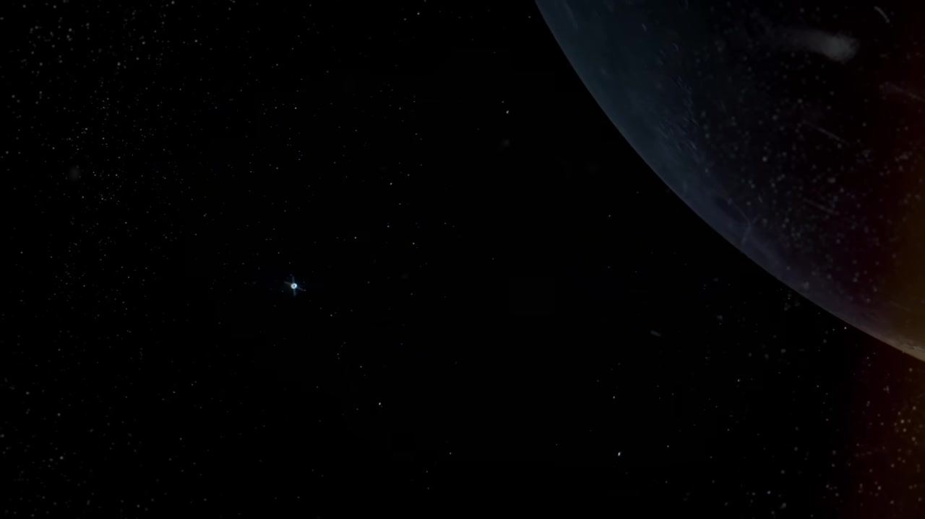
Caption: Orion spacecraft with solar panels tiny and far from Earth, seen from behind.
[0:04:55]
Caption: Distant view of Earth at right edge, with a small bright dot in space at left.
[0:04:56]
Caption: Orion spacecraft with solar panels, close flyby of the Moon's far side.
[0:05:04]
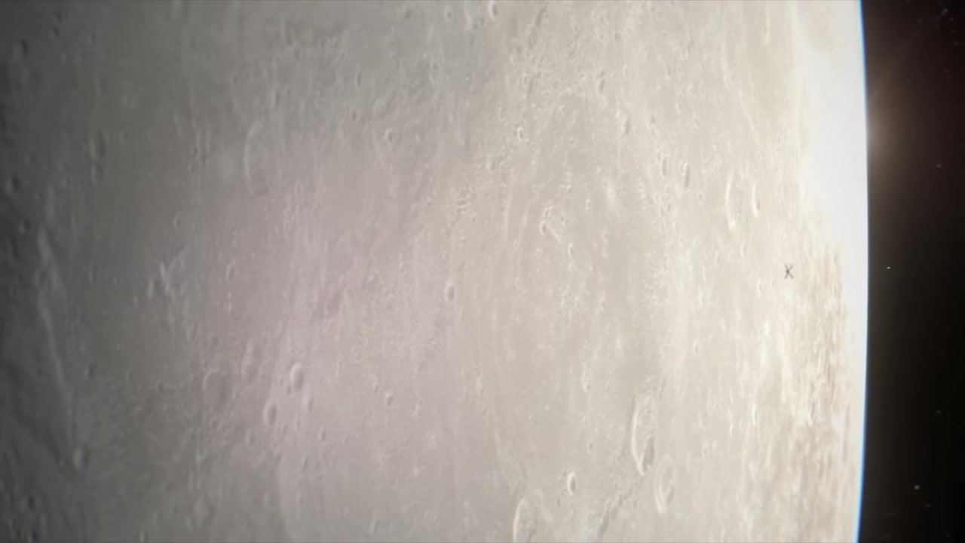
Caption: Close-up of the Moon's surface, with a small "X" marking a spot.
[0:05:06]
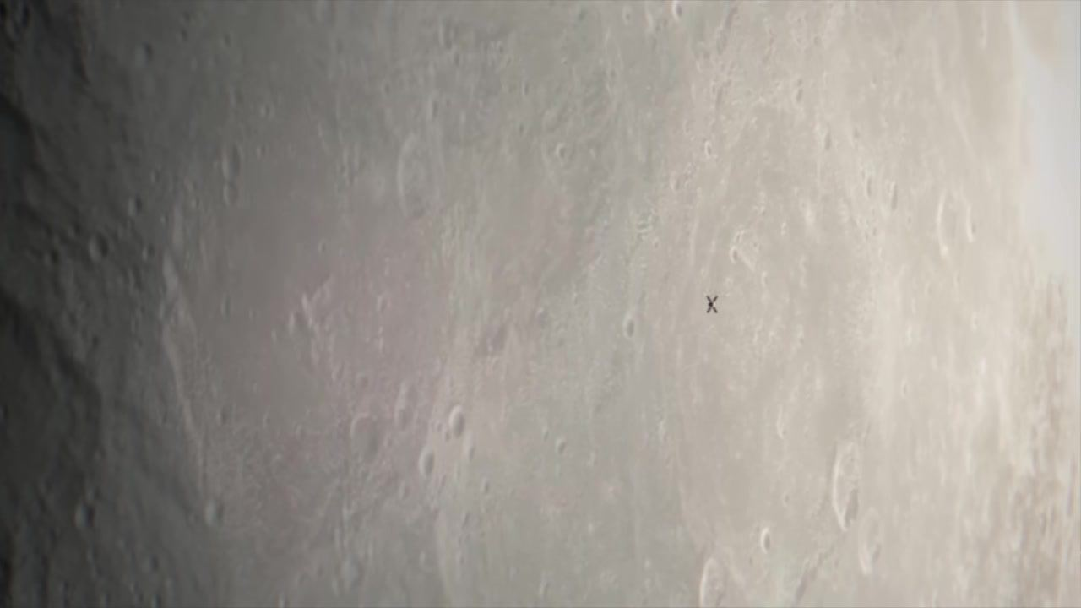
Caption: Closer view of the Moon's surface, "X" marking a spot near center.
[0:05:08]
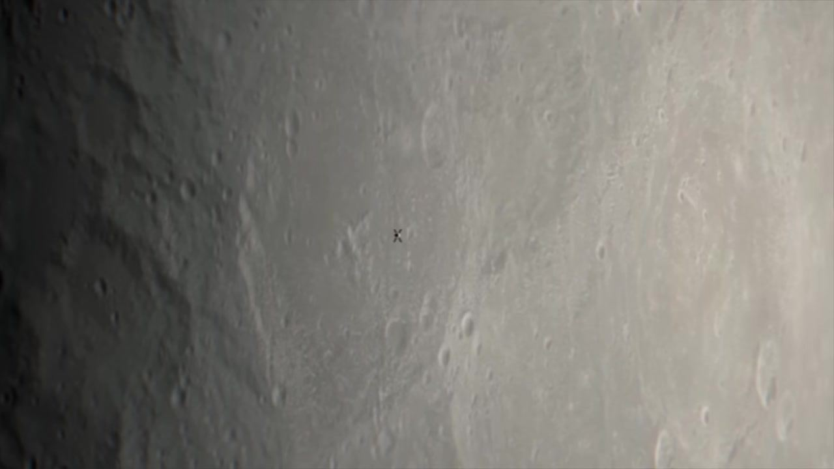
Caption: Extreme close-up of the Moon's surface, "X" marking a spot near center.
[0:05:08]
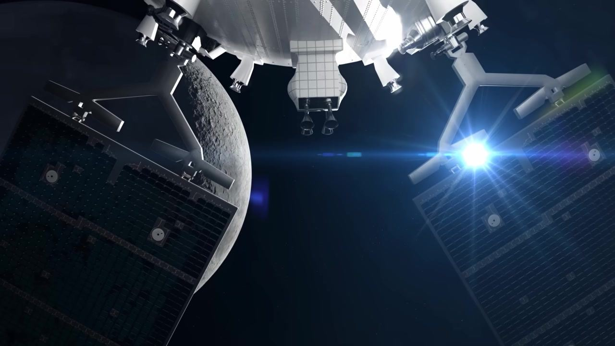
Caption: Orion spacecraft with solar panels, Moon at left, bright blue flare at right.
[0:05:12]
Caption: Orion spacecraft with solar panels, Moon at left, bright blue flare at right.
[0:05:14]
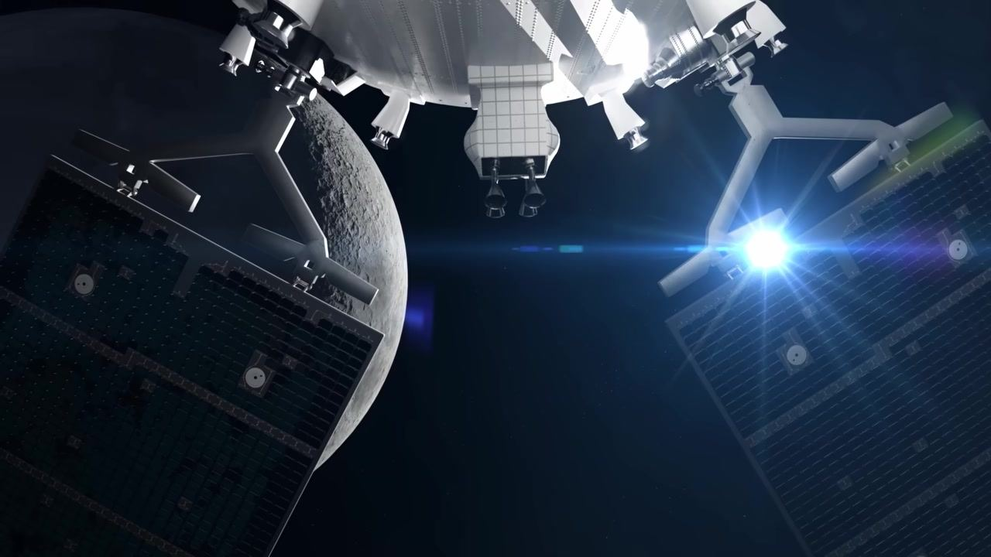
Caption: Orion spacecraft with solar panels, Moon at left, bright blue flare at right.
[0:05:14]
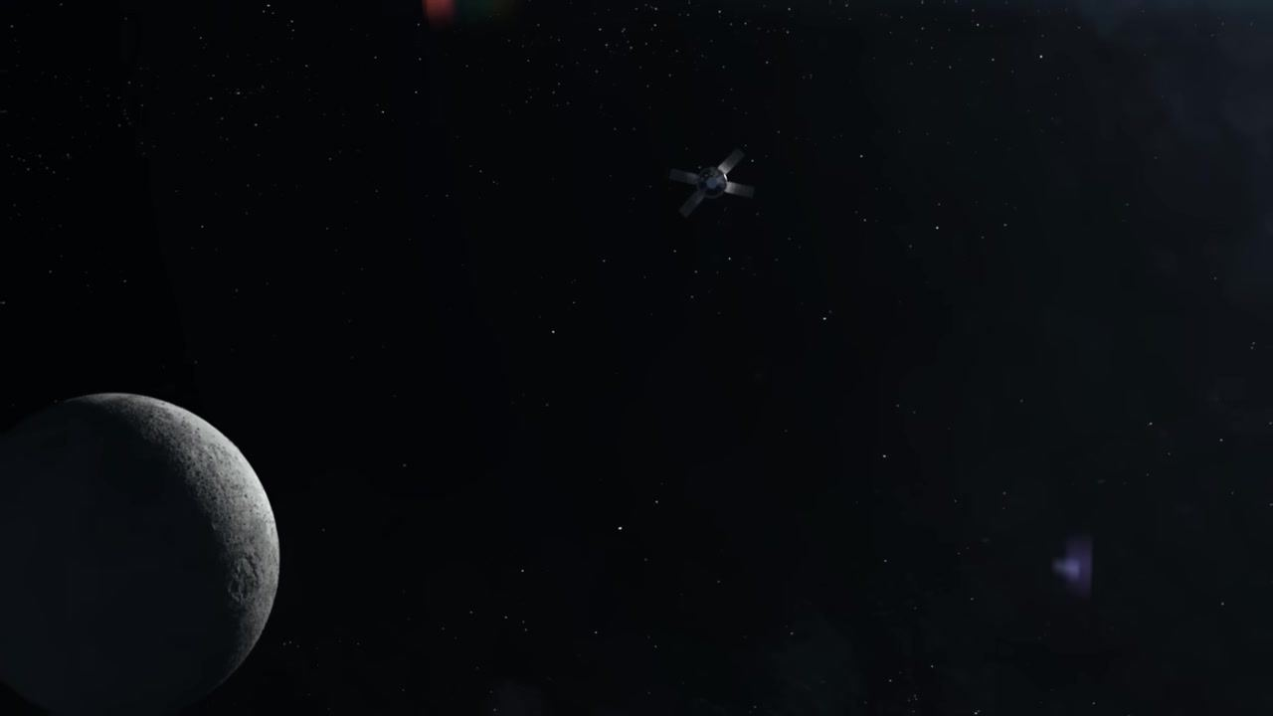
Caption: Distant view of Orion spacecraft in space, Moon at lower left, stars in background.
[0:05:16]
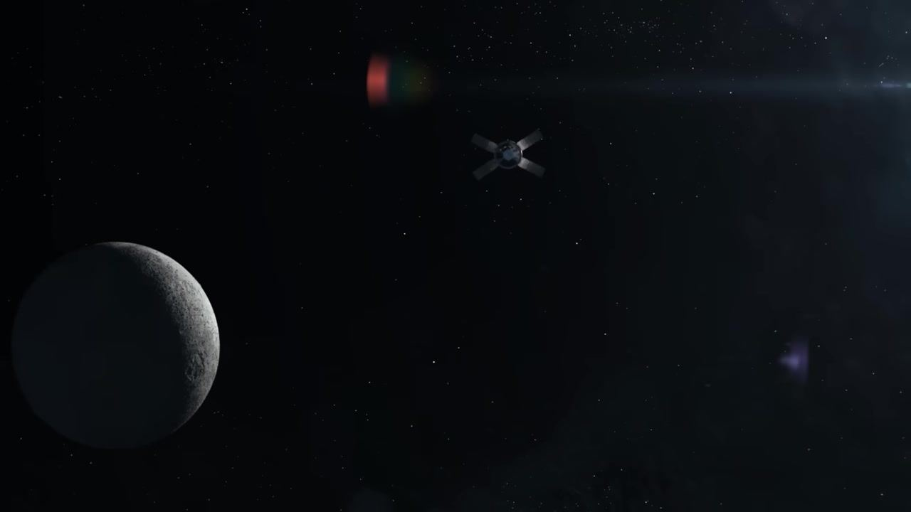
Caption: Orion spacecraft with solar panels traveling away from the Moon, stars in background.
[0:05:18]
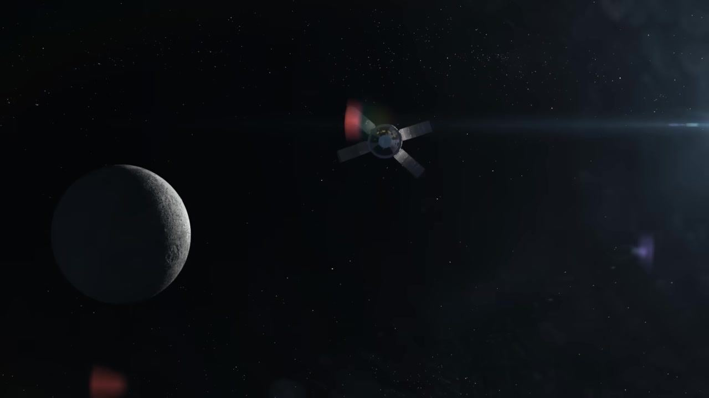
Caption: Orion spacecraft with solar panels moving farther from the Moon, heading toward sunlight.
[0:05:19]
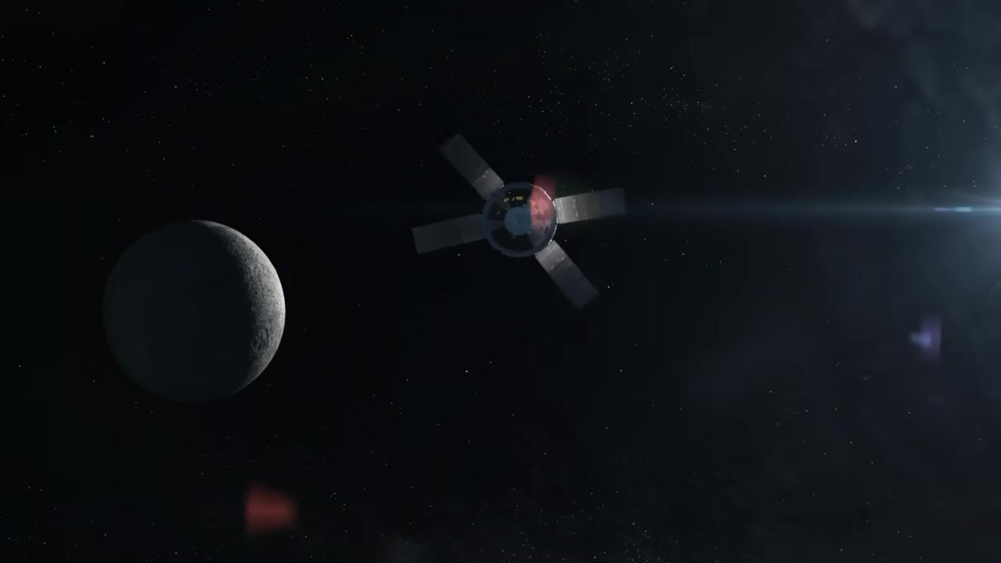
Caption: Orion spacecraft with solar panels, close-up, Moon at left, sunlight at right.
[0:05:20]
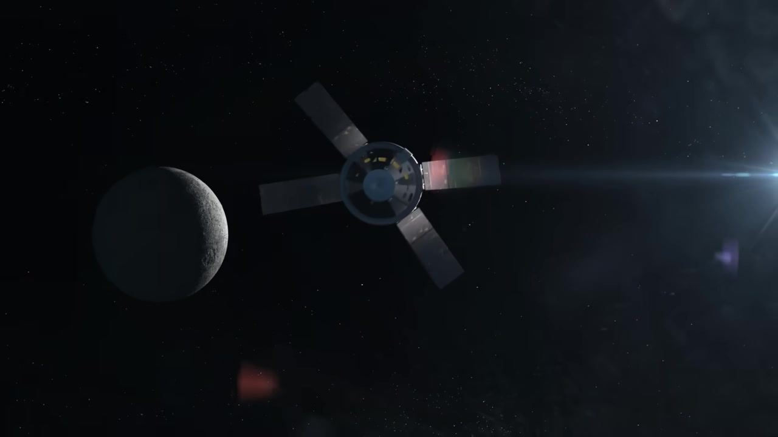
Caption: Orion spacecraft with solar panels, close-up, Moon at left, sunlight at right.
[0:05:21]
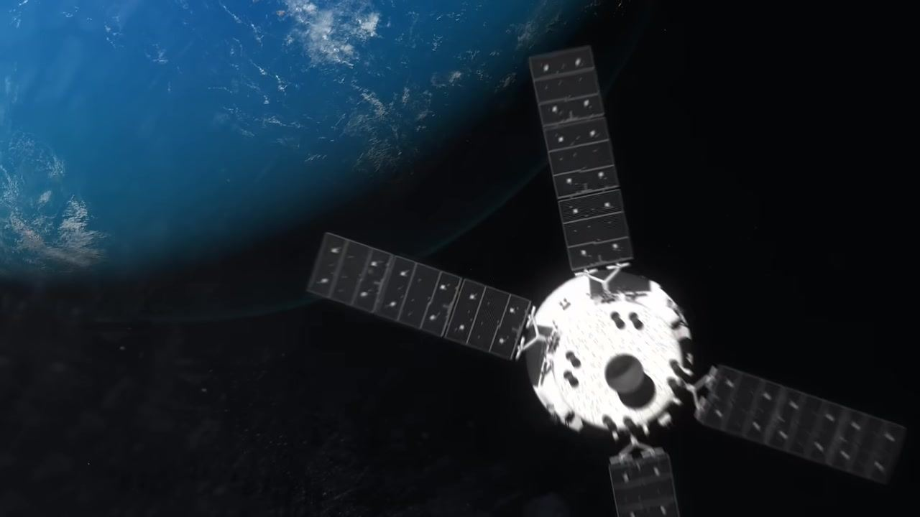
Caption: Orion spacecraft with solar panels approaching Earth, blue planet fills upper left.
[0:05:21]
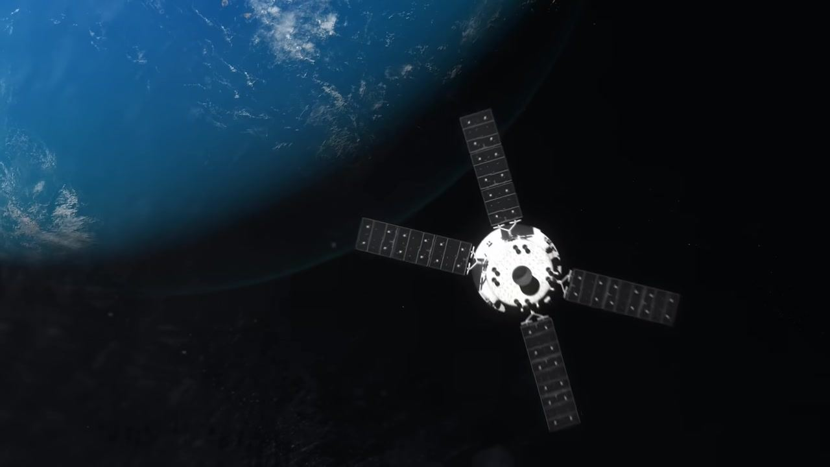
Caption: Orion spacecraft with solar panels, Earth in background, spacecraft illuminated.
[0:05:23]
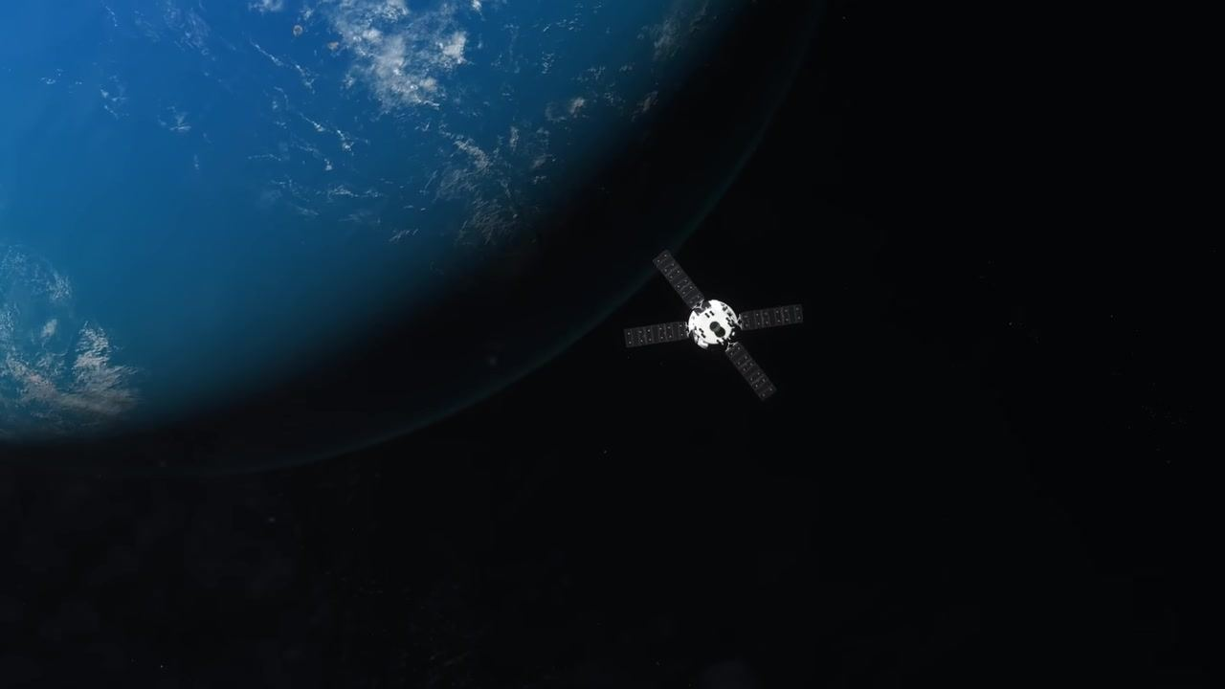
Caption: Orion spacecraft with solar panels, farther from Earth, blue planet fills upper left.
[0:05:23]
Caption: Orion spacecraft with solar panels, farther from Earth, blue planet fills upper left.
[0:05:24]
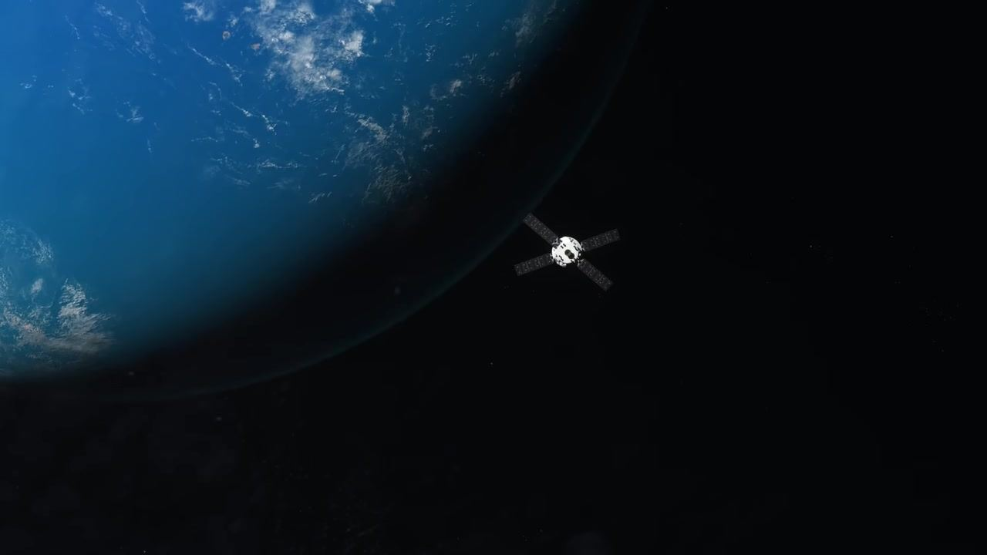
Caption: Orion spacecraft with solar panels, farther from Earth, blue planet fills upper left.
[0:05:24]
Caption: Orion spacecraft with solar panels, farther from Earth, blue planet fills upper left.
[0:05:25]
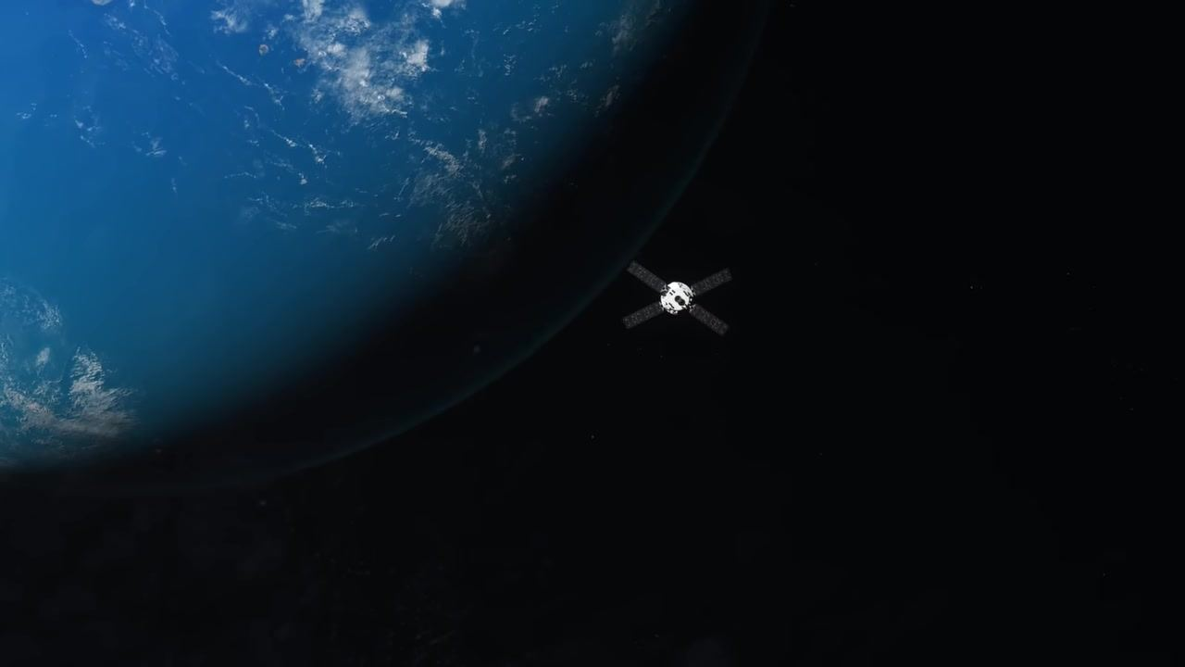
Caption: Orion spacecraft with solar panels, farther from Earth, blue planet fills upper left.
[0:05:31]
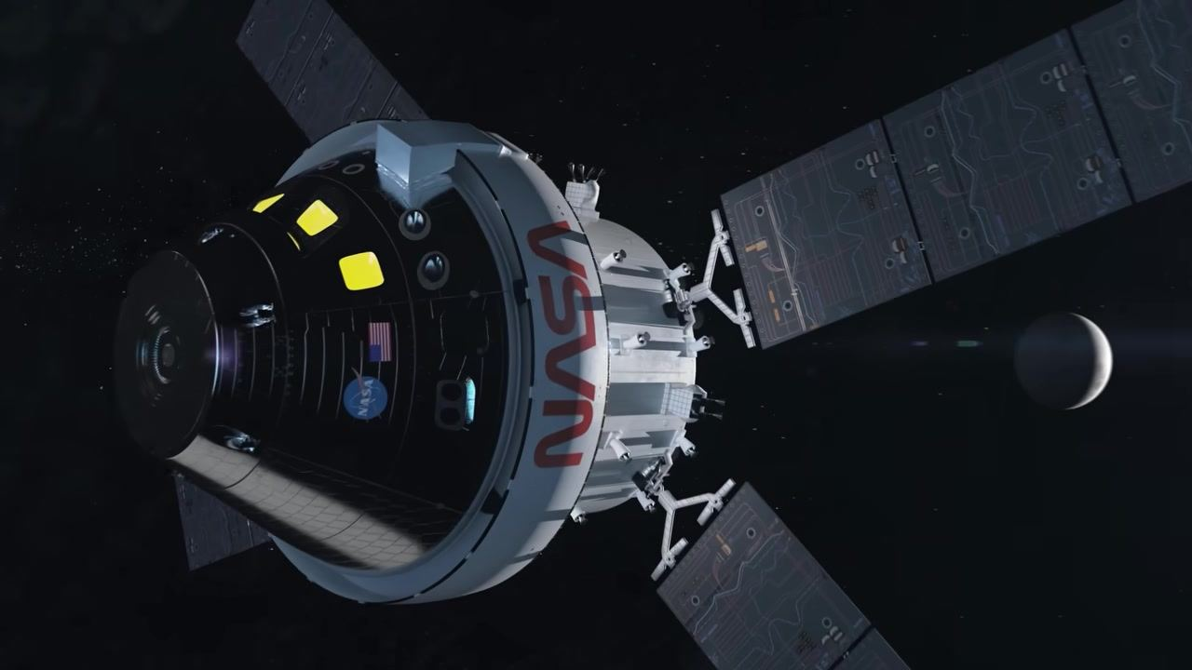
Caption: Close-up of Orion spacecraft with NASA logo and solar panels, crescent Moon in background.
[0:05:33]
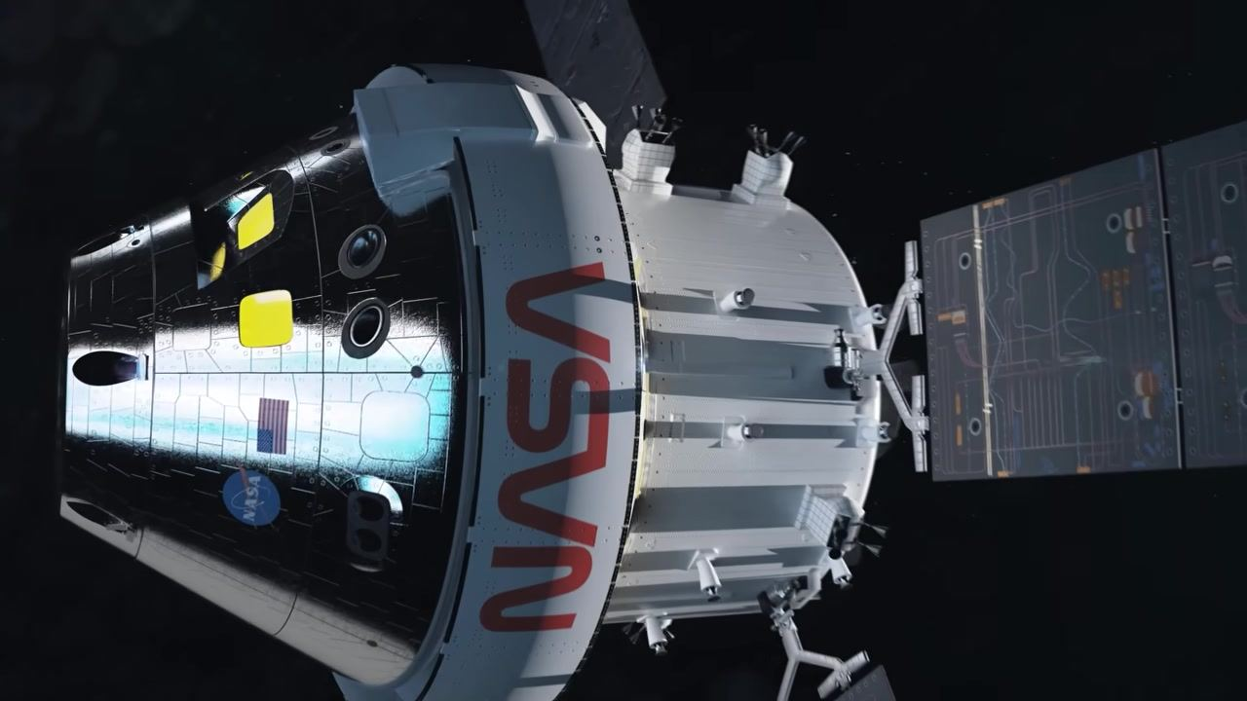
Caption: Orion crew module and service module connected, close-up, NASA logo visible, solar panel at right.
[0:05:35]
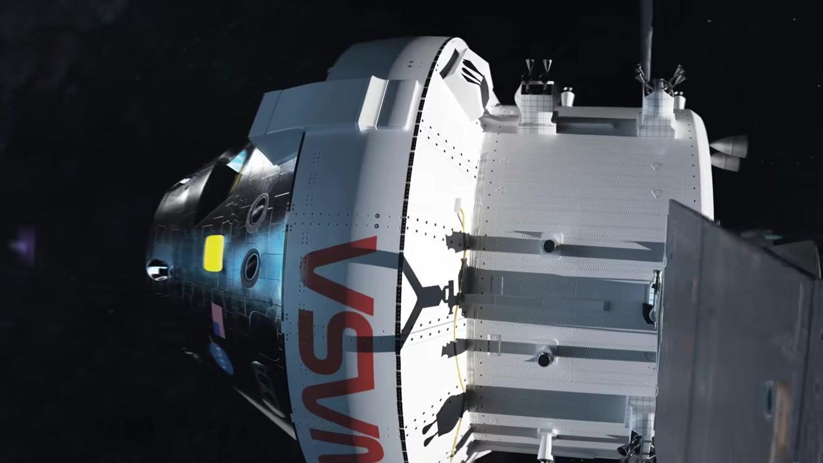
Caption: Orion crew module and service module about to separate, NASA logo visible, solar panel at right.
[0:05:37]
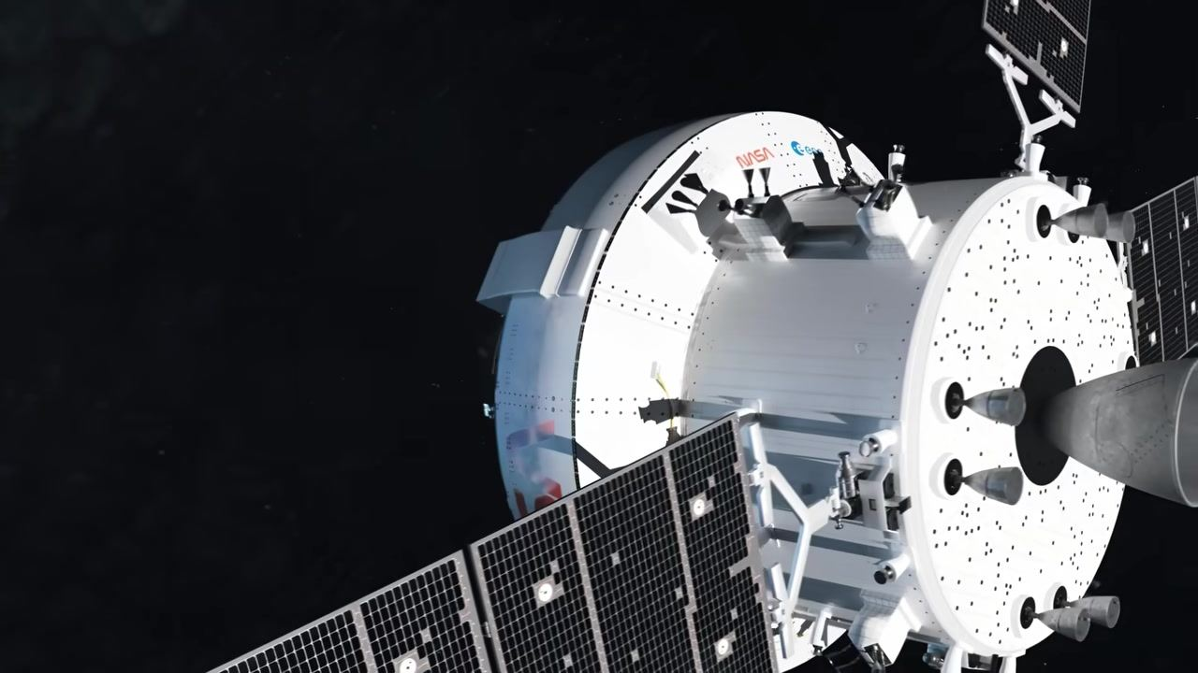
Caption: Orion crew module separating from service module, solar panels and thrusters visible.
[0:05:39]
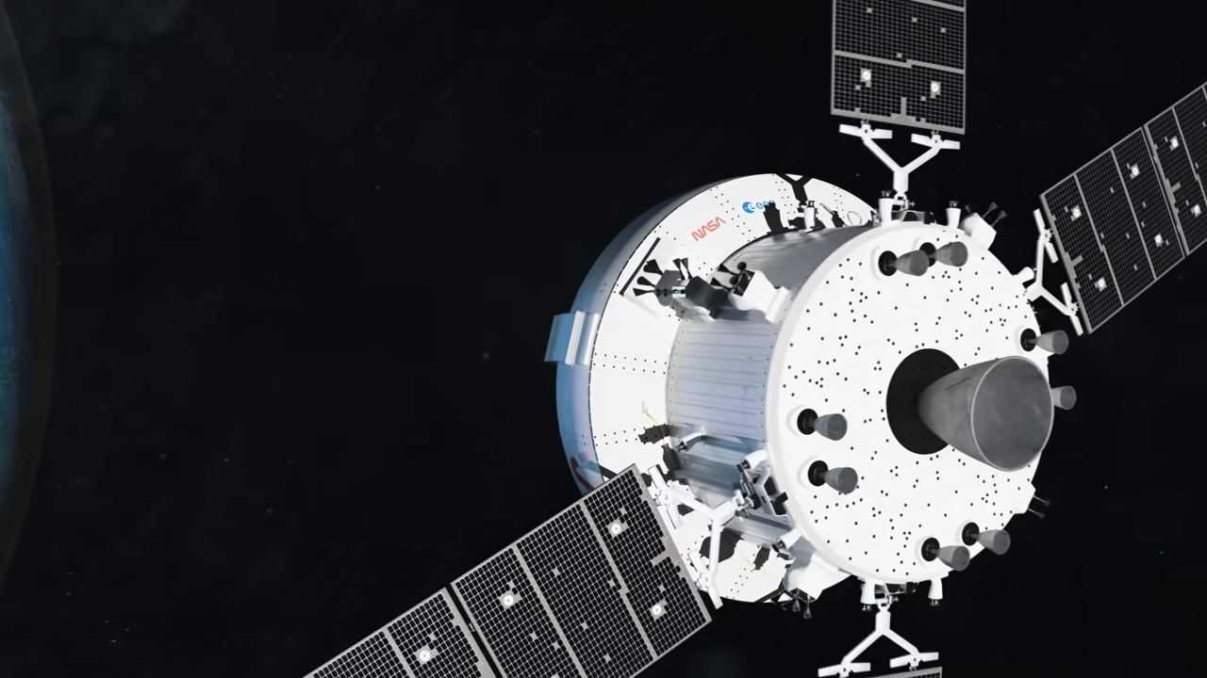
Caption: Service module drifting away from Orion crew module, Earth at left, solar panels extended.
[0:05:40]
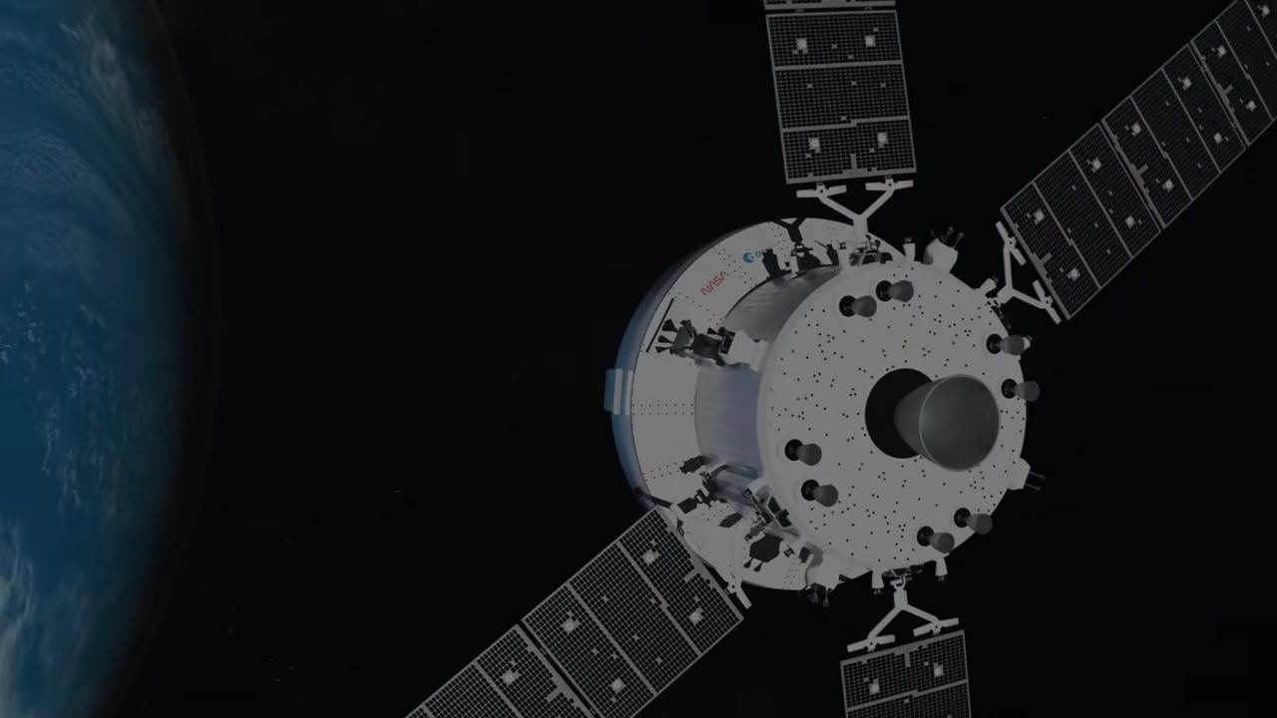
Caption: Service module further from Orion crew module, Earth at left, solar panels extended.
[0:05:41]
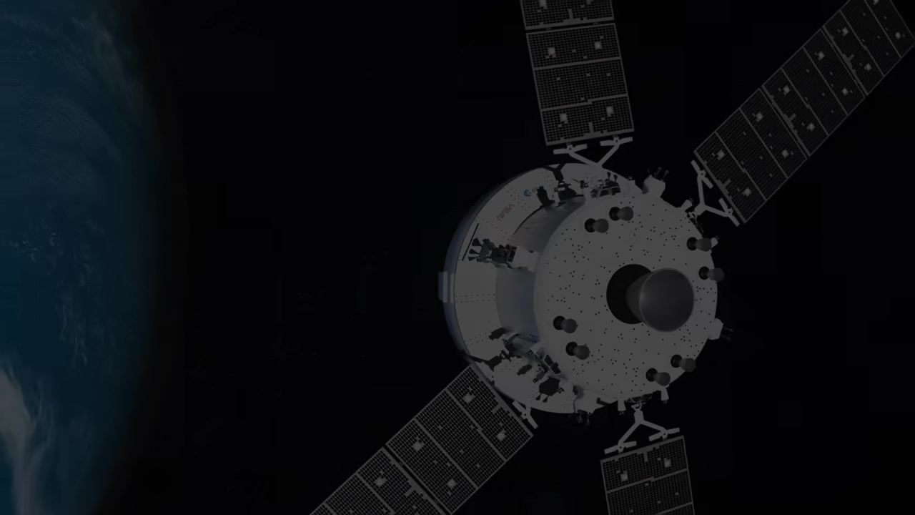
Caption: Service module receding into darkness, Earth at left, solar panels extended.
[0:05:41]
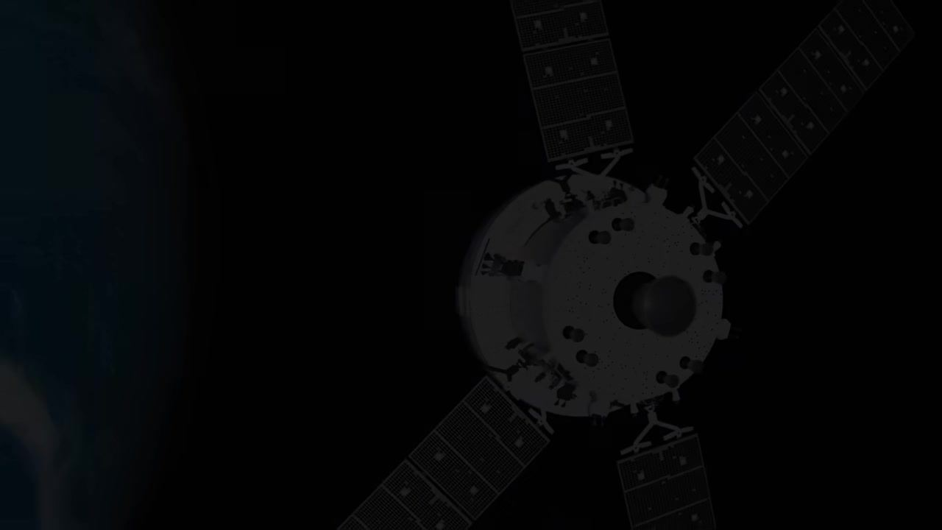
Caption: Service module barely visible, mostly dark, Earth at left.
[0:05:42]

Caption: Service module almost completely faded into darkness, Earth at left.
[0:05:43]
Caption: Completely black screen.
[0:05:44]
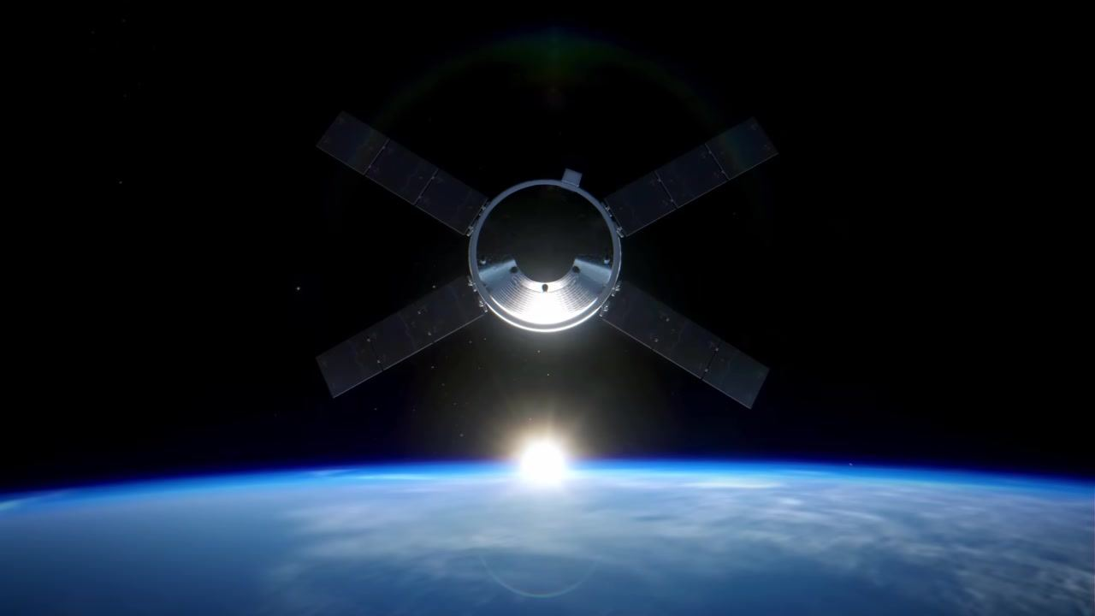
Caption: Orion crew module above Earth, sunrise on horizon, service module gone.
[0:05:46]
Caption: Orion crew module above Earth, sunrise on horizon, sun just above horizon.
[0:05:49]
Caption: Orion crew module above Earth, sunrise on horizon, sun slightly higher above horizon.
[0:05:51]
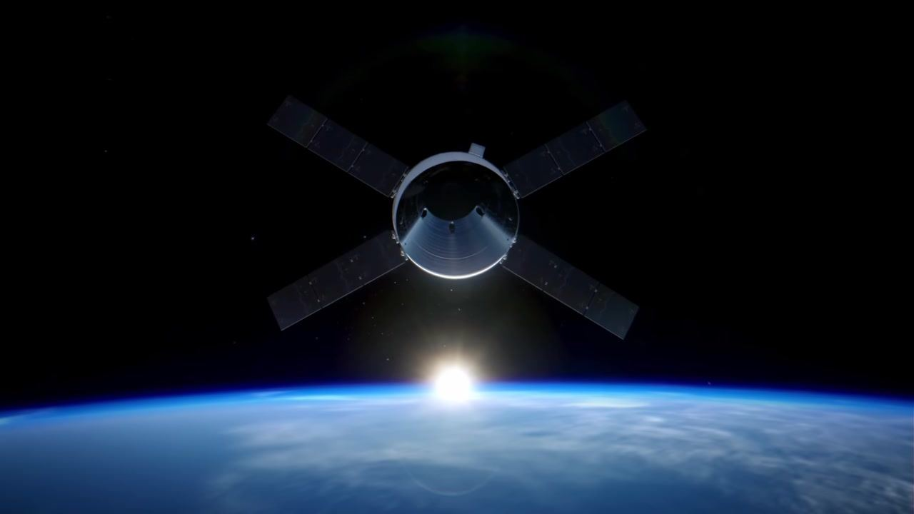
Caption: Orion crew module above Earth, sunrise on horizon, sun rising further.
[0:05:53]
Caption: Orion crew module above Earth, sunrise on horizon, sun continuing to rise.
[0:05:55]
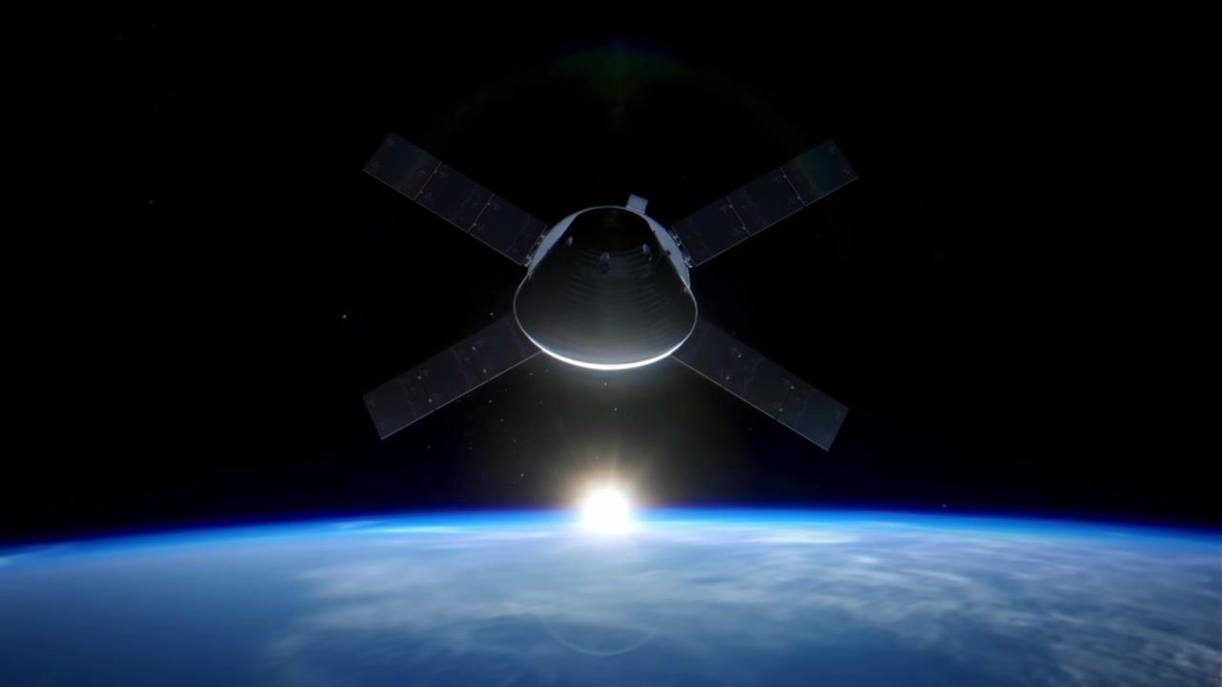
Caption: Orion crew module above Earth, sunrise on horizon, sun nearly halfway above horizon.
[0:05:56]
Caption: Orion crew module above Earth, sunrise on horizon, sun halfway above horizon.
[0:05:58]
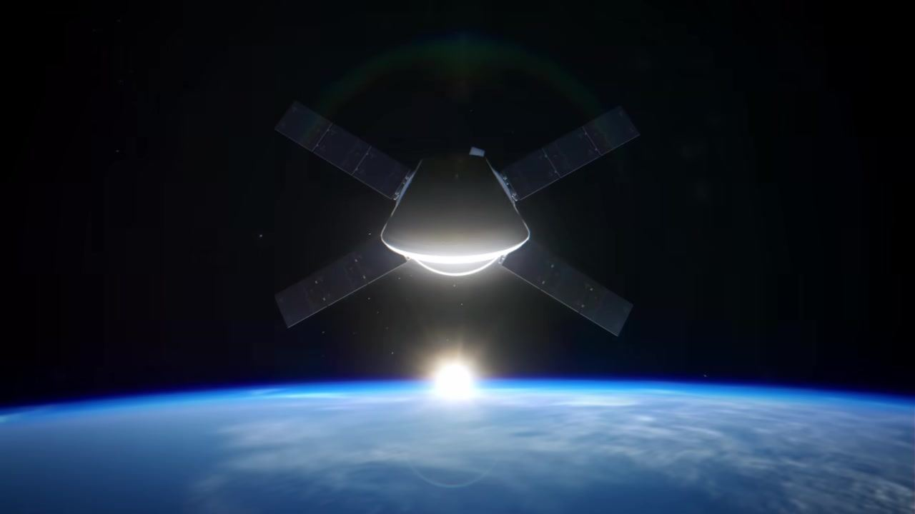
Caption: Orion crew module above Earth, sunrise on horizon, sun more than halfway above horizon.
[0:05:59]
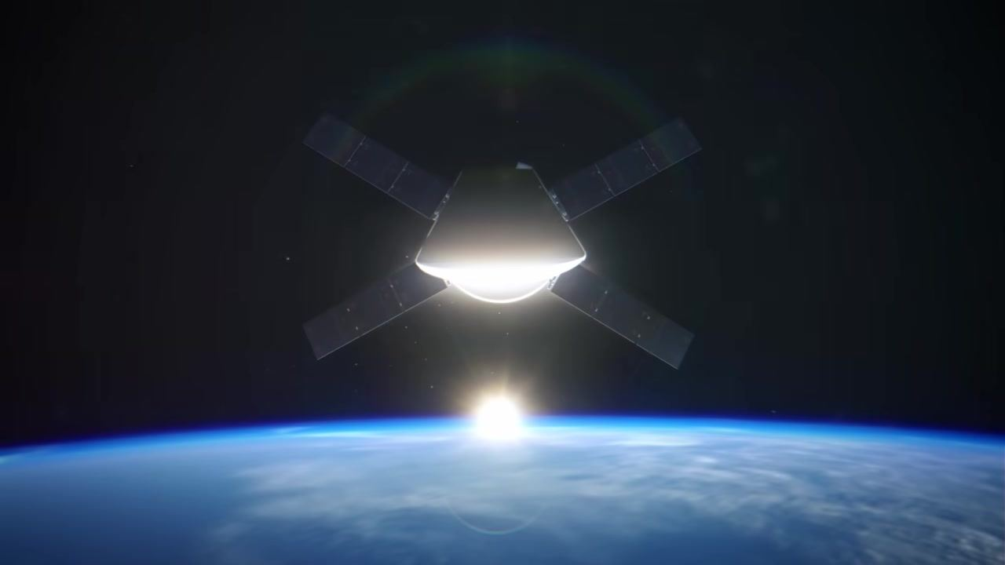
Caption: Orion crew module above Earth, sunrise on horizon, sun almost fully above horizon.
[0:06:03]
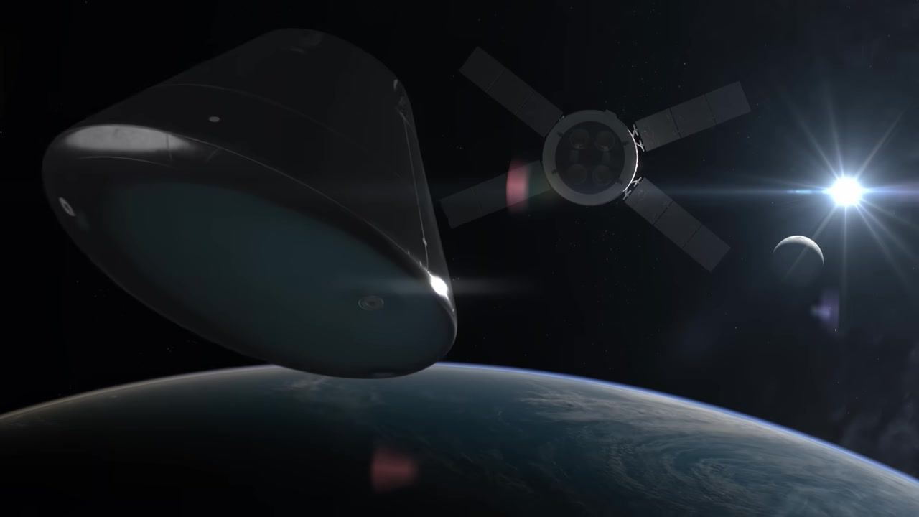
Caption: Orion capsule separates from the service module above Earth, with the Moon and Sun in the background.
[0:06:12]
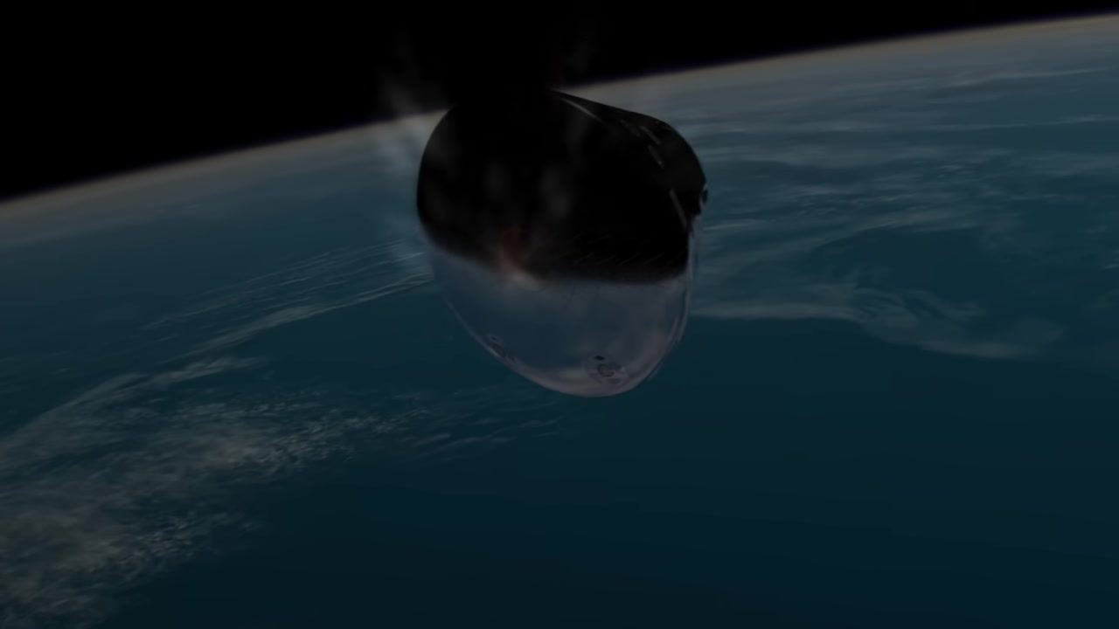
Caption: Orion capsule begins re-entry into Earth's atmosphere, heat shield facing forward.
[0:06:14]
Caption: Orion capsule surrounded by plasma and heat as it descends through the atmosphere.
[0:06:16]
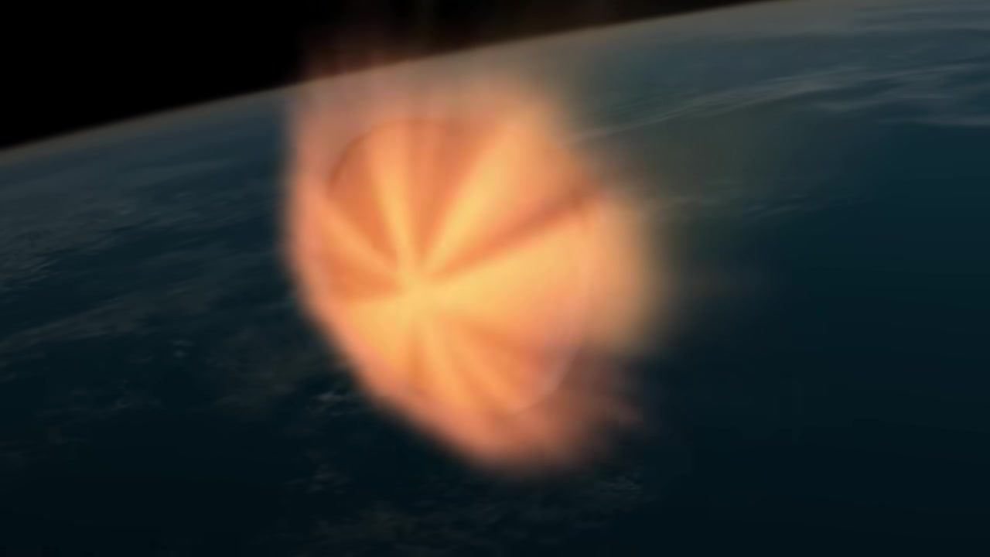
Caption: Orion capsule enveloped in a bright plasma sheath during peak re-entry heating.
[0:06:25]
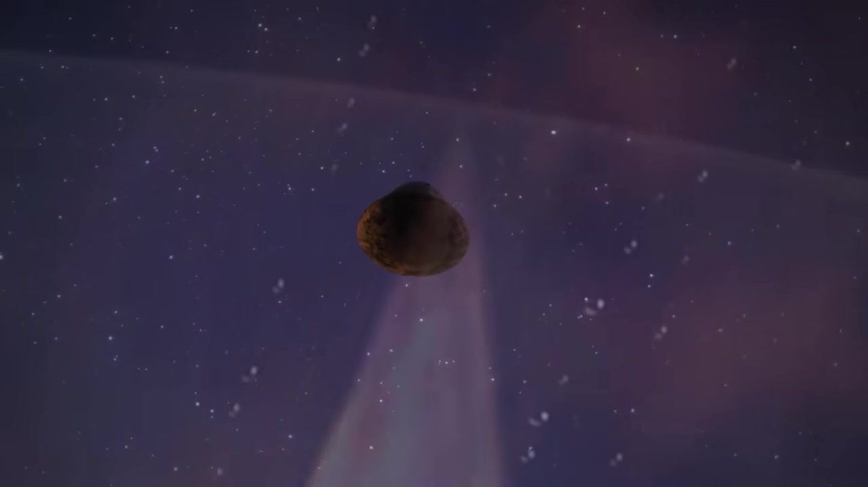
Caption: Orion capsule, scorched and darkened, falling through the upper atmosphere with stars and streaks in the background.
[0:06:27]
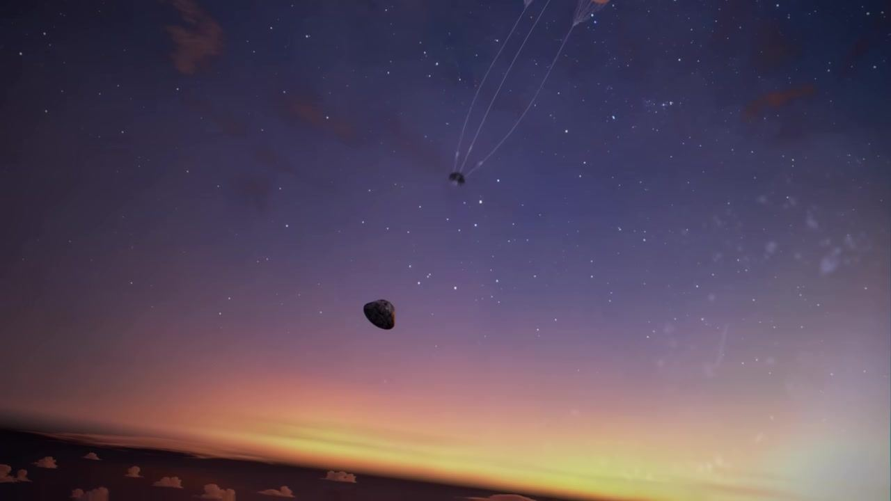
Caption: Orion capsule descending against a twilight sky, stars visible, above clouds and horizon.
[0:06:29]
Caption: Orion capsule with faint trails as parachutes begin to deploy against a twilight sky with stars.
[0:06:29]
Caption: Orion capsule with three small parachutes deployed, visible as orange dots at the end of long lines, twilight sky and stars.
[0:06:30]
Caption: Orion capsule below three small deployed parachutes, one object separating above, twilight sky and stars.
[0:06:32]
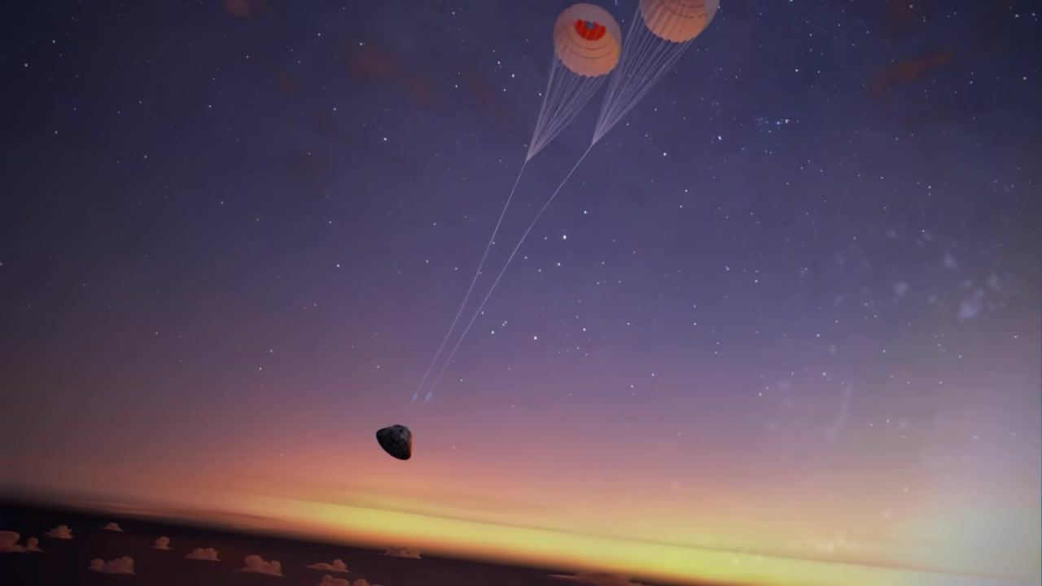
Caption: Orion capsule descending with two larger orange-and-white parachutes fully deployed, twilight sky and stars.
[0:06:33]
Caption: Orion capsule with two large orange-and-white parachutes open above, twilight sky and stars.
[0:06:33]
Caption: Orion capsule with two large orange-and-white parachutes, lines taut, twilight sky and stars.
[0:06:34]
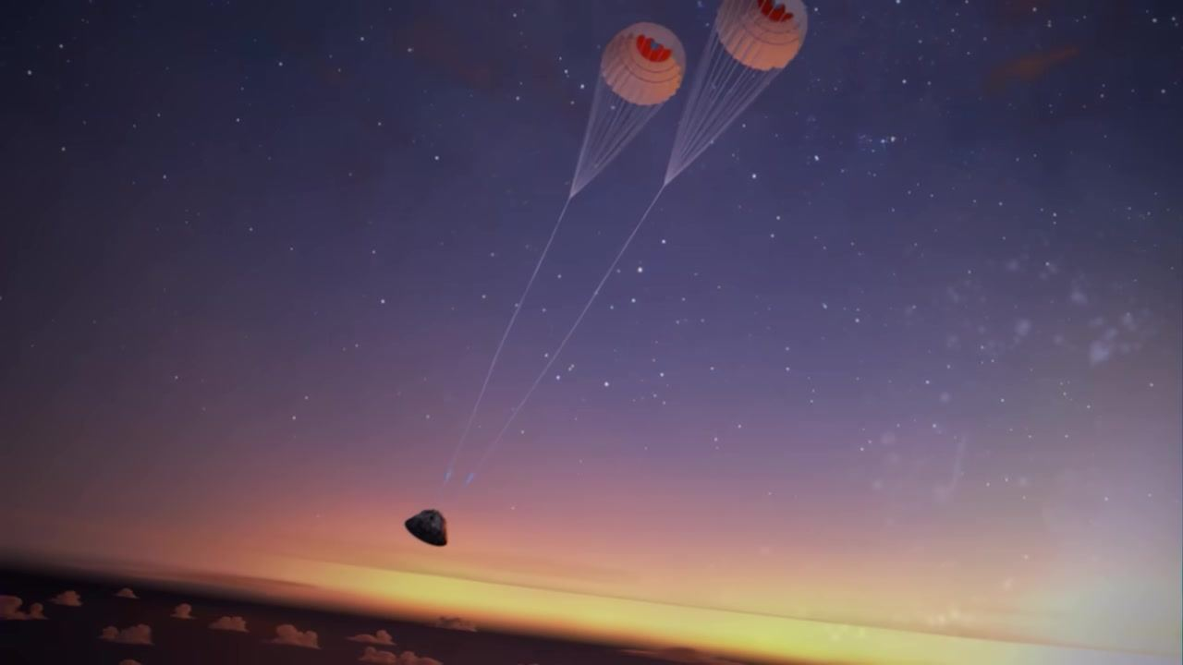
Caption: Orion capsule with two large orange-and-white parachutes, descending toward the ocean at sunrise.
[0:06:34]
Caption: Orion capsule with two large orange-and-white parachutes, closer to the ocean, sunrise on the horizon.
[0:06:36]
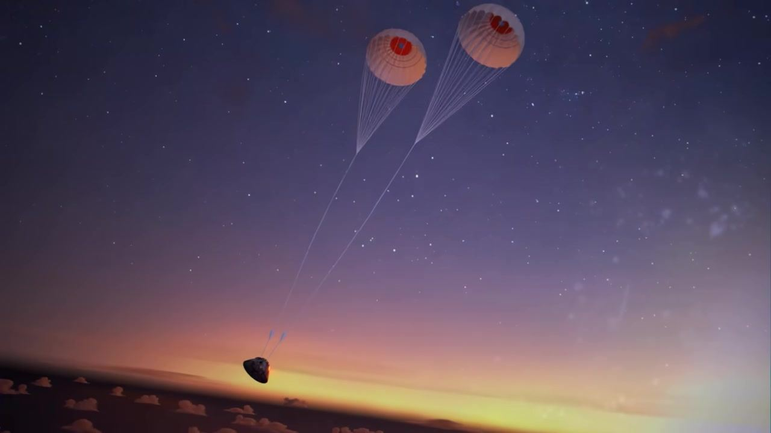
Caption: Orion capsule with two large orange-and-white parachutes, low over the ocean, sunrise and clouds visible.
[0:06:36]
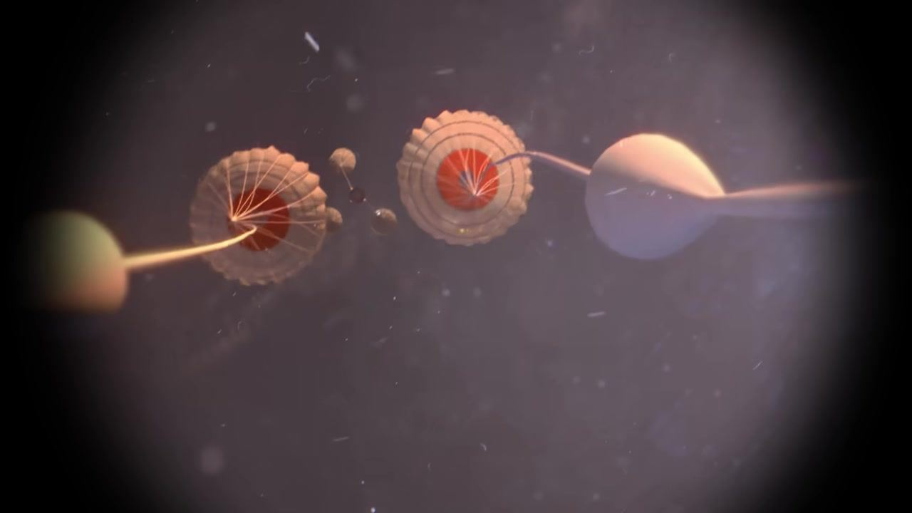
Caption: Two large orange-and-white parachutes with pilot chutes and lines visible, viewed from above, twilight sky.
[0:06:38]
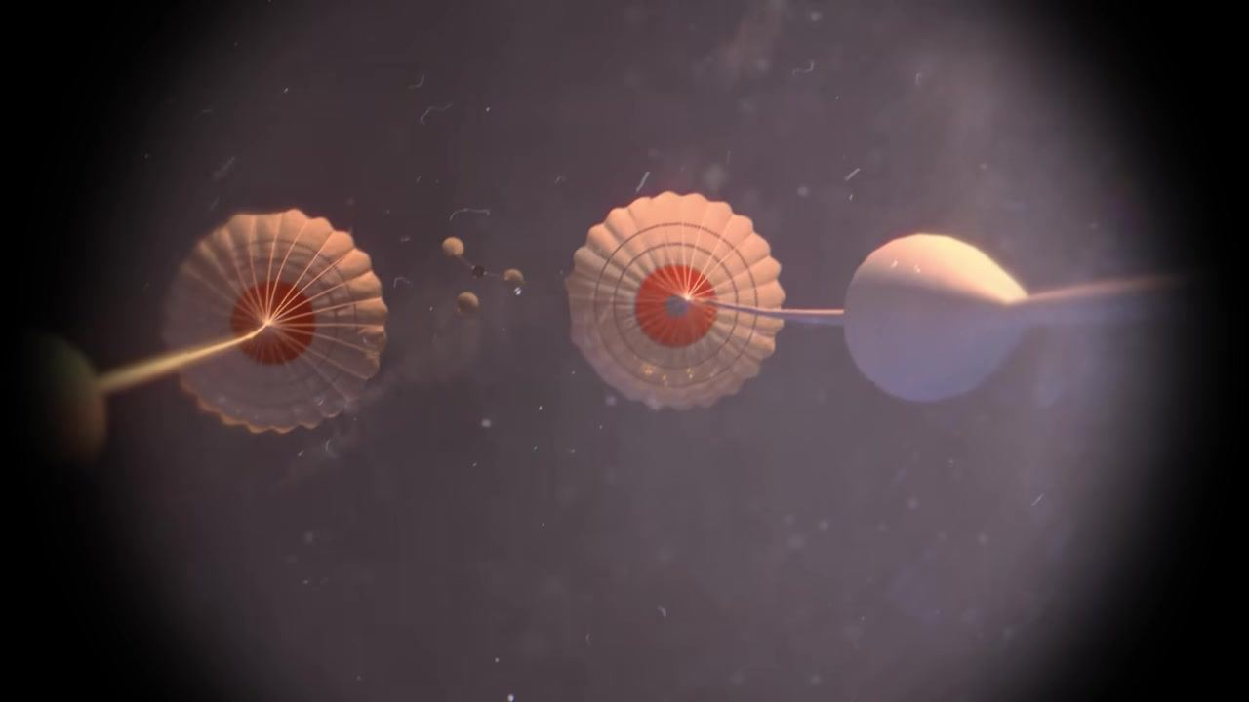
Caption: Two large orange-and-white parachutes with pilot chutes and lines, viewed from above, twilight sky.
[0:06:39]
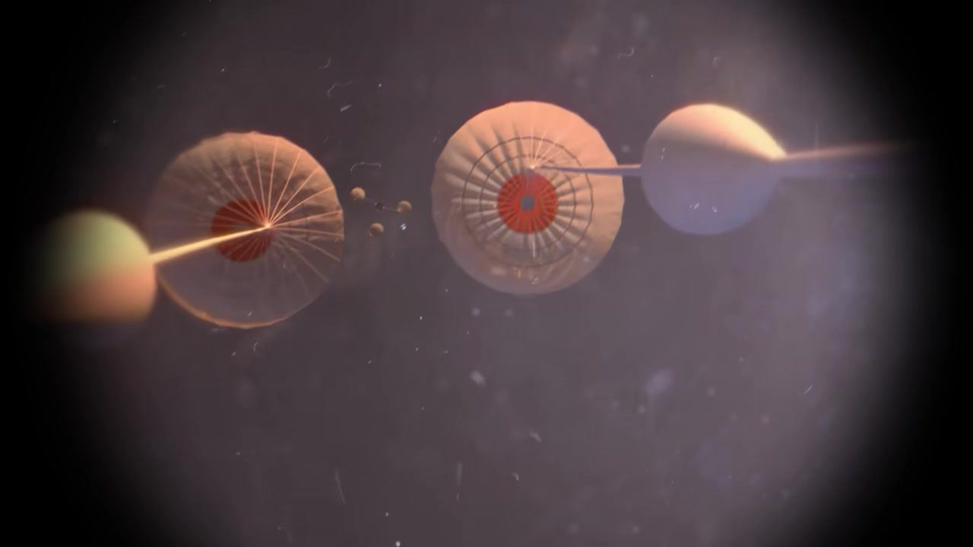
Caption: Two large orange-and-white parachutes with pilot chutes and lines, viewed from above, twilight sky.
[0:06:40]
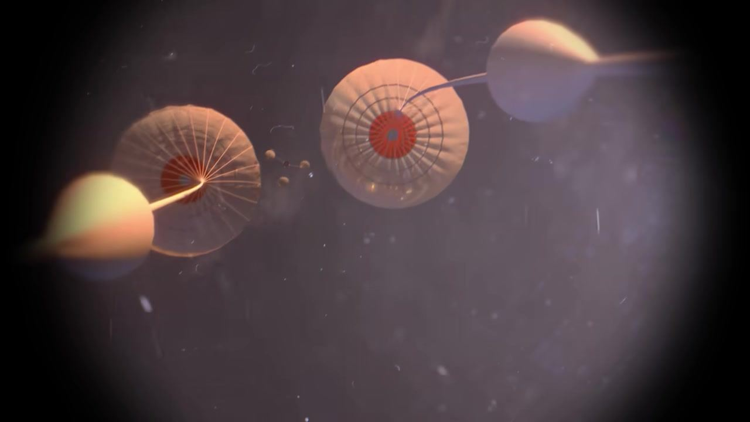
Caption: Two large orange-and-white parachutes with pilot chutes and lines, viewed from above, twilight sky.
[0:06:40]
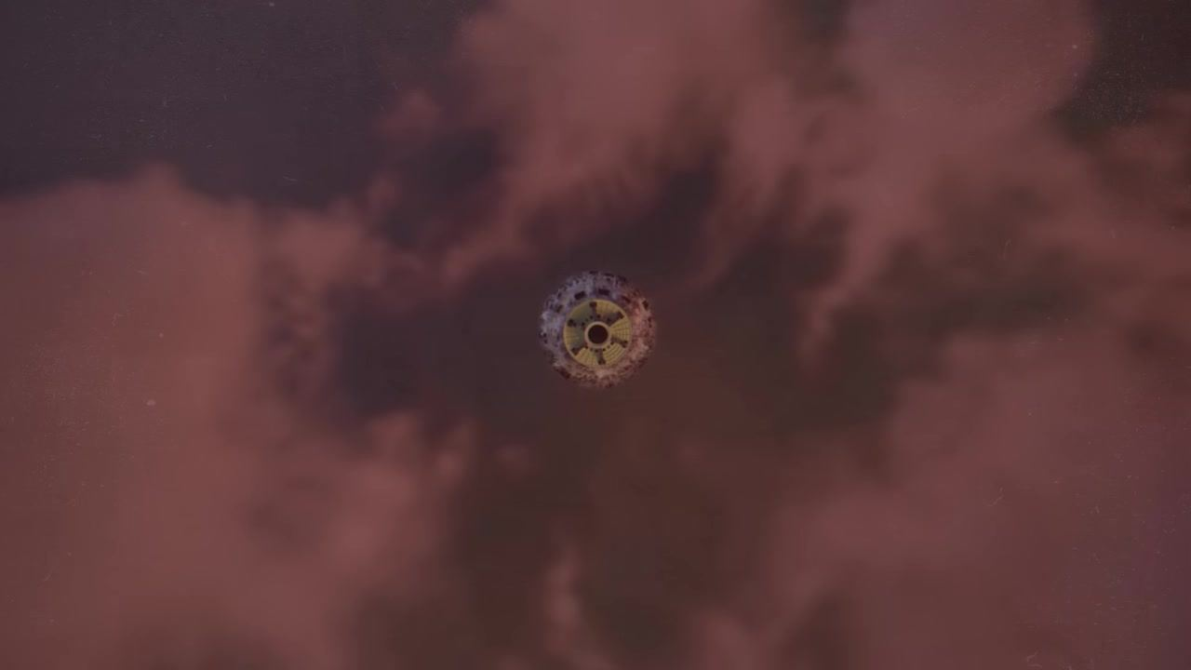
Caption: Orion capsule viewed from below against reddish clouds, no parachutes visible.
[0:06:42]
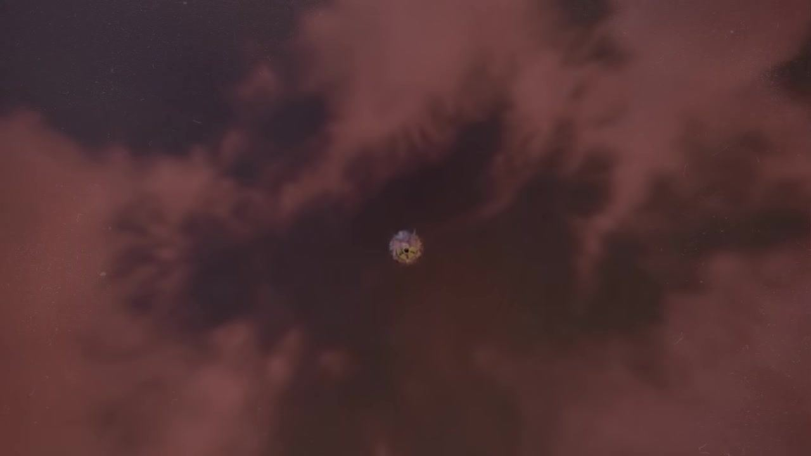
Caption: Orion capsule viewed from below, smaller in frame, reddish clouds in background, no parachutes visible.
[0:06:44]
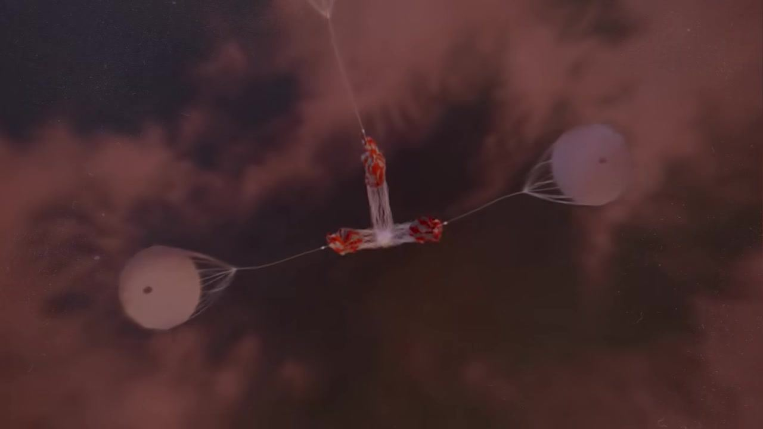
Caption: Three pilot chutes deployed, viewed from below, reddish clouds in background.
[0:06:46]
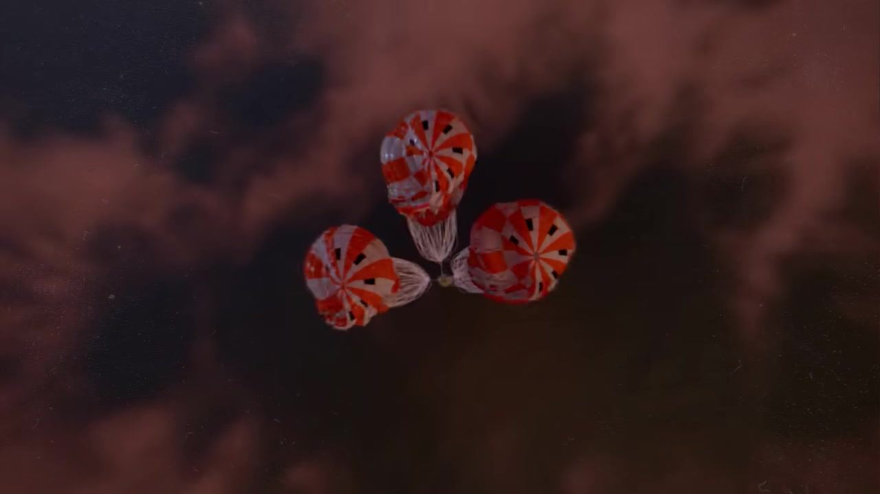
Caption: Three orange-and-white main parachutes beginning to inflate, viewed from below, reddish clouds in background.
[0:06:48]
Caption: Three fully inflated orange-and-white main parachutes, viewed from below, reddish clouds in background.
[0:06:50]
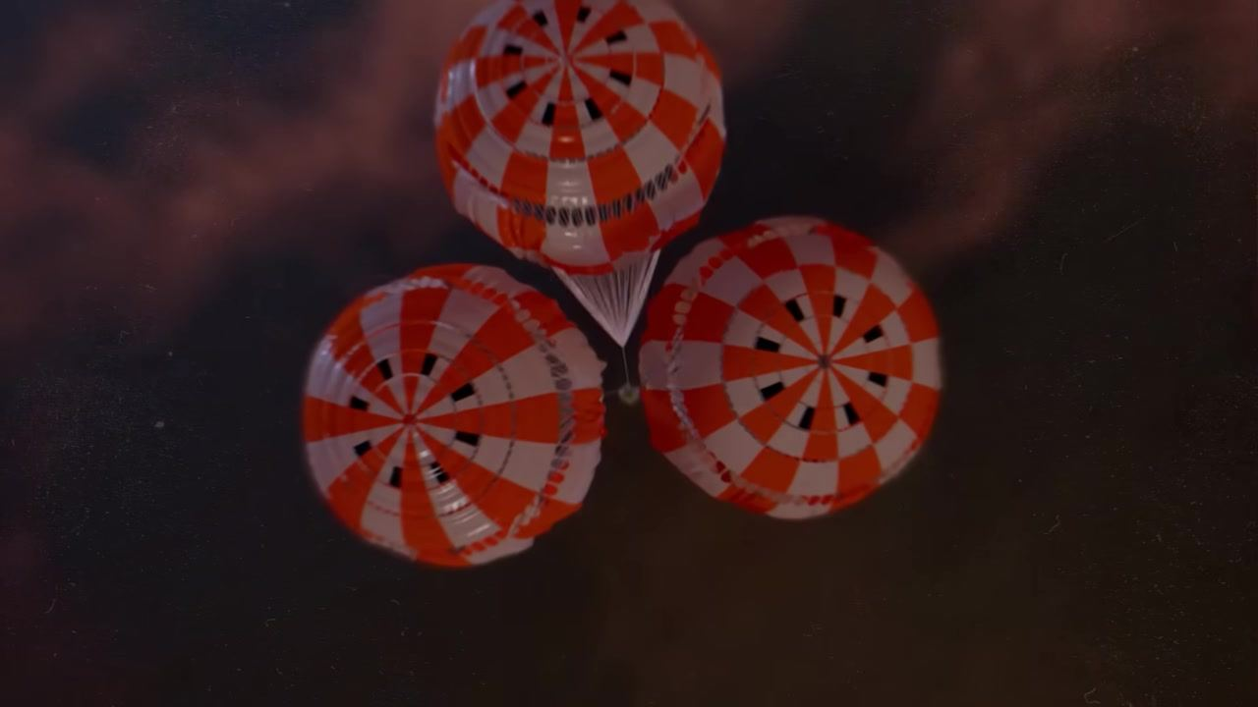
Caption: Three fully inflated orange-and-white main parachutes, close-up from below, reddish clouds in background.
[0:06:52]
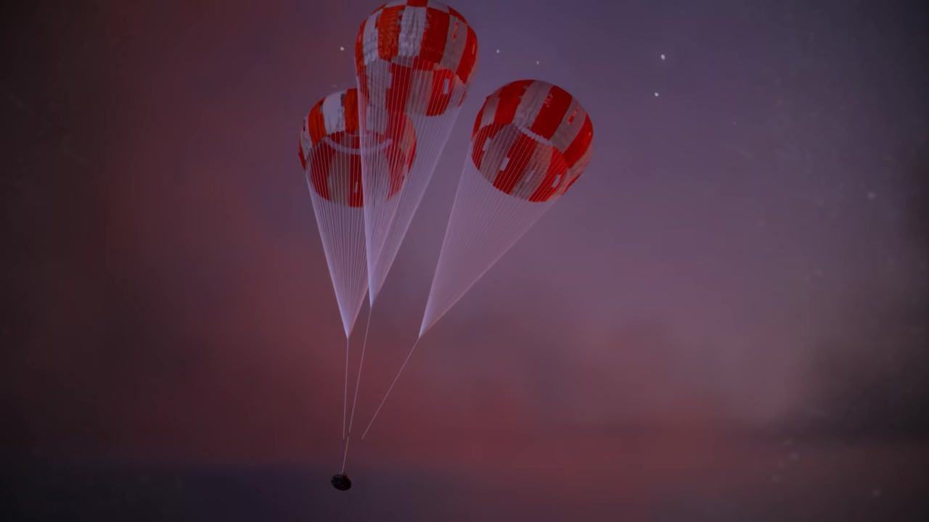
Caption: Three fully inflated orange-and-white main parachutes, capsule descending toward ocean, twilight sky.
[0:06:54]
Caption: Three fully inflated orange-and-white main parachutes, capsule closer to ocean, twilight sky.
[0:06:56]
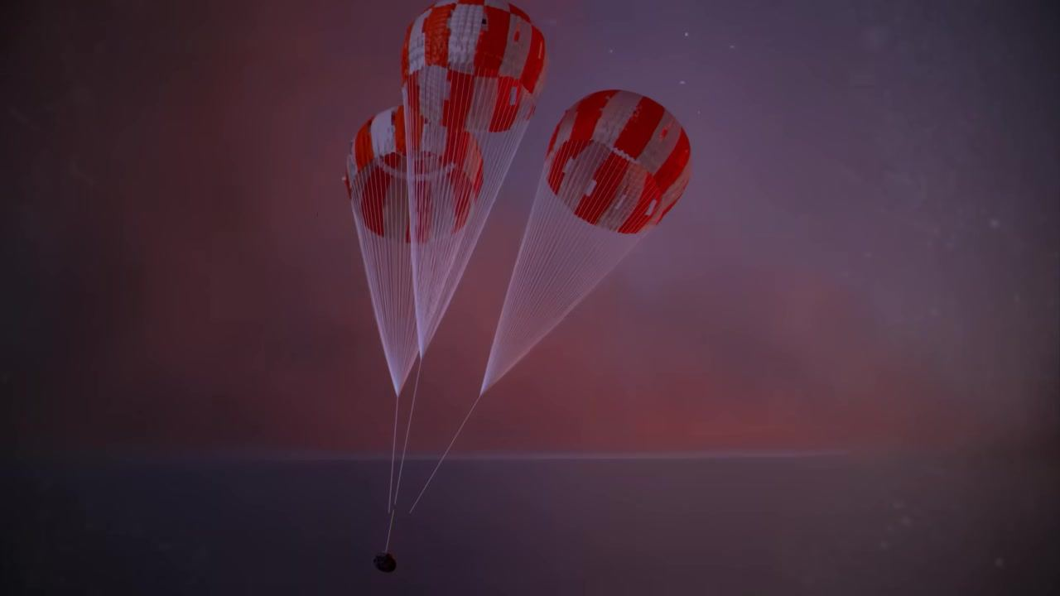
Caption: Three fully inflated orange-and-white main parachutes, capsule just above ocean surface, twilight sky.
[0:06:58]
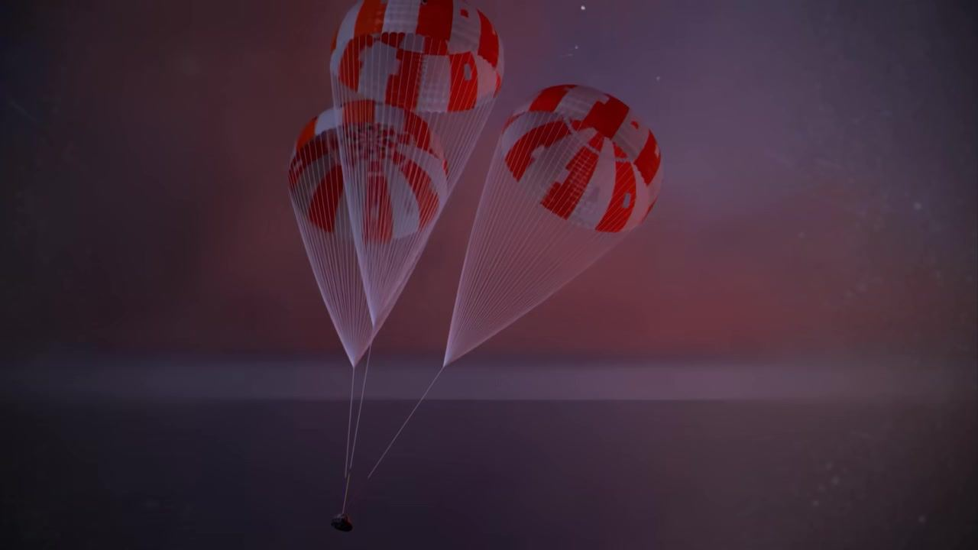
Caption: Three fully inflated orange-and-white main parachutes, capsule about to touch ocean, twilight sky.
[0:07:00]
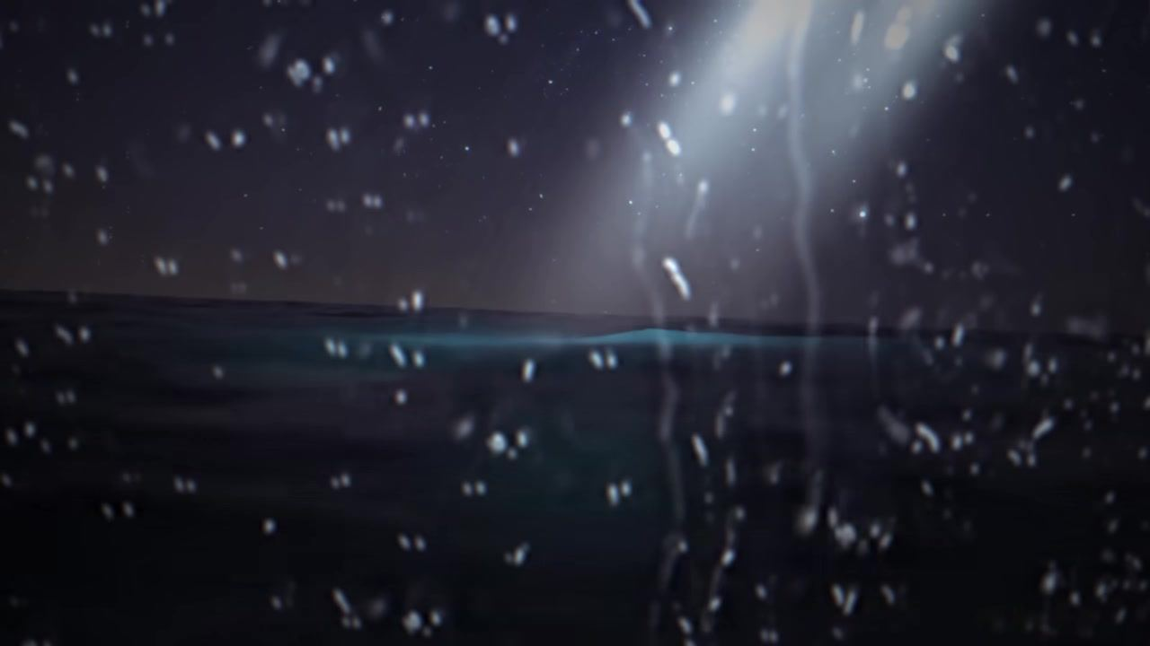
Caption: Ocean surface at night, splash and water droplets in foreground, searchlight beam.
[0:07:01]
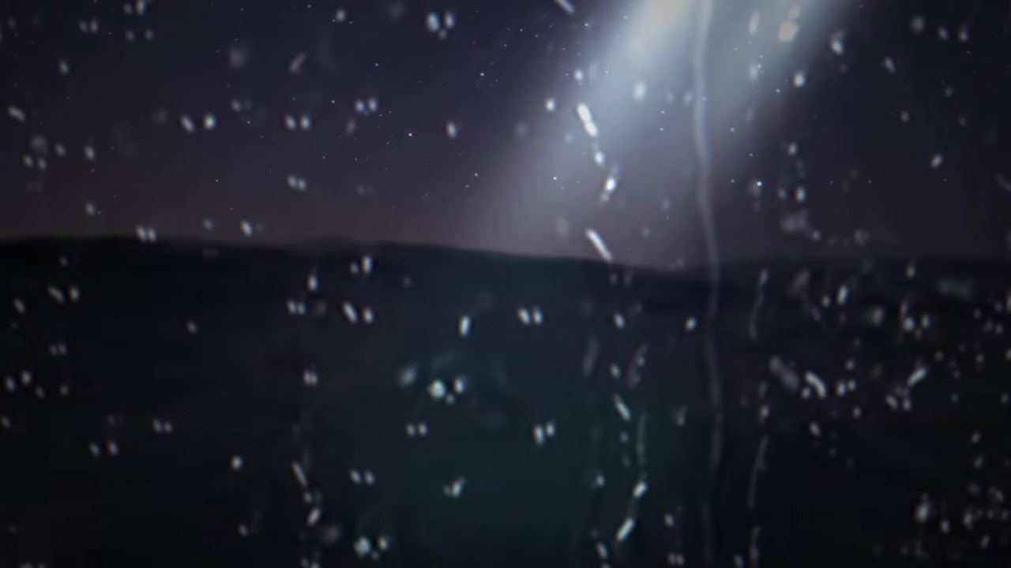
Caption: Ocean surface at night, water droplets in foreground, searchlight beam.
[0:07:01]

Caption: Underwater view, blue-tinted, surface line visible, dark above.
[0:07:03]

Caption: Underwater view, blue-tinted, surface line visible, darker above.
[0:07:03]

Caption: Underwater view, blue-tinted, mostly dark, faint surface line.
[0:07:04]
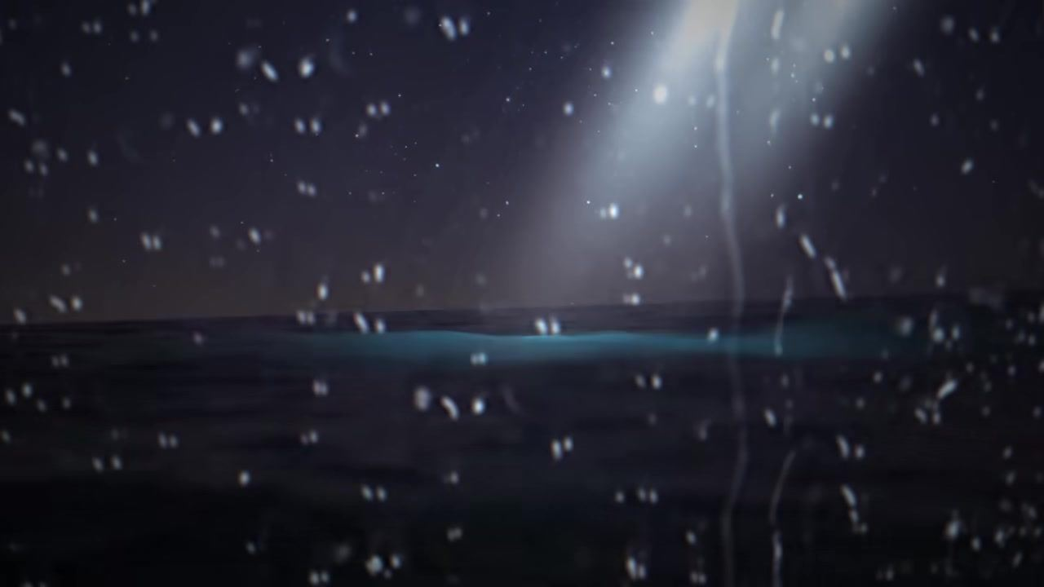
Caption: Ocean surface at night, water droplets in foreground, searchlight beam.
[0:07:05]
Caption: Capsule splashing into ocean at night, water spray and droplets, searchlight beam, colored parachute lines visible.
[0:07:05]
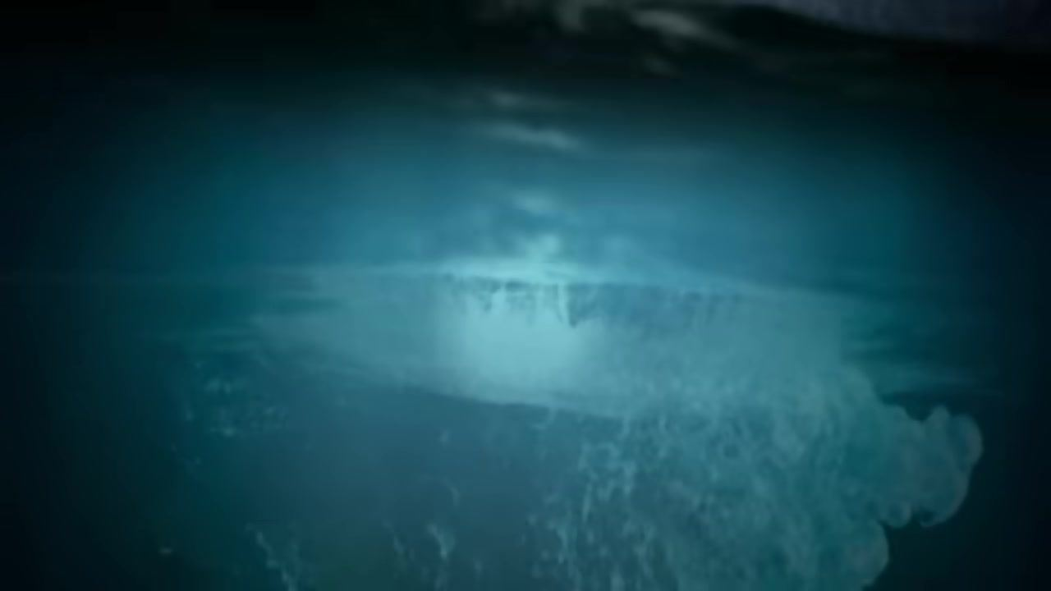
Caption: Underwater view, blue-tinted, capsule entering water, splash and bubbles visible.
[0:07:07]

Caption: Underwater view, blue-tinted, bubbles rising, surface disturbed above.
[0:07:09]

Caption: Capsule floating in ocean at night, water splashing, searchlight beam, droplets on lens.
[0:07:11]

Caption: Capsule floating in ocean at night, illuminated by searchlight, droplets on lens.
[0:07:12]

Caption: Capsule floating in ocean at night, illuminated by searchlight, parachute canopy above, droplets on lens.
[0:07:13]
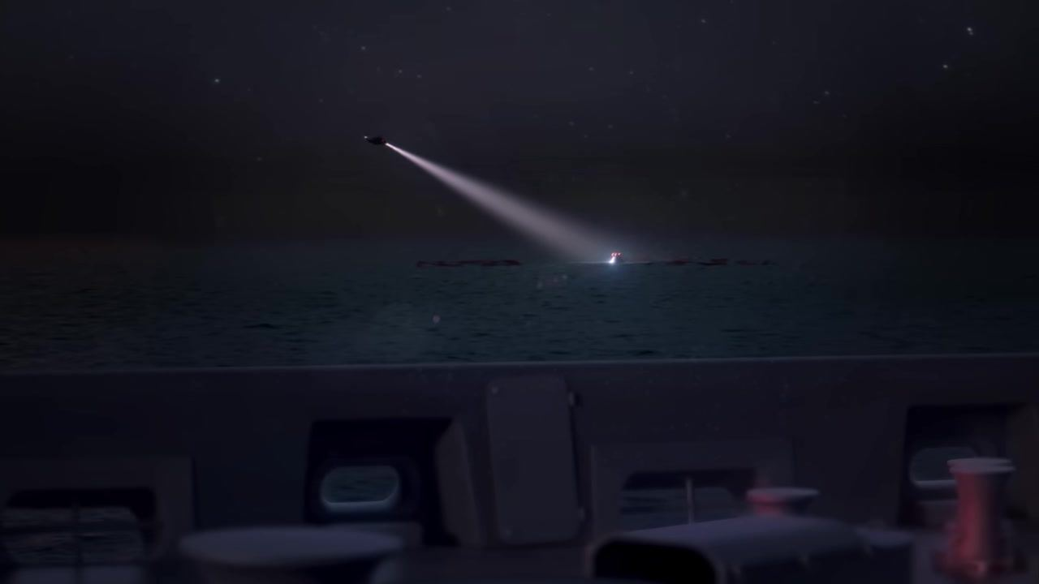
Caption: Distant view from ship, helicopter searchlight illuminating capsule in ocean at night, parachutes floating on water.
[0:07:14]
Caption: Distant view from ship, helicopter searchlight illuminating capsule in ocean at night, parachutes floating on water.
[0:07:16]
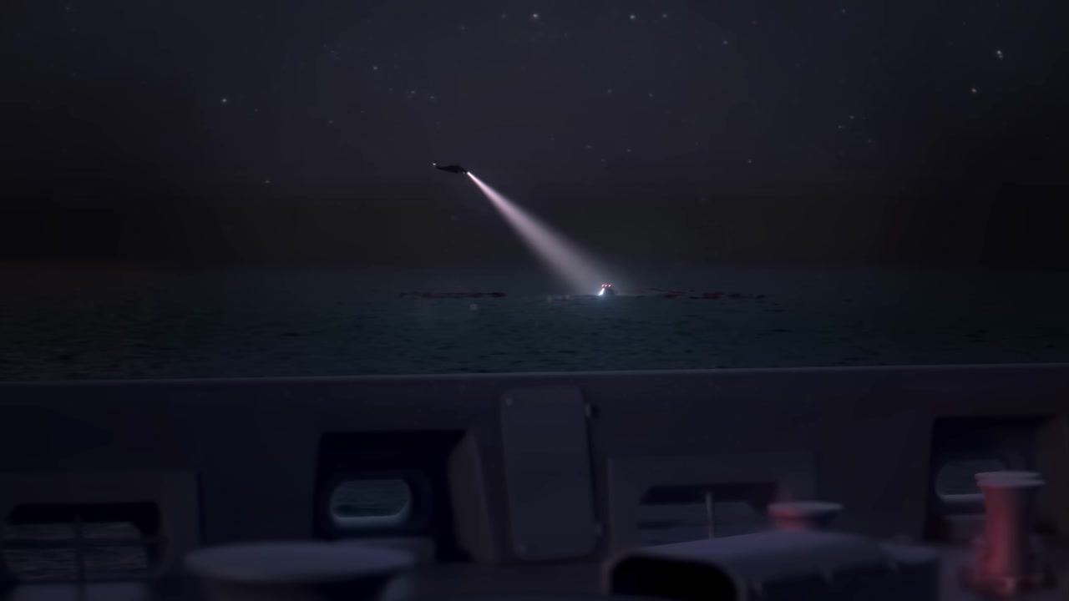
Caption: Distant view from ship, helicopter searchlight illuminating capsule in ocean at night, parachutes floating on water.
[0:07:18]
Caption: Distant view from ship, helicopter searchlight illuminating capsule in ocean at night, parachutes floating on water.
[0:07:24]
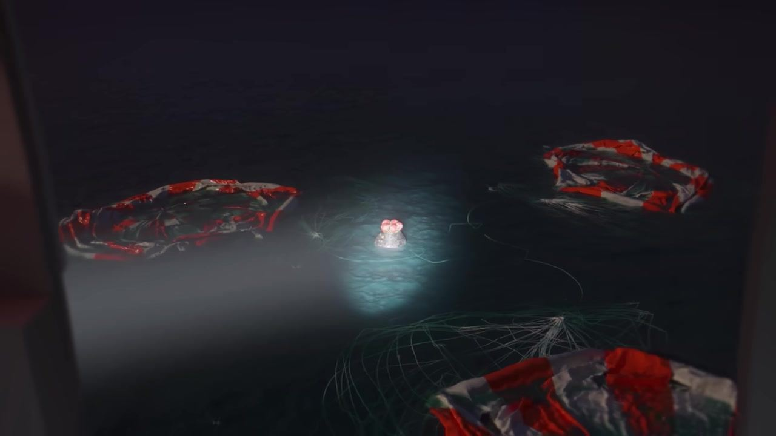
Caption: Close view from ship, capsule floating in ocean at night, illuminated by searchlight, three large red-and-white parachutes floating nearby, parachute lines visible.
[0:07:35]
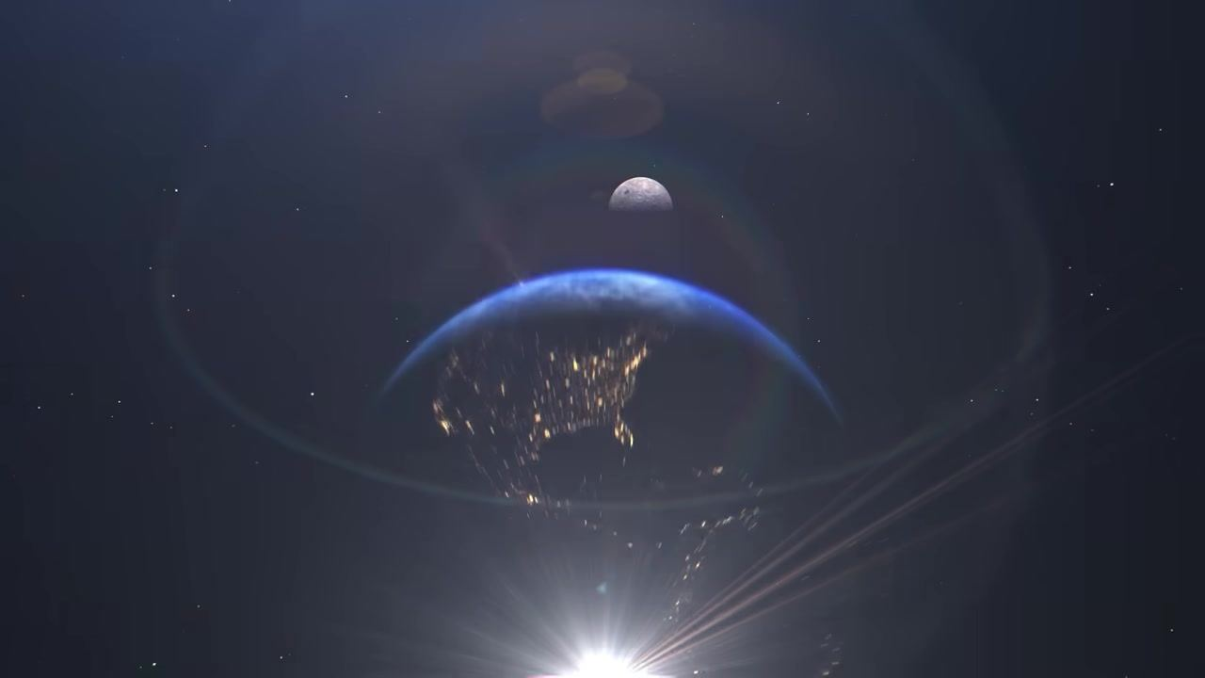
Caption: View of Earth from space, North America illuminated at night, Moon above horizon, bright light flare at bottom.
[0:07:36]
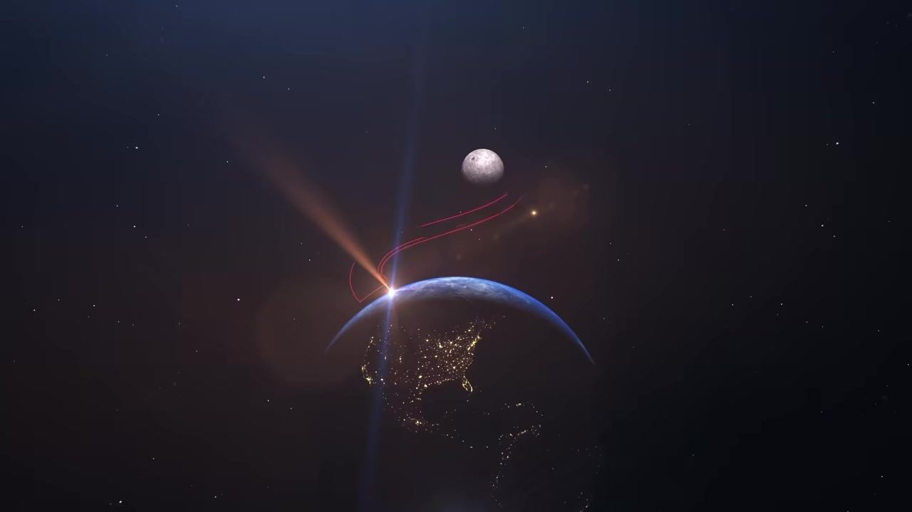
Caption: View of Earth from space, North America illuminated at night, Moon above horizon, red trajectory lines curve from Earth toward Moon.
[0:07:37]

Caption: Artemis program logo, stylized "A" with red swoosh and gray circle, blue arc below, "ARTEMIS" text, faint Earth lights in background.
[0:07:37]

Caption: Artemis program logo, stylized "A" with red swoosh and gray circle, blue arc below, "ARTEMIS" text, star field background.
[0:07:39]

Caption: NASA logo, blue circle with white "NASA" text and red swoosh, star field background.
[0:07:43]
Caption: NASA logo, blue circle with white "NASA" text and red swoosh, star field background.
[0:07:44]
Caption: Black screen.

