How to Build a Chain in Workiva: Creating a Basic SFTP Chain in WData
This guide walks you through how to build a chain in Workiva WData that downloads a file over SFTP, creates it within Workiva, and imports it into an existing table. By the end, you will have a working chain that you can publish, execute, and monitor.

Prerequisites
- Access to your Workiva workspace.
- A pre-configured SFTP connector (for example, an AWS-based connector).
- An existing Workiva table where the imported data will land.
- The Table ID of that existing table, available from its URL.

Step 1: Log in to the Workiva workspace
Open your browser and navigate to your Workiva workspace. Make sure you are on the Chains interface, which lists all available chains in your environment.
The interface displays columns such as Name, Last Updated, BizApps, and Actions. You may see example chains already listed, such as "Ayudatek end to end demo Chain," "Delete Old Data," "Demo," or "SFTP Chain."
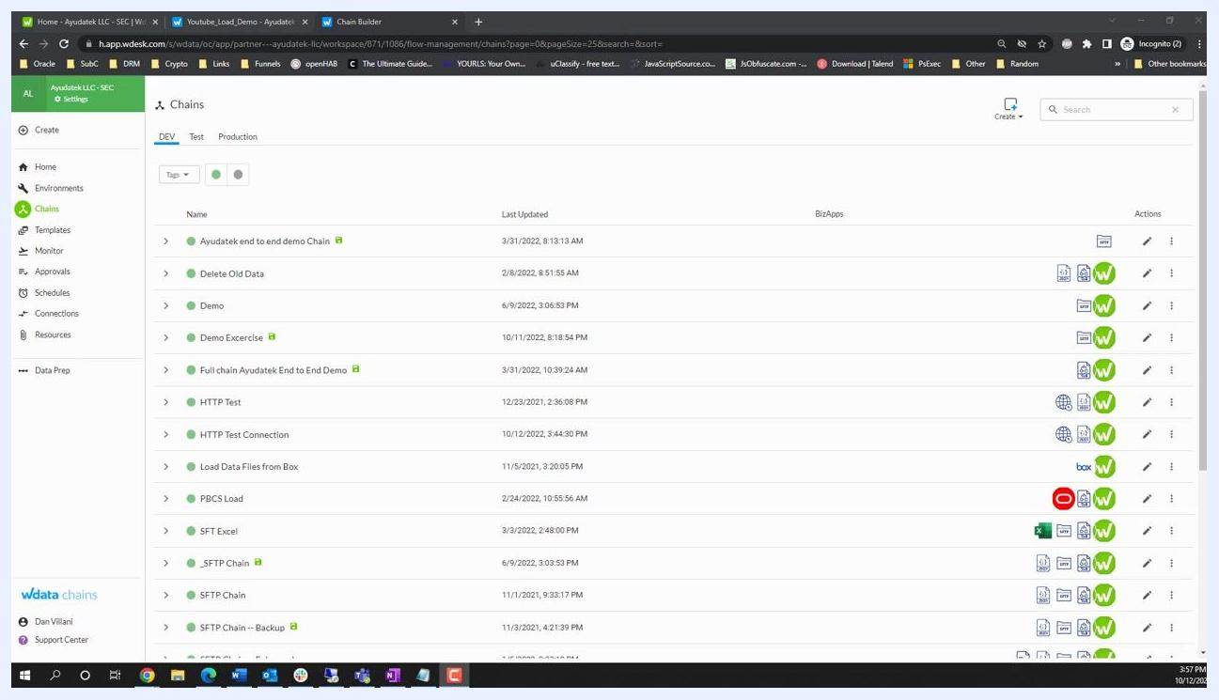
Chains interface showing a list of existing chains, a navigation menu on the left, and options to create a new chain

Step 2: Initiate a new chain
Click the Create button at the top right of the Chains interface, then select Create Chain from the dropdown menu.
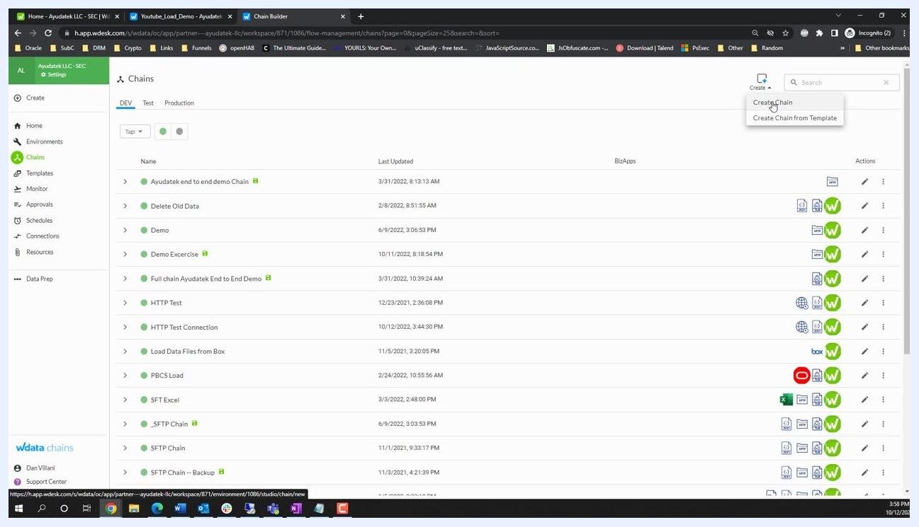
Cursor hovering over "Create" with a dropdown showing "Create Chain" and "Create Chain from Template"

Step 3: Name the new chain
In the Edit Chain window, enter a name for your new chain in the Name field—for example, Youtube Demo SFTP. You can optionally add a description.
You may also configure options such as Allow concurrent runs or Disable execution if your workflow requires them. Click SAVE at the top right to create the chain.
After saving, you are redirected to the chain editor. The workspace displays a blank chain with a START node and a prompt to use the menu to drag a node into the chain start. The left panel lists available BizApps, such as Box, Data Prep, Email, and SFTP Connector.
Edit Chain screen with "Youtube Demo SFTP" entered as the name and the SAVE button highlighted

Step 4: Add the SFTP connector to download a file
In the BizApps panel, locate and select the SFTP Connector. Under Operations, drag the Download File operation onto the chain canvas and connect it to the START node.
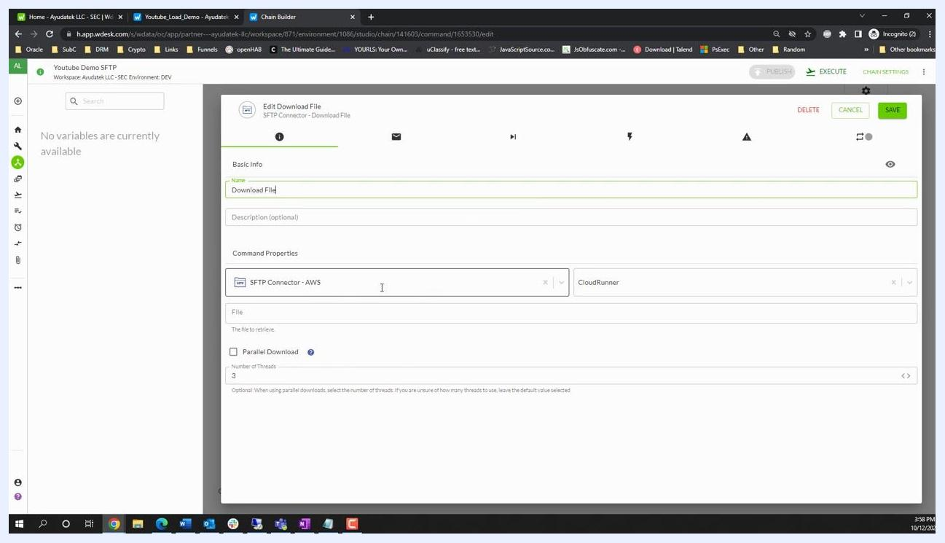
SFTP Connector operations panel, with the "Download File" operation dragged onto the chain canvas
It's good practice to use List Directory first when troubleshooting, but for this basic chain, you can proceed directly with Download File.

Step 5: Configure the Download File operation
Click the Download File node to open its properties. In the Edit Download File window, set the Name field to Download File.
Configure the following:
- SFTP Connector: Select your pre-configured connector (for example, SFTP Connector - AWS).
- CloudRunner: Select the appropriate runner if required.
- File: Enter the path of the file you want to download.
- Parallel Download: Optionally enable this and set the number of threads (default is 3).
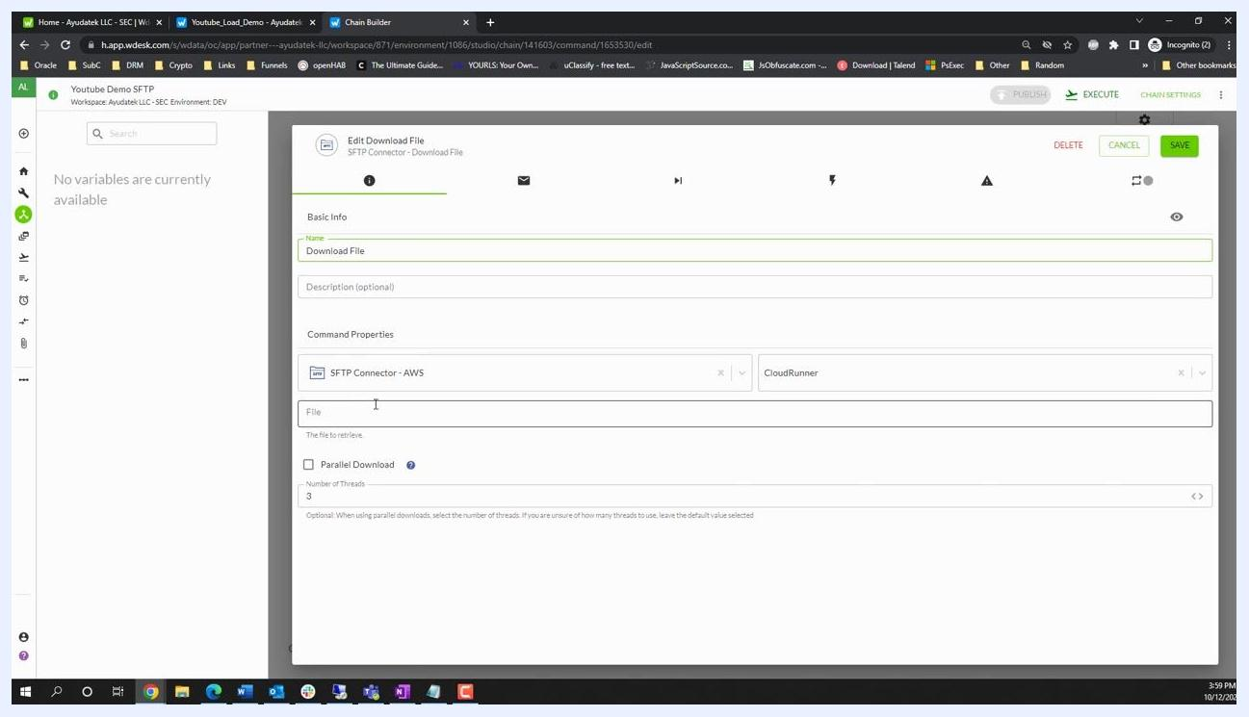
Edit Download File dialog with SFTP Connector selected and the file path field ready for input
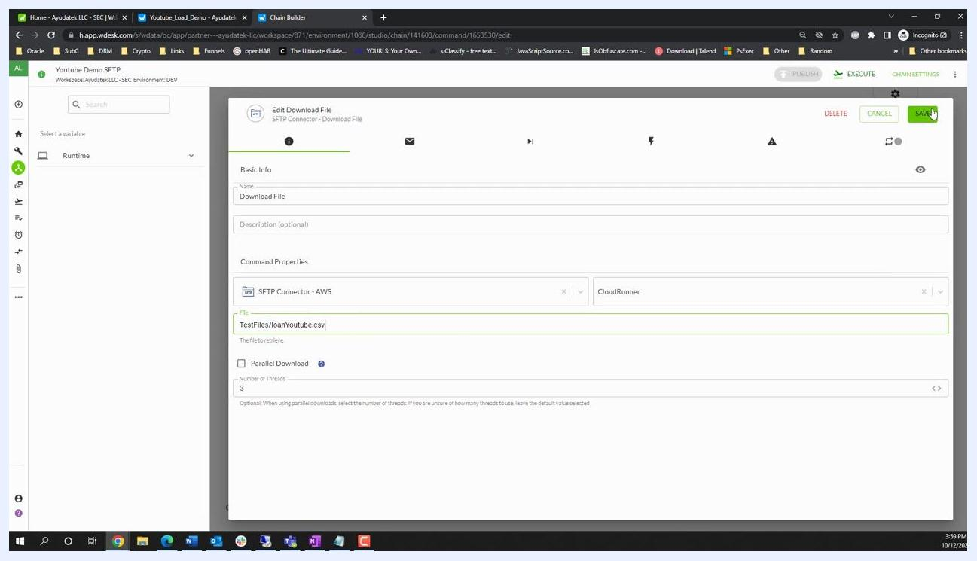
Edit Download File dialog with "TestFiles/loanYoutube.csv" entered and the SAVE button highlighted
Double-check that the File field contains the correct path for your test file. For example, update it to TestFiles/loanYoutube.csv if needed, then click SAVE at the top right to confirm your changes.

Step 6: Add the Create File step
This guide assumes a table already exists in Workiva for this workflow, so you don't need to create or configure a new one.
In the chain editor, locate the Create File operation under the Workiva BizApp in the left panel. Drag it onto the canvas and connect it after the Download File node, so the chain reads: START → Download File → Create File.
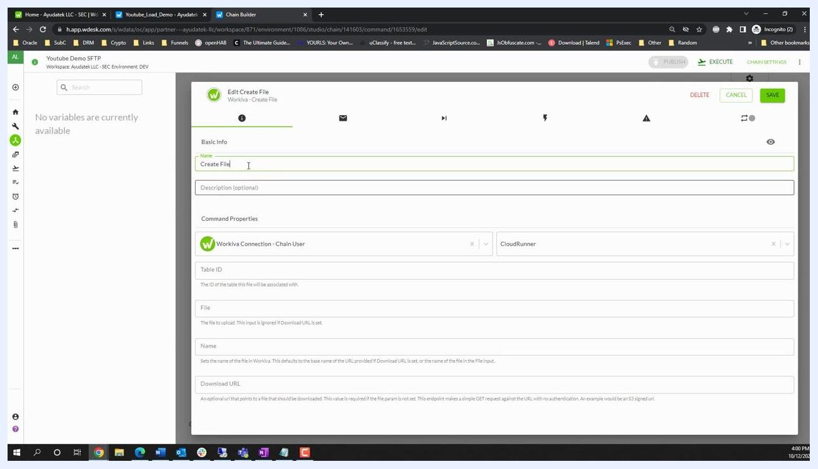
Chain editor showing the "Create File" node added after "Download File," with green link indicators

Step 7: Configure the Create File operation
Click the Create File node to open its configuration dialog, then fill out the following fields:
- Name: Enter Create File.
- Workiva Connection: Select the appropriate connection (for example, Chain User).
- CloudRunner: Select the runner if required.
- Table ID: Open your table in Workiva and copy the string that follows /tables/ in the URL (for example, 6562bb34305ae47a192a5a9f869229d).
- File: Select the output from the previous Download File step (for example, Downloaded File).
- Name: Enter the desired file name for upload, such as YouTubeDemoFile.csv.
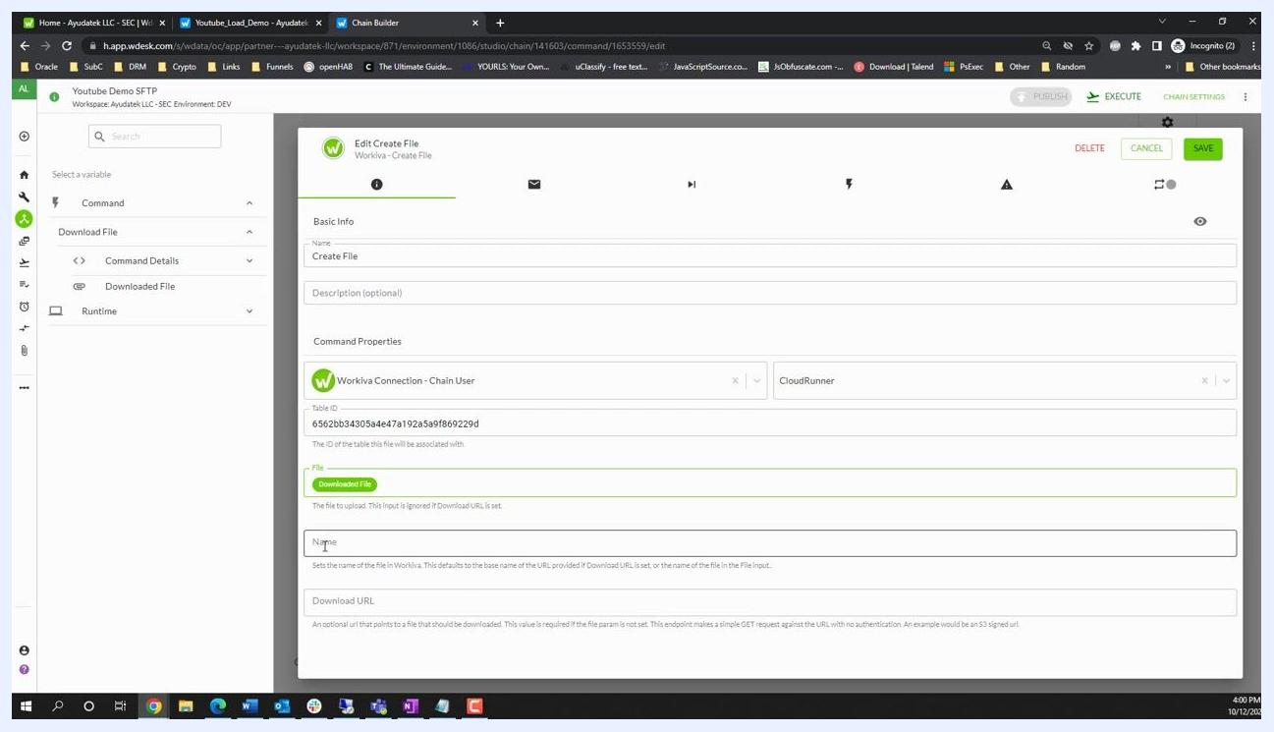
Edit Create File dialog with the Table ID, Downloaded File, and Name fields being filled in
Review all fields before saving:
- Name: Create File
- Workiva Connection: Chain User
- CloudRunner: selected as needed
- Table ID: 6562bb34305ae47a192a5a9f869229d
- File: Downloaded File
- Name: YoutubeDemoFile.csv
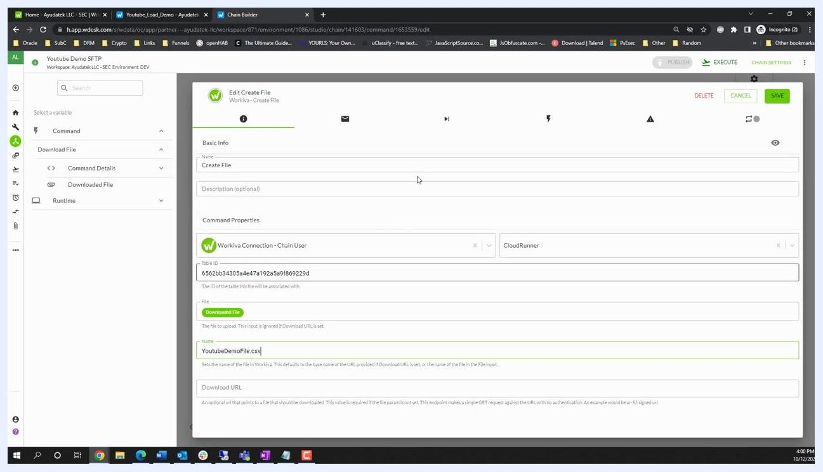
Edit Create File dialog with all fields filled in and the SAVE button highlighted
Click SAVE at the top right to confirm your configuration.

Step 8: Add and configure the Import File into Table step
Importing a file into a Workiva table is a two-step process: first you create the file in Workiva, then you import that created file into the table.
In the chain editor, drag the Import File into Table operation from the Workiva BizApp panel onto the canvas and connect it after the Create File node. Click the new node to open its configuration dialog and fill out the following fields:
- Name: Enter Import File into Table.
- Workiva Connection: Select Chain User.
- CloudRunner: Select as needed.
- Table ID: Paste 6562bb34305ae47a192a5a9f869229d.
- File ID: Set this to the output from the Create File step. Expand the Create File step in the variable selector, then under Result, select Id to use the file ID generated by the previous step.
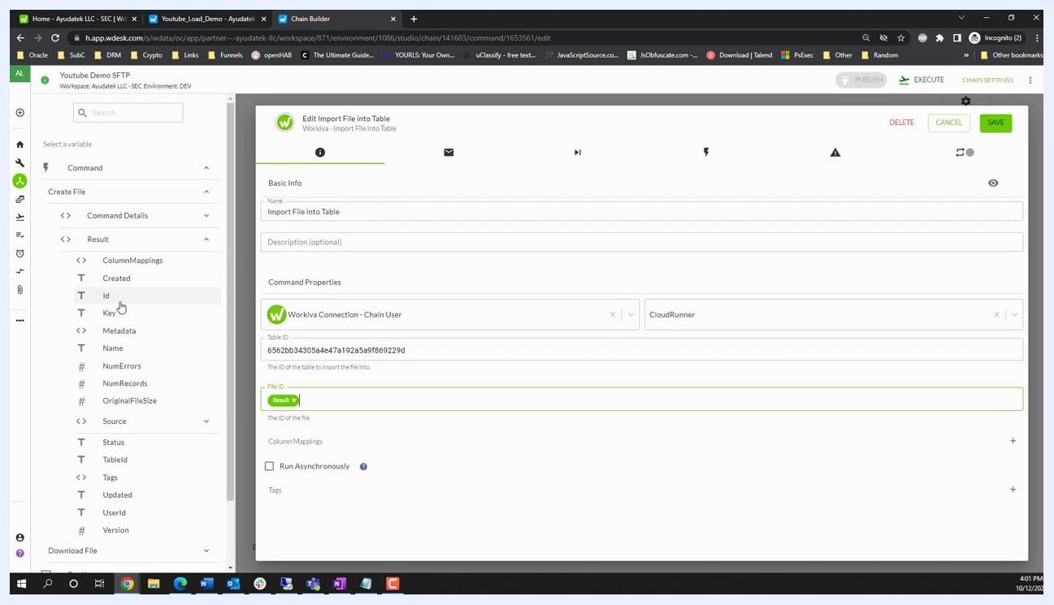
Edit Import File into Table dialog with Table ID and File ID fields, showing variable selection for the file ID
Click SAVE at the top right of the dialog to confirm your settings.

Step 9: Publish and execute the chain
Confirm your chain now shows the full sequence: START → Download File → Create File → Import File into Table. Click PUBLISH at the top right to publish your chain, then click EXECUTE to run it.
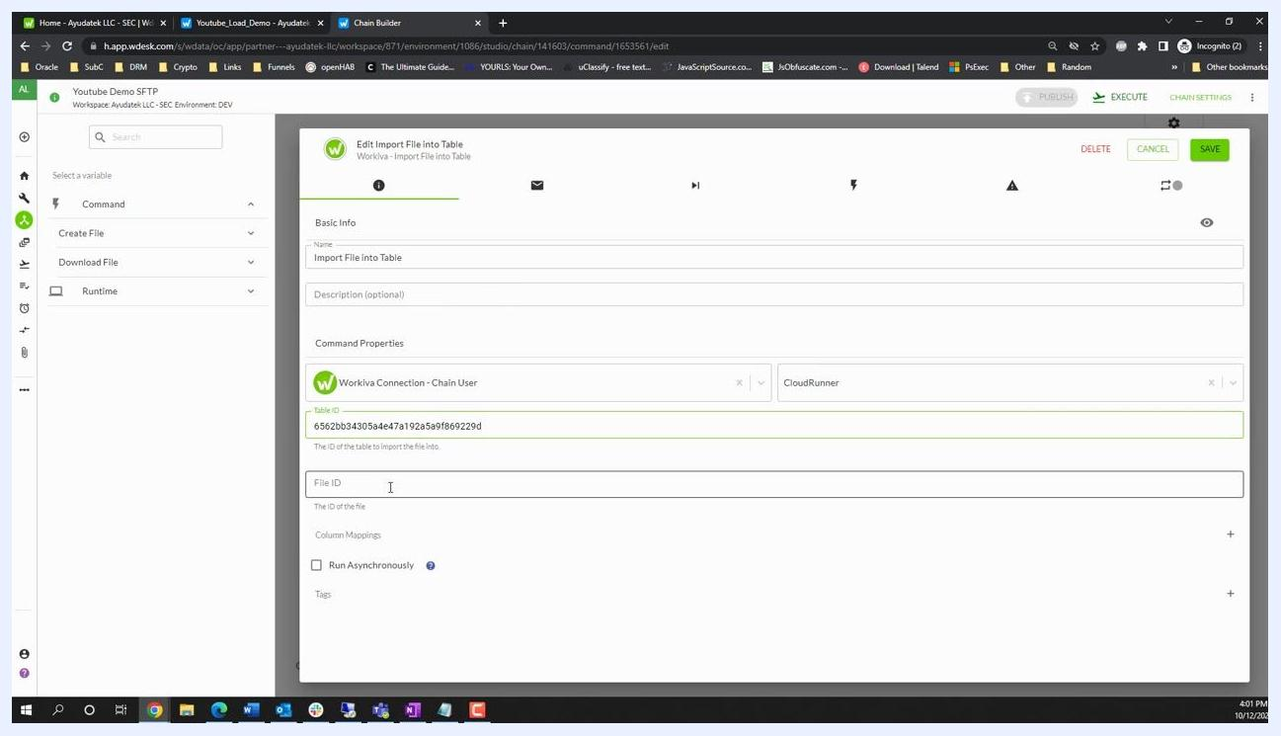
Chain editor with all three steps connected and the EXECUTE button highlighted

Step 10: Monitor chain execution status
Return to the Chain Monitor screen in Workiva and confirm that each step in your chain has completed successfully, indicated by a green checkmark next to Download File, Create File, and Import File into Table.
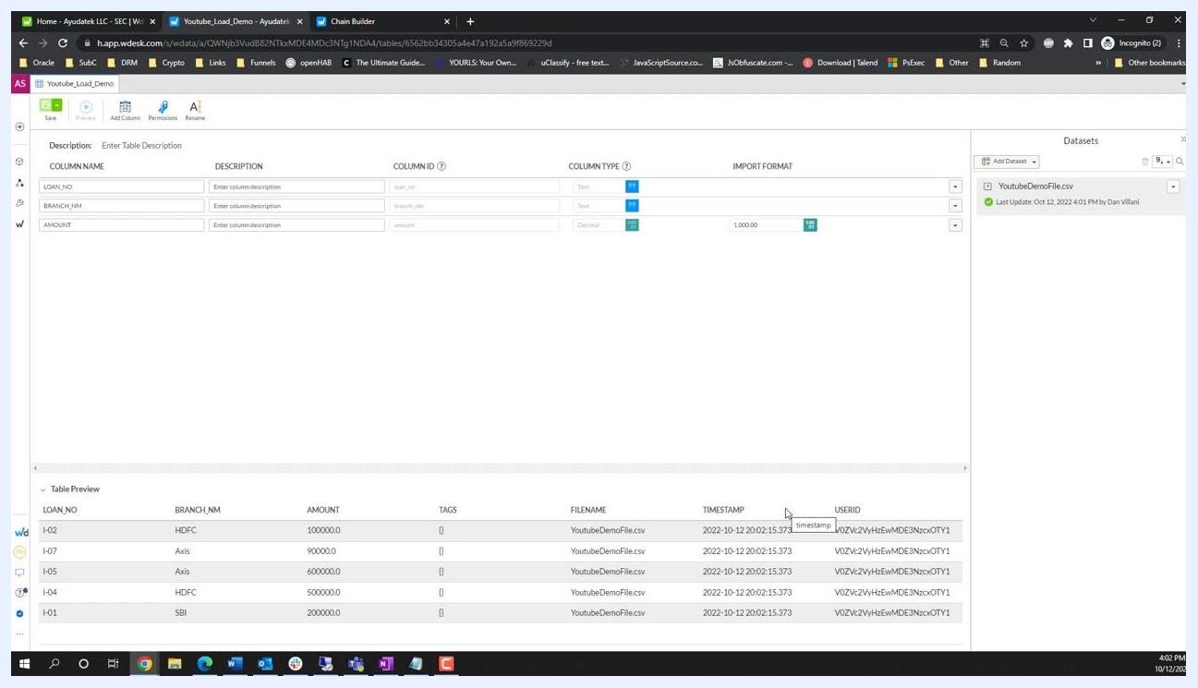
Chain monitor showing all steps with green checkmarks and run details
The run details show the chain name (Youtube Demo SFTP), who ran it, the start and end times, and the total duration of the run.

Step 11: Verify the file import in the table
Open your Workiva table and check the Datasets panel on the right. Confirm that YoutubeDemoFile.csv appears as a dataset and shows as loaded and available for use in the table.

Step 12: Preview the imported data
Navigate to your Workiva table where the file was imported, and in the Datasets panel, locate YoutubeDemoFile.csv. Click the dataset to preview its contents.
Workiva table editor showing columns LOAN_NO, BRANCH_NM, AMOUNT, and YoutubeDemoFile.csv as a loaded dataset
You should see columns such as LOAN_NO, BRANCH_NM, and AMOUNT, with LOAN_NO and BRANCH_NM set as Text and AMOUNT set as Decimal, formatted as 1,000.00.
Table preview showing sample data: LOAN_NO, BRANCH_NM, AMOUNT, and metadata columns
Expand the Table Preview section at the bottom of the screen to review the first few records and confirm the data imported correctly. Example records include:
- LOAN_NO: I-02, BRANCH_NM: HDFC, AMOUNT: 100000.0
- LOAN_NO: I-07, BRANCH_NM: Axis, AMOUNT: 90000.0
- LOAN_NO: I-05, BRANCH_NM: Axis, AMOUNT: 600000.0
- LOAN_NO: I-04, BRANCH_NM: HDFC, AMOUNT: 500000.0
- LOAN_NO: I-01, BRANCH_NM: SBI, AMOUNT: 200000.0
Additional metadata columns, such as TAGS, FILENAME, TIMESTAMP, and USERID, are also shown in the preview.

Best practices for production environments
- Before importing, check whether a file with the same name already exists in the table.
- If it exists, delete the old file before importing the new one.
- This ensures that daily or repeated imports always bring in the latest data.
- Consider implementing advanced features such as file existence checks and automated deletions for more robust production workflows.
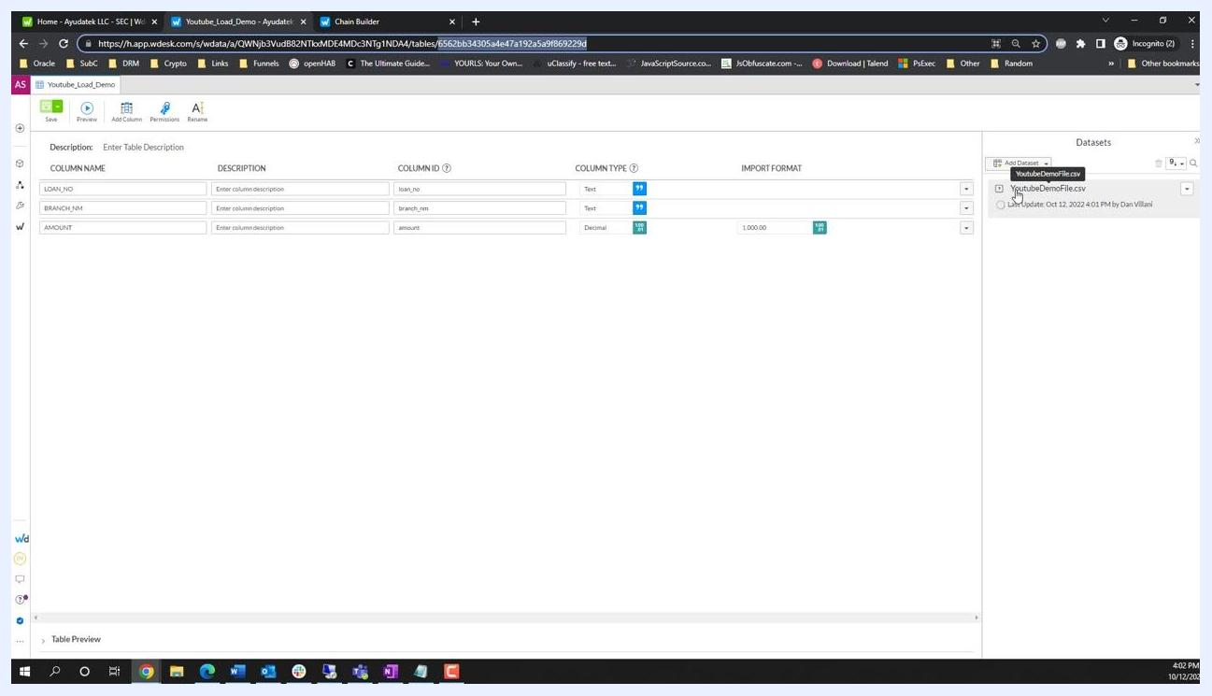
Workiva table editor showing YoutubeDemoFile.csv as a loaded dataset

Summary
You have now learned how to build a chain in Workiva WData from start to finish: downloading a file over SFTP, creating it in Workiva, and importing it into an existing table. Monitor your results after each run, and consider adding the production safeguards described above before relying on this chain for regular, repeated imports.

