How to Use Sick Time in Workday: Requesting, Tracking, and Cancelling Time Off
This guide walks you through how to use sick time in Workday, from opening the request form to confirming your submission. It also covers how to check the status of a pending request and how to cancel a time off entry if your plans change.

Prerequisites
- Access to your Workday account and dashboard.
- Awareness of your available sick time balance before submitting a request.

Requesting sick time off in Workday

1. Navigate to the Workday home page
Open Workday and confirm you are on the main dashboard. The dashboard displays sections such as "Hi There," "Awaiting Your Action," "Announcements," "Important Dates," and "Your Top Apps." Check the date shown in the top right corner to confirm you are viewing current information.
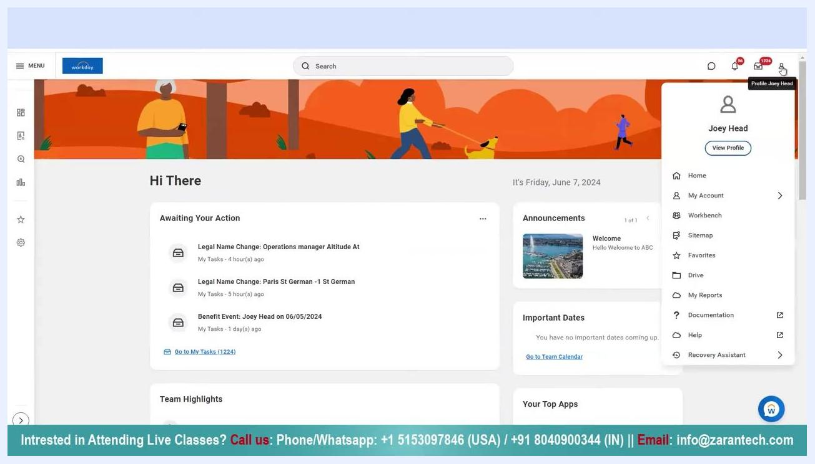
Workday dashboard showing a user greeting, action items, announcements, and navigation menu

2. Access your profile
Click your profile icon or name in the upper right corner. From the dropdown menu, select View Profile.
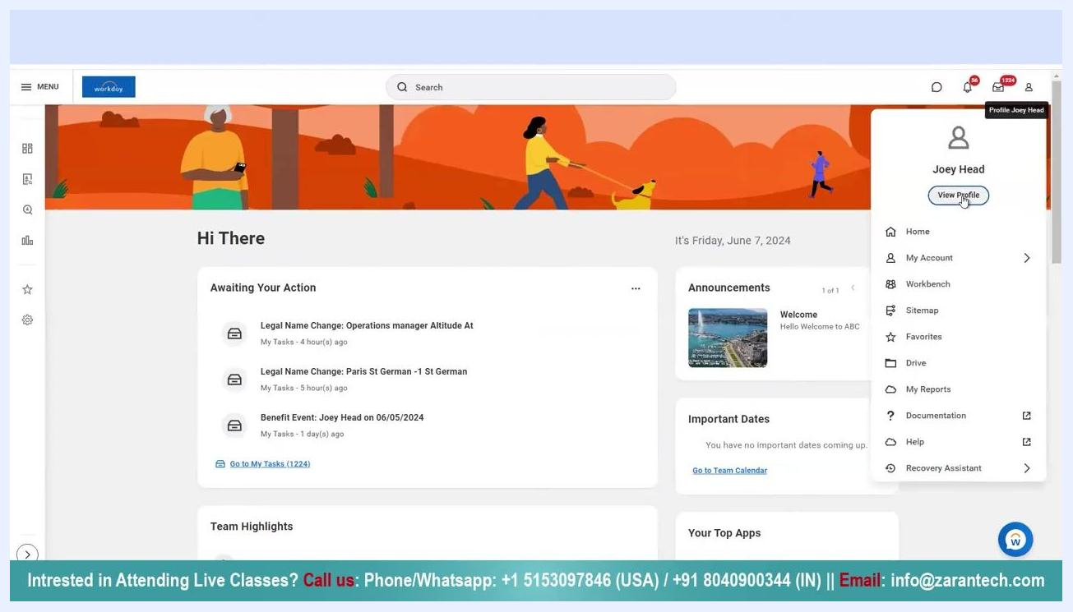
Profile dropdown menu open, with the cursor on 'View Profile' and the user name displayed

3. Open the Actions menu
On your profile page, locate the left sidebar and click the Actions button to open the actions menu. Scroll down until you find the Time and Leave section.
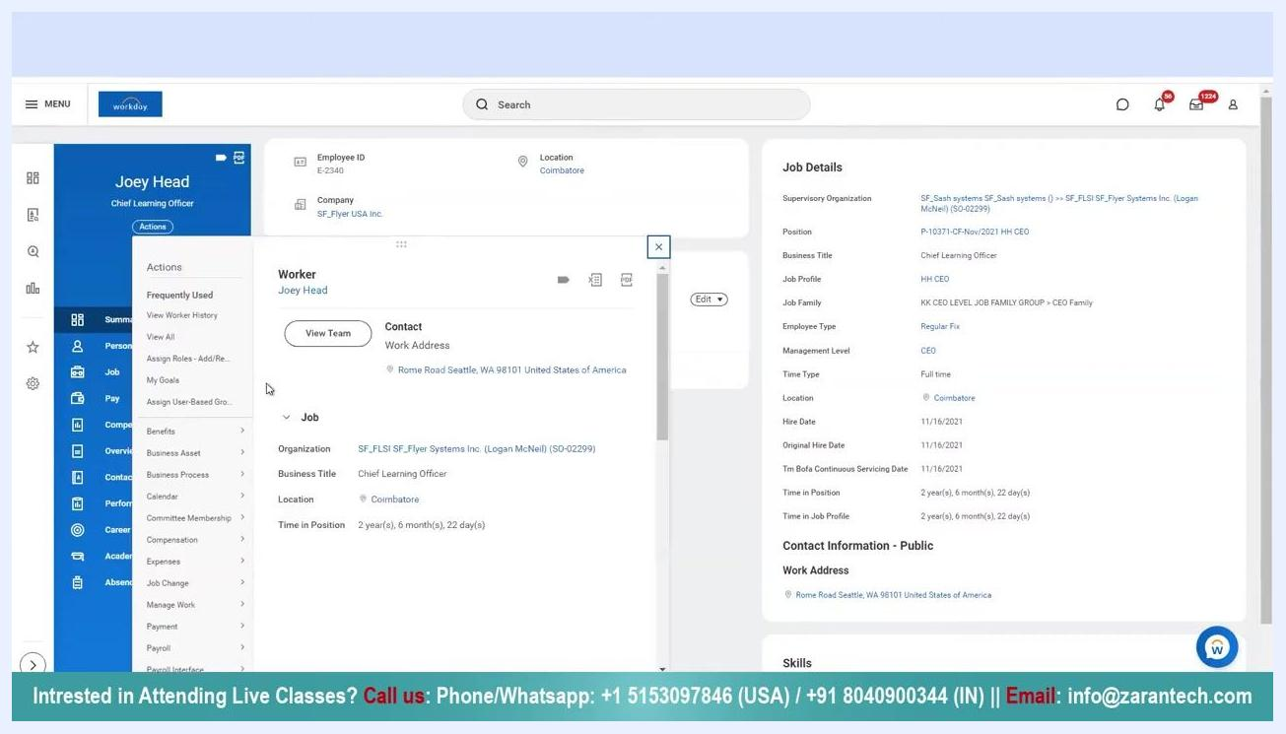
Profile page with the Actions menu open, showing options such as 'Benefits,' 'Compensation,' and 'Absence'

4. Select Request Absence or Request Time Off
Under Time and Leave in the Actions menu, hover over or click to expand the available options. Select Request Absence or Request Time Off from the dropdown list.
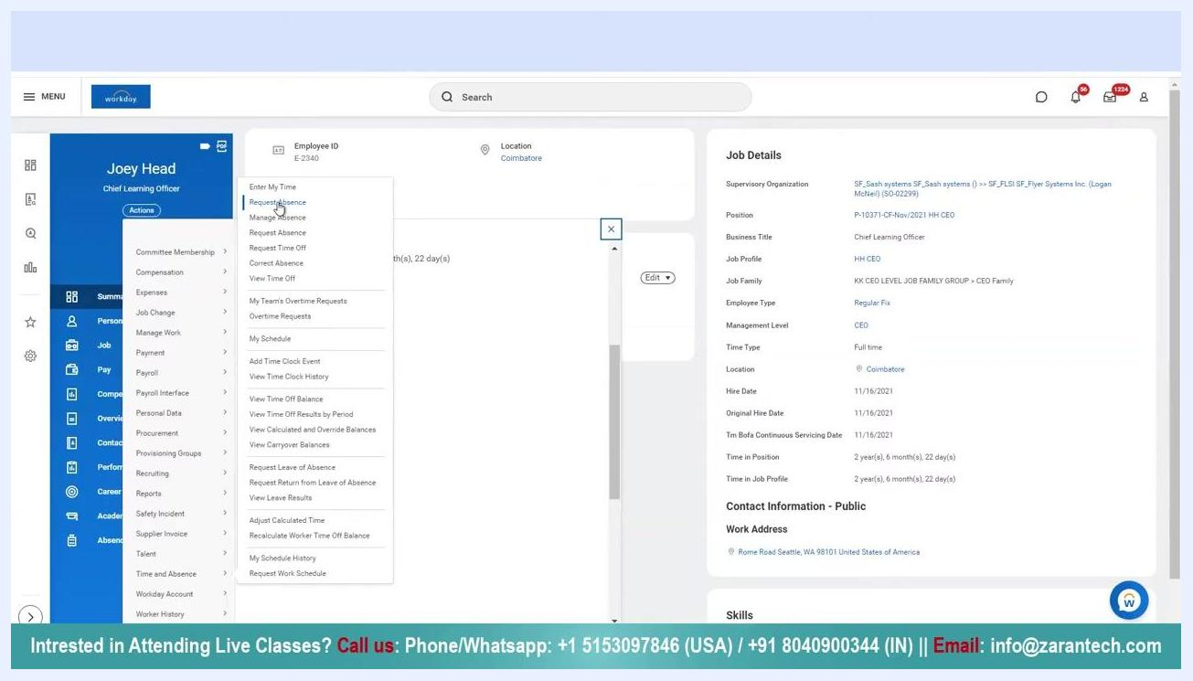
Actions menu expanded with the cursor on 'Request Absence,' showing related time and leave options

5. View the Request Time Off calendar
The Request Time Off page opens with a calendar for the current month. You will see View Teams and View Absence Thresholds buttons at the top. Allow the page a moment to fully load.
Request Time Off calendar view for the current month, with navigation and action buttons

6. Review your available balances
On the left side of the Request Time Off page, find the Balances section. This "Balance Per Plan" list shows all available time off types and their current balances, such as Floating Holiday, Hire Anniversary, and PTO Plan hours. If you want to use sick time in Workday, check the Sick Time Off Plan balance here to confirm you have hours available before proceeding.
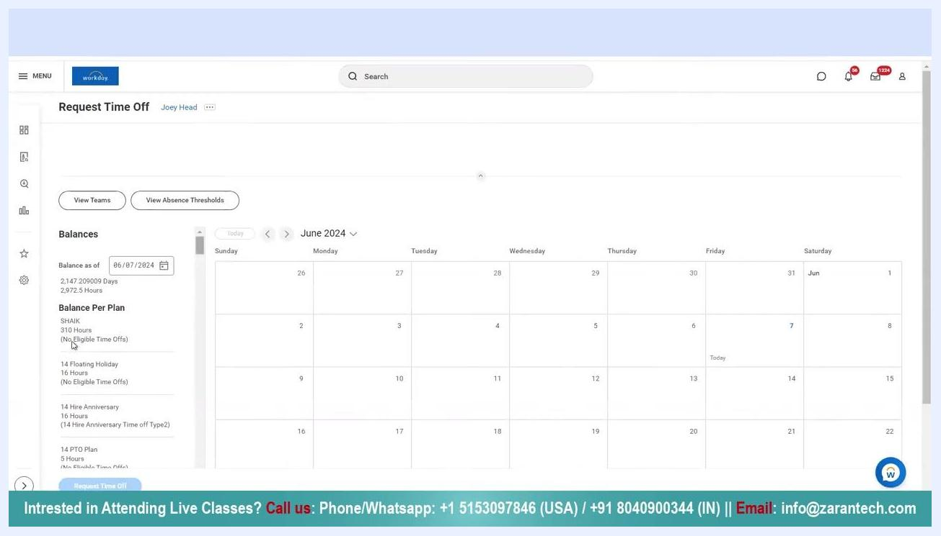
Balances section listing various time off plans and available hours, with the calendar visible on the right

7. Select the date for your time off
On the calendar, click the specific date you want to request off. A blue highlight appears on the selected date to confirm your choice.
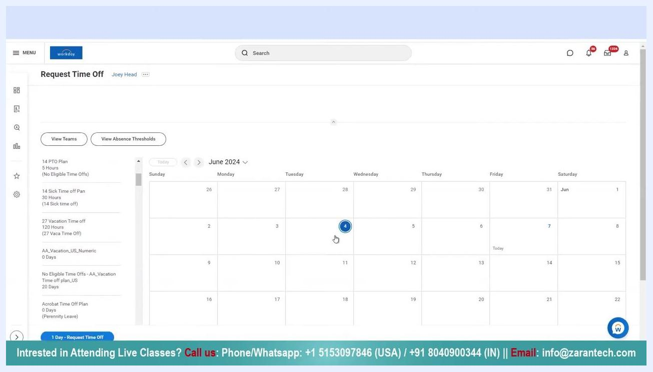
Calendar view with a specific date selected for a time off request

8. Wait for the Request Time Off pop-up
After selecting a date, wait for the Request Time Off pop-up window to load. If the system responds slowly, allow a few moments for the window to appear. The pop-up includes fields for "When," "Type," "Daily Quantity," "Unit of Time," "Comment," and "Attachments."
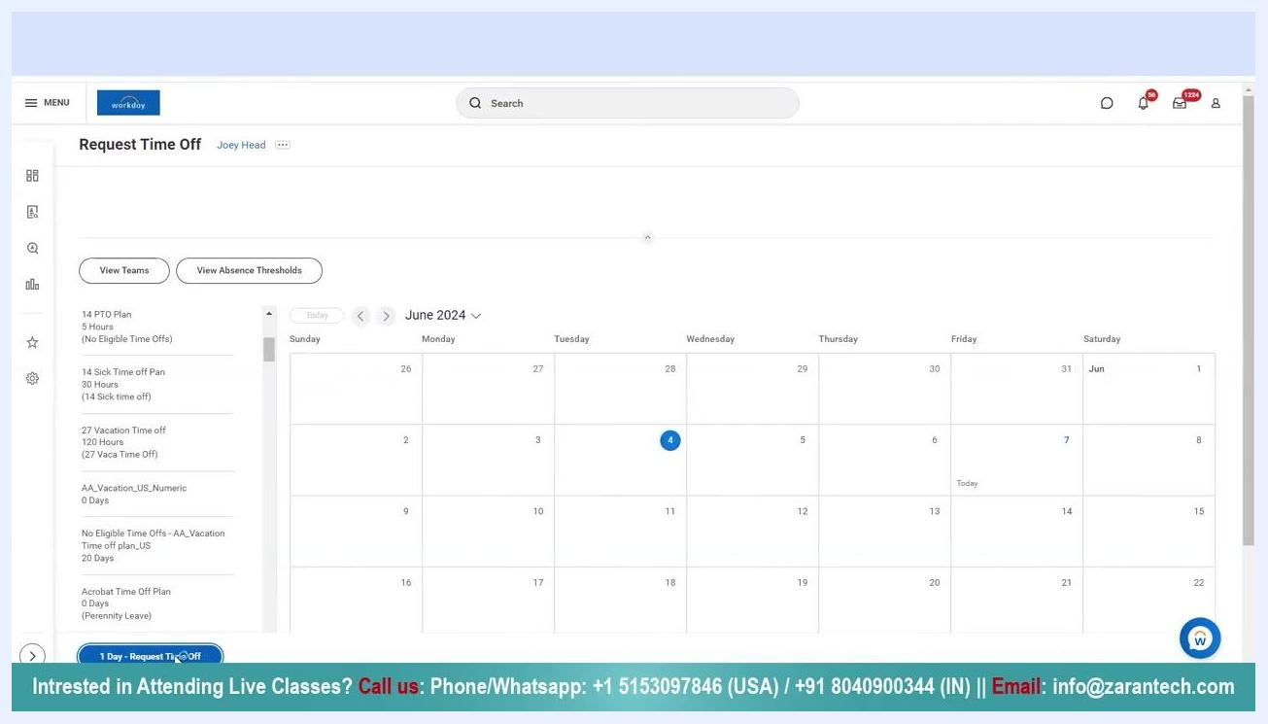
Request Time Off pop-up window with fields for date, type, daily quantity, and comments

9. Choose the sick time off type
In the "Type" dropdown, scroll through the available options and select 14 Sick time off to request sick leave.
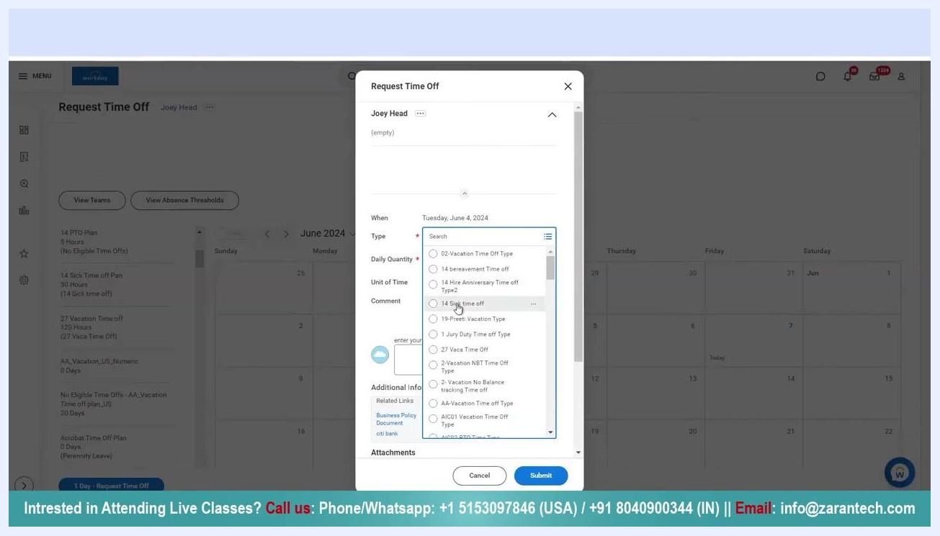
Type dropdown expanded with '14 Sick time off' highlighted in the list

10. Enter the daily quantity
In the "Daily Quantity" field, enter 1 to request one day off. If you try to submit without entering a value, an error message appears: "Error: The field Daily Quantity is required and must have a value."
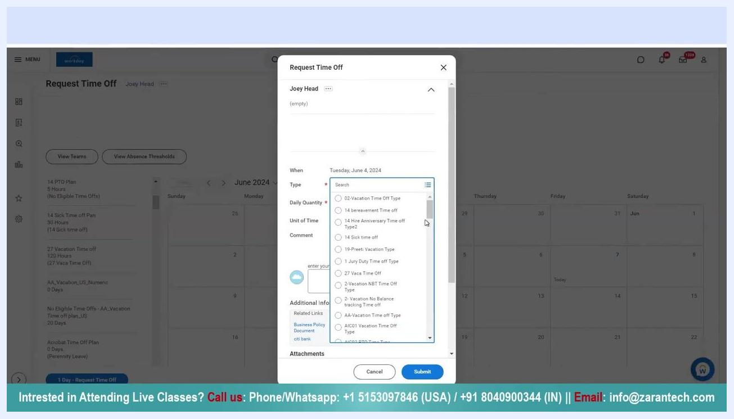
Daily Quantity field showing an error for a missing value, with '14 Sick time off' selected

11. Submit the time off request
Once all required fields are filled in, click Submit at the bottom of the pop-up window and wait for the system to process your request.
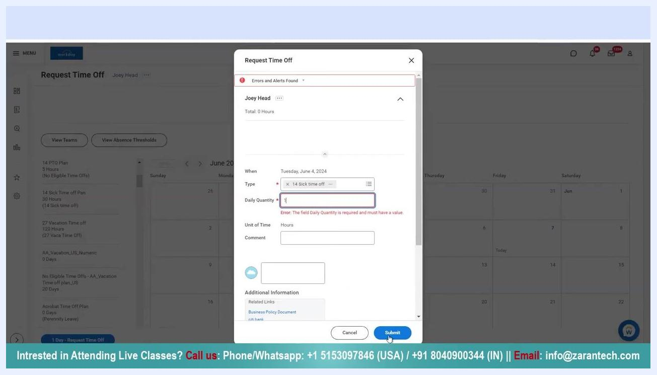
Submit button highlighted with all required fields completed for a sick time off request

12. Confirm your submission
After submitting, a confirmation message appears at the top of the screen: "Your request has been submitted." Your sick time off entry now appears on the calendar for the selected date.
Confirmation message 'Your request has been submitted' with sick time off marked on the calendar

Checking the status of your request

13. Check the status of your submitted request
View the calendar in the Request Time Off section and locate your requested date. Hover over the date to see its status, which displays as "Submitted | 14 Sick time off" with the corresponding date until your manager approves it. The confirmation message "Your request has been submitted" also appears at the top of the screen.
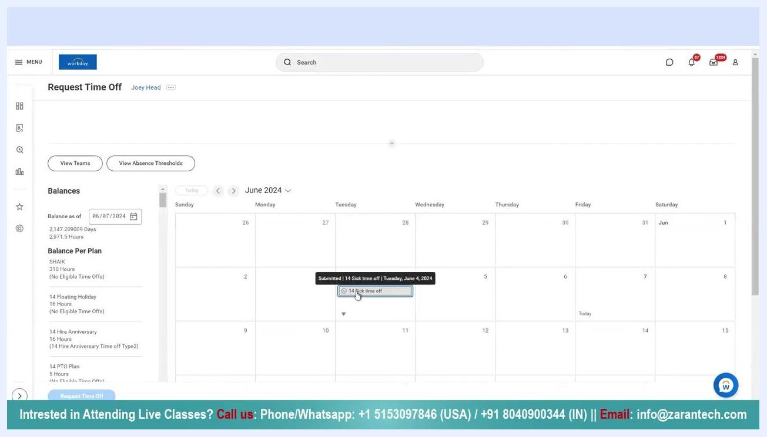
Calendar view showing a submitted sick time off entry with a confirmation message

14. Wait for manager approval
Your request is sent to your manager for approval. Once approved, the calendar status updates to "Approved" for the selected date. Until then, the status remains "Submitted."
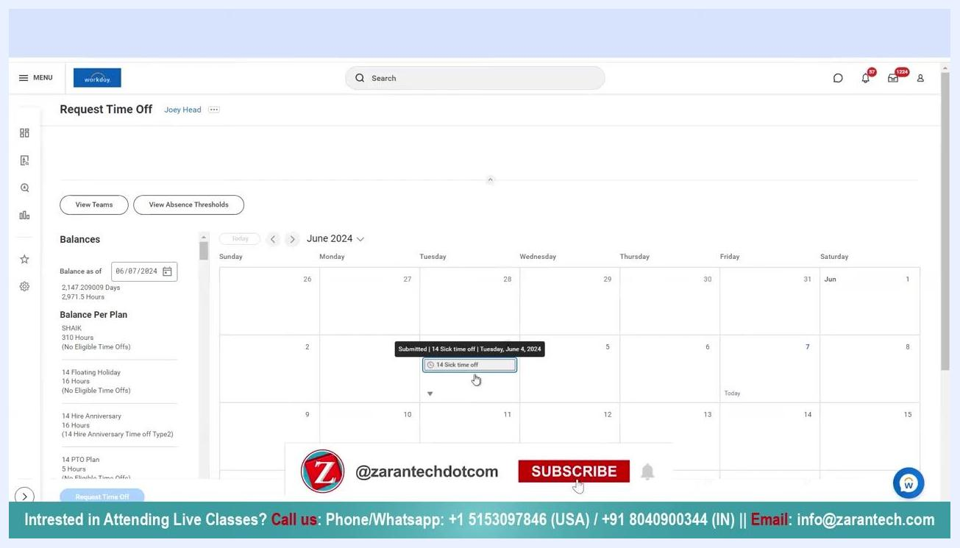
Calendar view with the time off request still showing as 'Submitted'

Cancelling a submitted time off request

15. Initiate the cancellation process
If you no longer need the requested time off, locate the submitted entry on the calendar and click on it. A dropdown or options menu appears for the selected request.
User clicking a submitted sick time off entry to begin cancellation

16. Open the Cancel Business Process window
Select the option to cancel the request. The Cancel Business Process window opens, showing the date, type, and quantity of the time off requested. In the "enter your comment" field, provide a reason for the cancellation, such as "Applied in error."
Cancel Business Process window with the comment 'Applied in error' being entered

17. Submit the cancellation
After entering your comment, click Submit at the bottom right of the window to confirm the cancellation.
Submit button highlighted in the Cancel Business Process window

18. Verify the cancellation
A confirmation message, "Event Canceled," appears at the top of the screen once the cancellation is submitted. The cancelled entry no longer appears on your calendar for that date.
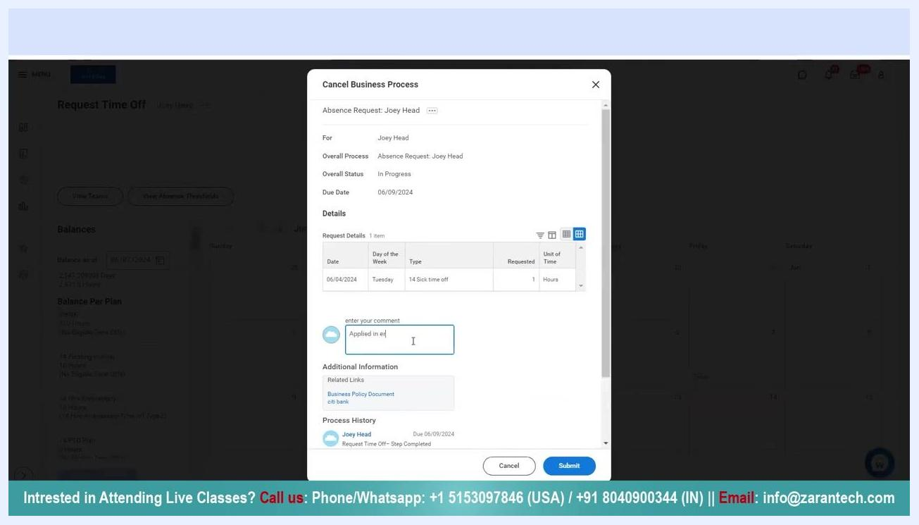
Calendar view displaying the 'Event Canceled' confirmation message

Additional support
If you need further assistance, the following contact options are available:
- Phone/WhatsApp (USA): +1 5153097846
- Phone/WhatsApp (IN): +91 8040900344
- Email: info@zarantech.com
- 24/7 chat support

Contact information and thank you message

What's next
Now that you know how to use sick time in Workday, you can monitor the approval status of any request and cancel it if your plans change. Always include a clear reason when cancelling a request to keep your records accurate.

