How to Reset Your Password in Workday
If you've forgotten your Workday password or simply need to update it, you can reset it in just a few minutes directly from the login page. This guide walks you through how to reset your password in Workday, from requesting a reset link to logging back in with your new credentials.

Prerequisites
- Access to the Workday login page in your web browser.
- Access to the email inbox associated with your Workday account.
- Your Workday username.

Steps to reset your password in Workday

1. Open the Workday login page
Go to the Workday login page in your web browser.

2. Click Forgot Password
Click the Forgot Password link on the login page. This redirects you to a new page for password recovery.
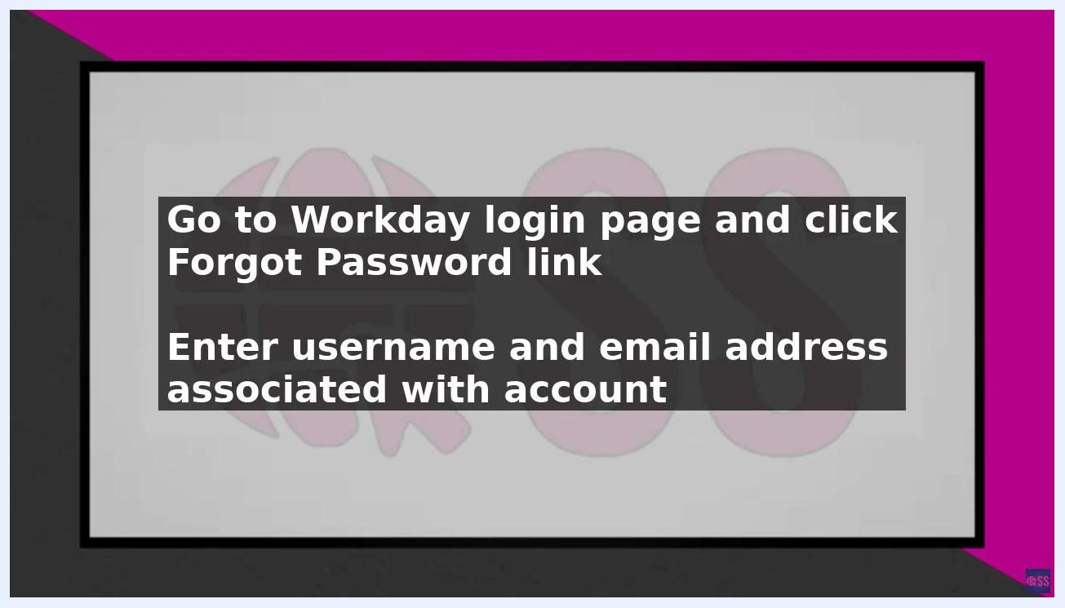
Workday login page with instructions to click Forgot Password and enter username/email

3. Enter your account details
Enter your username and the email address associated with your Workday account in the provided fields.

4. Submit your request
Click the Next button to proceed.

5. Check your email
Check your email inbox for a message from Workday containing a password reset link.

6. Open the reset link
Open the email and click on the password reset link provided. This takes you to a new page where you can create a new password.
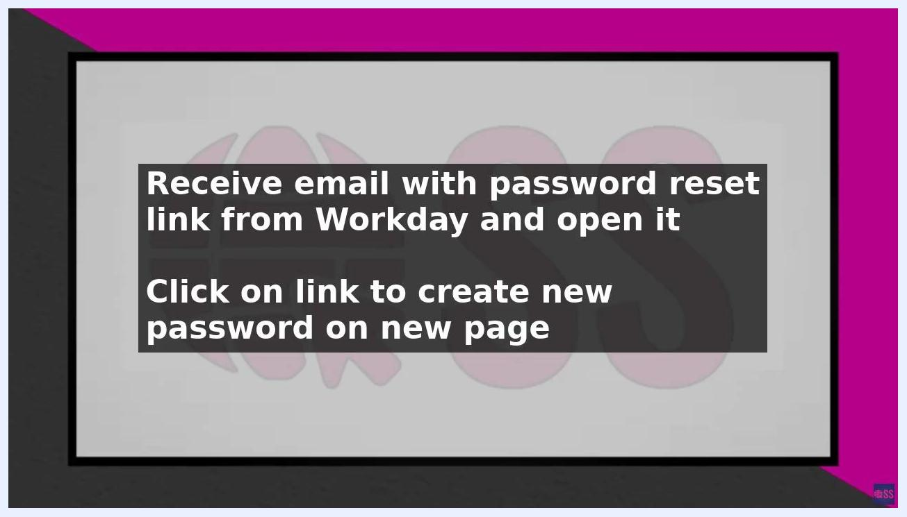
Instructions to open the Workday password reset email and click the link

7. Create a new password
On the password creation page, enter a new password that meets your organization's requirements:
- Use a combination of uppercase and lowercase letters.
- Include numbers and special characters.
- Ensure the password is at least 8 characters long.
- Avoid easily guessable information such as your name, birth date, or common words.
- Choose a password that is easy for you to remember but hard for others to guess.
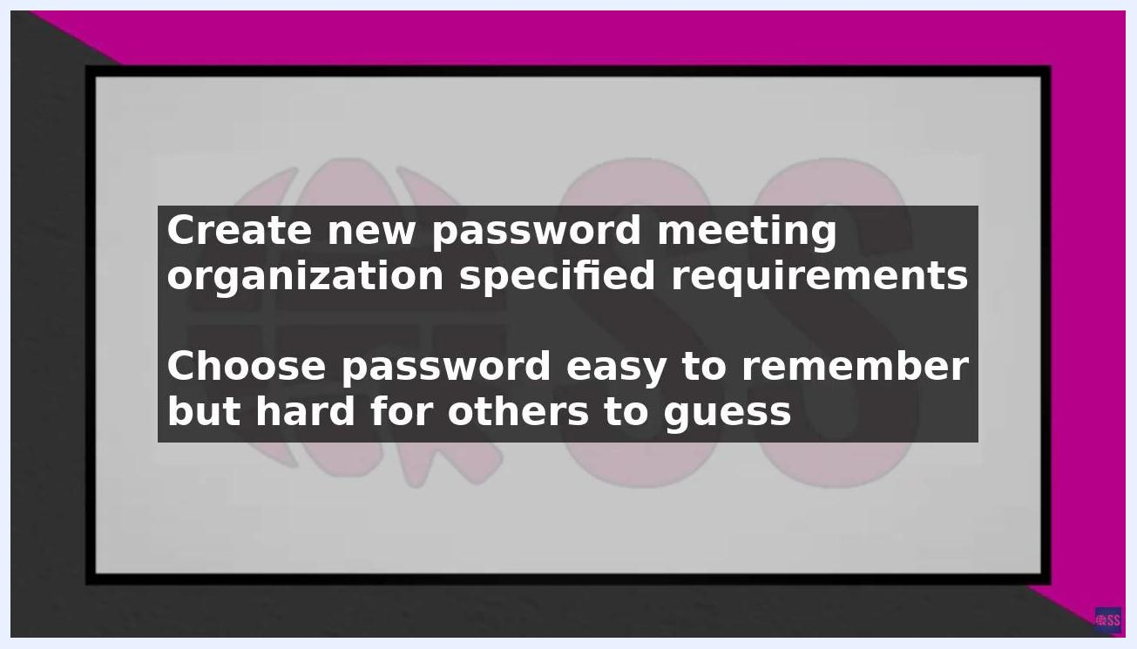
Instructions to create a new password meeting organization requirements

8. Save your new password
Click the Submit button to save your new password. You will be redirected back to the Workday login page.

9. Log in with your new password
Enter your new password on the login page to access your account.

Security recommendations
- Reset your password regularly to keep your account protected.
- Use a unique password for your Workday account that you don't reuse on any other accounts.
- These practices help protect your account from unauthorized access and ensure the security of your organization's data.
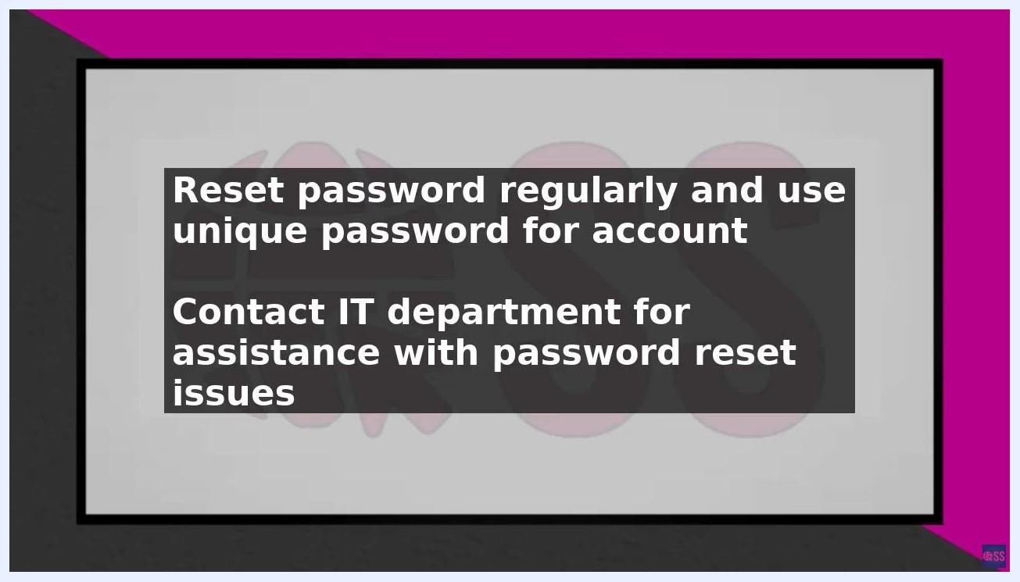
Screen displaying security reminders about resetting your password regularly and contacting IT for assistance

What's next
If you encounter any issues during the password reset process, contact your organization's IT department for assistance. The IT department can provide additional guidance and support to help resolve password reset issues. Do not attempt to bypass security procedures — always seek authorized help if you are unable to reset your password.
By following these steps, you can securely reset your Workday password and maintain the safety of your account and your organization's data.

