How to Find and Download Your W-2 Form in Workday
This guide walks you through locating, reviewing, and saving your W-2 form using Workday. Follow the steps below to access your payroll records, download the correct tax year's form, and store it securely for tax filing.

Prerequisites
- An active Workday account with a valid username and password.
- Access to the Payroll section, typically found under My Account or Employee Self-Service.

Steps to access your W-2 form

- Log in to your Workday account using your username and password.
- Navigate to the Payroll section. This is typically found under the My Account or Employee Self-Service tab.
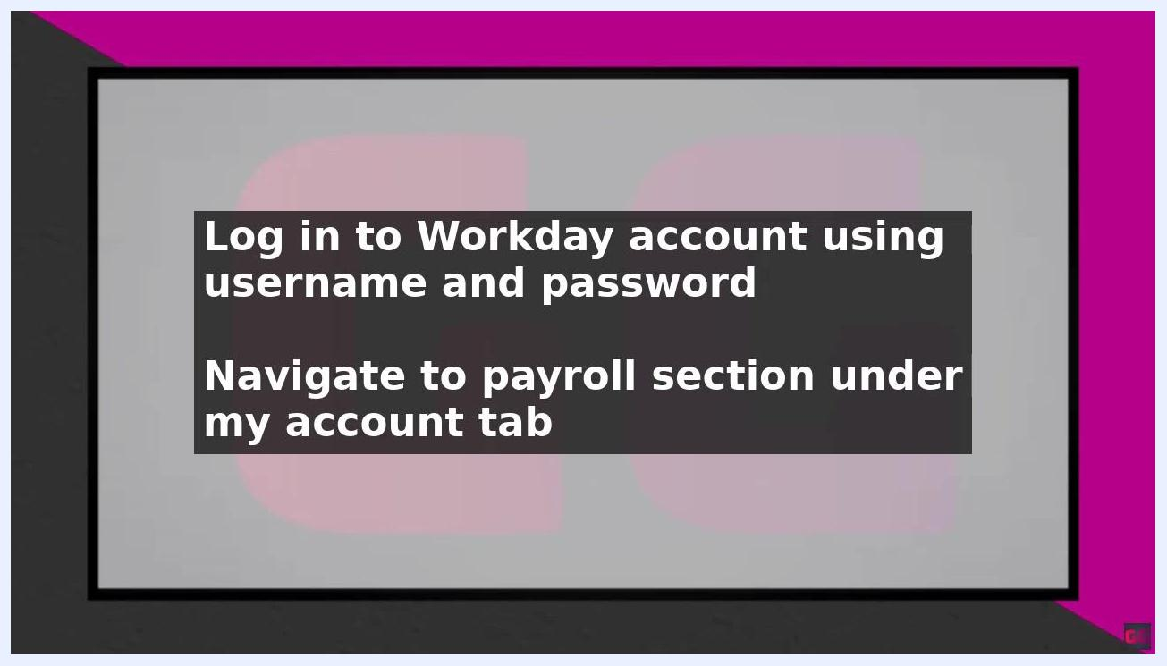
Screen showing instructions to log in to a Workday account and navigate to the payroll section under the My Account tab

- In the Payroll section, click View Payroll Documents to access your payroll records.
- On the payroll documents page, locate the drop-down menu at the top of the page.
- Select the tax year for which you want to view your W-2 form from the drop-down menu.
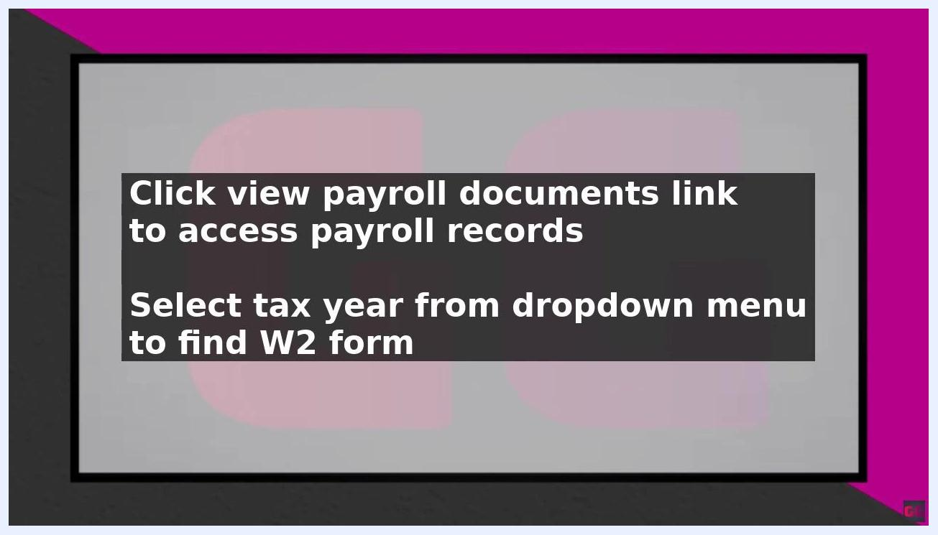
Screen showing instructions to click the View Payroll Documents link and select a tax year from the dropdown menu to find the W-2 form

- Click the W-2 link to view and download your form for the selected tax year.
- Your W-2 form will be displayed on the screen.
- Review your W-2 form carefully to ensure all information is accurate and complete.
- Print or save the W-2 form to your computer for future reference.

Screen showing instructions to review the W-2 form carefully for accuracy and completeness, then print or save it for future reference

If you have trouble finding your W-2 form
If you cannot locate your W-2 form in Workday, contact your payroll department or HR representative for assistance. They can help you troubleshoot any issues and provide further guidance on accessing your form.
Tips:
- Always save a copy of your W-2 form to your computer or an external hard drive for your records.
- Double-check all details on your W-2 form before submitting it for tax purposes.

Best practices for managing your W-2 form
Once you have downloaded your W-2 form, follow these recommendations to keep it secure and ready for tax filing.

- Save a copy of your W-2 form to your computer or an external hard drive. This ensures you have a backup in case you need to access it in the future. Use a secure folder or encrypted drive if possible for added protection.
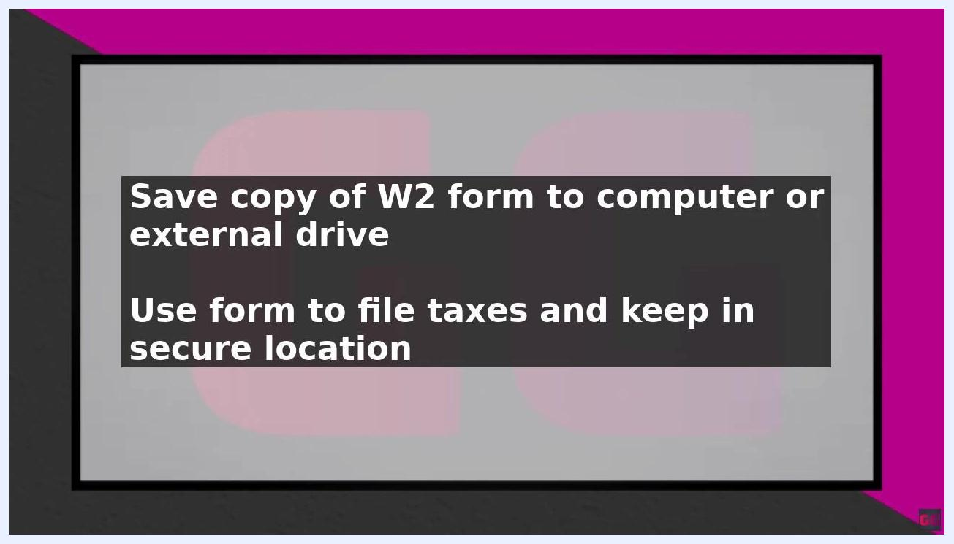
Screen displaying instructions to save a copy of the W-2 form to a computer or external drive, use it to file taxes, and keep it in a secure location

- Use your W-2 form to file your taxes. Refer to the saved digital copy or print a physical copy as needed for your tax preparation.
- Keep your W-2 form in a safe and secure location. Store both digital and printed copies in places protected from unauthorized access or loss.
- Review your W-2 form carefully for accuracy and completeness before using it for tax filing. Double-check all personal and financial information.
- Always save a copy of your W-2 form for your records. Retain your W-2 forms for several years, as they may be needed for future reference or audits.
- If you encounter any issues or cannot locate your W-2 form, contact your payroll department or HR representative for assistance.
Screen displaying instructions to save a copy of the W-2 form to a computer or external drive, use it to file taxes, and keep it in a secure location
Best Practices:
- Use strong passwords and secure storage for digital copies.
- Do not share your W-2 form with unauthorized individuals.
- Back up your files regularly to prevent data loss.

Summary
By following these steps, you can quickly and easily access your W-2 form in Workday and use it to file your taxes. Review your form carefully and save a copy for your records so it remains safe, accessible, and ready whenever you need it.

