How to Clock In and Clock Out in Workday
This guide walks you through how to clock-in and clock-out in Workday, as well as how to access the platform, review your personal information, check your pay details, and submit your timesheet. Whether you're starting your shift, taking a meal break, or ending your workday, these steps will help you manage your timesheet accurately and on time.

Prerequisites
Before you begin, make sure you have the following:
- A web browser (such as Chrome or Internet Explorer)
- Your myUSC username and password
- Access to the USC employee website

Accessing Workday

Step 1: Open your web browser
Launch your preferred web browser. You should see your browser's homepage or a new tab displaying the Google search page.
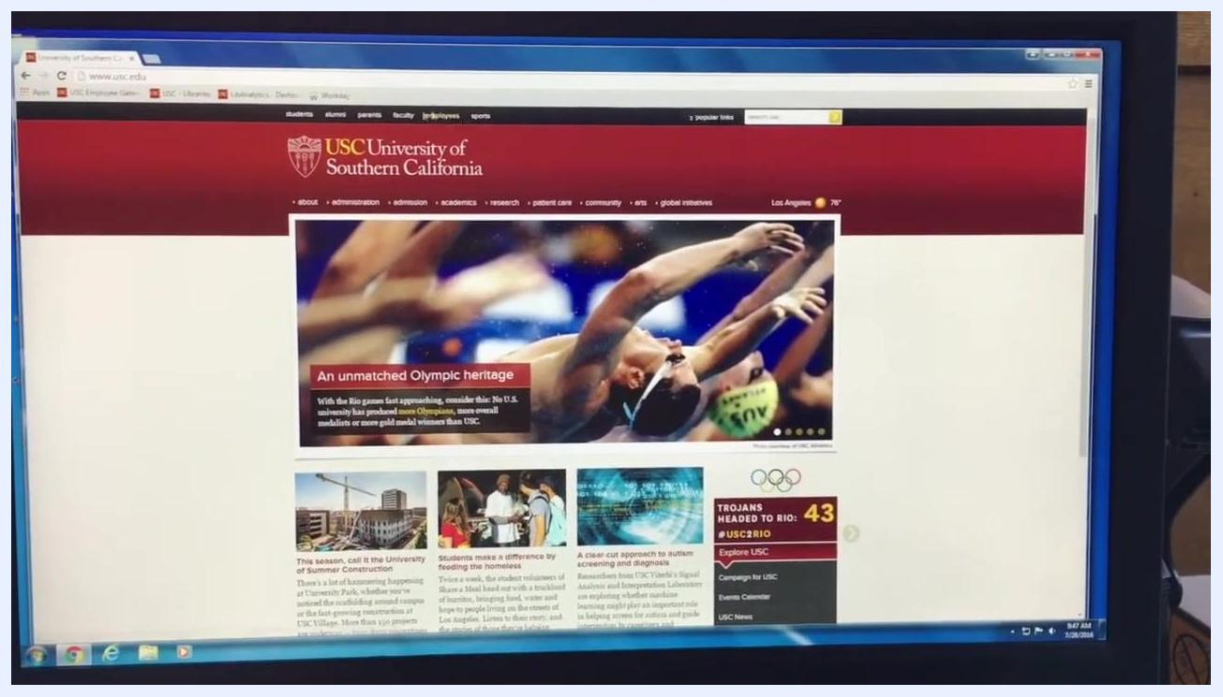
A computer screen displaying the Google homepage in a web browser. Several shortcut tiles appear below the search bar.

Step 2: Navigate to the USC main website
In the address bar, type www.usc.edu and press Enter. Wait for the USC homepage to load.
The browser address bar is being used to enter a URL. The Google homepage is visible, and the user is starting to type a web address.

Step 3: Access the Employees section
On the USC homepage, locate the top navigation bar and click Employees, found on the top left side of the page.
The USC homepage is displayed. The top navigation bar includes links such as Students, Alumni, Parents, Faculty, Employees, and Sports.

Step 4: Open the USC Employee Gateway
The Employee Gateway page loads with a list of popular links. Look for the Workday icon, typically located in the middle of the page or in the list at the bottom, and click it to proceed.
The USC Employee Gateway page is shown, with popular links including University holidays, Academic calendar, Benefits site, Policy site, USCard, Workday, HR Service Center, IT help, Buses, Credit Union, and Directories.

Step 5: Sign in to Workday
You are redirected to the USC login page. Enter your myUSC username and password in the provided fields, then click Sign in to continue.
The USC login page is displayed with fields for username and password, and a Sign in button. The background is red with the USC logo at the top.

Step 6: Arrive at the Workday homepage
After signing in, the Workday homepage appears with several icons leading to different sections, including USC Quicklinks, Time, Inbox, Directory, Time Off, Personal Information, Pay, and Benefits.
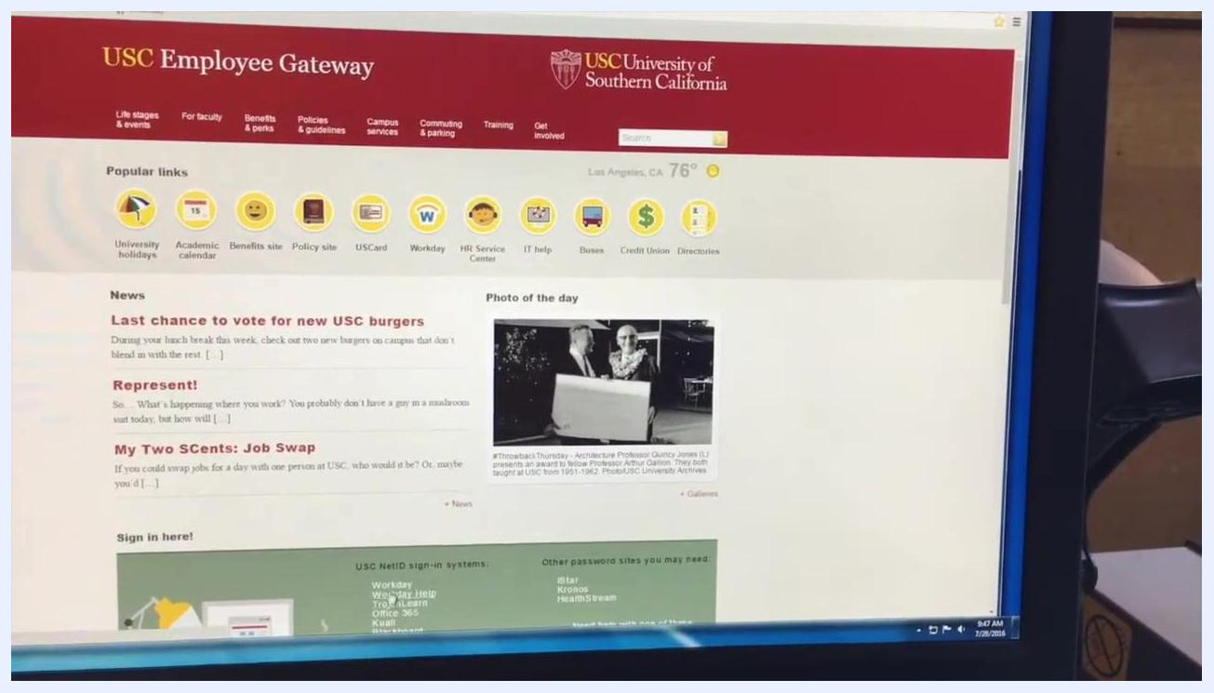
The Workday homepage is shown with icons for USC Quicklinks, Time, Inbox, Directory, Time Off, Personal Information, Pay, and Benefits.

Step 7: Identify key icons
The most important icons for employees are Time (for clocking in and out), Personal Information (for updating your contact details), and Pay (for accessing payslips and tax documents).
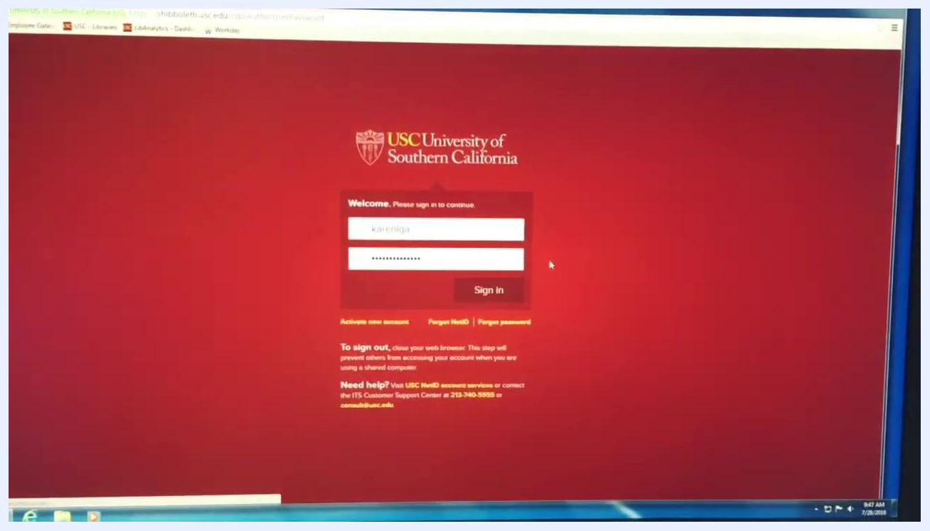
A close-up of the Workday homepage, highlighting the Time, Personal Information, and Pay icons.

Managing your personal information and pay

Step 8: Update personal information at the start of each semester
Click the Personal Information icon. On the next screen, you can change your contact information, personal information, emergency contacts, photo, and legal name, or view details such as About Me, Addresses, Email Addresses, Address Changes, and Name.
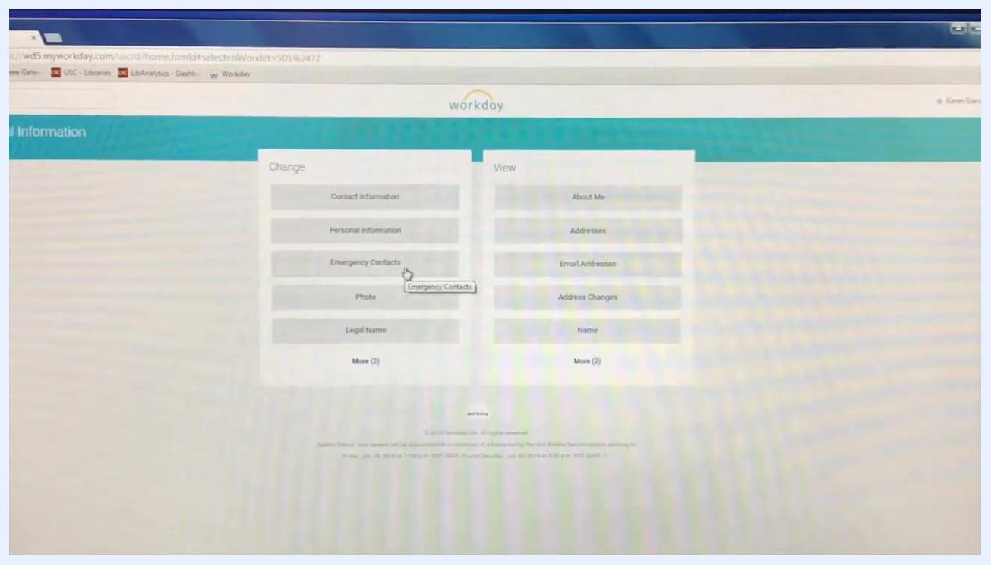
The Personal Information section in Workday, showing options to change or view contact information, personal information, emergency contacts, photo, legal name, and more.

Step 9: Ensure your information is current
Make sure your home address, phone number, email, and emergency contact numbers are up to date. Keeping this information current ensures you can be reached if necessary.
The Personal Information section is displayed, with the cursor hovering over Emergency Contacts.

Step 10: Access your pay information
Click the Pay icon on the Workday homepage. Here, you can view payslips for previous pay periods, access important tax documents, and manage payment elections.
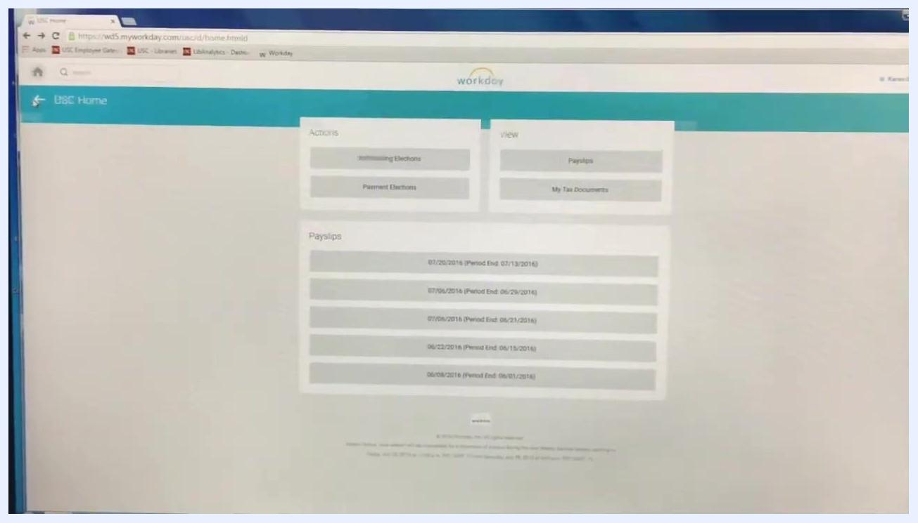
The Pay section in Workday, showing options for payment elections, payslips, and tax documents. Several payslip entries are listed.
Note: The Time icon is used to clock in and out for your timesheet. Shortcuts to Workday may also be available and explained to you in person.

Clocking in and out in Workday

Step 11: Clock in for your shift
Navigate to the Time section in Workday and locate the Time Clock area on the page. Click the Check In button, then click OK in the confirmation dialog to record your clock-in time. Your check-in time will be displayed, for example, "Checked in at 8:43 AM."
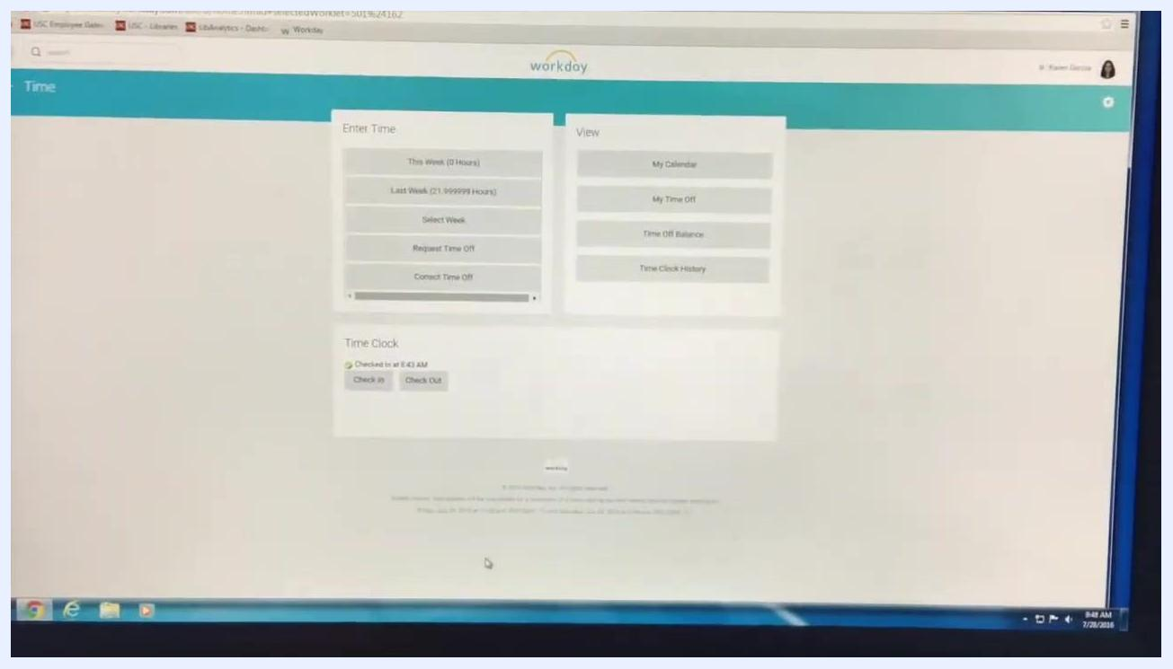
Workday Time Clock screen showing 'Checked in at 8:43 AM' with Check In and Check Out buttons.

Step 12: Verify your clock-in time at the end of your shift
At the end of your shift, return to the Time Clock section in Workday and verify that your clock-in timestamp is visible, for example, "Checked in at 8:43 AM."
Workday Time Clock screen showing the clock-in timestamp and Check Out button.

Step 13: Click Check Out
Click the Check Out button under Time Clock.
Cursor hovering over the Check Out button in the Time Clock section.

Step 14: Select the correct check-out reason
In the Check Out dialog, select the appropriate reason: choose Out if you are ending your shift, or Meal if you are taking a meal break (for shifts over 6 hours). You can optionally add a comment in the Details section, then click OK to confirm your check out.
Workday Check Out dialog with options for Meal or Out, and a comment box.

Handling missed punches
If you forget to clock in or out, notify your supervisor immediately so they can approve any edits you need to make to your timesheet.

Submitting your timesheet

Step 15: Log in and open the Time section
Every other Wednesday, you must submit your timesheet to get paid the following week. Log in to Workday and click the Time icon on the homepage.
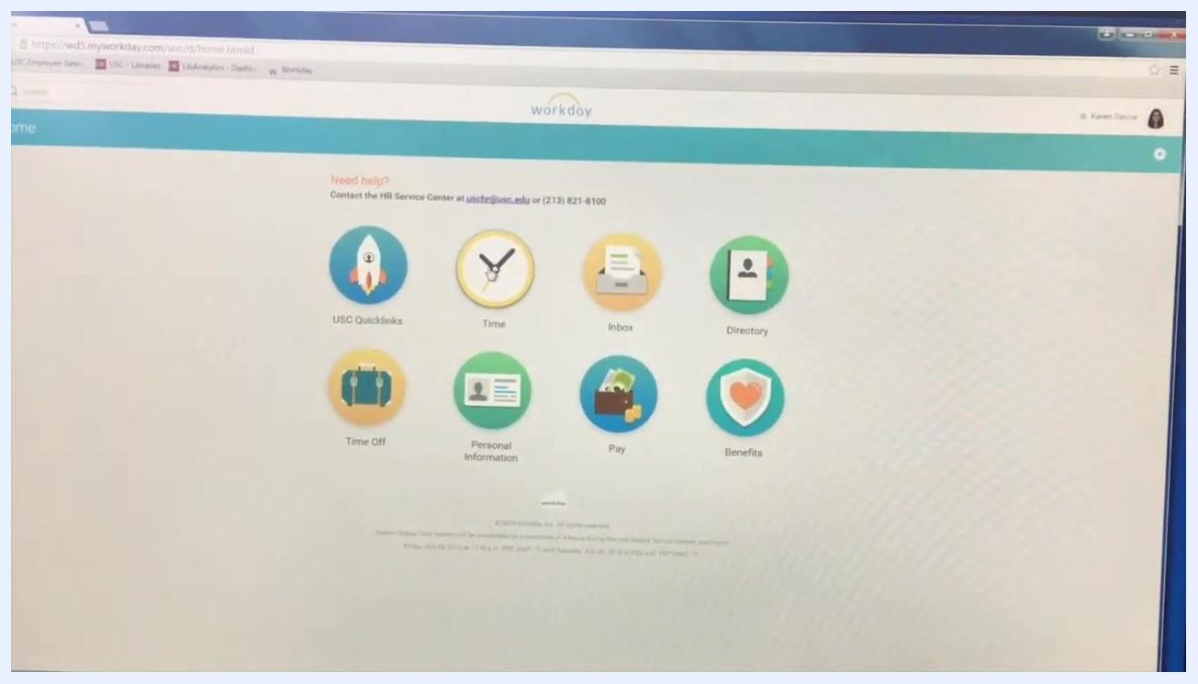
Workday homepage with icons for Time, Inbox, Directory, Time Off, Personal Information, Pay, and Benefits.

Step 16: Open My Calendar
Under the View section, click My Calendar.
Cursor selecting 'My Calendar' under the View section in Workday.

Step 17: Review your weekly hours
Review the weekly layout of the hours you have worked, and check for any missing punches or alerts, such as "Unmatched clock events exist for the day."
Workday calendar view showing a weekly layout and an alert for unmatched clock events.

Step 18: Submit your timesheet
If all times are correct, click Submit in the bottom left corner, then click OK to finalize your timesheet submission.
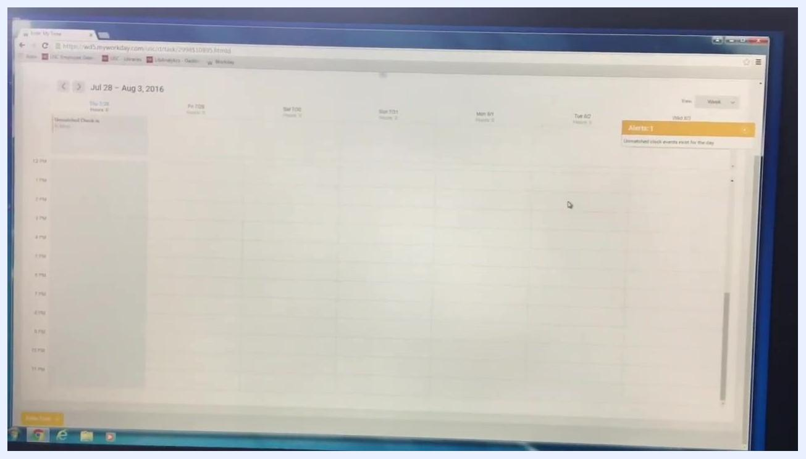
Workday calendar view with the Submit button visible in the bottom left corner.
Important notes:
- If you have a missing punch, Workday will alert you in the top right corner. You must get your supervisor's approval to correct or edit the missing punch before making any changes.
- Always ensure your timesheet is accurate before submitting to avoid payment delays.

What's next
Now that you know how to clock-in and clock-out in Workday, make it a habit to check in and out for every shift and meal break, keep your personal information current each semester, and submit your timesheet on time every other Wednesday to avoid payment delays. If you notice a missed punch, reach out to your supervisor right away for approval before editing your timesheet.

