How to Change Your Profile Picture in Workday
This guide walks you through how to change your profile picture in Workday, from preparing your photo to confirming the update on your profile page. Follow these steps in order to replace your current profile picture with a new one.

Prerequisites
Before you begin, save the photo you want to use as your profile picture in an easily accessible folder on your device, such as Pictures under This PC. Having the file ready beforehand makes the upload process faster once you're in Workday.
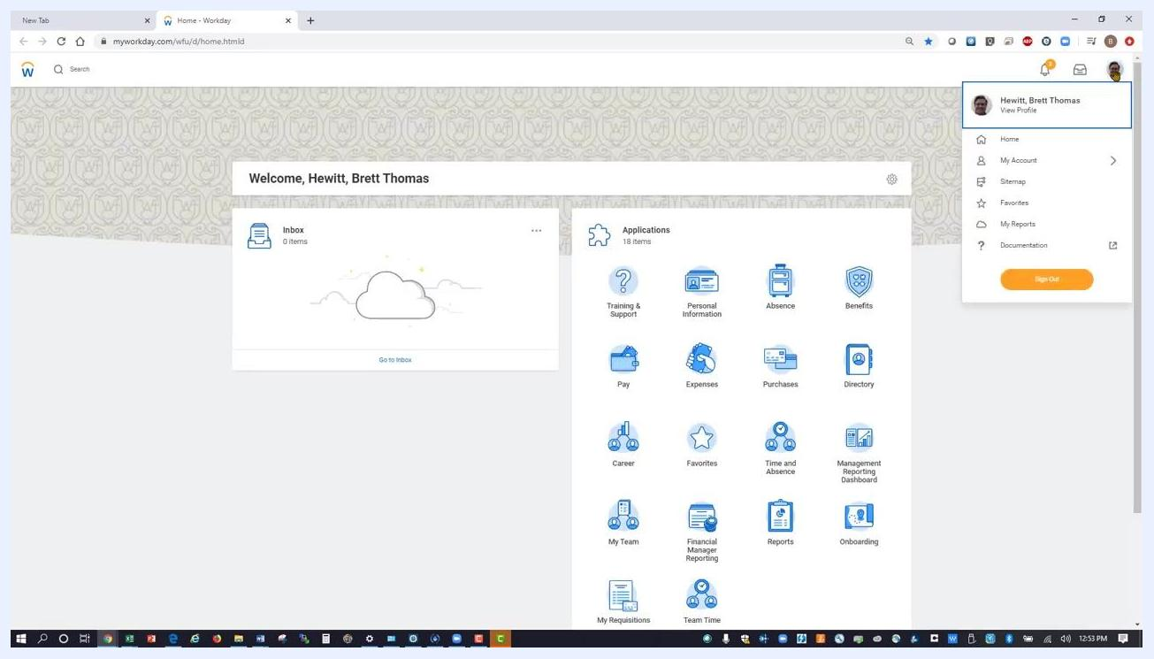
A Google Chrome browser window open to a new tab, showing the search bar and several shortcut icons, including one for Workday. The Windows taskbar appears at the bottom, and no Workday content is open yet.

Step 1: Sign in to Workday
Open your web browser and navigate to your Workday login page. Sign in using your credentials, and make sure you land on the Workday home page before continuing.

Step 2: Open your profile menu
Click your profile picture or icon located in the top right corner of the Workday home page. A dropdown menu opens, showing your name and a View Profile option.
The Workday home page in Chrome, with the user profile icon in the top right clicked, revealing a dropdown menu with the user's name and the "View Profile" option.

Step 3: View your profile
In the dropdown menu under your name, left-click View Profile.
The Workday home page with the profile dropdown open and "View Profile" highlighted under the user's name.

Step 4: Go to the Actions menu
Wait for your profile page to load. On the left-hand side, directly under your name and position title, left-click the Actions button.
The Workday profile page, with the "Actions" button visible under the user's name and title in the left sidebar.

Step 5: Navigate to Personal Data
In the Actions menu that appears, hover over Personal Data in the list. A submenu opens to the right.
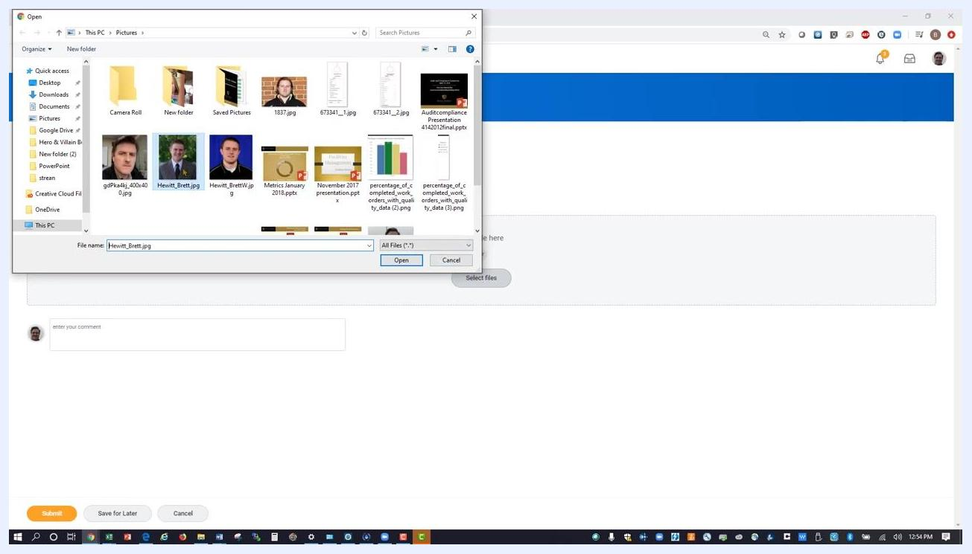
The expanded Actions menu on the Workday profile page, with the cursor hovering over "Personal Data."

Step 6: Select "Change My Photo"
In the submenu, move your mouse up to Change My Photo and left-click it.
The Actions menu with "Personal Data" expanded, showing options including "Change My Photo."

Step 7: Upload your new profile picture
Click the Select files button in the center of the screen. In the file dialog that opens, navigate to the folder where your profile picture is saved, such as Pictures, select the desired image file, and click Open to upload it.
A file explorer window open to the Pictures folder, with several image files visible and one file selected. The Open button is highlighted.
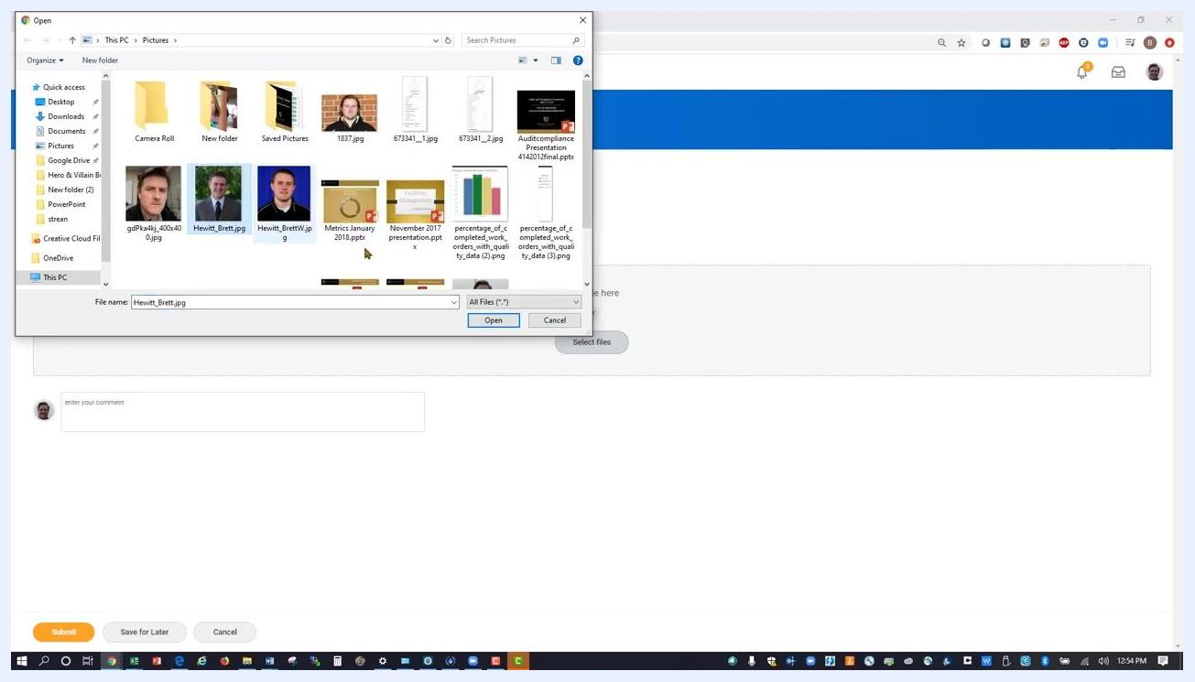
A file explorer window with the selected image ready to be opened.

Step 8: Adjust and position your profile picture
Once the image uploads, position the circle around your profile photo as desired. Click and hold the left mouse button to move the circle until the photo is positioned the way you want it.

Step 9: Confirm the photo selection
After positioning your profile photo, click the orange OK button at the bottom of the Change Photo dialog to confirm your selection.
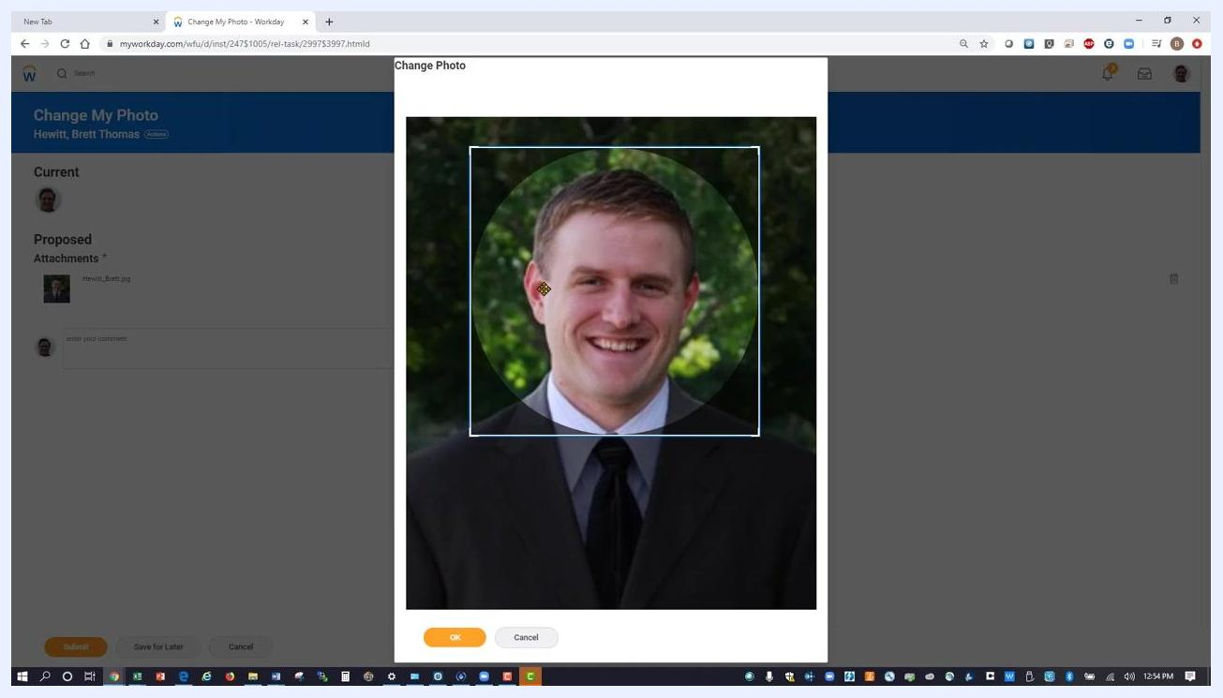
The Workday "Change Photo" dialog with the new profile photo positioned and the orange OK button visible at the bottom.

Step 10: Submit the profile picture change
Review the Change My Photo page and confirm that your new photo appears under Proposed Attachments. Click the orange Submit button in the lower left corner of the screen to finalize your update.
The Workday "Change My Photo" page showing the new photo under Proposed Attachments, with the Submit button highlighted in the lower left.

Step 11: Complete the process
Wait for the confirmation screen to appear, then click the Done button if prompted. This completes the profile picture update process.

Step 12: Verify your updated profile picture
Return to your Workday profile page and confirm that your new profile picture now displays next to your name and title.
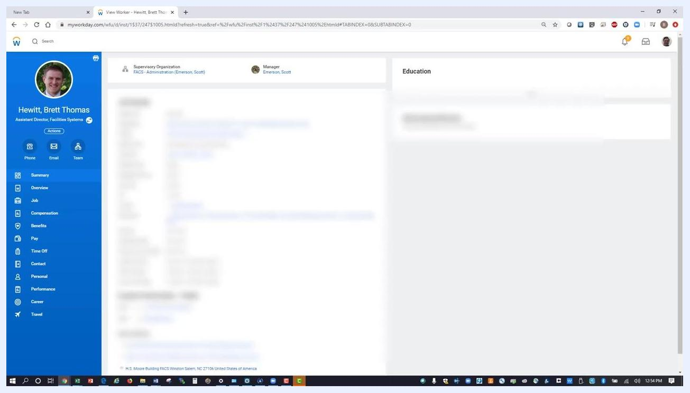
The Workday profile page with the updated profile picture visible in the left sidebar next to the user's name and title.

Summary
You have now successfully changed your profile picture in Workday by signing in, navigating through Actions > Personal Data > Change My Photo, uploading and positioning your image, and submitting the change for confirmation.
Note that the update may take a few moments to appear across all Workday pages. If you don't see the change immediately, refresh your browser.

