How to Change Your Availability in Workday: Correcting an Absence Request
This guide shows you how to change your availability in Workday by correcting an absence request through the SUNY Erie Workday Training Tools. Whether your absence has been submitted but not yet approved, or already approved by your supervisor, you can update or cancel it directly from your Absence Calendar. The steps below walk you through both scenarios.

Prerequisites
- Access to the SUNY Erie Workday Training Tools portal.
- Valid login credentials for your Workday dashboard.
- An existing absence request (submitted or approved) that you need to correct.

Accessing the absence worklet

- Open the Workday Training Tools portal.
Begin at the SUNY Erie Workday Training Tools welcome screen and confirm you are on the correct training portal for the State University of New York at Erie.

SUNY Erie logo and Workday Training Tools welcome screen

- Go to your main Workday dashboard.
Log in to Workday and confirm you are on your main dashboard, where you'll see a greeting such as "Welcome, On behalf of: Sallie Suny (WD0009000004)." Locate the Applications section, which includes icons for Personal Information, Pay, Time, Absence, Benefits, Favorites, and Reports.
Workday dashboard showing Applications and Inbox

- Open the Absence worklet.
In the Applications section, click the Absence icon, shown as a suitcase or briefcase, to open the Absence management area.
Absence icon highlighted in the Applications section

Correcting a submitted but unapproved absence

- Select Correct My Absence.
In the Absence worklet, find the Request section and click Correct My Absence. This lets you view and modify previously submitted absence requests.
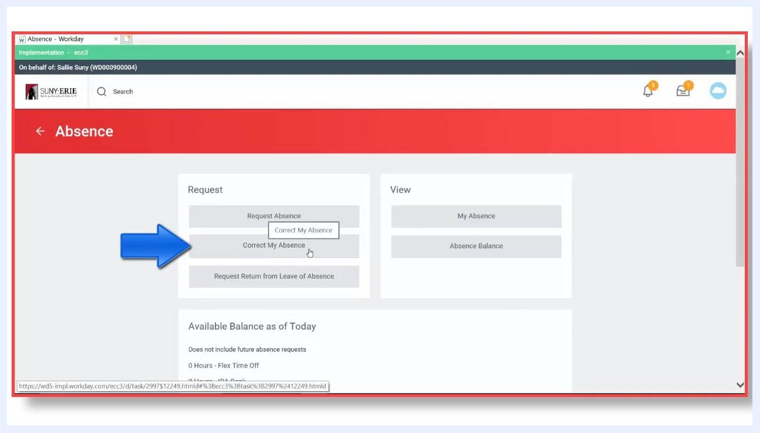
Correct My Absence button highlighted in the Absence worklet

- Review your Absence Calendar.
The Absence Calendar displays all your submitted absences. For example, "Vacation Time Off" on July 2nd appears with a gray bar, indicating it has been submitted but not yet approved by your supervisor. Approved absences, such as "Sick Time Off" on July 9th, display with a green bar and a check mark. Keep these status indicators in mind as you review your calendar: The correction process differs depending on which status applies.
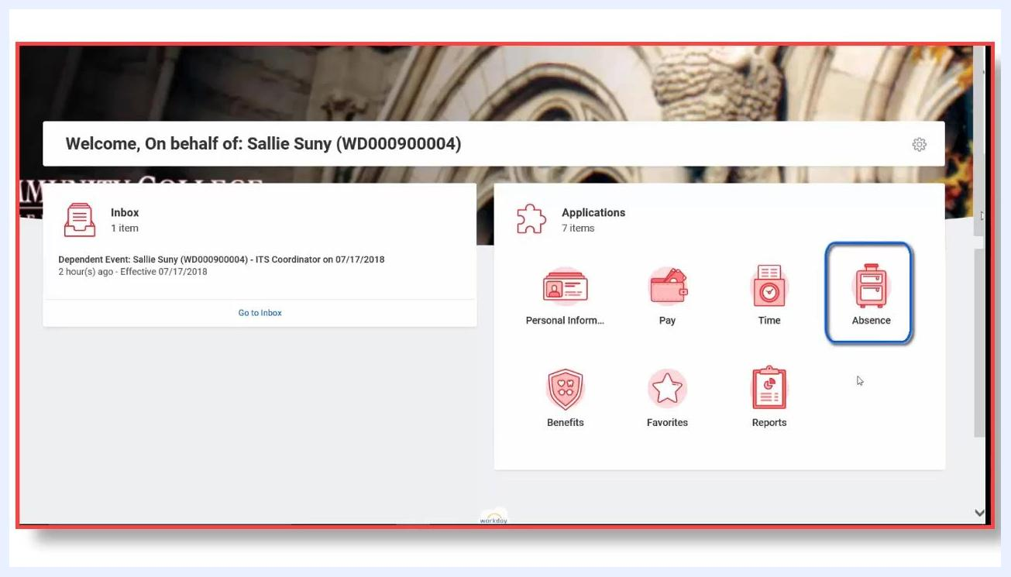
Absence calendar showing Vacation Time Off with a gray bar and Sick Time Off with a green check mark
- A gray bar means the absence is submitted but not approved.
- A green bar with a check mark means the absence is submitted and approved.

- Select the absence you want to correct.
Click the absence entry you need to change, such as "Vacation Time Off" on July 2nd. A tooltip may appear confirming its status, for example "Vacation Time Off | Submitted."
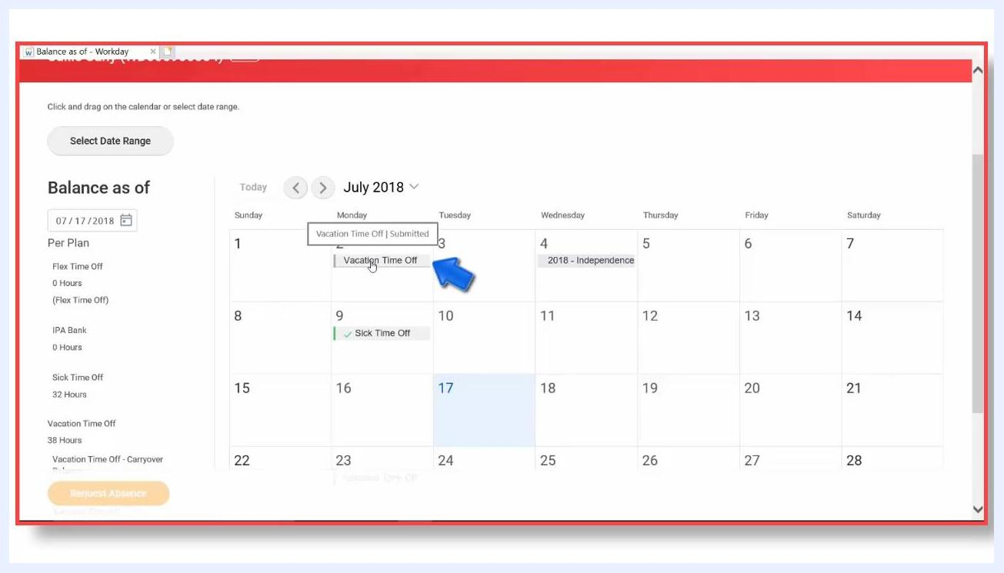
Selecting the Vacation Time Off absence on July 2nd

- Cancel the absence request.
After selecting the absence, choose the option to cancel the request, then click Submit to proceed with the cancellation.
- Enter a required comment.
When prompted, type a comment explaining the cancellation, for example "do not need," then submit the comment to finalize the cancellation.
- Verify the absence is removed.
Check your calendar to confirm the absence, such as the July 2nd entry, no longer appears. The date should now be empty, confirming the absence has been successfully canceled.
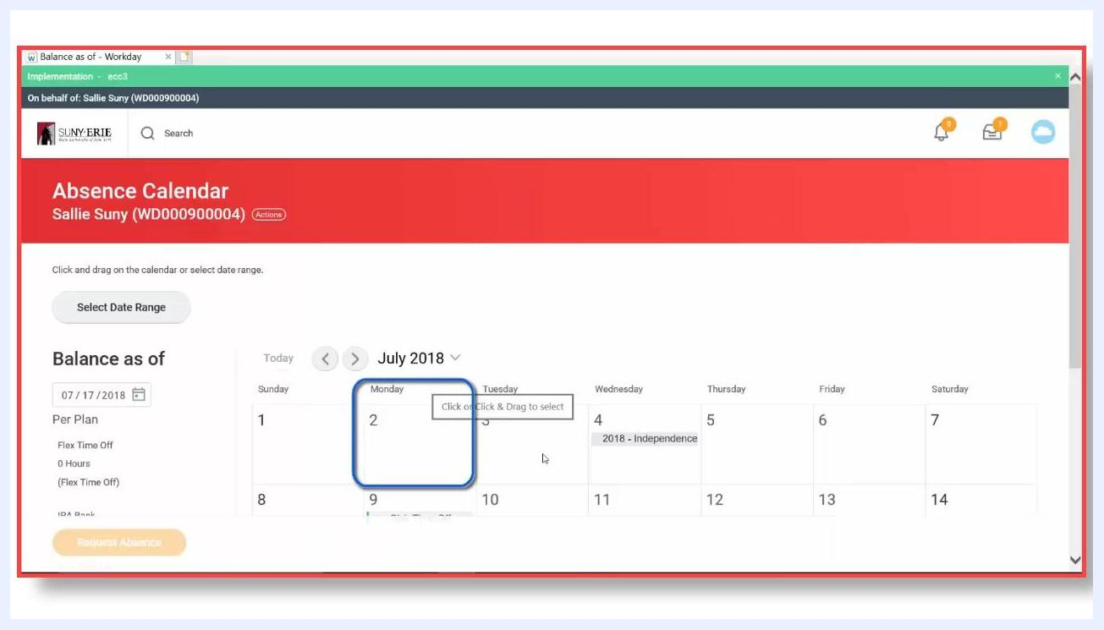
Absence calendar showing July 2nd now empty after cancellation

Correcting an approved absence

- Identify the approved absence.
On your Absence Calendar, locate the entry with a green bar and check mark, such as "Sick Time Off" on July 9th. This green bar confirms the absence has already been approved by your supervisor.
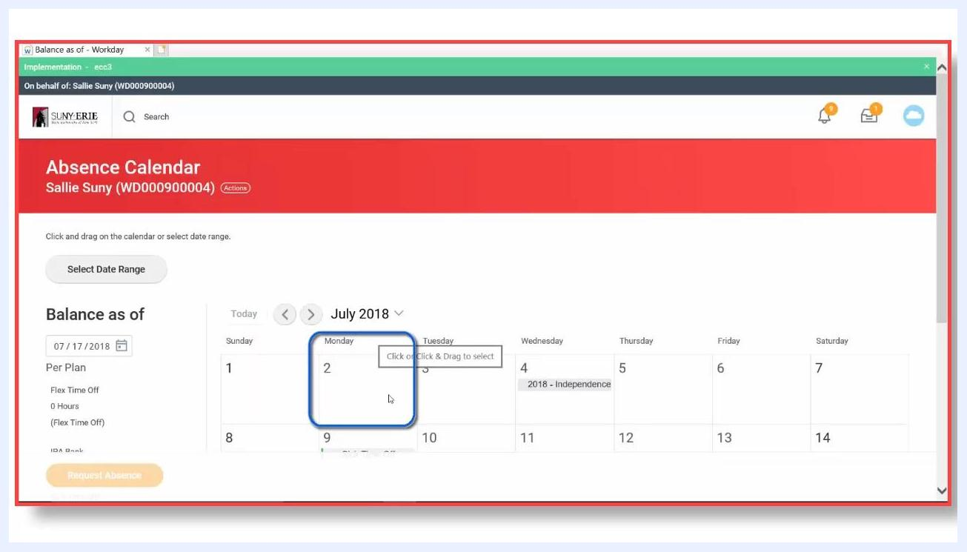
Absence calendar showing Sick Time Off on July 9th with a green bar and check mark

- Select the approved absence to correct.
Click the approved entry, for example "Sick Time Off" on July 9th, to open the Correct Absence window, where you can make changes or cancel the request.
Correct Absence window for Sick Time Off on July 9th with 8 hours selected

- Choose your correction action.
At the bottom of the Correct Absence window, you have two options:
- Cancel the absence if you no longer need it.
- Edit the absence details if you need to change the hours or other information.

- Edit the absence details.
To change the number of hours, update the Quantity per Day field. For example, change the value from 8 to 2 to reflect taking only 2 hours of sick leave instead of 8.
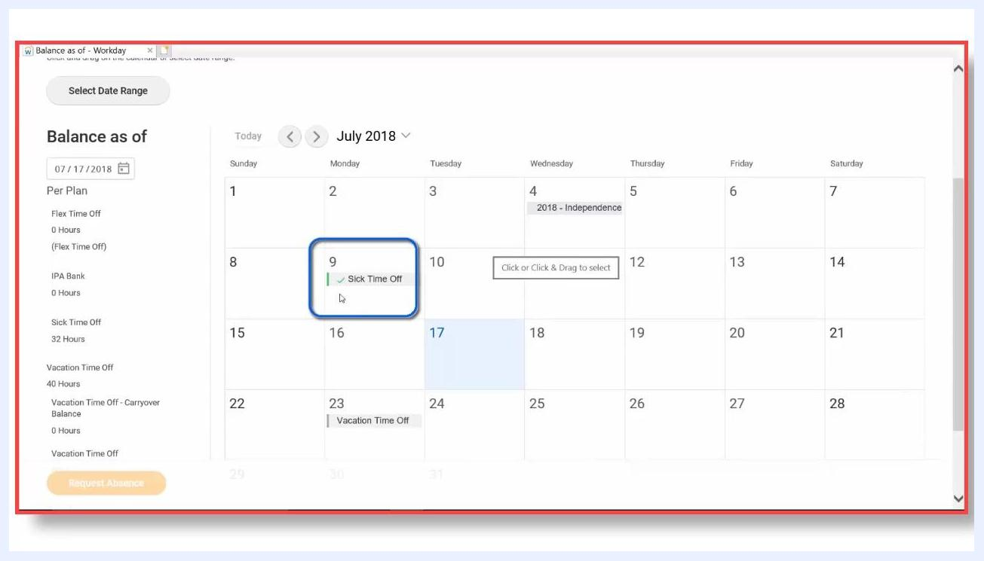
Quantity per Day field being changed from 8 to 2

- Enter the required comments.
In the Comment field, enter the specific hours or reason for the change, for example "8 a.m. to 10 a.m." to indicate the new time range. If you have supporting documents, use the attachment section to upload files, and add any additional comments as needed.
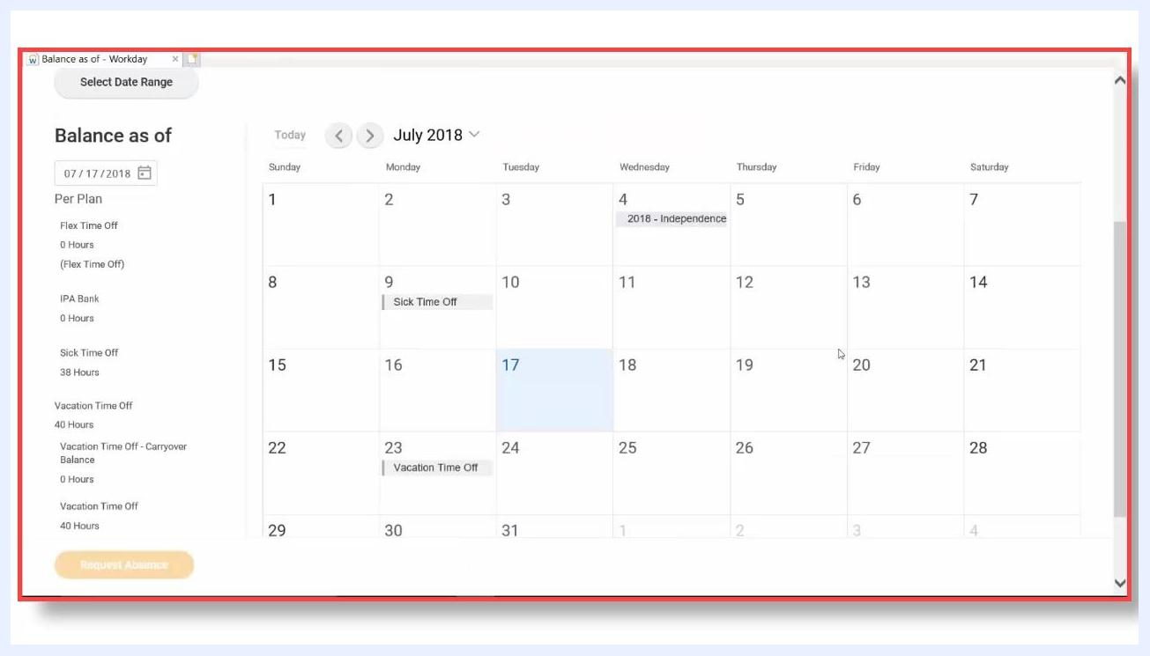
Comment field highlighted for entering details such as "8 a.m. to 10 a.m."

- Submit the correction.
Once all changes and comments are entered, click Submit to finalize your correction.
- Verify the correction status.
Return to your Absence Calendar. The corrected absence, such as the July 9th entry, now displays with a gray bar, indicating it is pending supervisor approval again.

Absence calendar showing Sick Time Off on July 9th now with a gray bar, pending approval

- Confirm completion.
You have successfully submitted a correction for an approved absence. The request is now routed back to your supervisor for review and approval.
SUNY Erie logo and Workday Training Tools screen confirming completion

Summary
You now know how to change your availability in Workday by correcting an absence request. For an absence that is submitted but not yet approved, select it on your calendar, cancel it, and provide a comment. For an absence that has already been approved, select it, edit the hours or cancel it, add a required comment, and submit the correction. Always check the status of your absence before proceeding, since corrections to approved absences will revert to a pending state and require supervisor approval again.

What's next
Once your correction is submitted, monitor your Absence Calendar to confirm your supervisor has reviewed and approved the updated request.

