How to Change Tax Withholding in Workday
Workday Payroll gives you the tools to manage worker tax elections, including country-specific rules for the U.S., Canada, the UK, and France. This guide walks you through how to change tax withholding in Workday, whether you're auditing existing elections, adding new tax elections on behalf of a worker, or reviewing a worker's current tax setup.
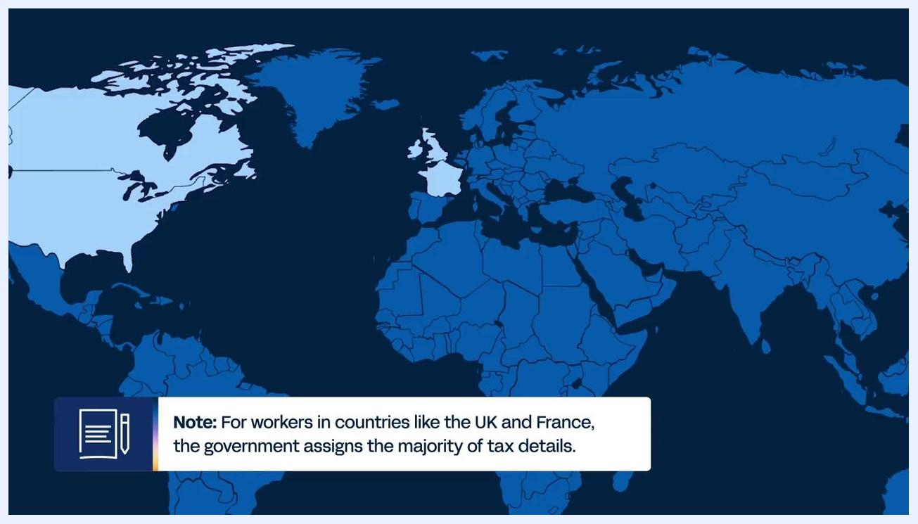
A world map highlights the UK and France, with a note explaining that the government assigns most tax details for workers in these countries.
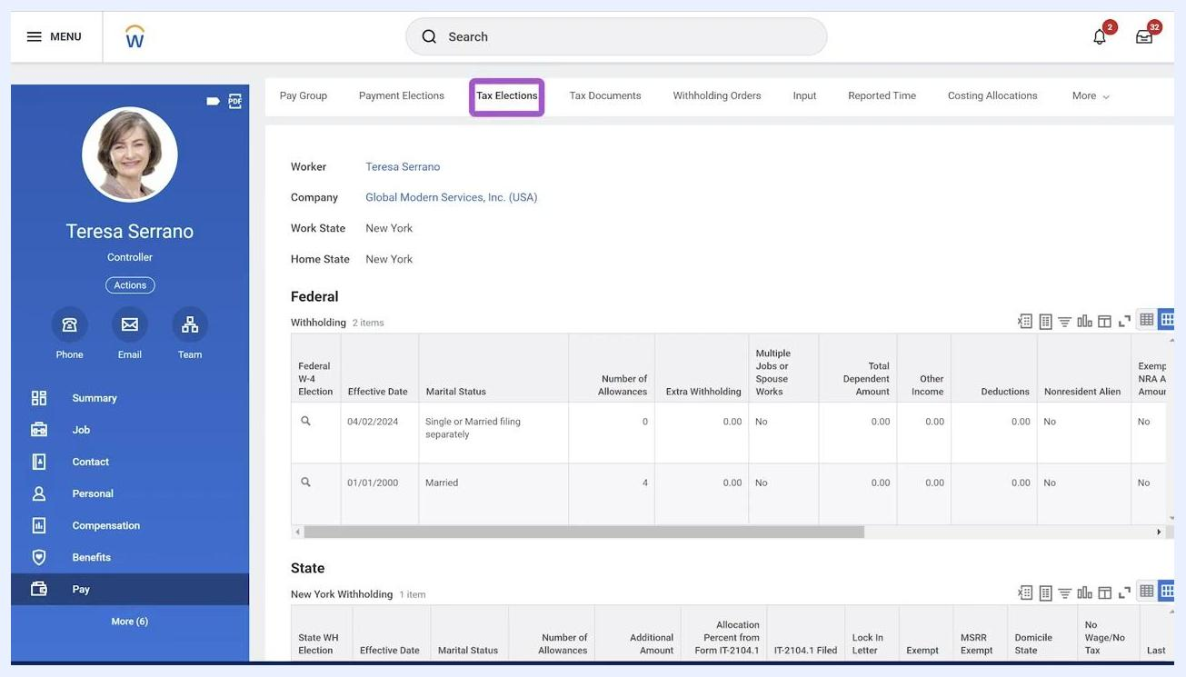
Workday logo on a blue background, indicating the end of the session.

Prerequisites
Before you load or update worker tax details, confirm the following:
- Each worker must be assigned both a company and a pay group. This assignment is required before tax details can be loaded, typically during the deployment phase of Workday Payroll.
- Worker home and work addresses must be accurate, since these addresses drive tax calculations in Canada and the U.S.
- Your ability to enter tax elections on behalf of workers depends on your assigned role and security settings in Workday.
A blue screen stating that if a worker has no tax elections when payroll calculates, Workday uses the defaults set by the government of that country as of the payment date.

Understand how tax elections are managed by country
Ongoing management of worker tax details varies depending on the country:
- U.S. and Canada: Workers can maintain their own federal and state or provincial tax withholding elections through the self-service Withholding Elections page.
- UK and France: The government assigns most tax details, so workers have limited self-service options. You can still update tax details on behalf of workers in bulk when needed. For the UK specifically, you can use available tasks to uplift or clear down tax codes for groups of workers.
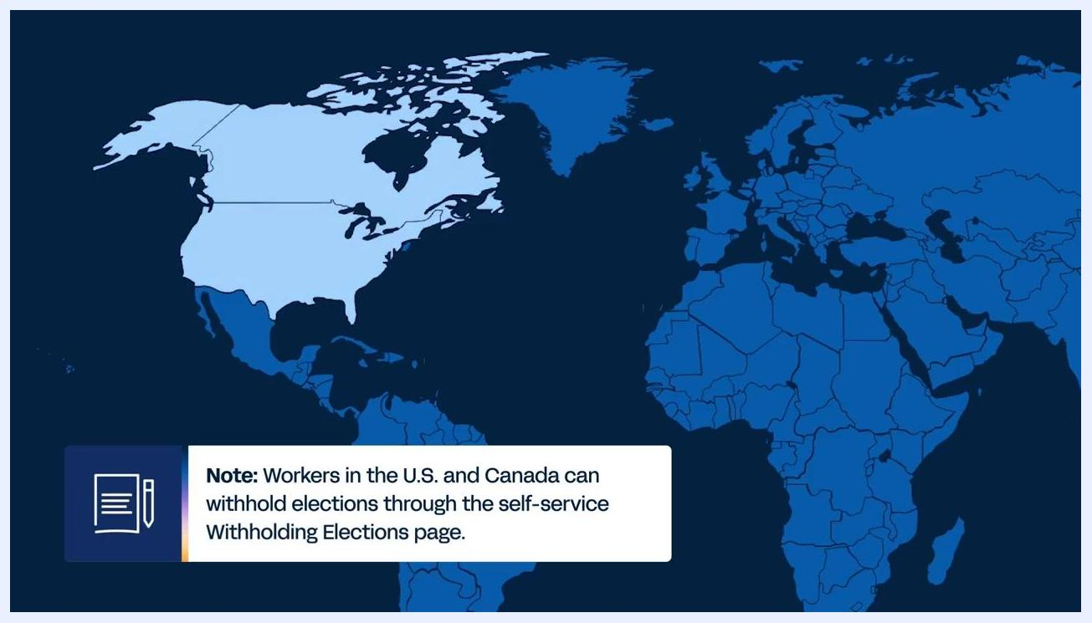
A world map highlights the U.S. and Canada, with a note explaining that workers in these countries can manage withholding elections through the self-service Withholding Elections page.
If a worker has no tax elections set when payroll is calculated, Workday automatically applies the default tax settings issued by that country's government as of the payment date.
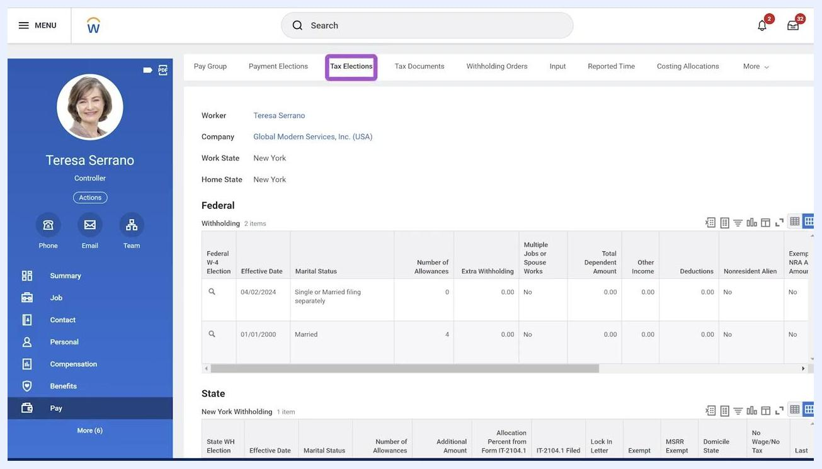
A presenter in a Workday shirt summarizes the session, with a blurred office background.

Step 1: Audit worker tax elections with reports
Before changing tax withholding, use Workday's built-in reports to check for gaps or prepare bulk updates.
- View Workers with Missing US Tax Elections — Run this report to list all workers in a company who are missing federal or state tax elections at the end of the selected period. Use it to identify compliance gaps and confirm that all required elections are in place.
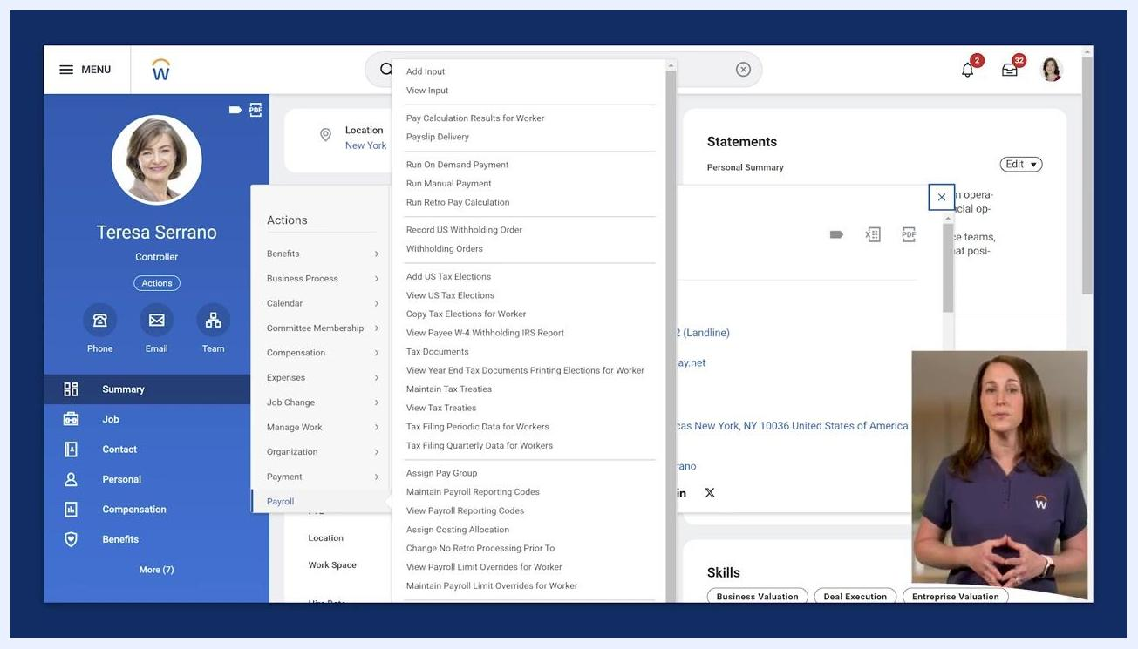
Workday interface showing the "Add Worker US Tax Elections" dialog with the Worker, Effective Date, and Company fields filled in.
- Copy Tax Elections for Workers — Use this task to duplicate tax elections from one company to another. This is especially useful during events like acquisitions and streamlines updates for large groups of workers.
- Workers by Employee / Contingent Worker Type — Run this report to list primary home and work addresses for workers, which are necessary for accurate tax calculations in Canada and the U.S. Confirm that all required tax withholding criteria are met for both the company and the worker before you enter tax elections.
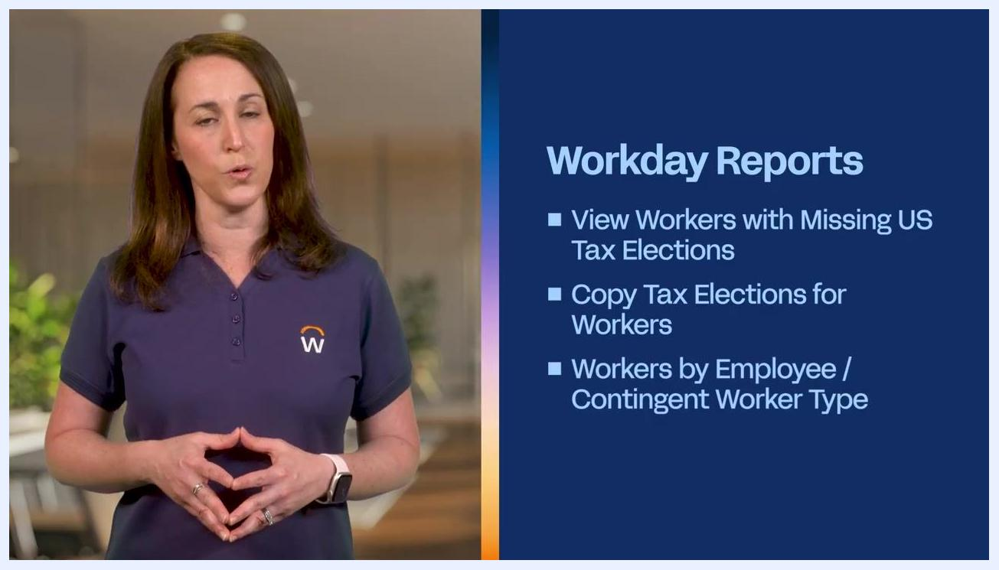
A screen titled "Workday Reports" showing the bullet "View Workers with Missing US Tax Elections."

Step 2: Access a worker's tax elections

- Navigate to the worker's profile in Workday.
- Click the Actions button.
- From the Actions menu, select Payroll.
- In the Payroll submenu, choose the appropriate report or task. For U.S. workers, select View US Tax Elections to review current tax elections.
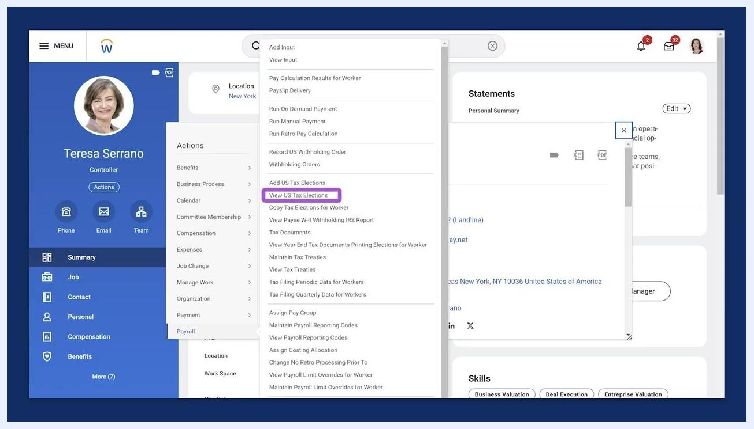
Workday interface showing a worker profile, the Actions button, the Payroll menu, and the "View US Tax Elections" option highlighted.

Step 3: Add US tax elections for a worker
If a worker needs updated tax information for the pay period — for example, a worker returning from leave — select Add US Tax Elections from the Payroll menu. This task has two parts.
On the first page, enter the general information:
- Worker: Select the worker's name.
- Effective Date: Enter the date the tax election should take effect.
- Company: Select the appropriate company.
- Work State and Home State auto-populate based on the worker's primary addresses. If the company allows multiple work tax jurisdictions, add any additional states as needed.
A screen titled "Workday Reports" showing two bullets: "View Workers with Missing US Tax Elections" and "Copy Tax Elections for Workers."

Step 4: Enter federal, state, and local tax details
After entering the general worker information, continue to the next page to add specific tax details.

- Navigate to the Federal, State, and Local tabs within the "Add Worker US Tax Elections" screen. Each tab manages tax elections specific to that jurisdiction.
- Click the plus (+) icon in the appropriate grid (for example, the Federal W-4 Election grid) to add a new tax election.
- Fill in all required fields for the new row, such as:
- Effective Date
- Marital Status (for example, Single or Married filing separately)
- Number of Allowances
- Extra Withholding
- Multiple Jobs or Spouse Works (check if applicable)
- Total Dependent Amount, Other Income, Deductions, Nonresident Alien, Exempt from NRA Additional Amount, Lock In Letter, Exempt, No Wage/No Tax (enter values as needed)

- Repeat this process on the State and Local tabs if additional elections are required.
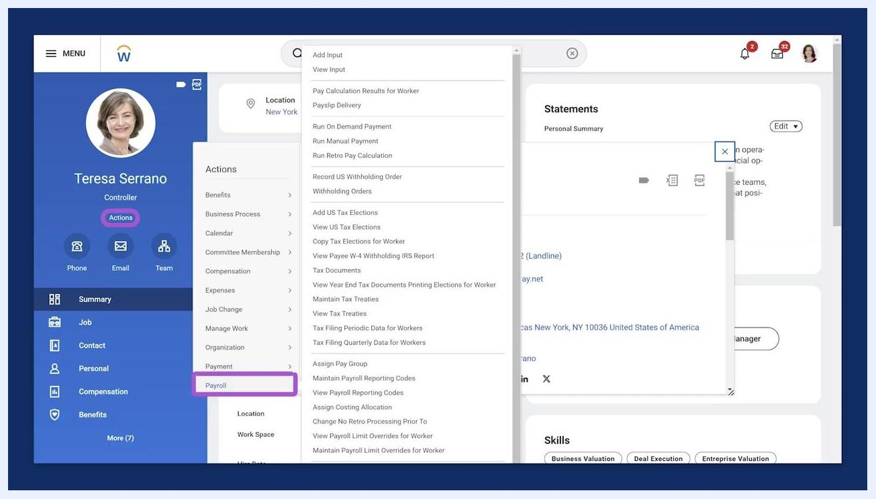
A screen titled "Workday Reports" showing three bullets: "View Workers with Missing US Tax Elections," "Copy Tax Elections for Workers," and "Workers by Employee / Contingent Worker Type."
Workday "Add Worker US Tax Elections" screen showing the Federal, State, and Local tabs, with a grid for entering detailed tax election information.
Close-up of the Federal tax election grid showing a completed row with Effective Date, Marital Status, and other tax details.
Before saving, confirm that all entered information is correct in the grid. You can review each election's details, including effective date and marital status, directly in the summary grid.

Step 5: View a worker's tax elections from the pay profile

- Go to the worker's profile and select the Pay section.
- Click the Tax Elections tab at the top of the pay profile.
- Review all federal, state, and local tax elections for the worker, including historical and current records.
Workday worker pay profile with the "Tax Elections" tab highlighted, showing federal and state tax election details.
Workers can also access their own tax elections from this tab, or by using the Pay Worklet on their Workday home page.

End screen with Workday branding, prompts to subscribe, check out playlists, and follow on social media.

Summary
Workday manages worker tax elections differently depending on the country, with self-service options available in the U.S. and Canada and more limited options in countries like the UK and France where the government assigns most tax details. Using Workday's reports and tasks, you can audit missing elections, copy elections between companies, and add or update federal, state, and local tax details for individual workers, giving you a complete and accurate view of tax withholding for payroll processing.
A presenter stands in front of a blurred office background. On the right, a graphic displays a checkmark icon with the words "Company" and "Pay Group."

