How to Change Personal Information of an Employee in Workday
This guide explains how HR representatives can update an employee's personal information in Workday, including how to submit changes, track approval status, and confirm completion.
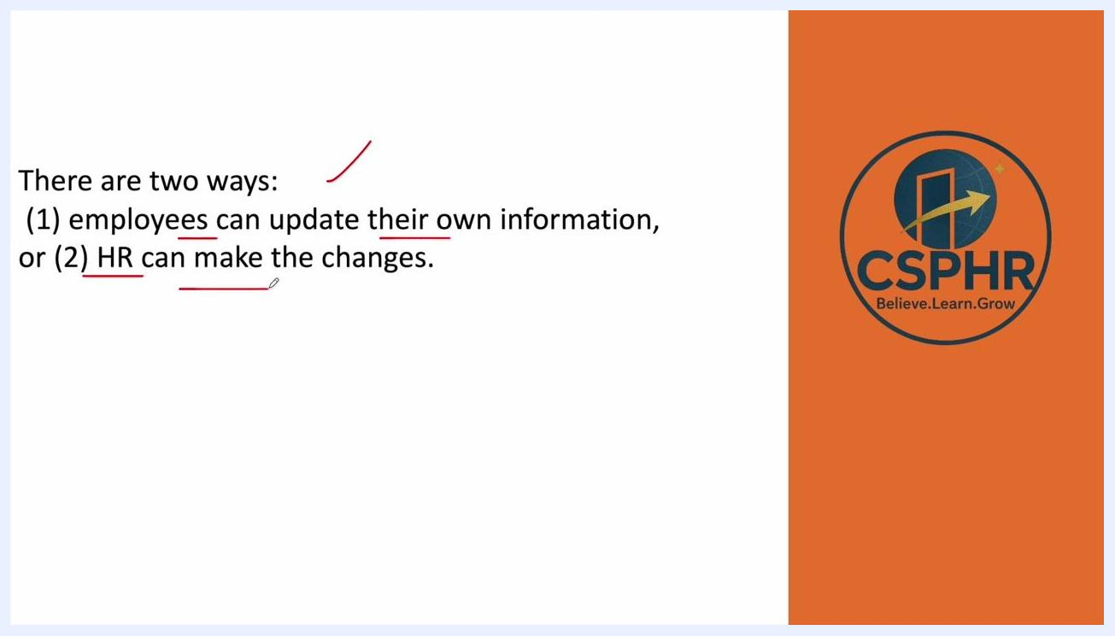
Title slide showing "How to Change Personal information of Employee in Workday!" with CSPHR logo

Prerequisites
- Access to the Workday portal with HR credentials.
- Appropriate permissions to view and edit employee personal information (the availability of certain options, such as the Edit button, depends on your permission level).

Overview of update methods
Workday allows personal information to be updated in two ways:
- Employees can update their own information directly.
- HR representatives can make changes on behalf of an employee.
This guide focuses on the HR process for updating employee personal information.

Step 1: Log in to the Workday portal
Access the Workday portal using your HR credentials.

Step 2: Search for the employee
Enter the employee's name in the search bar at the top of the Workday dashboard.

Step 3: Open the employee profile
Select the employee from the search results to open their profile.

Step 4: Locate the Personal option
In the employee profile, use the left-hand navigation menu and click Personal to access the employee's personal information.
Employee profile screen with the "Personal" option highlighted in the left menu, showing employee details

Step 5: Edit employee information
On the Personal Information page, click the Edit button to begin making changes.
Note: The Edit button may not always be visible, depending on your permissions.
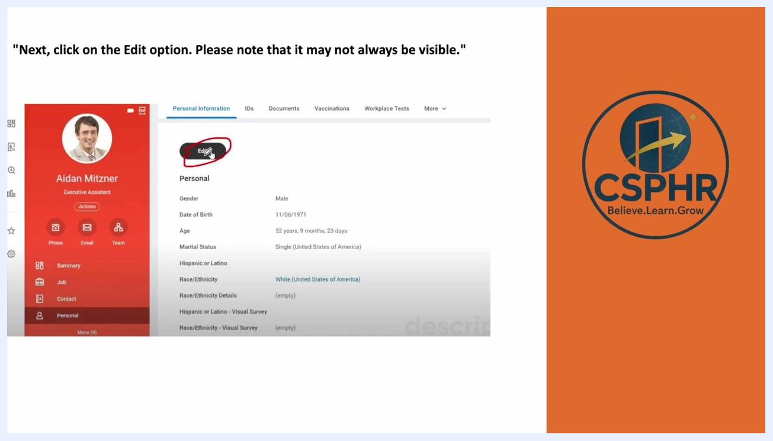
Personal Information screen with the "Edit" button circled, showing employee details such as gender, date of birth, and marital status

Step 6: Use the Actions menu if Edit is not visible
If the Edit button is not available, click Actions in the employee profile, then select Personal Data from the drop-down menu. This opens additional options for editing personal information.
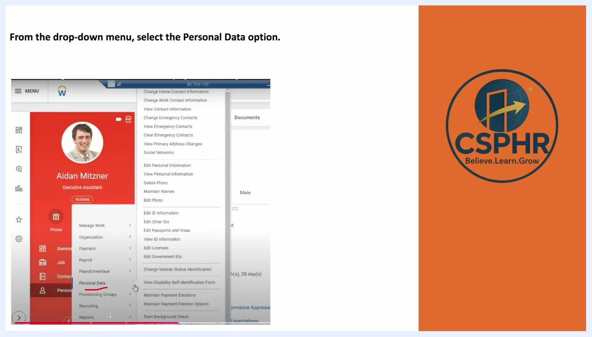
Actions menu open with "Personal Data" highlighted, showing options such as Edit Personal Information and View Personal Information

Step 7: Select Edit Personal Information
In the expanded menu, click Edit Personal Information to change specific details such as date of birth or marital status.
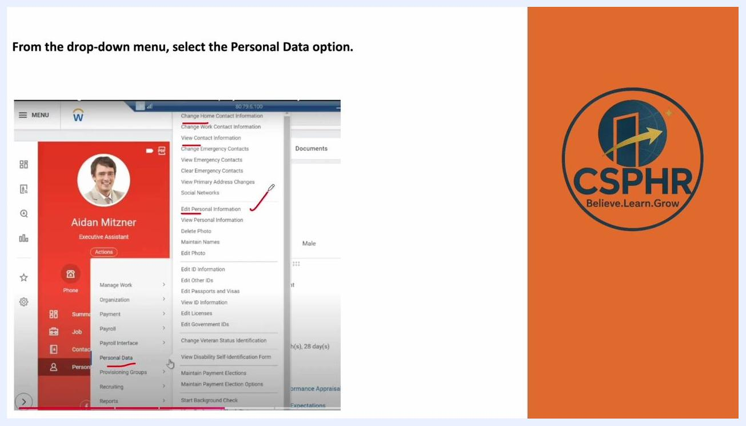
Dropdown menu with "Edit Personal Information" highlighted, showing available actions

Step 8: Update the required information
For example, to change the date of birth:
- Locate the Date of Birth field.
- Enter the new date (for example, changing from 11/06/1971 to the correct date).
- Use the calendar picker if needed.
After making the necessary changes, click Submit at the bottom of the page.
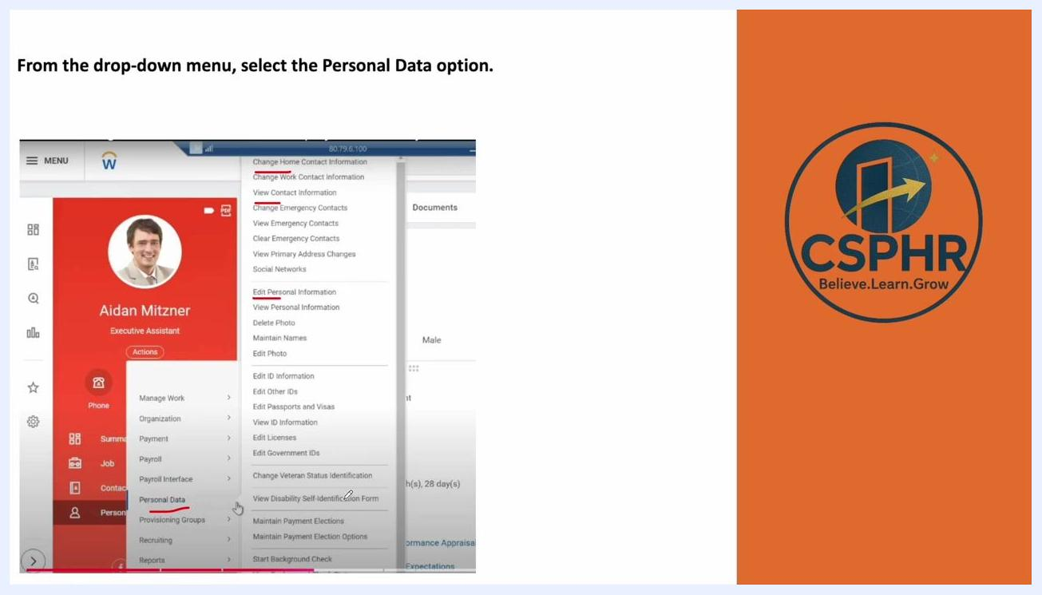
Edit screen showing the Date of Birth field being updated, with a calendar picker and "Submit" button visible

Step 9: Review and process the changes
Once submitted, review the updated details in the Details and Process section. Confirm that the employee name and the pending action are correct.

Step 10: Wait for employee approval
After submitting changes to personal information (such as date of birth), the process requires approval from the employee. In the Details and Process section, review the Process History table:
- Locate the row labeled "Personal Information Change."
- Check the Status column for "Awaiting Action."
- Confirm the Person column lists the employee's name (for example, "Aidan Mitzner (Employee As Self)").
This confirms the process is pending employee approval.
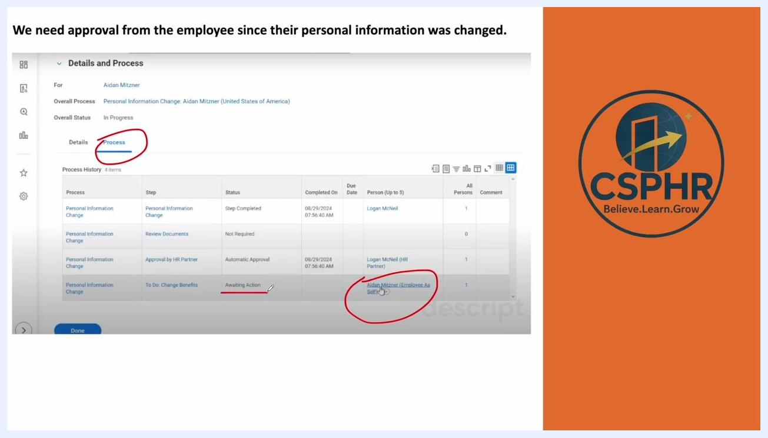
Workday Details and Process screen showing Process History with "Awaiting Action" status for employee approval, with the employee name circled

Step 11: Complete the HR task
Click Done at the bottom of the Details and Process screen to finish your part of the process.
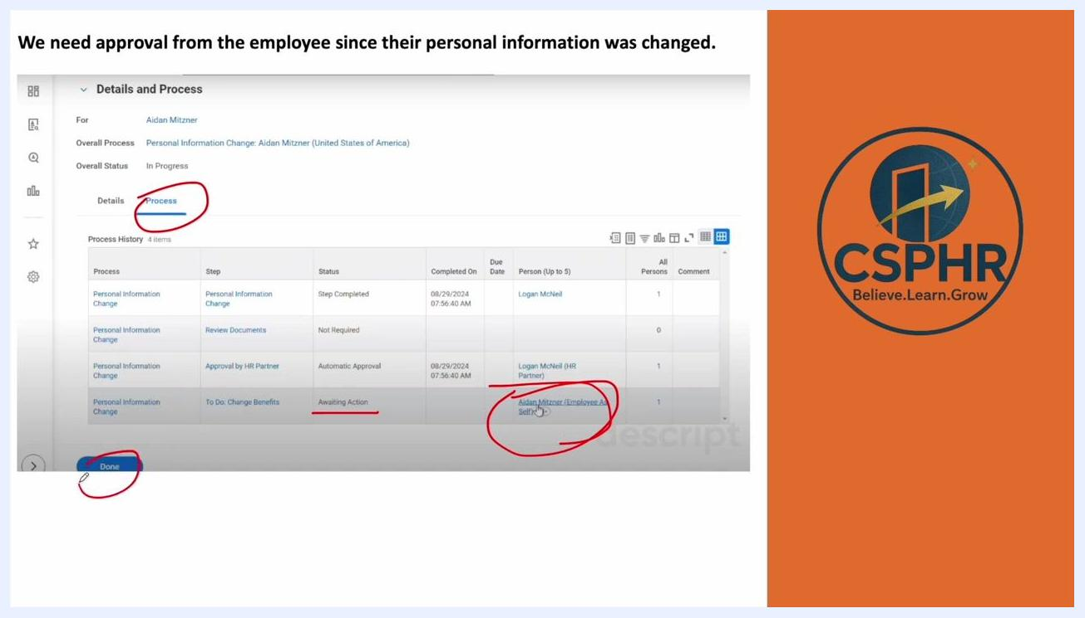
Workday Details and Process screen with the "Done" button highlighted, indicating HR's part is complete

Step 12: Verify the change in Worker History
Navigate to the employee's profile, click the Job tab in the left-hand menu, then select Worker History from the top navigation bar. In the Worker History table, locate the entry for "Personal Information Change" and check the Status column:
- "In Progress" means the change is still awaiting employee approval.
- "Successfully Completed" means the process is finished.
The Assigned To column displays the employee's name if action is still required.

Worker History screen showing the "Personal Information Change" entry with "In Progress" status and the employee name circled in "Assigned To"

Step 13: Wait for the employee to approve the change
The process remains "In Progress" until the employee logs in and approves the change. Once approved, the status updates to "Successfully Completed" in the Worker History.

Additional resources and support
For more guidance on Workday or HR processes, consider enrolling in practical HR training. CSPHR offers:
- 100% practical HR training with live online classes.
- Coverage of Core HR, Payroll, Excel, HR Analytics, and AI tools.
- Personalized guidance, resume support, and placement assistance.
- Job-readiness within 90 days of training completion.
Contact details:
- Website: www.csphr.co.in
- Phone: +91-9108617806
- Email: management@csphrglobal.com
Thank you slide with CSPHR logo, contact details, and a summary of training and support services
If you are looking for specific HR training, visit the CSPHR website, reach out via WhatsApp or phone at +91-9108617806, or contact management@csphrglobal.com by email.
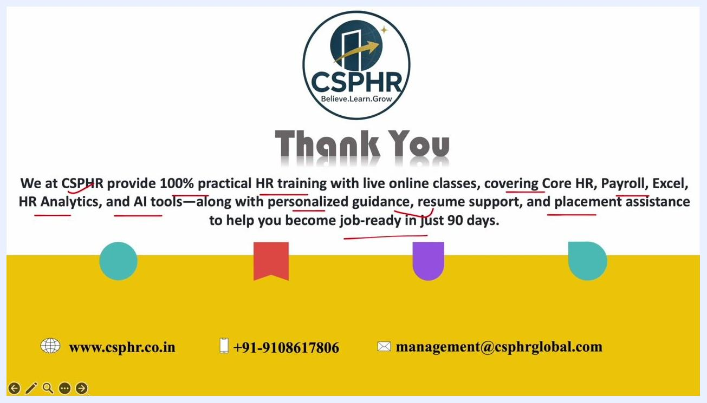
Thank you slide with CSPHR logo, summary of HR training services, and contact details including website, phone, and email
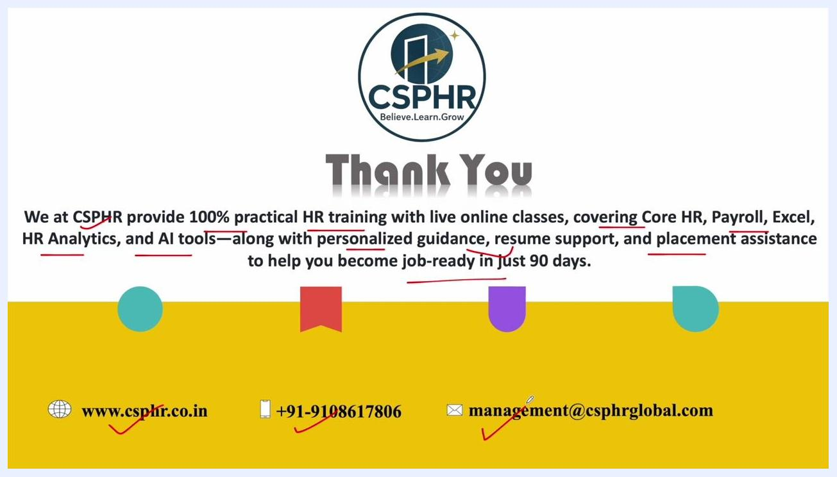
Thank you slide with CSPHR logo, summary of HR training services, and contact details including website, phone, and email

Summary
By following these steps, HR representatives can efficiently update and track changes to employee personal information in Workday, ensuring accuracy and compliance throughout the process. For additional guidance, revisit the contact information above or explore further training resources on the CSPHR website.

