How to cancel approved time off in Workday
If you need to cancel a previously approved time off request, Workday provides a straightforward process that includes manager approval and confirmation steps. This guide walks you through how to cancel approved time off in Workday, from locating your request to verifying it has been removed from your schedule.

Prerequisites
- Access to your Workday account with your organization's login credentials.
- An existing time off request that has already been approved.
- Awareness that canceling approved time off may require manager approval and could affect your vacation or leave balance.

Steps to cancel approved time off in Workday

1. Log in and navigate to the Time Off section
Log in to your Workday account using your organization's credentials. Navigate to the Time Off section, which may be labeled Time Off or Absence depending on your organization's configuration.

2. Open your time off requests
Click the Request Time Off button. Locate the time off request you wish to cancel by searching for the specific request or browsing through your request history.
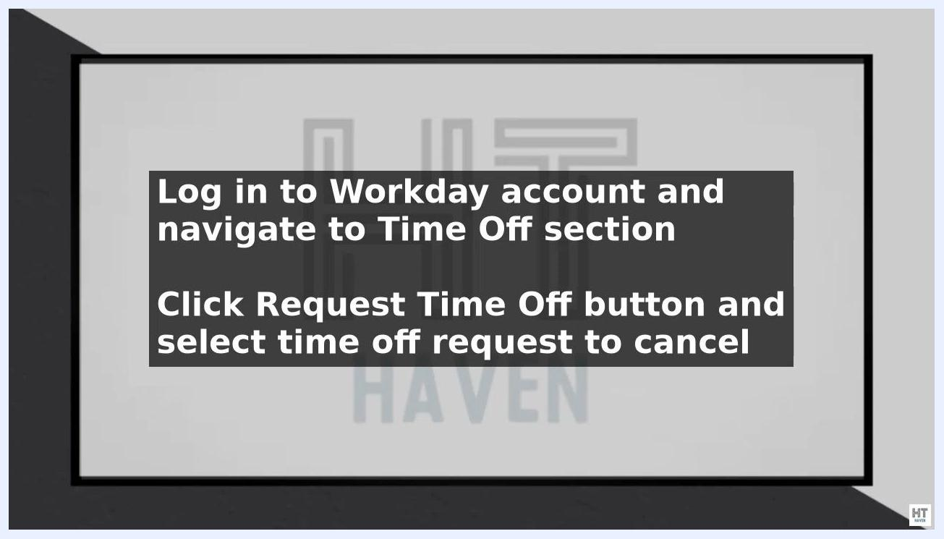
Screen with instructions: "Log in to your Workday account and go to the Time Off section. Click the Request Time Off button and select the time off request you want to cancel."

3. Select the request and submit a cancellation reason
Select the time off request you want to cancel, then click the Cancel Request button. When prompted, enter a reason for canceling the request. Providing a reason is recommended for record keeping and clear communication with your manager.
If your time off request was previously approved, you will need to obtain approval from your manager to cancel it. Canceling approved time off may impact staffing and scheduling, so your manager must be informed and approve the change.
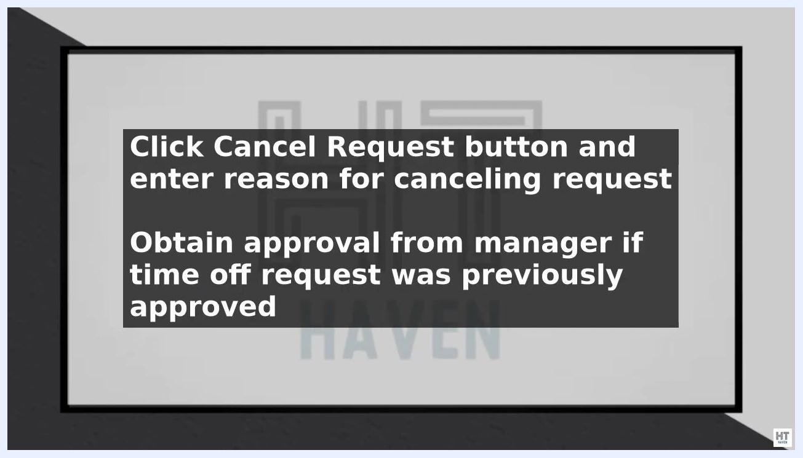
Screen with instructions: "Click the Cancel Request button and enter a reason for canceling the request. Obtain approval from your manager if the time off request was previously approved."

4. Submit the cancellation for manager approval
Click the Submit for Approval button, then select your manager as the approver. Your manager will receive a notification to review and approve the cancellation request.
Communicate with your manager and team in advance to let them know you are canceling your time off request. This helps avoid confusion or disruption to work schedules.
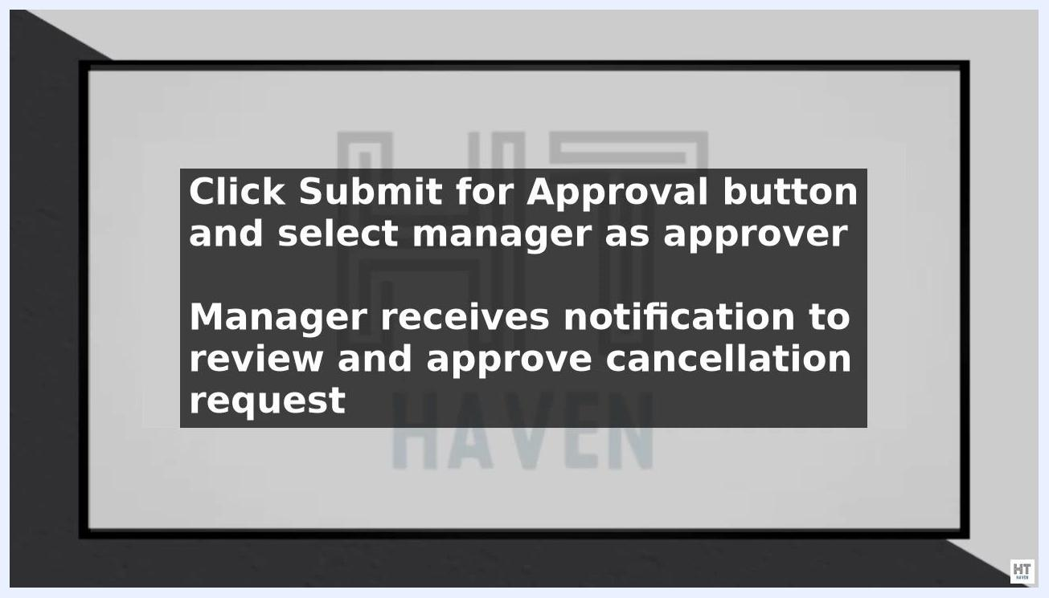
Screen with instructions: "Click the Submit for Approval button and select your manager as the approver. The manager receives a notification to review and approve the cancellation request."

5. Confirm the cancellation
After your manager approves the cancellation request, the time off will be removed from your schedule. You will receive a confirmation notification once the cancellation is complete.
Double-check your schedule in Workday to confirm the cancellation was successful. Ensure the canceled dates no longer appear as approved absences on your calendar or schedule.
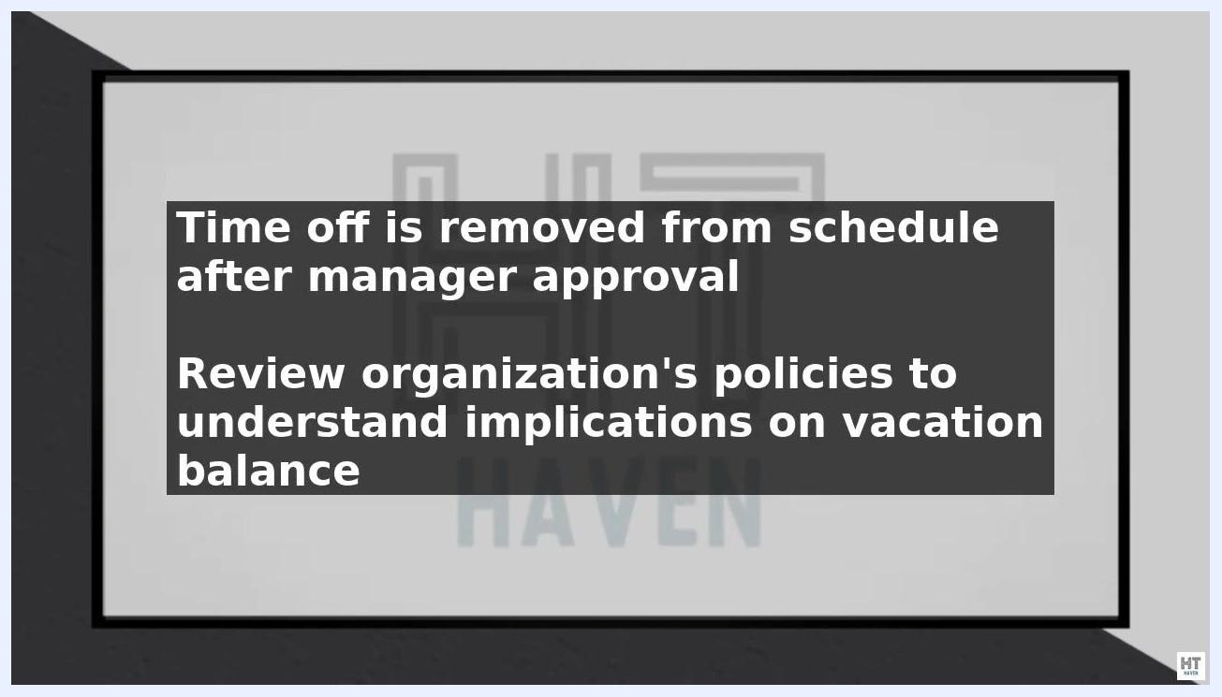
Screen displaying: "Time off is removed from the schedule after manager approval. Review your organization's policies to understand the impact on your vacation balance."

Important considerations
- Be aware that canceling approved time off may impact your vacation or leave balance. The effect on your balance depends on your organization's policies.
- Review your organization's time off policies and procedures to understand how canceling approved time off may affect benefits such as vacation accruals or leave entitlements. If unsure, consult your HR department or manager for clarification.
- Maintain clear communication with your manager and team throughout the process to avoid confusion and ensure accurate scheduling.
- Follow all organizational best practices for time off management, and adhere to your company's policies and procedures for a smooth and efficient process.
- If your time off still appears on your schedule after your manager approves the cancellation, contact your manager or HR for assistance.
- Regularly review your vacation or leave balance in Workday to ensure accuracy after any changes.

Summary
By following these steps, you can cancel approved time off in Workday while ensuring proper communication and approval processes are followed. Keeping your schedule accurate and staying informed about your organization's policies will help you manage time off changes smoothly and in compliance with company procedures.

