How to Assign Roles in Workday
This guide explains how to assign roles in Workday and how role inheritance works across your organization's hierarchy. You'll learn to locate a supervisor organization, review which roles are inherited versus manually assigned, and assign a role such as Manager directly to a worker.

Prerequisites
- An active Workday account with access to the dashboard.
- Permission to view and edit organization roles (via related actions).

Step 1: Access the Workday dashboard
Log in to your Workday account. On the dashboard, locate the Let's Focus on You section, which displays your tasks, announcements, and important dates.
Note the navigation menu on the left and the search bar at the top, which provide quick access to Workday features.
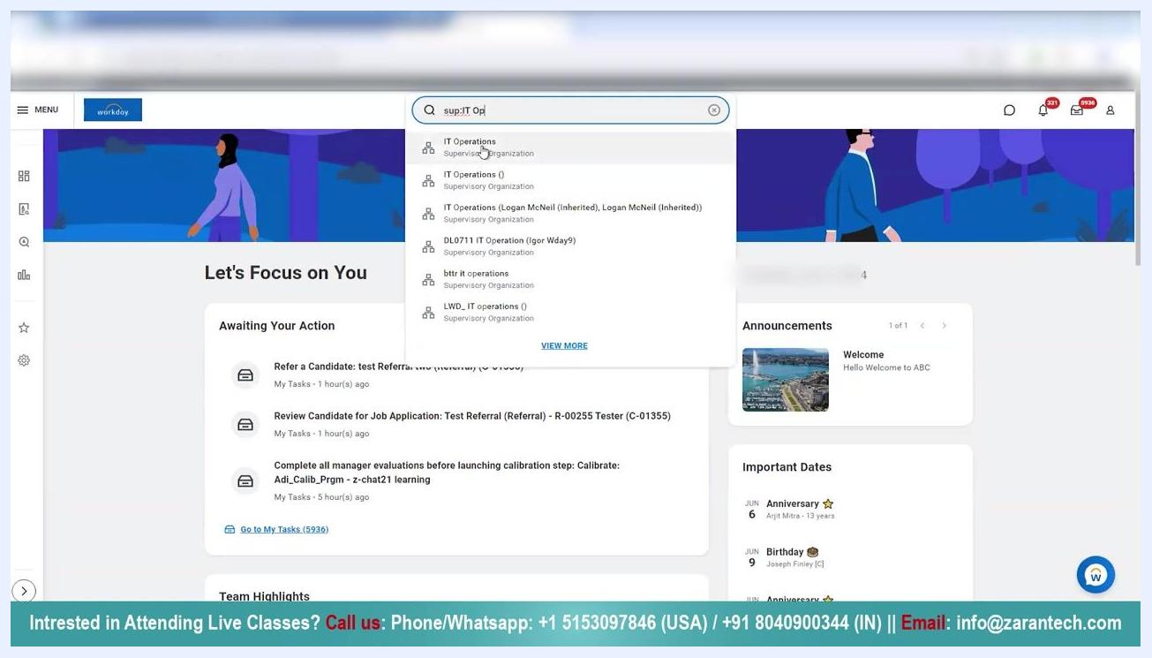
Workday dashboard showing "Let's Focus on You" with tasks, announcements, and important dates

Step 2: Search for the supervisor organization
Click the search bar at the top of the Workday dashboard. Enter the prefix sup: followed by the organization name (for example, sup:IT Operations).
Review the search results and select the relevant supervisor organization, such as IT Operations.
Workday search bar with "sup:IT Op" entered and supervisor organization search results displayed

Step 3: View organization details
After selecting the supervisor organization, review the organization details page. The page displays tabs for Members, Details, Staffing, Unavailable to Fill, Roles, Security Groups, Organization Assignments, Goals, and Additional Data.
Navigate to the Roles tab to view all roles assigned within the organization. Under Members, review the list of current members along with their positions, contact information, and locations.
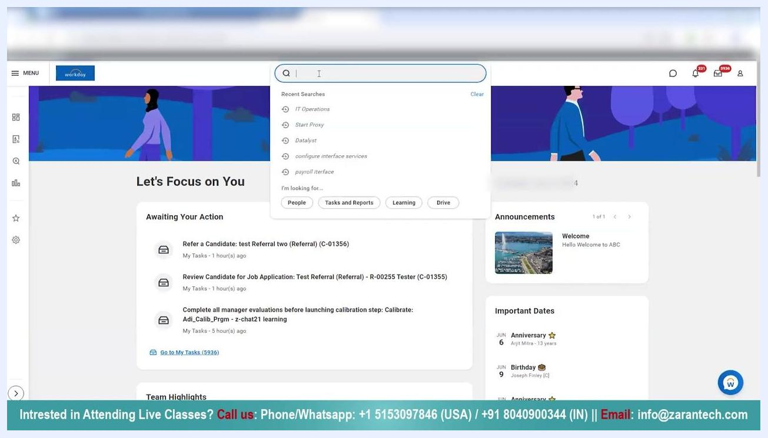
Organization details page with tabs and member list visible, "Roles" tab selected

Step 4: Filter and review assigned roles
In the Roles tab, use the filter option to search for specific roles — for example, type "Manager" in the filter box, then click Filter to display only the relevant roles.
Review the resulting list, which shows who each role is assigned to, the source of the role (such as inherited), the effective date, and whether it is a single assignment.
Roles tab with filter dropdown open, "Manager" role being filtered, and assignments to Logan McNeil shown as inherited

Review role inheritance from a superior organization
Roles assigned to a superior organization (for example, "Information Tech 2022") are automatically inherited by its child organizations, such as "IT Operations." On the IT Operations organization details page, note the Superior Organization field and the list of subordinate organizations.
In the Roles tab, review the Assignable Role column (such as Manager), the Assigned To column (such as Logan McNeil or JK_Joy Banks), and the Role From column, which shows "Inherited" for roles that cascade from the superior organization. Inherited roles do not require manual assignment at the child organization level.
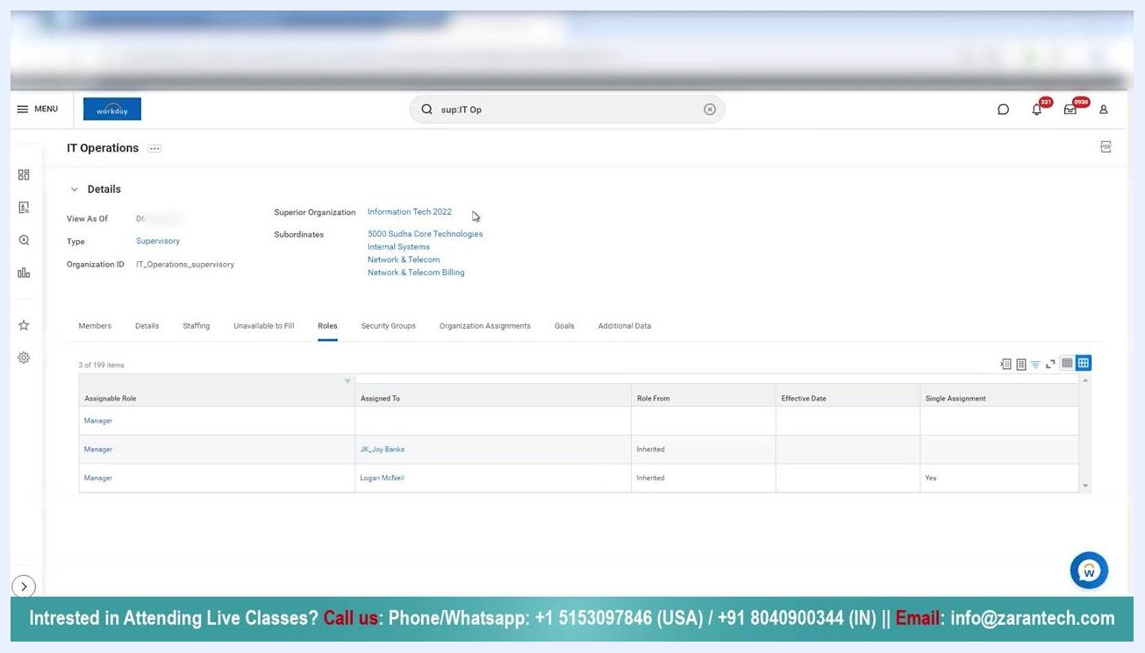
Workday IT Operations details page showing inherited Manager roles from Information Tech 2022, with columns for Assignable Role, Assigned To, Role From, Effective Date, and Single Assignment

Step 5: Confirm the organizational hierarchy
Verify that the current organization (for example, IT Operations) is a child of the listed superior organization. This hierarchical relationship is what enables role inheritance, allowing roles assigned at a higher level to cascade down to subordinate organizations.
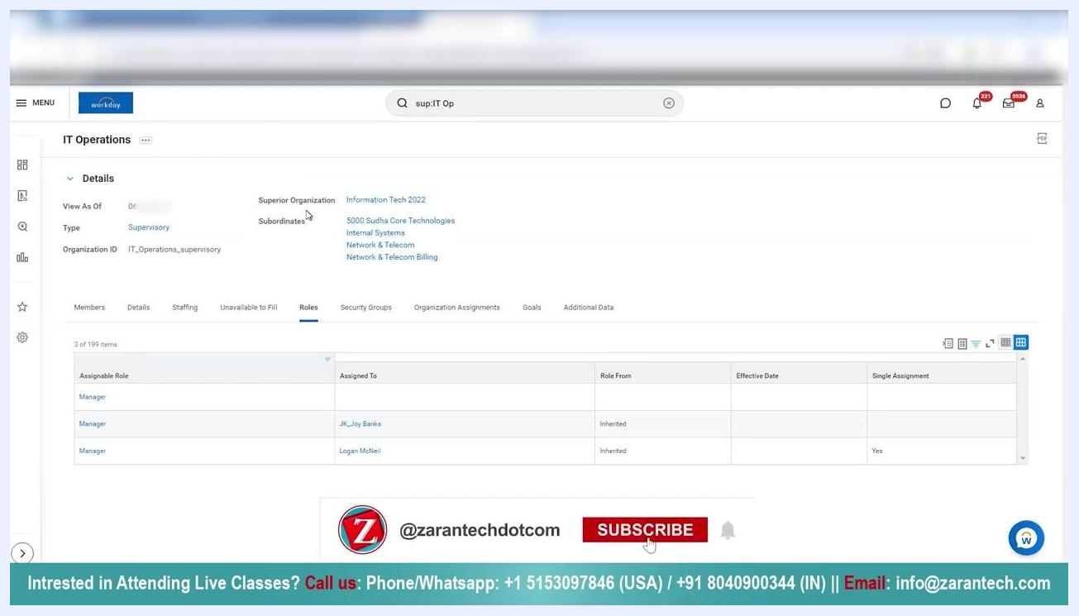
Details tab showing superior organization and subordinates, confirming organizational hierarchy and role inheritance

Understand downward inheritance to subordinate organizations
Roles assigned at the current organization level (such as IT Operations) are also inherited by its subordinate organizations. This cascading inheritance ensures consistency in role assignments throughout the organizational hierarchy.
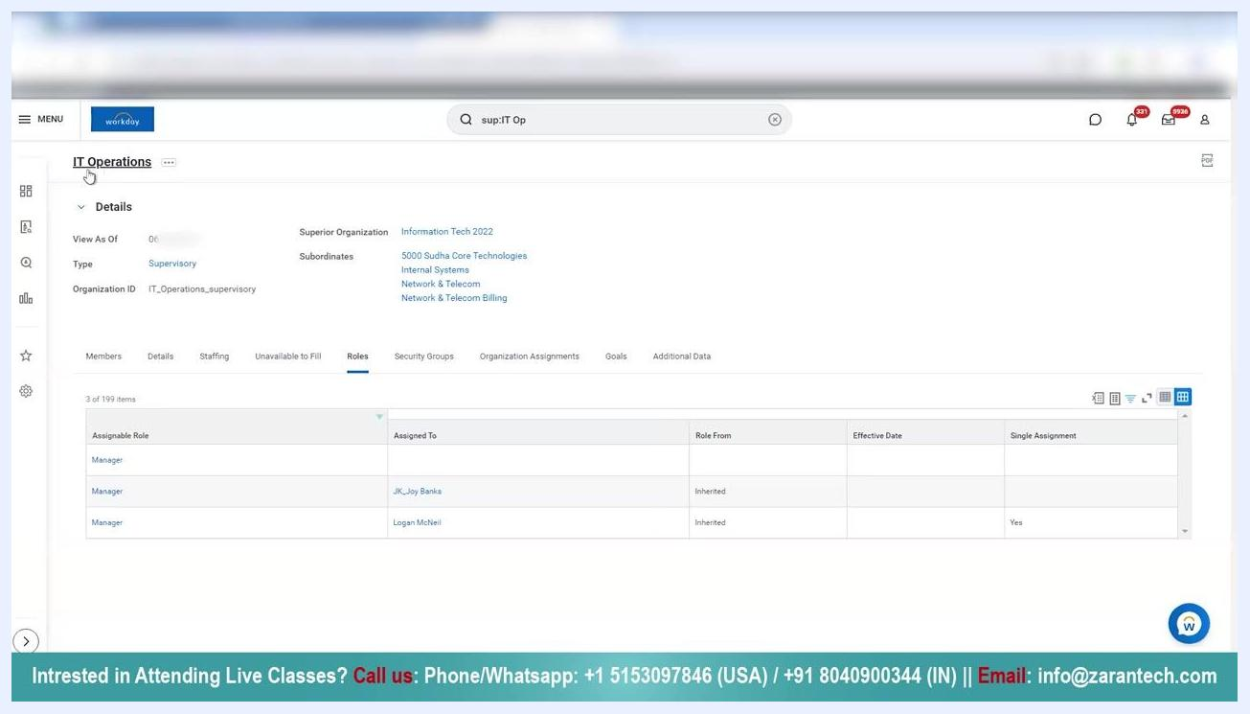
Workday IT Operations details page with focus on subordinates and inherited roles, showing the hierarchical relationship

Step 6: Navigate to the superior organization for further review
Click the Superior Organization link (for example, "Information Tech 2022") to open its details in a new tab. Review the available tabs, such as Members, Details, Staffing, Roles, Security Groups, Organization Assignments, and Additional Data.
Note that the Members tab may show "No items available" if the organization has no direct members.
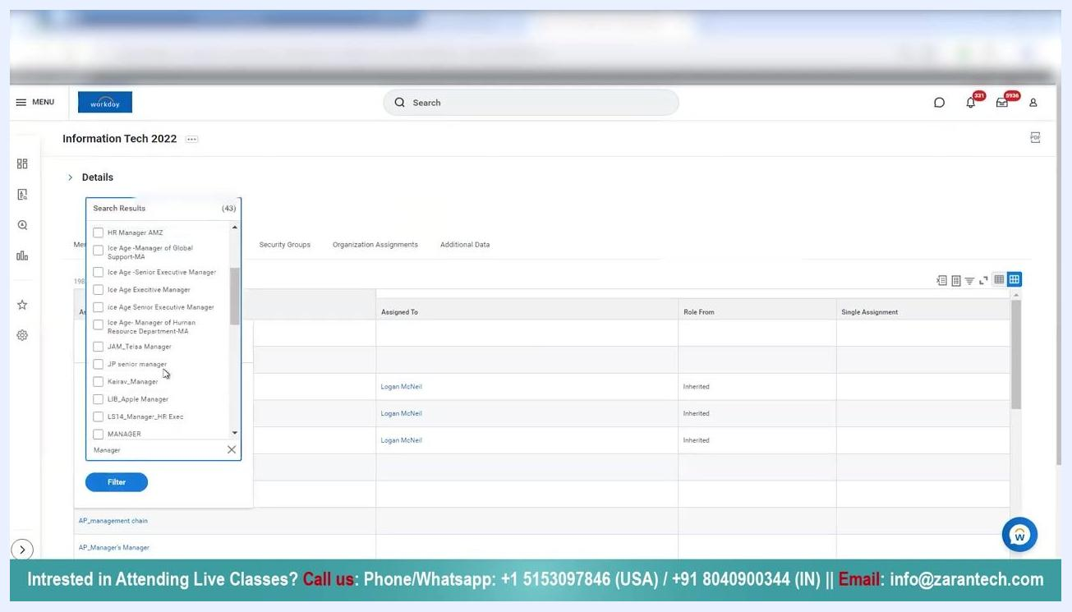
Information Tech 2022 organization details page with Members tab selected and no items available

Step 7: Filter and review Manager role assignments in the superior organization
Switch to the Roles tab in the superior organization. Use the filter box to search for the "Manager" role, select it from the search results, and click Filter to display only relevant assignments.
The filtered list shows the Manager role assigned to Logan McNeil and JK_Joy Banks, both marked as "Inherited."
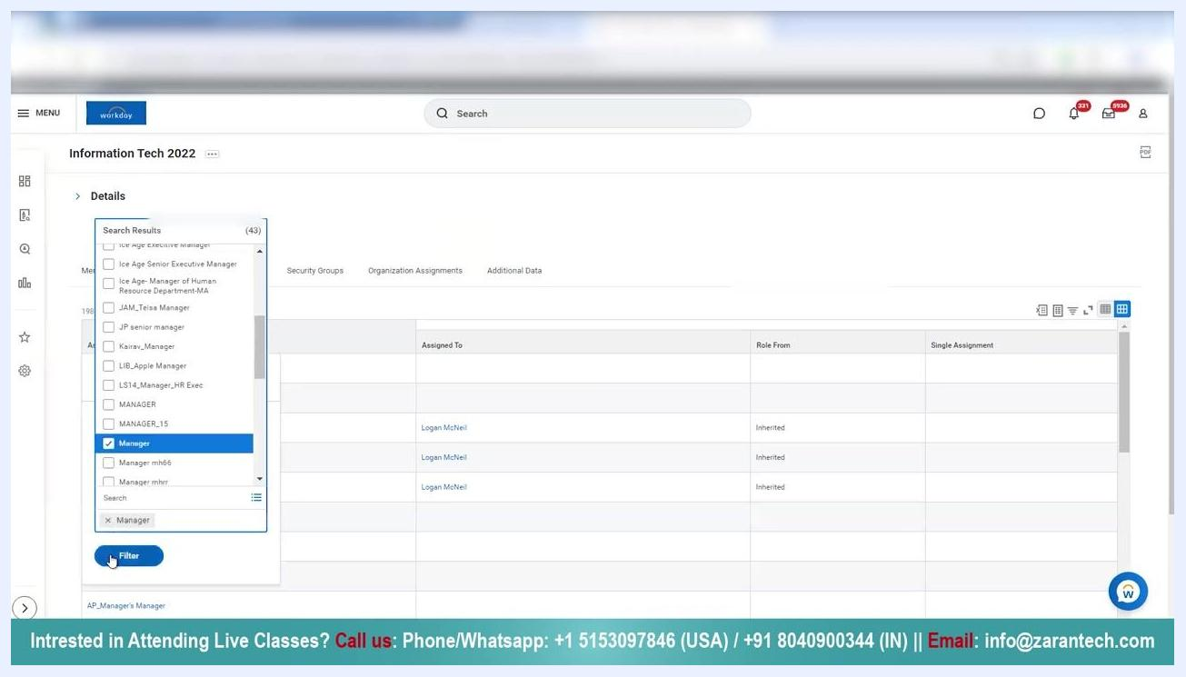
Roles tab in Information Tech 2022 with filter dropdown open, "Manager" role selected, and assignments to Logan McNeil shown as inherited

Step 8: Manually assign roles using related actions
If you need to change or assign roles manually, use the organization's related actions menu. Open the related actions menu for the organization (for example, "Information Tech 2022").
In the actions panel, navigate to Roles and select Assign Roles. This lets you override inherited roles or assign new roles directly to the organization.
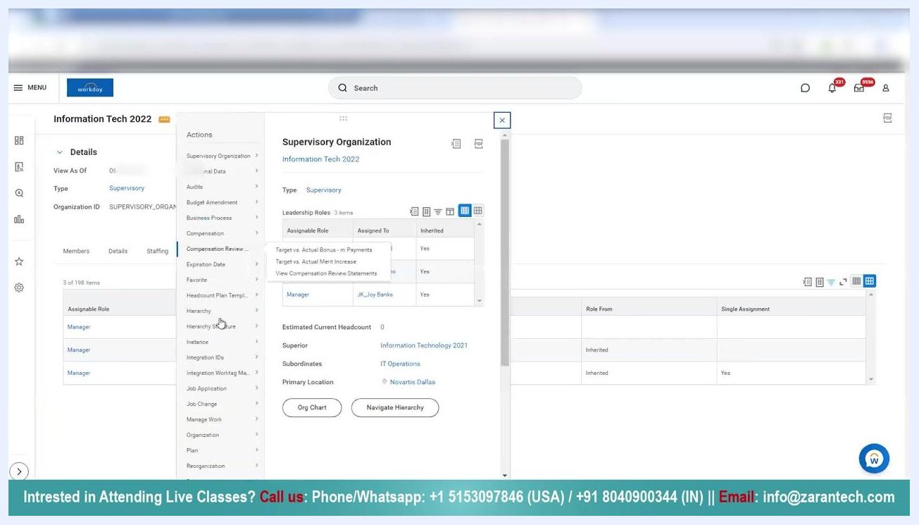
Workday related actions menu open for Information Tech 2022, showing options for roles, compensation, hierarchy, and assign roles

Step 9: Open the Assign Roles page
Navigate to the Assign Roles screen for the desired organization (for example, "Information Tech 2022"). Review the instructions at the top of the page: "Assign workers to roles. Your role changes will take effect at the beginning (midnight) of the date in Pacific Time (GMT-8 or, during daylight saving time, GMT-7)."
Note the Effective Date field, which determines when the role assignment becomes active. The Assign Roles section lets you add new role assignments, while the Current Roles section lists all existing role assignments, including columns for Assignable Role, Assigned To, Role From, and Single Assignment.
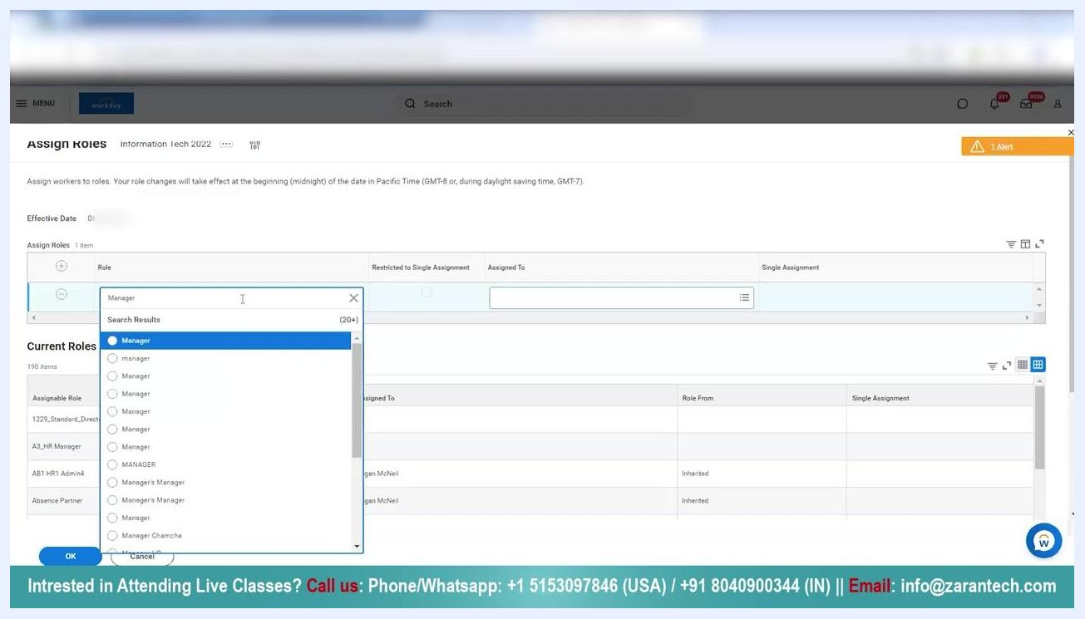
Assign Roles page in Workday showing Effective Date, Assign Roles input row, and Current Roles table with existing assignments

Step 10: Select the role to assign
In the Assign Roles section, click the field under Role and begin typing the name of the role you want to assign, such as "Manager." A dropdown list of matching roles appears, including various case variations and related roles.
Select the appropriate "Manager" role from the search results.
Role selection dropdown open with multiple "Manager" options listed in the Assign Roles section

Step 11: Choose the worker to assign the role to
In the Assigned To field, click to open the worker selection dialog. Search for and select the worker you want to assign the chosen role to.
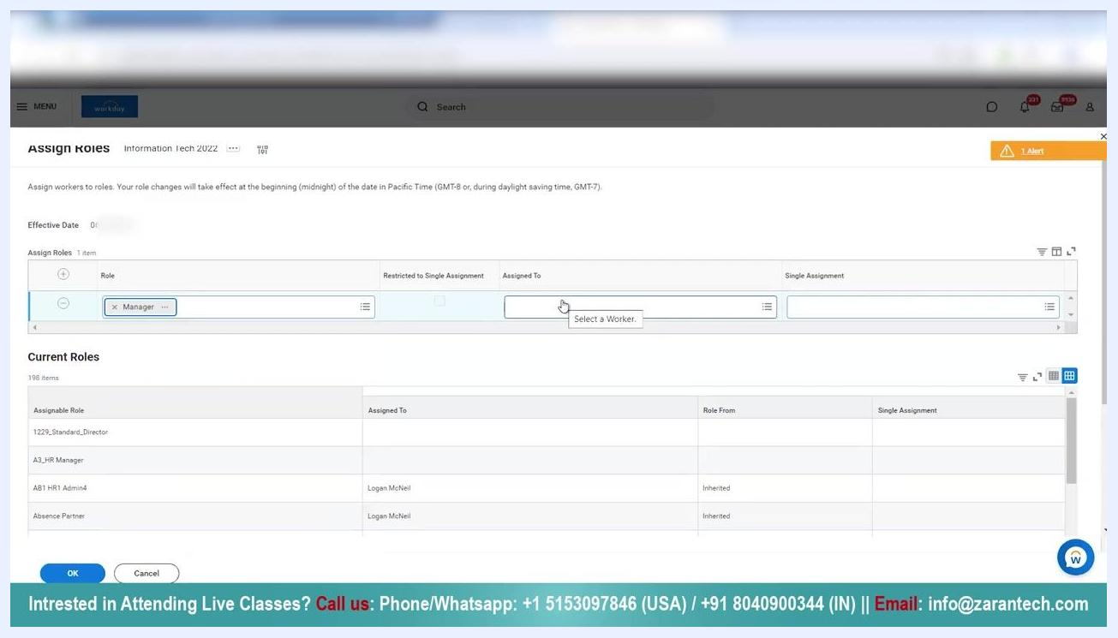
Assign Roles section with "Manager" role selected and cursor over the Assigned To field, prompting to select a worker

Step 12: Review and confirm the assignment
Ensure the correct role and worker are selected in the Assign Roles row. Review the Current Roles table below to verify existing assignments and avoid duplicates.
Click OK to save the new role assignment, or Cancel to discard your changes.

Summary
By following these steps, you can assign roles in Workday and understand how role inheritance works based on organizational hierarchy. This ensures that roles such as Manager, Absence Partner, and HR Partner are properly assigned and inherited throughout your organization, while still giving you the ability to manually assign or override roles when needed to keep assignments accurate and consistent at every level.

