How to Use a Ratchet Tie Down Strap
This guide walks you through how to use a ratchet tie down strap safely and effectively, from identifying its components to threading, tensioning, securing excess webbing, and releasing the strap after transport. Ratchet straps come in a range of sizes, weight capacities, and lengths, but the basic components and setup steps are the same across models, so the instructions below apply to most ratchet tie down straps.

Purpose
This procedure describes the correct method for setting up, tensioning, securing, and releasing a ratchet tie down strap when securing a load, such as items in a truck bed.

Scope
This procedure applies to standard ratchet tie down straps used to secure cargo. It covers component identification, strap preparation, threading and tensioning, managing excess webbing, and safe release of the strap after use.

Required equipment
- Ratchet tie down strap (with ratchet mechanism and connecting hooks)
- Secure anchor points on the vehicle or trailer
- Zip tie (for securing excess webbing)
- Scissors or a cutting tool (for removing the zip tie after transport)

Step 1: Review ratchet strap options
Ratchet straps are sold in various working loads, breaking strengths, and lengths. Common examples include a 500 lb. working load / 1,500 lb. breaking strength strap (12 feet), a 1,000 lb. working load / 3,000 lb. breaking strength strap (10–12 feet), and a heavier-duty 2" x 27' strap rated at 3,300 lb. working load. Select a strap appropriate for your load before beginning.
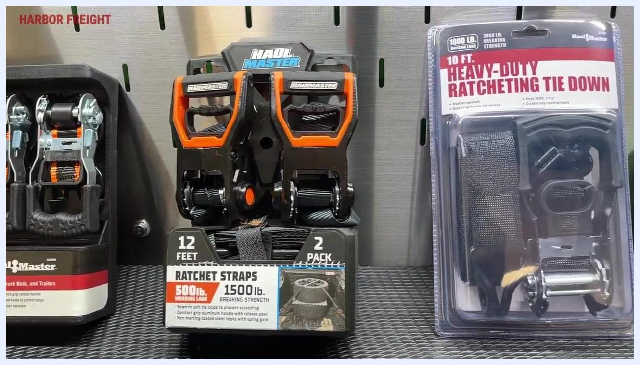
Three views of a ratchet strap in use: hands operating the ratchet, a retail display of ratchet tie downs rated at 500 lb. working load and 1,500 lb. breaking strength, and a hand holding a ratchet strap hook.
Retail packaging comparing a 12-foot ratchet strap (500 lb. working load / 1,500 lb. breaking strength) and a 10-foot heavy-duty ratchet tie down (1,000 lb. working load / 3,000 lb. breaking strength).
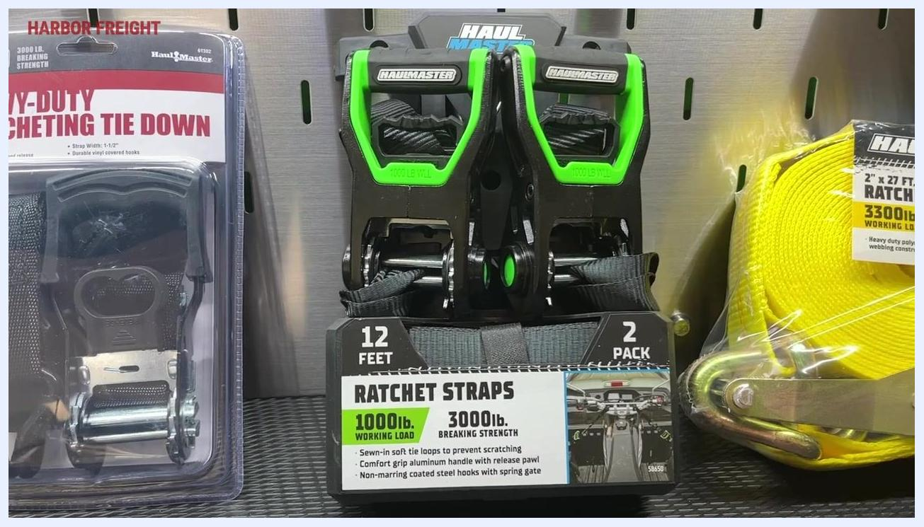
Retail display of green-handled ratchet straps rated at 1,000 lb. working load / 3,000 lb. breaking strength, alongside a yellow heavy-duty 2" x 27' strap rated at 3,300 lb. working load.

Step 2: Identify the two main sections of the strap
Every ratchet strap has two main sections: the ratchet mechanism section, which includes the ratchet itself and a connector (typically a hook), and the open-ended strap or webbing, which also ends in a hook or connector. Identifying these two sections before use makes setup easier.

Step 3: Attach both ends to secure anchor points
Attach the hook on the ratchet mechanism section to a secure anchor point. Lay out the open-ended strap or webbing and attach its hook or connector to a second secure anchor point.
A truck bed lined with blue moving blankets. The ratchet mechanism is hooked to the left anchor point, while the orange strap is laid out with a pile of webbing and its hook visible on the right.

Step 4: Untangle the strap before feeding it into the ratchet
Untangle the strap so it feeds cleanly into the ratchet mechanism. This step is necessary for proper operation and should not be skipped.
A truck bed with the orange strap hooked to the left anchor point while the other end sits in a loose pile with its hook visible on the right.
Hold the strap between your thumb and pointer finger and pull it through to straighten and remove any twists.
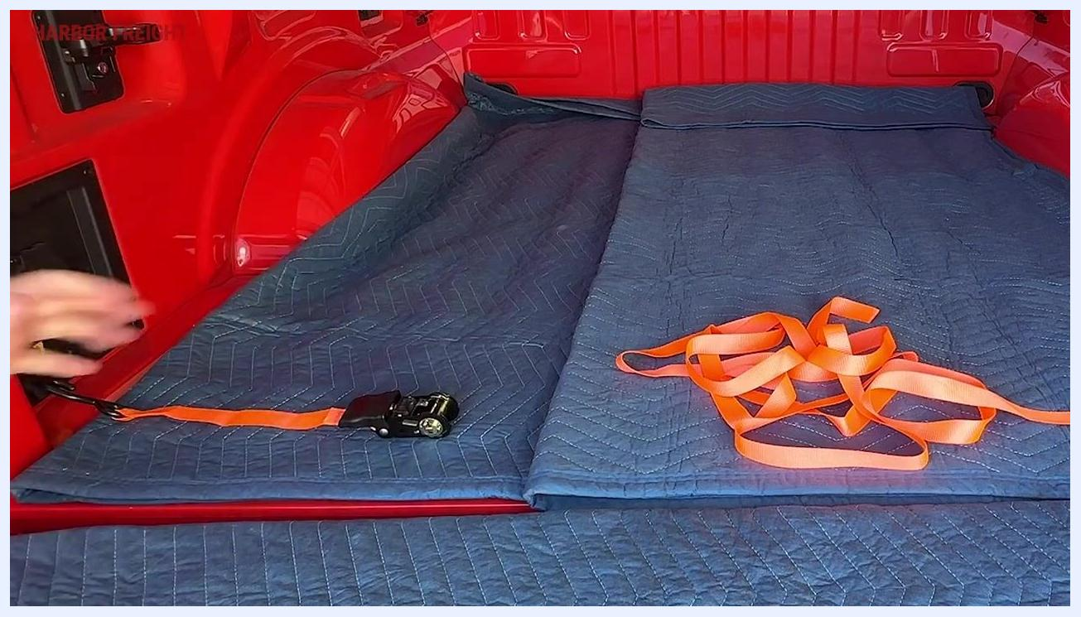
A hand holding and pulling the orange strap between thumb and pointer finger to untangle the webbing in the truck bed.
Lay the untangled strap down in front of the ratchet so it is ready to be fed through the mechanism.
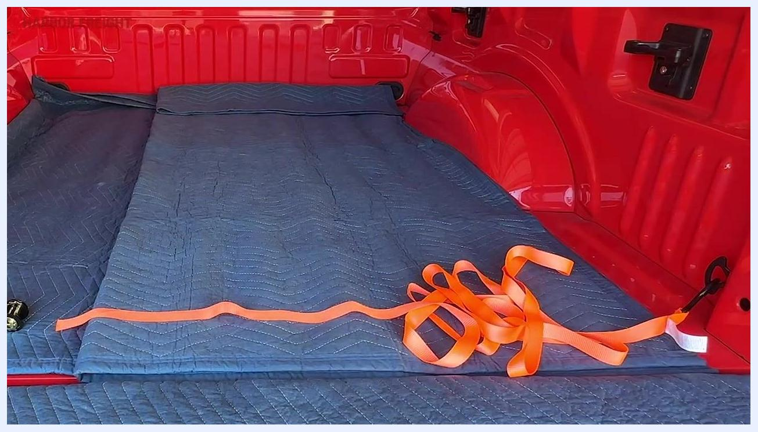
A hand holding the straightened orange strap in preparation for feeding it into the ratchet, with the rest of the strap laid out in the truck bed.

Step 5: Learn the key parts of the ratchet mechanism
Before threading the strap, familiarize yourself with the main components of the ratchet mechanism:
- Teeth: the notched wheel that allows the ratchet to hold tension
- Pawls: small levers that engage the teeth to prevent backward movement
- Release mechanism: used to release tension after use
- Windlass: the central rotating drum where the strap winds as you ratchet
A close-up of hands pointing to the ratchet mechanism, highlighting the teeth and internal components.
The windlass is one of the most important parts of the ratchet, since it is responsible for winding and holding the strap securely.
A close-up of hands holding the ratchet mechanism, showing the windlass with the strap threaded through it.

Step 6: Position the ratchet for threading
The windlass is the spool inside the ratchet mechanism where the webbing winds and holds securely once tensioned.
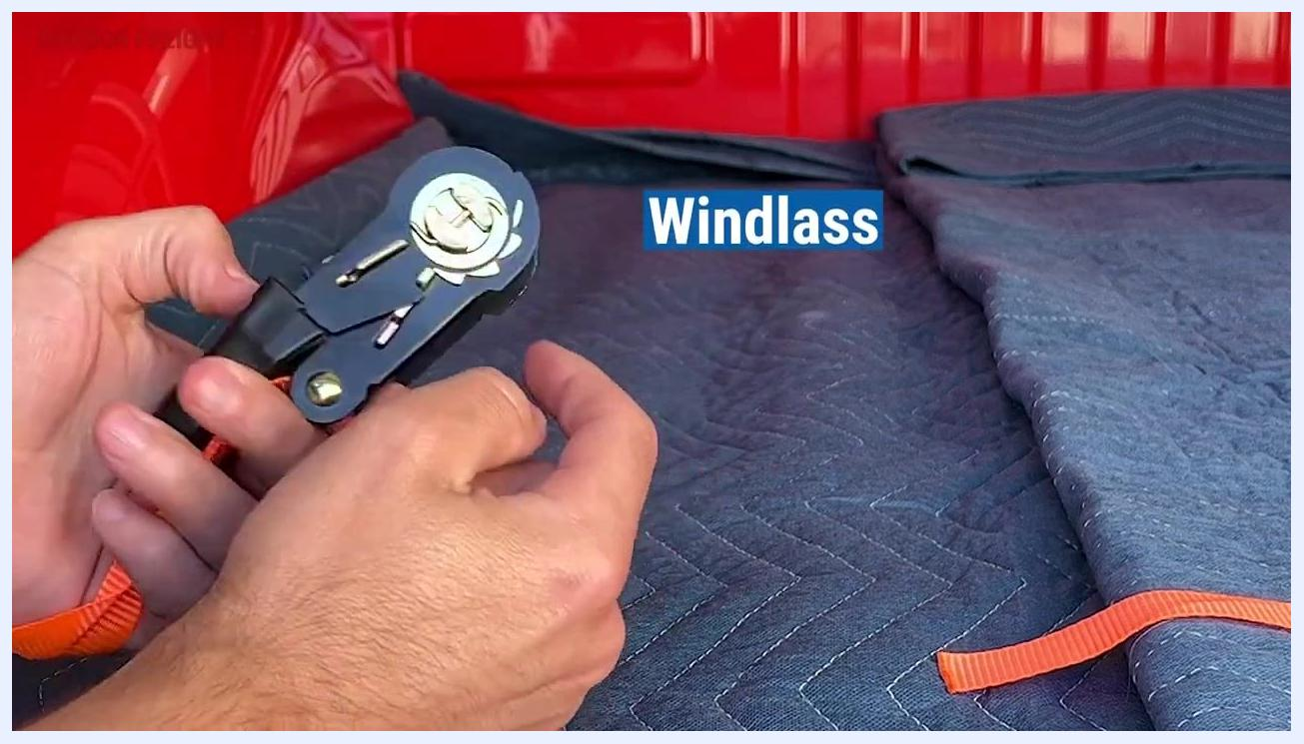
A close-up of hands holding a ratchet mechanism with the windlass labeled. The orange strap is visible, and the ratchet rests on a blue moving blanket in a red truck bed.
Position the ratchet so the opening in the middle of the windlass is parallel, or straight up and down. This alignment makes it easier to feed the strap through.
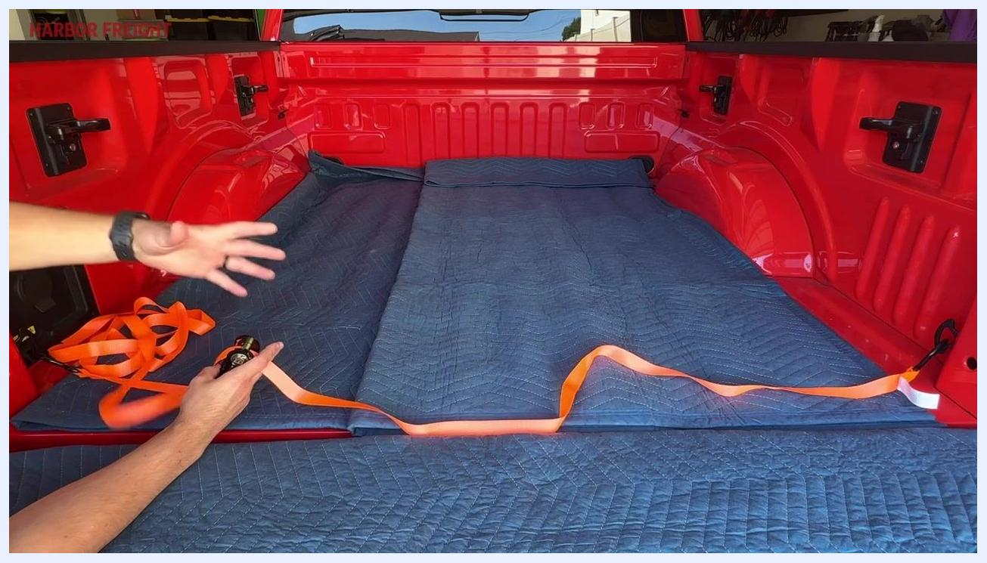
A hand positioning the ratchet mechanism upright on a blue moving blanket in a red truck bed, with the orange strap nearby.

Step 7: Thread and pull the strap through the windlass
Feed the open end of the strap from the back side of the windlass through to the front, holding the ratchet steady as you do this. Pull the strap all the way through the windlass, keeping the webbing straight and untwisted. This step is critical: do not leave excess slack or bunching in the strap.
A hand pulling the orange strap through the ratchet mechanism, keeping it straight and untangled across a truck bed lined with blue moving blankets.
Avoid pulling only a small amount of strap through and immediately applying tension, as this can cause too much webbing to build up on the windlass, leading to binding and improper function.
A person gesturing with one hand while holding the ratchet and strap with the other, emphasizing the need to pull enough strap through before tensioning.

Step 8: Apply tension with the ratchet handle
Leave a slight amount of slack in the strap after pulling it through. Hold onto the webbing and begin applying tension by cranking the ratchet handle up and down.
As you crank, the webbing starts to wind around the windlass. It typically takes about three full cranks of the handle to complete one full revolution of the strap around the windlass.
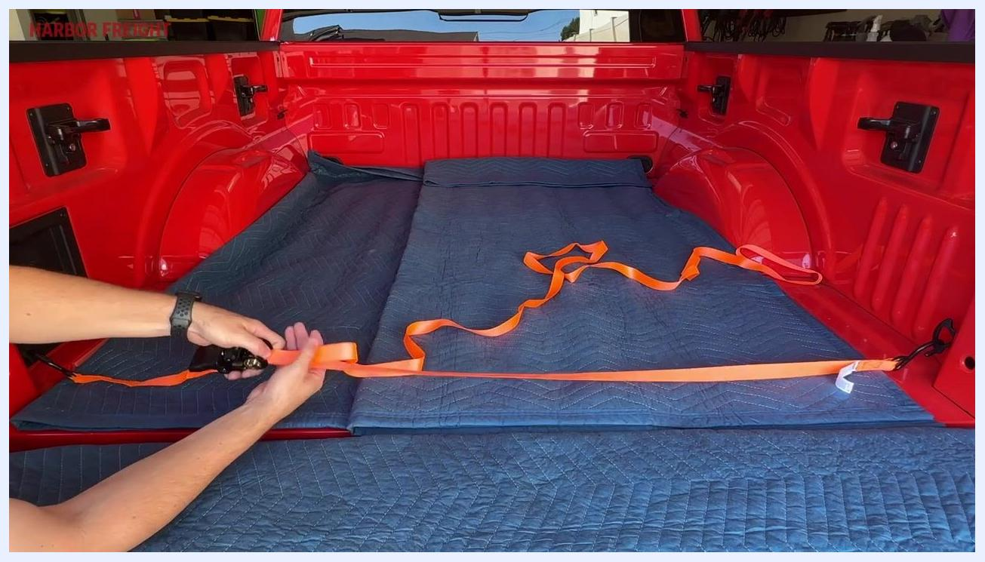
A hand operating the ratchet handle, causing the orange strap to wind around the windlass, with some slack still visible across the truck bed.
Safety note: Aim for a minimum of one full revolution of webbing around the windlass and no more than four full revolutions. Fewer than one revolution risks insecure tensioning, while more than four revolutions can cause the strap to bind and block the pawl, preventing proper ratchet operation.
A close-up of the ratchet mechanism with the orange strap wound around the windlass, labeled "Minimum 1 Full Revolution."
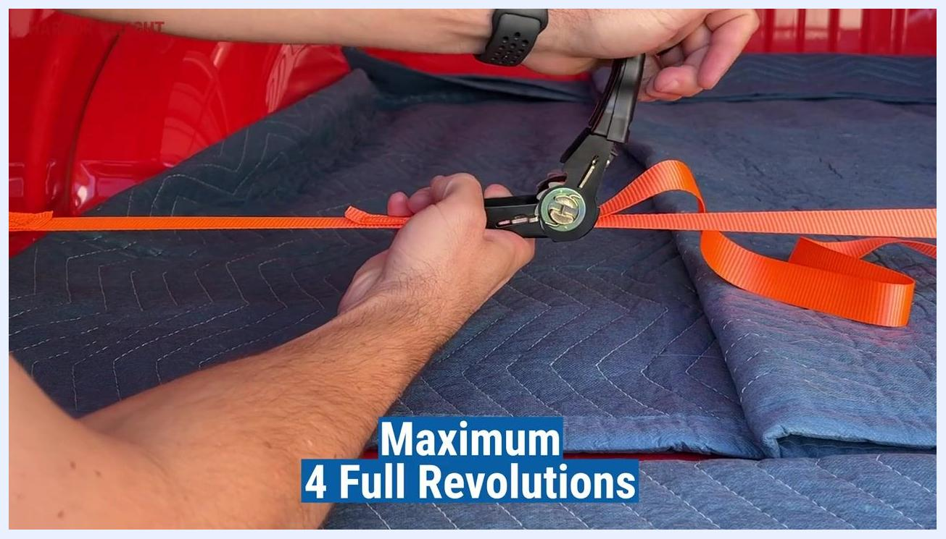
A close-up of the ratchet mechanism with the handle being operated, labeled "Maximum 4 Full Revolutions."

Step 9: Lock the ratchet mechanism
Once the desired tension is achieved and the strap is taut, push the ratchet handle down to its lowest position to lock the mechanism in place. The ratchet strap is now properly tensioned and ready for use.
A hand pushing the ratchet handle down to lock the mechanism, with the orange strap taut and secured across the truck bed.

Step 10: Manage the loose webbing ("dog ear")
After tensioning, address the loose webbing left over, commonly called a "dog ear." Leaving loose webbing unsecured can create legal and safety issues during transport.
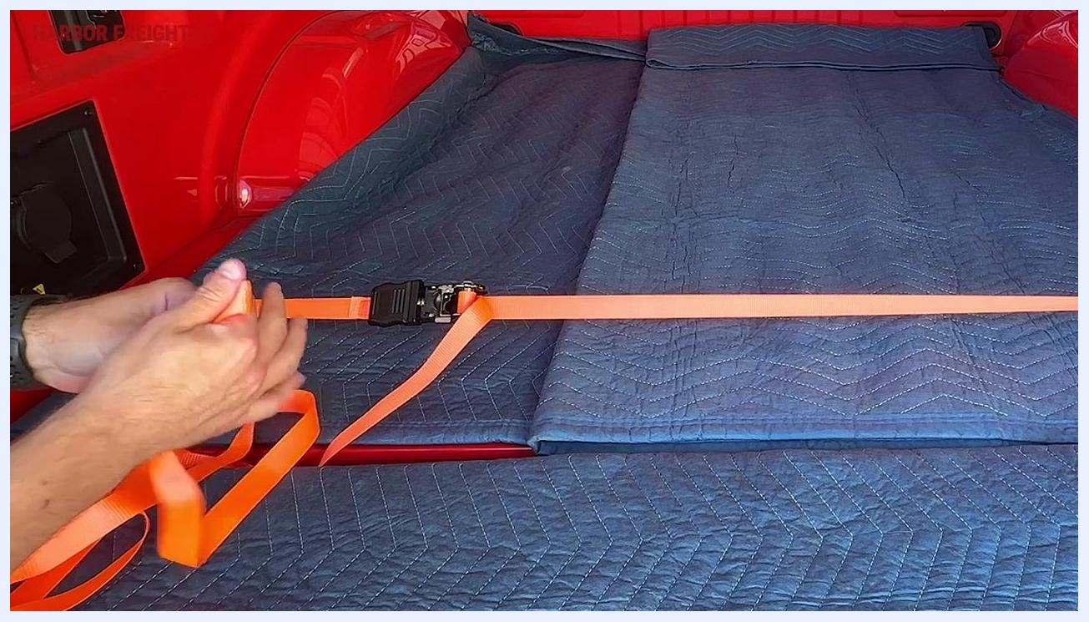
Hands holding a ratchet strap with excess orange webbing, preparing to manage the loose end in the bed of a red truck lined with blue moving blankets.
Gather the loose webbing by folding it over itself and winding the extra strap into a neat, compact bundle to keep it orderly and in one place.
A hand folding and winding the excess orange webbing into a bundle, with the ratchet strap stretched across the truck bed.
Continue winding until all the excess webbing is bundled together. It does not need to be perfect, but it should be tidy and manageable.
Hands continuing to wind the orange webbing into a compact bundle near the ratchet mechanism.

Step 11: Secure the bundled webbing
Secure the bundled webbing with a zip tie, placing it around the center of the bundle and tightening it to prevent the webbing from unraveling or becoming a hazard during transport.
Note: Zip ties are inexpensive and can be purchased in bulk, such as a 100-pack for a few dollars.
A hand using a zip tie to secure the bundled orange webbing next to the ratchet mechanism.
Position the secured bundle so it lies flat and does not interfere with the ratchet mechanism or the load. Confirm the zip tie is tight and the bundle will not come loose.
Bundled and zip-tied orange webbing lying flat next to the ratchet mechanism, ready for transport.
Once the extra webbing is secured, the load is ready to travel, and the ratchet strap and bundle should remain secure throughout transport.

Step 12: Release the ratchet mechanism at your destination
Upon arrival, prepare to release the ratchet strap. Note that the strap cannot simply be pulled free due to the tension built up during use.
Locate the release mechanism and lift the ratchet handle upward. You will pass the position used for tensioning and continue lifting until you hear a "pop" sound, indicating the mechanism has released.
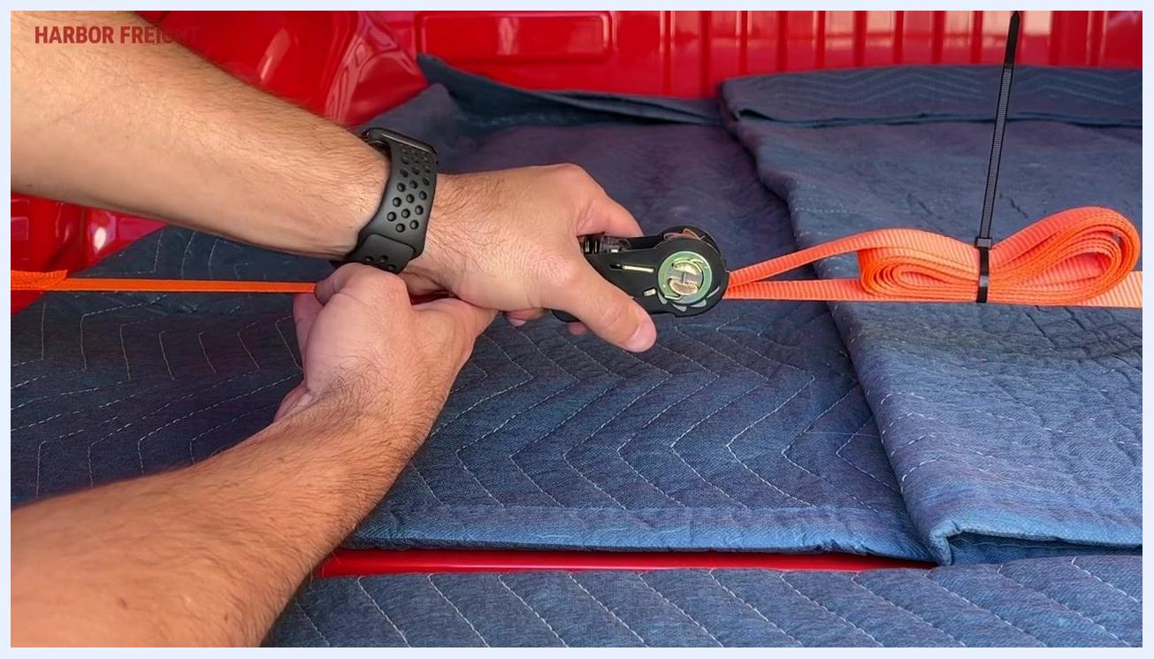
A close-up of hands operating the ratchet release mechanism, with the bundled and zip-tied webbing visible.

Step 13: Remove the zip tie and open the ratchet handle
Once released, cut the zip tie securing the bundled webbing using scissors or a suitable cutting tool, then remove the zip tie and set aside the extra webbing.
A hand using scissors to cut the zip tie from the bundled orange webbing, preparing to remove the strap.
Flatten the ratchet handle so it is parallel to the base. This fully opens the mechanism and allows the strap to be pulled back through the windlass.
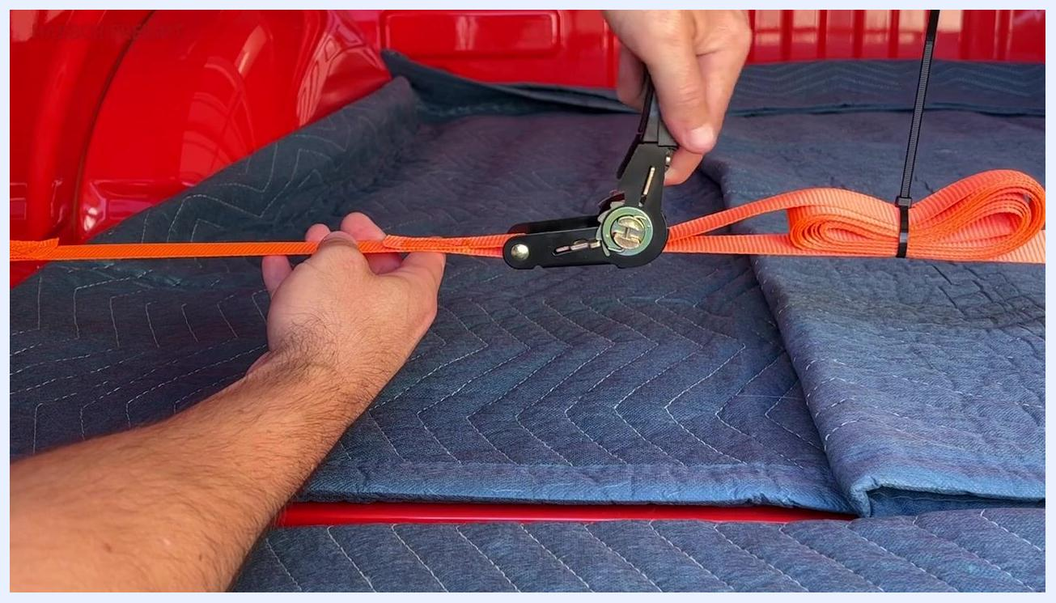
A hand holding the ratchet handle flat, with the orange strap being pulled free from the mechanism across the truck bed.

Step 14: Pull the strap free and remove it
Feed the loose end of the webbing back through the ratchet mechanism, confirming there is no remaining tension on the line as you pull the strap through. Hold the ratchet mechanism steady with one hand and use your other hand to pull the webbing completely free.
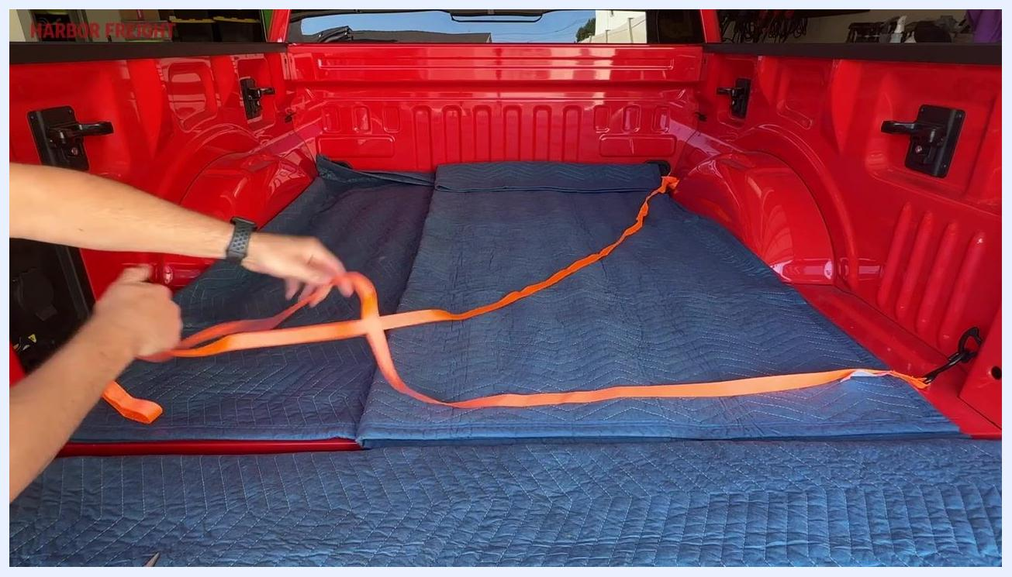
A hand pulling the orange ratchet strap free through the mechanism in the bed of a red truck lined with blue moving blankets, with the strap loose and no visible tension.
Verification: Confirm the strap slides easily and pulls completely free, indicating all tension has been released. Continue pulling until the webbing is fully removed from the ratchet mechanism, then detach the strap from any anchor points or hooks.

Step 15: Complete the unloading process
Once the strap is removed and the load is free, remove the strap and store it for future use. Your unloading process is now complete.

Summary
By following this procedure, you can identify a ratchet strap's components, prepare and thread the webbing, apply and lock proper tension, secure excess webbing safely for transport, and release the strap correctly at your destination. Following these steps minimizes the risk of binding, malfunction, or safety hazards during use.

What's next
For additional ratchet straps, accessories, or product support, visit your local Harbor Freight store or their website.
Harbor Freight logo on a red background with the text "Quality Tools Lowest Prices" and "1400+ Stores Nationwide."

