How to Thread a Ratchet Strap: Complete SOP
This SOP explains how to thread a ratchet strap correctly, covering the differences between common and smart ratchet straps, the threading process, and how to tighten and release the strap once your load is secure. Following these steps ensures your strap is loaded properly and your load stays secure.

Purpose
The purpose of this procedure is to guide you through identifying your ratchet strap type, threading the strap through the barrel, tightening it with the ratchet handle, and releasing it safely once you are finished.

Scope
This procedure applies to both common ratchet straps and smart ratchet straps (such as Smart Straps). It covers the full workflow from identification through threading, tightening, and release.

Required equipment
- A ratchet strap (common or smart type)
- A load or item to secure (e.g., lumber)

Step-by-step procedure

Step 1: Identify your ratchet strap type
There are two main types of ratchet straps:
- Common ratchet strap: Requires pressing two spring mechanisms simultaneously to release the strap.
- Smart ratchet strap: Requires pressing only one mechanism, making it easier to operate, especially with one hand.
Both types are available for purchase online, including on Amazon. The smart ratchet is generally preferred for its one-finger operation versus the two-finger control required by the common ratchet.

A person sits cross-legged on a wooden dock by a lake, holding a ratchet strap. Two strap types are shown, one red and one green, with a covered boat visible in the background.

Step 2: Understand the release mechanisms
On a common ratchet strap, locate the two spring-loaded levers. You must press both simultaneously to open and release the strap.
On a smart ratchet strap, find the single release lever. Pressing this lever allows the barrel to spin freely, simplifying the release process.

Step 3: Prepare to thread the strap
Both ratchet strap types are loaded the same way. Identify the folded side of the ratchet, which is the side where the handle folds down.
Locate the barrel at the center of the ratchet. You will see a split in the barrel where the strap is threaded through.

Step 4: Thread the strap through the barrel
Take the beginning end of your strap and insert it through the split in the barrel, starting from the folded side of the ratchet. Pull the strap through so that about 1–2 inches comes out on the other side.

Close-up of hands threading a green strap through the barrel of a ratchet mechanism, held open on a wooden dock.

Step 5: Tighten the strap by ratcheting
Begin operating the ratchet handle to wind the strap around the barrel. As you continue ratcheting, the strap will wrap around itself and tighten, securing itself in place. The mechanism prevents the strap from slipping out.
Hands operating the ratchet handle, winding the green strap around the barrel as it wraps around itself.

Step 6: Check strap position
Make sure the strap is winding evenly and not bunching up as you ratchet. Stop ratcheting once the strap is tight and the barrel is nearly full.
Safety note: Do not over-tighten the strap, as this can bind the ratchet and make it difficult to release later.
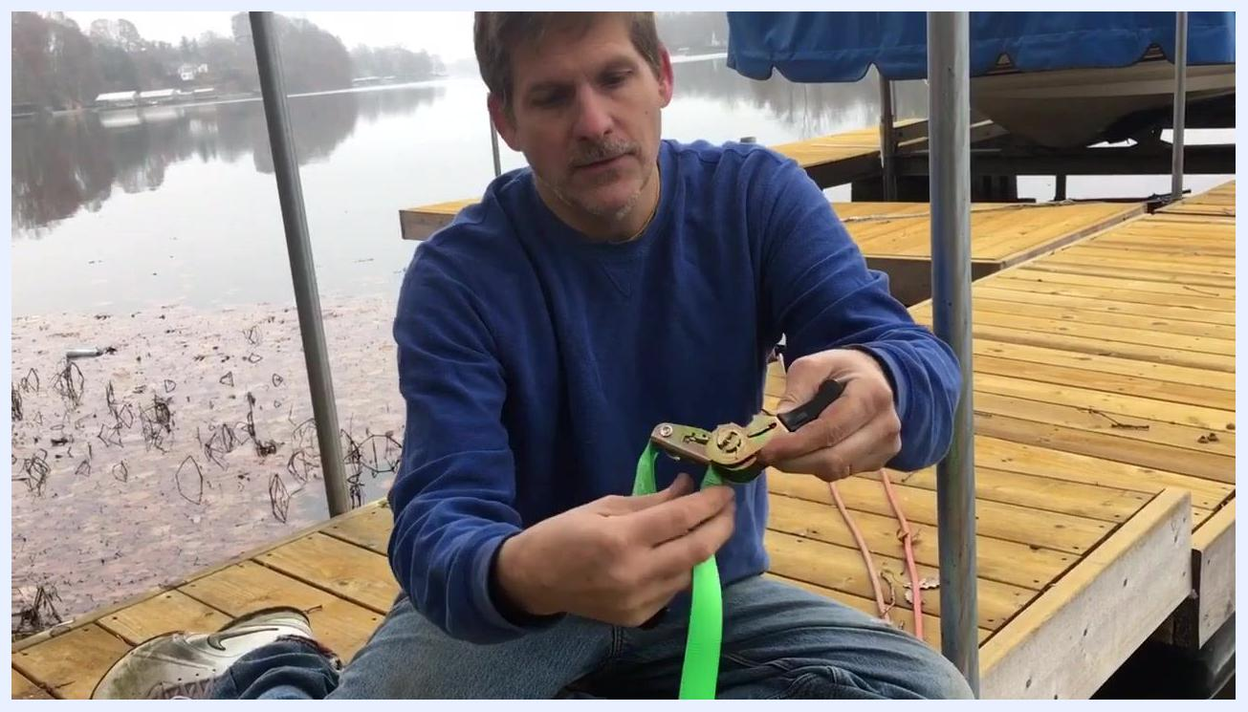
The ratchet strap wound tightly around the barrel, with the dock and lake visible in the background.

Step 7: Release the strap
To release tension, locate the release lever. On a smart ratchet, this is a single lever that can be pulled with one finger. Pulling the lever disengages the ratchet, and the strap comes free easily.

A hand pulling the single release lever on the ratchet with one finger, loosening the strap from the barrel.

Step 8: Avoid over-tightening
As you ratchet, the wound strap moves closer to the side of the ratchet frame. Stop ratcheting before the strap binds against the frame to prevent jamming.
Close-up of the ratchet mechanism with the strap wound tightly, approaching the side of the ratchet frame.

Repeating the process
If you need to re-tighten the strap, feed it through the barrel again and repeat the ratcheting process described in Step 5. The smart ratchet design allows for easy one-finger release and operation, making it more convenient than traditional two-lever ratchets.

Usage recommendations
- Use smart ratchet straps for a wide variety of projects, including securing lumber from the store.
- Ratchet straps are suitable for nearly any application requiring a strong, reliable hold.

Verification and summary
By following this procedure, you can identify, thread, tighten, and release both common and smart ratchet straps confidently. Proper threading and controlled tightening ensure your load stays secure, while the correct release technique keeps the strap easy to remove when the job is done.

A person in a blue sweatshirt and jeans sits cross-legged on a wooden dock by a calm lake. The dock has metal posts and a covered boat is visible in the background. The person is looking at the camera, appearing to wrap up the demonstration. The environment is outdoors, overcast, and peaceful, with trees and houses visible across the lake.

