Forklift Daily Inspection Checklist: Pre-Shift Inspection SOP

Purpose
This document provides the standard forklift daily inspection checklist for verifying that a forklift is safe to operate before each shift. Following these steps ensures the forklift's structural condition, safety systems, and operational controls are checked and confirmed functional prior to use.

Scope
This procedure applies to any operator responsible for performing a pre-shift inspection on a forklift before beginning work. It covers the visual walk-around inspection, seated operational checks, and final functional tests.
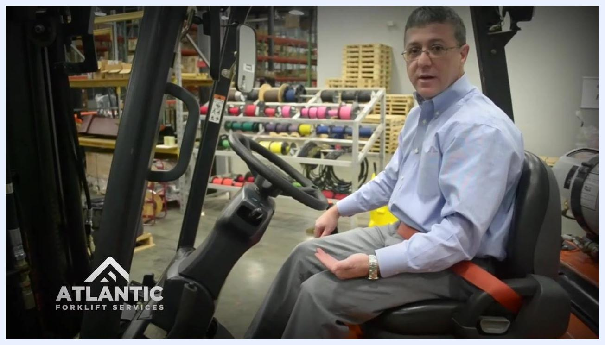
Operator seated in the forklift, demonstrating hydraulic control operation, with visible steering wheel, levers, and seat belt fastened.

Operator finishing the inspection, hand on the dashboard, seated in the forklift with the seat belt fastened, in a warehouse setting.

Required equipment and PPE
No special tools are required to complete this checklist. You only need access to the forklift itself and its standard safety features, including the LP tank, overhead guard, seat belt, mirrors, parking brake, and hydraulic controls.

Pre-shift visual inspection

- Approach the forklift. Begin your inspection from the front side or the operator's compartment. This is the recommended starting point for the forklift daily inspection checklist.
- Check for visible damage. Perform a quick visual scan of the body and attachments, looking for dents, cracks, or any signs of impact.
- Inspect the steering area. Check for debris, tangled objects, or leaks that could obstruct the steering mechanism.
- Walk around the forklift. Continue your visual inspection on all sides, checking for any new or existing damage.
- Examine the LP tank. Confirm the LP (liquefied petroleum) tank is locked securely and properly mounted. Physically check the mounting brackets and locking mechanism, and confirm there are no leaks or loose fittings.
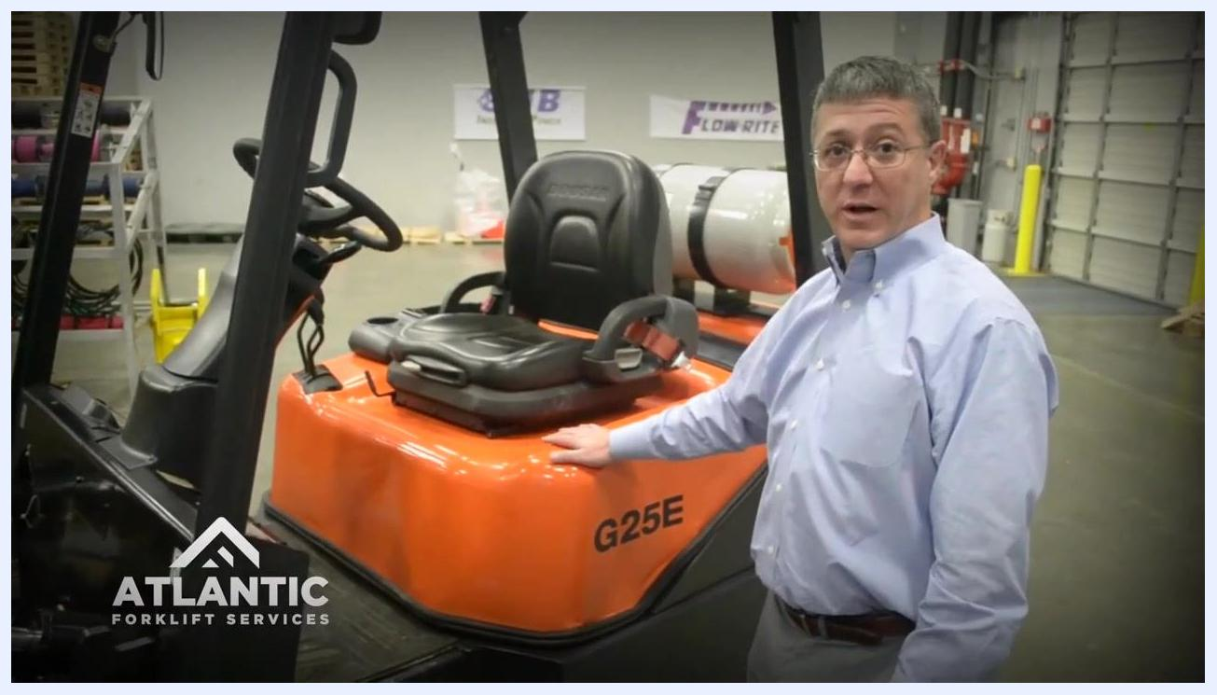
Inspector checking the LP tank on the back of an orange DOOSAN forklift, verifying secure mounting and condition.

- Check the opposite side. Repeat the visual inspection on the other side of the forklift, looking for the same issues: damage or leaks.
- Inspect the overhead guard. Look for damaged lights or structural damage. Confirm all lights are intact and functional, and that the guard is not bent or compromised.
- Check the mast for debris. Look through the mast for debris, shrink wrap, or broken pallets, and remove any foreign objects that could interfere with operation.
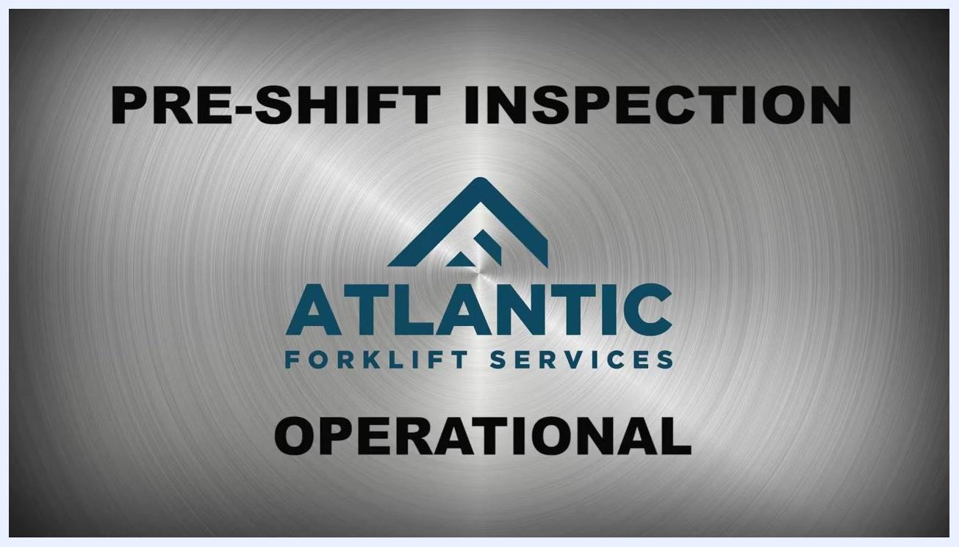
Inspector walking around the front mast area of the forklift, checking for debris and obstructions.

- Complete the perimeter check. Continue around the forklift, repeating the inspection for debris, shrink wrap, or other obstructions, and confirm the entire perimeter is clear and safe.
- Check the seat belt. Pull the belt out fully and inspect it for fraying or cuts. Buckle and unbuckle it to confirm proper operation before proceeding.
Inspector standing next to the forklift, reaching for the seat belt to check its condition and function.

Operational pre-shift checks

- Confirm the emergency brake is engaged. Visually check the brake lever or pedal position before starting the forklift.
- Start the forklift. Follow the manufacturer's instructions to start the vehicle.
- Check the mirrors. Ensure all safety mirrors are properly installed and adjusted for maximum visibility.
- Verify the brake is still engaged. After startup, confirm the brake remains engaged. Do not proceed until the brake is confirmed operational.
- Test the parking brake. With the forklift running, gently attempt to move the vehicle to ensure the brake holds. If the forklift moves, the parking brake may need adjustment or repair.
Inspector seated in the forklift, preparing to test the parking brake with visible controls and mirrors.

Final operational tests

- Test the parking brake in gear. Put the forklift in gear and gently attempt to move it. Confirm the parking brake holds and the lift remains secure. If the forklift moves, the parking brake may require adjustment or repair.
Inspector seated in the forklift, preparing to test the parking brake with visible controls and mirrors.

- Exercise the hydraulic controls. Operate all hydraulic functions—lift, tilt, side shift, and others—to confirm smooth operation. Listen for any unusual sounds that could indicate a problem, and confirm all movements are responsive and free of hesitation.
- Test the side shift and other hydraulic attachments. Move the side shift and any additional hydraulic features to verify proper function, observing for smooth, coordinated movement without abnormal noises.
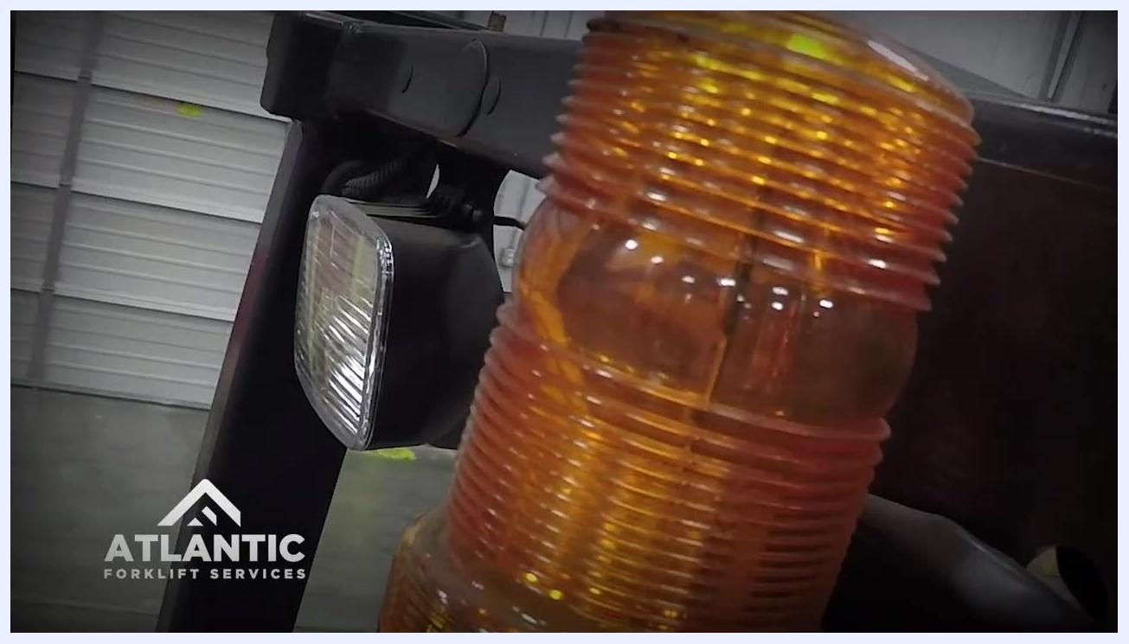
Operator actively manipulating hydraulic controls, focusing on the side shift function, with a clear view of the forklift mast and controls.

- Check the backup alarm. Shift the forklift into reverse and listen for the backup alarm to sound, confirming it is operational.
Operator shifting the forklift into reverse, hand on the gear lever, checking the backup alarm function.

- Perform a brake test. Drive the forklift forward a short distance, then apply the brakes to ensure they engage promptly and stop the forklift safely.
Close-up of the forklift's warning light and headlight, indicating operational status during the brake test.

- Complete the pre-shift inspection. Confirm that all checks have been performed and that the forklift is safe for use. If any issues were found, report them immediately and do not operate the forklift until repairs are made.

Support and contact information

- For service needs or questions, contact Atlantic Forklift Services:
- Phone: 704-816-8960
- Website: ATLANTICFORKLIFTSERVICES.COM
- Email: refer to the website for current contact information
Atlantic Forklift Services contact information displayed on a metallic background: website, logo, and phone number.

Atlantic Forklift Services contact information displayed on a metallic background: website, logo, and phone number.

- Keep this contact information accessible for future reference in case service or support is needed.

Verification and summary
By completing this forklift daily inspection checklist, you confirm that the forklift's structural components, safety systems, and operational controls have all been checked before use. The procedure covers the visual pre-shift inspection, seated startup checks, and final functional tests including the parking brake, hydraulic controls, backup alarm, and brakes. Following these steps in order promotes safety and compliance before operating the forklift, and gives you quick access to your service provider if any issues arise.
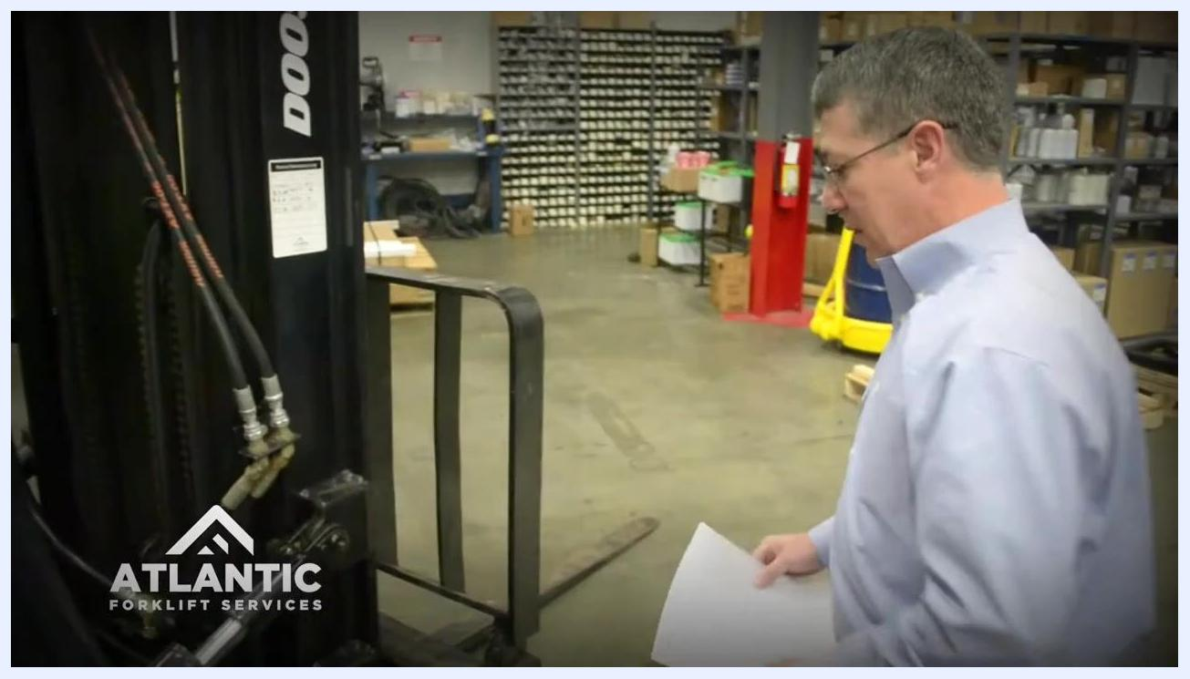
Inspector visually checking the overhead guard and lights above the operator's seat on the forklift.
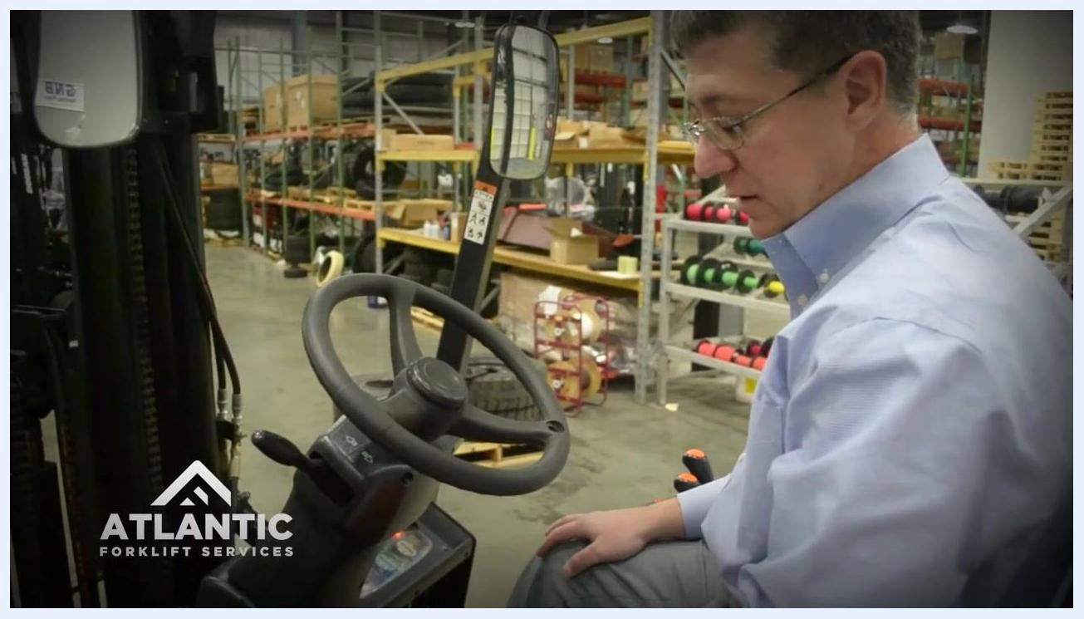
Operator seated in the forklift, hand on controls, visually confirming the parking brake holds with the lift secure in a warehouse setting with shelves and equipment in the background.

