How to Create a Document Version in Veeva Vault
Learn how to create a document version in Veeva Vault when you need to correct an error or update content in an existing released document. This guide walks you through the full process—from understanding how versioning works, to creating a draft, editing the document, and releasing the new version—using the Veeva Vault interface.

Prerequisites
- You need access to the document you want to update in Veeva Vault, with permissions to create a draft and release a new version.
- Identify the document's current document number, version, and status before you begin.
- If you plan to upload a corrected file instead of editing in place, have that file ready on your computer.

Understanding document versioning

Know when to create a draft
Use the draft creation process whenever you need to make the current uploaded version obsolete because of errors or required corrections. This process changes only the version number—the document number stays the same.
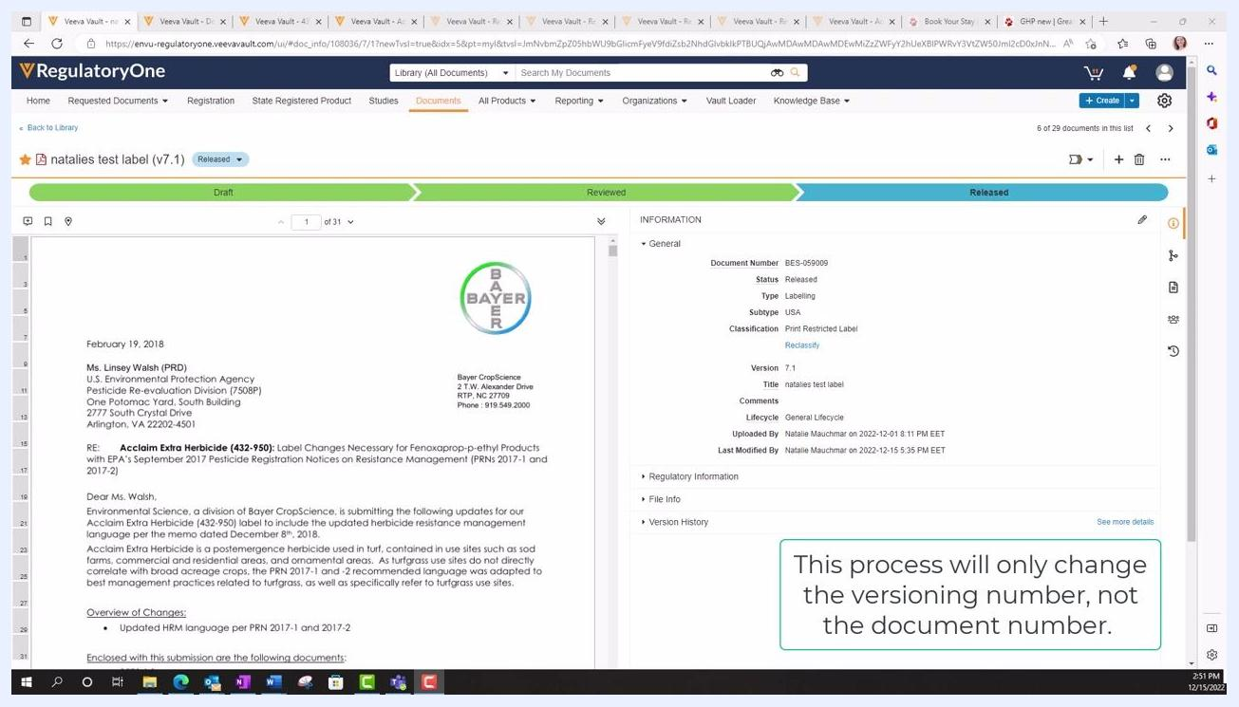
A note overlay on the Veeva Vault interface stating: "This process will only change the versioning number, not the document number."
For standard version updates, always use the Create Draft option. Creating a draft:
- Maintains the same document number.
- Increments the version number (for example, from 8.0 to 8.1, then to 9.0 upon release).
- Preserves the document's history and audit trail.
This is the recommended approach for updating or revising existing documents within the same document lifecycle.

Distinguish "Create Draft" from "Make a Copy"
The Make a Copy option is different from creating a draft, and it's important not to confuse the two. You can find it in the action menu (three vertical dots) next to the document title or in the INFORMATION panel, listed below Create Draft and above Delete.
Selecting Make a Copy will:
- Create an entirely new document in Vault.
- Assign a new, unique document number.
- Reset the version number to 0.0 for the new document.
- Start a new document lifecycle, separate from the original.
Use Make a Copy only when you need a completely independent document, not a new version of the current one.
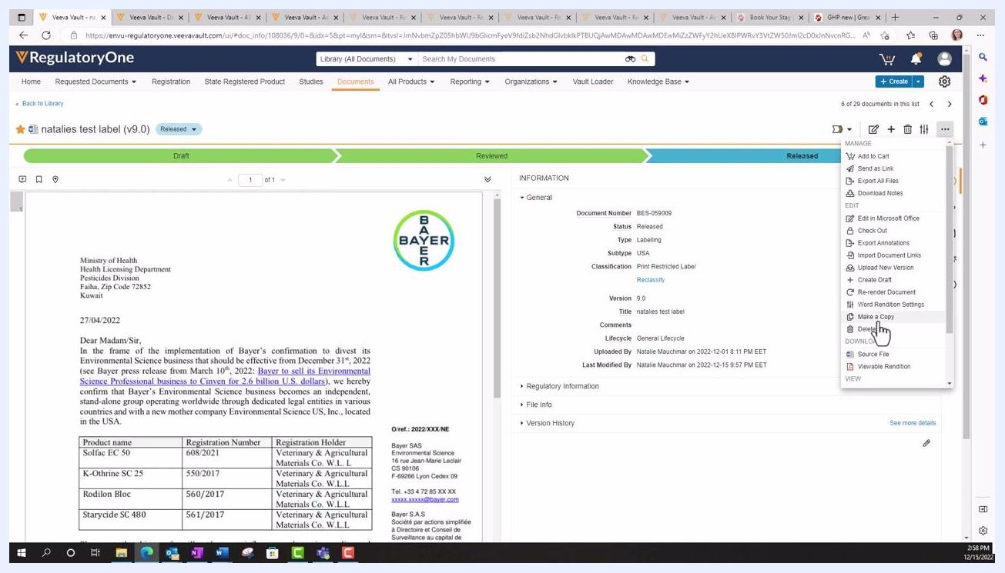
Veeva Vault interface showing the action menu open with "Make a Copy" highlighted, and the document details panel visible. The pointer hovers over "Make a Copy" to distinguish it from "Create Draft".

Step 1: Identify the document to update
Locate the document you want to update in Vault. For example, you might find a cover letter titled "natalies test label (v7.1)" with document number BES-095009, status Released, and version 7.1.
Confirm the document details in the INFORMATION panel, including type, subtype, classification, and lifecycle, before making any changes.
Veeva Vault RegulatoryOne interface showing a released document with details such as document number, version, and status. The document content appears on the left, with metadata on the right.

Step 2: Create a draft

Open the document actions menu
Click the three vertical dots (action menu) in the upper right corner of the document information panel. A dropdown menu appears with several options.
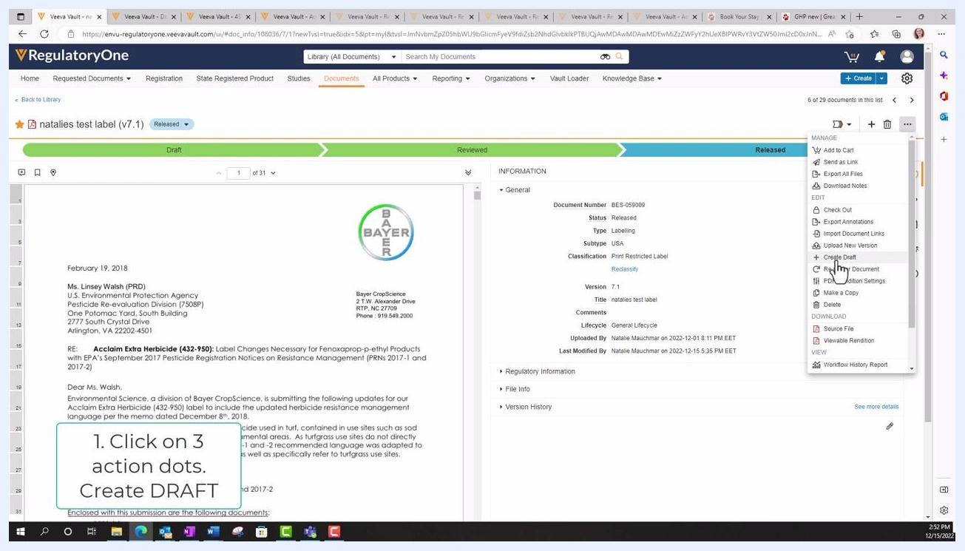
Dropdown action menu open in Veeva Vault, showing options such as Add to Cart, Send as Link, Upload New Version, Create Draft, and others. The cursor hovers over "Create Draft".

Select Create Draft
Select Create Draft from the dropdown menu. Ignore the Upload New Version option directly above it, as it does not function as required for this process. Clicking Create Draft initiates the versioning process without changing the document number.
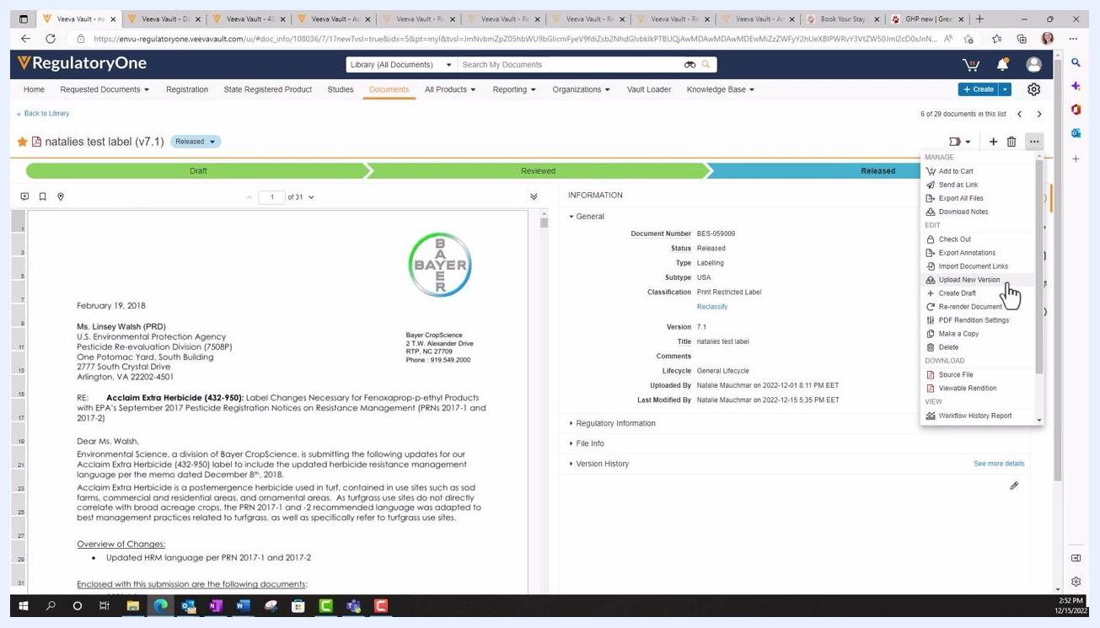
Dropdown action menu in Veeva Vault with "Create Draft" highlighted and the cursor pointing at it.

Choose how to update the draft document
In the Create Draft dialog, decide whether to edit the existing document directly in the system or upload a new corrected file:
- To edit the current version, click Create. This lets you make changes to the document already stored in Vault.
- To upload a new file, click the file icon in the dialog, browse your computer, and select the corrected document (for example, "Notification Letter VAMCO.docx"), then click Open to attach it.
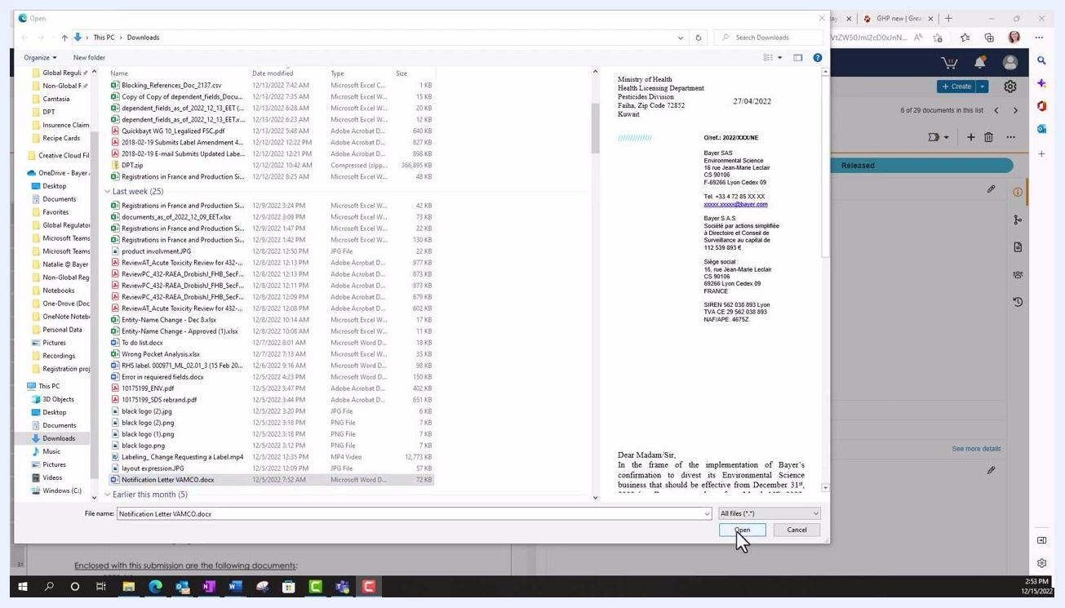
Create Draft dialog in Veeva Vault with options to copy from the current version or upload a new file. Purple arrows highlight "Upload new version from your desktop" and "Create new version from the existing version (Edit a word document)".

Option A: Edit the existing document

Confirm the new draft version
If you choose to edit the current version, click Create in the dialog to proceed. This lets you make changes directly to the document stored in Vault, eliminating the need to re-upload a file.
Wait for the system to generate the new draft version (for example, v8.1). The document status displays as "Draft" and the file becomes available for editing.
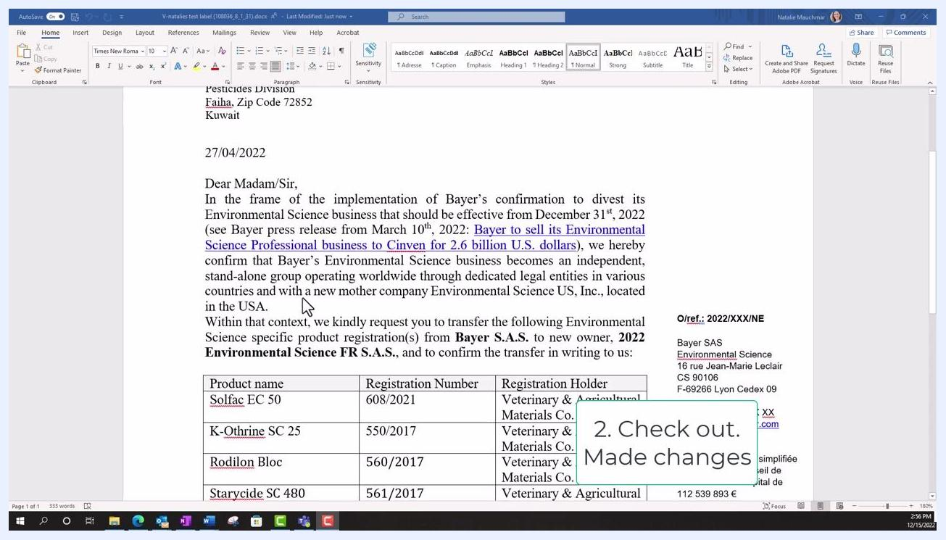
Veeva Vault interface showing the new draft version (v8.1) being generated, with the file "Notification Letter VAMCO.docx" and status "Draft".

Edit the document in Microsoft Office
Click Edit in Microsoft Office in the Vault toolbar. The document opens in Microsoft Word (or the appropriate Office application). Make the necessary changes to the document, such as deleting a section or updating text, then save and close the document.
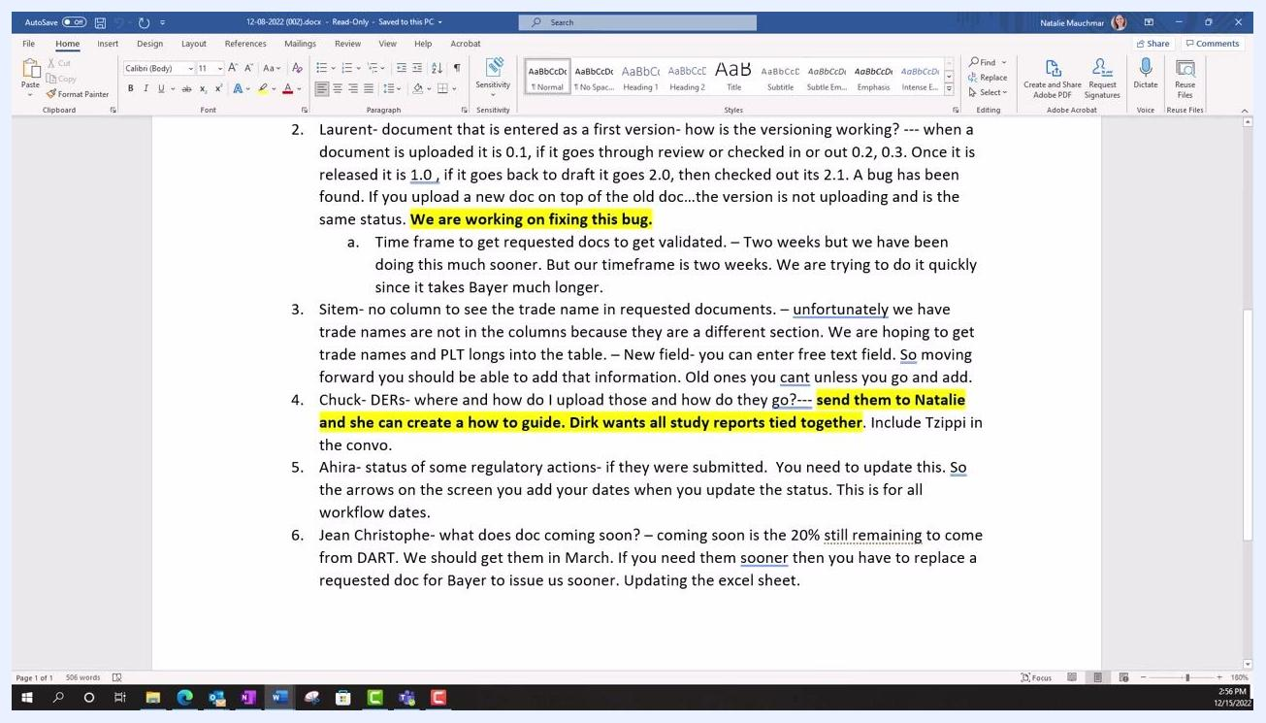
Microsoft Word open with the document checked out, showing text being edited and a callout: "2. Check out. Made changes".

Check the document back in
Return to the Vault interface and check the document back in to save your changes to the system. This finalizes your edits and updates the draft version in Vault.
Confirm that the changes you made, such as deleted sections, are reflected in the document preview.
Microsoft Word document with highlighted changes, ready to be checked in.

Option B: Upload a new file

Add a version description and create the draft
If you uploaded a new file instead of editing in place, enter a description of the changes in the Version Description field of the Create Draft dialog (for example, "changes to notification letter"). Click Create to finalize the draft creation.
Create Draft dialog in Veeva Vault with a new file selected and a version description being typed. The "Create" button is visible.

Verify the new draft version
Confirm that the new document is now listed as a draft with an updated version number (for example, version 7.2). Check that the document number remains the same (for example, BES-095009) while the version has incremented. The document status should show "Draft," and the new file should appear in the viewer.
Veeva Vault interface showing the new draft version (v7.2) of the document, with status "Draft" and the updated file displayed.

Step 3: Release the new document version

Review and update metadata
Double-check all metadata fields in the INFORMATION panel on the right. Update any necessary fields, such as regulatory action, text date, or other document-specific metadata, to ensure accuracy for the new version.
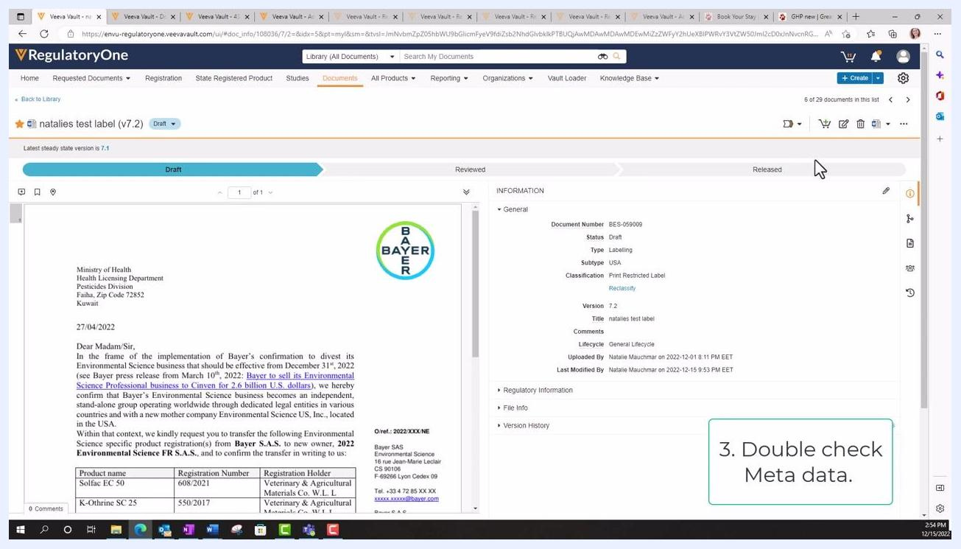
Veeva Vault interface with the draft document open and a callout box stating "3. Double check Meta data." The INFORMATION panel is visible.

Release the document
Once you have verified your changes, release the draft:
- Click the action menu (three vertical dots) in the INFORMATION panel.
- Select the option to Release the document.
The version number increments (for example, from 8.1 to 9.0), the previous version is marked as superseded, and the document status updates to "Released" for the new version.

Step 4: Verify version history and document status
Check the Version History section in the INFORMATION panel to confirm that the new version (for example, v9.0) is now the current released document, and that previous versions are listed as "Superseded." Ensure the document number remains the same while the version and status reflect your recent changes.
Veeva Vault interface showing the updated draft version (v8.2) with status "Draft" and the version history panel displaying previous versions as "Superseded".

Summary
To create a document version in Veeva Vault:
- Use the action menu to create a draft from the released document.
- Choose to edit the existing file directly in Vault, or upload a corrected file.
- Make and save your changes in Microsoft Office, if editing directly.
- Check the document back in and verify your edits.
- Release the new version and confirm the version history for proper document control.

