How to Request Time Off in UKG
This guide walks you through how to request time off in UKG Ready, from submitting a new request to checking your balances, history, and calendar. You'll see exactly what to click at each stage, including how to choose a time off type, enter hours, calculate your projected balance, and submit your request for approval.

Prerequisites
- You must be logged in to your UKG Ready account before starting this process.

Step 1: Access your dashboard
After logging in, you land on your dashboard. Locate the Quick Links section on the left side of the screen. Under My Time, find and click the Request link.
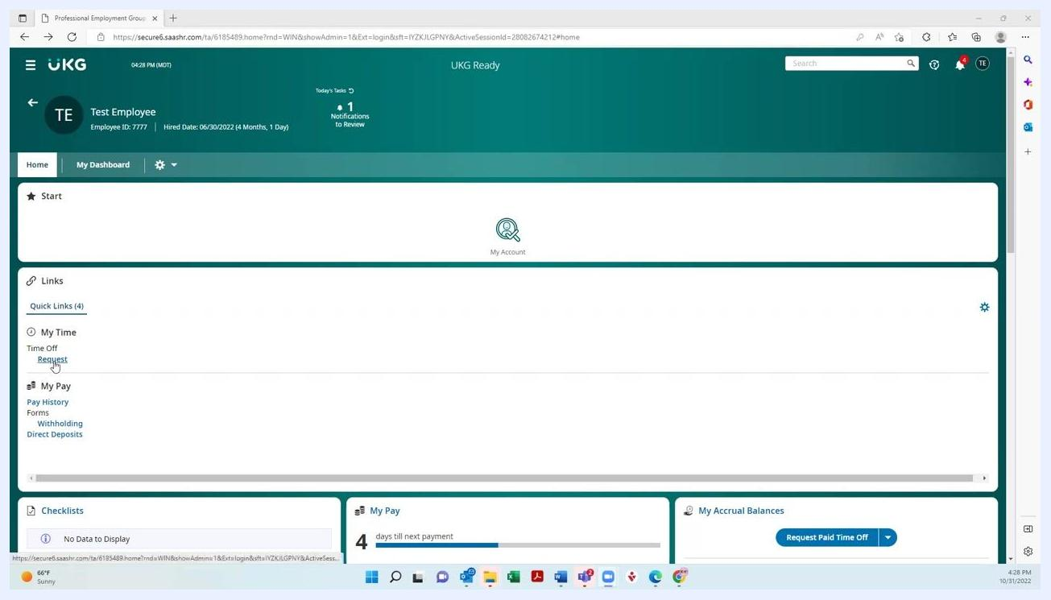
UKG dashboard with Quick Links and the Request link highlighted under My Time

Step 2: Open the Time Off Request page
Clicking Request takes you to the Time Off Request page. At the top, find the Time Off Type field. Click the magnifying glass icon next to the Choose... field to browse the available time off types.
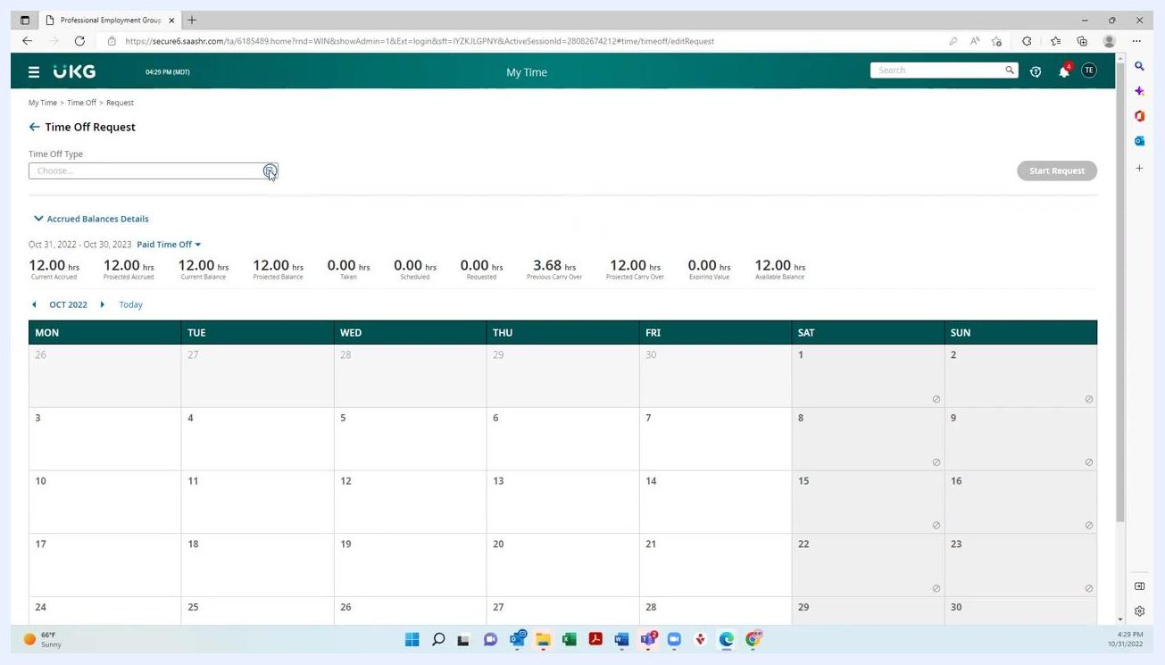
Time Off Request page with the magnifying glass icon for browsing time off types

Step 3: Select the type of time off
A Browse and Select window appears, listing available time off types such as Jury Duty, Paid Time Off, Public Health Emergency, Sick, and Unpaid Time Off. Select the type that applies to your request.
Note that the options shown may vary depending on your state and employer.
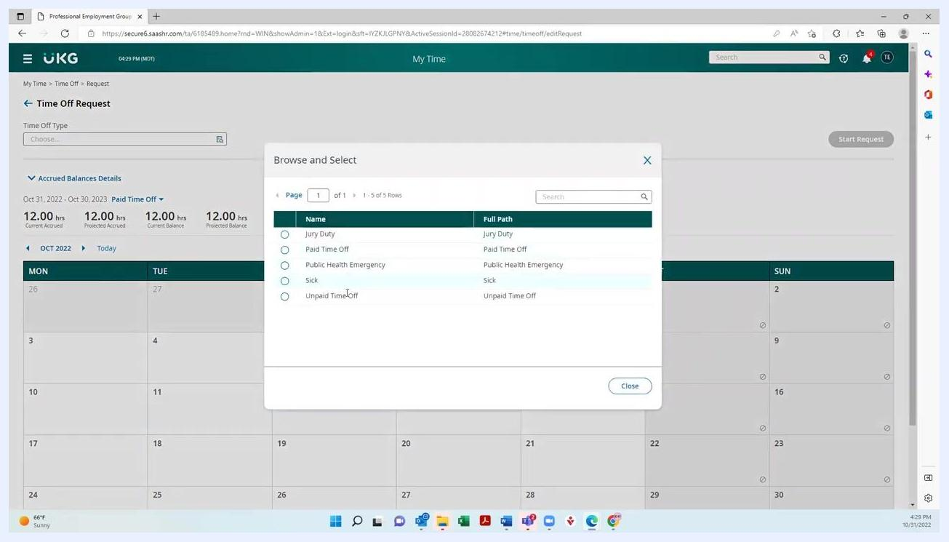
Browse and Select window listing the available time off types

Step 4: Start the time off request
After selecting your time off type (for example, "Paid Time Off"), the main request page updates accordingly. Click the blue Start Request button on the right to continue.
If you selected the wrong type, you can still edit it in the Time Off Type field before proceeding.
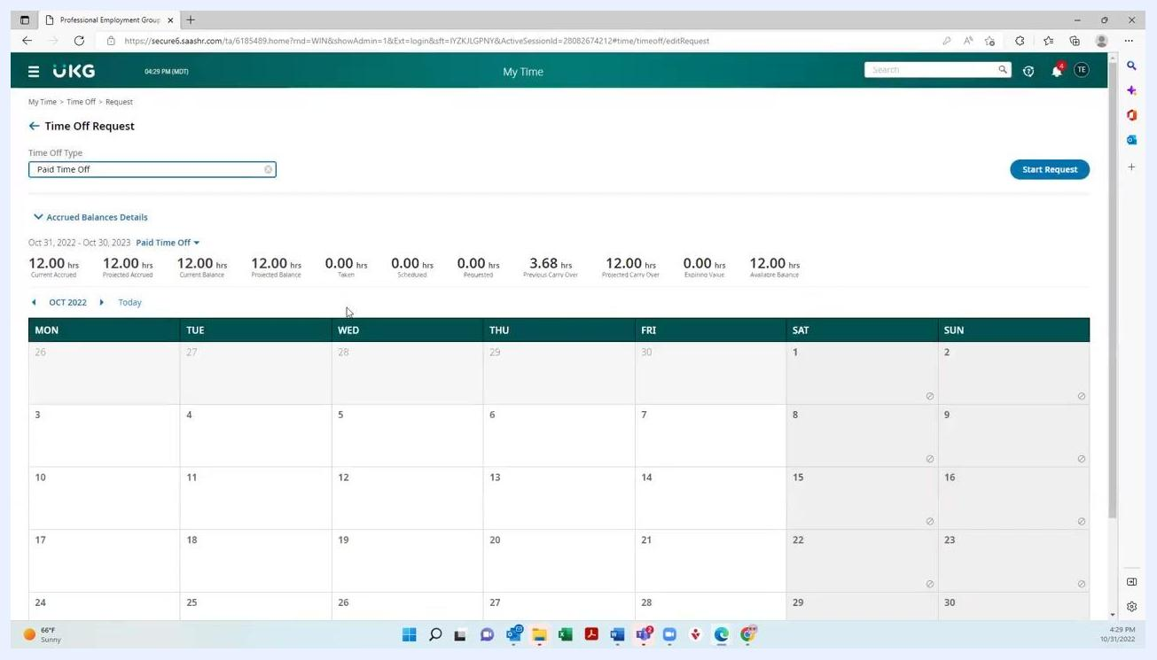
Time Off Request page with Paid Time Off selected and the Start Request button visible

Step 5: Choose the request type
In the Request Type dropdown, select how long you will be taking off:
- Full Day: Automatically sets to 8 hours.
- Multiple Days: Lets you enter a date range.
- Partial Day (Bulk): Lets you specify the number of hours, such as 4 or 6 hours.
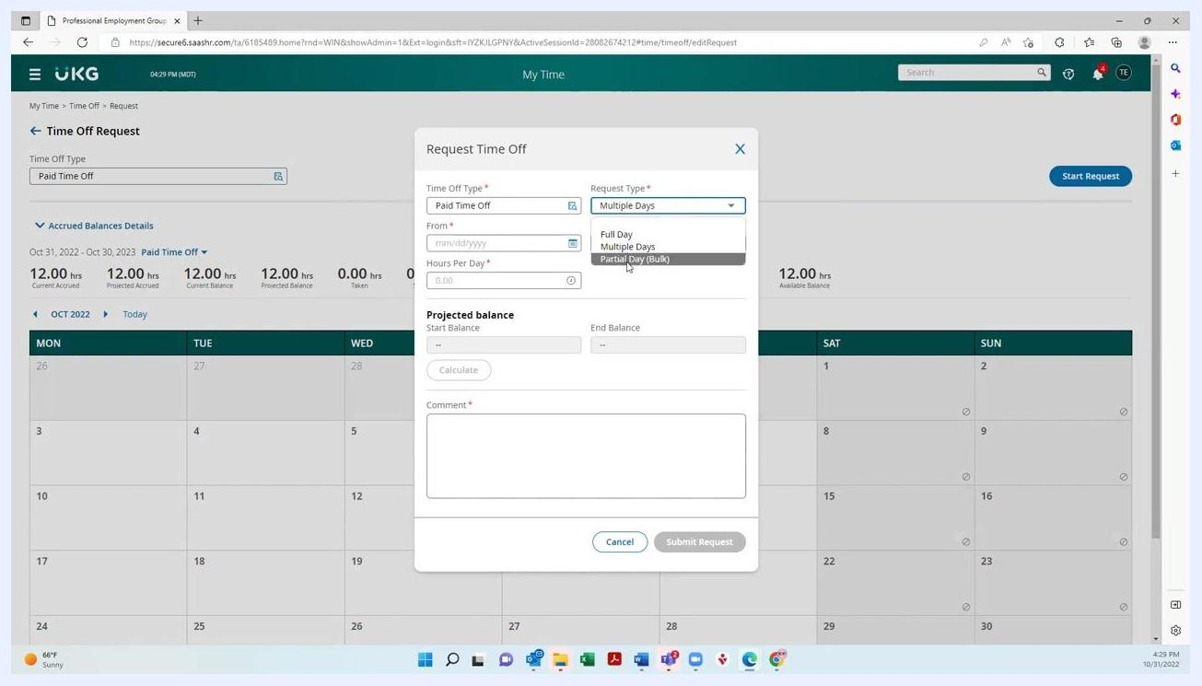
Request Time Off dialog with the Request Type dropdown open

Step 6: Select the date
For a partial day, click the calendar icon in the Date field and select the desired date. For multiple days, select the start and end dates as needed.
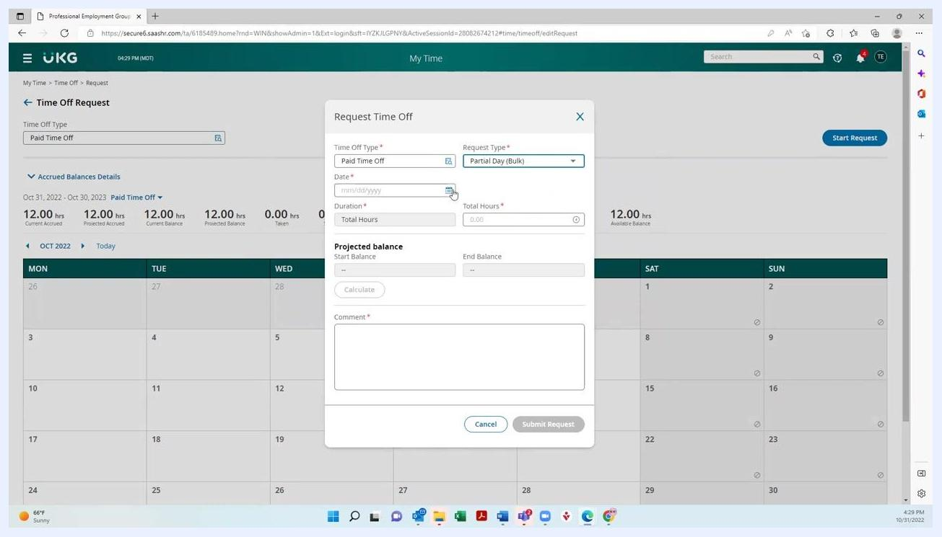
Request Time Off dialog with the date selection field highlighted

Step 7: Enter duration and add a comment
Enter the total number of hours you wish to request in the Total Hours field (for example, 4.00 for a half day). In the Comment field, enter a brief note — this is required to submit the request.
You don't need to go into detail; a note like "Personal time" is sufficient, though you may add more information if you wish.
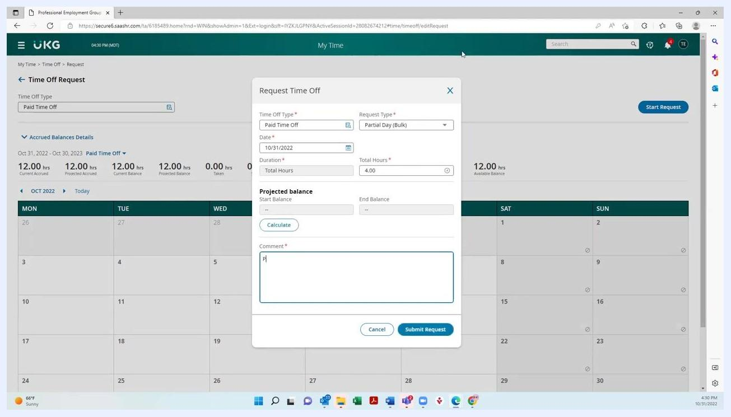
Request Time Off dialog with 4 hours entered and a comment being typed

Step 8: Calculate your projected balance
Before submitting, you can see what your balance will be after the time off is deducted. Click the Calculate button in the Projected Balance section.
For example, if you start with 12.00 hours and request 4.00 hours off, your end balance will be 8.00 hours.
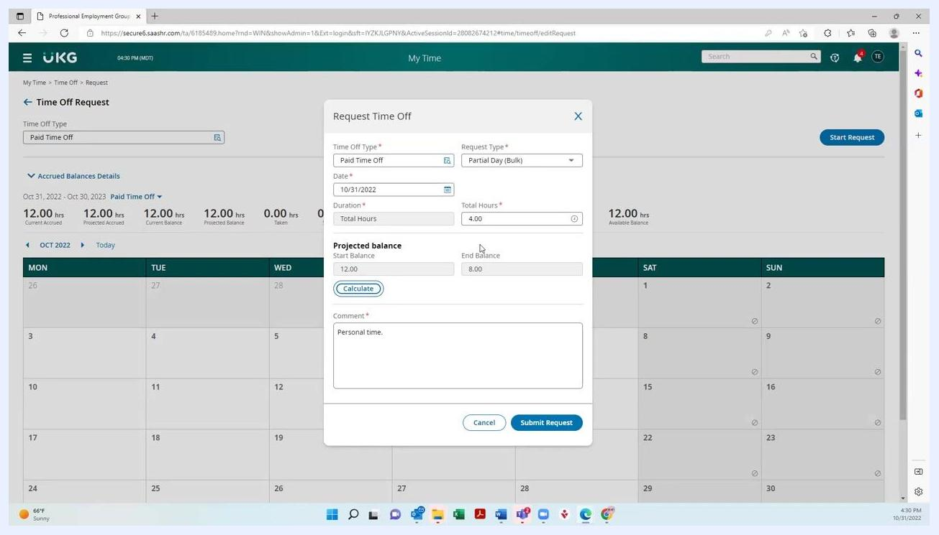
Request Time Off dialog showing a projected balance calculation: starting balance 12.00, ending balance 8.00, with 4.00 hours requested

Step 9: Submit your request
Review all the details you entered: Time Off Type, Request Type, Date, Total Hours, and Comment. Click the Submit Request button to finalize your request.
Your request is then sent to your time card approver for approval.
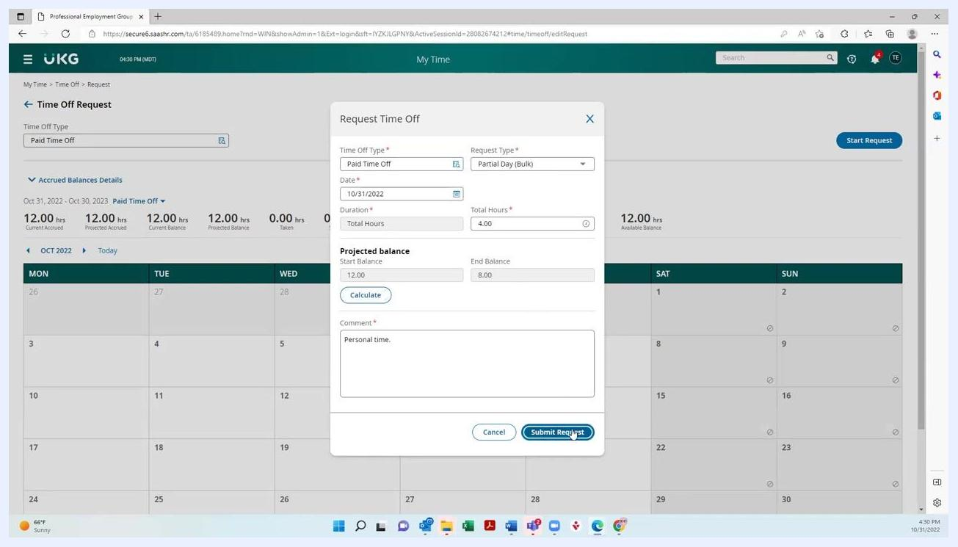
Request Time Off dialog with the cursor positioned on the Submit Request button

Step 10: Review your balances and request status
After submitting, you return to the main Time Off Request page, where you can view:
- Current Accrued: Total hours accrued to date.
- Projected Accrued: Hours expected to accrue.
- Current Balance: Hours currently available.
- Projected Balance: Hours available after pending requests.
- Taken: Hours already used.
- Scheduled: Hours scheduled for future use.
- Requested: Hours currently pending approval.
- Previous Carry Over: Hours carried over from previous periods.
- Expiring Value: Hours set to expire.
- Available Balance: Hours available for use.
For example, after requesting 4.00 hours, "Requested" shows 4.00 and "Projected Balance" shows 8.00.
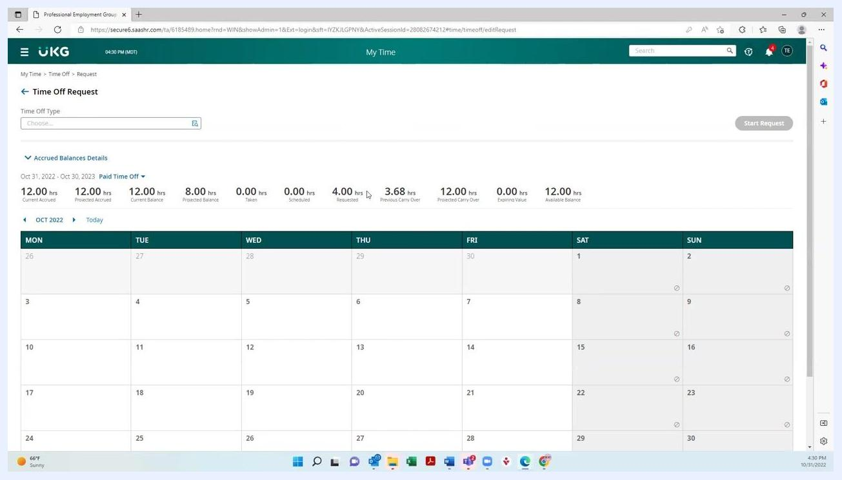
Time Off Request summary showing updated balances with 4.00 hours requested

Step 11: Toggle between types of time off
You can switch between different types of time off, such as Paid Time Off and Sick, using the dropdown menu next to the time off type label.
Note that the availability of certain types, such as Sick time, depends on your state and employer.
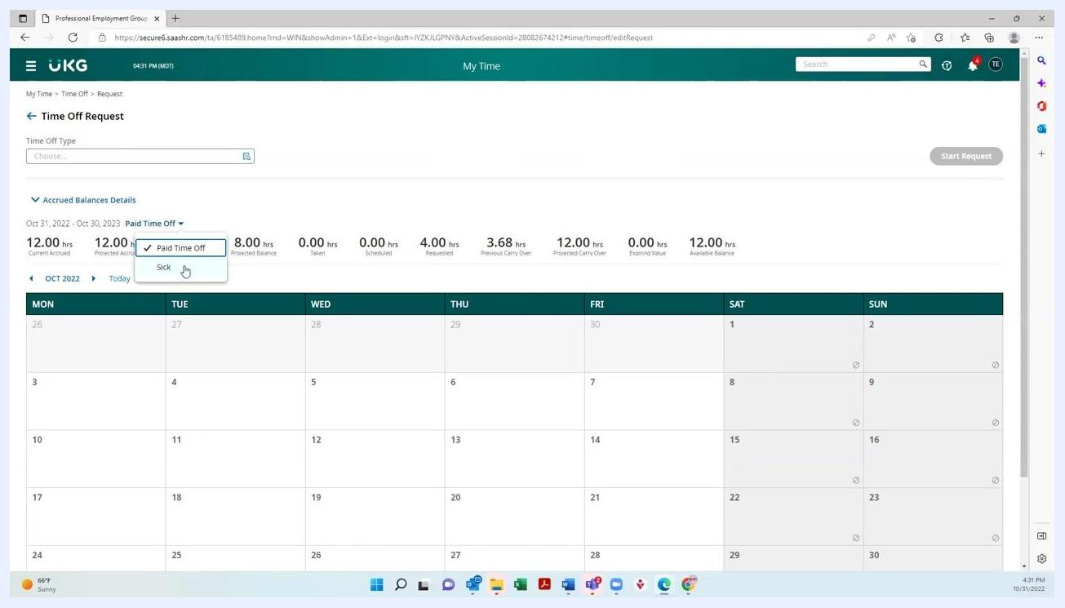
Dropdown menu for switching between Paid Time Off and Sick time

Step 12: View details for each time off type
After selecting a different time off type, the balances and details update to reflect that category. This lets you see how many hours you have available for each type.
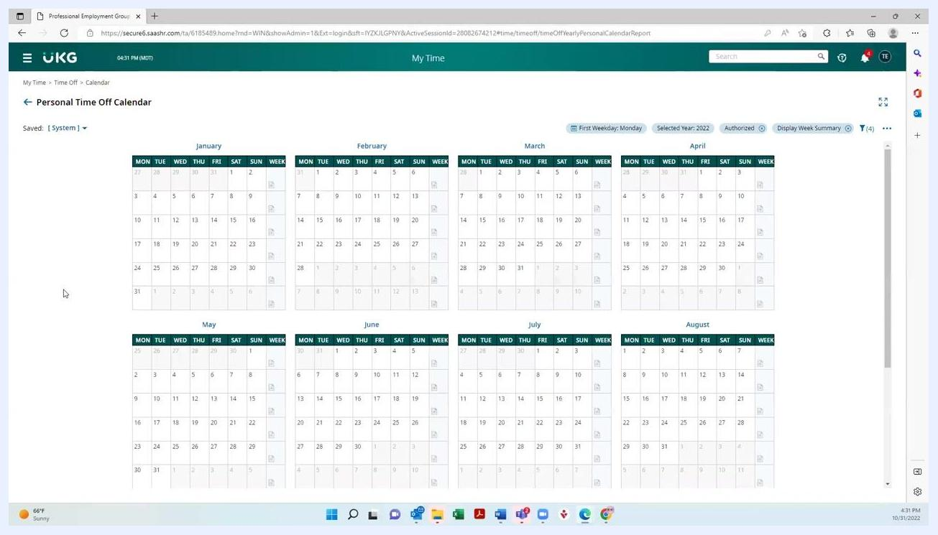
Balances updating after a different time off type is selected

Step 13: Access your time off history, balances, and calendar
Open the left navigation menu. Under My Time > Time Off, you can select:
- Request: To make a new request.
- History: To view past requests and their statuses.
- Balances: To see your current and projected balances.
- Calendar: To view your time off on a calendar.
Navigation menu open showing the Time Off options: Request, History, Balances, and Calendar

Step 14: View your personal time off calendar
Select Calendar to see a yearly view of your time off. The calendar displays all months, letting you track your scheduled and taken time off at a glance.
Personal time off calendar showing all months of the year

Step 15: Navigate back to the homepage
Use the home icon in the left navigation menu to return to the main dashboard at any time.
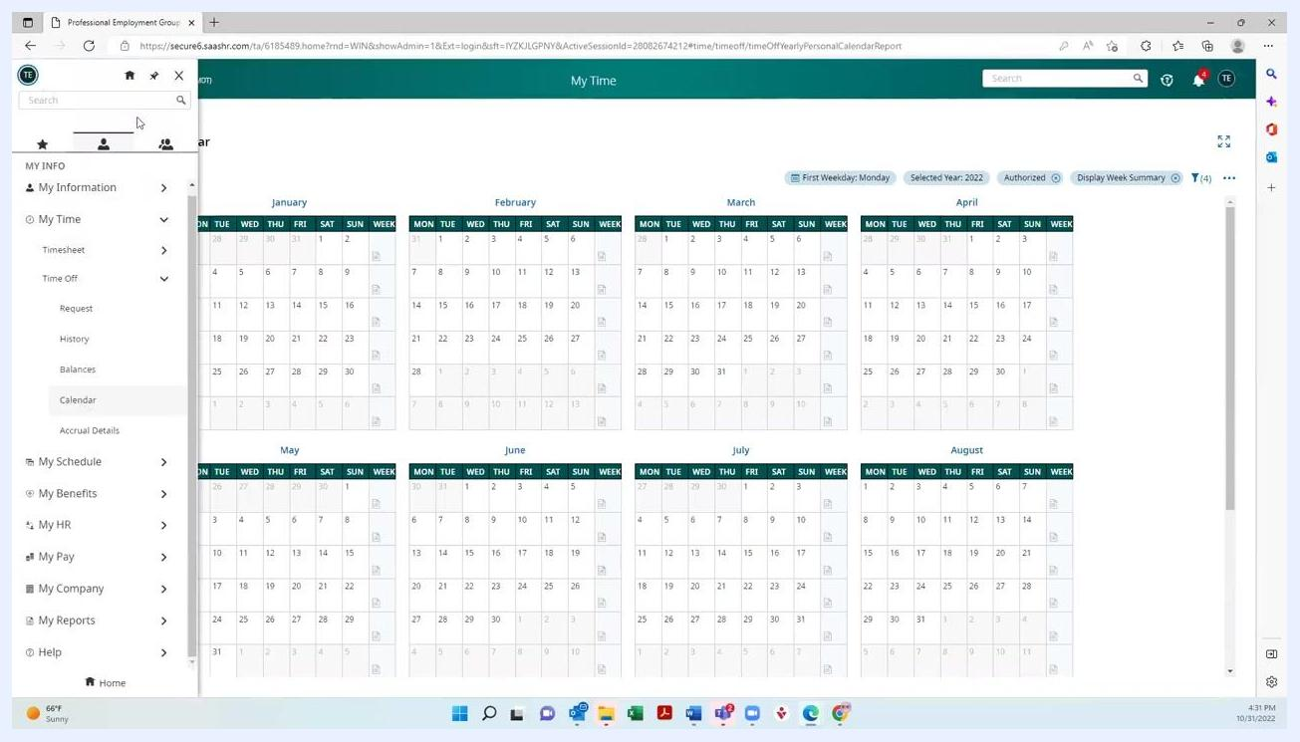
Navigation menu with the home icon highlighted for returning to the homepage

What's next
You have now completed the process for requesting and managing time off in UKG Ready. You can continue to monitor your balances, toggle between different types of leave, and review your time off history and calendar whenever needed. If you have any questions, contact your HR or payroll administrator for assistance.

Screen displaying a blue geometric logo with three interconnected circles and triangles, set against a white background. No other objects, text, or actions are visible.

