How to create a picklist in SuccessFactors
This guide shows you how to create a picklist in SuccessFactors using the Picklist Center. You first create a parent picklist for states and add values to it. You then create a child picklist for districts, link it to the states picklist, and map each district to its state.

Prerequisites
Before you begin, make sure you have:
- A SuccessFactors login that gives you access to the Home screen and the Picklist Center, which is available under the Admin Center.
- The picklist details you want to enter: a code, a name, and the values you plan to add.

Create the parent picklist

1. Open the SuccessFactors Home screen
Log in to SuccessFactors. The Home screen displays widgets such as To-Do, My Team, and My Info.
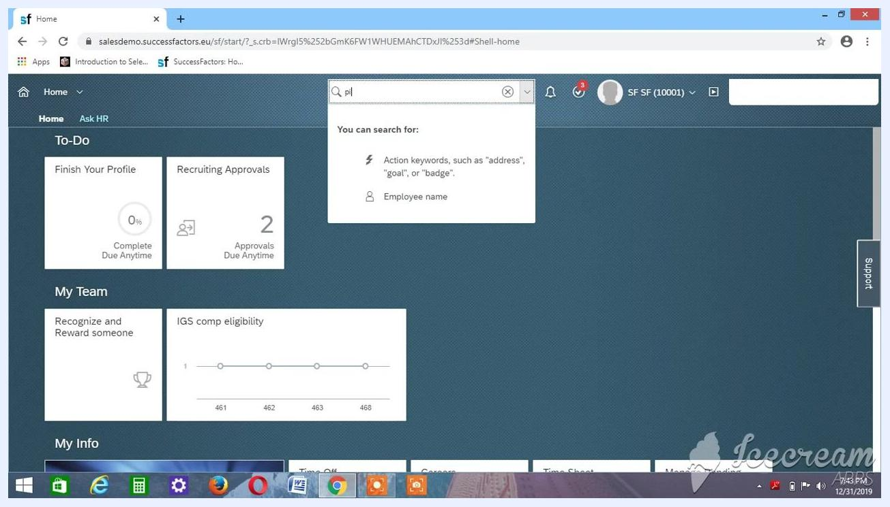
SuccessFactors Home screen with the navigation bar, search bar, and dashboard widgets visible

2. Search for the Picklist Center
Click the search bar at the top of the screen and start typing "pl". Search suggestions appear below the search bar.
Search bar with "pl" typed and search suggestions displayed

3. Open the Picklist Center
Select Picklist Center from the search results. The screen lists existing picklists with the columns Code, Name, Status, Effective Start Date, and Parent Picklist. Confirm that the "As of date" is set (for example, Dec 31, 2019).
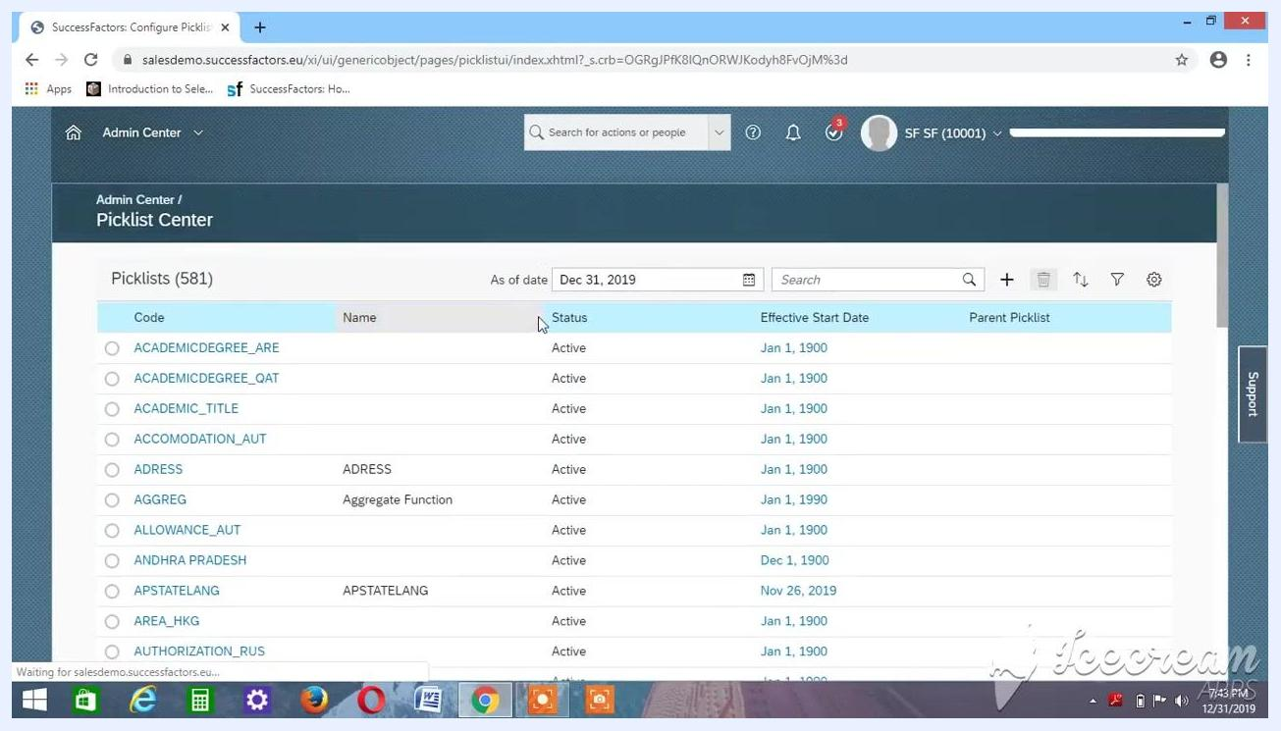
Picklist Center screen listing picklists with columns for Code, Name, Status, Effective Start Date, and Parent Picklist

4. Start creating a new picklist
Click the + (plus) icon. The Create a New Picklist dialog opens with fields for Code, Name, Status, Effective Start Date, Display Order, and Parent Picklist.
Create a New Picklist dialog open with its empty fields

5. Enter the picklist details
This example creates a picklist named State. Fill in the dialog as follows:
- In the Code field, enter Test_AK_State.
- In the Name field, enter State.
- Make sure Status is set to Active.
- Set Display Order to Alphabetical.
- Leave Parent Picklist blank, unless you are creating a hierarchical picklist.
The Effective Start Date defaults to the current date (for example, Dec 31, 2019).
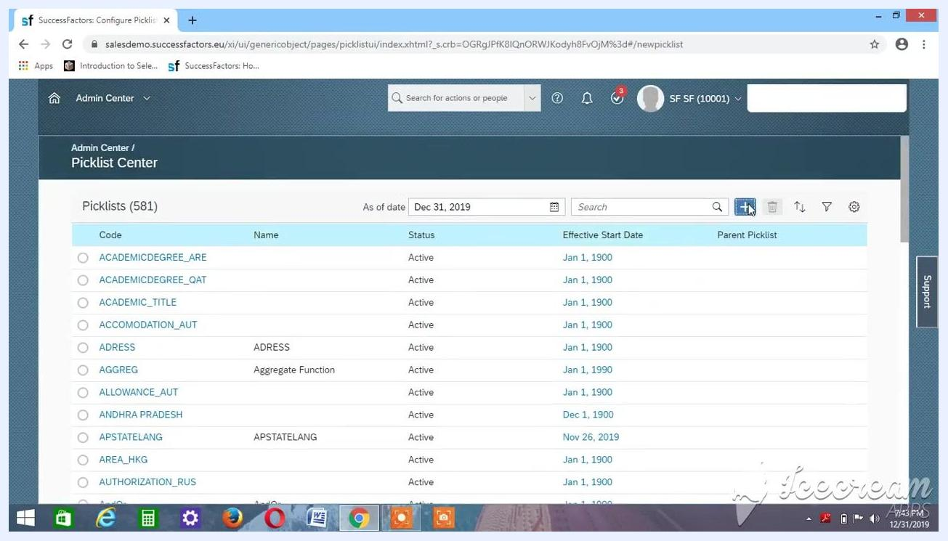
Create a New Picklist dialog with Code Test_AK_State, Name State, Status Active, Effective Start Date Dec 31, 2019, and Display Order Alphabetical

6. Set the Effective Start Date to the standard value
Click the calendar icon next to the Effective Start Date field. In the date picker, navigate to the year 1900 and select January 1, 1900.
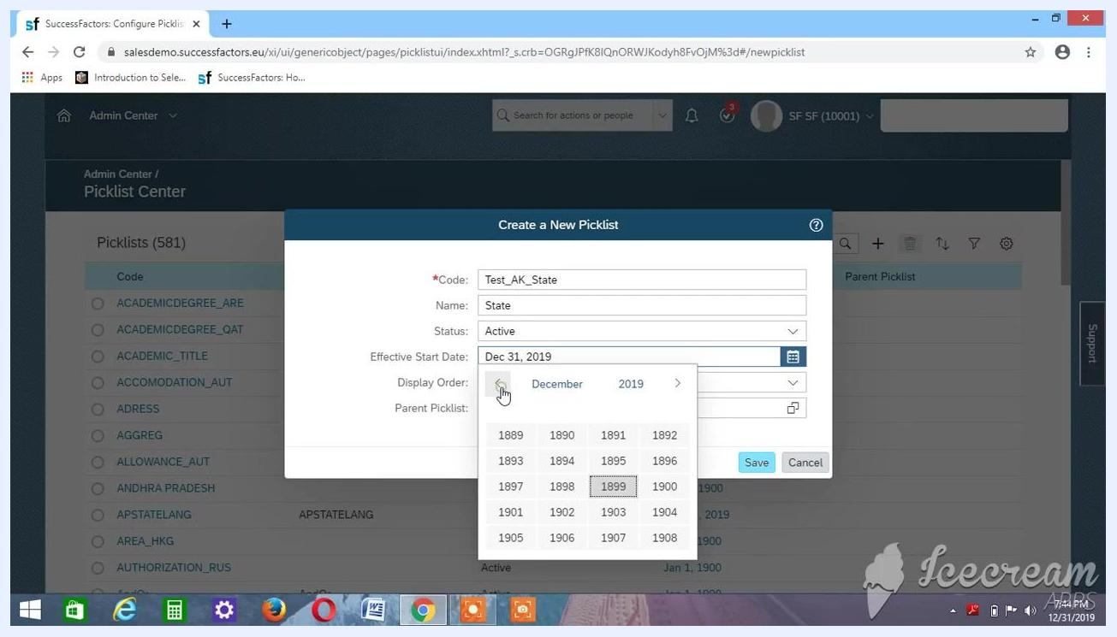
Date picker open while navigating to the year 1900 to select January 1, 1900

7. Review the picklist details
Check that the dialog shows these values:
- Code: Test_AK_State
- Name: State
- Status: Active
- Effective Start Date: Jan 1, 1900
- Display Order: Alphabetical
- Parent Picklist: blank
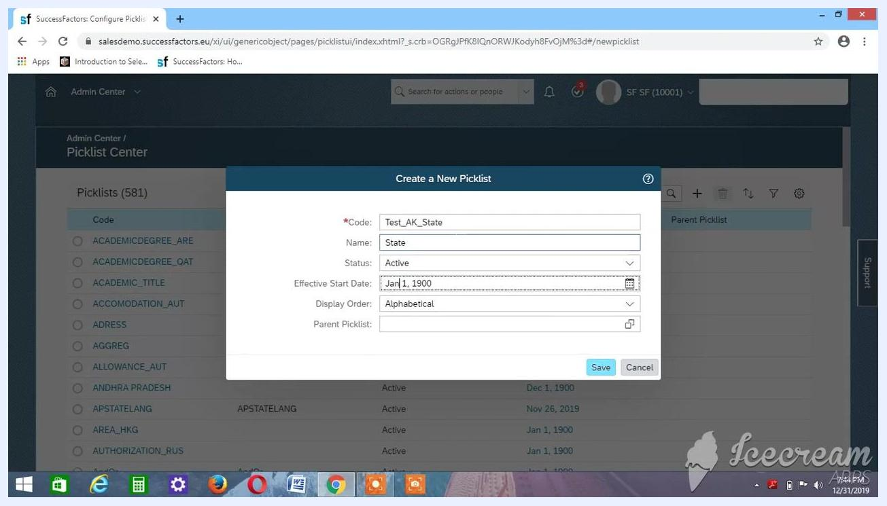
Create a New Picklist dialog with all fields completed and the Effective Start Date set to Jan 1, 1900

8. Save the picklist
The saved picklist in this example has the code Test_AK_State1, and later steps refer to it by that code. Confirm these values in the dialog, then click Save:
- Code: Test_AK_State1
- Name: State
- Status: Active
- Effective Start Date: Jan 1, 1900
- Display Order: Alphabetical
- Parent Picklist: blank for now
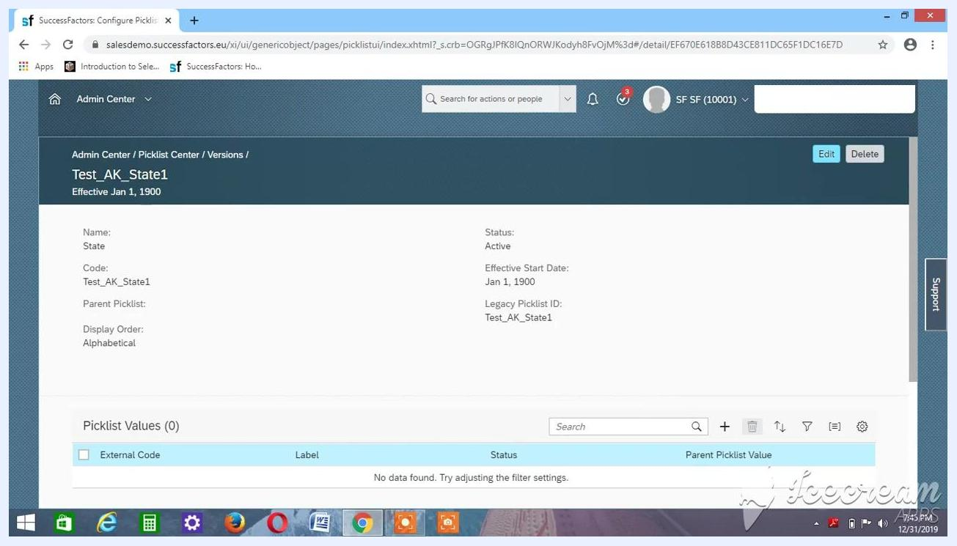
Create a New Picklist dialog with Code Test_AK_State1, Name State, Status Active, Effective Start Date Jan 1, 1900, and Display Order Alphabetical

9. Verify the picklist was created
After you save, SuccessFactors opens the picklist details page. Confirm that it shows:
- Name: State
- Code: Test_AK_State1
- Status: Active
- Effective Start Date: Jan 1, 1900
- Display Order: Alphabetical
- Parent Picklist: blank
The Picklist Values section shows "No data found" because you haven't added any values yet.
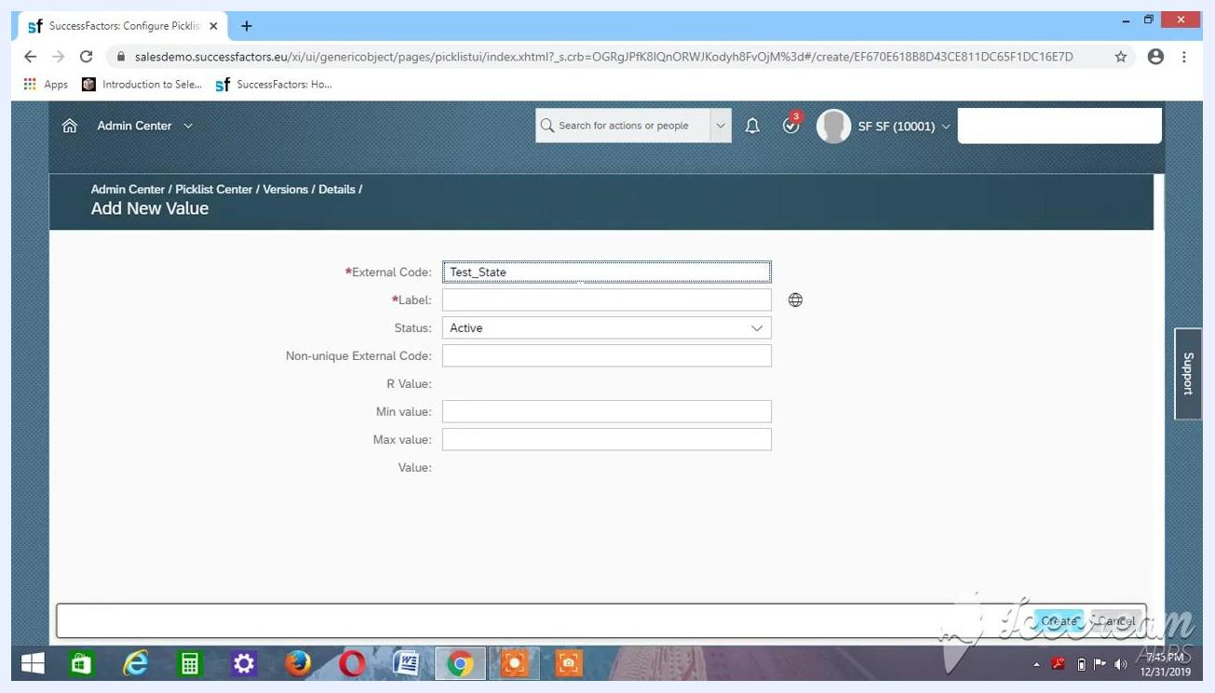
Picklist details page showing Name State, Code Test_AK_State1, Status Active, Effective Start Date Jan 1, 1900, Display Order Alphabetical, and an empty Picklist Values section

Add values to the parent picklist

10. Open the Add New Value dialog
Scroll down to the Picklist Values section and click the + (plus) icon. The Add New Value dialog appears.

11. Enter the first picklist value
In the Add New Value dialog, fill in these fields:
- External Code: Test_State
- Label: Enter the label you want, such as a state name.
- Status: Active
Leave the other fields (Non-unique External Code, R Value, Min value, Max value, and Value) blank unless you need them.
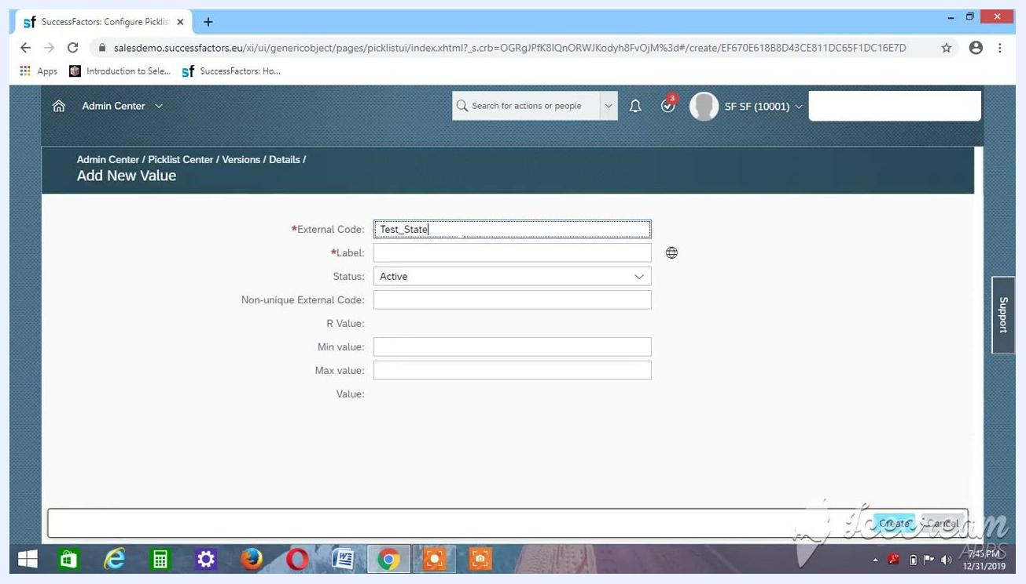
Add New Value dialog with External Code Test_State, an empty Label, and Status Active

12. Add more picklist values
Repeat the process for each new value, and click Create after you enter each one:
- External Code: Enter a unique code, such as Test_Ak_Madhya or Test_Ak_Karnataka.
- Label: Enter the matching label, such as Madhya.
- Status: Set to Active.
Leave the other fields blank unless you need them.
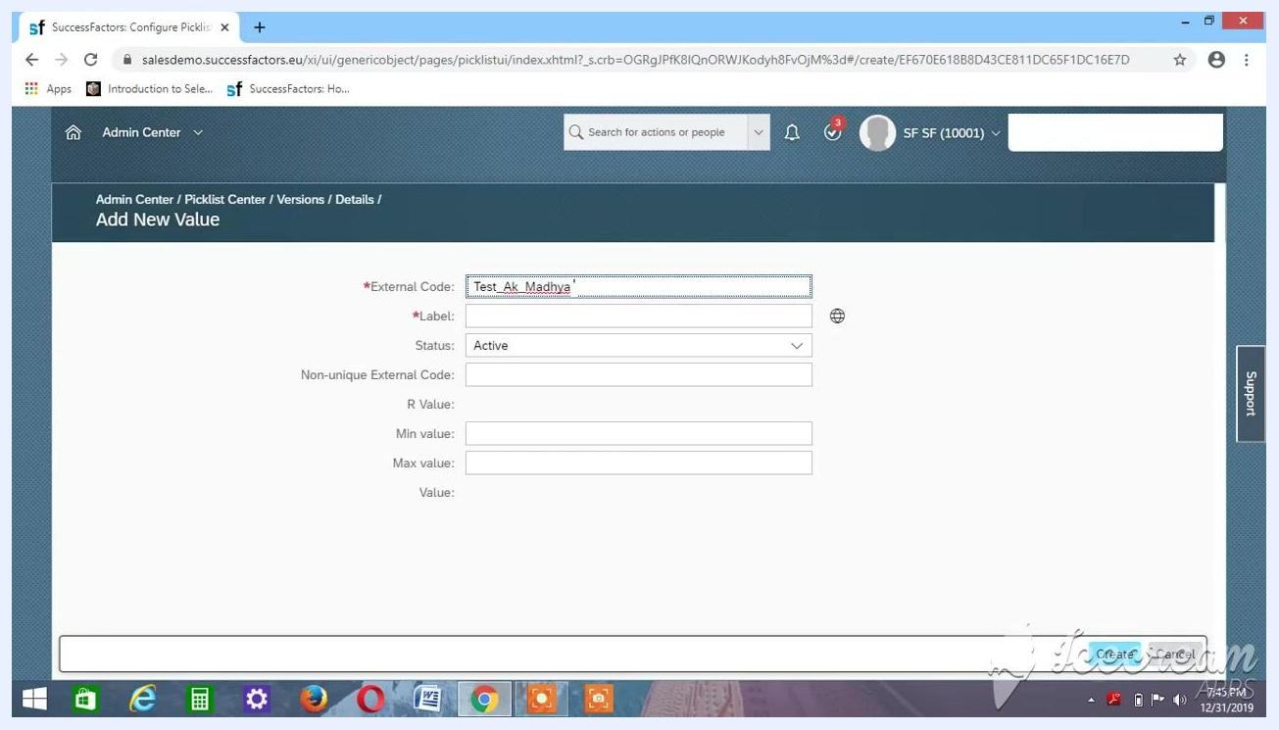
Add New Value dialog with External Code Test_Ak_Madhya and Status Active
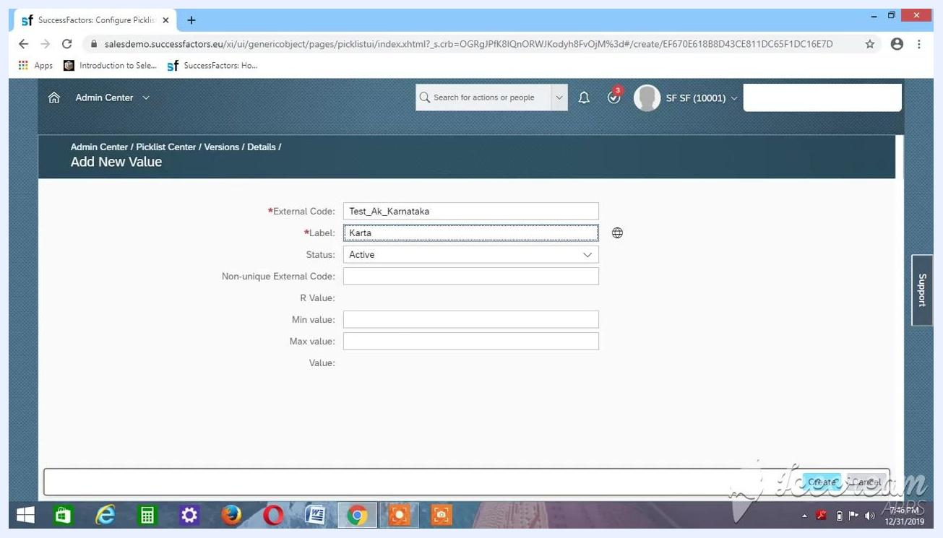
Add New Value dialog while the Karnataka value is being entered, with External Code Test_Ak_Karnataka and Status Active

13. Add the Karnataka value
In the Add New Value dialog, enter these details and click Create:
- External Code: Test_Ak_Karnataka
- Label: Karnataka
- Status: Active
Leave all other fields blank unless you need them.
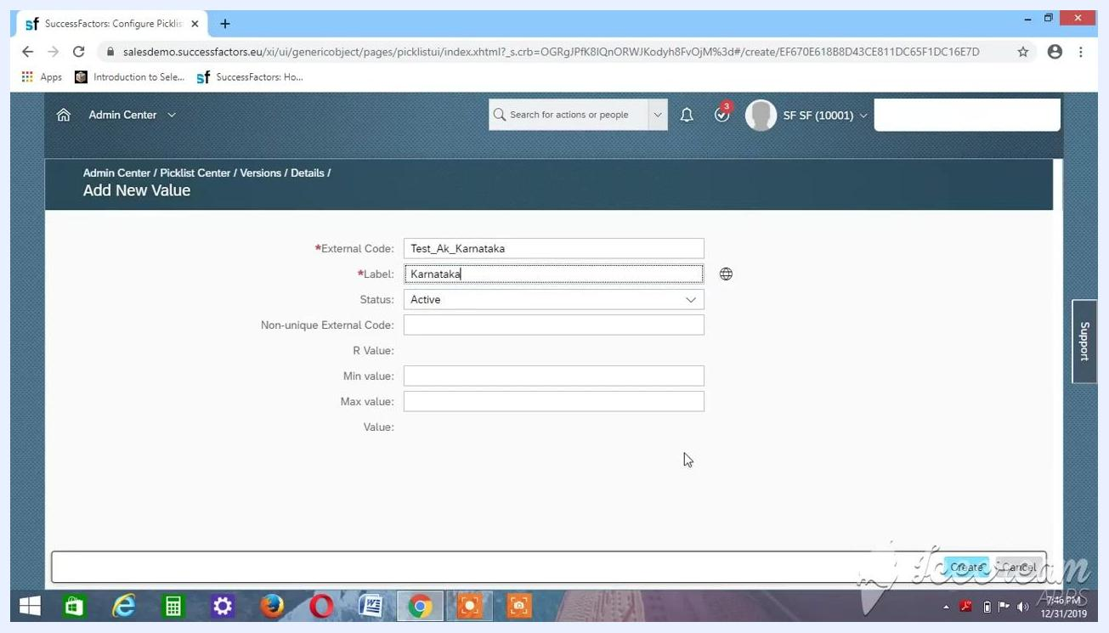
Add New Value dialog with External Code Test_Ak_Karnataka, Label Karnataka, and Status Active

14. Verify the value appears in the picklist
Confirm that the value appears in the Picklist Values section with:
- External Code: Test_Ak_Karnataka
- Label: Karnataka
- Status: Active
- Parent Picklist Value: blank
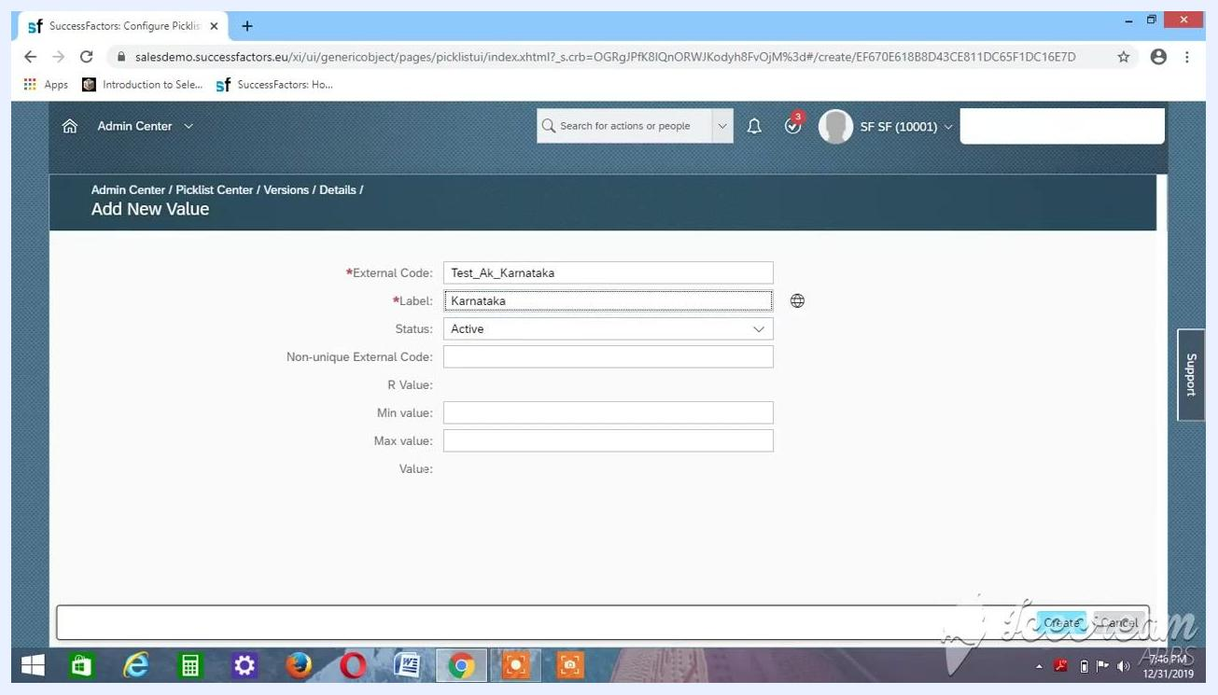
Picklist Values section showing Test_Ak_Karnataka, Karnataka, and Active

15. Add the Telangana value
Click the + (plus) icon to add another value. In the Add New Value dialog, enter these details and click Create:
- External Code: Test_Telangana
- Label: Telangana
- Status: Active
Leave all other fields blank.
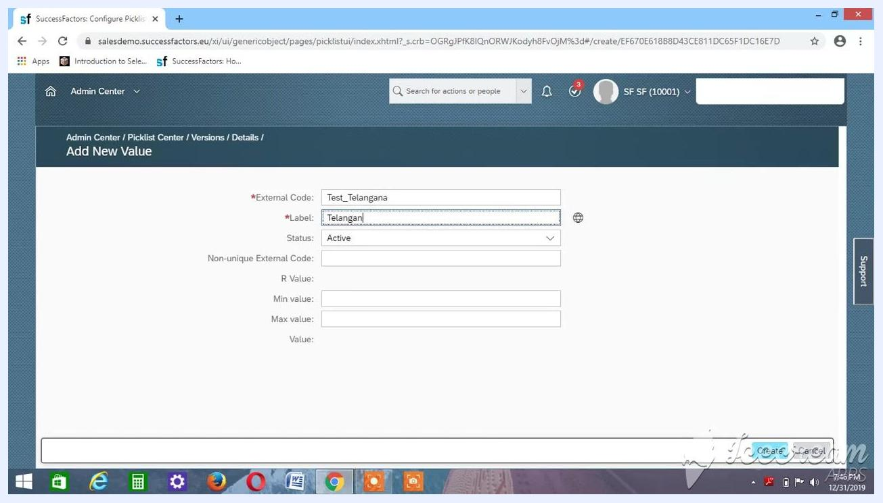
Add New Value dialog with External Code Test_Telangana, Label Telangana, and Status Active

16. Confirm multiple values are listed
Verify that both values now appear in the Picklist Values section:
- Test_Ak_Karnataka | Karnataka | Active
- Test_Telangana | Telangana | Active
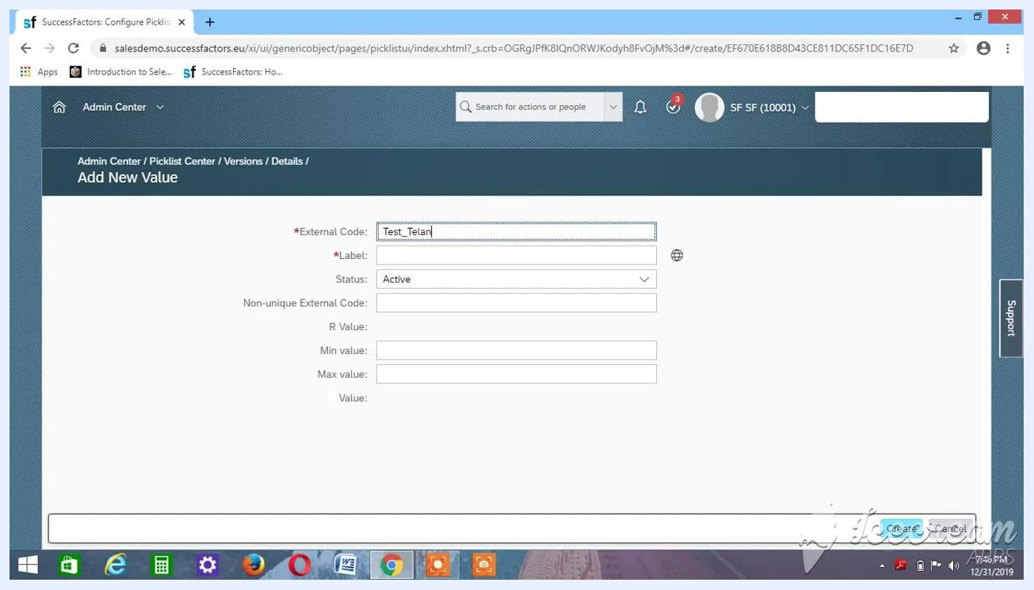
Picklist Values section listing Test_Ak_Karnataka, Karnataka, Active and Test_Telangana, Telangana, Active

17. Enter the Maharashtra value
Click the + (plus) icon to add a new value. In the Add New Value dialog, enter the following. Leave all other fields blank.
- External Code: Test_Maharastra
- Label: Maharastra
- Status: Active
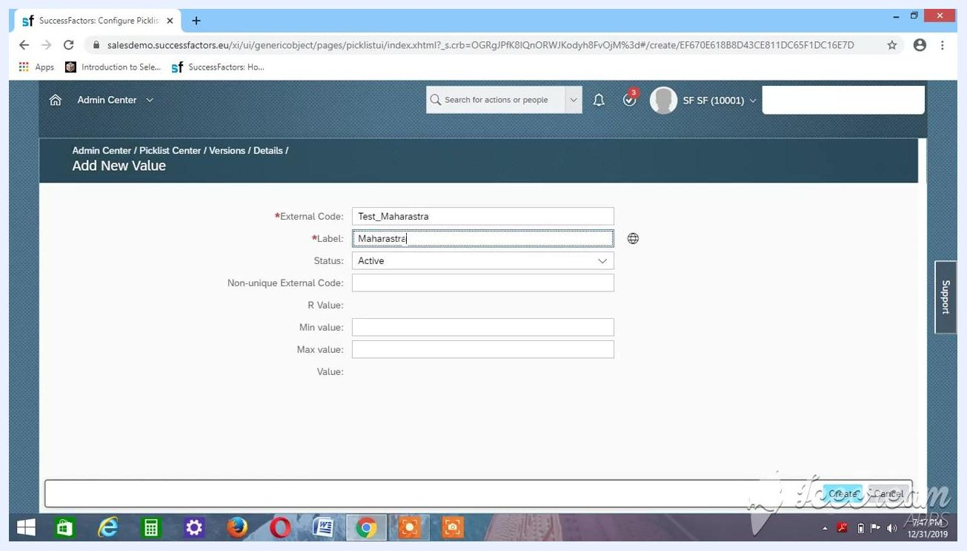
Add New Value dialog with External Code Test_Maharastra, Label Maharastra, and Status Active

18. Review the value before you save
Confirm that the Add New Value dialog is open in the Admin Center under the Picklist Center, and check these fields:
- External Code: Test_Maharastra
- Label: Maharastra
- Status: Active
Verify that the other fields (Non-unique External Code, R Value, Min value, Max value, and Value) are blank unless you need them. Double-check the values for typos. The Create and Cancel buttons appear at the bottom right of the dialog.
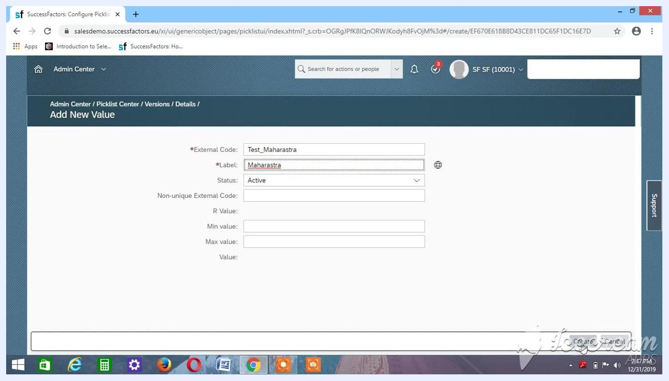
Add New Value dialog with External Code Test_Maharastra, Label Maharastra, Status Active, other fields blank, and the Create and Cancel buttons visible

19. Save the new value
Click Create at the bottom right of the dialog to add the value to the picklist.

20. Verify the new value is listed
Check that Test_Maharastra with the label Maharastra and the status Active now appears alongside the values you added earlier. Make sure all values display correctly and are active.
Each picklist value needs a unique external code, an appropriate label, and the status Active. Repeat these steps for every value you need.

Create the child picklist

21. Return to the Picklist Center
Open the Picklist Center in SuccessFactors. The list shows existing picklists with their codes, names, statuses, effective start dates, and parent picklists. Example picklists include ACADEMICDEGREE_ARE, AGGREG, and ANDHRA PRADESH.
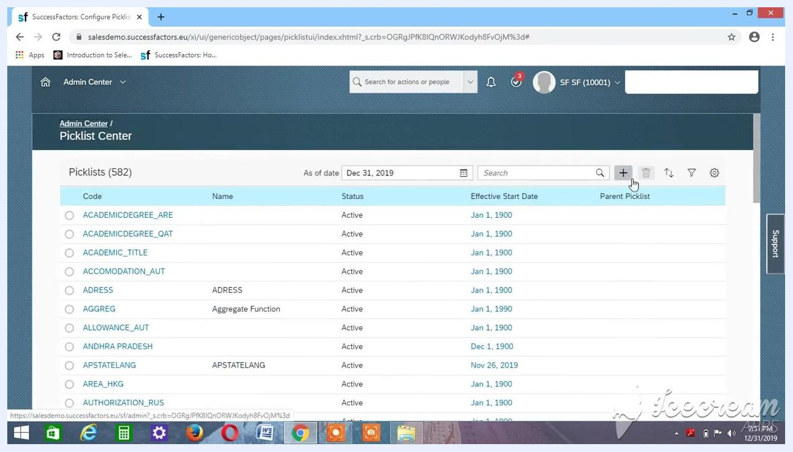
Picklist Center listing picklists with columns for Code, Name, Status, Effective Start Date, and Parent Picklist, ready for a new picklist to be created with the plus button

22. Start a new picklist
Click the + (plus) button to create a new picklist.

23. Enter the child picklist details
In the Create a New Picklist dialog, enter the details for a districts picklist:
- Code: Test_AK_Districts
- Name: Districts
- Status: Make sure it is Active.
- Effective Start Date: Change it to Jan 1, 1900.
- Display Order: Set it to Alphabetical.
- Parent Picklist: Leave blank for now.
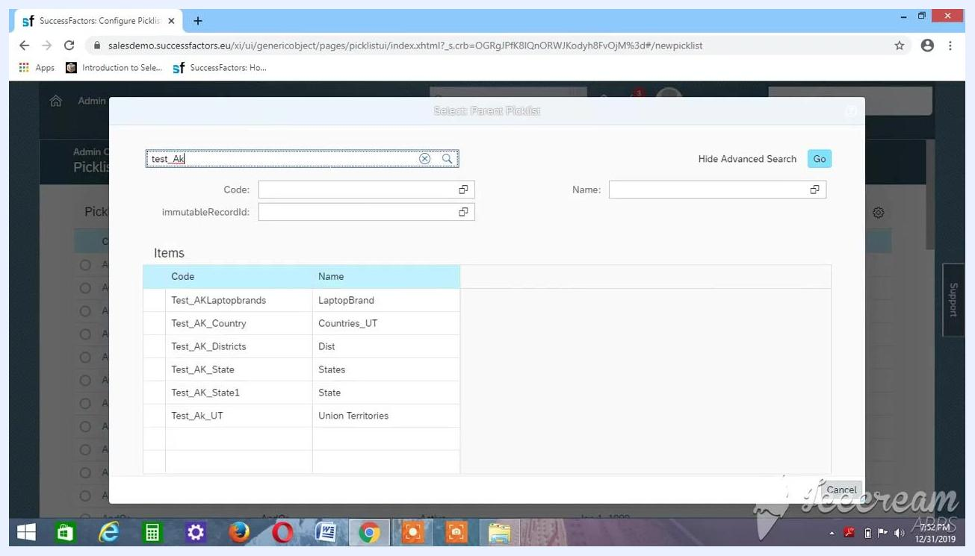
Create a New Picklist dialog with Code Test_AK_Districts, Name Districts, Status Active, Effective Start Date Jan 1, 1900, Display Order Alphabetical, and Parent Picklist blank

24. Set the Effective Start Date
Click the calendar icon next to the Effective Start Date field. In the calendar picker, select the year 1900 and the date Jan 1, 1900.
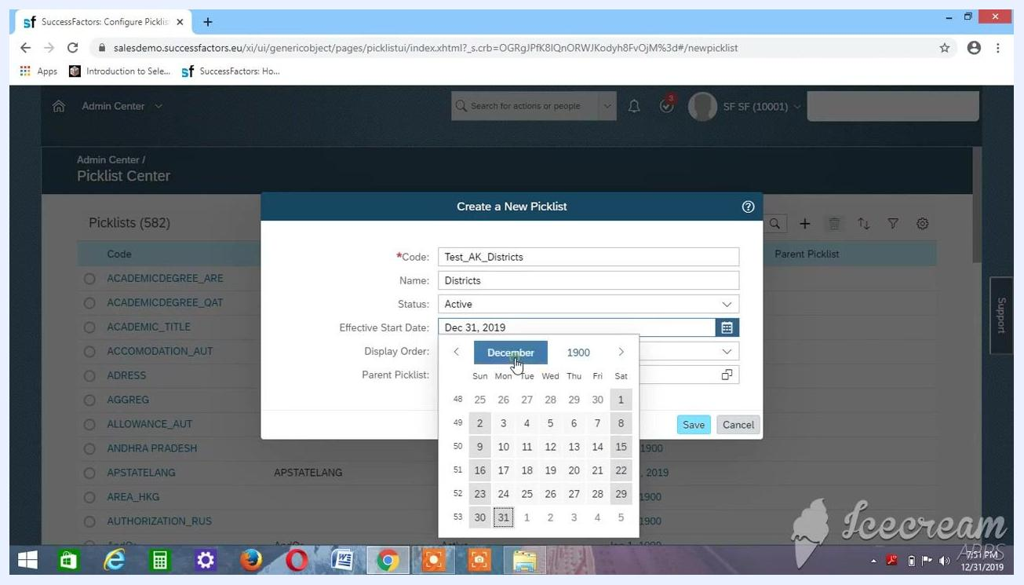
Calendar picker open with the year 1900 and the month January selected for the Effective Start Date

25. Assign the parent picklist
To link the districts picklist to the states picklist, follow these steps:
- Click the icon next to the Parent Picklist field.
- In the Select Parent Picklist dialog, enter test_Ak in the search field.
- Click Go or press Enter to search.
- From the results, select the parent picklist. To link districts to states, select Test_AK_State1.
Select Parent Picklist dialog with search results for test_Ak, including Test_AK_Districts, Test_AK_State, and Test_AK_State1

26. Review the details and save
In the Create a New Picklist dialog, confirm these values:
- Code: Test_AK_Districts
- Name: Districts
- Status: Active
- Effective Start Date: Jan 1, 1900
- Display Order: Alphabetical
- Parent Picklist: Test_AK_State1
Click Save to create the picklist.
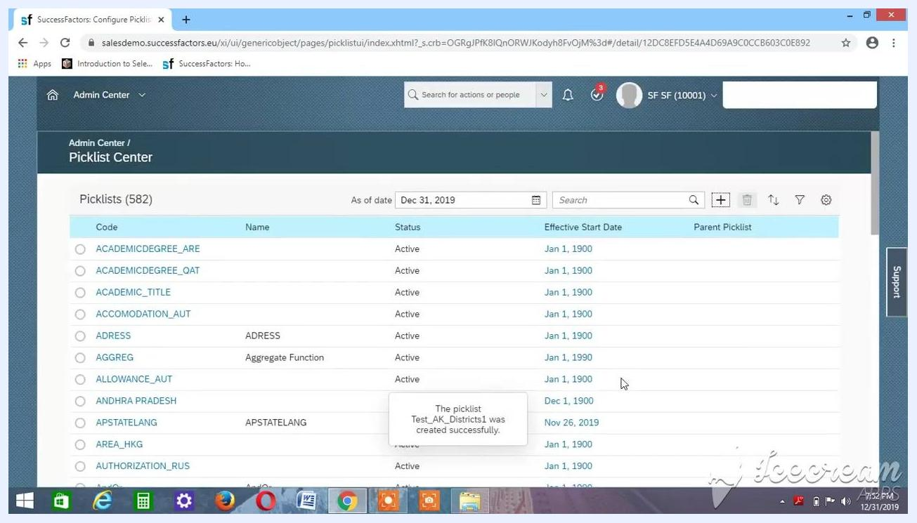
Create a New Picklist dialog with all fields filled and the Save button highlighted

27. Confirm the picklist was created
Wait for the confirmation message. In this example, it reads "The picklist Test_AK_Districts1 was created successfully." The new picklist now appears in the Picklist Center list.
Picklist Center with a confirmation message that the picklist Test_AK_Districts1 was created successfully

28. Open the new picklist
Click the new picklist, Test_AK_Districts1, to open its details page. The page displays:
- Code: Test_AK_Districts1
- Parent Picklist: State (Test_AK_State1)
- Display Order: Alphabetical
- Effective Start Date: Jan 1, 1900
- Picklist Values: Empty ("No data found")
Picklist details page for Test_AK_Districts1 with no picklist values yet

Add values to the child picklist

29. Open the Add New Value dialog
Click the + (plus) button in the Picklist Values section.

30. Enter the Hyderabad value
In the Add New Value dialog, enter these details:
- External Code: Test_hyderabad
- Label: Hyderabad
- Parent Picklist Value: Click the icon and select the parent value. Because Hyderabad is a district in Telangana, select Telangana.
- Status: Make sure it is Active.
Leave the other fields blank unless you need specific values.
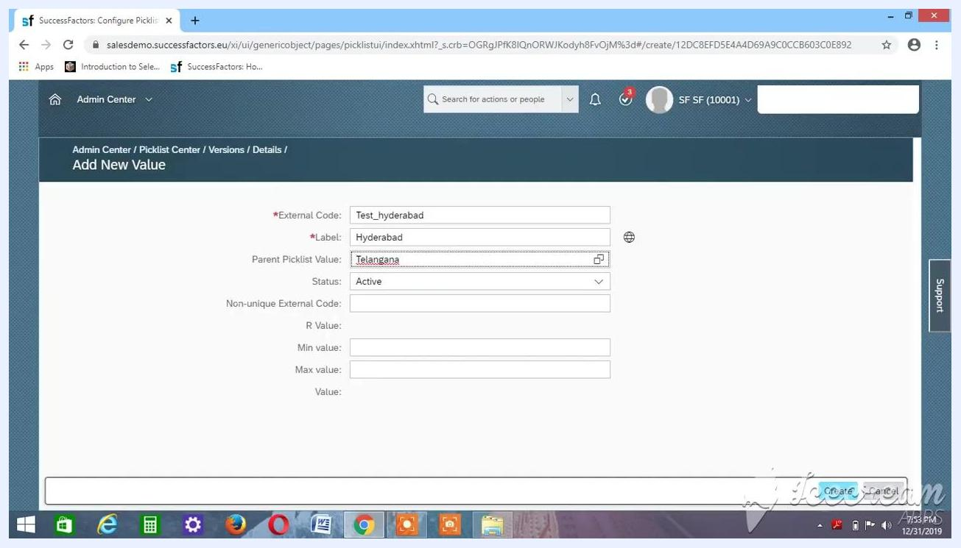
Add New Value dialog with External Code Test_hyderabad, Label Hyderabad, Parent Picklist Value Telangana, and Status Active

31. Save the value and repeat for other districts
Click Create to add the value. Then repeat the previous steps for each additional district. For each one:
- Enter a unique External Code, such as Test_nizamabad.
- Enter the Label (the district name).
- Select the correct Parent Picklist Value (the state).
- Set Status to Active.
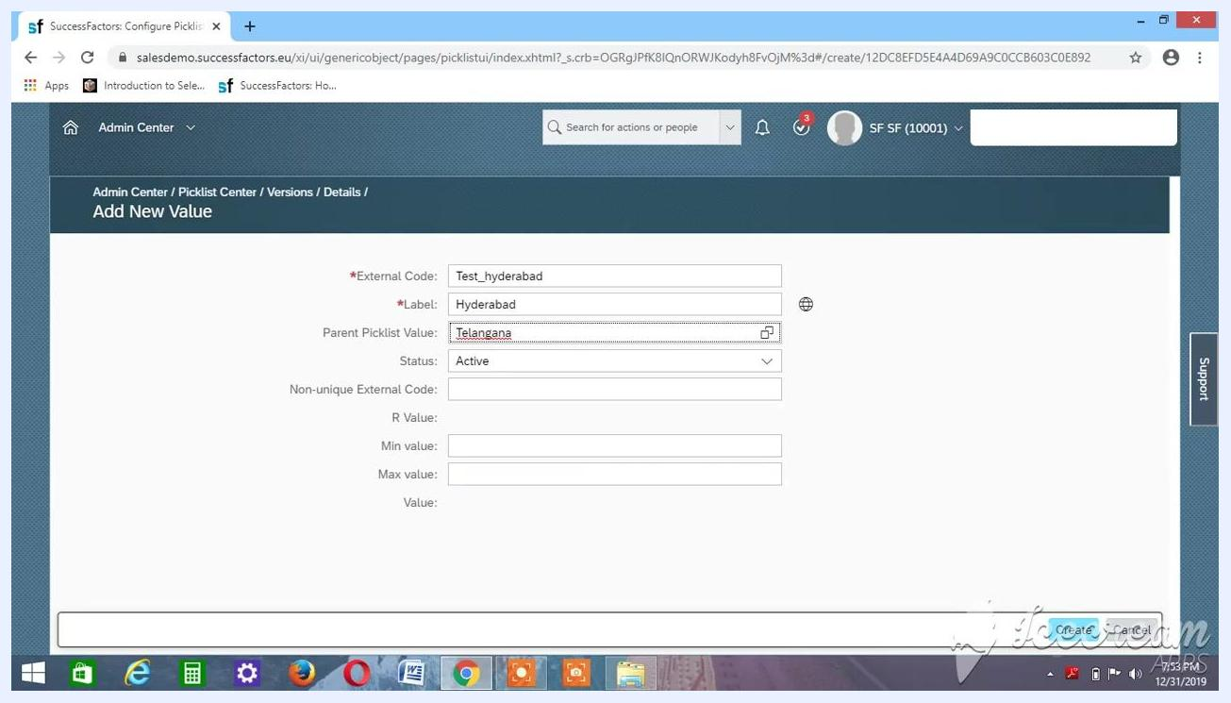
Add New Value dialog with all required fields filled for the Hyderabad district mapped to Telangana

32. Begin the Bengaluru value
In the Add New Value dialog, start entering the next district. You reach this screen from the Picklist Center under the Admin Center.
- External Code: Begin with Test_Be and complete it in the next step.
- Label: Leave blank for now.
- Parent Picklist Value: Leave blank for now.
- Status: Make sure it is Active.
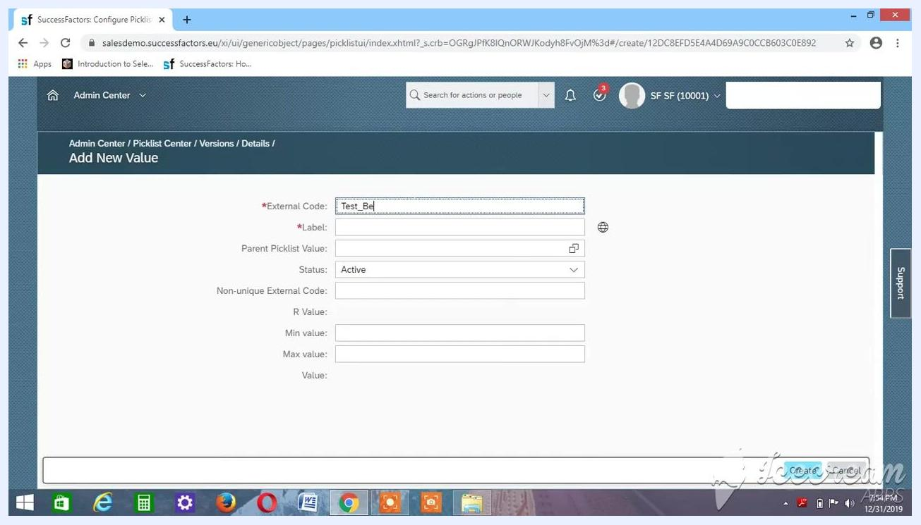
Add New Value dialog with External Code partially entered as Test_Be, other fields blank, and Status Active

33. Complete the Bengaluru entry
Finish the entry with these values:
- External Code: Test_Bengaluru
- Label: Bengaluru
- Parent Picklist Value: Leave blank for now.
- Status: Active
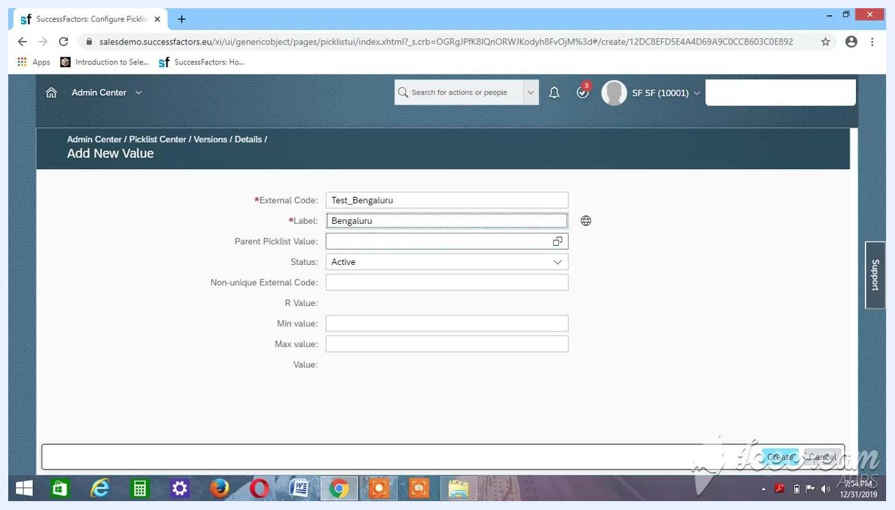
Add New Value dialog with External Code Test_Bengaluru, Label Bengaluru, and Status Active

34. Search for the parent picklist value
Click the icon next to the Parent Picklist Value field to open the selection dialog. In the Select Parent Picklist Value dialog, enter test_kar in the search field to filter for Karnataka. No matching items appear at first.
Select Parent Picklist Value dialog with a search for test_kar and no matching items found

35. Refine the search and select Karnataka
Change the search to test_Ak_kar. The item Test_Ak_Karnataka with the label Karnataka appears in the results. Select Test_Ak_Karnataka as the parent picklist value.
Select Parent Picklist Value dialog showing Test_Ak_Karnataka in the results

36. Confirm the Bengaluru entry
Check that the dialog shows these values. All other fields remain blank.
- External Code: Test_Bengaluru
- Label: Bengaluru
- Parent Picklist Value: Karnataka
- Status: Active
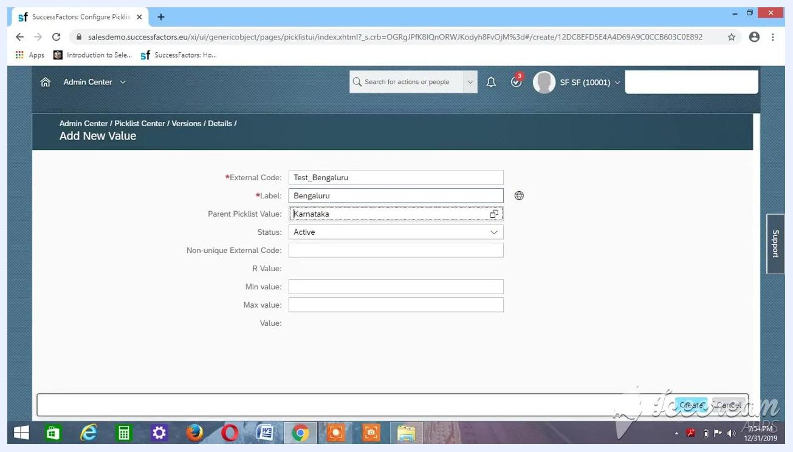
Add New Value dialog with all fields filled for Bengaluru and the Parent Picklist Value set to Karnataka

37. Save the Bengaluru value
Click Create to add the Bengaluru district value to the picklist.

38. Start the Mumbai value
Repeat the process for Mumbai. In the Add New Value dialog, enter:
- External Code: test_Mumbai
- Label: Mumbai
- Parent Picklist Value: Leave blank for now.
- Status: Make sure it is Active.
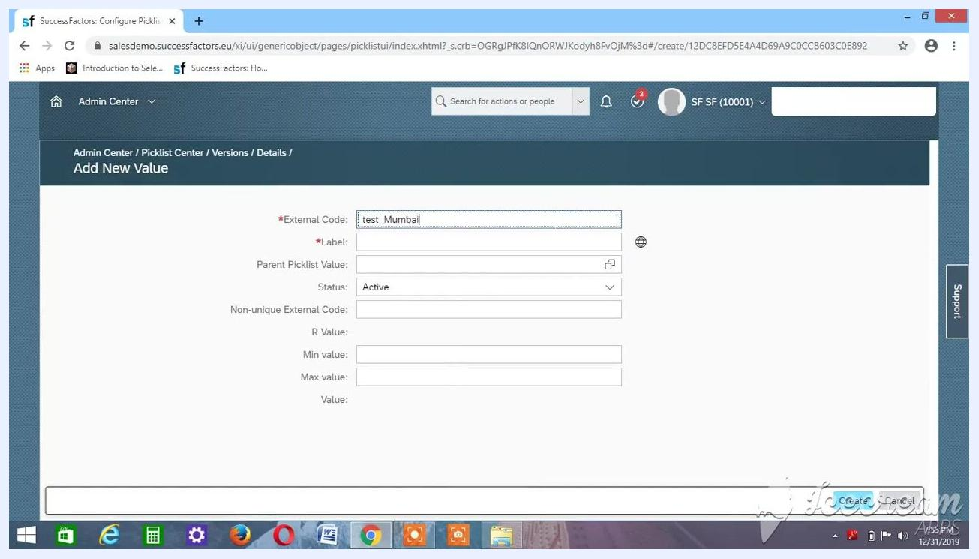
Add New Value dialog with External Code test_Mumbai, Label Mumbai, and Status Active

39. Select the parent value for Mumbai
Click the icon next to the Parent Picklist Value field. Search for and select Maharastra (Test_Maharastra) as the parent picklist value. Make sure Status is set to Active.
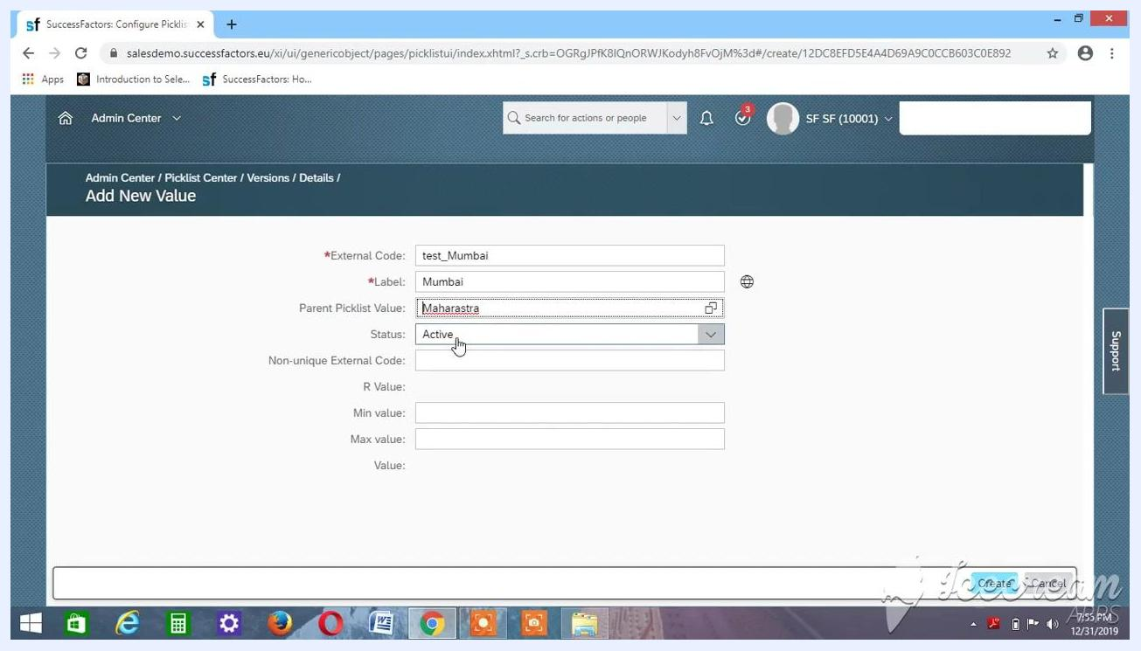
Add New Value dialog with External Code test_Mumbai, Label Mumbai, Parent Picklist Value Maharastra, and Status Active

40. Save the Mumbai value
Click Create to add the Mumbai district value to the picklist.

41. Review the completed picklist
The picklist Test_AK_Districts1 now contains three values:
- Test_hyderabad (Hyderabad), with the parent Telangana (Test_Telangana)
- Test_Bengaluru (Bengaluru), with the parent Karnataka (Test_Ak_Karnataka)
- test_Mumbai (Mumbai), with the parent Maharastra (Test_Maharastra)
All values have Status set to Active.
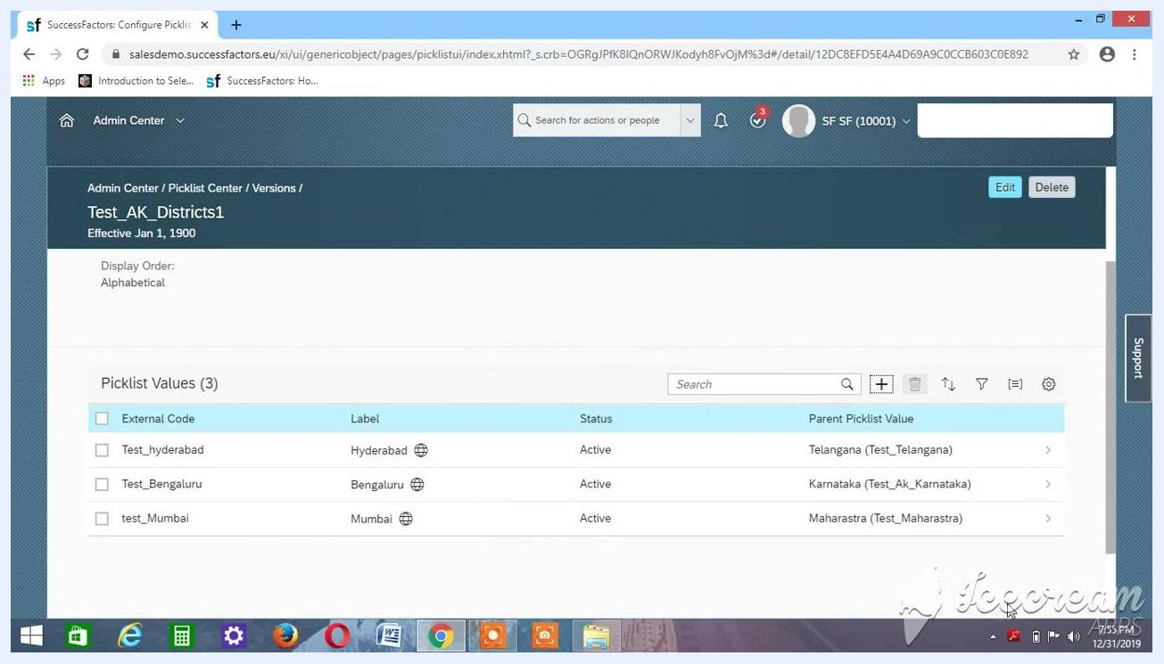
Picklist Center showing Test_AK_Districts1 with three district values and their parent states

Review the parent-child mapping

42. Verify the district picklist
Confirm that the picklist named Test_AK_Districts1 contains the following values:
- Test_hyderabad (Label: Hyderabad), with the Parent Picklist Value Telangana (Test_Telangana)
- Test_Bengaluru (Label: Bengaluru), with the Parent Picklist Value Karnataka (Test_Ak_Karnataka)
- test_Mumbai (Label: Mumbai), with the Parent Picklist Value Maharastra (Test_Maharastra)
Ensure all values have Status set to Active. Confirm that the Effective Date for the picklist is Jan 1, 1900 and that the display order is Alphabetical.
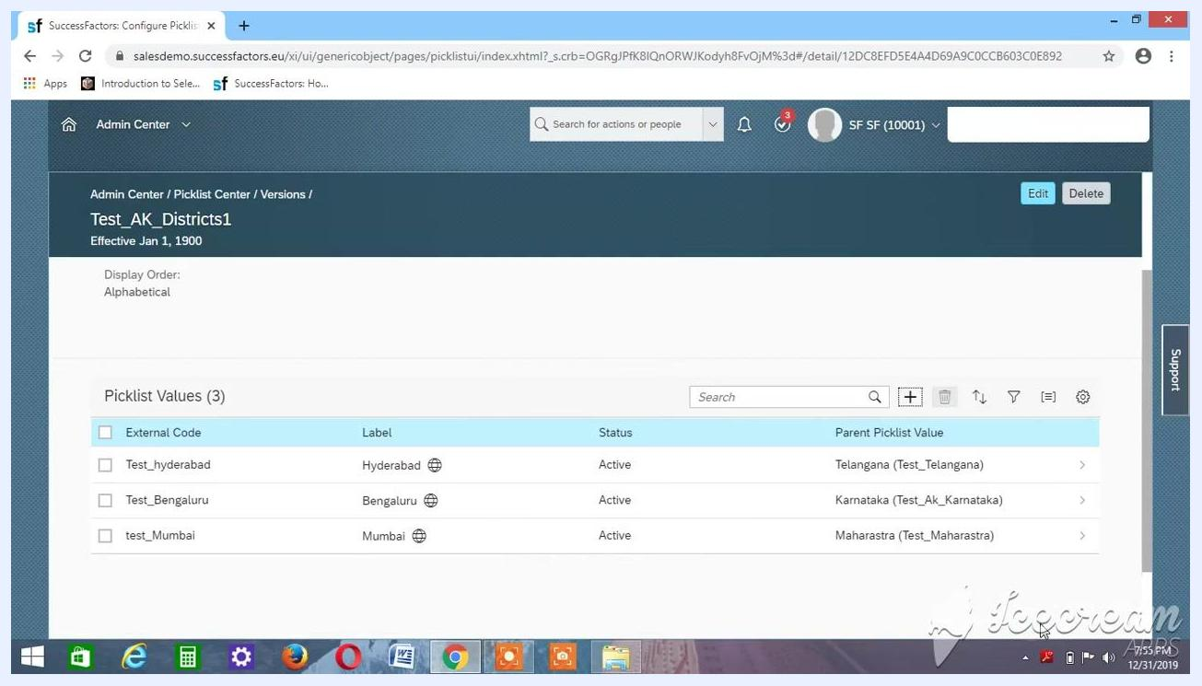
Picklist Center showing Test_AK_Districts1 with three district values, their labels, statuses, and parent picklist values

43. Understand the parent-child relationship
Keep these points in mind when you create a child picklist:
- The district picklist (Test_AK_Districts1) uses the state picklist as its parent.
- Always specify the parent picklist (states) when you set up the child picklist (districts).
- Use a meaningful picklist name so you can identify it easily during testing or production use.
- Set the Effective Date to Jan 1, 1900 for consistency and to avoid future-dated issues.
- When you assign the parent, search for the exact name or external code, such as Test_Ak_Karnataka for Karnataka.

44. Return to the SuccessFactors Home page
When you finish configuring the picklists, navigate back to the Home page. It displays widgets such as:
- To-Do: Finish Your Profile (0% Complete) and Recruiting Approvals (2 Approvals Due Anytime)
- My Team: Recognize and Reward someone and IGS comp eligibility chart
- My Info: Additional personal and HR-related widgets
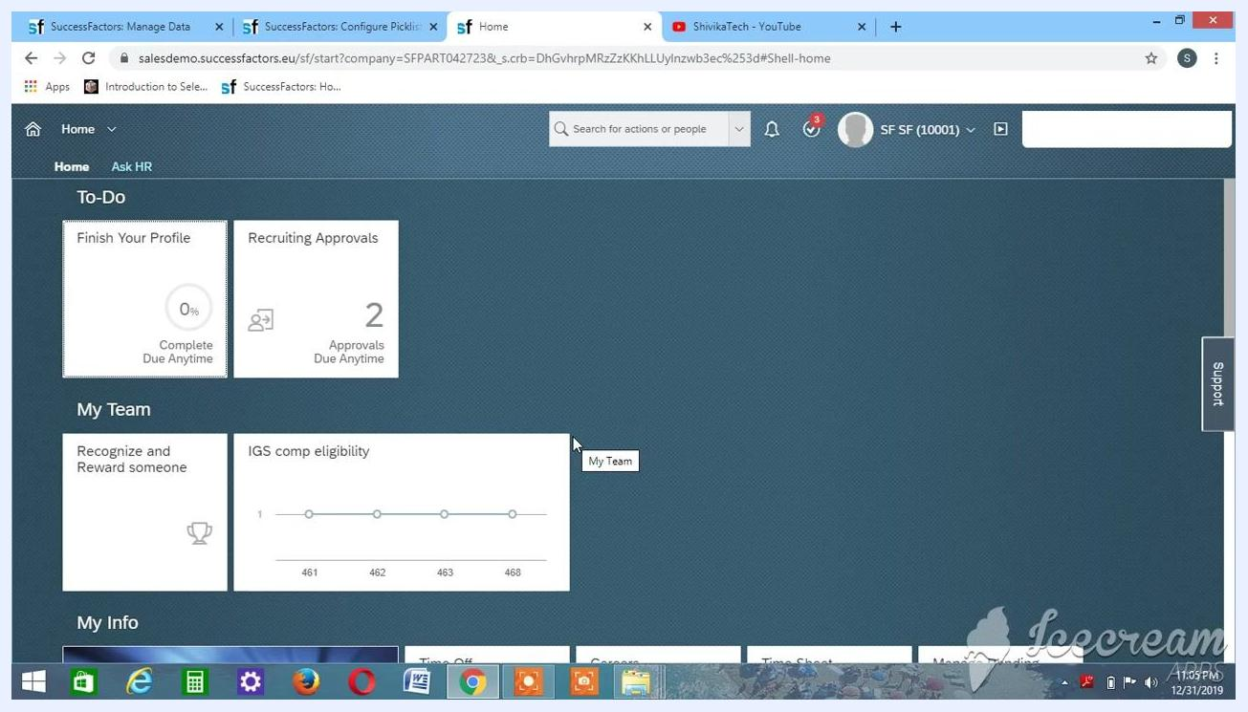
SuccessFactors Home page showing the To-Do, My Team, and My Info widgets
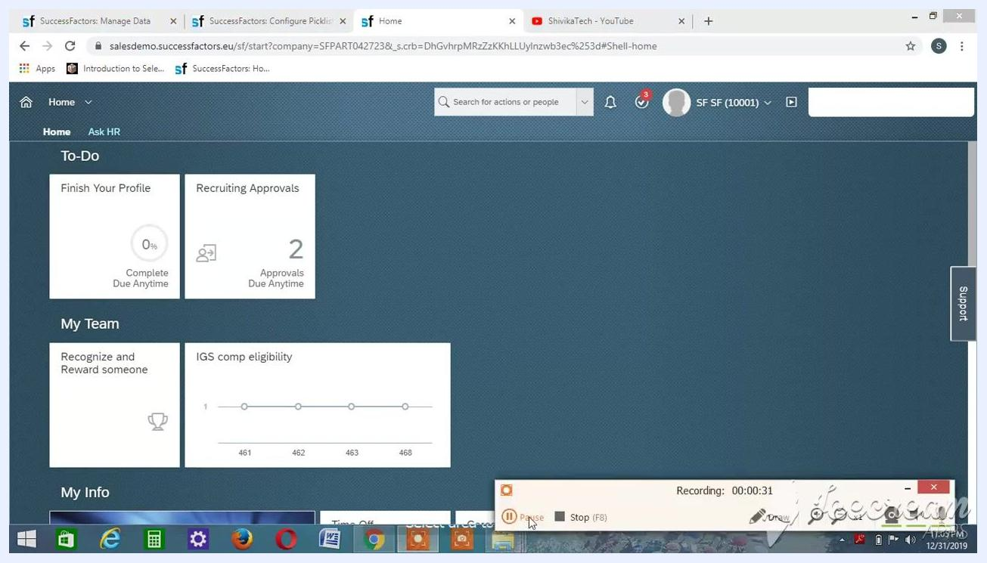
SuccessFactors Home page with screen recording controls visible, indicating the end of the session.

Summary
You have created a hierarchical picklist structure in SuccessFactors, with states as the parent picklist and districts as the child picklist. Each district is mapped to its corresponding state. You can now link the picklist to MDF (Metadata Framework) objects and HRIS elements.

What's next
- Link the picklist to MDF objects and HRIS elements in your SuccessFactors configuration.
- Use the picklist in employee or organizational data forms. This enables dynamic, hierarchical dropdowns, such as selecting a state to filter the available districts.
- Use the picklist in SuccessFactors modules that require hierarchical picklists.
- To make changes, return to the Picklist Center and edit the picklist or its values.

