How to Move Files in SharePoint
This guide explains how to move files in SharePoint, whether within the same library, between libraries on the same site, or across different sites. It also covers how to copy files between sites and how to manage sharing permissions during these operations.

Prerequisites
- Access to a SharePoint site with at least one document library (e.g., Documents).
- Permission to move, copy, and manage sharing for files within the relevant libraries and sites.

Overview
You can move or copy a file in SharePoint in three ways:
- Within a library
- Within a site
- To another site
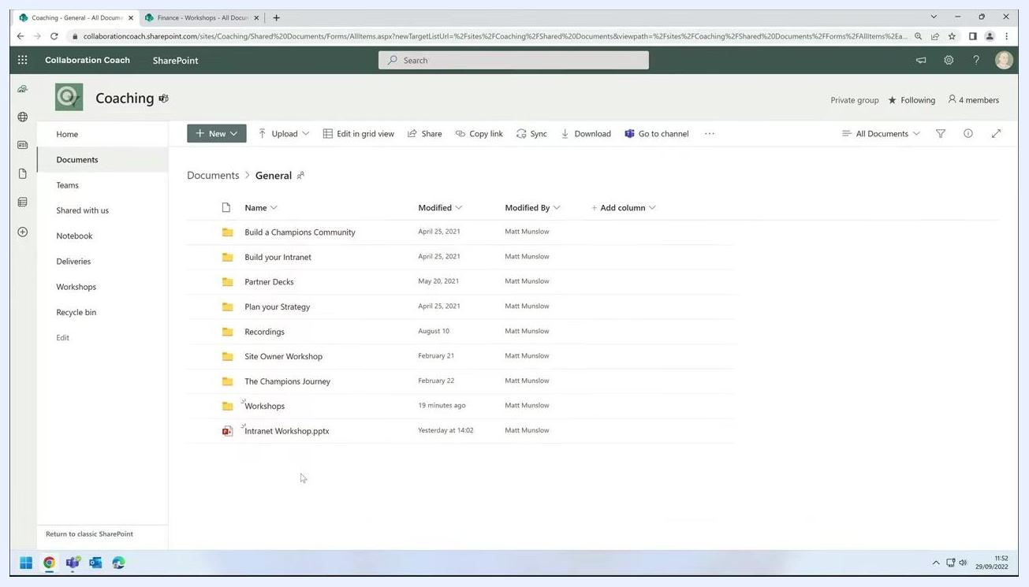
Overlay text: "You can move or copy a file: Within a library, Within a site, To another site"
Always check for the progress indicator or confirmation message after each action to ensure it has completed successfully.

Moving a file within the same library

- Navigate to your SharePoint site. In this example, go to the Coaching site.
- Open the Documents library and select the General folder.
SharePoint Documents library open to the General folder, showing several folders and a file named "Intranet Workshop.pptx"

- Identify the file you want to move. In this example, select Intranet Workshop.pptx.
- Decide on the destination folder within the same library. Here, the destination is the Workshops folder.
- Click and drag Intranet Workshop.pptx and drop it onto the Workshops folder.
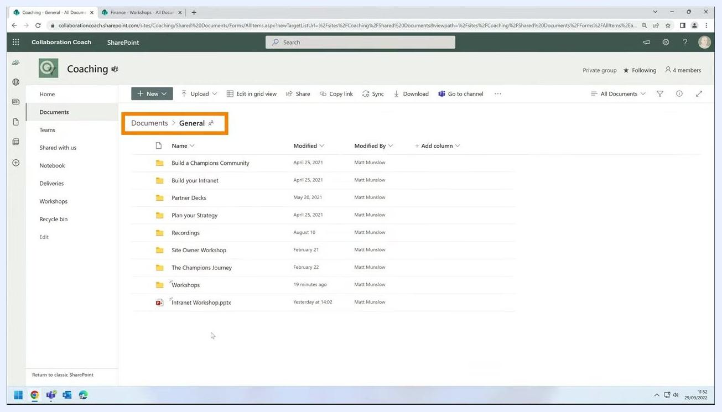
Dragging "Intranet Workshop.pptx" toward the "Workshops" folder, both highlighted

- Wait for the progress indicator to appear in the top right corner, confirming the move is in progress.
- Open the Workshops folder to verify that Intranet Workshop.pptx is now inside.
Workshops folder open, showing "Intranet Workshop.pptx" present

Moving a file to another library on the same site

- Return to the General folder in the Documents library of the Coaching site.
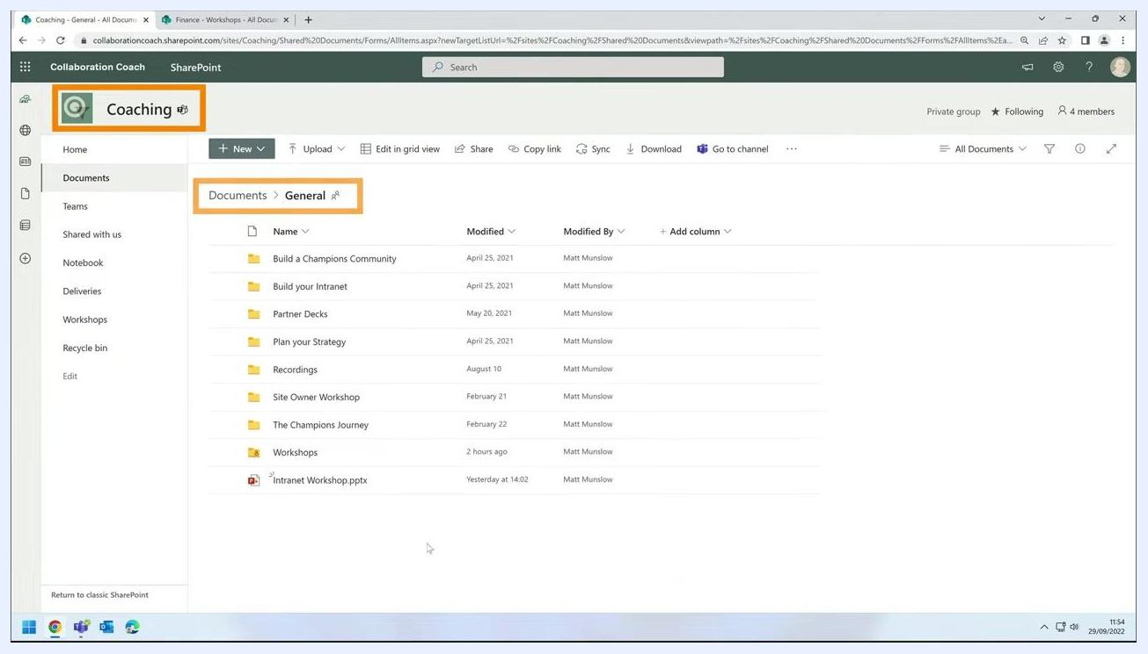
SharePoint Documents library open to the General folder, with site and folder highlighted

- Locate the file to move, Intranet Workshop.pptx.
- Right-click Intranet Workshop.pptx to open the context menu.
- Select Move to from the menu.
Right-click context menu open on "Intranet Workshop.pptx", with "Move to" option highlighted

- In the Move dialog, check your current location in the breadcrumb at the top. It should show Coaching > Documents > General.
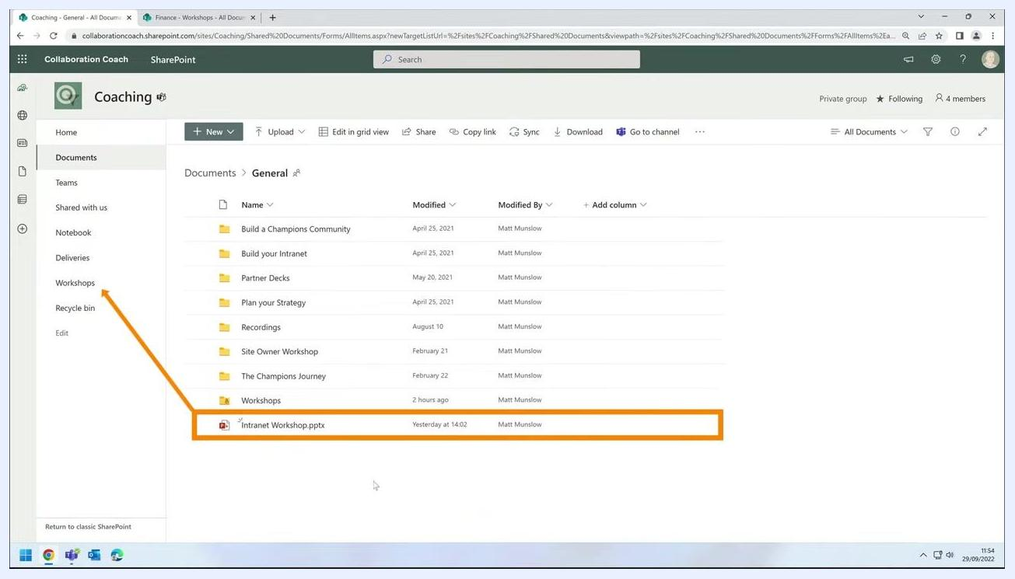
Move dialog open, breadcrumb showing "Coaching > Documents > General"

- Click Coaching in the breadcrumb to navigate up.
- Select the Workshops library as the destination.
- Click Move here to complete the move.
- Wait for the confirmation message in the top right corner indicating the file has been moved.
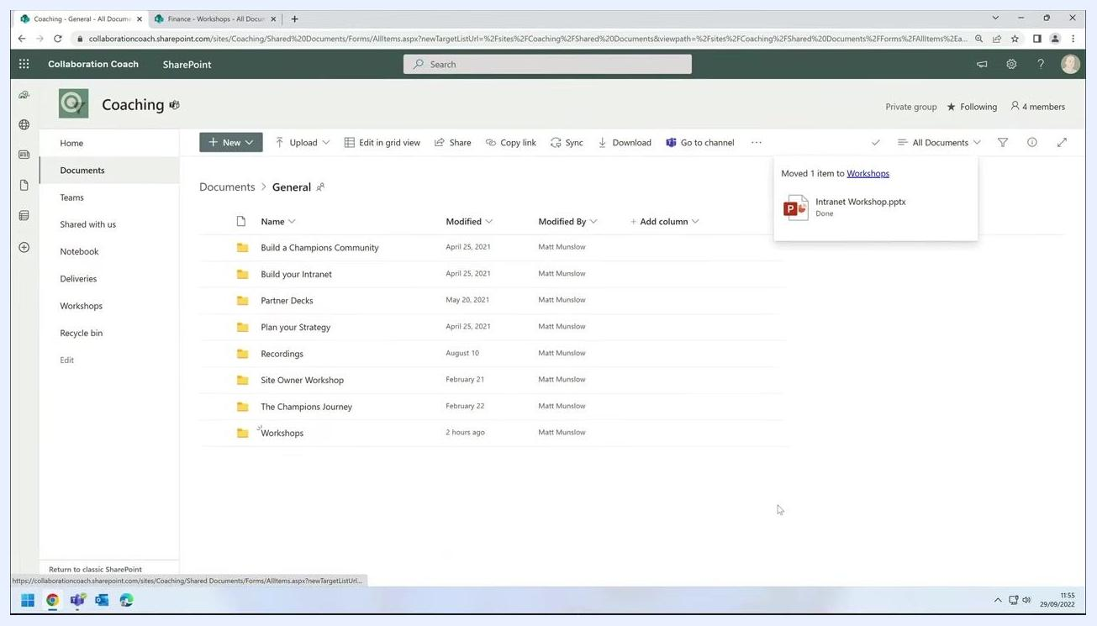
Confirmation message reading "Moved 1 item to Workshops" with the file name and a "Done" status

- Optionally, open the Workshops library to verify the file is present.

Moving a file to another site
This scenario shows how to move a file from one SharePoint site to another—for example, from the Coaching site to the Finance site—while optionally preserving sharing permissions.

- Locate the file you want to move in your current site. In this example, select Intranet Workshop.pptx in the General folder of the Coaching site.
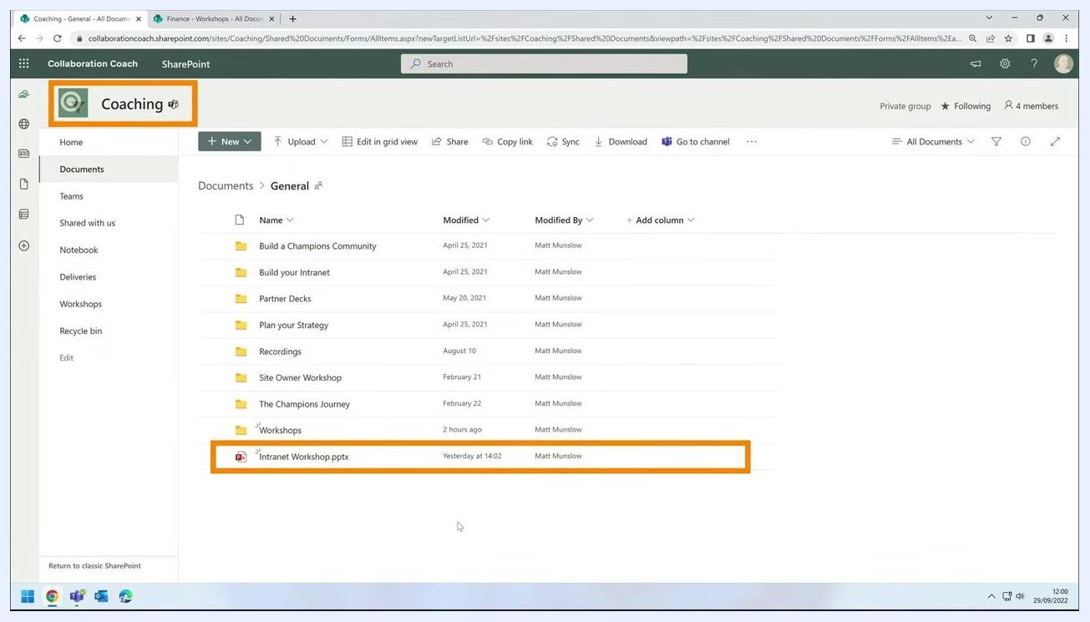
SharePoint Documents library open to the General folder, "Intranet Workshop.pptx" highlighted, Coaching site indicated

- Right-click Intranet Workshop.pptx to open the context menu.
- Select Move to from the context menu.
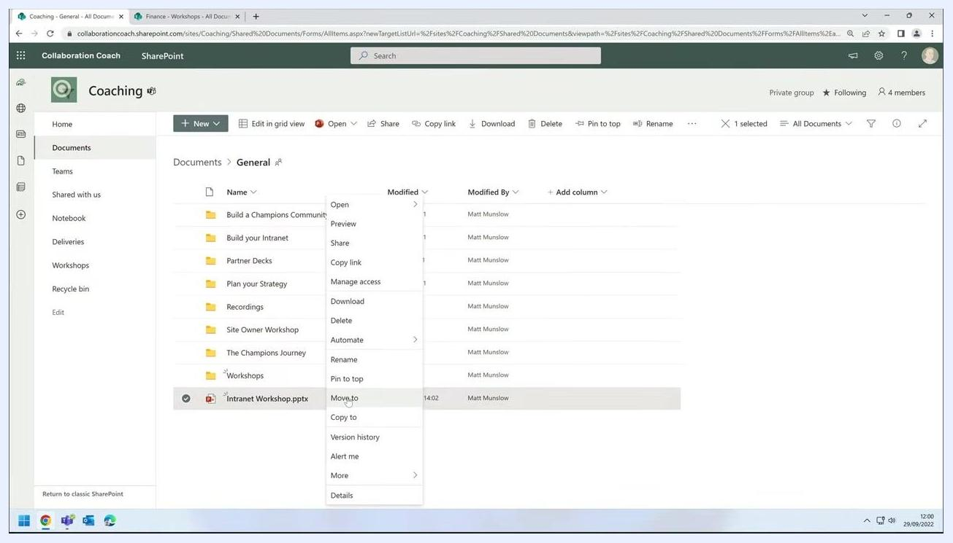
Context menu open on "Intranet Workshop.pptx", with "Move to" option highlighted

- In the Move Item dialog, use the Quick access panel on the left to select the destination site. In this example, click Finance. You can pin your favorite sites to this panel for quick access, as shown here with the Finance site.
Move Item dialog open, Quick access panel visible with the Finance site pinned and selected

- In the destination site (Finance), navigate to the desired folder, such as Workshops, where you want to move the file.
- Click Move here to initiate the move.
- Wait for the progress indicator or confirmation message in the top right corner, confirming the move is complete.
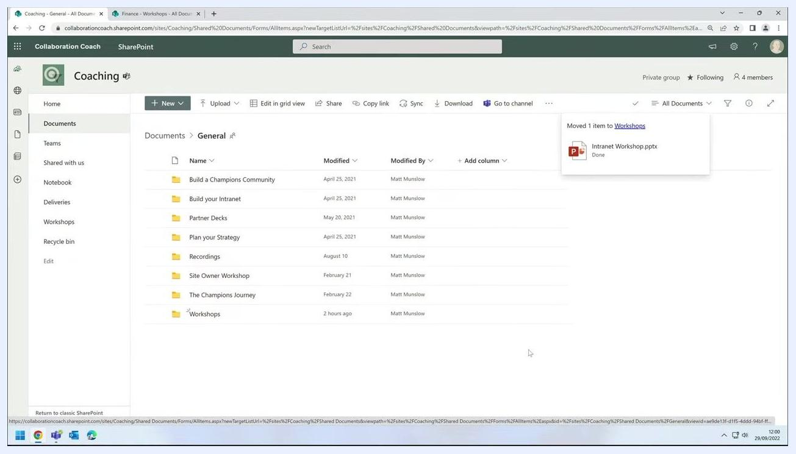
Confirmation message reading "Moved 1 item to Workshops" with the file name and a "Done" status

Checking sharing permissions after a move
When you move a file between sites, existing sharing permissions are not retained by default. For example, if the file was shared with a user named Sarah, she will lose access after the move.
To check current sharing, right-click the file, select Manage access, and review the list of people with access.
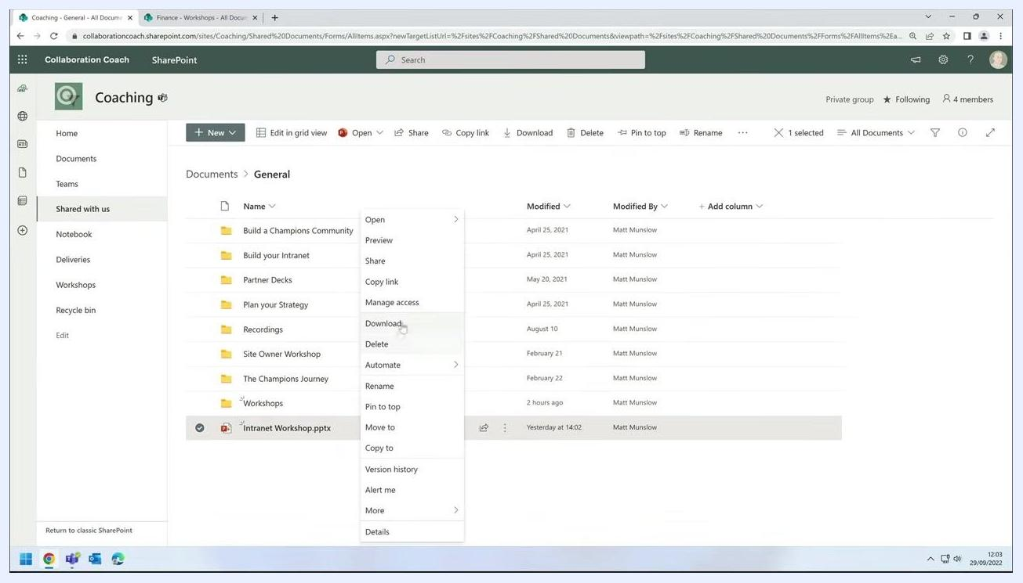
Manage access dialog open, showing Sarah and Coaching Owners with access to the file

Keeping the same sharing permissions during a move
When using the Move to dialog to move a file between sites, look for a checkbox at the bottom labeled Keep sharing with the same people. Select this checkbox before completing the move to ensure all existing sharing permissions are preserved.
Context menu open on "Intranet Workshop.pptx", with "Move to" option highlighted, referencing the keep-sharing option

Copying a file to another site
Copying a file between sites uses the same interface and options as moving a file. This example copies Intranet Workshop.pptx from the Coaching site to the Finance site.

- Locate the file you want to copy in your current site. In this example, select Intranet Workshop.pptx in the General folder of the Coaching site.
- Right-click Intranet Workshop.pptx to open the context menu.
- Select Copy to from the context menu.
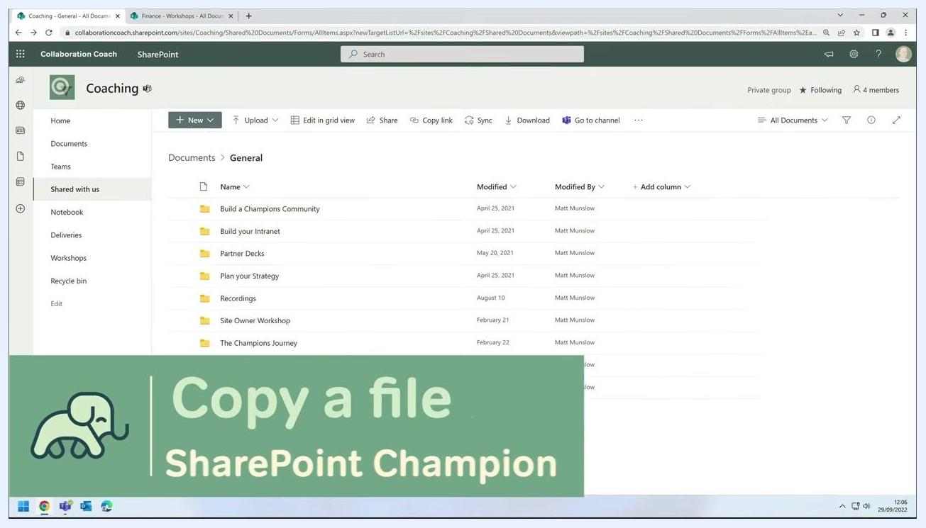
Context menu open on "Intranet Workshop.pptx", with "Copy to" option highlighted

- In the Copy Item dialog, use the Quick access panel on the left to select the destination site. For example, click Finance.
- In the destination site (Finance), navigate to the desired folder, such as Workshops, where you want to copy the file.
- At the bottom of the dialog, select the Keep sharing with the same people checkbox if you want to preserve existing sharing permissions. For example, if the file was shared with Sarah, she will retain access after the copy.
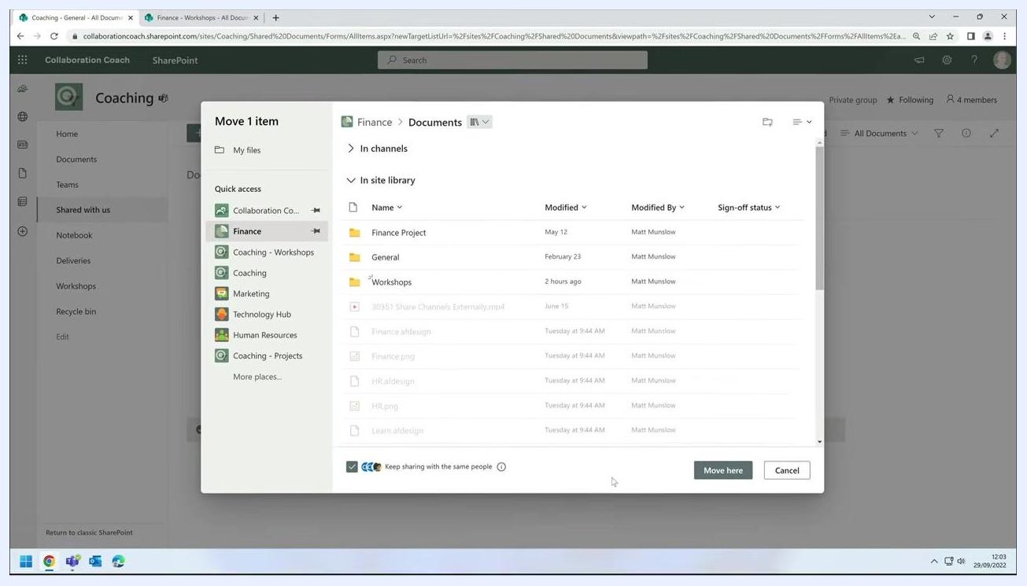
Move Item dialog open, Finance site selected, "Keep sharing with the same people" checkbox visible and checked

- Click Copy here to initiate the copy.
- Wait for the progress indicator or confirmation message confirming the copy is complete.
- Verify the file appears in the destination folder (for example, Workshops in the Finance site) and that sharing permissions are retained.
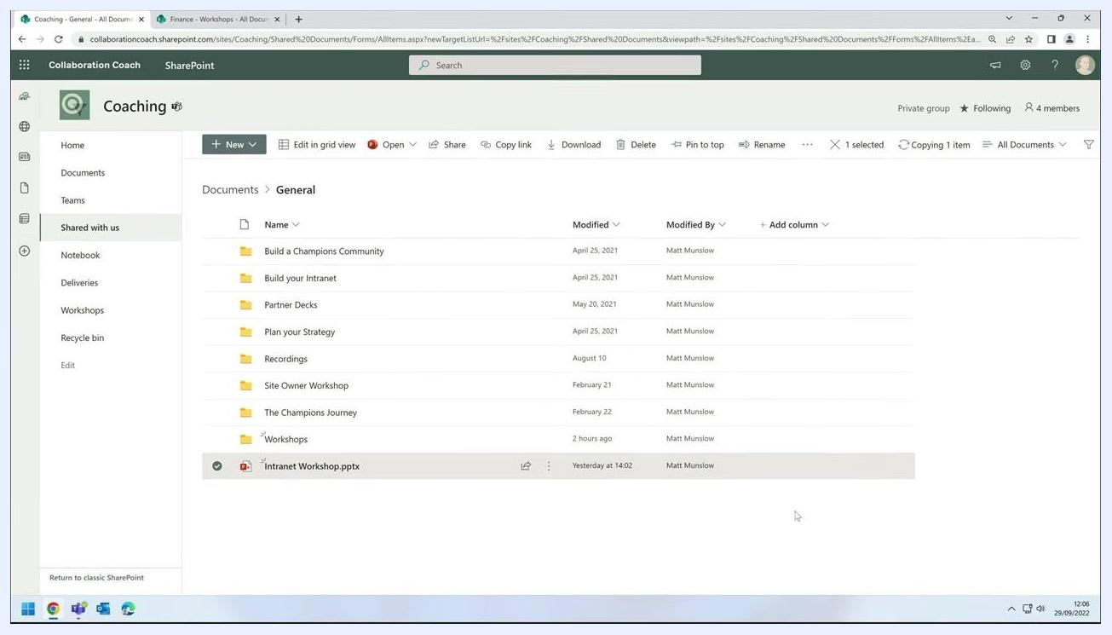
File "Intranet Workshop.pptx" visible in the Finance > Workshops folder, highlighted to indicate a successful copy

Summary
You now know several ways to move files in SharePoint: within a library, between libraries on the same site, and across different sites. You've also seen how to copy files between sites using the same Quick access panel and breadcrumb navigation.
Key points to remember:
- Always check the progress indicator or confirmation message to confirm an action is complete.
- Moving a file between sites does not retain existing sharing permissions by default.
- Select Keep sharing with the same people during a move or copy if you want collaborators to retain access.
- The steps for copying a file are nearly identical to those for moving a file.

