How to Create Team Sites and Communication Sites in SharePoint
This guide walks you through creating both a Team Site and a Communication Site in SharePoint using Office 365. You'll learn how to configure site details, set privacy options, add members, and choose a design layout for each site type.

Prerequisites
- Access to your organization's SharePoint homepage
- An Office 365 account with permissions to create sites
- Names or email addresses of any users you want to add as owners or members

Creating a team site
Follow these steps to create a new Team Site connected to an Office 365 group.

- Open your web browser and navigate to your SharePoint homepage.
- Click the App Launcher (grid icon) in the top left corner of the screen.
- Select the SharePoint tile from the list of available apps.
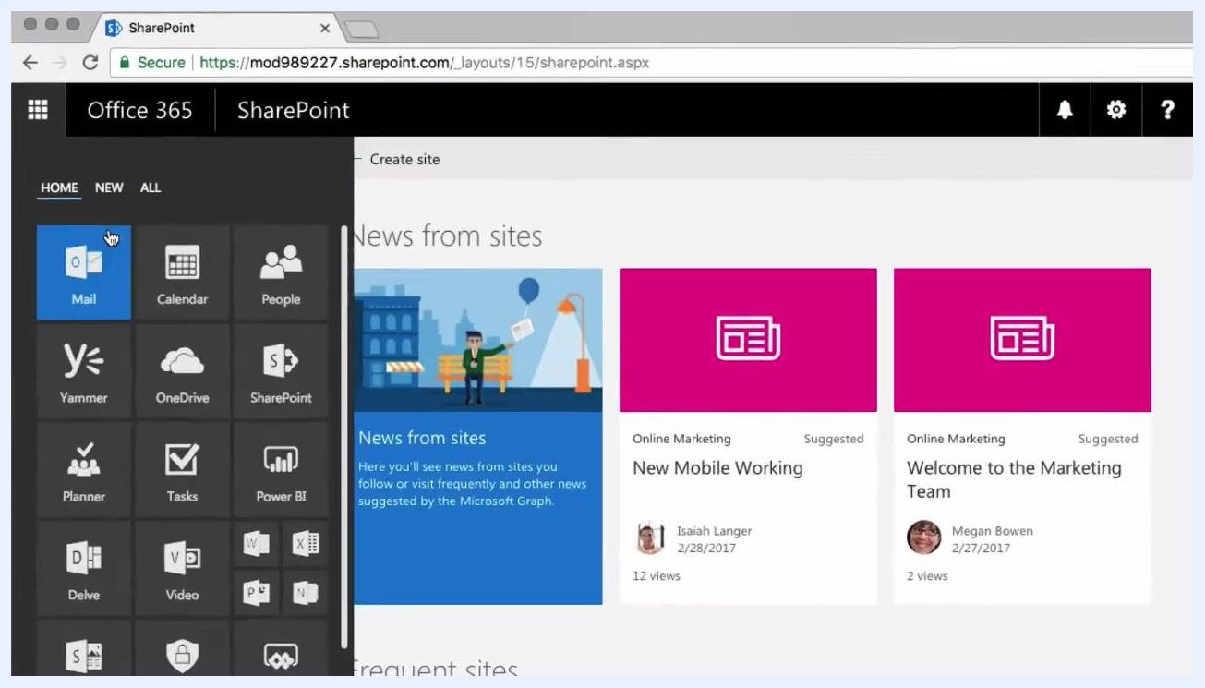
The App Launcher is open, displaying tiles for Mail, Calendar, People, Yammer, OneDrive, SharePoint, Planner, Tasks, Power BI, Delve, and Video. The SharePoint tile is highlighted. The SharePoint homepage shows "News from sites" and suggested articles.

- On the SharePoint homepage, click the Create site button.
- Choose the type of site you want to create. Two options are available:
- Team site: For team communication, document sharing, and collaboration. Connected to an Office 365 group.
- Communication site: For publishing dynamic content to inform and engage people across your organization.
The "Create a site" screen shows two options: Team site, illustrated with people working on a race car, and Communication site, illustrated with people using a megaphone. Each option includes a brief description.

- Click Team site to proceed.
- Enter the required information for your new team site:
- Site name: Enter a name for your team site (for example, My Team).
- Site description: Enter a brief description (for example, a site for my team).
- The Group email address and Site Address are generated automatically based on your site name. For example, the group email address becomes MyTeam and the site address becomes https://mod989227.sharepoint.com/sites/MyTeam.
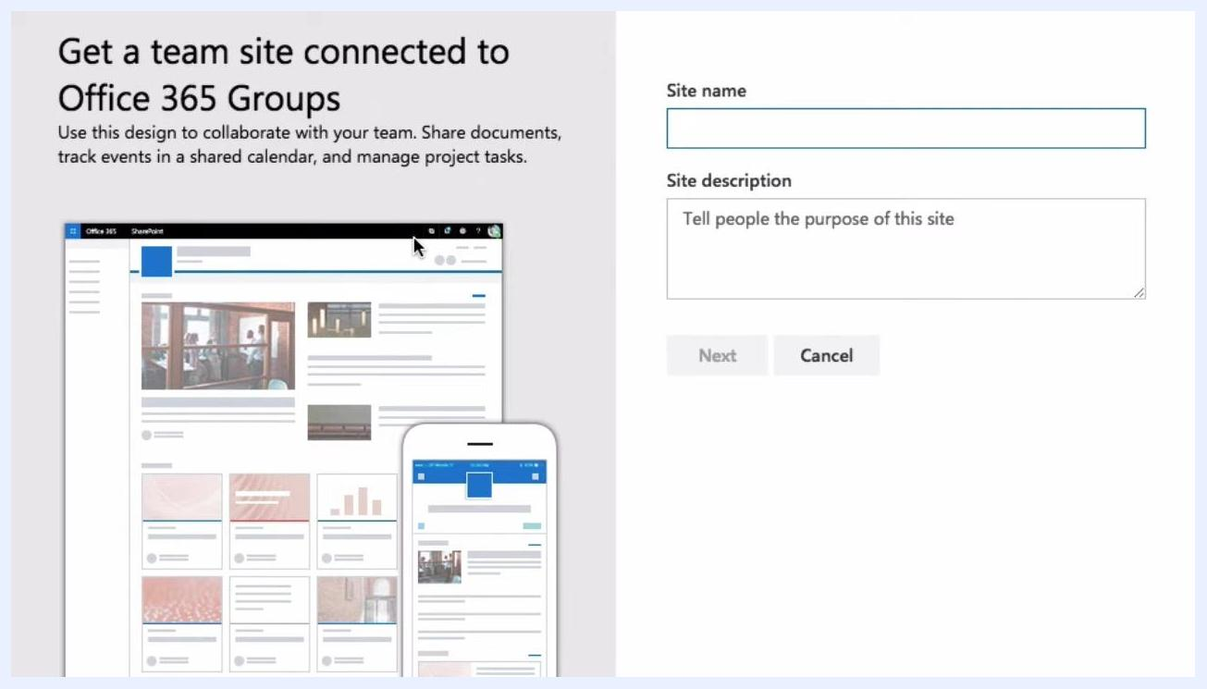
Form for creating a team site connected to Office 365 Groups, with fields for Site name and Site description, plus a preview of the generated Group email address and Site Address. Example values shown: Site name "My Team", Group email address "MyTeam", Site Address "https://mod989227.sharepoint.com/sites/MyTeam".

- Scroll down to Privacy settings and choose between: For a private team site, select Private - only members can access this site.
- Public: Anyone in your organization can access the site without authorization.
- Private: Only members you specify can access the site; others must request access and be approved by an owner.
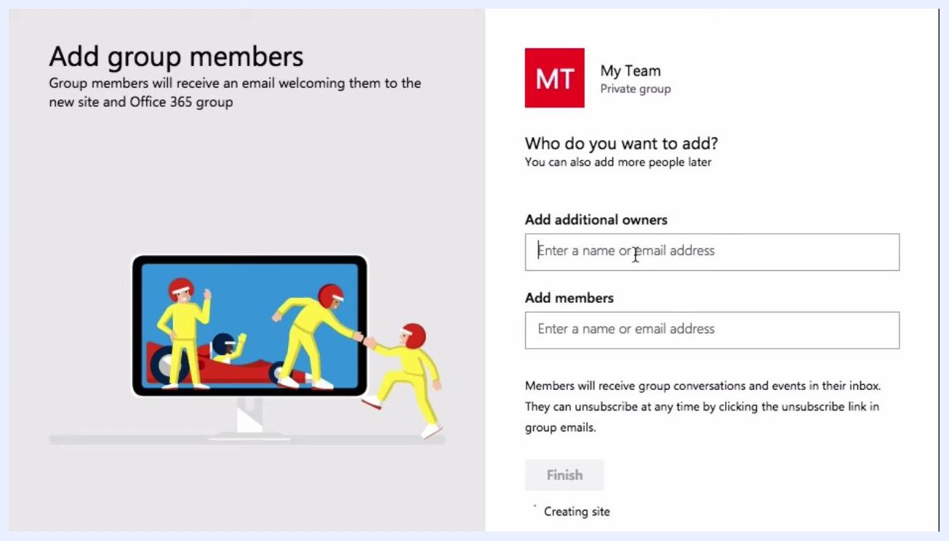
The Privacy settings dropdown is open, showing the options "Public - anyone in the organization can access this site" and "Private - only members can access this site".

- Click Next to continue.
- Add group members: You can add as many owners and members as needed.
- Add additional owners: Enter names or email addresses of users you want to assign as additional owners (for example, Alex Wilber).
- Add members: Enter names or email addresses of users you want to add as members.
The Add group members screen shows the "Add additional owners" field containing "Alex Wilber" and an empty "Add members" field ready for input. A note explains that members will receive group conversations and events in their inbox.

- Click Finish to create the site and add the specified users.
After completing these steps, you will have a private team site with assigned owners and members, and the appropriate privacy settings for your organization.

Creating a communication site
Once your Team Site is set up, you can create a Communication Site to publish content across your organization.

- After creating your Team Site, you're taken to the new site's homepage. Note the following: You can customize these entries as needed.
- Default News and Activity entries appear in the main area.
- The left-hand navigation includes standard libraries and lists: Home, Conversations, Documents, Notebook, Pages, Site contents, and Recycle bin.
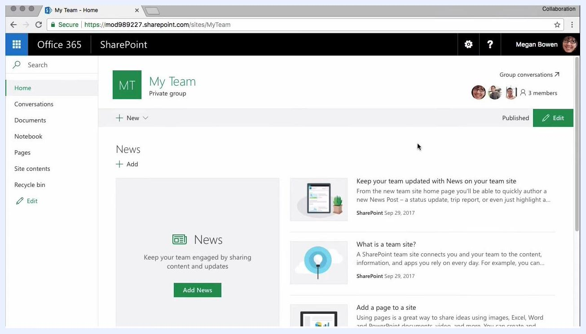
The SharePoint Team Site homepage displays default News entries, an Activity feed, and a left navigation panel with standard libraries and lists.

- Return to the SharePoint homepage and click the Create site button at the top of the page.
The SharePoint homepage with the "+ Create site" button highlighted, showing the "News from sites" and "Frequent sites" sections.

- In the "Create a site" dialog, select Communication site.
- Choose a design for your Communication Site from three options: As you select each design, a sample preview appears below to show what the site will look like.
- Topic: Use this design if you have a lot of information to share, such as news, events, and other content.
- Showcase: Use this design to showcase a product, team, or event using photos or images.
- Blank: Start with a blank layout and customize it as needed.
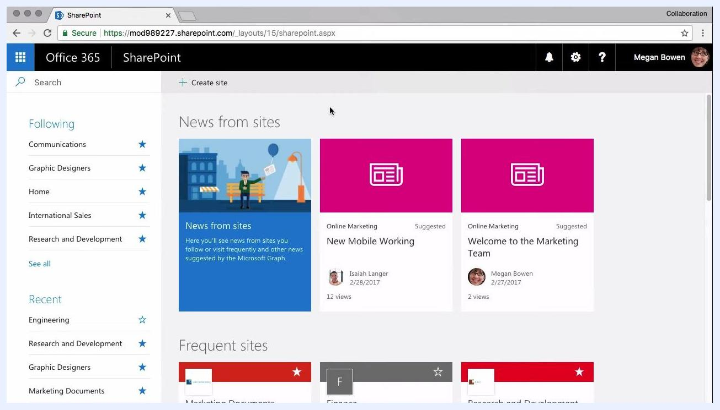
The Communication Site creation screen shows a "Choose a design" dropdown with Topic, Showcase, and Blank options, along with a preview of the selected design.

- For this example, select Showcase as the design.
- Enter the required information for your new Communication Site:
- Site name: Enter a name for your site (for example, New Product).
- Site Address: Generated automatically based on your site name (for example, https://mod989227.sharepoint.com/sites/NewProduct).
- Site description: Enter a brief description of the site's purpose.
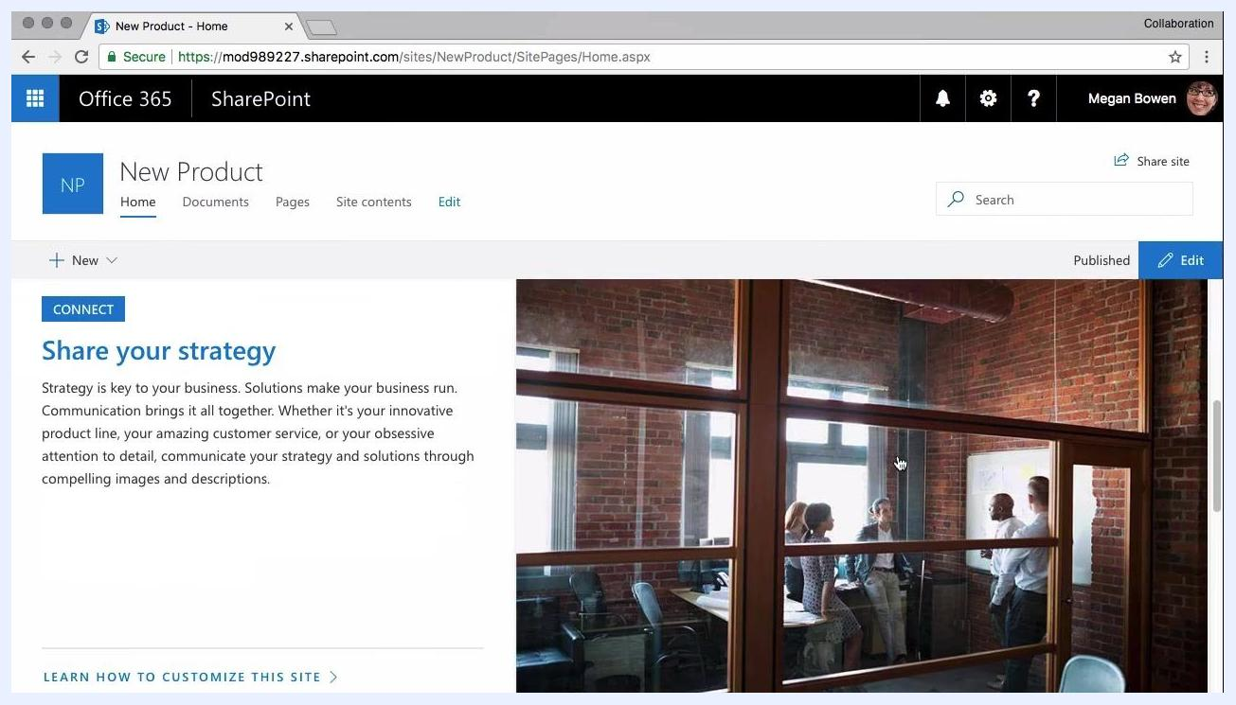
The Communication Site creation form shows "Showcase" selected, Site name "New Product", Site Address "NewProduct", and a field for Site description.

- Click Finish to create the Communication Site.
- Once the site is created, you're taken to the new Communication Site homepage. Notice that the visual layout differs from the Team Site: it includes large images, text sections, and a prominent area to share your strategy or key messages.
The Communication Site homepage for "New Product" shows a large image, a "Share your strategy" section, and navigation links for Home, Documents, Pages, and Site contents.

- Scroll down to view the Image gallery at the bottom of the homepage, which displays a grid of images and makes the site highly visual and engaging.
The Communication Site homepage shows the "Image gallery" section with multiple images arranged in a grid layout.
After completing these steps, you'll have a Communication Site with your chosen design, site details, and a visual layout suited to sharing content across your organization.

What's next
To stay updated on future SharePoint and collaboration tutorials:
- Click the Subscribe button on the video platform (such as YouTube) if you haven't already.
- Enable notifications, usually by clicking the bell icon, to receive alerts when new videos are posted.
New tutorials are posted every week, so subscribing ensures you receive the latest tips, guides, and updates on SharePoint and other collaboration tools as soon as they're available.
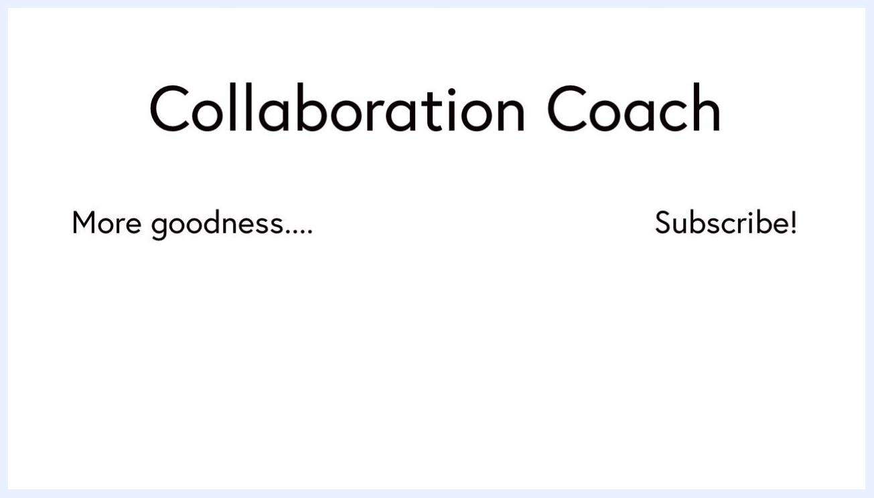
The closing screen displays the title "Collaboration Coach" at the top, "More goodness...." on the left side, and a "Subscribe!" call to action on the right side.

