How to Create and Configure an Invoice Tracker List in SharePoint Online
This guide walks you through creating a custom SharePoint Online list to track invoices from start to finish. You will learn how to create a blank list, rename and add columns of various data types, enter a sample invoice, edit items in grid view, and consider next steps for workflow automation.

Prerequisites
- Access to a SharePoint Online site where you have permission to create lists.
- You must be logged in to the site before you begin.

Creating the Invoice Tracker list

- Navigate to the SharePoint Online site where you want to create your list. Ensure you are logged in and have the necessary permissions.
- Click Site contents in the left navigation menu. This displays all the contents of your SharePoint site.
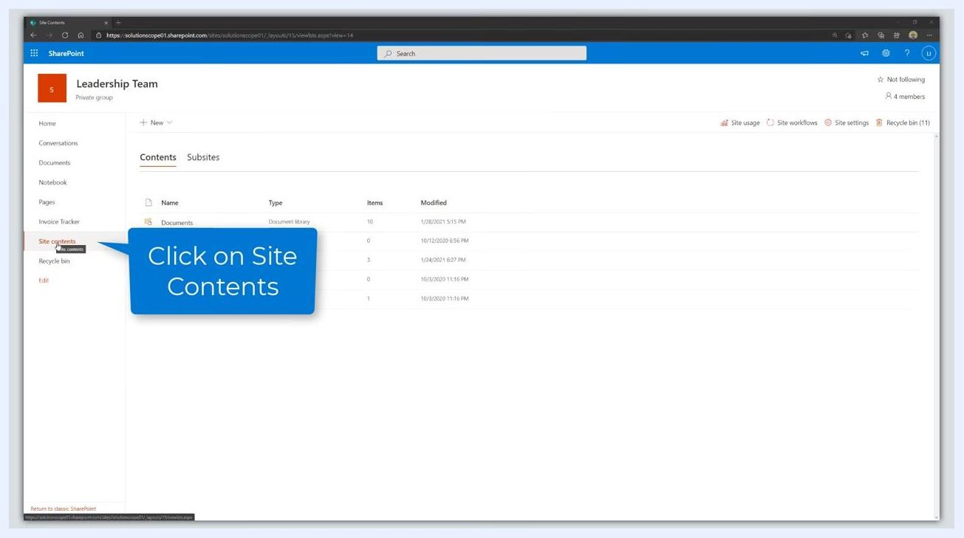
The SharePoint Online site contents page is open. The left navigation menu is visible with "Site contents" highlighted. The main area lists existing libraries and pages.

- Click the New button at the top of the Site contents page. A dropdown menu appears with options to create new items.
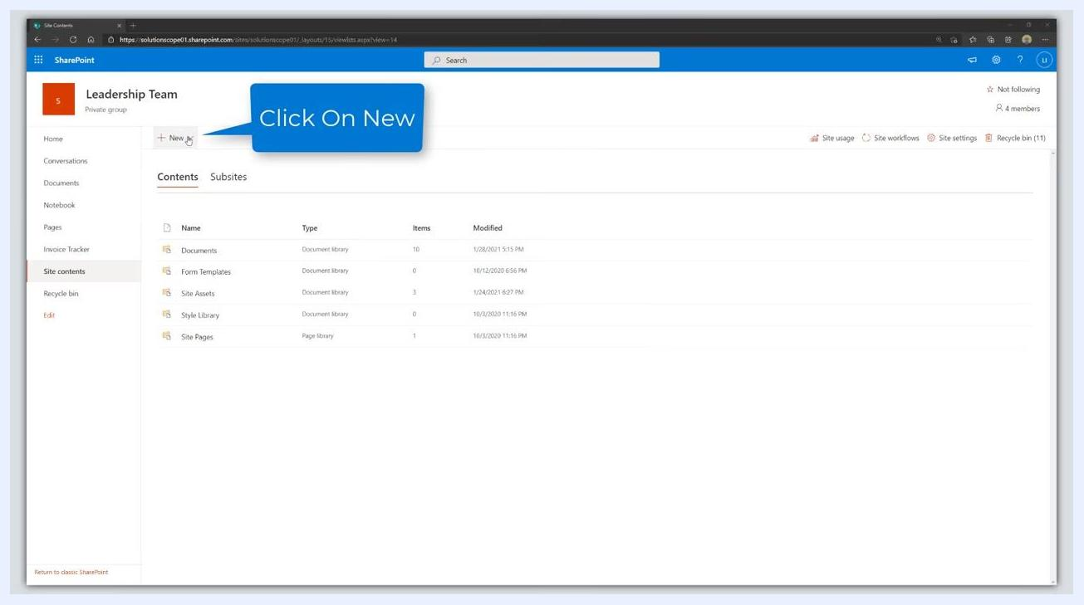
The "Site contents" page with a blue callout pointing to the "+ New" button at the top, instructing you to click it.

- Select List from the dropdown menu. A dialog appears with options to create a list from a template or from scratch.
- Click Blank list to start from scratch. This lets you build a fully custom list without using a template.
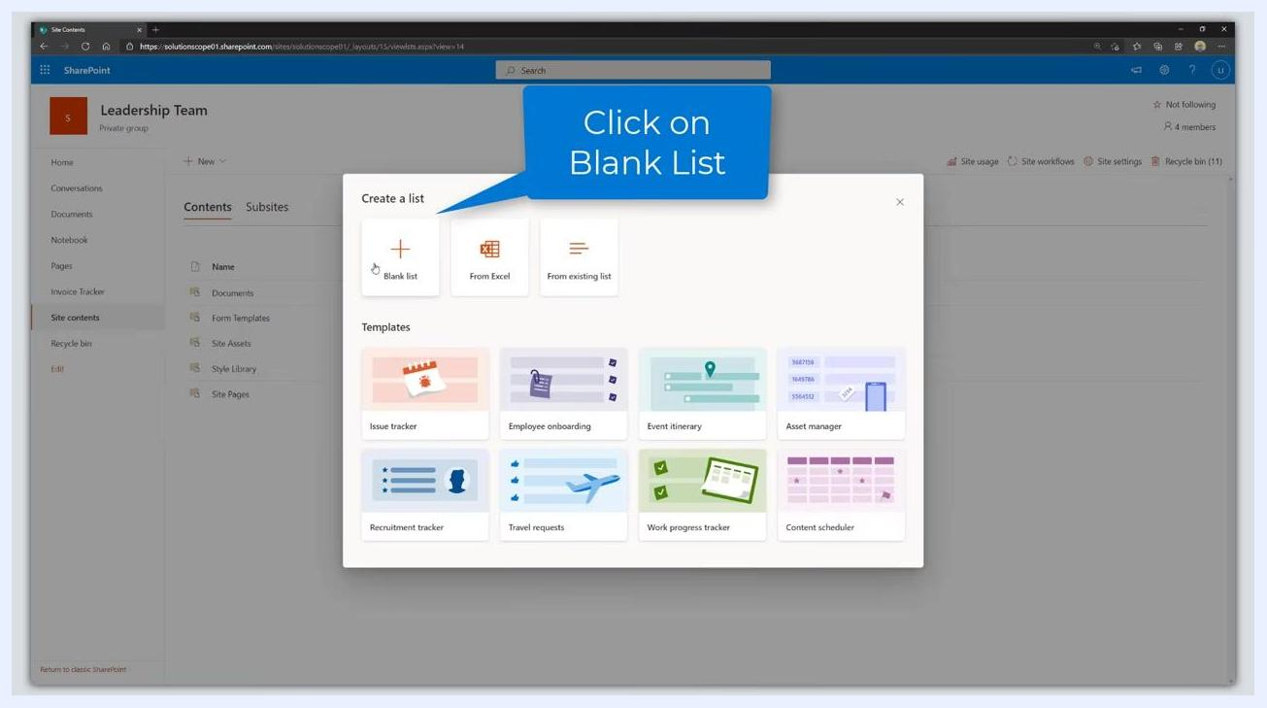
A dialog titled "Create a list" is open, showing options for "Blank list", "From Excel", and "From existing list". The "Blank list" option is highlighted. Various template options are also visible below.

- Enter the list details:
- Name: Enter "Invoice Tracker".
- Description: Optionally, provide a description (for example, "A list to record invoice details for approval and review workflow").
- Check Show in site navigation if you want the list to appear in the site's navigation.
A dialog box is open for creating a new list. The "Name" field is being filled in with "Invoice Tracker". The "Show in site navigation" option is checked. A blue callout says "Enter a Name & Description".

- Click Create to generate the new list.
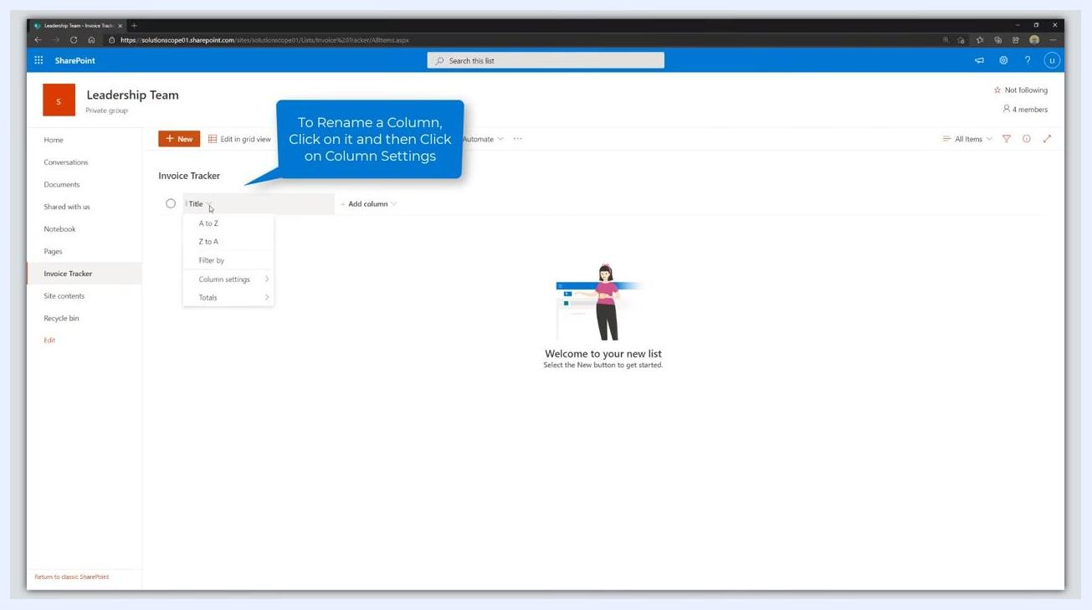
The "Create a list" dialog is open with "Invoice Tracker" entered as the name. The "Create" button is highlighted with a blue callout.

- Review your new SharePoint list. By default, the list contains only one column named "Title". The main area displays a welcome message prompting you to start adding items.
The new "Invoice Tracker" list is open. Only one column, "Title", is present. The page displays a welcome message: "Welcome to your new list".

- Repurpose the default "Title" column:
- Click the Title column header.
- Select Column settings from the dropdown menu.
- Click Rename.
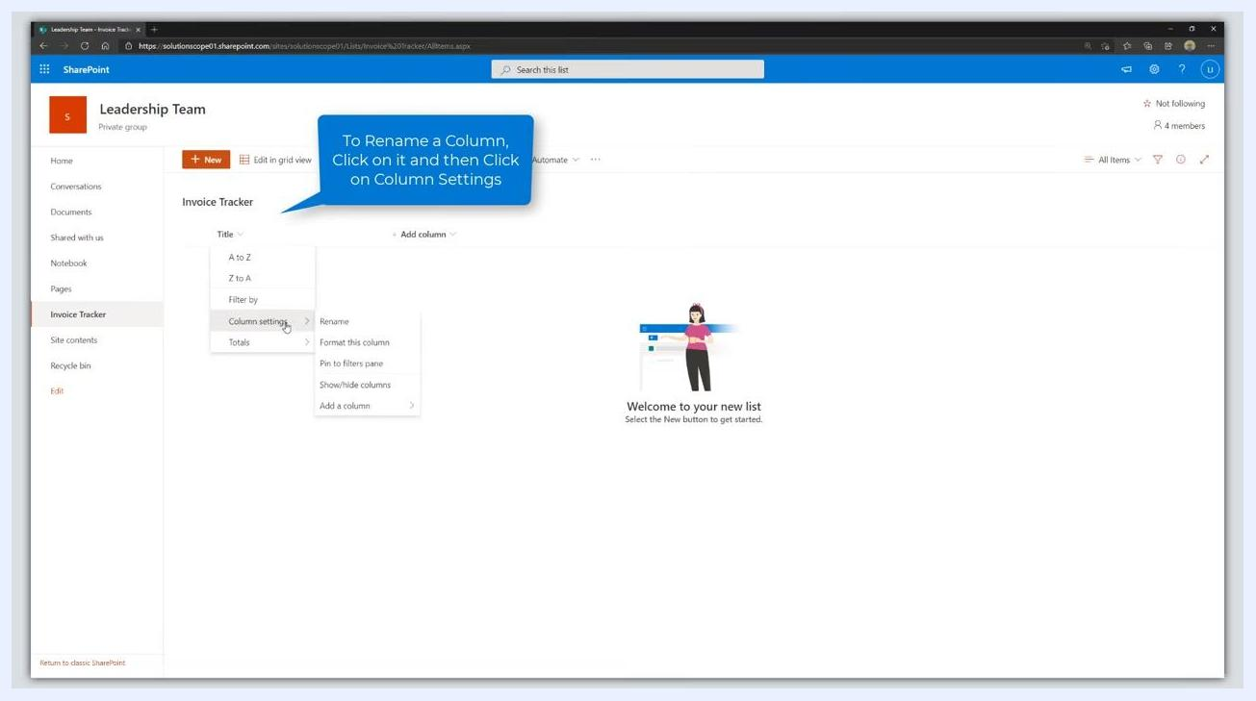
The "Invoice Tracker" list is open. The "Title" column dropdown is expanded, showing options including "Column settings". A blue callout explains how to rename a column.

- Rename the column to Invoice Description. Enter "Invoice Description" as the new column name and click Save to apply the change.
- Add a new column to the list by clicking Add column next to the "Invoice Description" column, then choose the appropriate column type for your next field (for example, text, number, or date).
The "Invoice Tracker" list now shows "Invoice Description" as the first column. The "Add column" option is visible next to it.
At this point, you have created a custom SharePoint Online list named "Invoice Tracker" and renamed the default column to "Invoice Description". You are now ready to add additional columns as needed for your workflow.

Adding the Invoice Date, Invoice Amount, and Vendor columns

- Add the "Invoice Date" column:
- Click Add column next to the existing columns in your "Invoice Tracker" list.
- From the dropdown menu, select Date and time as the column data type.
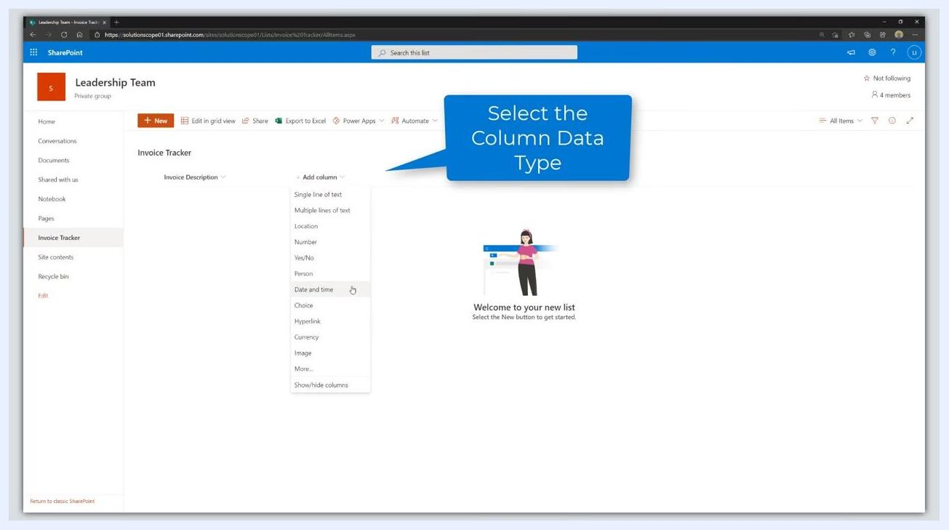
The "Invoice Tracker" list is open. The "Add column" dropdown is expanded, and "Date and time" is highlighted. A blue callout says "Select the Column Data Type".
- In the Create a column panel on the right, enter Invoice Date in the Name field.
- Leave Type set to Date and time.
- Set Include Time to No.
- Set Friendly format to No.
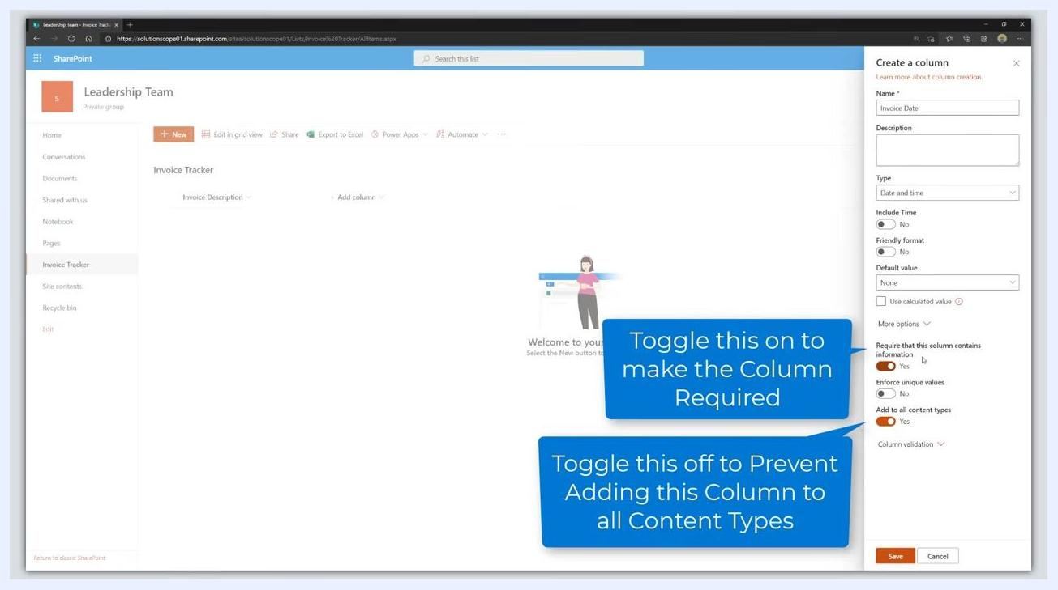
The "Create a column" panel is open with "Invoice Date" entered as the name. The type is set to "Date and time". A blue callout says "Enter the Column Name".
- Click More options to expand additional settings.
The "Create a column" panel is open. "More options" is highlighted with a blue callout.
- Toggle Require that this column contains information to Yes to make the column required.
- Toggle Add to all content types to No to prevent adding this column to all content types.
The "Create a column" panel is open. "Require that this column contains information" is toggled on, and "Add to all content types" is toggled off. Blue callouts explain these settings.
- Click Save to create the column.
The "Create a column" panel is open with all settings configured. The "Save" button is highlighted with a blue callout.

- Add the "Invoice Amount" column:
- Click Add column again.
- Select Currency from the dropdown menu as the data type.
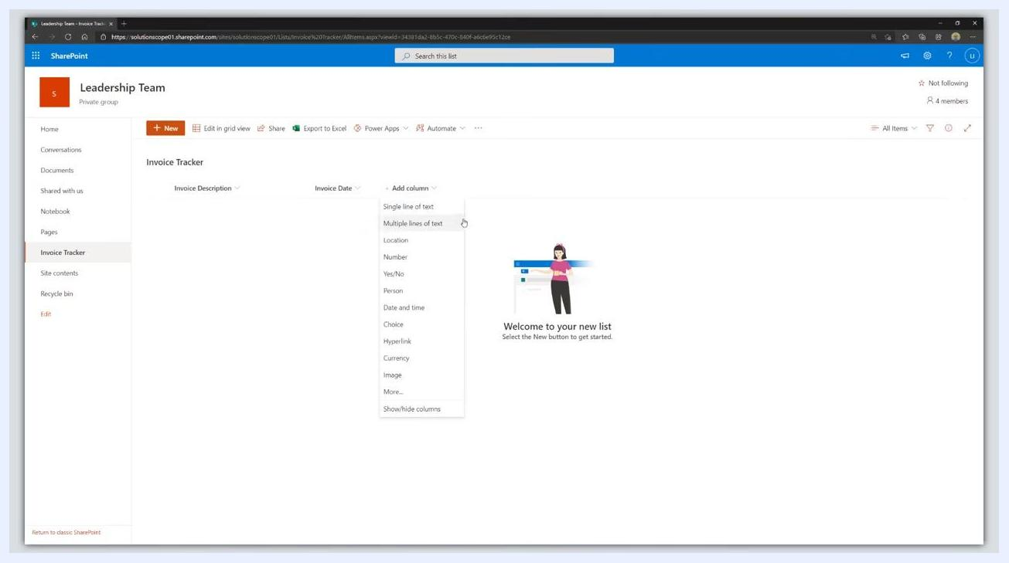
The "Invoice Tracker" list now shows "Invoice Description" and "Invoice Date" columns. The "Add column" dropdown is expanded, and "Currency" is visible as an option.
- In the Create a column panel, enter Invoice Amount in the Name field.
- Set Number of decimal places to 2.
- Leave Currency format at the default (for example, $123,456.00 United States).
- Click More options.
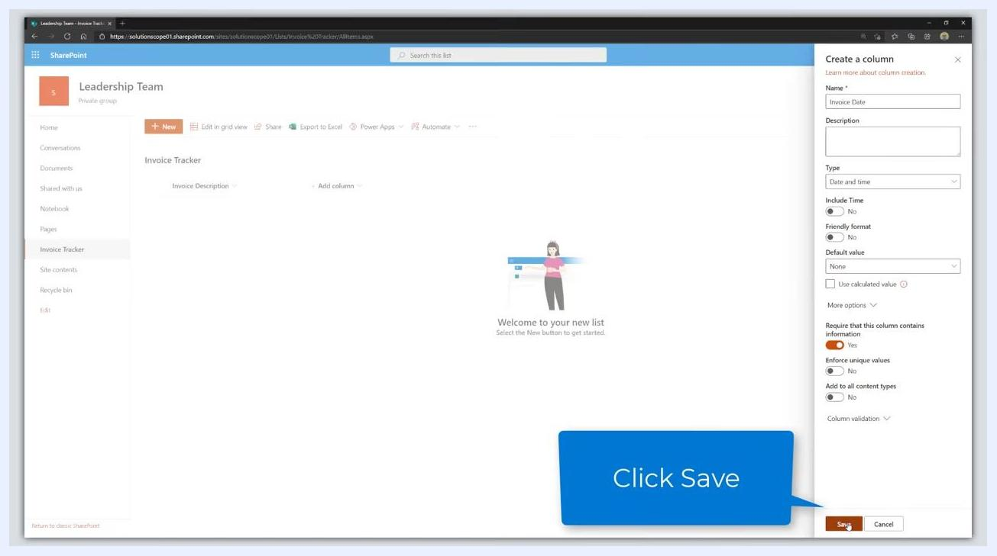
The "Create a column" panel is open for "Invoice Amount". "Number of decimal places" is set to 2. The "More options" link is being clicked.
- Toggle Require that this column contains information to Yes.
- Toggle Add to all content types to No.
- Click Save to create the column.
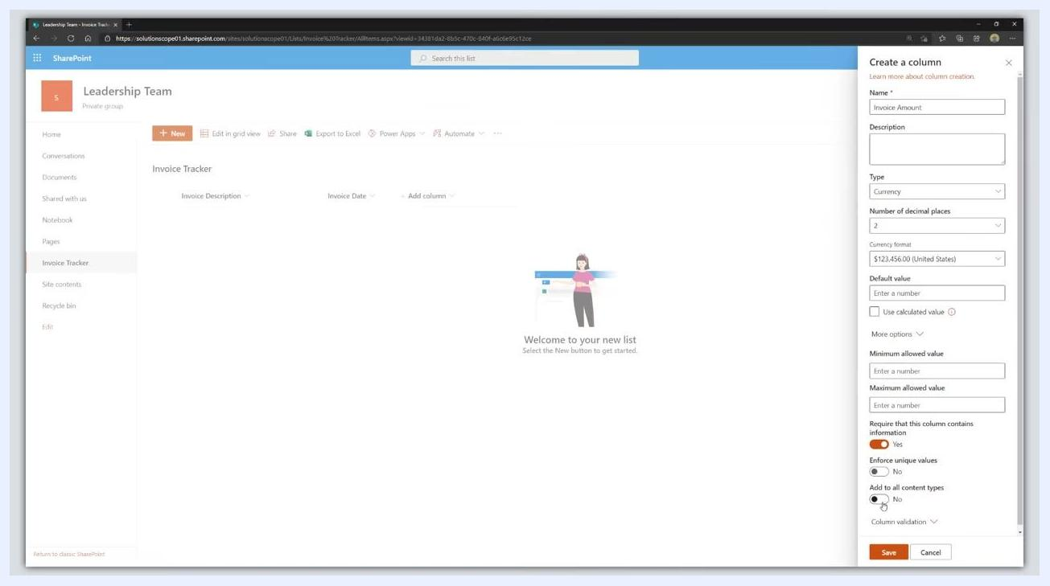
The "Create a column" panel is open for "Invoice Amount". "Require that this column contains information" is toggled on, and "Add to all content types" is toggled off. The "Save" button is visible.

- Add the "Vendor" column:
- Click Add column once more.
- Select Single line of text from the dropdown menu to capture the vendor name.
The "Invoice Tracker" list now shows "Invoice Description", "Invoice Date", and "Invoice Amount" columns. The "Add column" dropdown is expanded, and "Single line of text" is highlighted.
At this point you have added the "Invoice Date" column (required, date only) and the "Invoice Amount" column (required, currency with 2 decimals), and started adding the "Vendor" column (single line of text) to your Invoice Tracker list.

Adding the Vendor Name and Status columns

Add the "Vendor Name" column
- Click Add column in your Invoice Tracker list.
- Select Single line of text as the column type.
- In the Create a column panel on the right, enter Vendor Name in the Name field.
- Leave Type set to Single line of text.
- (Optional) Set the Maximum number of characters as needed (default is 255).
- Click More options to expand additional settings.
- Toggle Require that this column contains information to Yes to make the column required.
- Toggle Add to all content types to No.
- Click Save to create the column.
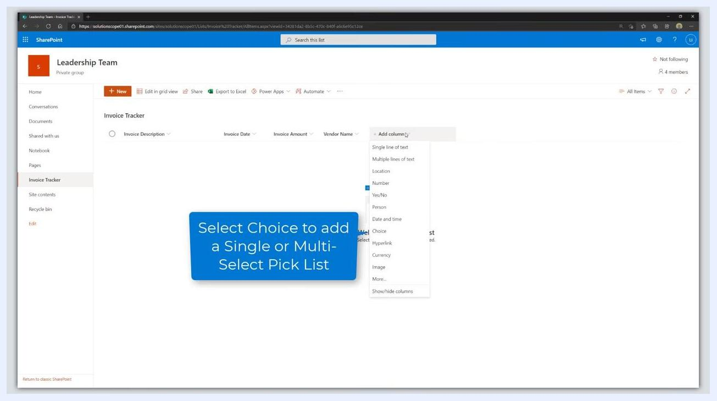
The "Create a column" panel is open for "Vendor Name". "Require that this column contains information" is toggled on, and "Add to all content types" is toggled off. The "Save" button is highlighted.

Add the "Status" column
- Click Add column again.
- From the dropdown menu, select Choice as the column type.
The "Add column" dropdown is expanded. "Choice" is visible as an option. A blue callout says "Select Choice to add a Single or Multi-Select Pick List".
- In the Create a column panel, enter Status in the Name field.
- Under Choices, enter the following options (one per line):
- Pending Approval
- Approved
- More Information Required
- Paid
- (Optional) Click the color palette icon next to each choice to assign a color for visual distinction.
- Set the Default value to Pending Approval so that new items default to this status.
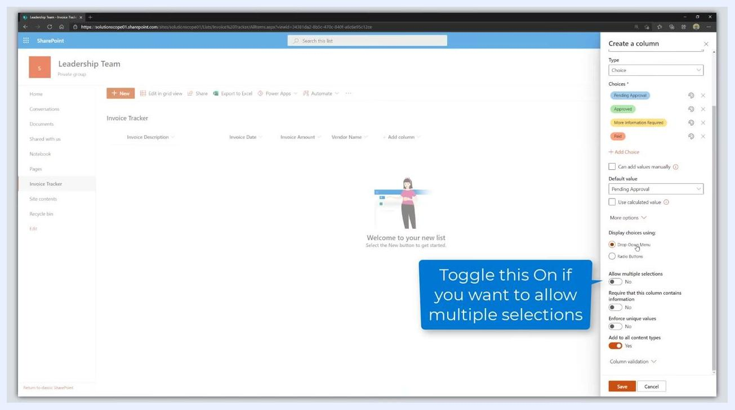
The "Create a column" panel is open for "Status". Choices "Pending Approval", "Approved", "More Information Required", and "Paid" are entered with different colors. The default value is set to "Pending Approval".
- Click More options to expand additional settings.
- Under Display choices using, leave the default Drop-Down Menu selected.
- Ensure Allow multiple selections is toggled to No.
- Toggle Require that this column contains information to Yes to make the column required.
- Toggle Add to all content types to No.
- Click Save to create the column.
The "Create a column" panel is open for "Status". All settings are configured: required, not added to all content types, drop-down menu, and default value set.
At this point, you have added the "Vendor Name" column (required, single line of text) and the "Status" column (required, choice with workflow statuses and a default value) to your Invoice Tracker list. Continue adding any additional workflow or tracking columns as needed for your process.

Adding person and comment columns

- Click the Add column dropdown in your SharePoint list to begin adding a new column. The dropdown menu appears with various data type options.
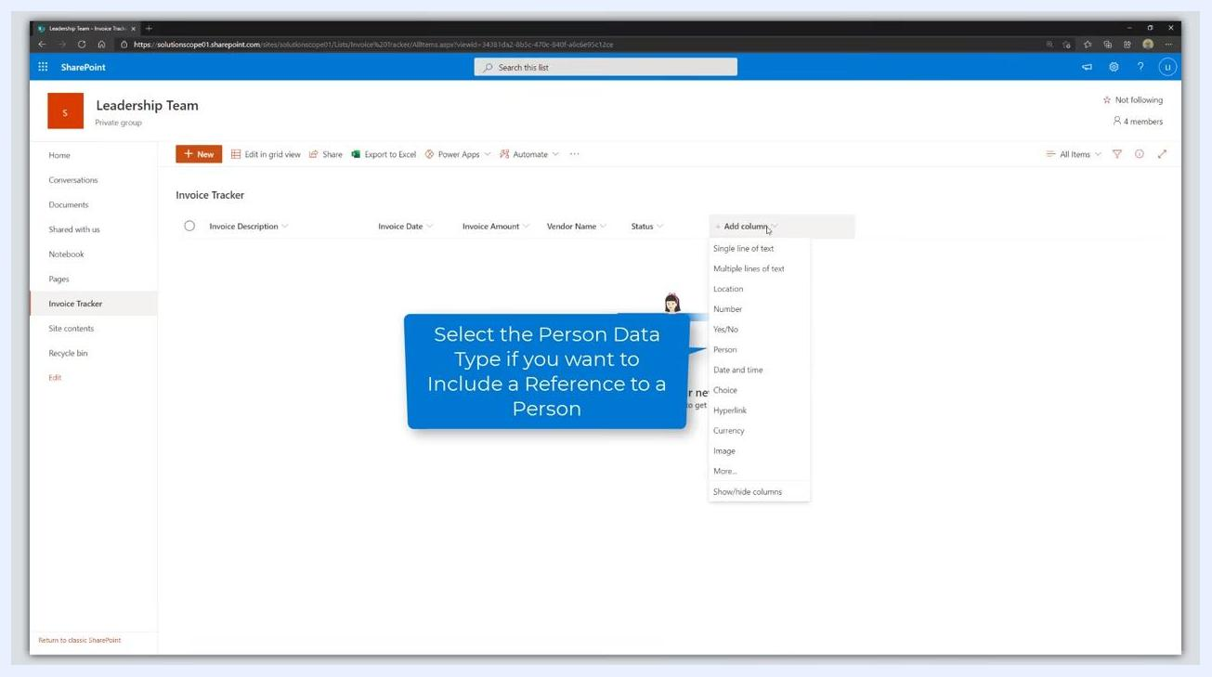
SharePoint list with "Add column" dropdown open, showing data type options such as Single line of text, Multiple lines of text, Location, Number, Yes/No, Person, Date and time, Choice, Hyperlink, Currency, Image, More...

- Select Person as the data type for the new column. This allows you to include a reference to a person in your list.
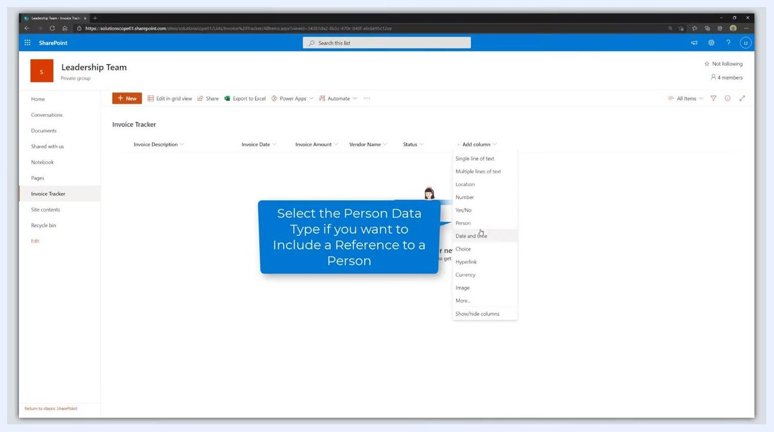
Cursor hovering over "Person" in the Add column dropdown, with a tooltip explaining the Person data type.

- In the Create a column panel on the right, enter the following details:
- Name: Requestor
- Type: Person or Group (automatically selected)
- (Optional) Check Allow selection of Groups if you want to allow the selection of Active Directory Groups (distribution lists).
- Click More options to expand additional settings.
Create a column panel open with Name set to "Requestor", Type set to "Person or Group", and the option to allow selection of Groups visible.

- Add another column for a different person reference:
- Click Add column again and select Person as the data type.
- In the Create a column panel, enter:
- Name: Manager
- Type: Person or Group
- Click More options to expand additional settings.
SharePoint list with columns including Requestor, and Add column dropdown open, cursor over Person data type.

- Make the "Manager" column required:
- Under More options, toggle Require that this column contains information to Yes.
- Ensure Allow multiple selections and Enforce unique values are set to No.
- Click Save to add the column.
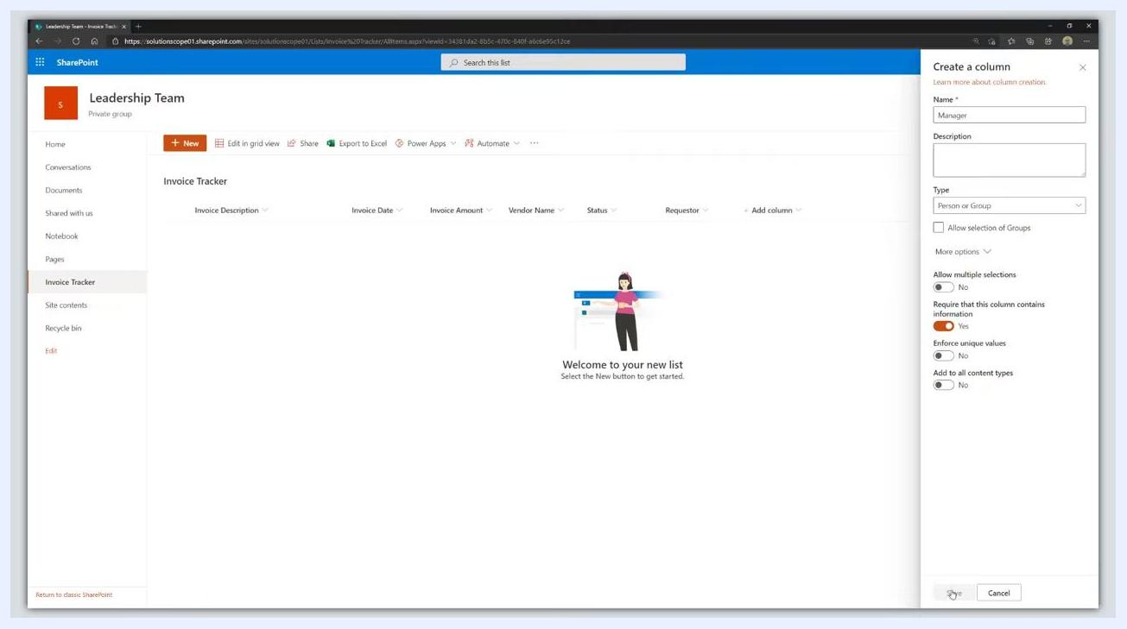
Create a column panel with Name "Manager", Type "Person or Group", and "Require that this column contains information" toggled to Yes.

- Add another person column if needed (for example, Finance):
- Repeat the process: click Add column, select Person, enter Name: Finance, and adjust settings as needed.
- Set Require that this column contains information to No if it is not required.
- Click Save.
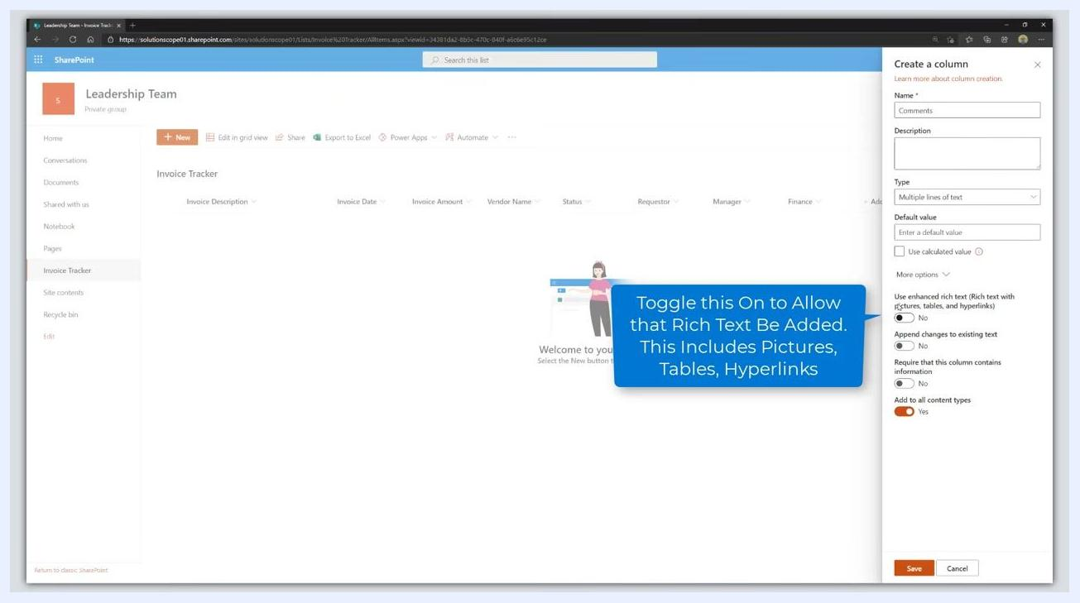
Create a column panel with Name "Finance", Type "Person or Group", and "Require that this column contains information" toggled to No.

- Add a Comments column with multiple lines of text:
- Click Add column and select Multiple lines of text from the dropdown.
- In the Create a column panel, enter:
- Name: Comments
- Type: Multiple lines of text
- Click More options to expand additional settings.
SharePoint list with Add column dropdown open, cursor over "Multiple lines of text".

- Enable enhanced rich text for the Comments column:
- Under More options, toggle Use enhanced rich text (Rich text with pictures, tables, and hyperlinks) to Yes if you want to allow rich formatting.
- Optionally, adjust other settings such as Append changes to existing text or Require that this column contains information.
- Click Save to add the column.
Create a column panel for Comments, with enhanced rich text option visible and a tooltip explaining its features.
At this point, you have added several columns to your Invoice Tracker list, including person references and a comments field with rich text capabilities. Each step ensures the correct data type and settings are applied for your workflow.

- Configure the Comments column settings. In the Create a column panel for the Comments field, ensure the following options are set: Leave Append changes to existing text set to No because the audit trail will record the history of an invoice.
- Use enhanced rich text (Rich text with pictures, tables, and hyperlinks): Yes (toggle is orange).
- Append changes to existing text: No (toggle is gray).
- Require that this column contains information: No (toggle is gray).
- Add to all content types: Yes (toggle is orange).
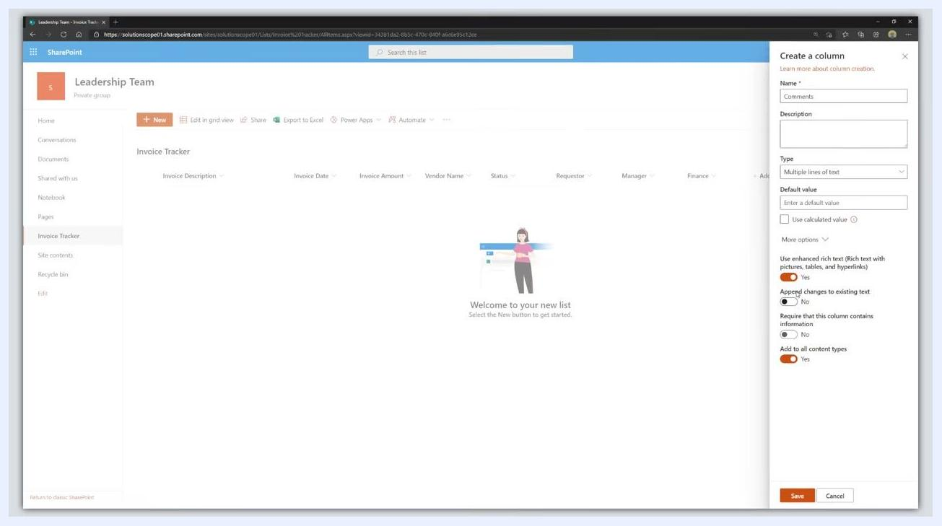
Create a column panel for Comments with enhanced rich text enabled, append changes to existing text set to No, and other options visible.

- Click the Save button at the bottom of the Create a column panel to add the Comments column to your list.
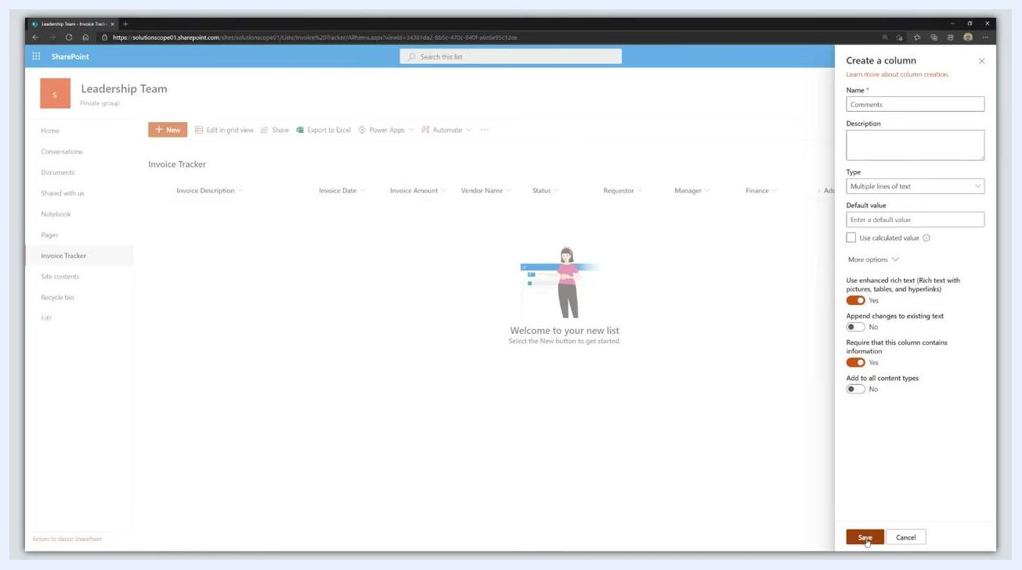
Create a column panel for Comments with Save button highlighted.

Adding a sample invoice entry

- Click the New button at the top of the Invoice Tracker list to open the new item form. In the New item panel, enter the following details:
- Invoice Description: New Laptop
- Invoice Date: 1/28/2021 (or select today's date)
- Invoice Amount: 2500
- Vendor Name: Dell
- Status: Pending Approval (default)
- Requestor: Enter your name or email address
- Manager: Enter the manager's name or email address
- Finance: Enter the finance contact's name or email address
- Comments: (optional, can be left blank or filled in as needed)
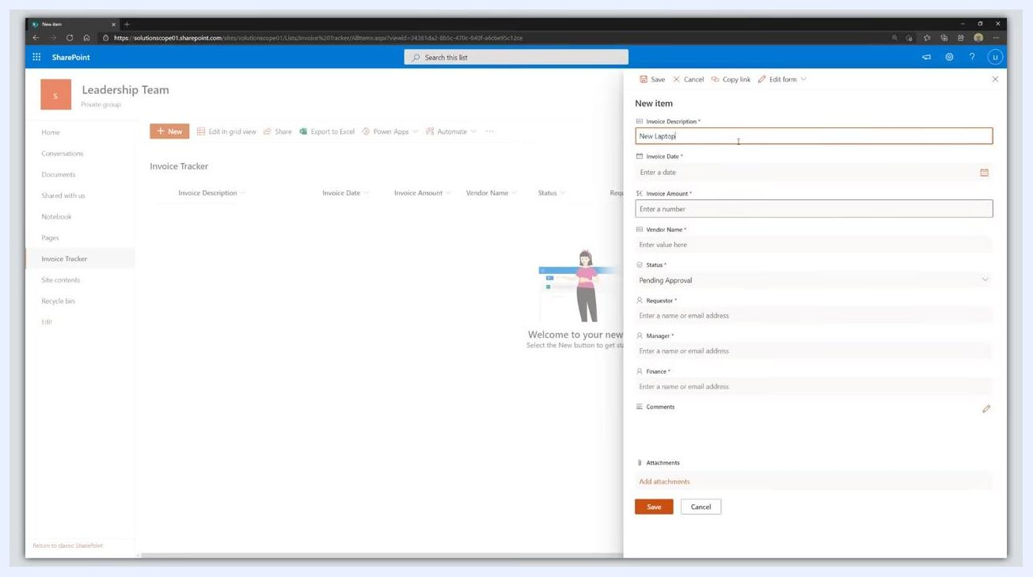
New item panel open with Invoice Description "New Laptop", Invoice Date "1/28/2021", Invoice Amount "2500", Vendor Name "Dell", Status "Pending Approval", and person fields ready for entry.

- Select the Requestor, Manager, and Finance contacts:
- In the Requestor field, enter your name or email address.
- In the Manager field, enter the manager's name or email address.
- In the Finance field, enter the finance contact's name or email address.
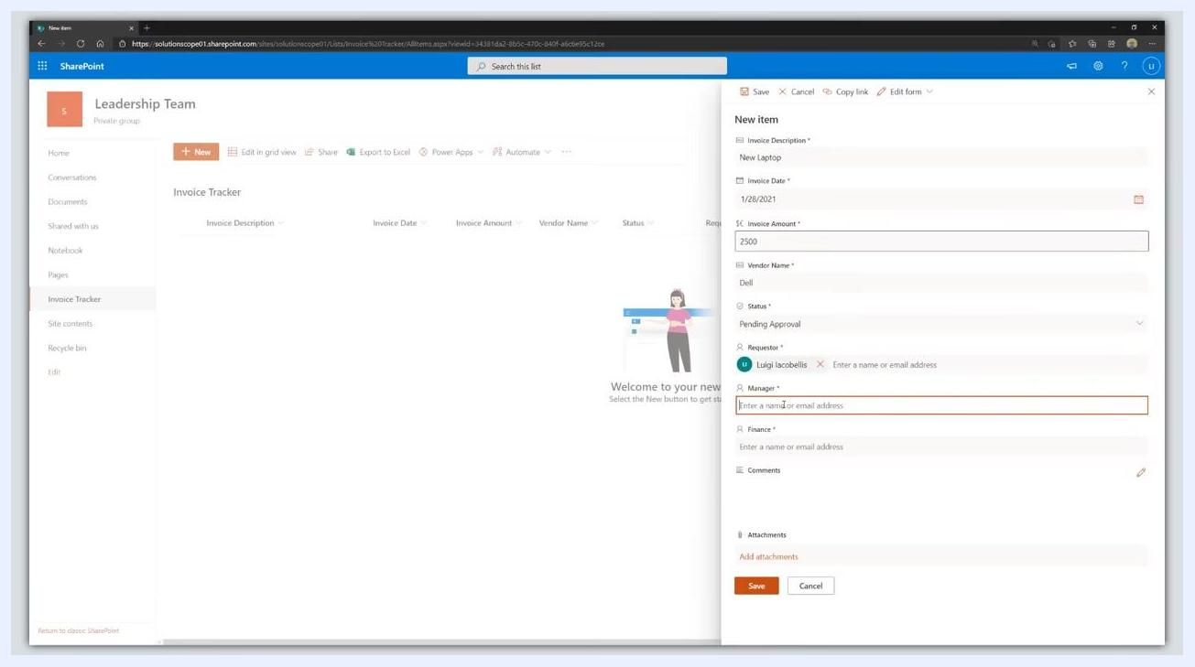
New item panel with Requestor, Manager, and Finance fields filled in with names or email addresses.

- (Optional) Add attachments to the invoice by clicking Add attachments at the bottom of the new item form to upload supporting documents.
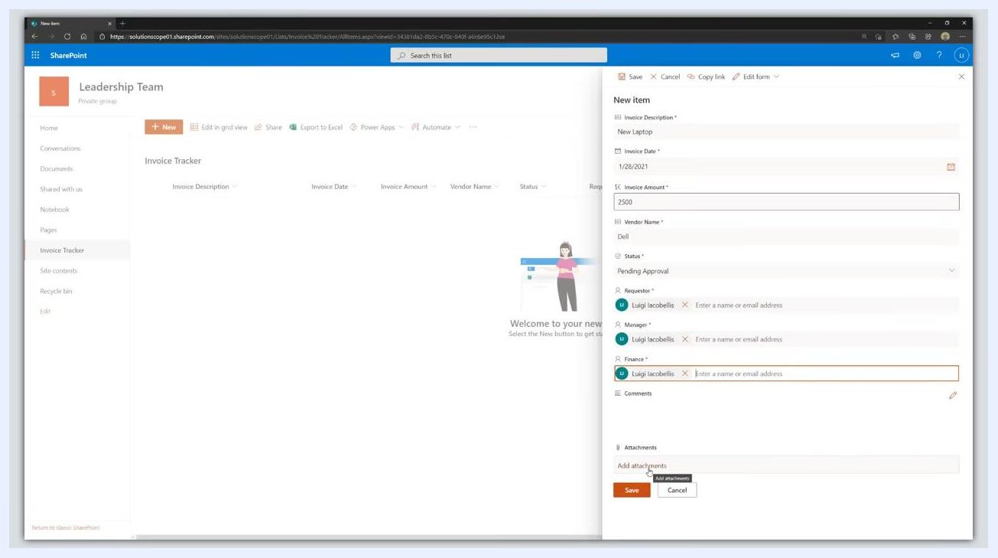
New item panel with cursor over Add attachments, ready to upload files.

- Click the Save button at the bottom of the new item form to add the invoice to your tracker.
- Edit items directly in grid view:
- Click Edit in grid view at the top of the Invoice Tracker list to enable inline editing.
- Update fields directly in the list, similar to working with a spreadsheet.
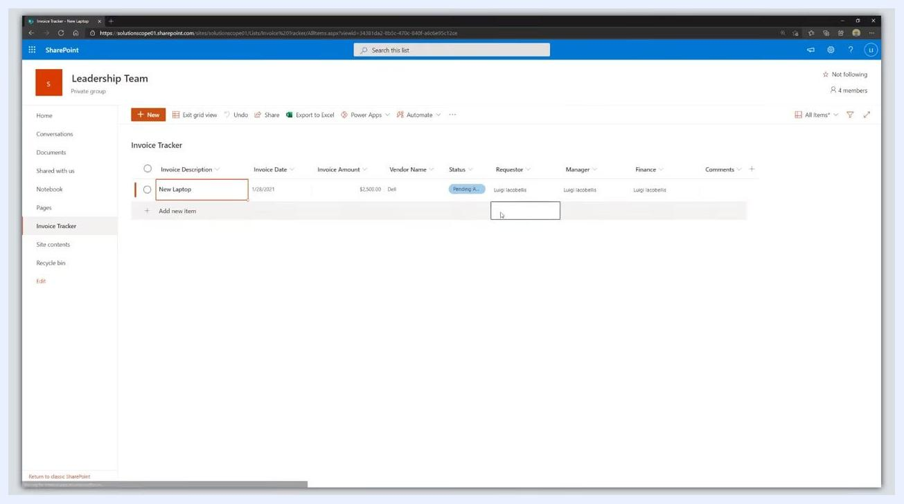
Invoice Tracker list in grid view with New Laptop entry, showing inline editable fields for Invoice Description, Date, Amount, Vendor, Status, Requestor, Manager, Finance, and Comments.

- Review your completed Invoice Tracker. Confirm that your new invoice entry appears in the list with all details filled in, including Invoice Description, Date, Amount, Vendor, Status, Requestor, Manager, Finance, and Comments.
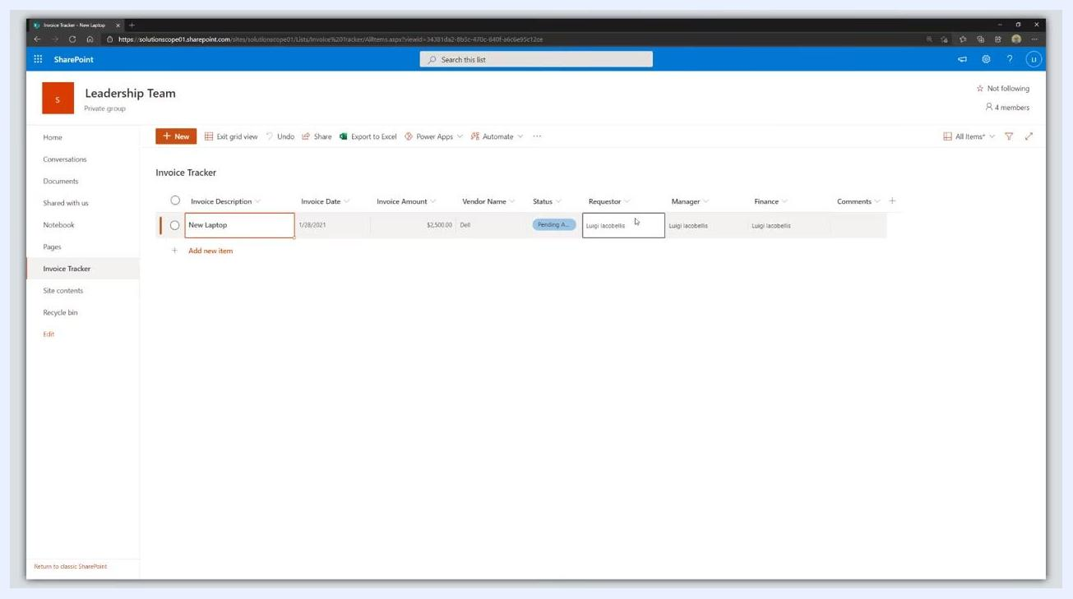
Invoice Tracker list showing completed entry for New Laptop with all relevant columns filled.
By following these steps, you have successfully configured your SharePoint Invoice Tracker list, added custom columns, and entered a sample invoice. You can now manage invoices, assign roles, add comments, and attach supporting documents directly within your SharePoint site.

What's next
- Set up email notifications for status changes: To keep all stakeholders informed, configure SharePoint to send email notifications to the Requestor, Manager, and Finance contacts whenever there are changes in the invoice status. This ensures that each individual is promptly notified about updates or required actions related to their assigned invoices. Note: the specific steps for setting up automated email notifications (such as using Power Automate or SharePoint alerts) are not covered in this guide, but this is a recommended next step for workflow automation.
- Stay updated with SharePoint tutorials: For ongoing learning and to stay current with the latest SharePoint Online features and best practices, subscribe to relevant tutorial channels or resources. This will help you maximize the value of your Invoice Tracker and other SharePoint solutions.
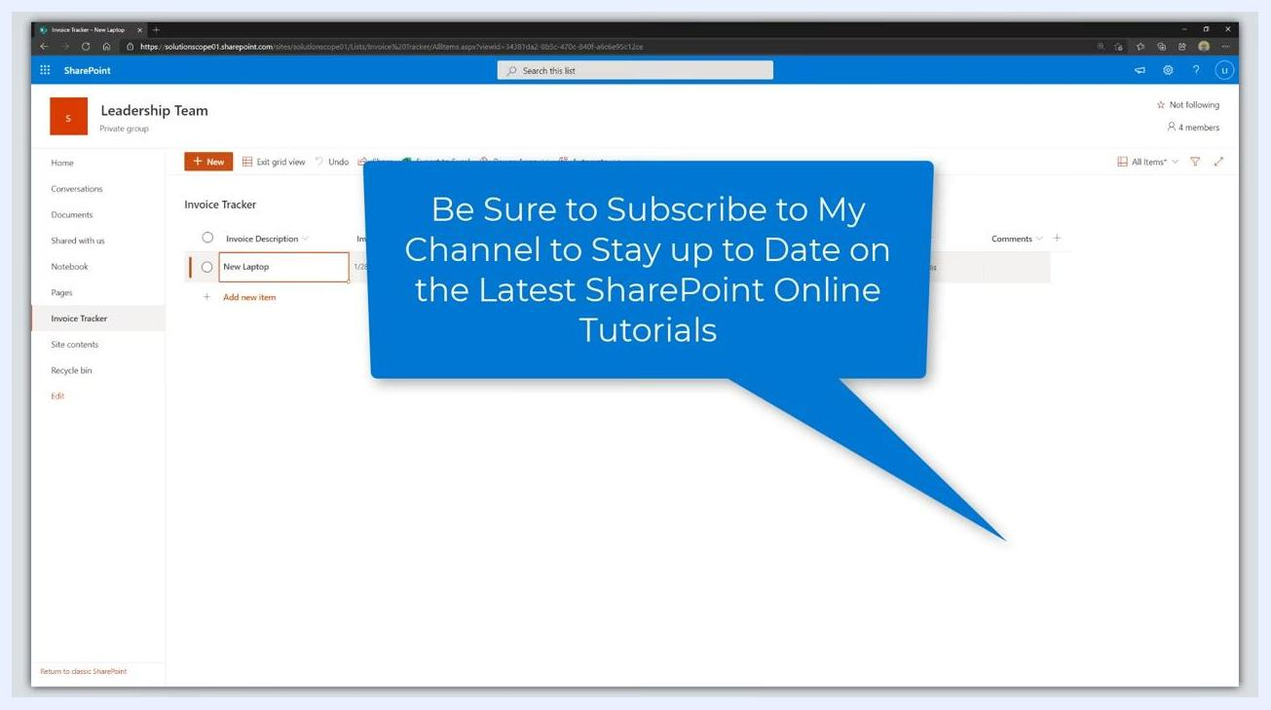
SharePoint Invoice Tracker list with a speech bubble overlay: "Be Sure to Subscribe to My Channel to Stay up to Date on the Latest SharePoint Online Tutorials".

Summary
By following all the steps in this guide, you have learned how to:
- Create and configure a custom SharePoint list for invoice tracking.
- Add and manage invoice entries, including attachments and comments.
- Assign roles and prepare for workflow automation with notifications.
- Continue your SharePoint learning journey with recommended resources.

