How to Create a Form in SharePoint
This guide walks you through how to create a form in SharePoint using the built-in Microsoft Forms web part. You'll learn how to add a fillable form to any SharePoint site page, add questions to it, and confirm it's ready to collect responses from your users.
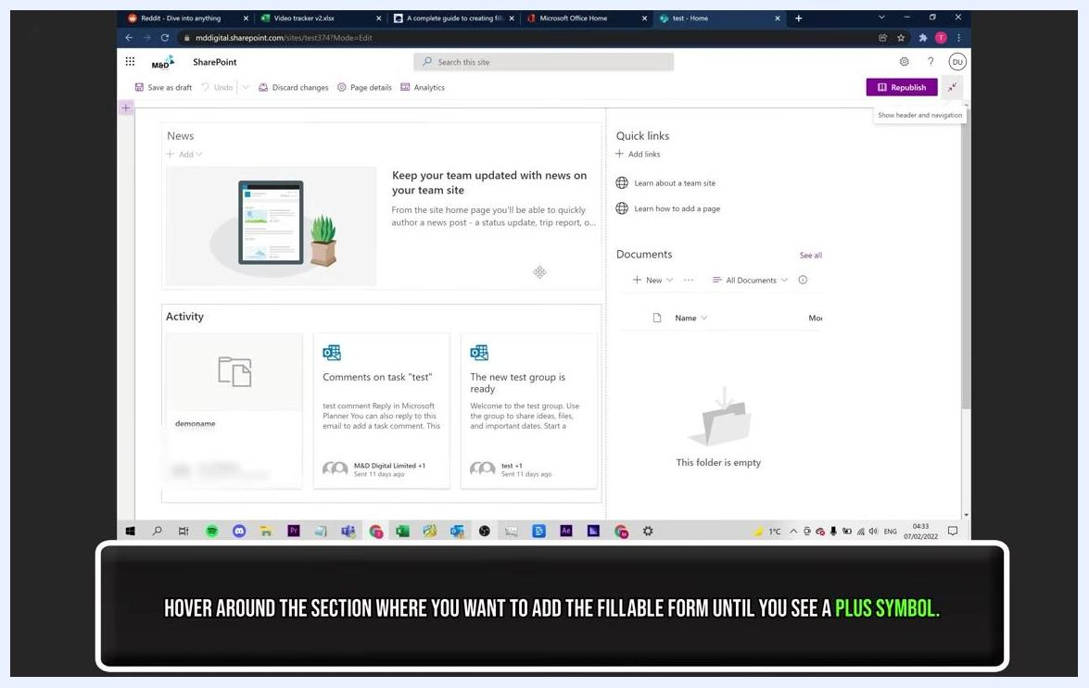
SharePoint page in edit mode, with a plus symbol visible where a new web part can be added

Prerequisites
- An active Office 365 account with access to SharePoint.
- Edit permissions on the SharePoint site where you want to add the form.

Step 1: Open Office 365 and access SharePoint
Make sure you are logged into your Office 365 account. Click the app launcher (grid icon) in the top left corner, then select SharePoint from the list of available apps.
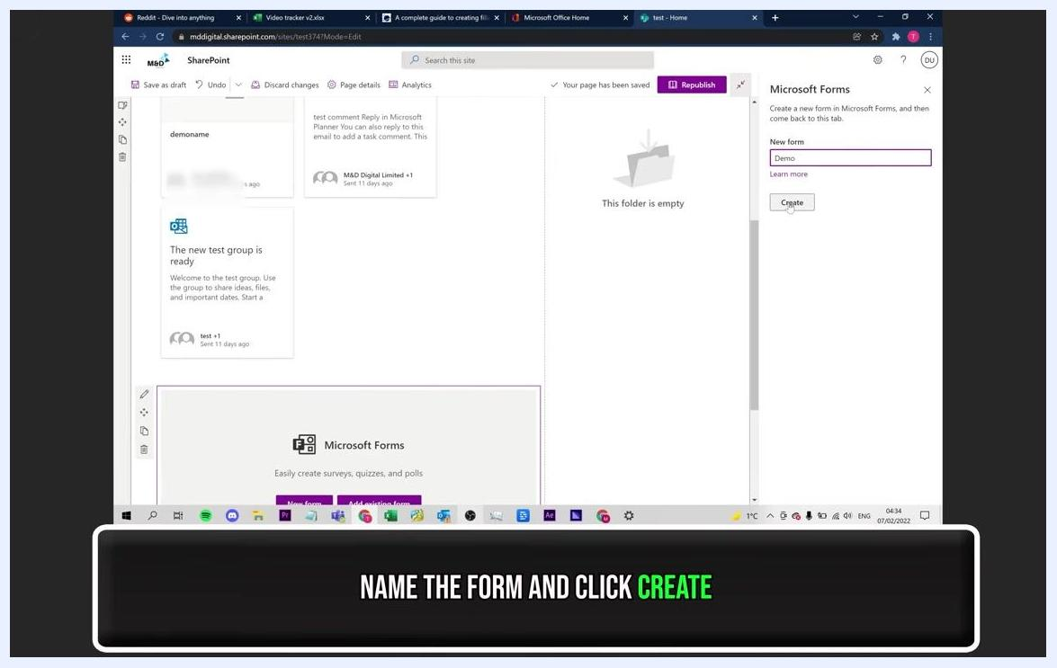
Microsoft Forms pane open, with "Demo" entered as the form name and the Create button highlighted

Step 2: Navigate to your SharePoint site
In SharePoint, go to the site where you want to add the fillable form.
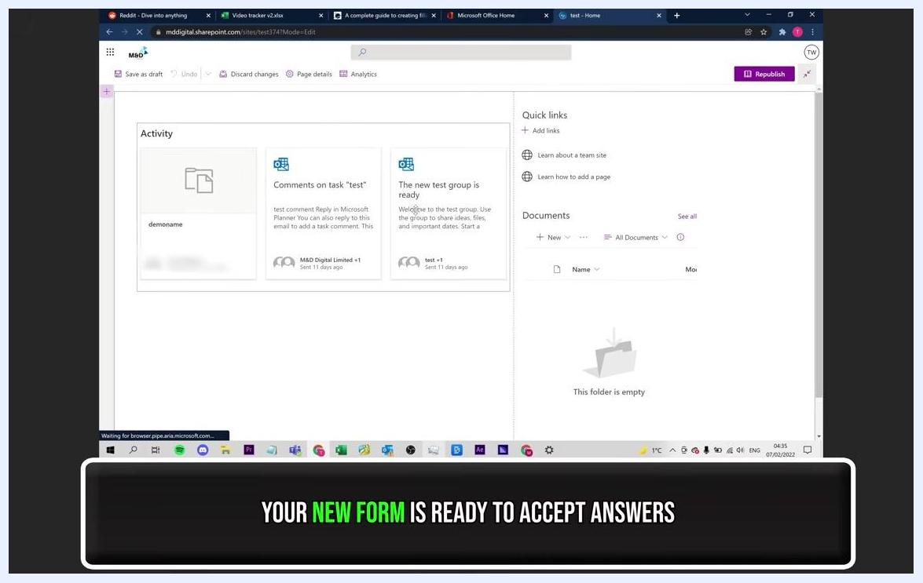
Yellow end screen with "THANK YOU FOR WATCHING", "SUGGESTED VIDEO", "SUBSCRIBE", Business Tech Planet logo, and website address

Step 3: Enter edit mode
Click the Edit button at the top right of your SharePoint site page to start making changes to the layout.

Step 4: Choose where to add the form
Hover your mouse over the section of the page where you want to insert the fillable form. Wait until a plus (+) symbol appears, which indicates you can add a new web part at that location.
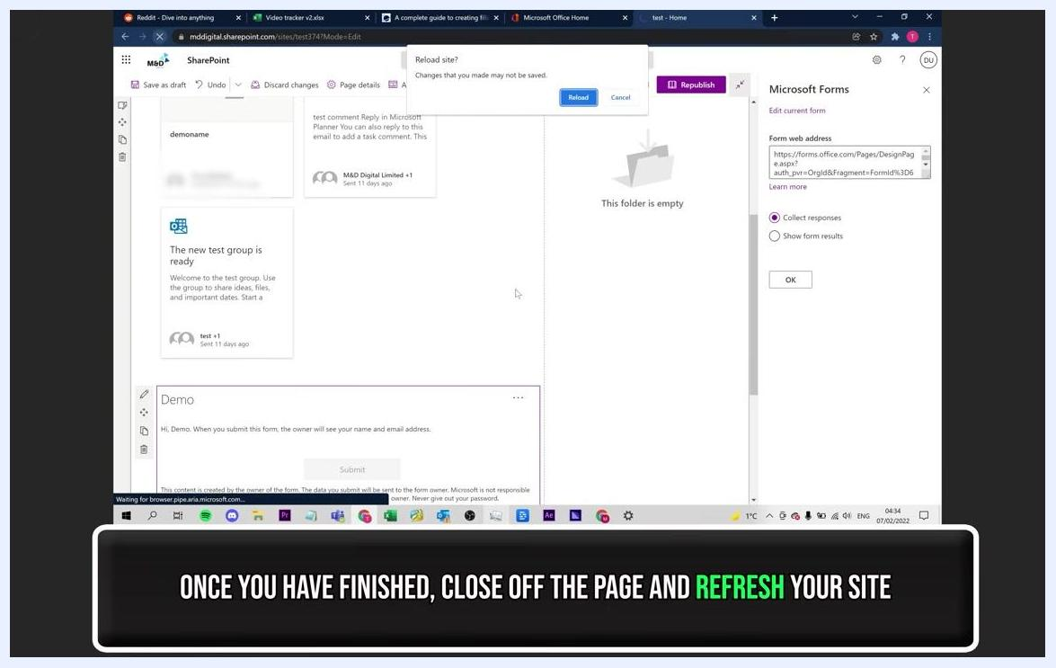
Microsoft Forms editor open, showing the "Demo" form with questions being added and the Add new button visible

Step 5: Add the Microsoft Forms web part
Click the plus (+) symbol to open the web part selection window, then locate and select Microsoft Forms from the list.

Step 6: Create a new form
In the Microsoft Forms pane on the right, click New Form. Enter a name for your form in the "Name your form" field (for example, "Demo"), then click Create to generate the new form.

Step 7: Add questions to your form
Click Add New to insert a new question or element into your form. For this example, select the Text option to add a text input field, then enter the desired question or prompt (for example, "Social Media"). Continue clicking Add New to add more elements as needed.
Office 365 app launcher open, with SharePoint highlighted among other Microsoft 365 apps

Step 8: Customize and finalize your form
Adjust the form elements and settings as needed—for example, toggle the "Long answer" or "Required" options. Experiment with different question types and settings until the form meets your requirements.
SharePoint site with the embedded "Demo" form visible, a reload prompt shown, and the Microsoft Forms pane on the right

Step 9: Save and refresh your SharePoint site
Once you have finished creating and customizing your form, close the Microsoft Forms editing page. Return to your SharePoint site and refresh the page to confirm the form is embedded and visible.
SharePoint site page with the Edit button highlighted, showing the site layout and navigation menu

Step 10: Confirm your form is live
Check that your new fillable form is embedded on your SharePoint site and ready to accept responses from users. Look for a confirmation message or visual cue indicating the form is active.
SharePoint site page in edit mode, showing activity cards, quick links, an empty documents folder, and a banner at the bottom stating "YOUR NEW FORM IS READY TO ACCEPT ANSWERS"

Summary
By following these steps, you have successfully created and embedded a fillable form on your SharePoint site using Microsoft Forms. Your form is now live and ready to collect responses from users.
Black screen with white and blue text: "MORE INFORMATION AT BUSINESSTECHPLANET.COM. LINK TO THE BLOG POST IS IN THE DESCRIPTION"

