How to Create a Folder in SharePoint
Organizing documents in SharePoint often starts with creating folders to structure your content. This guide walks you through how to create a folder in SharePoint, including how to confirm you have the right permissions and how to enable folder creation if it has been disabled.

Prerequisites
Before you create a folder in SharePoint, confirm that you have the required permission to do so. This permission is enabled by default, but a site owner or administrator may have turned it off. If you're not sure whether folder creation is enabled, follow the steps below to check and, if necessary, enable it.

Step 1: Open your SharePoint site
Open your web browser and go to your SharePoint platform. Navigate to the specific SharePoint site where you want to create a new folder.
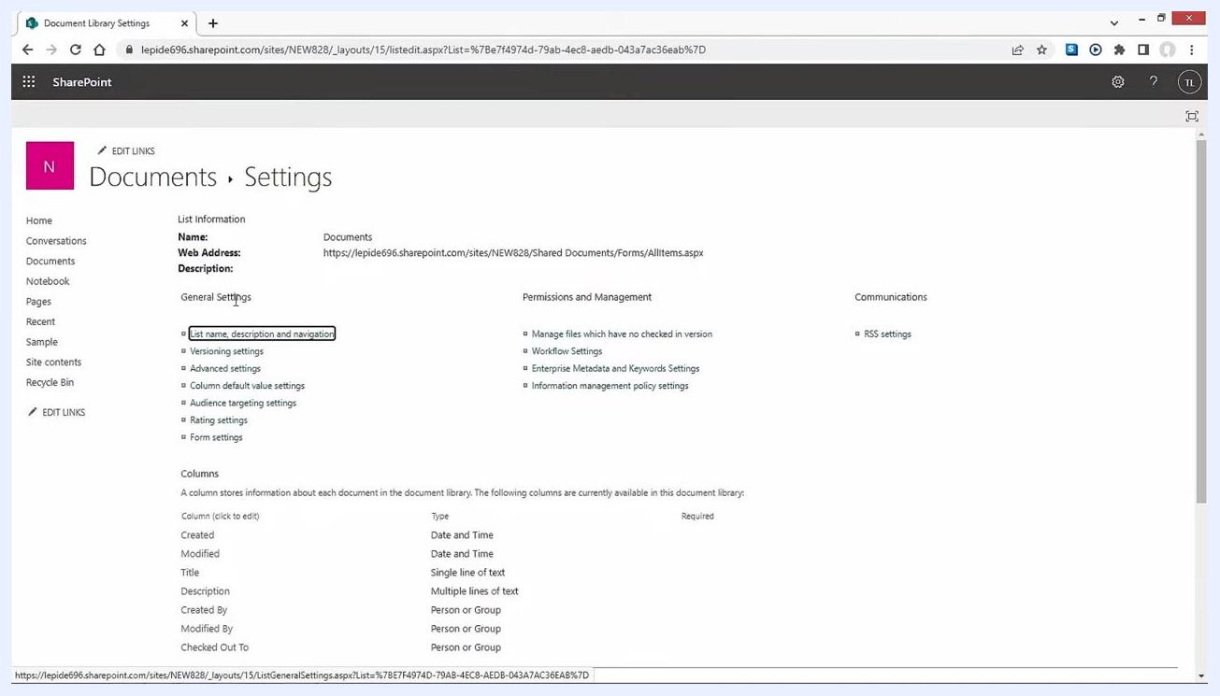
SharePoint home screen showing frequently visited sites and the navigation panel

Step 2: Access library settings
Select the Documents tab from the left navigation menu. Click the Settings (gear) icon, then choose Library Settings from the dropdown menu.

Step 3: Open advanced library settings
In the Library Settings window, locate the General Settings section and click Advanced settings.
SharePoint Library Settings page displaying the General Settings and Advanced Settings options

Step 4: Enable the folder creation option
Scroll down to the Folders section on the Advanced Settings page. Select Yes for the Make "New Folder" command available option, then click OK at the bottom of the page to save your changes.
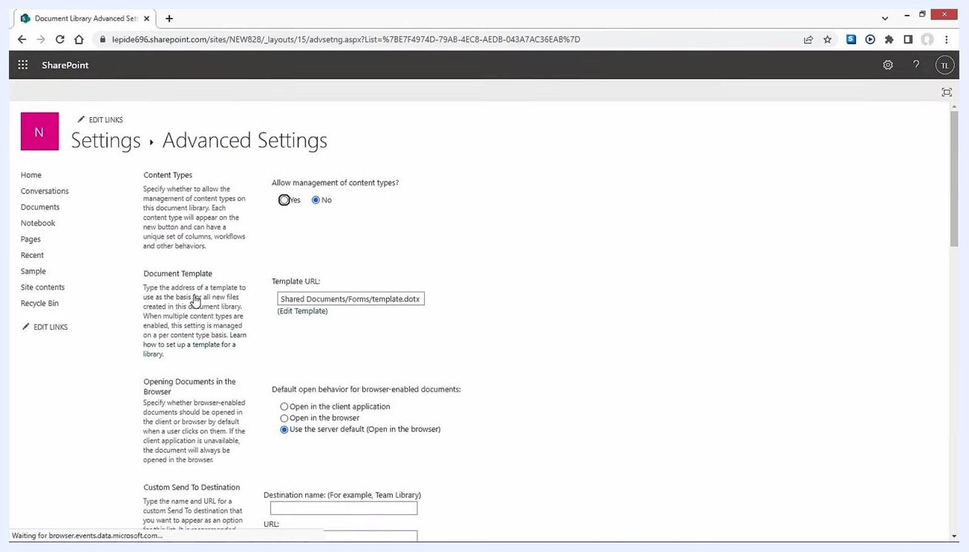
SharePoint Advanced Settings page with the folder creation option highlighted

Step 5: Create the folder
Return to your SharePoint site and go to the Documents tab. Click the + New button, then select Folder from the dropdown menu.
- If Folder does not appear in the menu, folder creation permission is still disabled and you'll need to complete Steps 2–4 again.
- Enter your desired folder name in the prompt that appears.
- Click Create to finish.
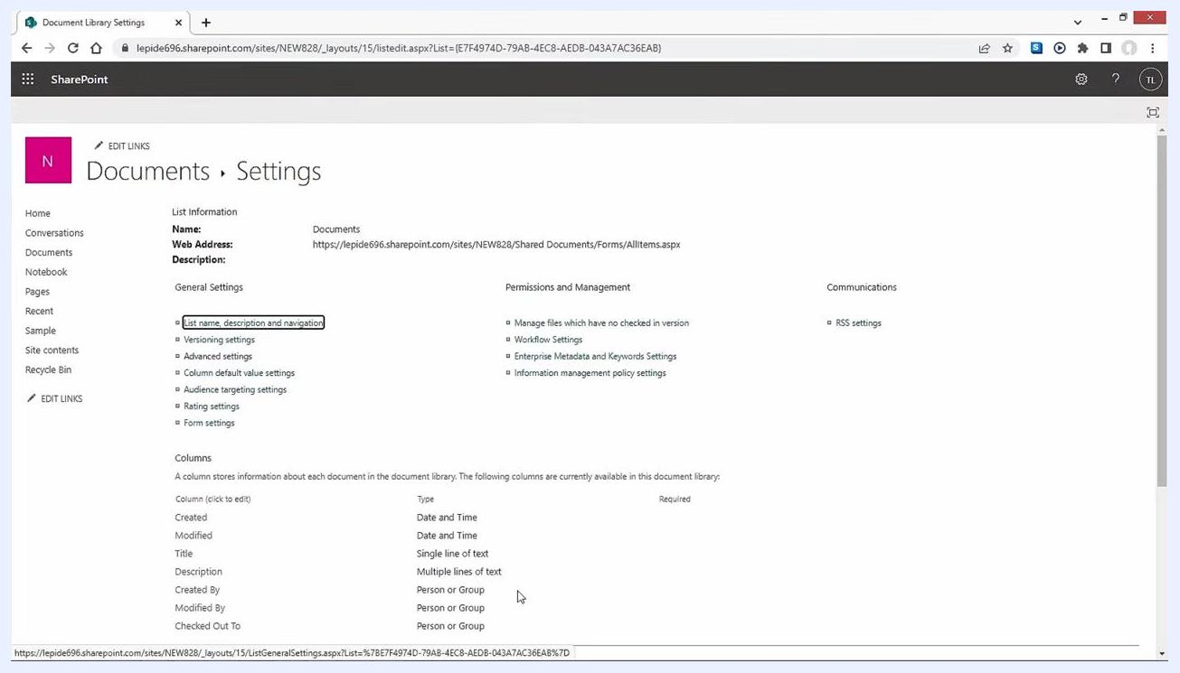
SharePoint Documents library with the "+ New" menu expanded and the Folder option highlighted

Step 6: Verify the folder and start organizing files
After creating the folder, confirm that it appears in your SharePoint document library. Look for the new folder (for example, one named "Sample") in the list of documents. Click on the folder to open it, then begin adding files and other documents to organize your content.
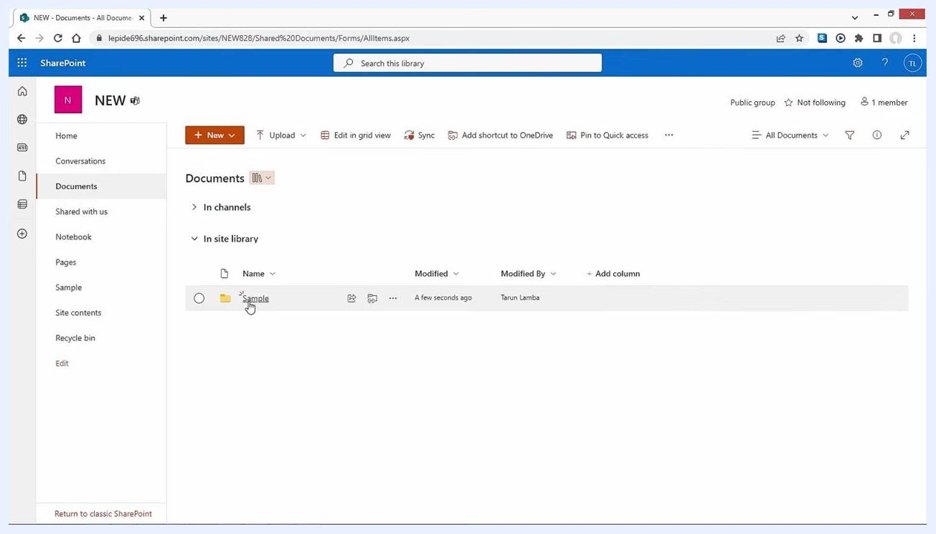
SharePoint Documents library showing the newly created "Sample" folder, with a cursor pointing to it. The left navigation menu and document details such as Modified and Modified By are visible.

Additional notes
- You can rename the folder later if needed.
- If you run into any issues, verify your permissions or contact your SharePoint administrator.

What's next
Once your folder structure is in place, you may also need to move or migrate data between SharePoint versions. For secure and efficient migration of entire or selective SharePoint data, consider using a professional migration tool such as Kernel Migrator for SharePoint, which uses advanced algorithms to help ensure data integrity during migration.
For more information or to obtain the tool:
- Visit:
- Email: support@nucleustechnologies.com
- Call: 1-866-348-7872
Kernel Migrator for SharePoint product box alongside the Kernel Data Recovery logo, website link, support email, and phone number, shown on a white background with network graphics.
By following these steps, you have successfully created a folder in SharePoint and learned about options for migrating your data securely between SharePoint versions.

