How to Create Additional Document Libraries in SharePoint
Every new SharePoint site—including those created through Microsoft Teams—comes with a single default document library. As your content grows or your organizational needs become more complex, you may need to create additional document libraries to keep files organized and manageable. This guide walks you through understanding the default SharePoint layout, creating a new document library, and following best practices for managing multiple libraries.
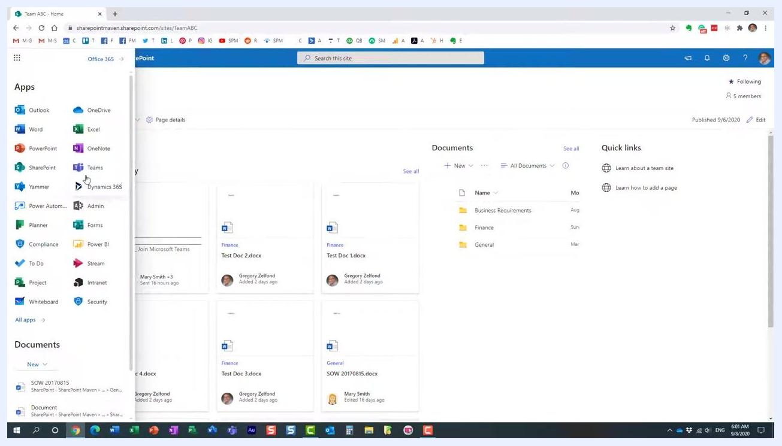
The SharePoint Maven introduction slide: on the left, the title "How to create additional document libraries in SharePoint" appears on a dark background; on the right, a person is smiling, with the SharePoint Maven logo below.

Prerequisites
- Access to a SharePoint site (for example, a Teams-connected site such as "Team ABC").
- Permissions to create and manage document libraries on that site.

Why you might need additional document libraries
Consider creating additional document libraries in the following scenarios:
- You have a large volume of documents and want to split them into separate "file cabinets."
- You require unique metadata or settings for different sets of documents.
- You want to separate content by department, project, or function.
- You need to apply different metadata, permissions, or workflows to different sets of documents.
If your SharePoint site is connected to Microsoft Teams, note that folders are automatically created for each standard channel within the default document library.

Understanding the default SharePoint site layout
When a new SharePoint site is created, it is typically associated with a Microsoft 365 group and may include Teams integration. The default document library will already contain folders that correspond to Teams channels, rather than folders you created manually.

- Navigate to your SharePoint site (for example, "Team ABC").
- On the homepage, locate the Documents section, which displays folders such as "Business Requirements," "Finance," and "General." These folders may have been created automatically by Teams channels.
SharePoint site homepage for "Team ABC" showing the Documents section with folders (Business Requirements, Finance, General), an activity feed, and quick links.

- Alternatively, use the Office 365 app launcher (grid icon) to access SharePoint and other Microsoft 365 apps. Confirm you are on the correct SharePoint site by checking the site name and URL.
Office 365 app launcher open on the left, showing apps such as Outlook, OneDrive, Word, Excel, PowerPoint, SharePoint, and Teams, with the SharePoint site "Team ABC" visible in the background.

- Confirm that the Documents library is present—this is the default library on all SharePoint sites, and its folders may be automatically generated by Teams channels.
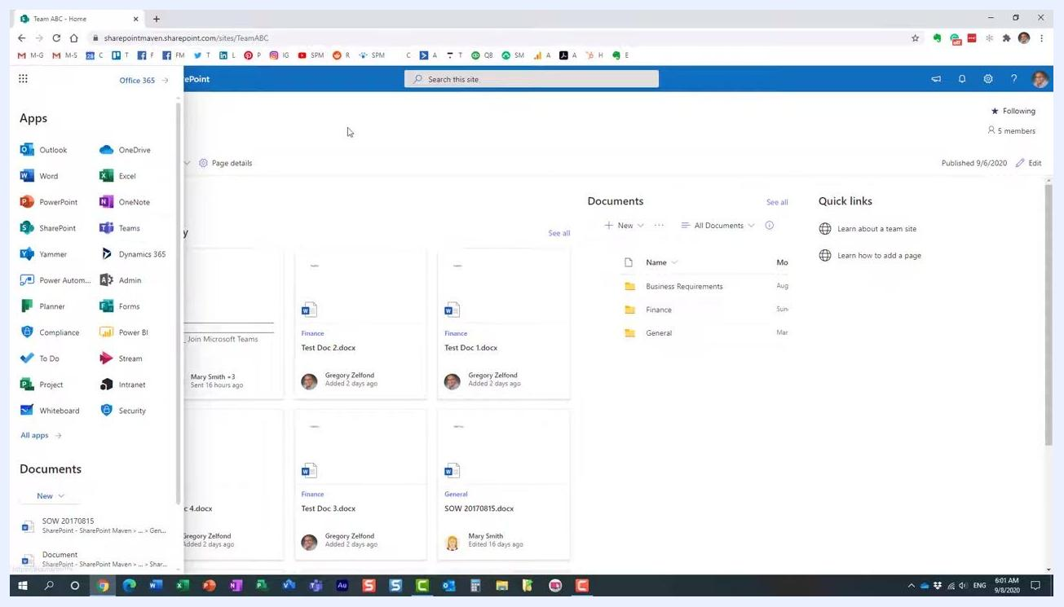
SharePoint site homepage for "Team ABC" with the Documents section and folders visible, and the Office 365 app launcher still open.
A single document library may be sufficient for small teams or limited content, but larger organizations or more complex needs benefit from additional libraries for better organization and management.
SharePoint site homepage for "Team ABC" showing the Documents section and folders, with the "New" button highlighted to indicate where new content can be added.
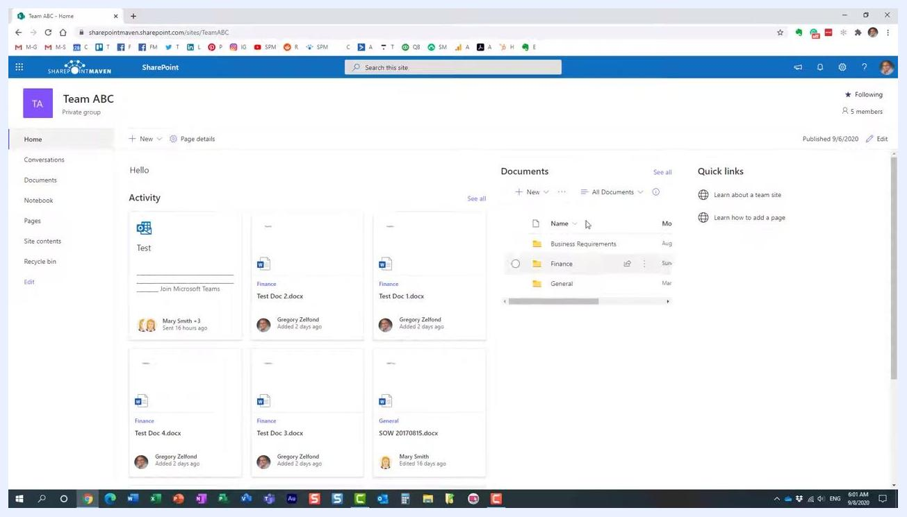
SharePoint site homepage for "Team ABC" with the Documents section and folders visible.

- Click the New button in the Documents section to begin adding new content or libraries.
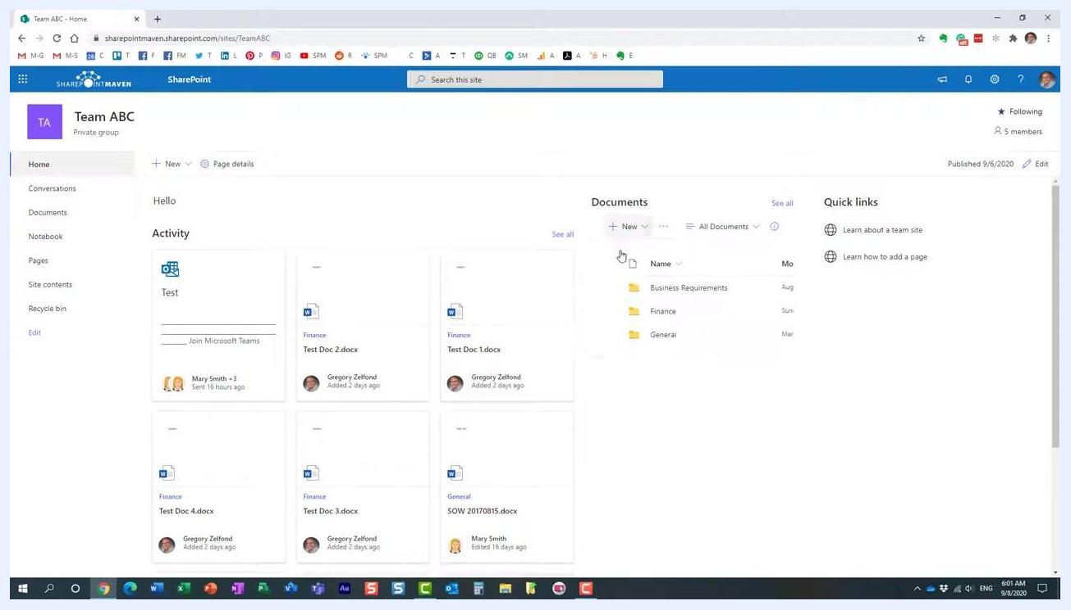
SharePoint site homepage for "Team ABC" with the "New" button in the Documents section being selected.
Folders in the default document library are created automatically when new standard channels are added in Microsoft Teams—they are not created manually, but are linked to the Teams channel structure.
SharePoint "Documents" library open, showing the "New" menu with options for Folder, Word document, Excel workbook, PowerPoint presentation, OneNote notebook, Forms for Excel, Visio drawing, Link, Edit New menu, and Add template. The library lists folders along with their modified dates.

Step-by-step: Creating an additional document library
If you want to organize documents independently of the Teams channel structure, follow these steps to create a new document library.

- Recognize that folders such as "Business Requirements," "Finance," and "General" are automatically created by Teams channels. If you want to organize documents in your own way, consider creating an additional document library.
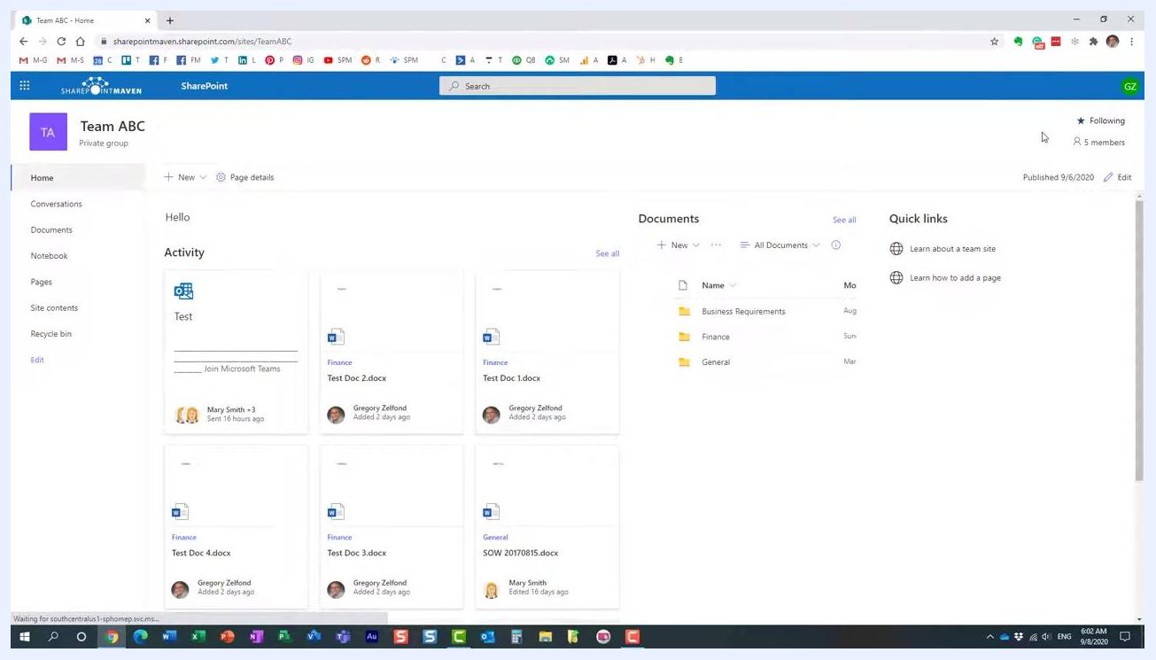
SharePoint "Documents" library open for Team ABC, showing folders (Business Requirements, Finance, General) with the cursor pointing at "Business Requirements." The left navigation includes Home, Conversations, Documents, Shared with us, Notebook, Pages, Site contents, and Recycle bin. The top bar shows options like New, Upload, Edit in grid view, Sync, Export to Excel, Power Apps, and Automate.

- Navigate to your SharePoint site (for example, "Team ABC"). Confirm the left navigation menu displays options such as Home, Conversations, and Documents.
SharePoint "Documents" library for Team ABC, showing the same folders and navigation as described above.

- Click Home in the left navigation to return to the main site page. Confirm you see the Activity feed, Documents section, and Quick links.
SharePoint site homepage for Team ABC, showing the Activity feed, Documents section with folders, and Quick links.

- Click the gear icon (Settings) in the top right corner. In the Settings panel, select Site contents from the list of options (Add a page, Add an app, Site contents, Site information, etc.).
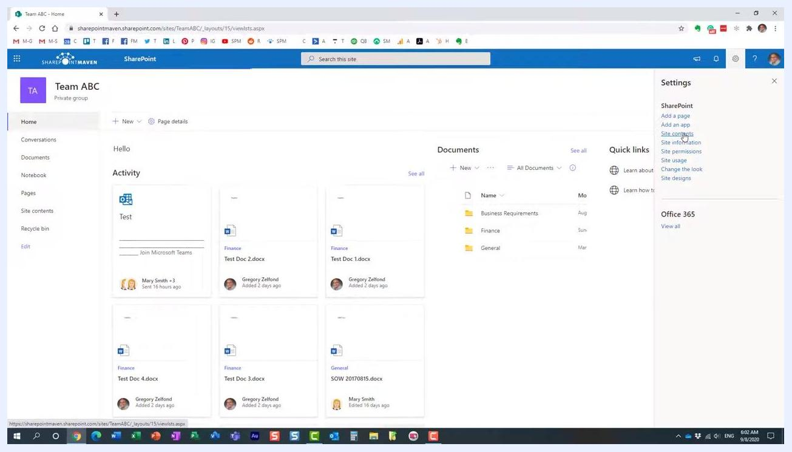
SharePoint site homepage with the Settings panel open on the right, showing options including "Site contents" highlighted.

- Review the Site Contents page, which lists all libraries and apps on the site. By default, you will see the Documents library (type: Document library), along with others such as Form Templates, Site Assets, Style Library, Teams Wiki Data, and Site Pages.
The default Documents library cannot be removed, as it is required for SharePoint and Teams functionality.
SharePoint Site Contents page for Team ABC, listing libraries: Documents, Form Templates, Site Assets, Style Library, Teams Wiki Data, and Site Pages, with "Documents" highlighted.
The Documents library is where Teams channel folders are stored, while other libraries (such as Site Assets and Style Library) serve different purposes and are created by SharePoint for site functionality.
SharePoint Site Contents page, "Documents" library highlighted, showing other libraries and their item counts.

- Click the + New button at the top of the Site Contents page. In the dropdown menu, select Document library (other options include List, Page, App, and Subsite).
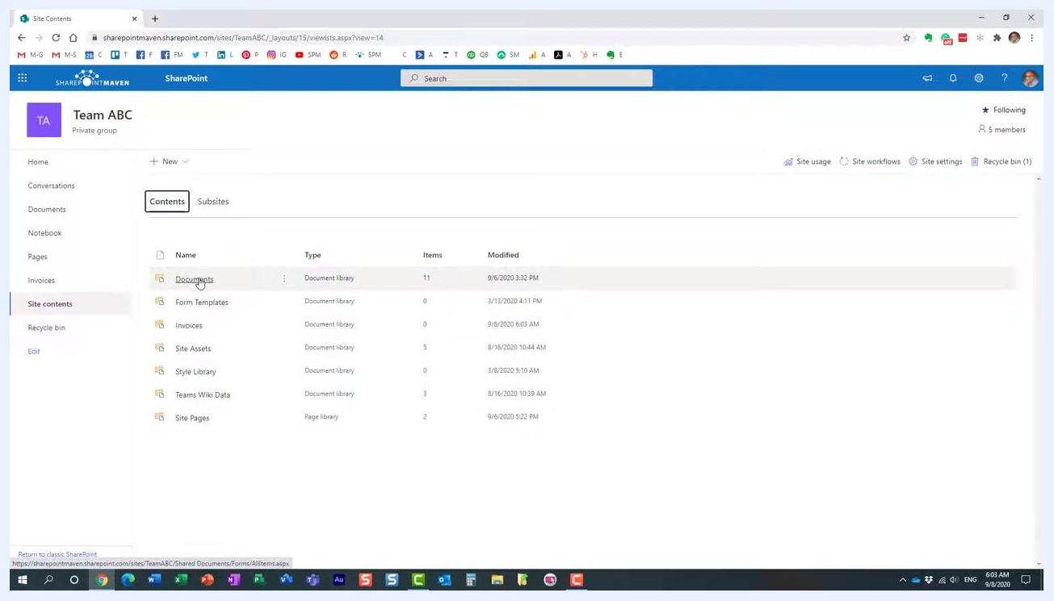
SharePoint Site Contents page with the "+ New" menu open, cursor highlighting the "Document library" option.

- Enter a name for your new library (for example, "Invoices"). Choose to add the library to the site navigation for easy access, then confirm and create the library.
- Verify the new library. It will open showing an empty state with the prompt "Drag files here." The library will also appear in the left navigation and in Site Contents.
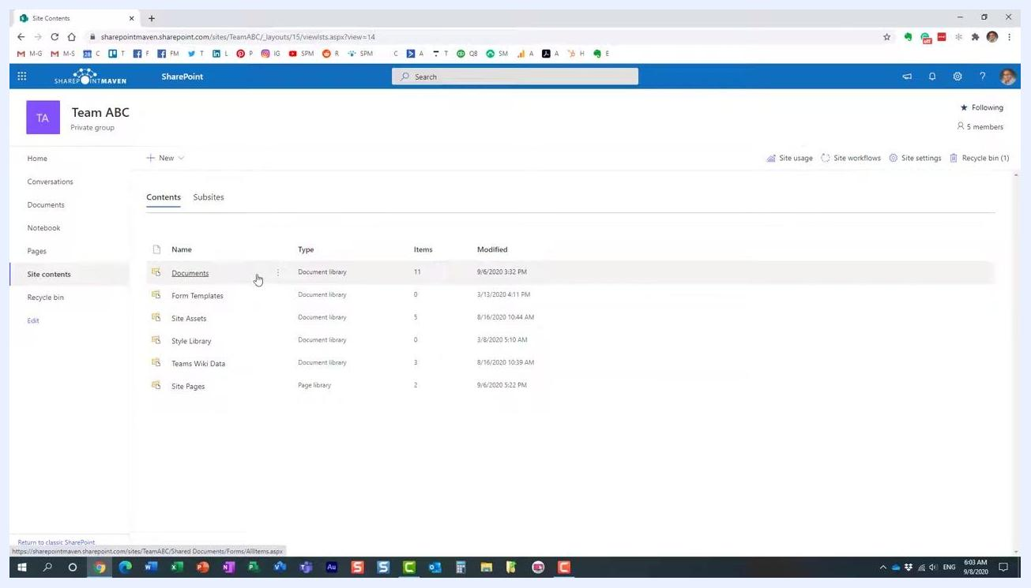
Newly created "Invoices" document library open, showing an empty state with the "Drag files here" prompt. The left navigation now includes "Invoices," and the top bar shows standard document library options.

- Return to Site Contents and verify that both the default Documents library and your new library (for example, "Invoices") are listed.
SharePoint Site Contents page showing both "Documents" and "Invoices" libraries, along with other default libraries.
You can create as many document libraries as needed—there is no practical limit. It is best practice to split large volumes of content across multiple libraries to avoid technical limitations and improve organization.
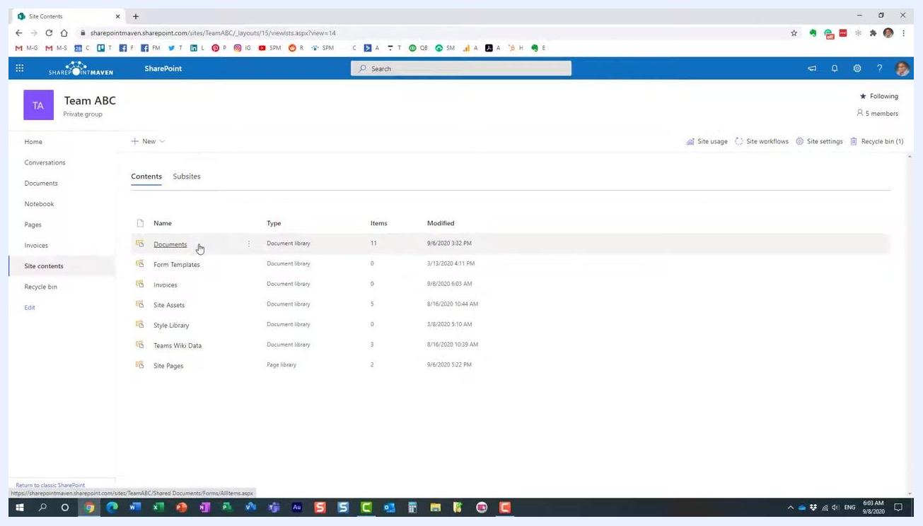
SharePoint Site Contents page, "Documents" library highlighted, showing multiple document libraries including the newly created one.

Best practices for managing multiple document libraries
- Create multiple document libraries for better organization. Split content logically—by department, project, or document type—to avoid technical limitations and improve manageability.
- Synchronize each library as needed. Each document library can be synchronized individually to your device using OneDrive sync. Choose which libraries to sync based on your workflow and storage needs.
- Verify all libraries in Site Contents regularly. Navigate to Site contents from the left navigation menu and confirm that all your document libraries (for example, "Documents" and "Invoices") are listed alongside default libraries like Form Templates, Site Assets, Style Library, Teams Wiki Data, and Site Pages. Check the Items and Modified columns to monitor usage and recent changes.
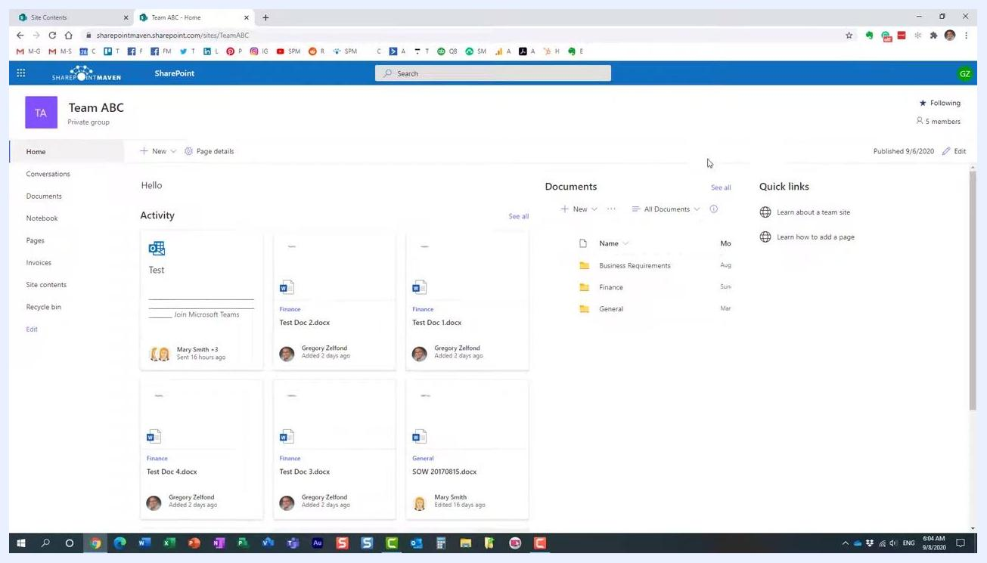
SharePoint Site Contents page for Team ABC, showing multiple document libraries including "Documents" and "Invoices," with columns for Name, Type, Items, and Modified. The cursor points at "Invoices." The left navigation includes Home, Conversations, Documents, Notebook, Pages, Invoices, Site contents, and Recycle bin.
For example, the "Invoices" library may show 0 items with a last modified date of 9/8/2020 6:03 AM.
- Return to the SharePoint site homepage regularly. Click Home in the left navigation to review the Activity feed for recent document changes and the Documents section for quick access to channel folders (such as "Business Requirements," "Finance," and "General"). Use Quick links for helpful resources such as "Learn about a team site" and "Learn how to add a page."
SharePoint site homepage for Team ABC, showing the Activity feed with recent documents, the Documents section with folders, and Quick links.
Additional document libraries are a powerful way to split content apart and keep your SharePoint site organized, which is especially useful for large teams or sites with diverse document management needs.
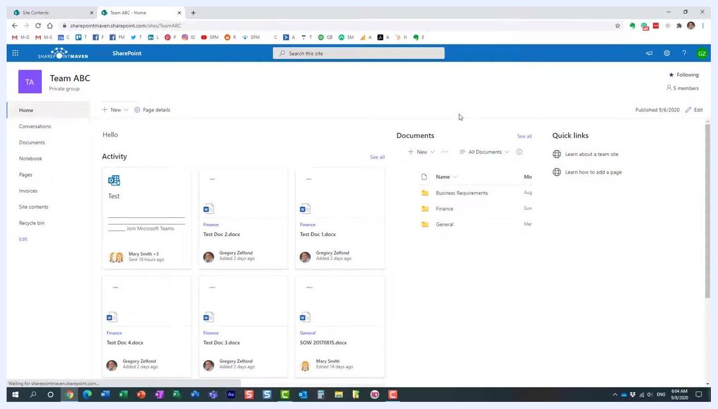
SharePoint site homepage for Team ABC, showing the same layout as above: Activity feed, Documents section, and Quick links.

What's next
For more tips and tutorials, visit the SharePoint Maven blog (SharePointMaven.com) or the SharePoint Maven YouTube channel to stay updated with best practices and maximize your SharePoint experience.
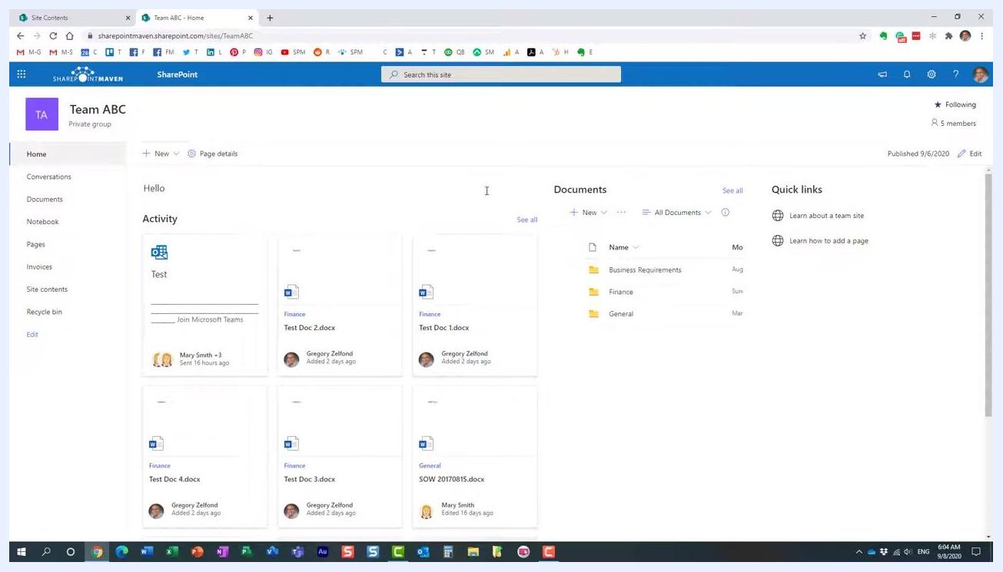
SharePoint site homepage for Team ABC, showing the Activity feed, Documents section, and Quick links, with no further actions being performed.

Summary
By creating multiple document libraries and organizing your content thoughtfully, you can avoid technical limitations, improve collaboration, and keep your SharePoint site efficient and easy to navigate. Synchronize only the libraries you need, and revisit the Site Contents page regularly to manage your libraries effectively.

