How to Add SharePoint to File Explorer
SharePoint Online is commonly used for document sharing, but managing files directly in a browser can be tedious and often requires many clicks. This guide shows you how to add SharePoint to File Explorer so you can manage your SharePoint Online files directly from your desktop instead of navigating through the browser every time.

Prerequisites
- Internet Explorer 11 (or any available version of Internet Explorer)
- The URL for your SharePoint Online site
- Access to your computer's File Explorer

Step 1: Open your SharePoint site in Internet Explorer
Open Internet Explorer 11 (or any available version of Internet Explorer) and navigate to your SharePoint Online site by copying and pasting the SharePoint link into the browser's address bar.
If a pop-up appears asking whether you want to trust the site, click Yes to trust it. If you've already trusted the site, or if the pop-up doesn't appear, you can check the trust status manually in a later step.

Step 2: Check the trust settings manually
To manually check or adjust trust settings, go to the toolbar in the top right-hand corner of Internet Explorer and click Internet Options.
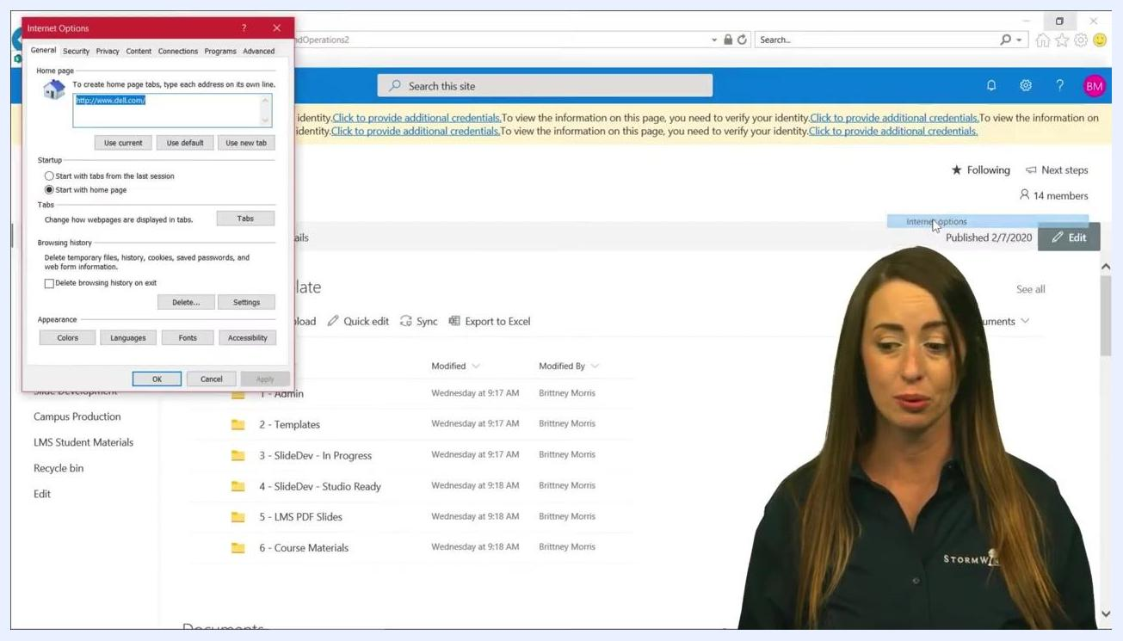
Internet Options dialog open in Internet Explorer, with the SharePoint Online site visible in the background showing folders such as "1 - Admin" and "2 - Templates."

Step 3: Open the security settings
In the Internet Options dialog, go to the Security tab. Ensure Trusted sites is selected — it should be highlighted automatically — then click the Sites button to open the Trusted sites window.
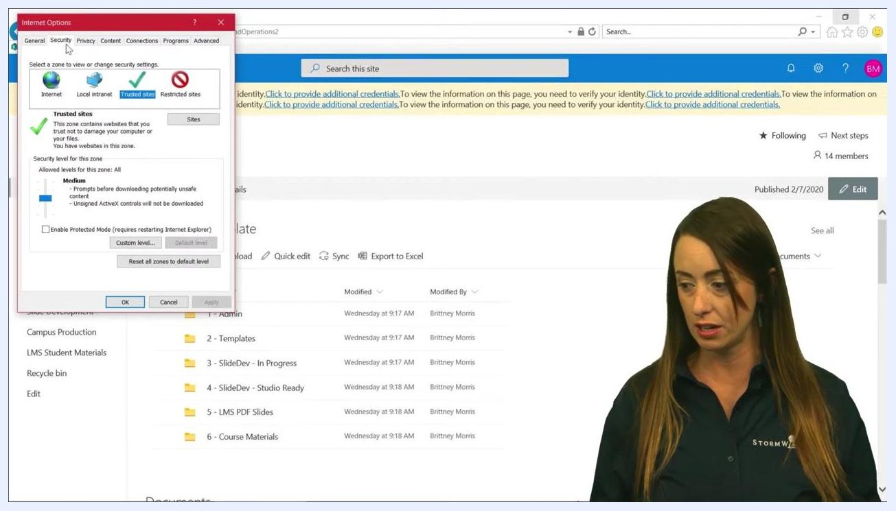
Internet Options dialog open to the Security tab, with Trusted sites highlighted and the Sites button visible, and the SharePoint Online site open in the background.

Step 4: Add your SharePoint site as a trusted site
In the Trusted sites window, paste your SharePoint site URL into the field labeled Add this website to the zone and click Add to include it in the trusted sites list. Confirm that your SharePoint site now appears in the list of trusted websites.
Uncheck the box labeled Require server verification (https:) for all sites in this zone. This step is required for the SharePoint site to appear in File Explorer.
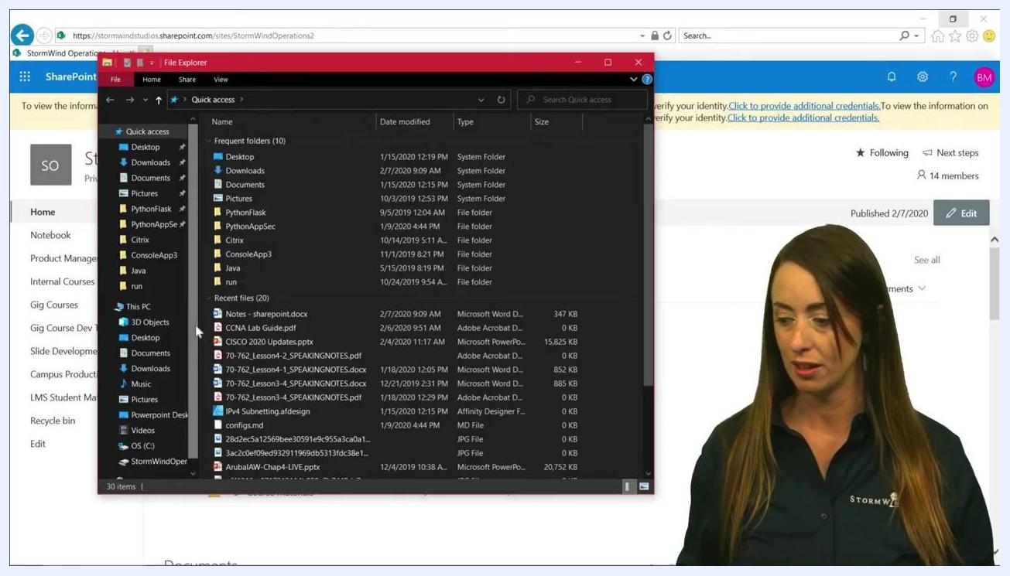
Trusted sites dialog showing SharePoint URLs added, with the "Require server verification (https:)" checkbox ready to be unchecked.
Click Close to exit the Trusted sites window, then click OK to close the Internet Options dialog.

Step 5: Open File Explorer
Open File Explorer on your computer.
File Explorer window open, showing Quick access and recent files, with the SharePoint site still visible in the background.
In File Explorer, click on This PC in the left navigation pane, then click the Computer tab at the top and select Map network drive.

Step 6: Map your SharePoint site as a network drive
In the Map Network Drive dialog:
- Choose a drive letter where you want your SharePoint link to appear (for example, Y:).
- Paste your SharePoint site link into the Folder field.
- Optionally, check Reconnect at sign-in if you want the drive to reconnect automatically.
- Click Finish to complete the mapping.
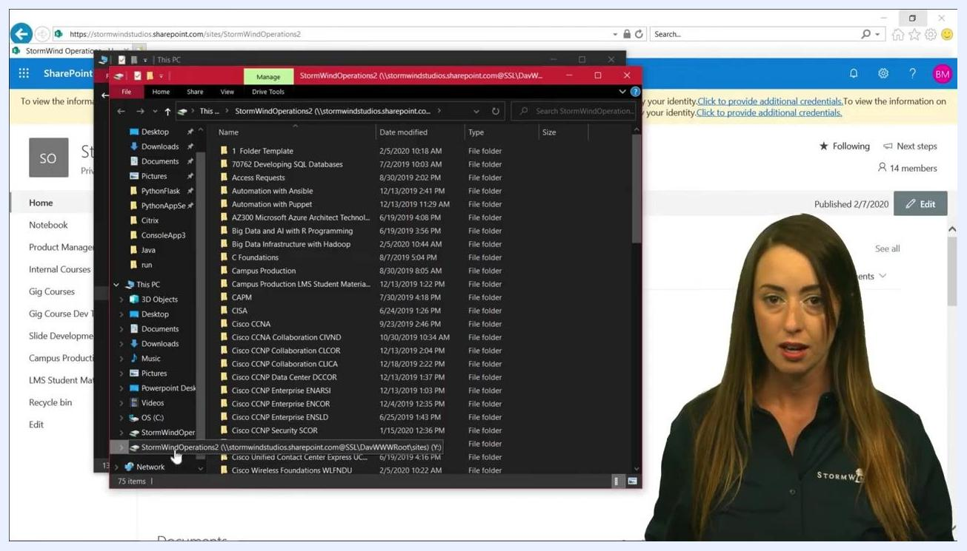
Map Network Drive dialog showing drive letter selection (Y:) and the SharePoint folder path entered.

Step 7: Access your SharePoint drive in File Explorer
Once the mapping is finished, your SharePoint site appears as a network location under This PC in File Explorer. Click on the mapped SharePoint drive to view all document libraries and folders available in your SharePoint site.
File Explorer showing the mapped SharePoint drive (Y:) with all document libraries and folders listed.

Step 8: Interact with your SharePoint files
You can now interact with your SharePoint files and folders directly from File Explorer. Click on any folder to open it, and save, edit, or manage multiple versions of documents as needed.
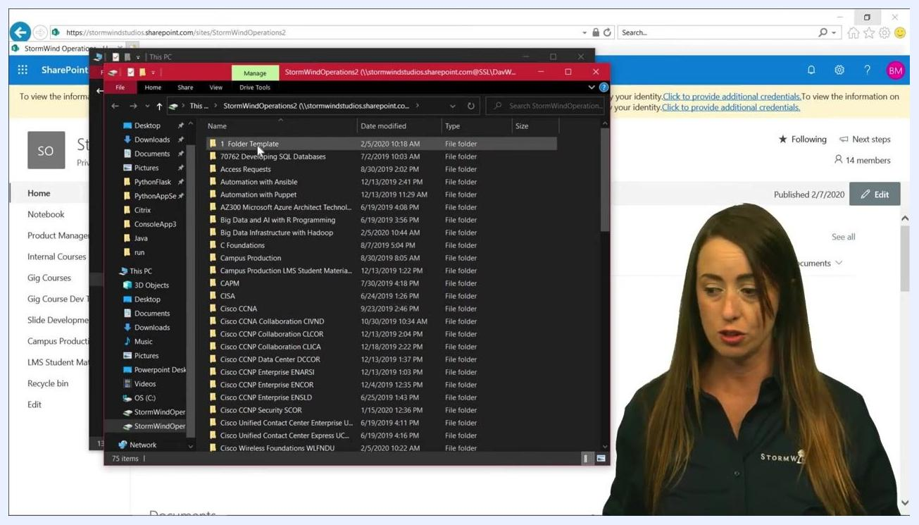
File Explorer open to a SharePoint folder, showing multiple folders and files available for access and management.

Syncing and collaborating on SharePoint files
Any changes you make within the mapped SharePoint folder — such as creating, renaming, moving, or deleting files and folders — automatically sync to your SharePoint Online site. All team members with access to the SharePoint site can see and collaborate on these files in real time.
For example, a folder named "1 - Admin" in the mapped drive might contain a file called "Document.docx," a Microsoft Word Document. The SharePoint site visible in the background confirms the connection between File Explorer and SharePoint Online.
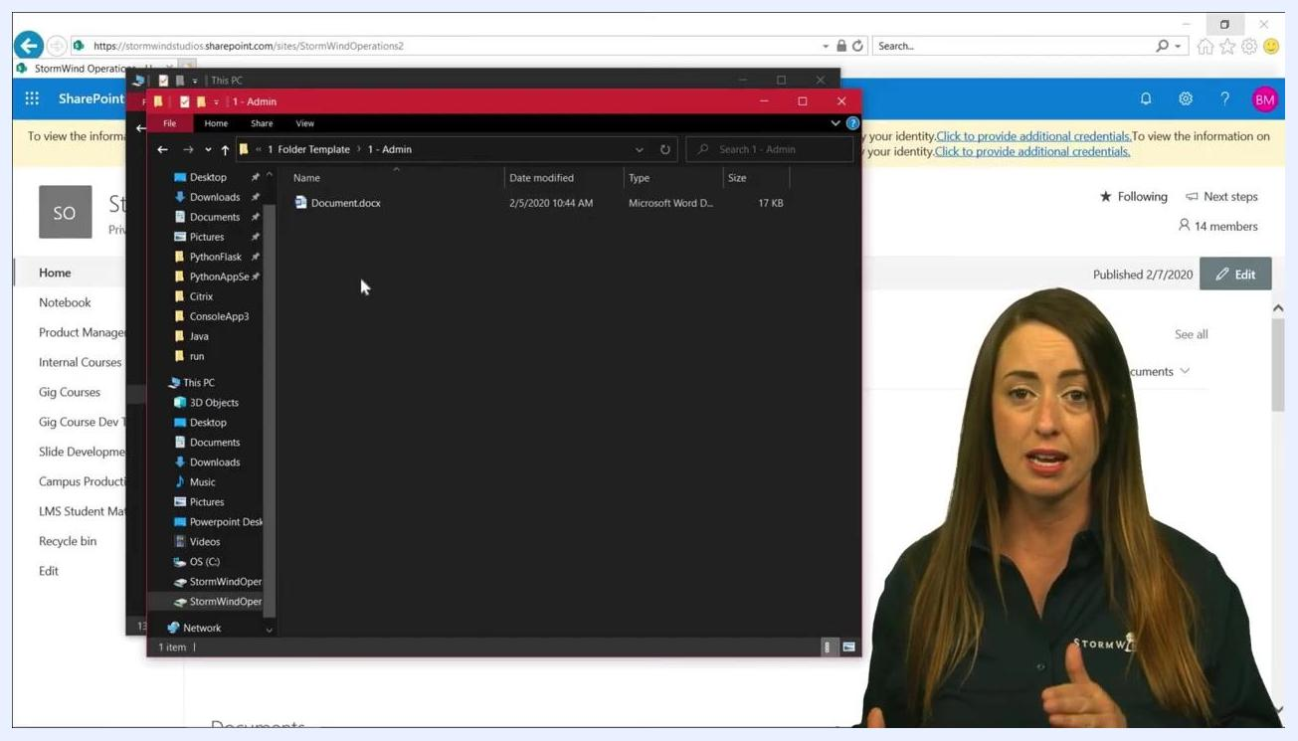
File Explorer window open to the mapped SharePoint folder "1 - Admin," showing a Word document, with the SharePoint site visible in the background.
Using File Explorer this way lets you quickly organize, move, or manage files without opening the browser, saving time and improving collaboration since all changes are reflected for your team.

Troubleshooting sync or visibility issues
If you encounter any issues with syncing or file visibility, check the following:
- The SharePoint site remains in your Trusted Sites list in Internet Options.
- The Require server verification (https:) box remains unchecked for the SharePoint URL.
- You are connected to the internet and logged into your SharePoint account.

Summary
By adding SharePoint to File Explorer, you can manage your SharePoint Online files directly from your desktop instead of repeatedly navigating the browser. Once mapped, any files you add, remove, or edit sync automatically and remain accessible to all authorized users on the SharePoint site, keeping your entire team up to date with the latest documents and changes.

