How to Export a ServiceNow Report to Excel
If you need to analyze or share ServiceNow data outside the platform, you can export any list—such as incidents, tasks, or other records—directly to an Excel file. This guide walks you through how to export a ServiceNow report to Excel, from locating the list to reviewing the downloaded spreadsheet.

Prerequisites
- Access to a ServiceNow instance with permission to view the list or report you want to export.
- A web browser with downloads enabled.

Step 1: Navigate to the desired list
Open your ServiceNow instance and use the search bar in the left navigation pane to find the list you want to export. For example, type Incident to locate incident records, then click the relevant list under its section (such as Incidents under Self-Service).
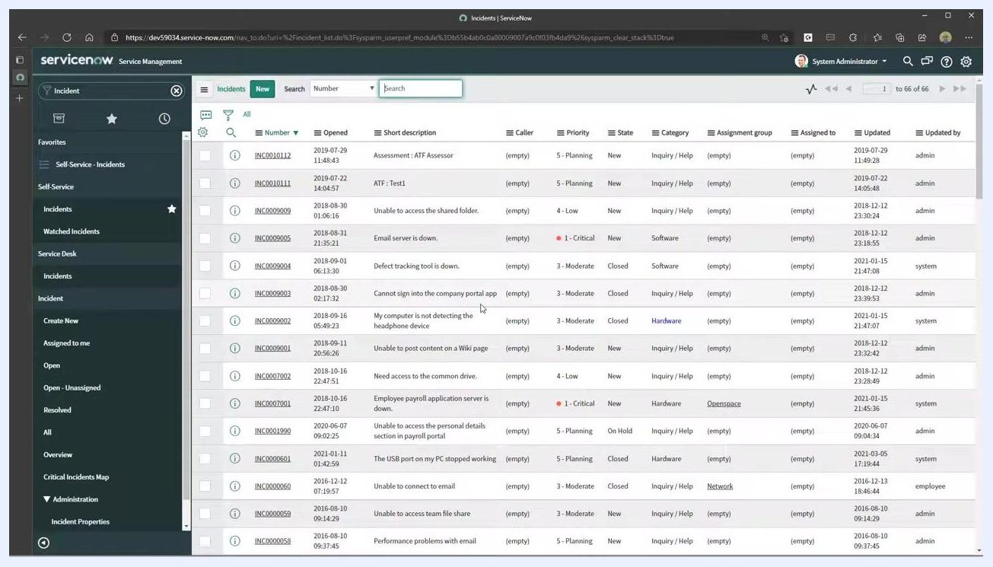
ServiceNow dashboard with the navigation pane, search bar showing "Incident" entered, and various quick links visible

Step 2: Open the list view
Confirm you are viewing the full list of records you intend to export, such as all incidents. The list view displays columns like Number, Opened, Short Description, Caller, Priority, State, Category, Assignment Group, Assigned To, Updated, and Updated By.
ServiceNow list view showing multiple incident records with columns including Number, Opened, and Short Description

Step 3: Access the export menu
Click on any column header in the list view, such as Number, to open its dropdown menu. Scroll down to find the Export option, then hover over it to reveal the available export formats. Select Excel (.xlsx) to export the report to Excel.
Dropdown menu from a column header showing export options including Excel (.xlsx), CSV, XML, JSON, PDF, and Export Set

Step 4: Download the exported file
Once you select Excel (.xlsx), ServiceNow begins the export process, and a download notification appears in your browser. Click the downloaded file (for example, incident.xlsx) to open it.
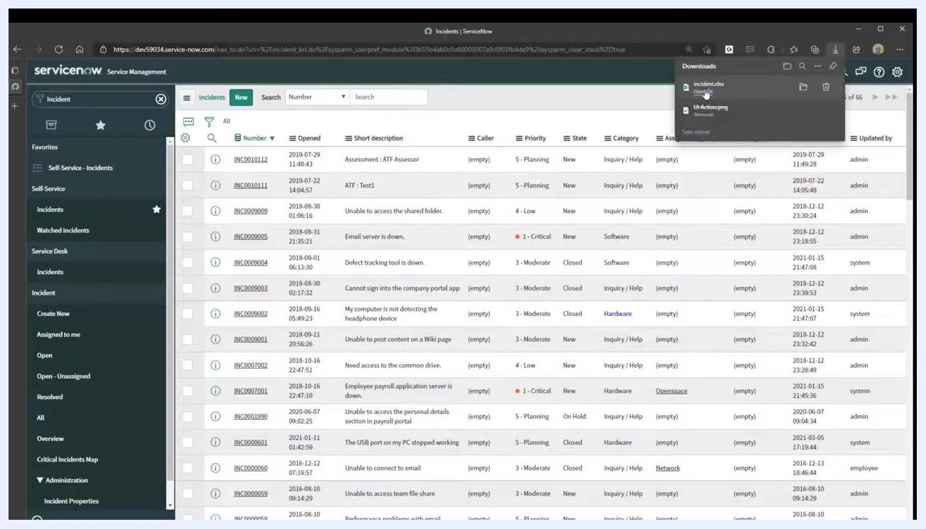
Browser download notification showing the "incident.xlsx" file ready to open

Step 5: Review the exported data
Open the Excel file to check that all column headers and data from your ServiceNow list appear correctly. The exported file includes every column that was visible in the ServiceNow list view at the time of export.
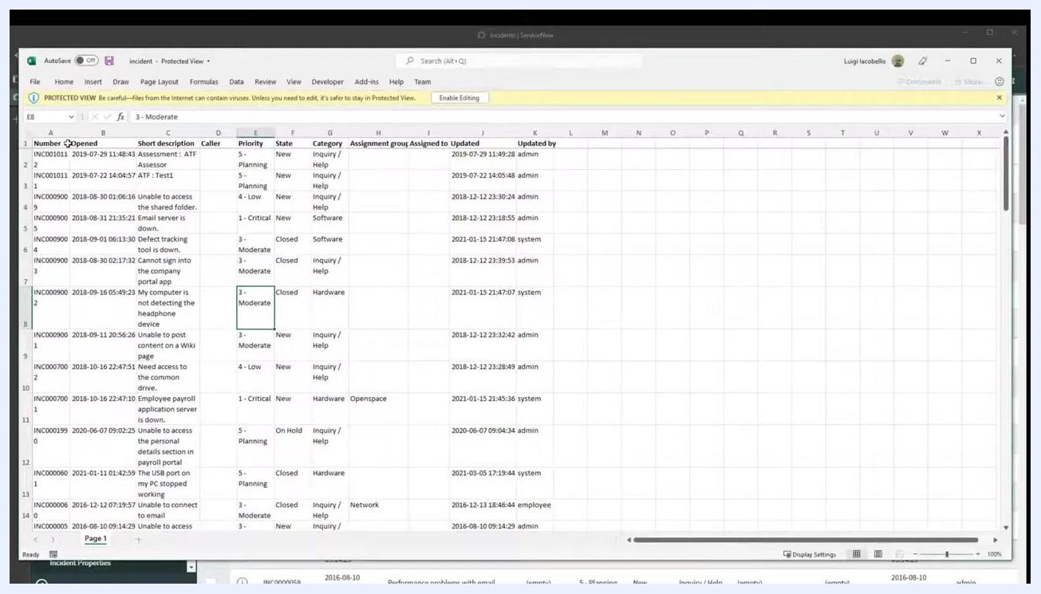
Excel spreadsheet open with incident data, showing columns such as Number, Opened, Short Description, Caller, Priority, State, Category, Assignment Group, Assigned To, Updated, and Updated By

Best practices for exporting from ServiceNow
Make sure all needed columns are visible before exporting. Only the columns currently shown in your list view are included in the export. If you need additional fields, customize your list layout to add or remove columns before you export.
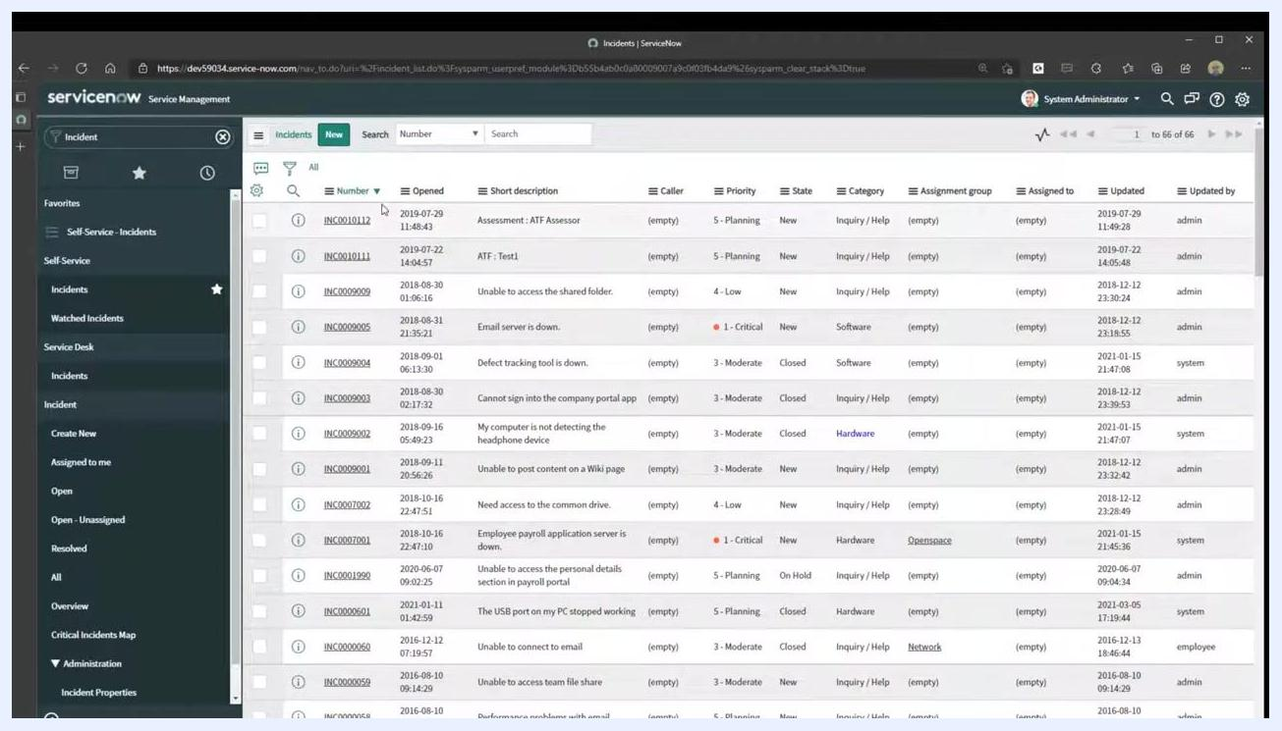
ServiceNow list view with multiple columns visible and the cursor positioned over the "Caller" column, showing column options
Start the export from any column header. You can click the dropdown arrow on any column—such as Caller or Number—to open the column options menu. The export option is available from any column, not only the first one.
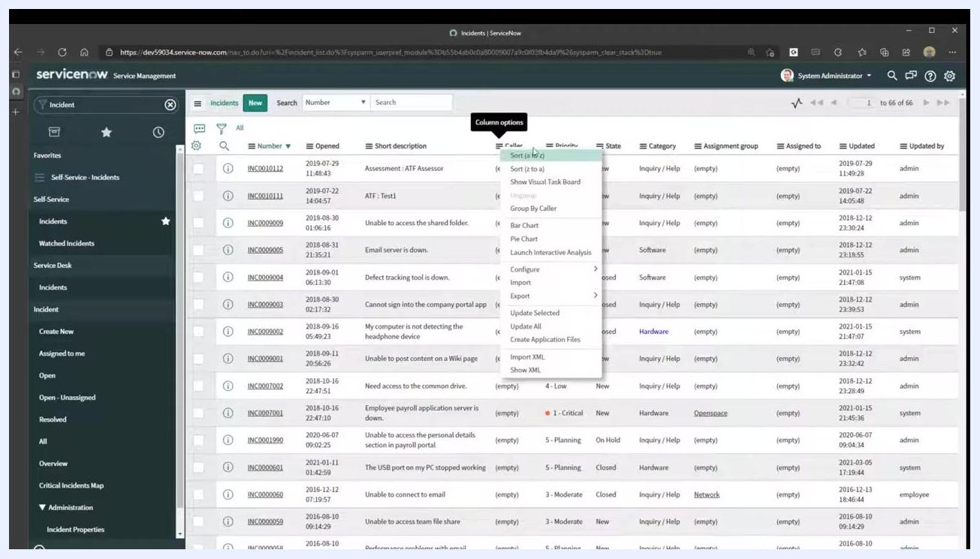
ServiceNow list view with the column options menu open for the "Caller" column, showing options such as Sort, Show Visual Task Board, Group By, Bar Chart, Pie Chart, Configure, Import, and Export
Choose the format that fits your needs. In the column options menu, hover over Export to see the available formats, including Excel (.xlsx), CSV, XML, JSON, and PDF. For most spreadsheet needs, select Excel (.xlsx).
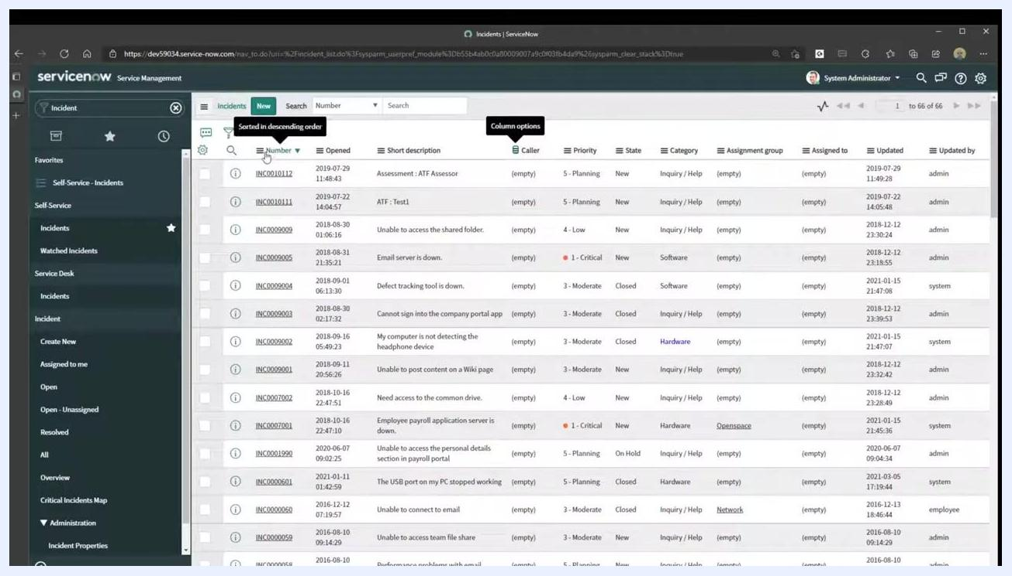
ServiceNow list view with the column options menu open for the "Number" column, highlighting the Export submenu with Excel (.xlsx) selected

Summary
- Confirm your list view includes every column you need before exporting.
- The export function is accessible from any column header in the list.
- ServiceNow supports multiple export formats, including Excel, CSV, XML, JSON, and PDF, so you can choose the one that fits your reporting needs.
- Always open and review the downloaded file to verify the data matches what was displayed in ServiceNow.
By following these steps, you can reliably export any ServiceNow report to Excel for further analysis or reporting.
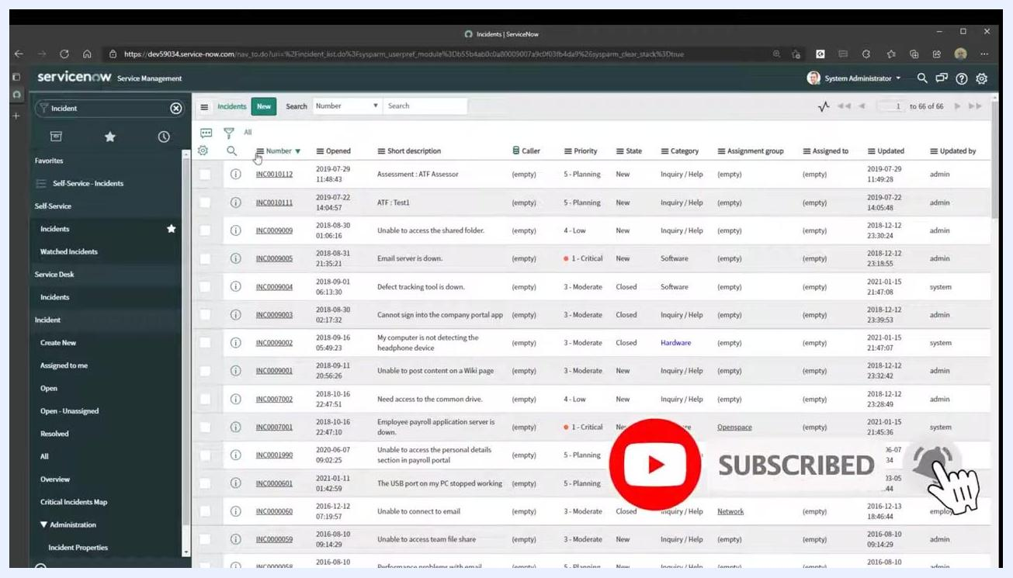
ServiceNow list view with a YouTube subscribe overlay, indicating a prompt to subscribe for more tutorials.

