How to Create a Report in ServiceNow
This guide walks you through how to create a report in ServiceNow, from opening the Reports module to configuring, visualizing, and exporting your finished report. You'll learn how to build a report on Change Request data, apply grouping and filters, switch between visualization types, and export the results in formats like Excel, CSV, or PDF.
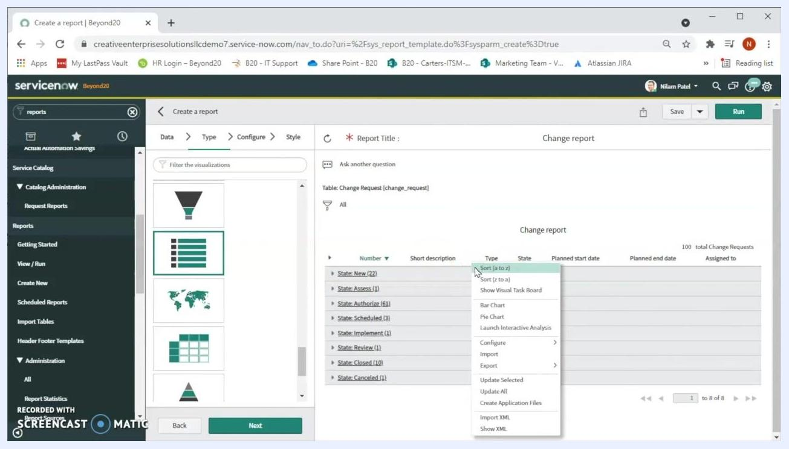
Report configuration screen with grouping by State, aggregation by Count, and a bar chart of change requests by state

Prerequisites
- Access to a ServiceNow instance with an active login session.
- Visibility into the homepage dashboard before you begin.
- If the Reports module does not appear in your navigation menu, contact your ServiceNow administrator and request ITIL access to enable reporting features.
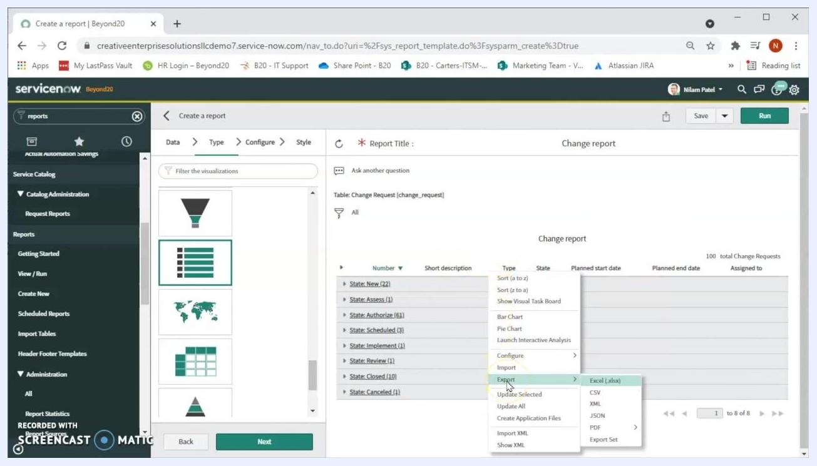
Beyond20 logo on a white background, marking the end of the tutorial

Step 1: Open your ServiceNow homepage
Open your web browser and navigate to your ServiceNow instance. Confirm you are logged in and can see the homepage dashboard, which typically displays widgets such as "Cases by SLA stage" and "Open Cases By Priority."
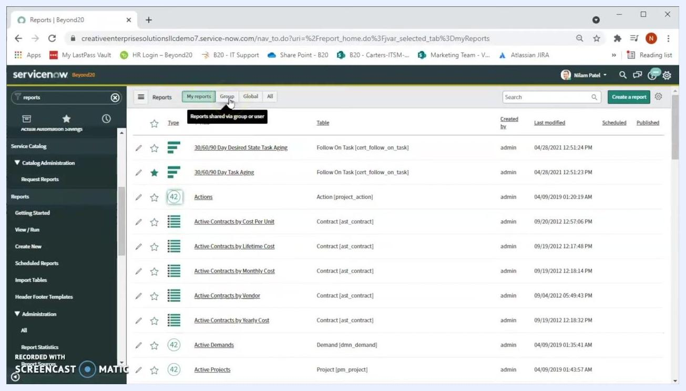
List of reports with tabs for My reports, Group, Global, All, and columns for report details

Step 2: Find the Reports module
In the left navigation pane, locate the filter navigator at the top and type reports into the search box. This surfaces the Reports module in the menu. If the module doesn't appear, contact your ServiceNow administrator to request ITIL access.
Reports section expanded in the navigation menu, showing a list of reports with filter tabs and detail columns

Step 3: Open the Reports section and view existing reports
Expand the Reports section in the left navigation to see options such as Getting Started, View / Run, Create New, and Scheduled Reports. Click View / Run to display the main panel listing all available reports.
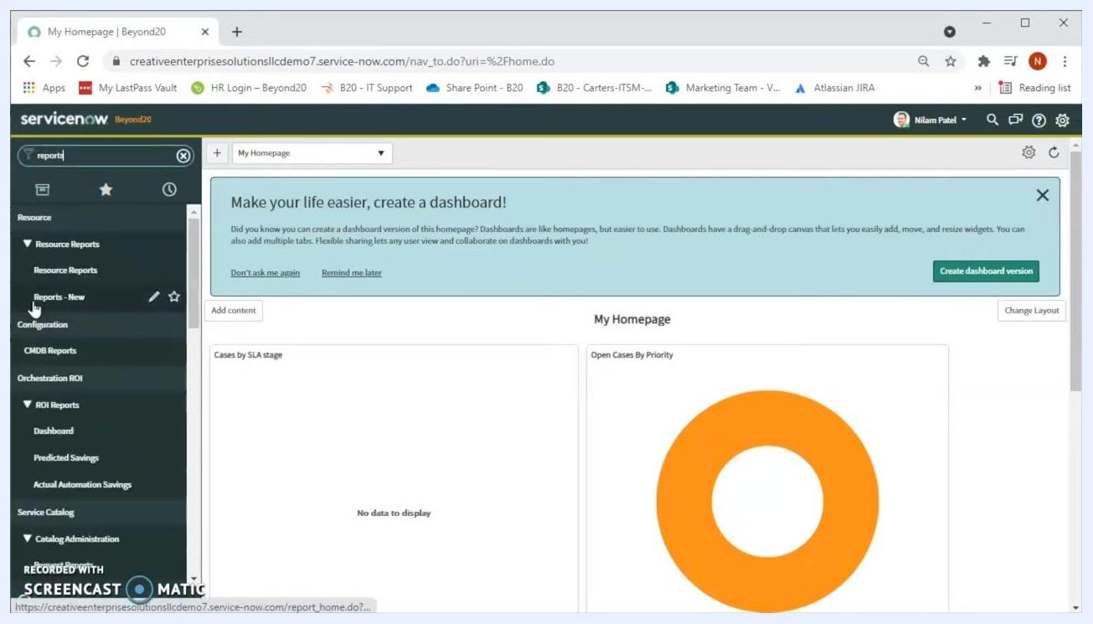
Filter navigator with "reports" entered, displaying the Reports module in the results
The report list includes tabs for My reports, Group, Global, and All, along with columns for Type, Title, Table, Created by, Last modified, Scheduled, and Published.

Step 4: Switch between report views
Click the Group tab to see reports shared with your group or user, or click the All tab to view every report you can access, including your own, group, and global reports.
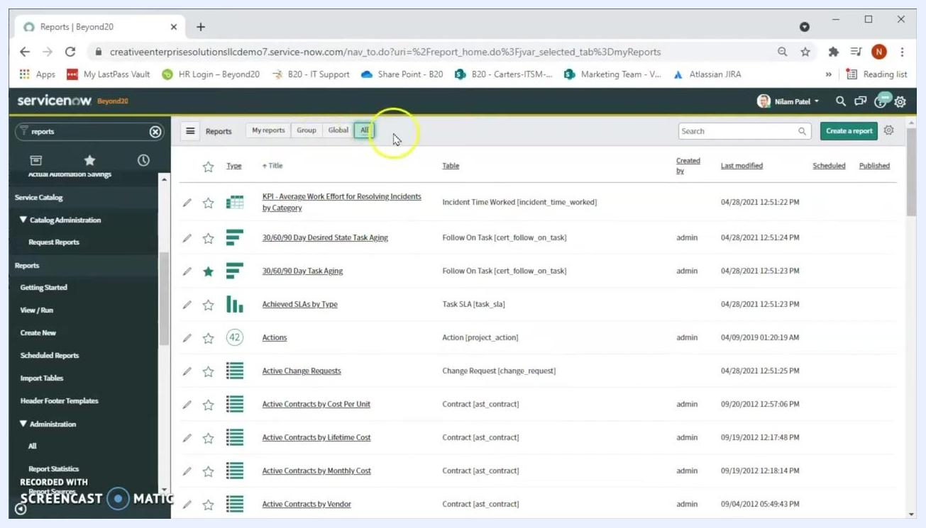
Tabs for switching between My reports, Group, Global, and All report views

Step 5: Start creating a new report
Click the green Create a report button in the upper right corner of the report list panel to begin building a new report. The following steps demonstrate creating a report for Change records based on different criteria.
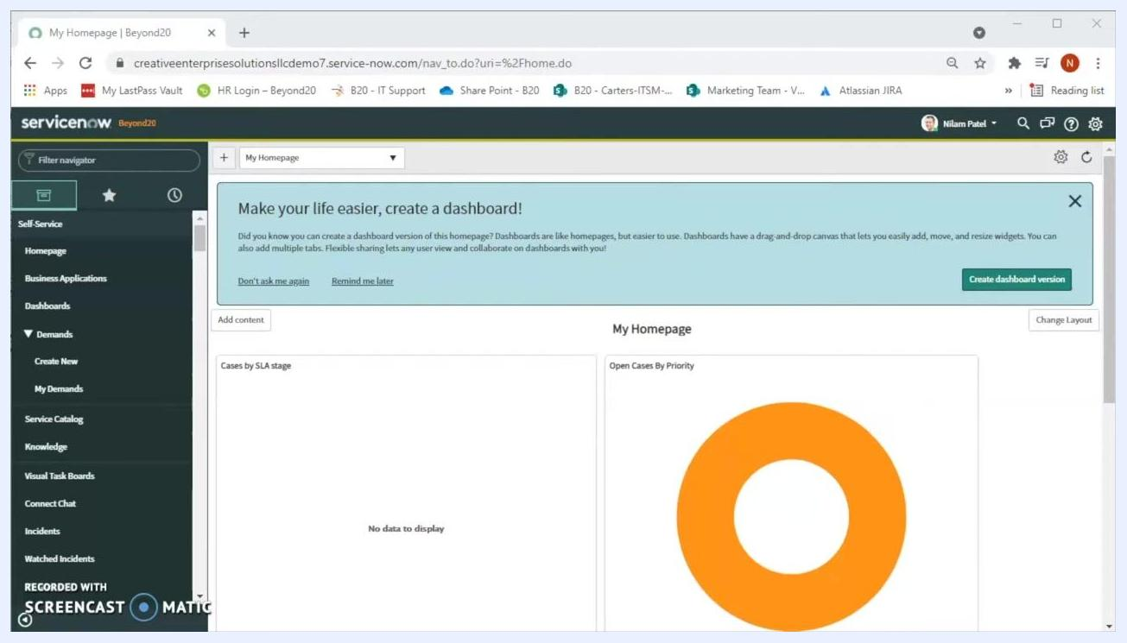
ServiceNow homepage showing dashboard widgets and the navigation menu

Step 6: Name your report
In the Create a report window, locate the Report name field and type Change report. You may see suggestions for existing report names, such as "30/60/90 Day Task Aging" or "Quarterly change report" — ignore these and continue with your chosen name.
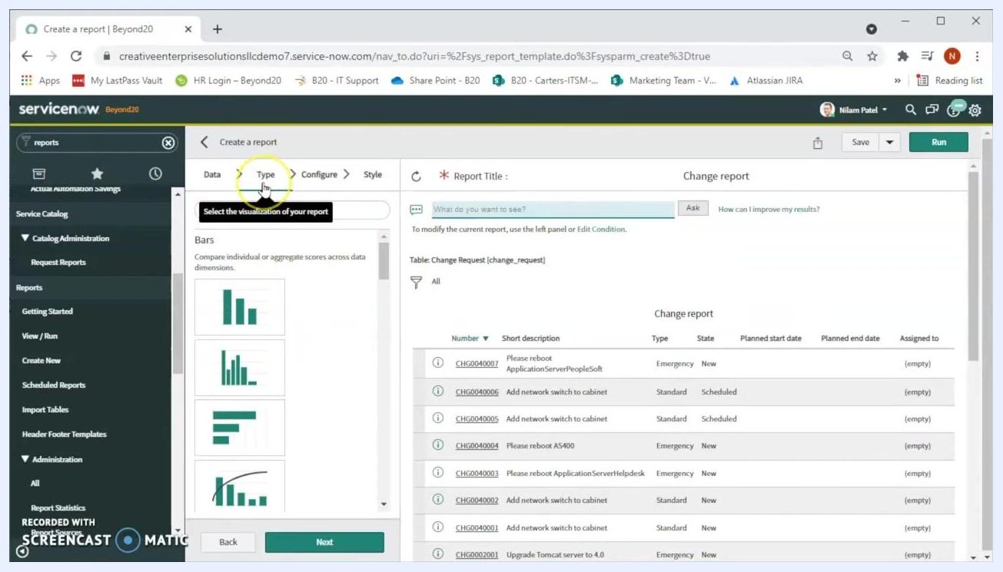
Report type selection screen showing various visualization options, with List selected by default

Step 7: Set the source type and select the table
In the Source type dropdown, ensure Table is selected. Click the Table dropdown, type change re to filter the list, and select Change Request [change_request]. If you're unsure which table to use, contact your ServiceNow administrator for guidance.
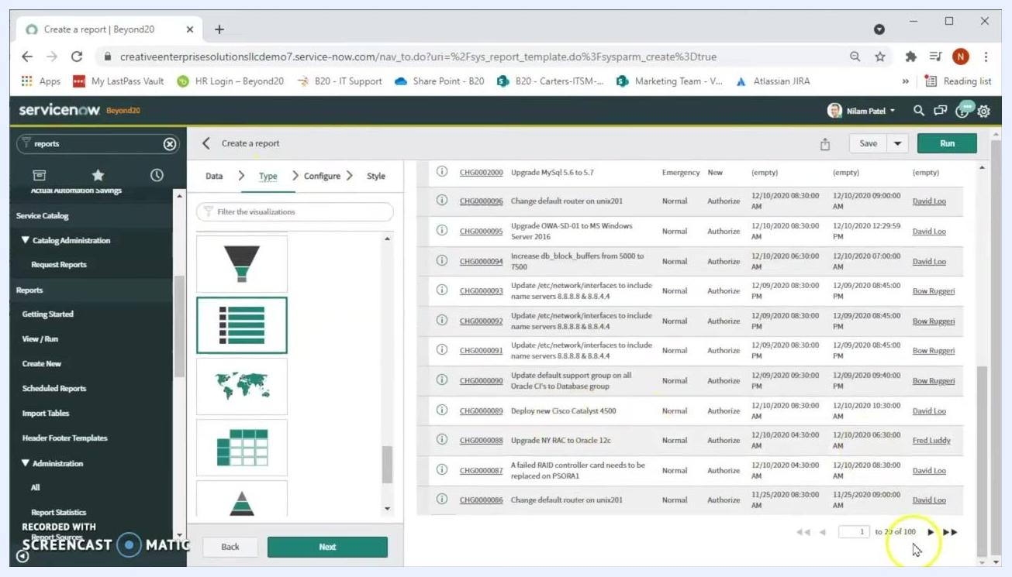
List visualization with a preview of 100 change requests displayed

Step 8: Choose the report type
Click Next to reach the Type step, where you select the visualization for your report. Available options include Bars, Time Series, Pies, Donuts, and Multidimensional reports. ServiceNow defaults to the List type, which is suitable for a tabular report.

Step 9: Review the initial data preview
After selecting the table and type, a preview of the report data appears, showing columns such as Number, Short description, Type, State, Planned start date, Planned end date, and Assigned to. This preview confirms that 100 change records are included.
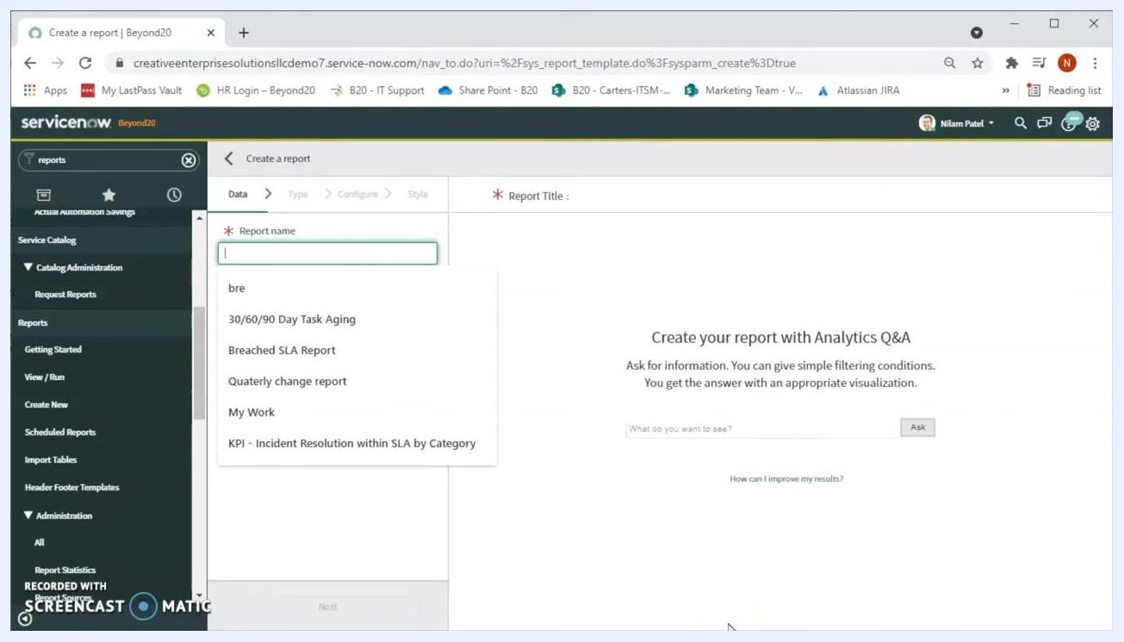
Report creation screen with the Report name field being filled in as "Change report"

Step 10: Configure the report columns
Click Next to open the Configure step. In the Choose columns section, click the column selector icon to add or remove fields as needed. You can also group data by specific fields or configure function fields for advanced calculations.
Configure step with 'Choose columns' option highlighted, ready to customize report fields

Step 11: Group the report data
In the Configure step, locate the Group by dropdown and select a field, such as Active, to group change requests by their active status. This lets you see how many requests are currently active versus inactive.

Step 12: Run the grouped report
Click Run in the upper right corner to execute the report with the selected grouping and review the resulting counts, such as 89 active and 11 inactive change requests.

Step 13: Group by assignment group
In the Group by dropdown, select Assignment group to organize change requests by team, then click Run. The report will display groups such as "CAB Approval," "Database," "Hardware," "ITSM Engineering," "Network," and "Service Desk."
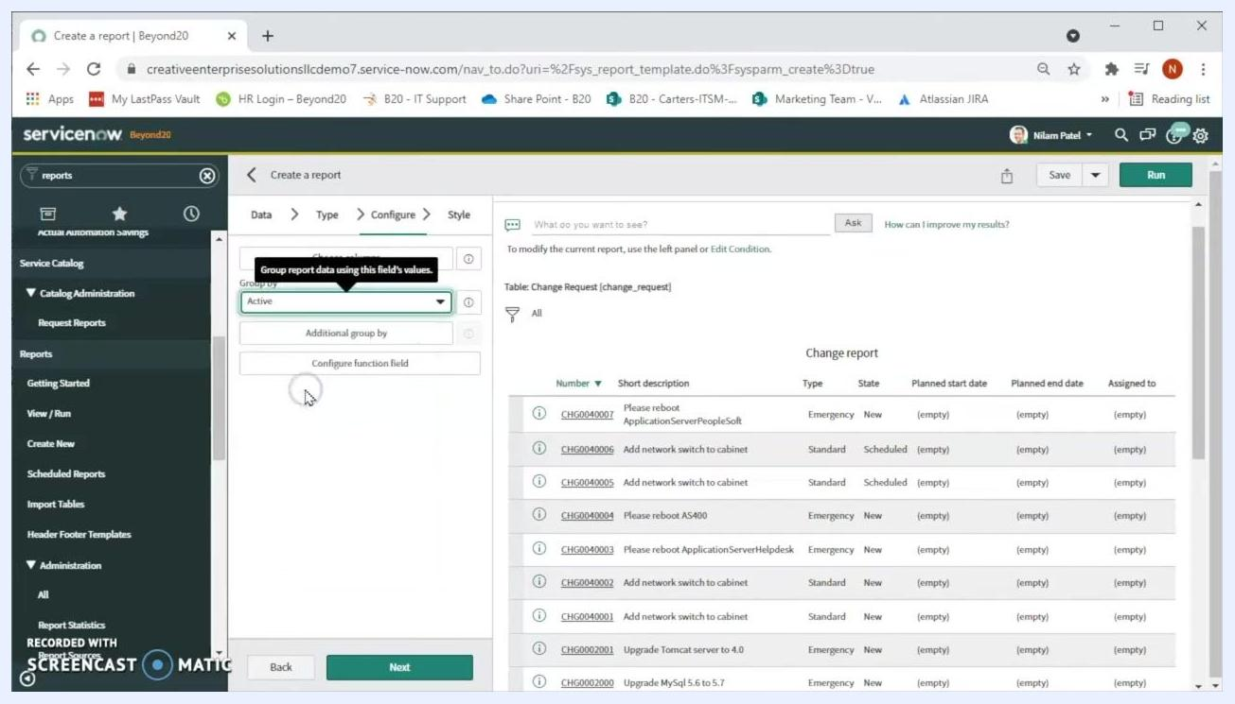
Report grouped by Assignment group, showing counts for each group such as Hardware (36) and Network (19)

Step 14: Group by state
In the Group by dropdown, select State and click Run to view change requests grouped by status, such as "New," "Assess," "Authorize," "Scheduled," "Implement," "Review," "Closed," and "Canceled."

Step 15: Change the report visualization
Navigate to the Type tab to change how your report is displayed. Select Pyramid to view the distribution of change requests as a pyramid chart, then click Run to update the report.
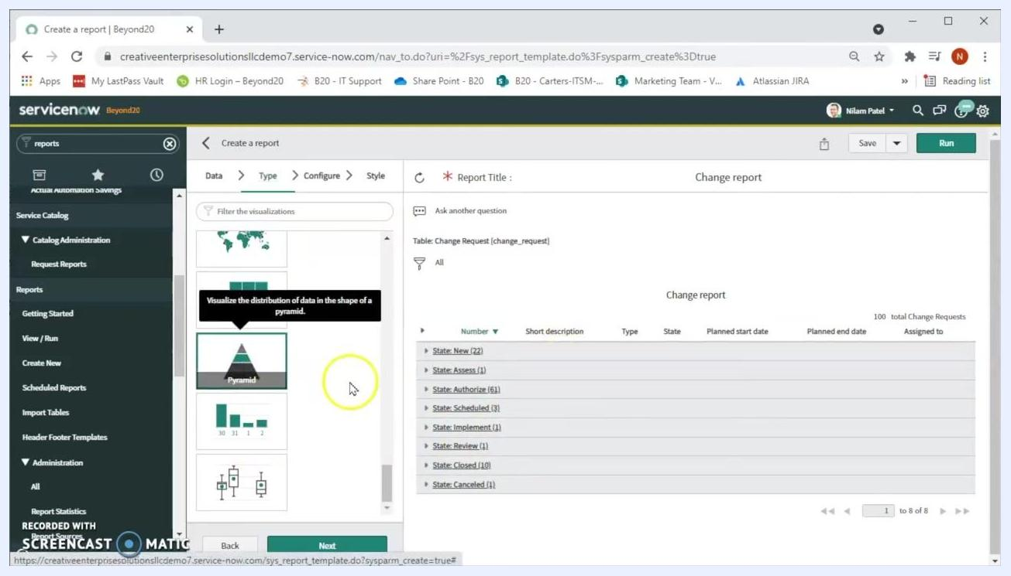
Visualization type selection screen with Pyramid selected

Step 16: Switch to the Pie visualization
In the Type tab, scroll through the available visualization options and select Pie. Click Run to regenerate the report using the pie chart format. Use the color legend below the chart to interpret the distribution of change requests by state.
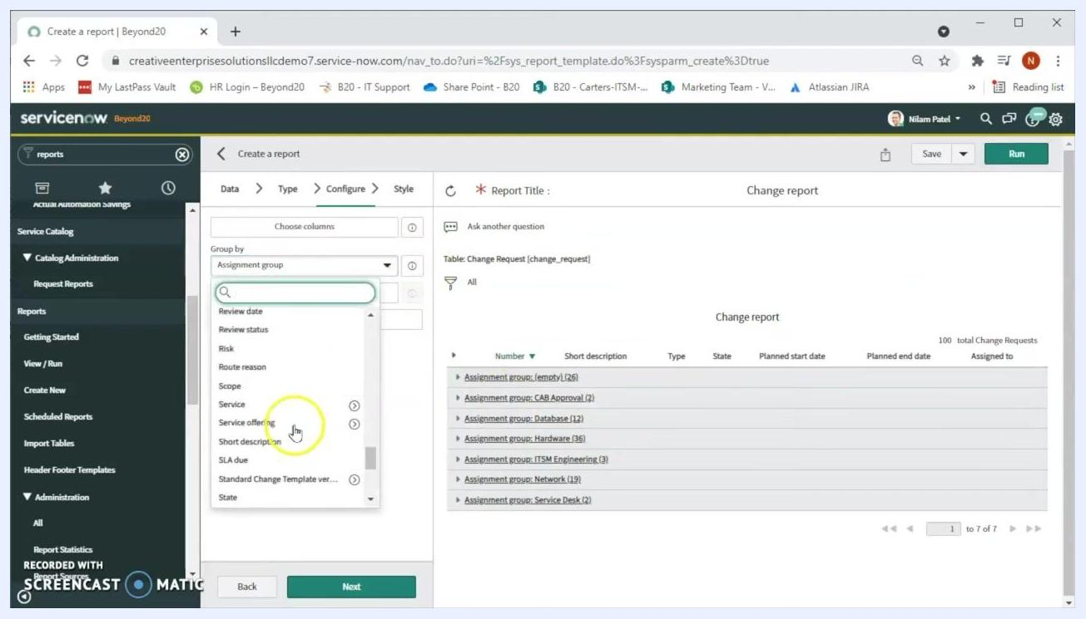
Report grouped by State, showing counts such as New (22) and Authorize (61)
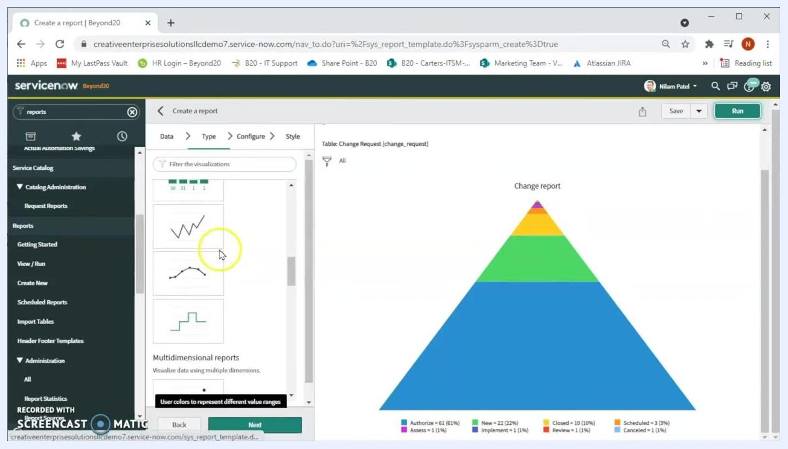
Visualization type selection panel with pie chart options, alongside a pyramid chart of change requests by state

Step 17: Select a bar chart visualization
In the Type tab, choose a bar chart option under Bars, such as Histogram. Hovering over each option shows a tooltip describing its purpose — for example, a histogram "shows the distribution of data by dividing it into a series of consecutive, equal-sized intervals."
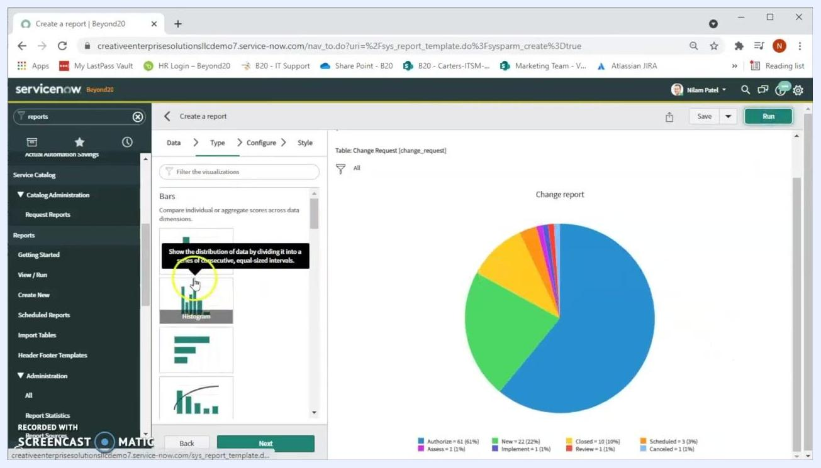
Bar chart visualization selection with a tooltip describing the Histogram option

Step 18: Configure the bar chart report
Switch to the Configure tab and set Group by to State to categorize data by change request status. Set Stack by to None unless you need additional segmentation, and set Aggregation to Count to display the number of records per state.
You can also adjust optional settings:
- Additional group by for further segmentation
- Display data table to show the underlying data
- Set Value Formatting to adjust how values appear
- Max number of groups (default: System Default)
- Show Other, which groups less common states together

Step 19: Export the report data
Switch to a list view of the report, then right-click a column header to open the context menu. Hover over Export to see the available formats — Excel (.xlsx), CSV, XML, JSON, or PDF — and select the one you need.
Report list view with the export context menu open, showing Excel, CSV, XML, JSON, and PDF options

Step 20: Access reports anytime from the navigation menu
To return to reports later, type reports in the navigation search bar. Click Create New to start another report, or View / Run to access existing ones.
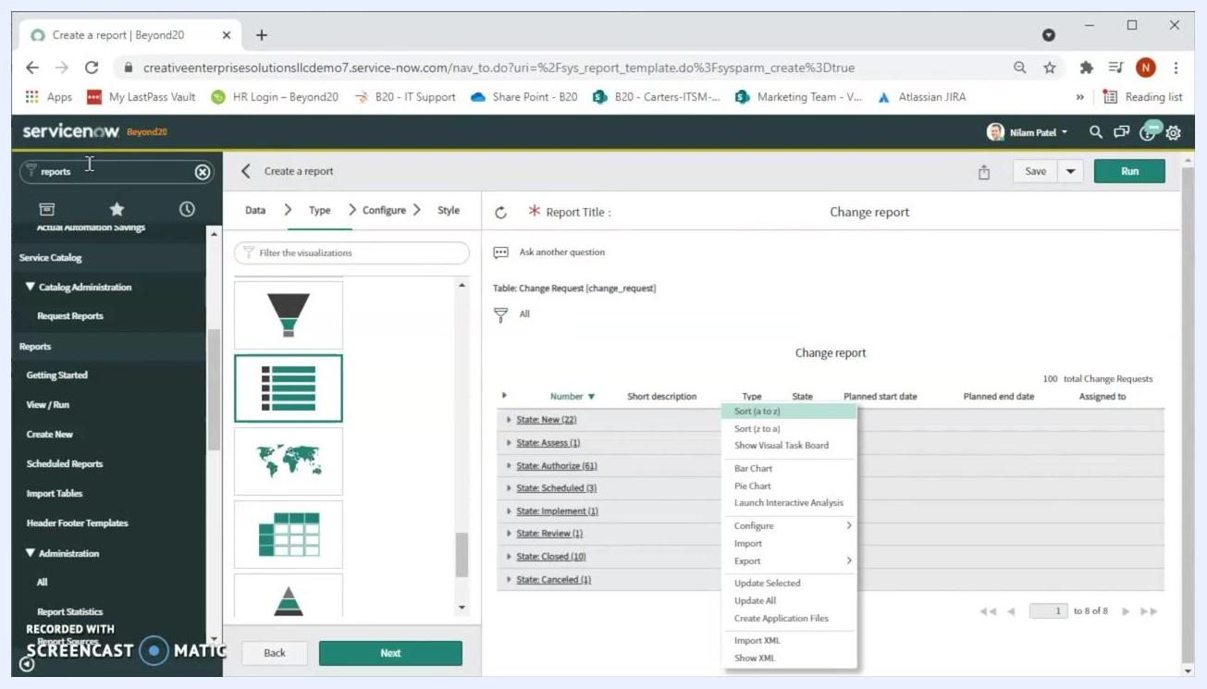
Navigation menu with "reports" entered in the search bar, showing options to create or view reports

What's next
You now know how to create a report in ServiceNow, from selecting a table and visualization type to grouping data, switching chart formats, and exporting results. Continue exploring by applying additional filters — such as filtering by Assigned to — or experimenting with other visualization types to find the format that best represents your data. Always click Run after making changes to see the updated report.
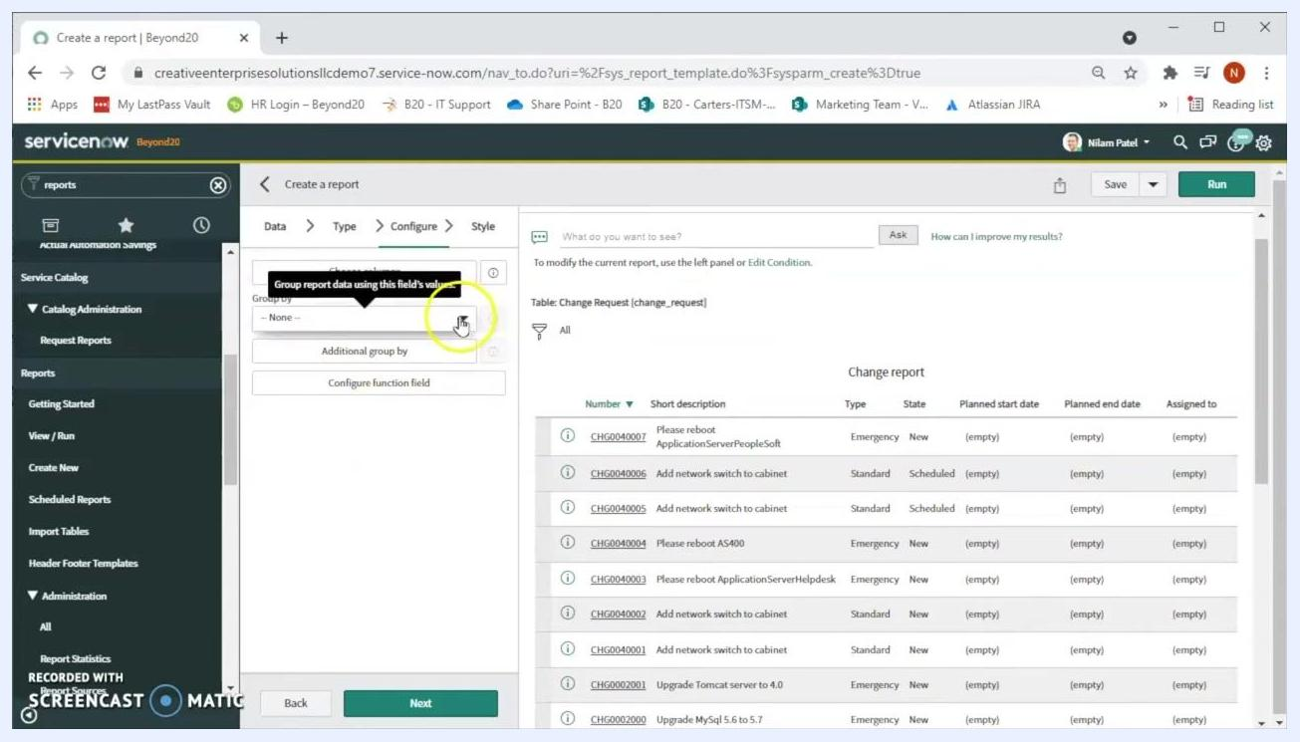
Configure step with Group by set to Active, showing 89 active and 11 inactive change requests out of 100 total

