Creating a Change Request from a Configuration Item (CI) in ServiceNow
This guide walks you through the process of creating a change request from a Configuration Item (CI) in ServiceNow. You will learn how to navigate the ServiceNow interface, search for the appropriate CI, customize your list view, and either associate CIs with an existing change request or create a new one.

Prerequisites
- Access to ServiceNow with permissions to view and manage Configuration Items and Change Requests.
- Familiarity with the UNIX Servers list and Change Request forms in your organization's ServiceNow instance.

Step 1: Access the change requests list
Open ServiceNow and navigate to the Change Requests page. This page displays a list of existing change requests with columns such as Number, Short Description, Type, State, Planned Start Date, Planned End Date, Requested By, and Assigned To.
Example entries include:
- CHG0040007: Please reboot ApplicationServerPeopleSoft (Emergency, New)
- CHG0040006: Add network switch to cabinet (Standard, Scheduled)
The left sidebar contains navigation options such as Create New, Open, Closed, Standard Change, and Change Advisory Board.
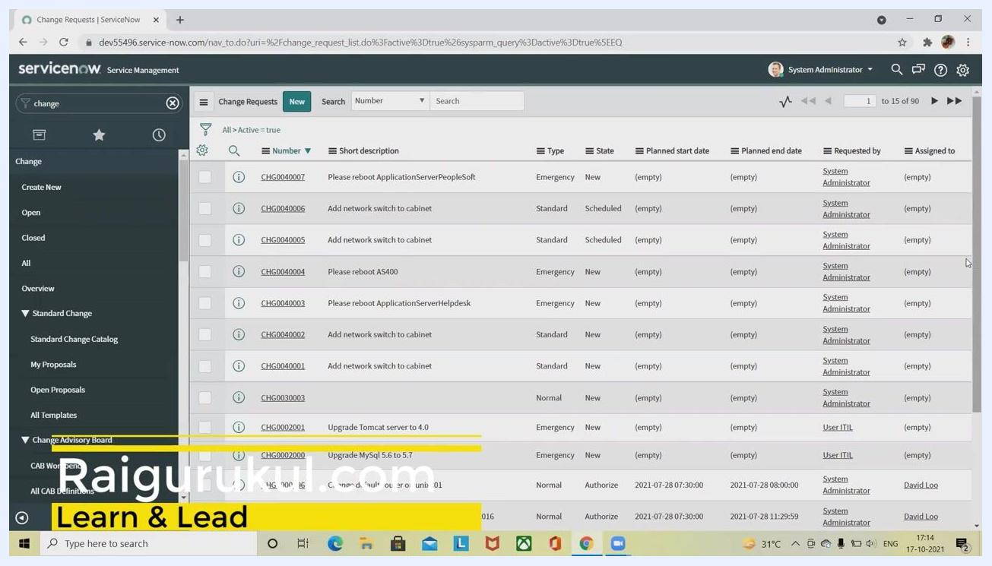
ServiceNow Change Requests list with navigation sidebar and multiple change requests displayed

Step 2: Navigate to configuration items
In the left sidebar, use the search bar and type "conf" or "configuration" to filter the menu. Locate and expand the Servers section under the filtered results.
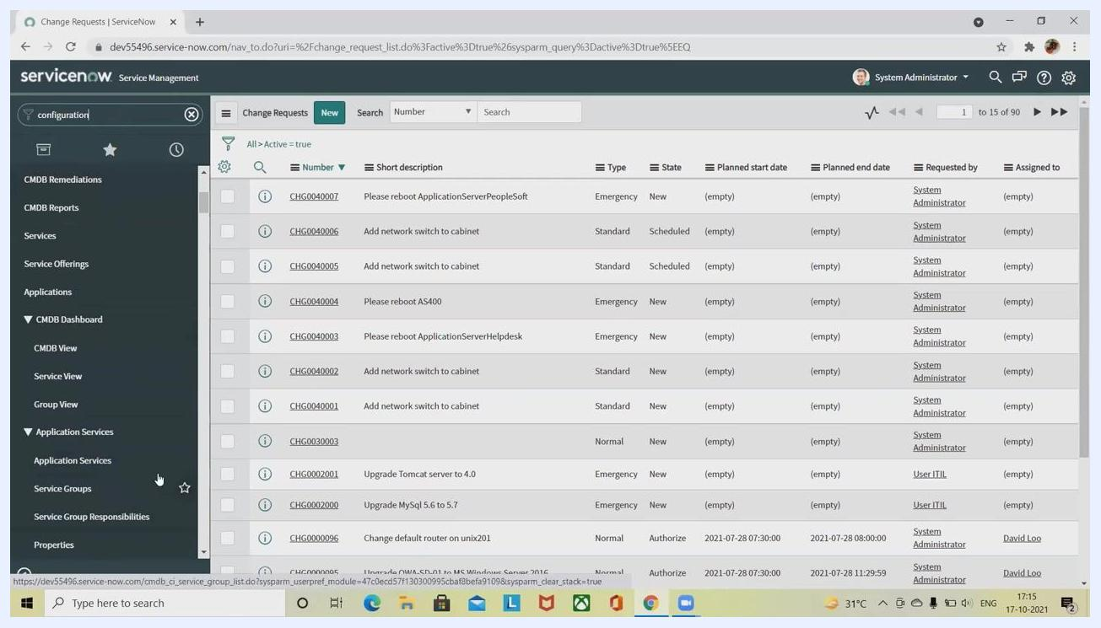
Sidebar search for 'configuration' with expanded menu showing Servers, Application Servers, and related options

Step 3: Select UNIX servers
Under the Servers section, click Unix to view the list of UNIX servers. The main panel updates to display a list of UNIX servers with columns for Name, Operating System, Description, OS Version, and Class.
Example server entries:
- dbaix900nyc (AIX, 5L, UNIX Server)
- lawson_app_100 (Solaris, 10, UNIX Server)
UNIX Servers list with columns for Name, Operating System, Description, OS Version, and Class

Step 4: Select one or more CIs
In the UNIX Servers list, select one or more CIs by checking the boxes next to their names. For example, select "dbaix900nyc" and "dbaix901nyc."
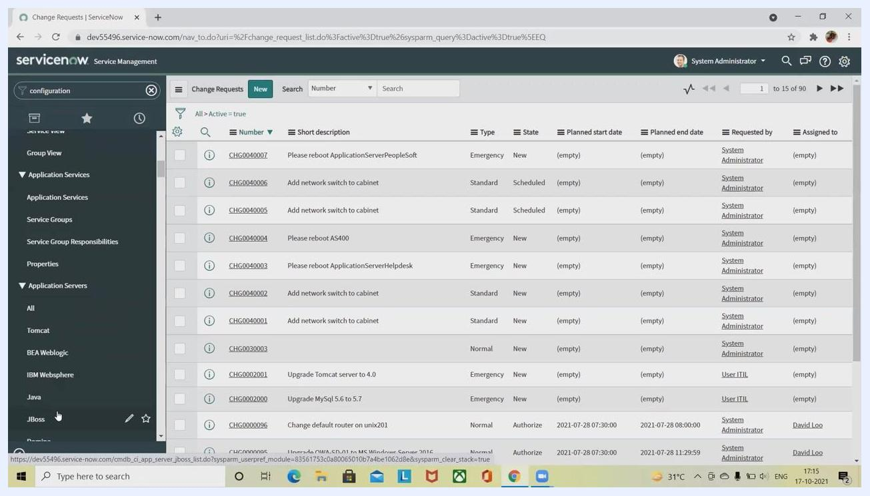
Two UNIX servers selected in the list, with checkboxes marked

Step 5: Customize list columns (optional)
To personalize the columns displayed in the UNIX Servers list, click the gear icon (Personalize List). In the Personalize List Columns dialog, move fields between Available and Selected as needed.
Default selected columns are Name, Operating System, Description, OS Version, and Class. Additional options include Approval group, Asset, Assigned to, CPU details, and more.
You can also enable options such as:
- Wrap column text
- Compact rows
- Active row highlighting
- Modern cell coloring
- Enable list edit
- Double click to edit
Click OK to apply your changes.
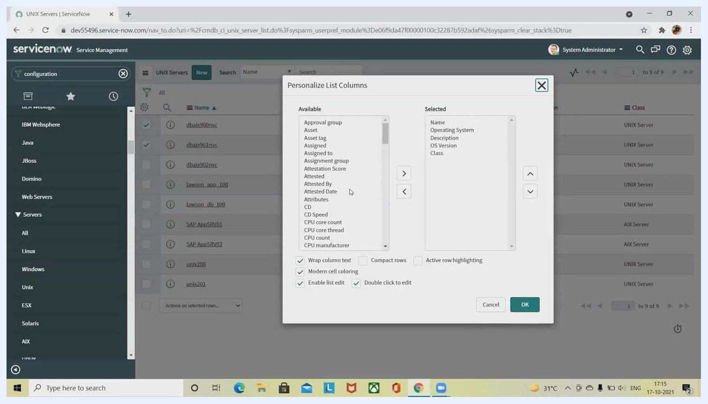
Personalize List Columns dialog with available and selected fields, and customization options

Step 6: Search and filter CIs
Use the search bar above the UNIX Servers list to filter by Name, Operating System, Description, OS Version, or Class. Select the desired filter from the dropdown and enter your search term.
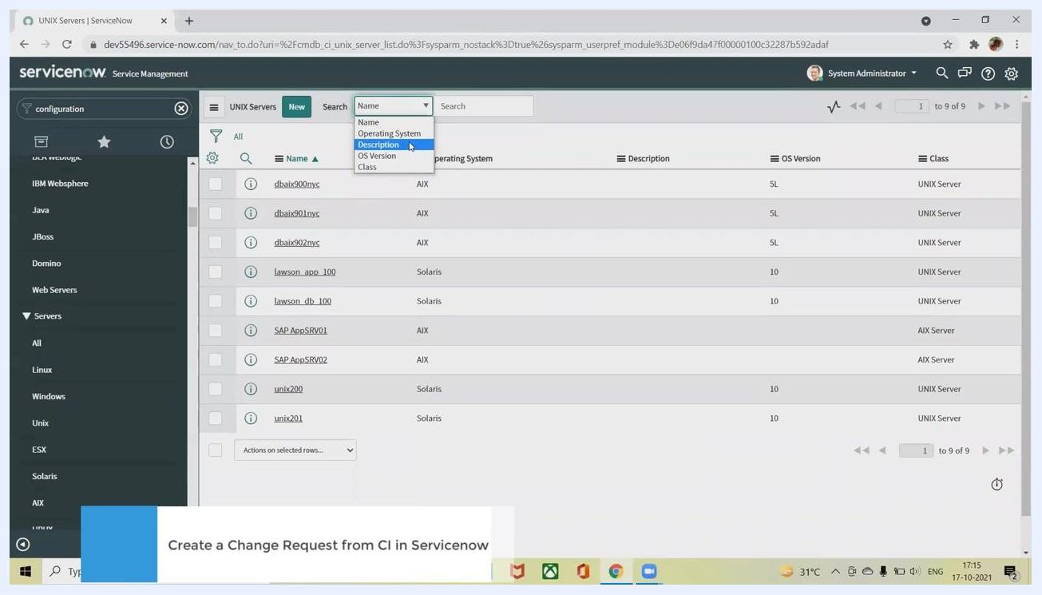
Search bar with dropdown filter options for Name, Operating System, Description, OS Version, and Class

Step 7: Create a new UNIX server CI (if needed)
If the CI you need does not exist, click the New button at the top of the UNIX Servers list.
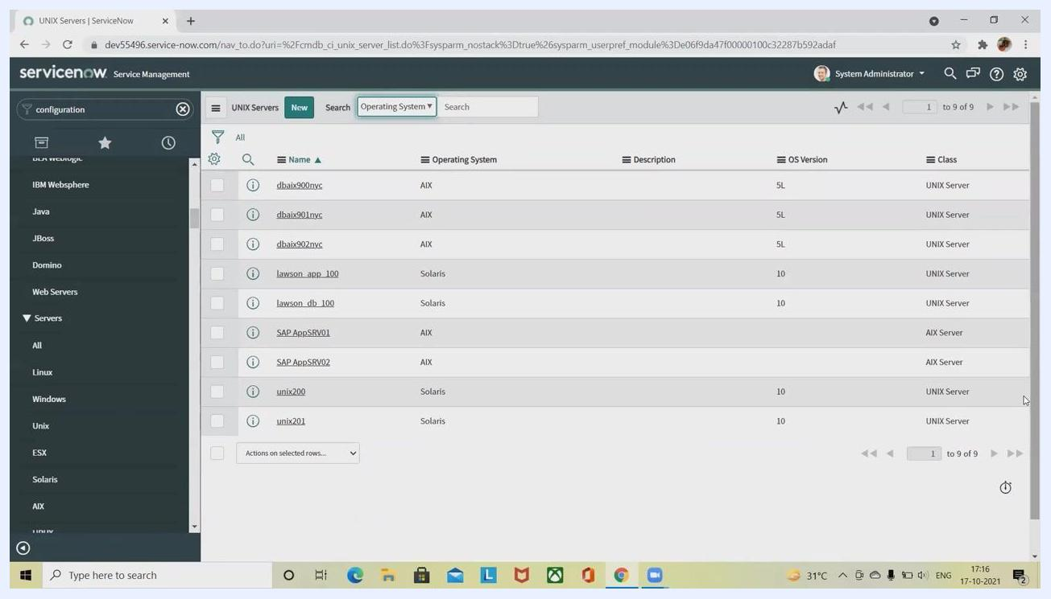
UNIX Servers list with 'New' button highlighted, showing server entries and search/filter options
A new record form appears. In the Name field, enter the name of your new UNIX server or the name associated with your team's request. Fill in additional details as required:
- Asset tag
- Manufacturer
- Asset
- Company
- Serial number
- Model ID
- Assigned to
- Configuration section: Model number, Operating System, OS Version, OS Service Pack, Disk space (GB), Description, RAM (MB), CPU speed (MHz), CPU count, CPU manufacturer, CPU type
Click Submit to save the new UNIX server CI.
New UNIX Server record form with fields for Name, Asset tag, Manufacturer, Company, Serial number, Model ID, Assigned to, and configuration details

Step 8: Choose an action for selected CIs
In the UNIX Servers list, select one or more CIs by checking the boxes next to their names. At the bottom of the list, open the Actions on selected rows... dropdown menu.
Available actions include:
- Add to existing Change Request
- Add to new Change Request
- Create Asset
- Delete
- Create Application File
- Assign Tag (New tag, Android, Java, JavaScript, Development, Temporary Attachments)
- Remove Tag (Android, Java, JavaScript, Development, Temporary Attachments)
Select the action you require. To associate the CIs with an existing change request, choose Add to existing Change Request.
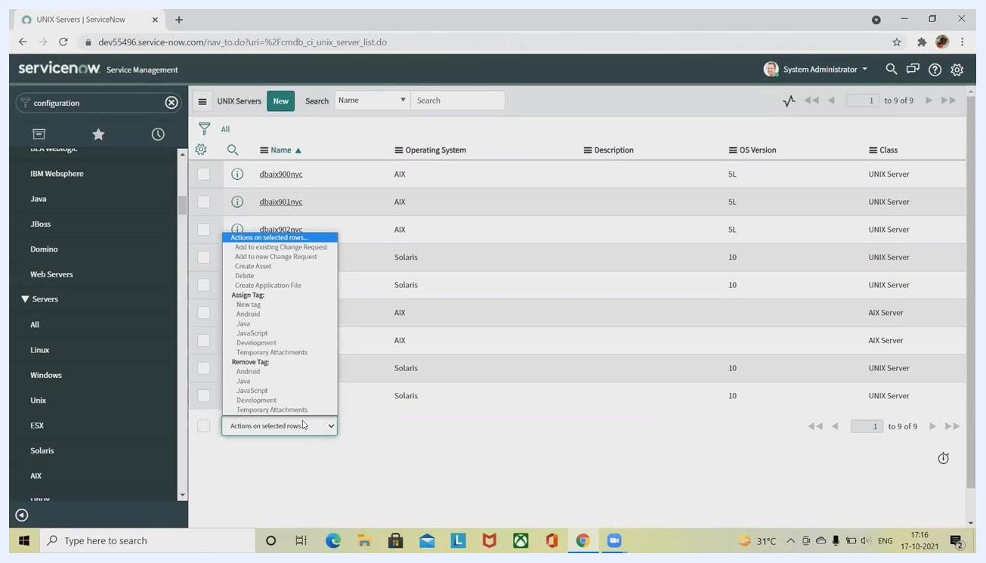
Actions on selected rows dropdown menu with options for adding to change requests, creating assets, assigning/removing tags, and more

Step 9: Add selected CIs to an existing change request
If you are unable to select the option, ensure you have selected multiple items in the list. After selecting the desired CIs, choose Add to existing Change Request from the dropdown.
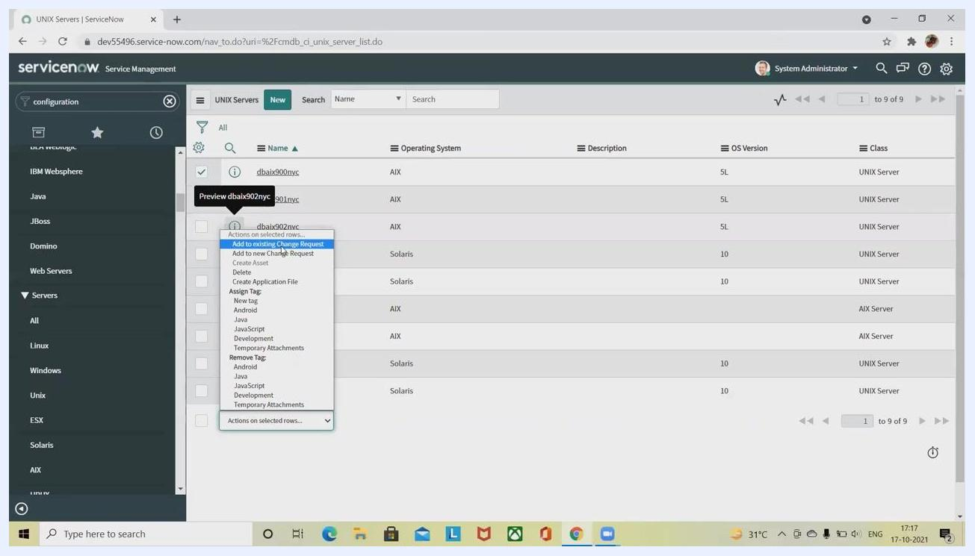
Multiple UNIX servers selected and 'Add to existing Change Request' highlighted in the actions dropdown
A dialog box titled Choose a Change Request appears. In the Change Request field, enter the number or search for the change request you want to associate with the selected CIs. Click the search icon to look up available change requests.
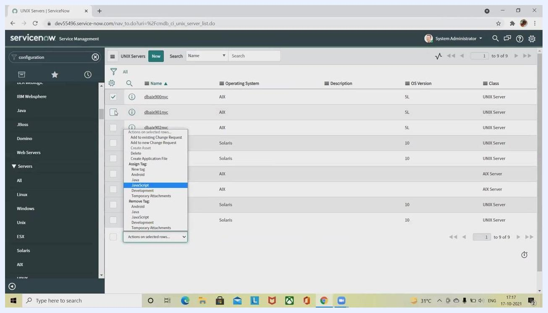
Choose a Change Request dialog with a field to enter or search for a change request number
A new window displays the list of change requests matching your search criteria. If no records are found, adjust your search term.
Change Requests search window showing no records found for the entered number
Once you find the appropriate change request, select it and click OK to associate the selected UNIX server CIs with the change request.

Step 10: Search for and associate a change request
In the Choose a Change Request dialog, use the Search tab to locate an existing change request. In the Number section, enter the change request number (for example, "123" or "CR") to search for a specific request. If no records are found, try different search terms or verify the number.
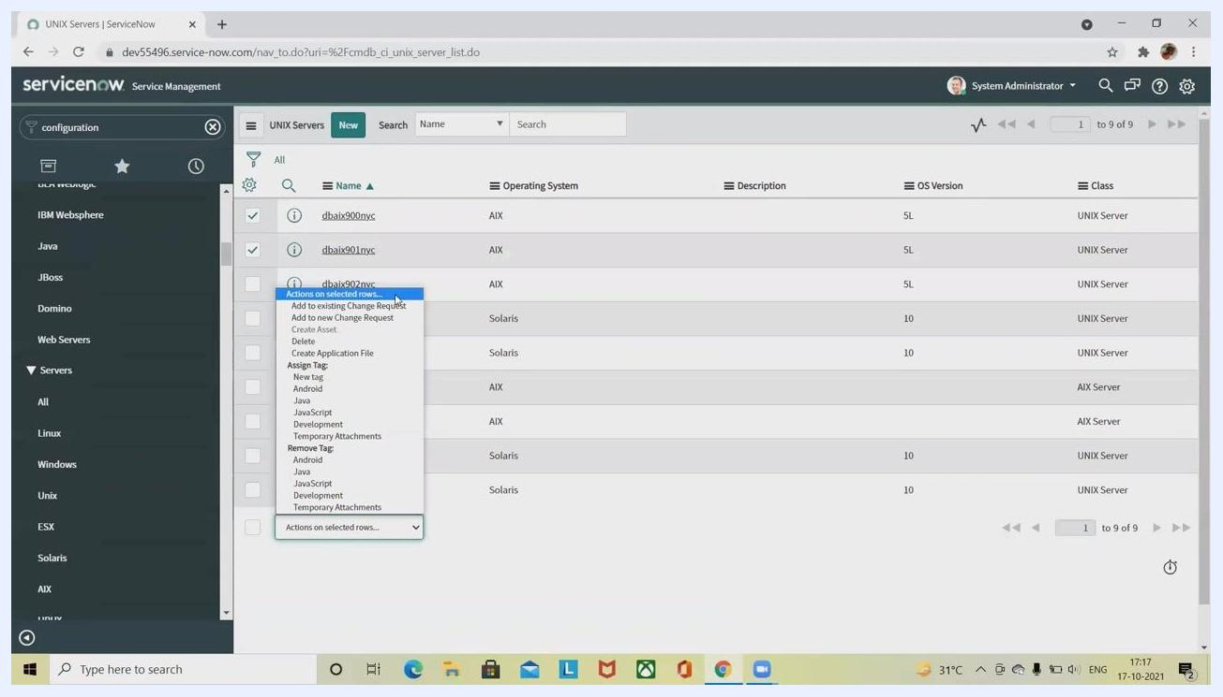
Choose a Change Request dialog open, with the Change Requests search window showing "No records to display" and search options for Number or Short description
You can change the search filter from Number to Short description if needed, using the dropdown next to the search box.
Change Requests search window with filter dropdown expanded, showing options for Number and Short description
If the change request exists, select it and click OK to associate the selected UNIX server CIs with the change request. If the change request does not exist, you cannot proceed with associating the CIs to an existing request.

Step 11: Create a new change request from selected CIs
If you want to create a new change request, first select the desired UNIX server CIs from the list. Open the Actions on selected rows... dropdown and select Add to new Change Request.
UNIX Servers list with multiple items selected and the Actions on selected rows dropdown open, highlighting "Add to new Change Request"
Click the New button at the top of the UNIX Servers list to start creating a new UNIX server CI if needed.
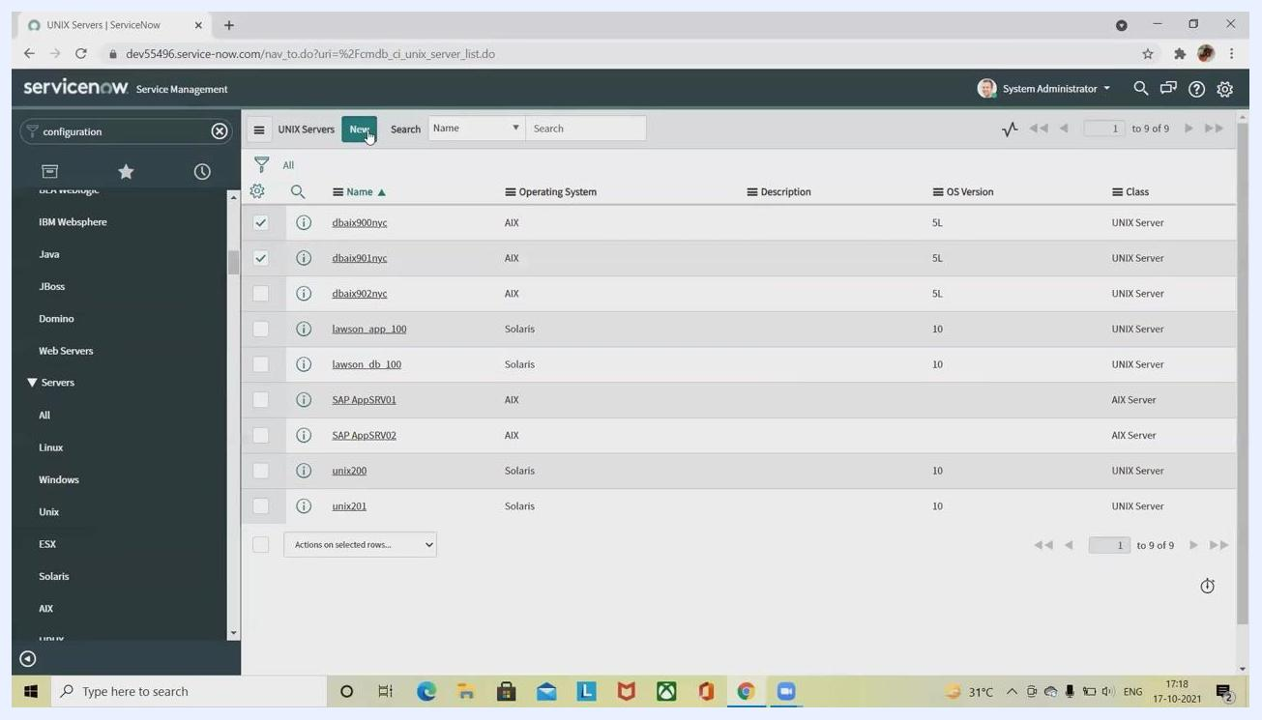
UNIX Servers list with the 'New' button highlighted, ready to create a new UNIX server CI
Fill in all required fields in the new record form:
- Name
- Asset tag
- Manufacturer
- Asset
- Company
- Serial number
- Model ID
- Assigned to
- Configuration section: Model number, Operating System, OS Version, OS Service Pack, Disk space (GB), Description, RAM (MB), CPU speed (MHz), CPU count, CPU manufacturer, CPU type
Ensure all mandatory fields are completed, then click Submit to create the new UNIX server CI or change request.
New UNIX Server record form with all required fields and configuration details visible, ready for data entry

Step 12: Complete the change request details
When creating a new change request, a detailed form appears. Enter or verify the following details:
- Number (auto-generated, e.g., "CHG0030004")
- Requested by (e.g., "System Administrator")
- Category (e.g., "Other")
- Service
- Configuration item
- Priority (e.g., "4 - Low")
- Risk (e.g., "Moderate")
- Impact (e.g., "3 - Low")
- Type (e.g., "Normal")
- State (e.g., "New")
- Assignment group, Assigned to (if applicable)
- Short description and Description
Use the tabs to provide additional information:
- Planning: Enter planned start and end dates, CAB required, CAB date, etc.
- Schedule
- Conflicts
- Notes
- Closure Information
Complete all required sections as per your organization's process.
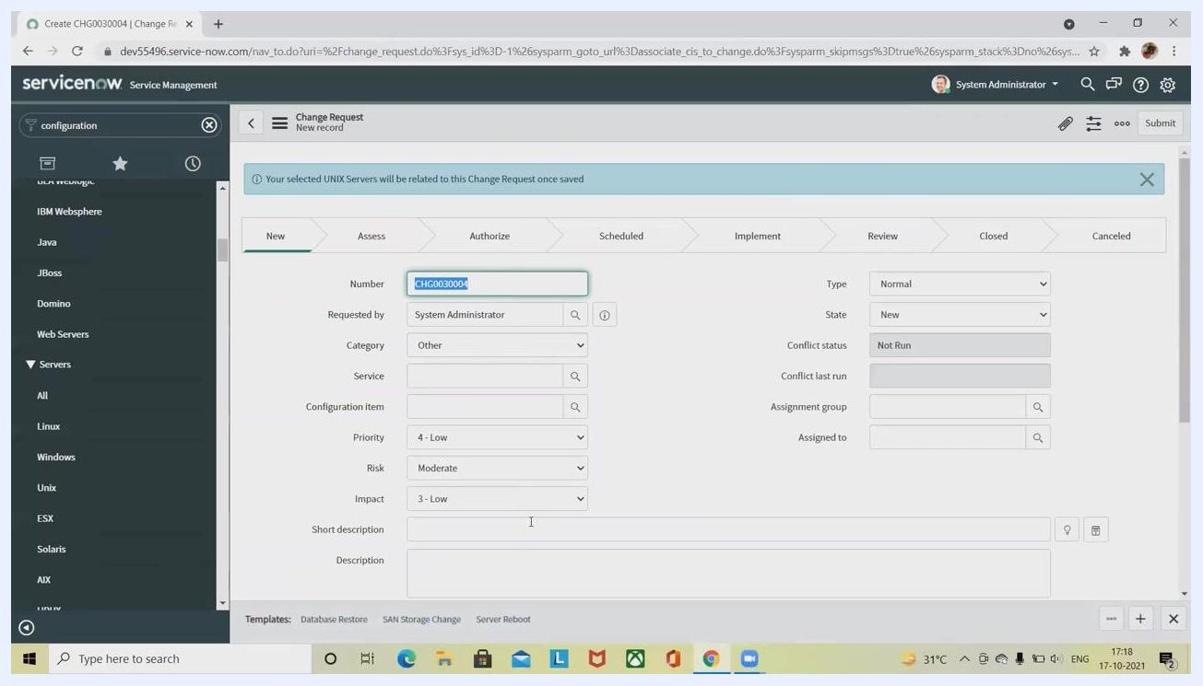
Change Request form with fields for Number, Requested by, Category, Service, Configuration item, Priority, Risk, Impact, and tabs for Planning, Schedule, Conflicts, Notes, and Closure Information
Click Submit to save and create the change request. Your selected UNIX server CIs will now be associated with the new change request.
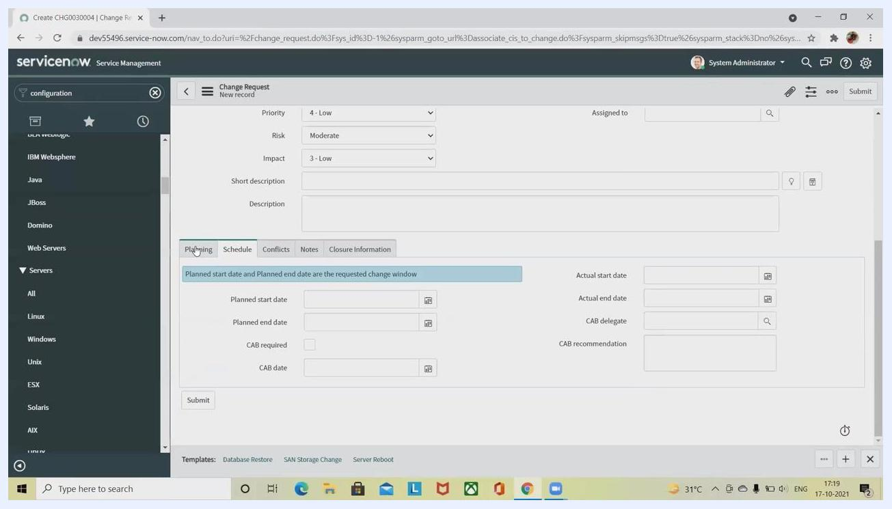
Change Request form showing Planning tab with fields for planned start/end date, CAB required, and other closure information

Step 13: Finalize and submit the change request
Review all entered details in the Change Request form to ensure accuracy and completeness. Navigate through the tabs (Planning, Schedule, Conflicts, Notes, Closure Information) to verify all required information is provided.
In the Schedule tab, confirm or enter the following fields as needed:
- Planned start date and Planned end date
- CAB required (check if a Change Advisory Board review is needed)
- CAB date (if applicable)
- Actual start date and Actual end date (if available)
- CAB delegate and CAB recommendation (if applicable)
Once all information is complete, click the Submit button at the bottom of the form to save and create the change request.
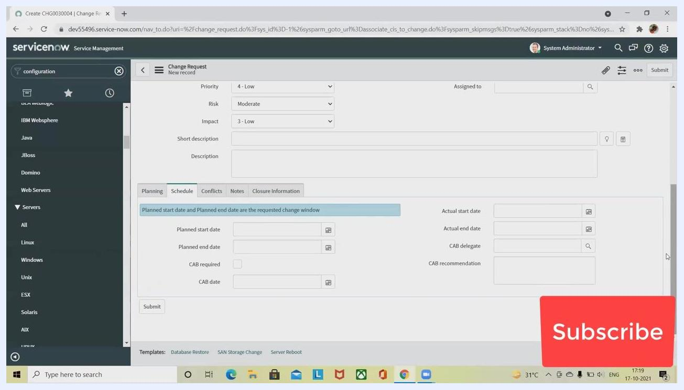
ServiceNow Change Request form open on the Schedule tab, with fields for planned/actual dates, CAB required, and Submit button visible. "Subscribe" overlay in the lower right corner.
After submission, the change request is created successfully, and your selected UNIX server CIs are associated with it.
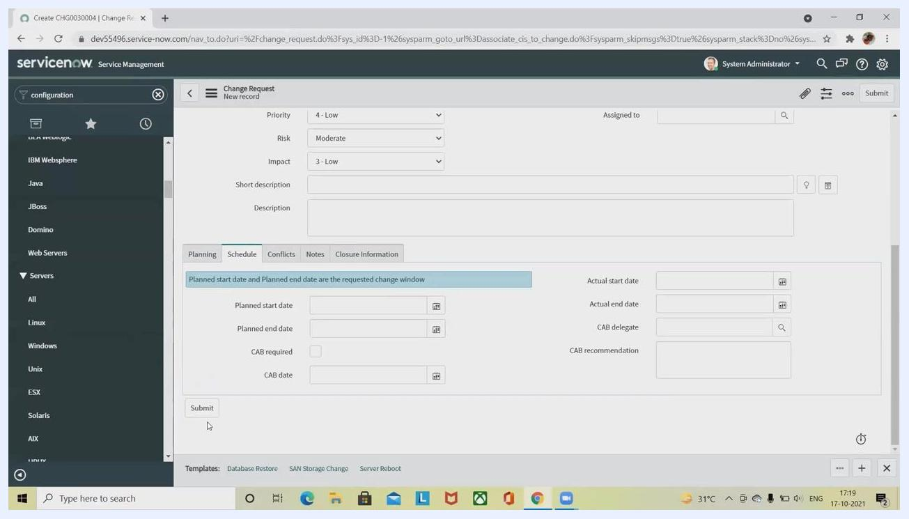
ServiceNow Change Request form with Schedule tab open, "Subscribe" overlay in the lower right corner, desktop environment visible.

Summary
By following these steps, you can efficiently locate and select configuration items (CIs) in ServiceNow, customize your view, and either associate existing CIs with a change request or create a new one. This ensures accurate tracking and management of changes within your IT environment, with all required details captured for effective change management.

What's next
For more tutorials and updates on ServiceNow workflows, consider subscribing to the relevant resource channel and enabling notifications to stay informed of new instructional content.

