How to Connect ServiceNow to Power BI
The Power BI Connector for ServiceNow lets you explore and analyze your ServiceNow data directly in Power BI. By combining ServiceNow data with other sources, you can build advanced data models and reports. This guide walks you through how to connect ServiceNow to Power BI, from configuring your data source to building visualizations.

Prerequisites
Before you connect ServiceNow to Power BI, assign the necessary role to the user within ServiceNow. This role grants the access required to use the Power BI Connector for ServiceNow.

Step 1: Log in to ServiceNow
Access your ServiceNow instance using the appropriate credentials and permissions.

Step 2: Find the Power BI Connector
Locate the Power BI Connector for ServiceNow in the ServiceNow Store or your ServiceNow environment. Confirm that it is compatible with your version (San Diego, Rome, or Quebec) and note the pricing if applicable ($795.00 per month). Review the product details and documentation as needed.
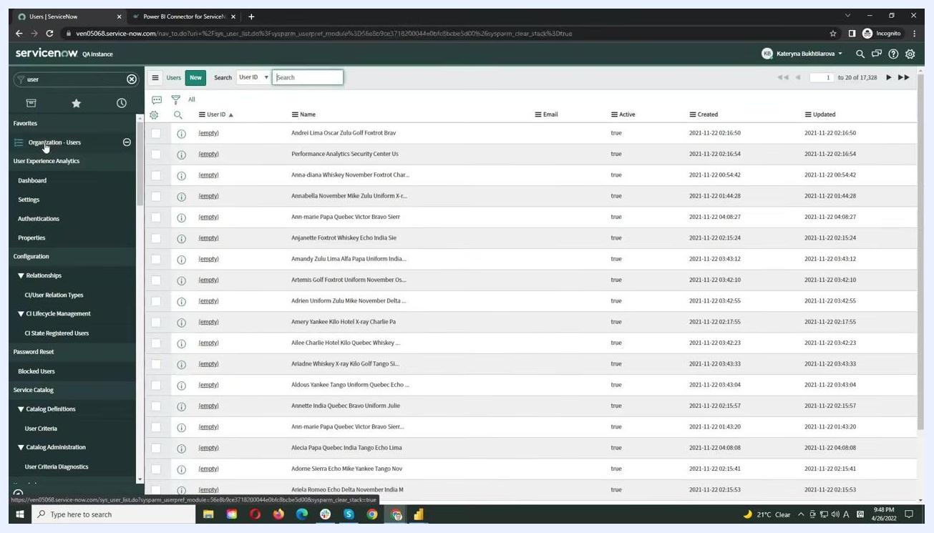
ServiceNow Store page for the Power BI Connector showing compatibility, pricing, and summary details

Step 3: Open the Data Sources section
In the Power BI Connector interface, go to the Data Sources section and click the New button to create a new data source.
Power BI Connector main screen with the Data Sources list and the New button highlighted

Step 4: Configure the data source details
Enter a name for your data source, such as "Emma's first data source," and optionally add a description like "for articles." Set the Rows limit according to your data needs (for example, 500 or 5000). Check the Use display value option if you want data descriptions to be fully displayed.
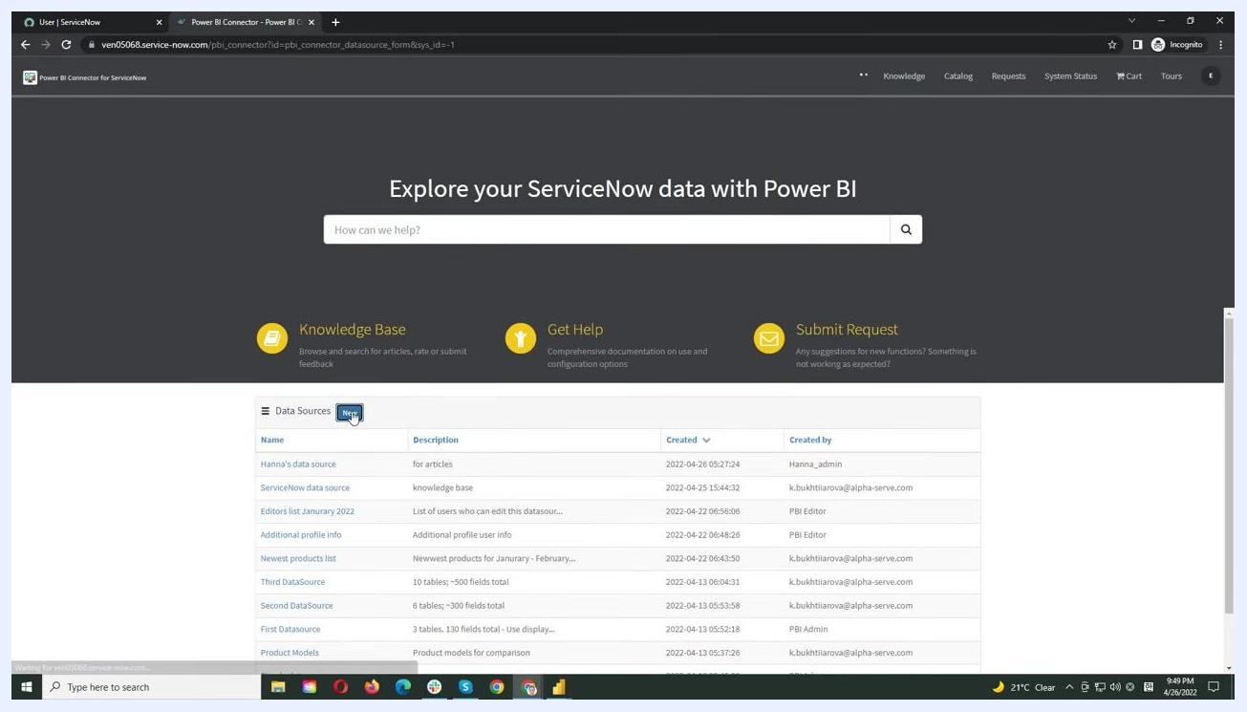
Edit Data Source screen with fields for Name, Description, Rows limit, Use display value, and the Add table button

Step 5: Add tables to export
Click the Add table button, then start typing the name of the table you want to add, such as "Incident." Select the desired table from the suggestions. You can add multiple tables as needed.

Step 6: Select fields for export
For each table, select the fields required for your Power BI report by checking the boxes next to the relevant fields, such as Active, Description, Domain, and Resolution code.
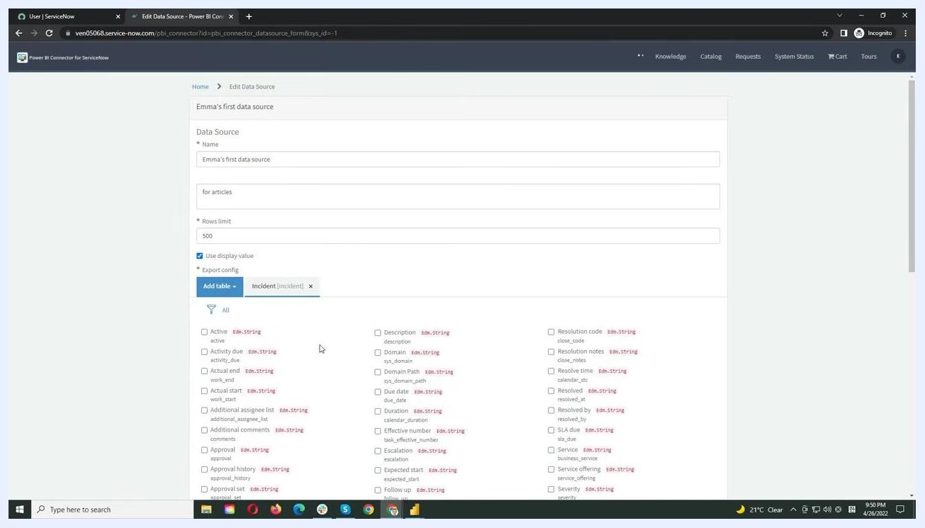
Field selection interface for the Incident table with several fields checked for export

Step 7: Apply filtering conditions
Use the filtering option to refine your data export. Click the filter icon and set conditions, such as filtering by Description with operators like is, is not, contains, or is empty. You can combine multiple criteria using AND/OR logic as needed.
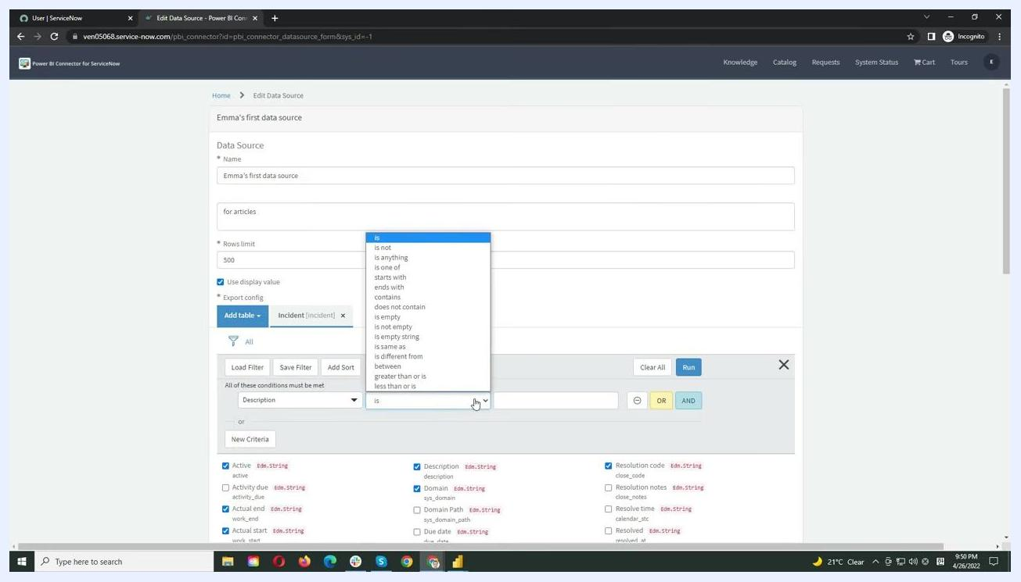
Filtering interface with a dropdown for filter conditions and logic options

Step 8: Save the data source
Scroll down and click the Save button, or use Ctrl+S, to save your connector configuration. You now have a data source configured in the Power BI Connector for ServiceNow, ready for export and analysis in Power BI.

Step 9: Copy the data feed URL
Click the Home link in the Power BI Connector for ServiceNow to return to the main menu. Locate and copy the data feed URL for your configured data source. You will use this URL to connect Power BI to your ServiceNow data.
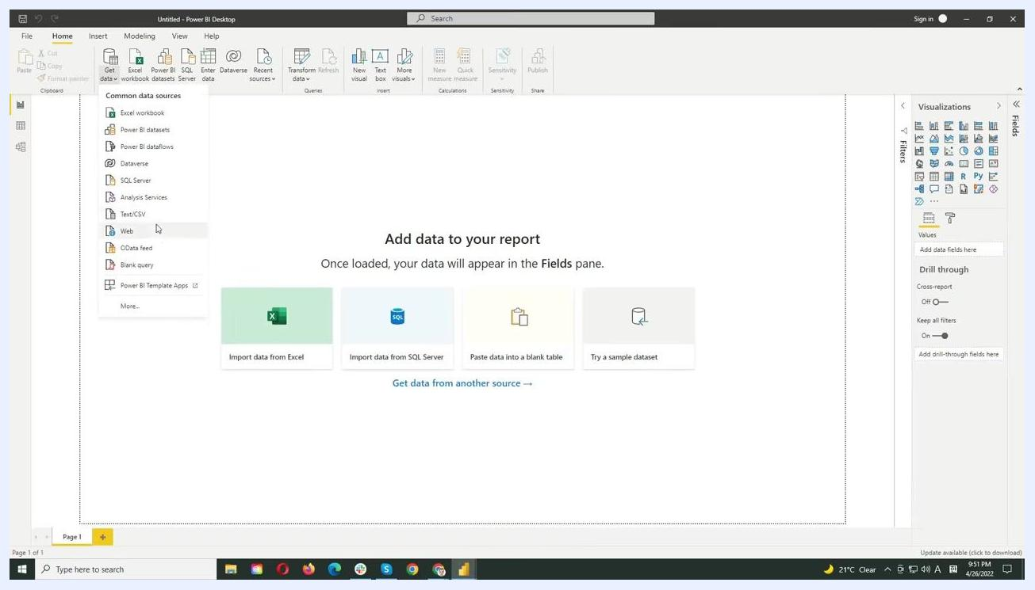
Power BI Connector for ServiceNow interface showing data source configuration, with the Home link visible and the data feed URL accessible

Step 10: Get data from an OData feed in Power BI Desktop
Launch Power BI Desktop and click the Get data button on the Home ribbon. From the list of data sources, select OData feed, then paste the copied ServiceNow data feed URL into the OData feed dialog box.
Power BI Desktop interface with the Get Data menu open and the OData feed option highlighted

Step 11: Authenticate with ServiceNow
When prompted, enter your ServiceNow credentials using the Basic authentication tab to provide your username and password, then click Connect to proceed.
Power BI Desktop interface showing the data loading process after entering the OData feed URL

Step 12: Select tables to import
After connecting, Power BI displays the tables you selected in your ServiceNow data source configuration. Choose the tables you want to import and click Load to bring the data into your Power BI workspace.
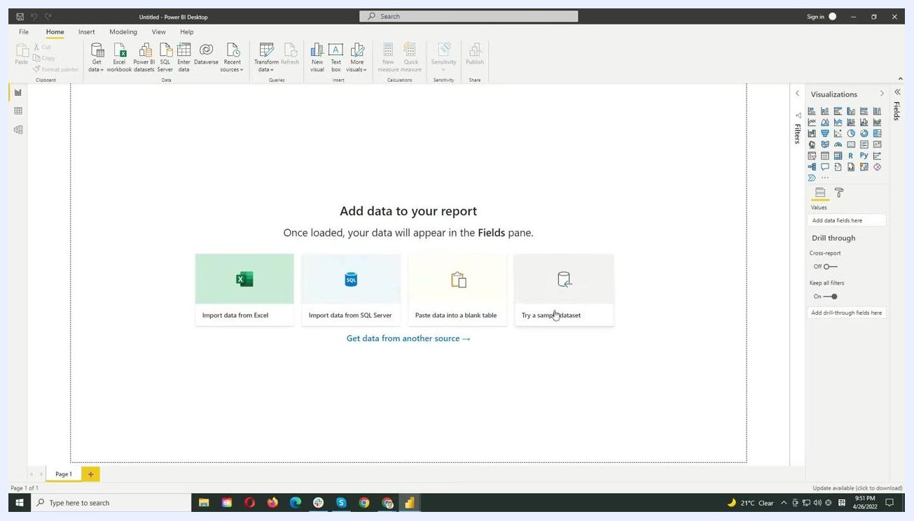
Power BI Desktop interface showing available tables for import after connecting to the ServiceNow OData feed

Step 13: Wait for the data to load
Allow a few seconds for Power BI to load your ServiceNow data. Once loaded, your tables and fields appear in the Fields pane on the right.
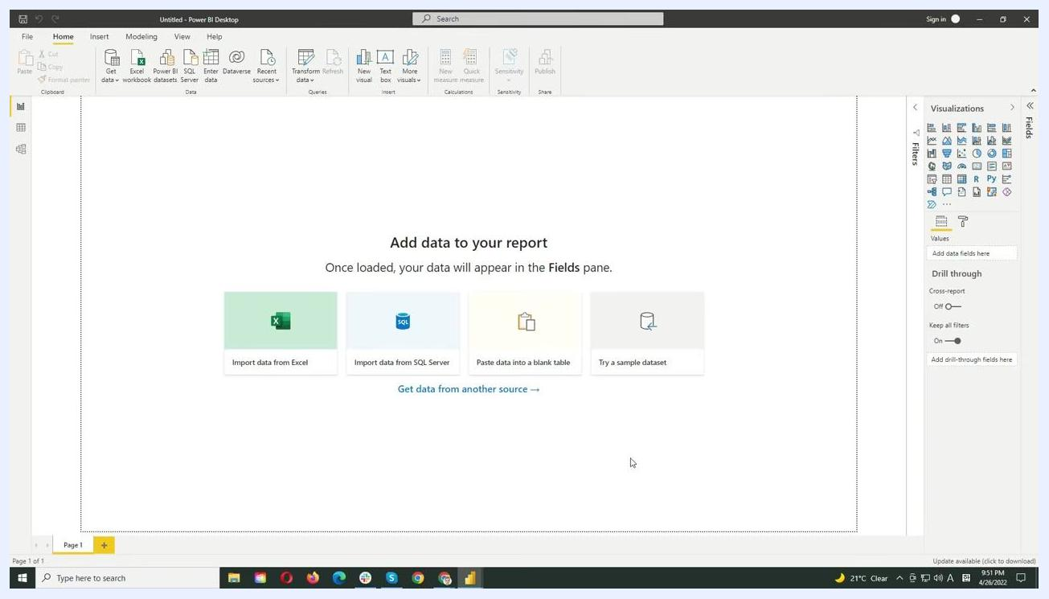
Power BI Desktop interface with data loading and the Fields pane visible

Step 14: Build visualizations and reports
Select the visualization type you want to use from the Visualizations pane, such as a bar chart, pie chart, or table. Drag and drop relevant fields from the Fields pane onto the report canvas to build your report.
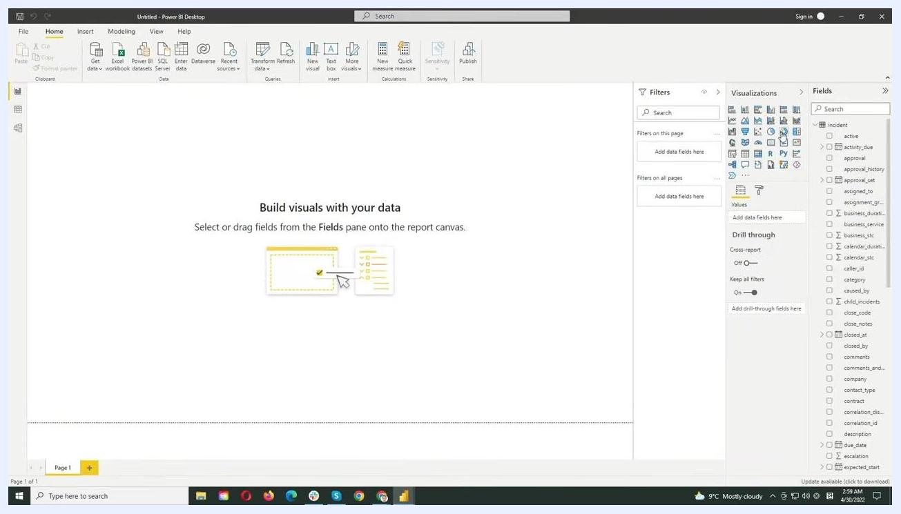
Power BI Desktop interface prompting the user to build visuals with data, showing the Visualizations and Fields panes

Step 15: Customize and analyze your data
Continue adding and configuring visualizations as needed. Apply filters, adjust chart types, and organize your report layout for optimal analysis. For example, you can create a donut chart visualizing the "made_sla" field from your imported ServiceNow data.
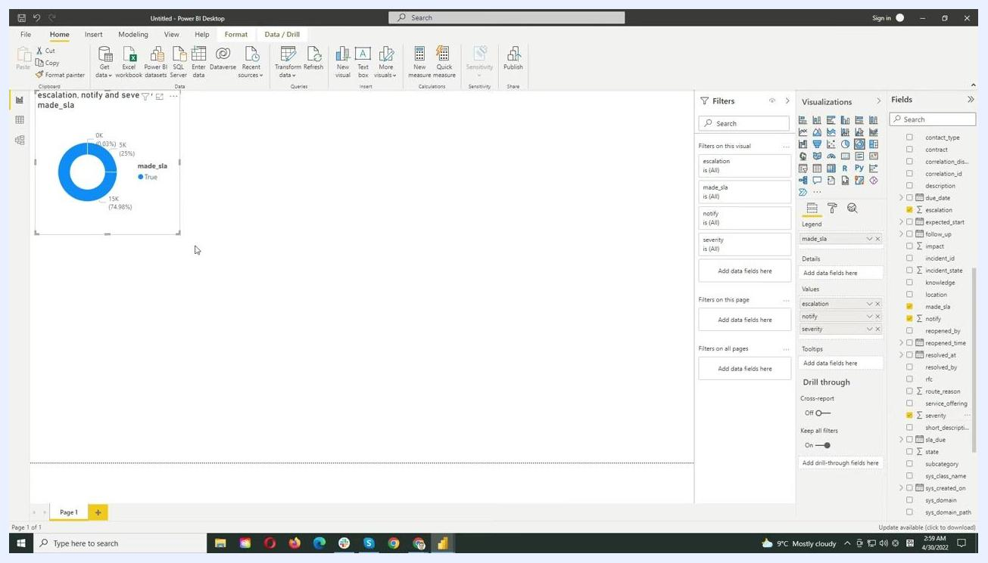
Power BI Desktop interface with a donut chart visualizing ServiceNow data, with filters and fields configured

What's next
You can try the Power BI Connector for ServiceNow for free via the ServiceNow Store. Visit the vendor's website at for more information, documentation, and support.
Once connected, you can leverage the Power BI Connector for ServiceNow to explore and analyze your ServiceNow data directly within Power BI, using built-in visualizations such as bar charts and donut charts to gain insights from your imported data. If you encounter any issues or need assistance, refer to the support resources available on the vendor's website.

Promotional slide for the Power BI Connector for ServiceNow, featuring a computer icon with a chart and two sample report visuals (a bar chart and a donut chart), with the text "Explore and analyze your ServiceNow data with Power BI" and the website URL https://www.alphaservesp.com/products/servicenow/

