How to see members in Schoology and manage them
This guide shows you how to see members in Schoology from your course's Members section. You can view everyone enrolled in the course, then manage roles, send messages, and preview the course as a student. You can also create grading groups and work with access codes.

Prerequisites
- Access to your Schoology course homepage.
- For some options, your district's settings. Section-level roles and password changes are available only if your district allows them.

Step 1: Open the Members section to see members in Schoology
- Go to your Schoology course homepage.
- In the left-hand menu, click Members.
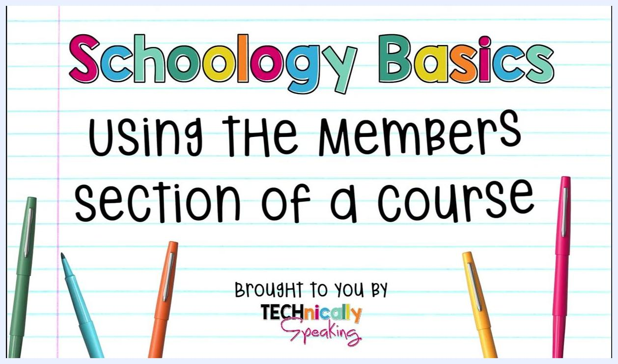
Schoology course homepage with the cursor hovering over Members in the left-hand menu
After you click Members, you see a list of everyone enrolled in the course. Each member appears with a name and profile picture. A small shield icon next to a name means that member is an admin for the course.

Step 2: Make a member an admin or unenroll a member
- Click the cogwheel next to the member's name.
- Select Make Admin to grant admin rights, or select Unenroll to remove the member from the course.
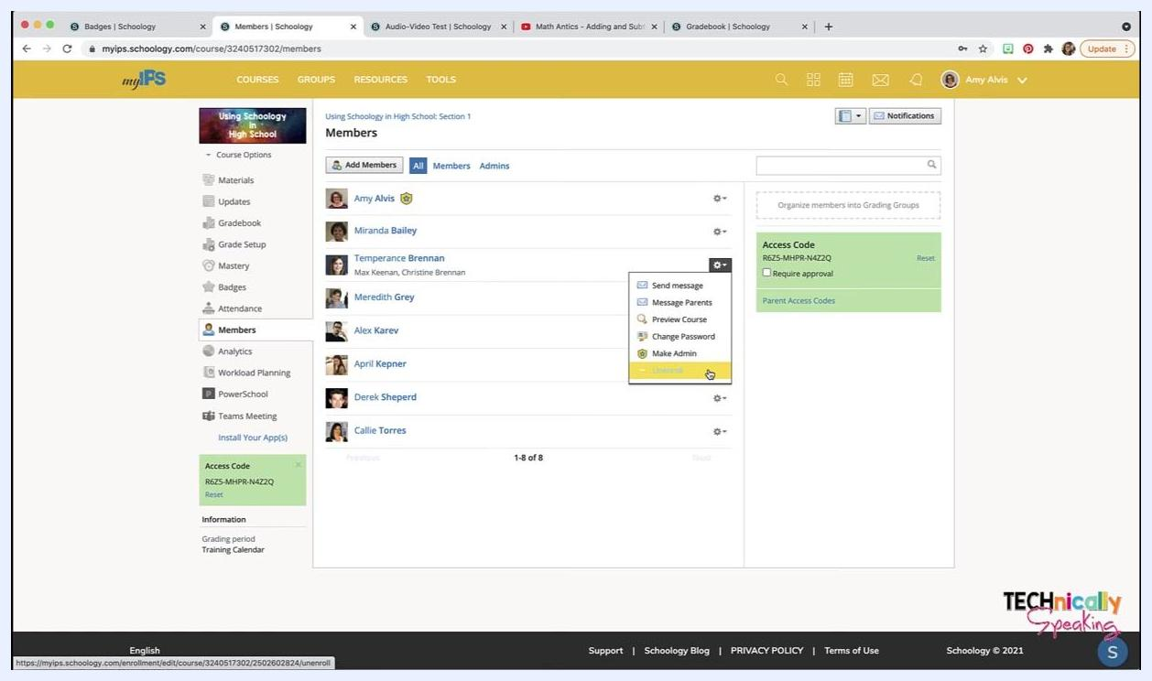
The cogwheel menu open with Unenroll highlighted
In some districts, unenrolling students isn't recommended if a student information system (for example, PowerSchool) manages enrollments. The system may add the students back automatically.

Step 3: Set a section-level role
- Click the cogwheel next to the member's name.
- Select Set Section-level Role to limit what the member can do within the course.
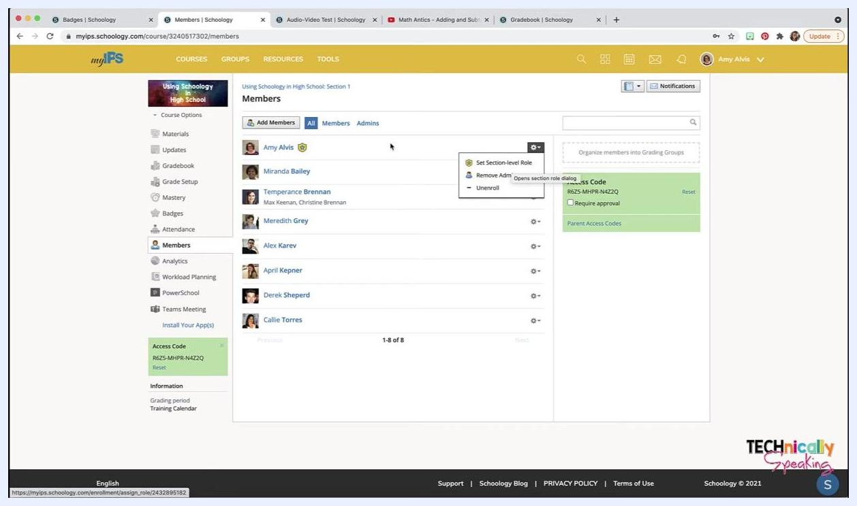
The cogwheel menu open with Set Section-level Role highlighted
This option appears only if your district has enabled section-level roles.

Step 4: Message a student or their parents
When you see members in Schoology, names listed underneath a student's name are the parents associated with that student.
- Click the cogwheel next to the student's name.
- Select Send Message to message the student directly, or select Message Parents to message the associated parents.
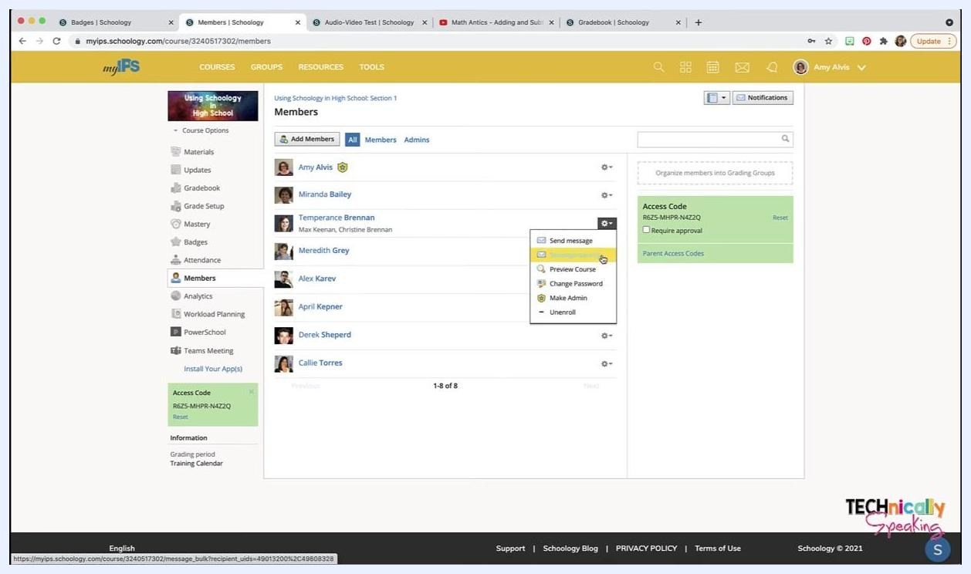
The cogwheel menu open with the Send Message and Message Parents options visible

Step 5: Preview the course as a student
- Click the cogwheel next to the student's name.
- Select Preview Course.
You now see the course from that student's perspective.

Step 6: Change a student's password
- Click the cogwheel next to the student's name.
- Select Change Password.
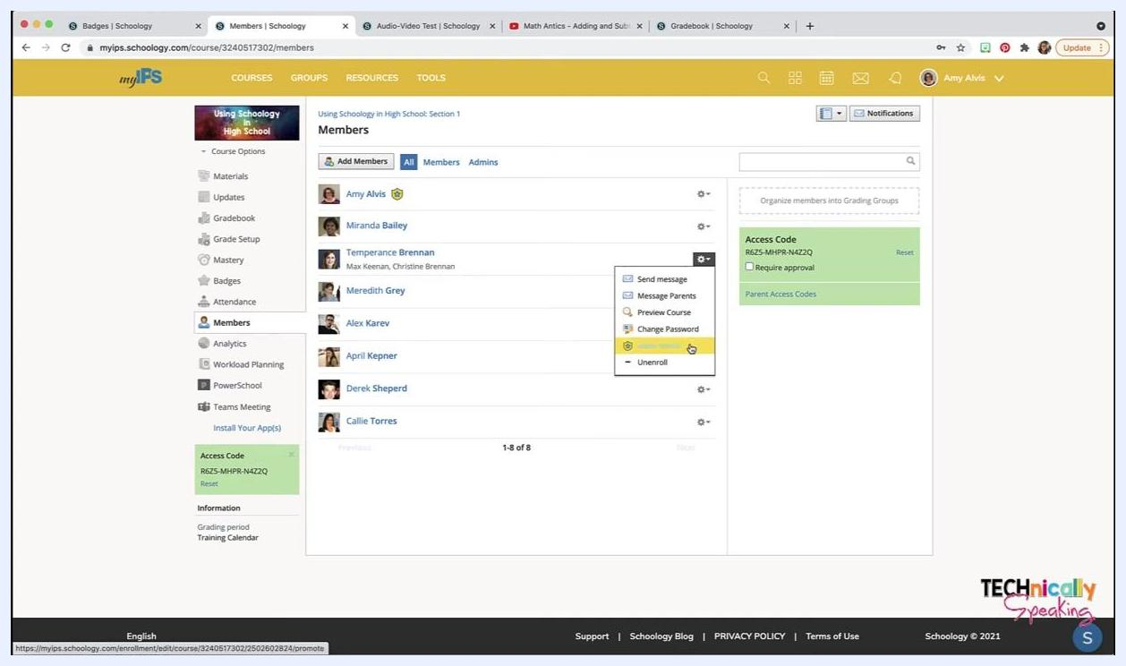
The cogwheel menu open with Change Password highlighted
This option may be disabled if your district doesn't allow password changes.

Step 7: Create a grading group for specific students
- In the Members section, click Add Grading Group on the right side of the screen.
- In the pop-up window, enter a name in the Group Name field (for example, "ESL").
- Click the names of the students you want in the group (for example, Miranda Bailey, Alex Karev, and Callie Torres).
- Click Create Grading Group.
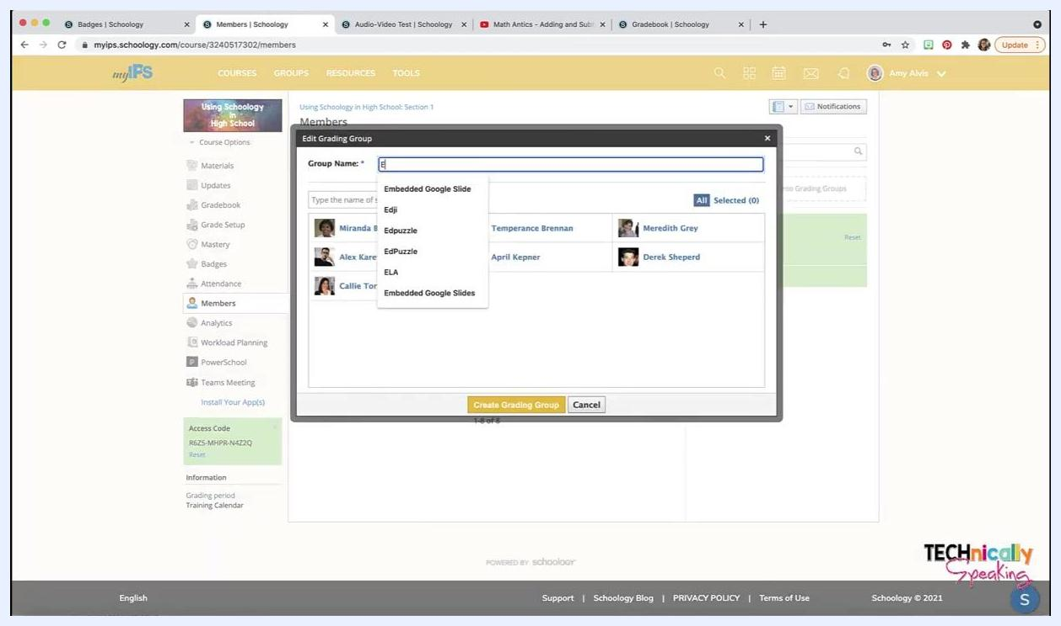
The Edit Grading Group dialog with a group name being typed and the student selection options visible

Step 8: Assign work to a grading group
- When you create an assignment, type the group name (for example, "ESL") in the assign-to field.
- Schoology assigns the work to every student in that group (in this example, Miranda, Alex, and Callie), so you don't have to enter each name.
Grading groups now appear next to student names in the Members list.
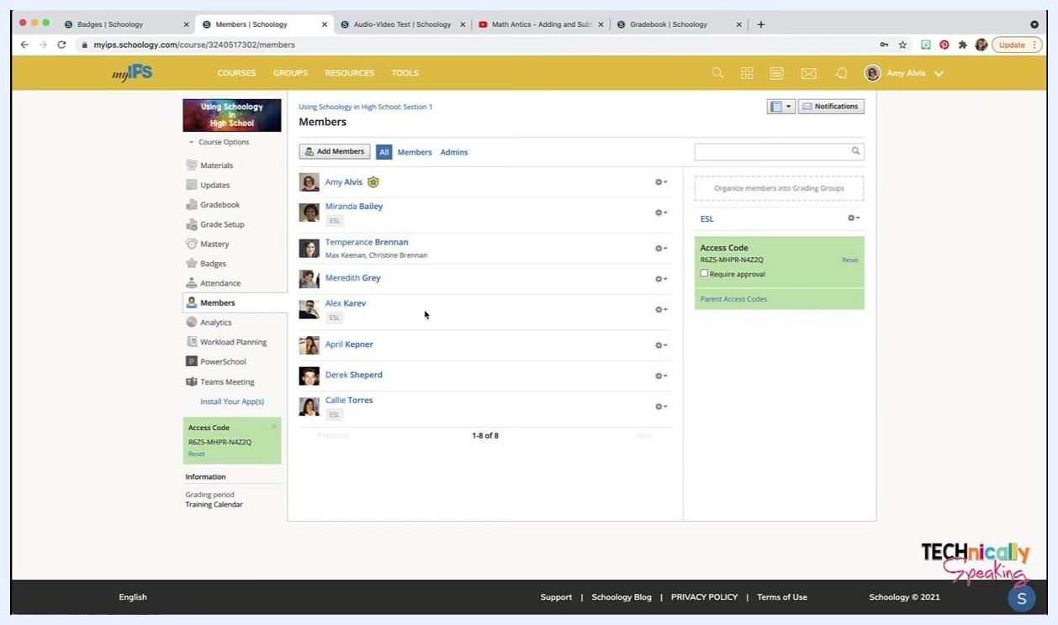
The Members list with an ESL label next to the selected students and the ESL grading group listed on the right

Step 9: Find the course access code
The Access Code for the course appears on the right side of the Members page (for example, RG25-MHPR-NA4ZQ).
- Students can use this code to register and join your course if manual enrollment is allowed.
- If a Student Information System (SIS) enrolls your students, you typically don't need the code.
- You can use the access code to add another teacher to the class.
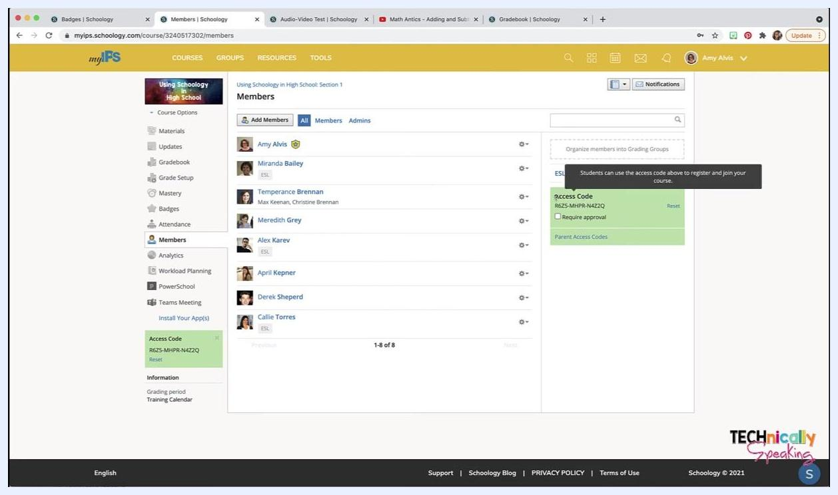
The Access Code section highlighted with a tooltip explaining its use

Step 10: Download parent access codes
- If your district uses parent access codes, click Parent Access Codes under the Access Code section.
- Click Download when prompted.
A CSV file (for example, parent-code-export.csv) downloads to your computer. It contains the parent access codes you can distribute to parents.
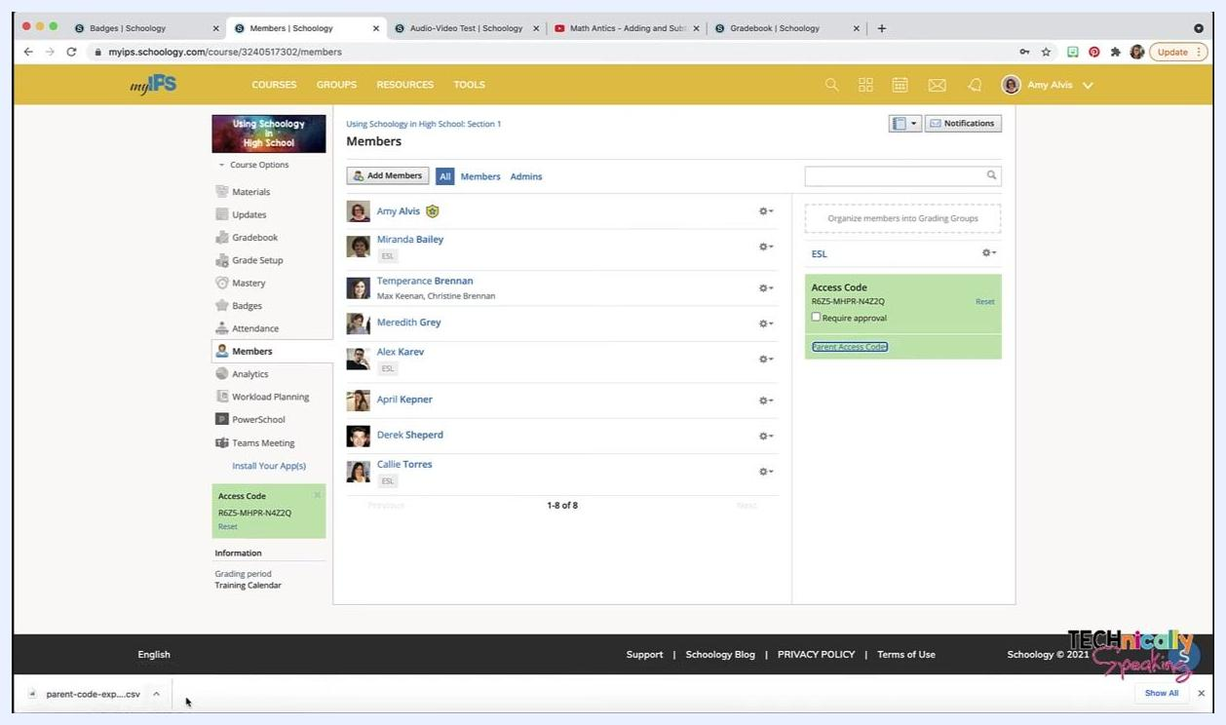
The cursor clicking the Parent Access Codes link, with the downloaded CSV file shown in the download bar at the bottom of the screen

Summary
Now you know how to see members in Schoology and use the Members section to manage them. You can assign roles, communicate with students and parents, adjust permissions, and preview the course as a student. You can also organize students into grading groups, streamline assignment distribution, and manage both student and parent access codes.

