How to enable submissions in Schoology (and turn them off when you don't need them)
Learn how to enable submissions in Schoology and how to disable them for individual assignments. The submissions toggle controls whether students can turn in work digitally. This guide uses the assignment "Personal Introduction" as an example.

Prerequisites
- A Schoology account that you can log in to.
- A course that contains an assignment you want to edit.

Steps

1. Open your courses
- Log in to your Schoology account.
- From the dashboard, find the Courses tab at the top of the page.
- Click Courses to see all your available courses.
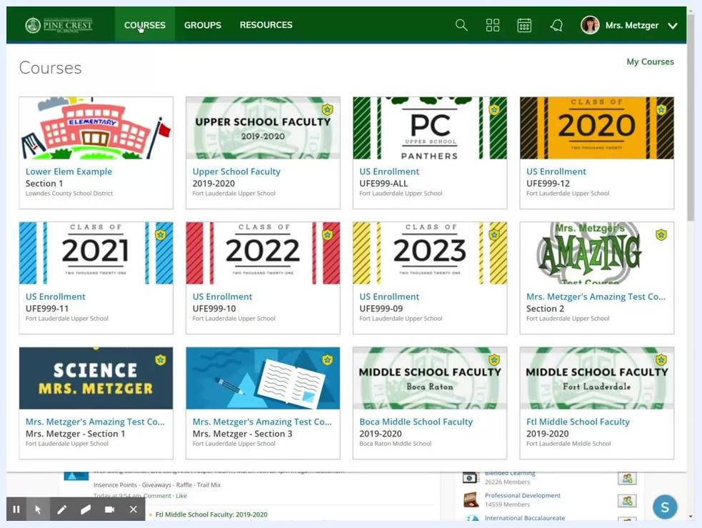
Schoology dashboard showing the Courses tab and a grid of course cards, including "Mrs. Metzger's Amazing Test Course: Section 2"

2. Select the course
Find the course where you want to manage assignment submissions and click it. In this example, select "Mrs. Metzger's Amazing Test Course: Section 2".
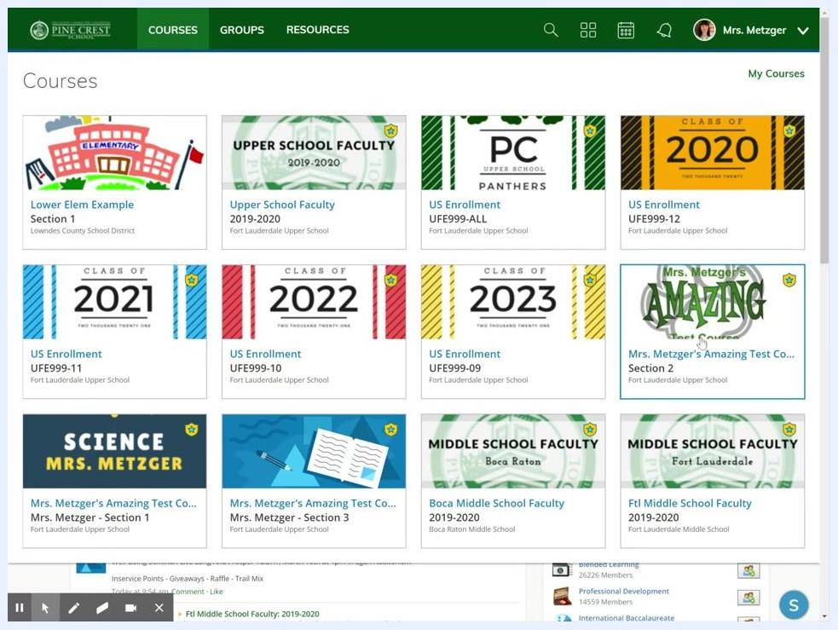
Courses grid with the cursor over "Mrs. Metzger's Amazing Test Course: Section 2"

3. Go to Materials and find the assignment
Make sure you are in the Materials section. If your course opens to another section, such as Updates, click Materials in the left-hand navigation bar.
Then find the assignment you want to edit. In this example, it's "Personal Introduction".
Course materials list showing assignments and folders, with "Personal Introduction" visible

4. Open the assignment editor
You can edit an assignment in two ways:
- Click the assignment name.
- Click the gear icon next to the assignment.
Use the gear icon, because it's a consistent place to find editing options. Click the gear icon next to "Personal Introduction", then select Edit from the dropdown menu.
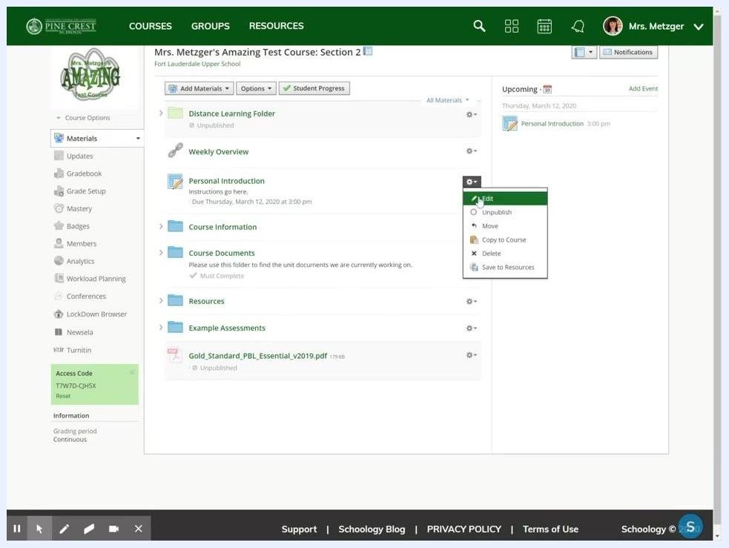
Gear icon dropdown menu next to "Personal Introduction" with Edit highlighted

5. Locate the submissions setting
- In the Edit Assignment window, scroll down to the Options section near the bottom.
- Find the small button that looks like a box with a green arrow. This is the submissions toggle.
- Hover over the button to see its tooltip. When submissions are on, it reads "Submissions Enabled".
Edit Assignment window with the Submissions Enabled button highlighted and its tooltip visible

6. Disable submissions
If the button is colored in, submissions are enabled. This is the default setting.
Click the button to turn submissions off. The button appears greyed out, and the tooltip reads "Submissions Disabled".
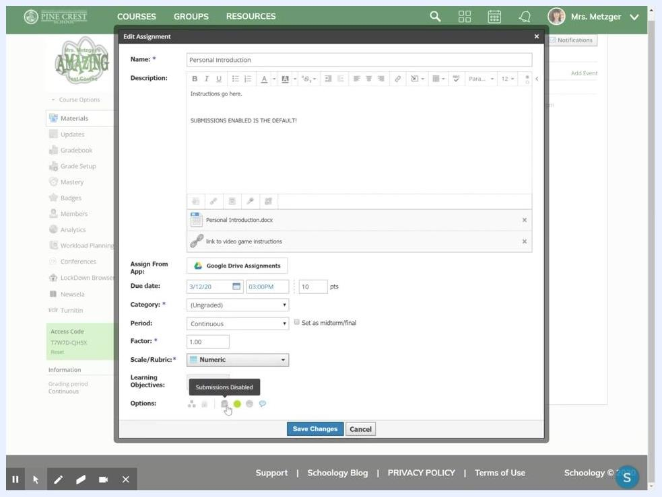
Edit Assignment window with the Submissions Disabled tooltip visible and the toggle button greyed out

7. Decide when to disable submissions
Consider disabling submissions when you don't want students to turn in digital work. For example:
- Assignments you collect in person during class.
- Assignments that act as reminders or checklists, such as reading homework like "Read chapters one through three".
- Tasks where students have nothing to submit online, but you still want the assignment to appear in their list.

8. Enable submissions in Schoology
When "Submissions Enabled" is active, students can submit their responses digitally, including any files or documents they need to upload. This is the default setting. If you want students to turn in work digitally, make sure it is on.
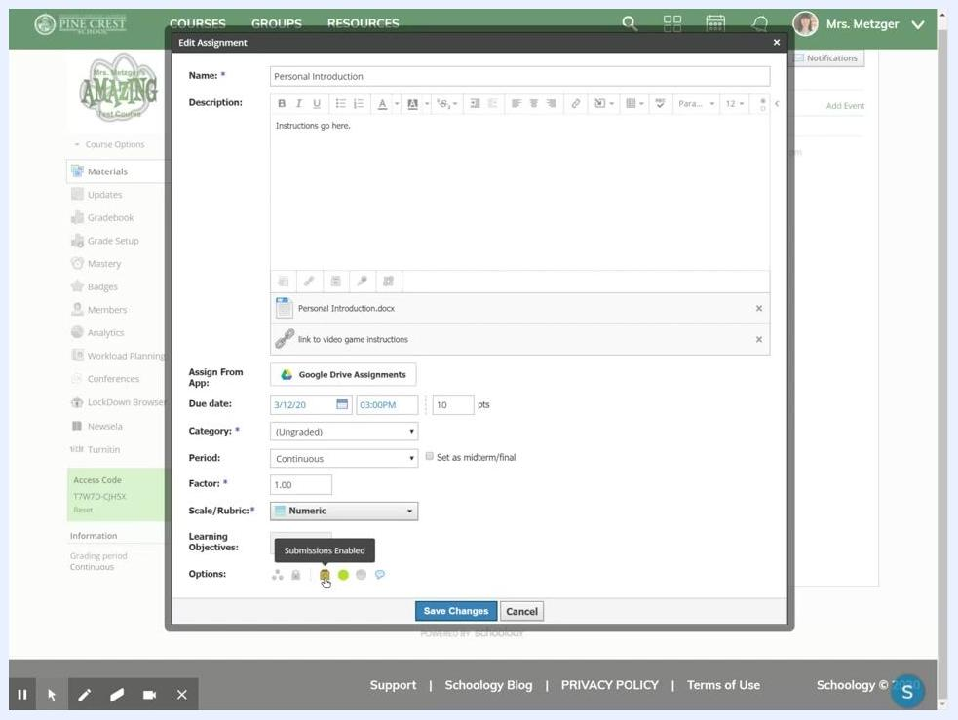
Edit Assignment window showing Submissions Enabled active, with assignment details filled in
If you previously disabled submissions, click the submissions toggle again. When submissions are enabled, the button is colored in and the tooltip reads "Submissions Enabled".
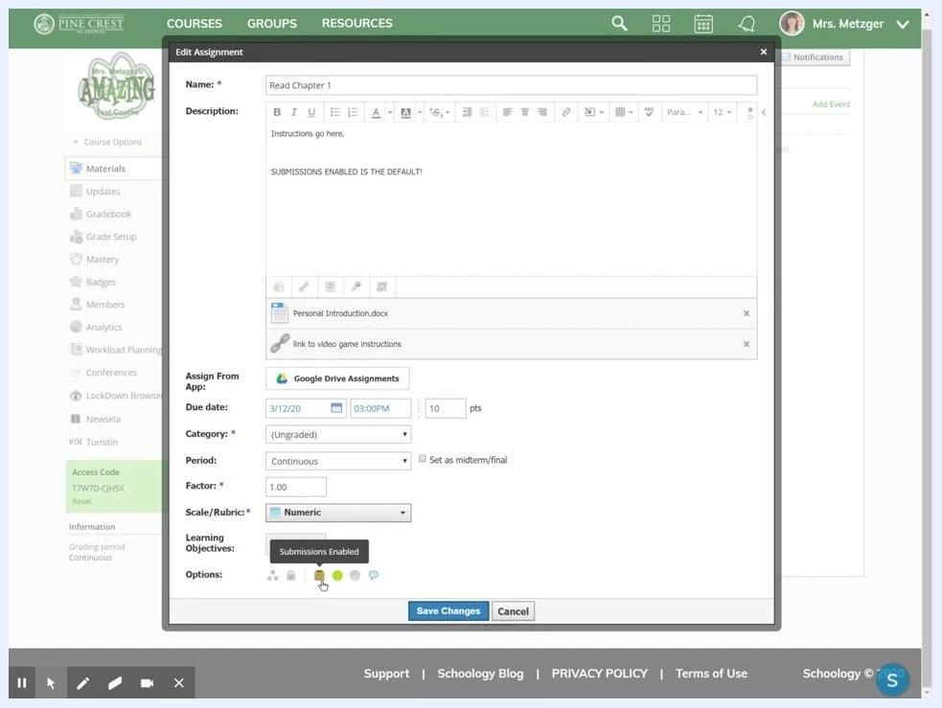
Edit Assignment window with the Submissions Enabled tooltip visible and the toggle button colored in

9. Save your changes
Click Save Changes at the bottom of the Edit Assignment window to apply your update.

Summary
- Use the submissions toggle to control whether students can submit an assignment digitally.
- Disable submissions for in-person or reminder assignments.
- Enable submissions for assignments that students turn in digitally.
- Always click Save Changes after you edit assignment settings.

