How to embed a video in Schoology assignments
This guide shows you how to embed a video in Schoology by adding it to an assignment description. You can upload a video file of up to 100 MB, or paste an embed code for larger or externally hosted videos. This guide covers embed codes from Outklip and YouTube.
When you embed a video, students watch it directly in Schoology. They don't need to open a new tab or leave the platform.

Prerequisites
Before you begin, make sure you have:
- A Schoology account with access to your course (for example, "Technology: Section 1").
- A video to add. This can be a file on your computer, an Outklip video, or a YouTube video.
- Access to the Share options for any Outklip or YouTube video you want to embed.

Create the assignment

Step 1: Open Schoology and go to your course
- Open your web browser and go to Schoology.
- Log in and select your course.
- Confirm that you are on the course materials page.
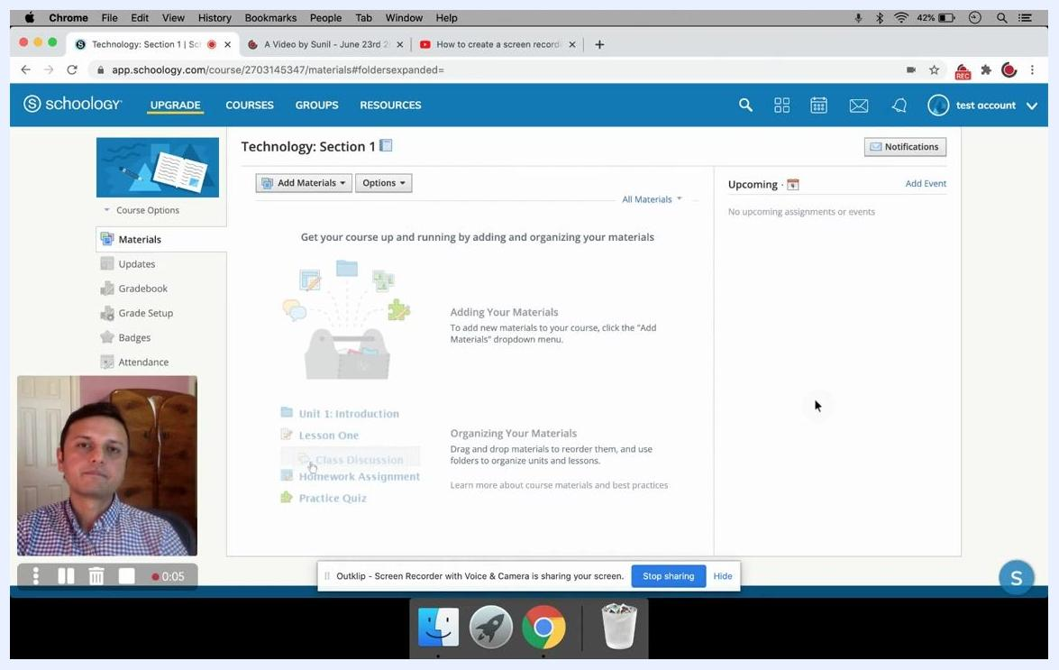
The Schoology course materials page in a browser, with navigation options such as Materials, Updates, and Gradebook in the left sidebar.

Step 2: Add a new assignment
- At the top of the Materials section, click Add Materials.
- From the dropdown menu, select Add Assignment.
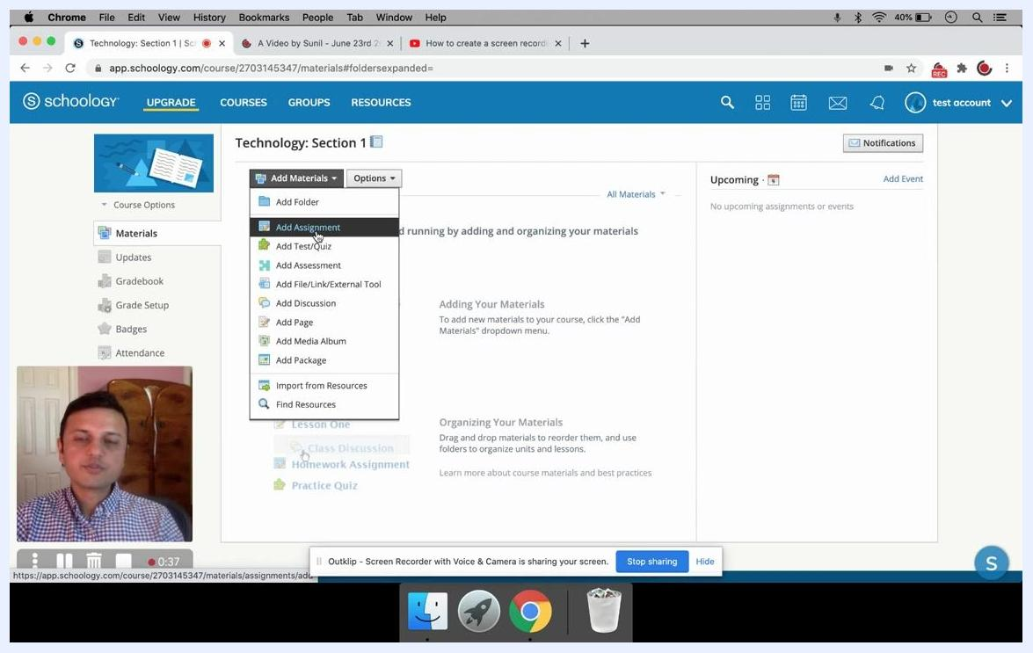
The Add Materials dropdown is open with the cursor on Add Assignment, alongside options such as Add Folder, Add Test/Quiz, and Add Assessment.

Step 3: Fill out the assignment details
- In the Create Assignment dialog, enter a name for the assignment in the Name field (for example, "test").
- Optionally, complete the description and other fields, such as Due Date, Category, Period, Factor, Scale/Rubric, and Learning Objectives.
The Create Assignment dialog with "test" entered in the Name field and the Description, Due Date, Category, Period, Factor, Scale/Rubric, and Learning Objectives fields visible.

Step 4: Open the media options in the description
- In the Description box, click the Insert Content button, which appears as a filmstrip or media icon.
- Select Image/Media from the dropdown.
The Insert Media dialog opens. Before you use it, get an embed code from your video host as described in the next section. If you are uploading a file instead, skip to Step 7.

Get the embed code

Step 5: Copy the embed code from an Outklip video
- Go to the main page of the Outklip video you want to embed.
- Click Share.
- In the dialog that appears, click Embed. The dialog displays the HTML code for embedding the video.
- Click Copy link to copy the entire embed code to your clipboard.
- Click OK to close the dialog.
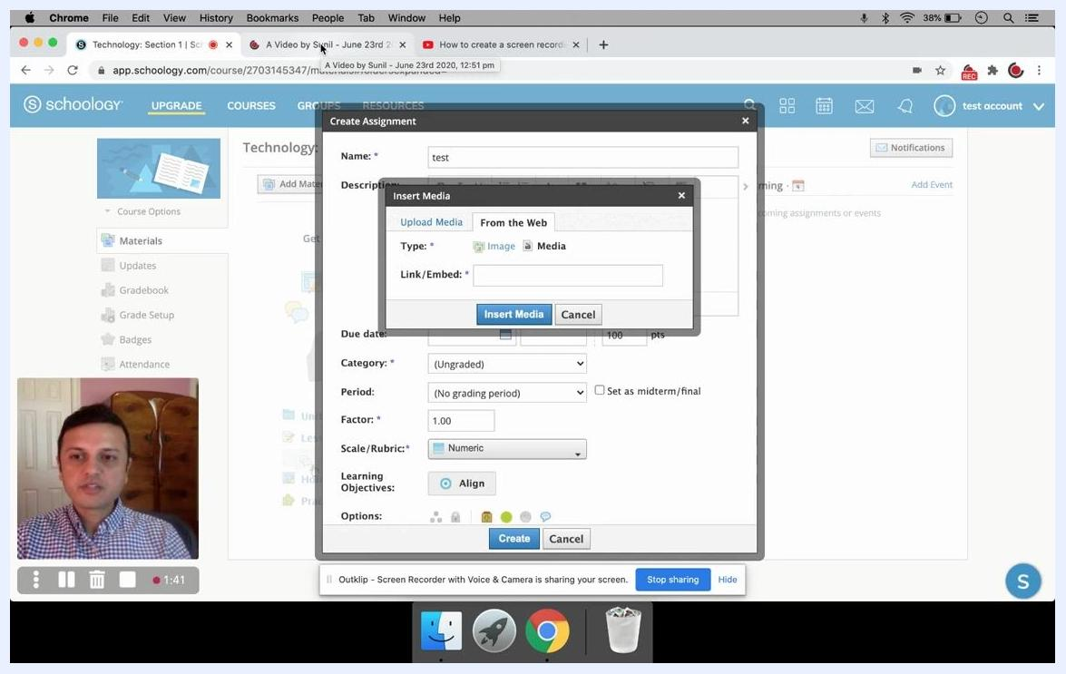
The Outklip embed dialog showing the iframe embed code and the Copy link button.

Step 6: Copy the embed code from a YouTube video
- Open the YouTube video in a new browser tab.
- Click Share below the video.
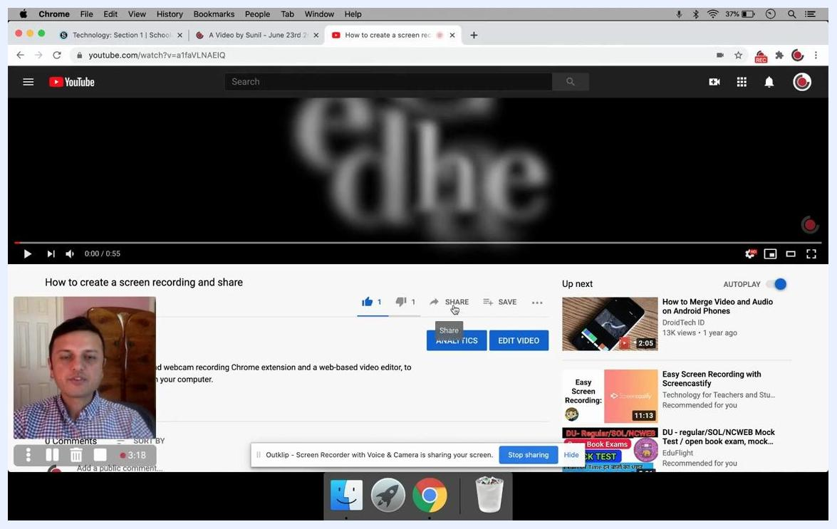
A YouTube video page with the cursor over the Share button below the video title.
- In the sharing dialog, select Embed.
- Copy the entire embed code provided.
- Close the YouTube sharing dialog.
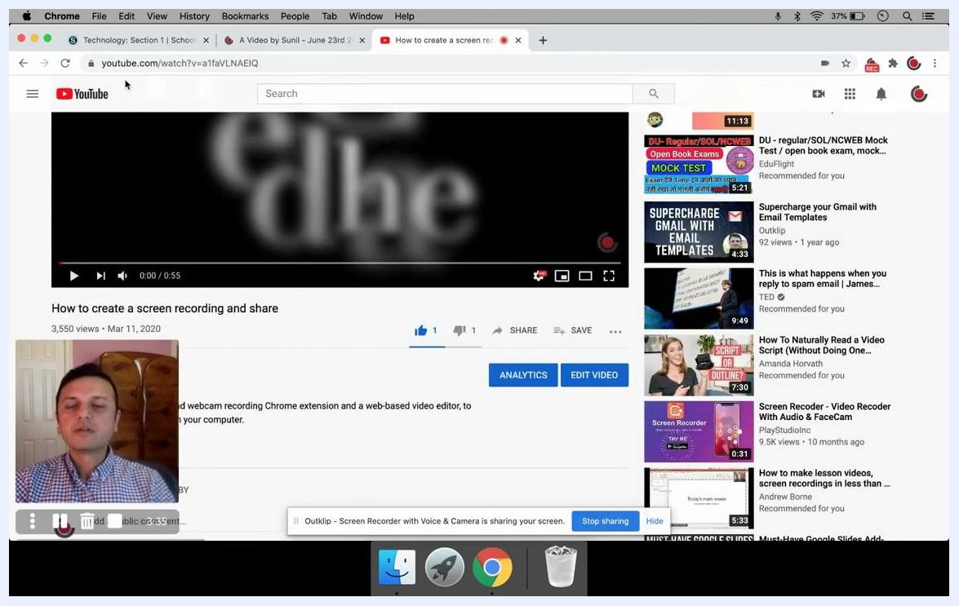
The YouTube page after the embed code is copied, with the sharing dialog ready to close.

Insert the media into the assignment

Step 7: Choose how to add your video
In the Insert Media dialog, you have two options:
- Upload Media: Click Attach File to upload a video file from your computer. The maximum file size is 100 MB.
- From the Web: If your video is larger than 100 MB or hosted online, click the From the Web tab.
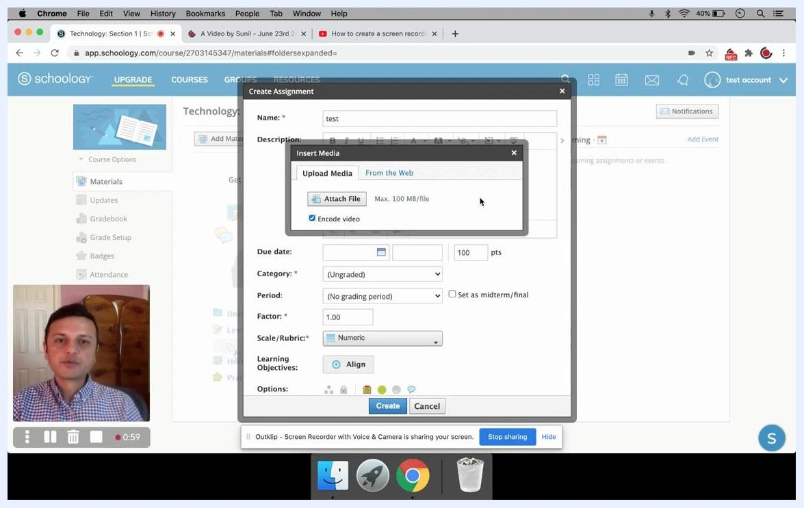
The Insert Media dialog with the Upload Media tab selected, the Attach File button visible, and a "Max. 100 MB/file" note.

Step 8: Paste the embed link for large or hosted videos
- On the From the Web tab, select Media as the type.
- Paste the embed link into the Link/Embed field. Use the embed code or direct embed link from your video hosting service, not just the video URL.
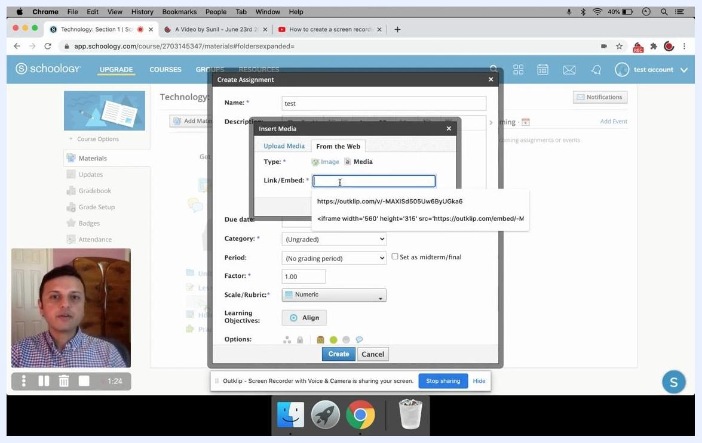
The Insert Media dialog on the From the Web tab with Media selected and the Link/Embed field ready for input. A tooltip shows a sample embed link and iframe code.

Step 9: Insert the media
After you enter the embed link, click Insert Media to add the video to your assignment description.
The Insert Media dialog ready for the embed link to be pasted and Insert Media to be clicked, with the Create Assignment dialog visible behind it.

Step 10: Create the assignment
- Review all assignment details.
- Click Create to post the assignment, with the embedded video, to your Schoology course.

Verify the embedded video

Step 11: Check an embedded Outklip video
- Click the new assignment (for example, "test") to open it.
- Confirm that the Outklip video appears and plays directly within Schoology.
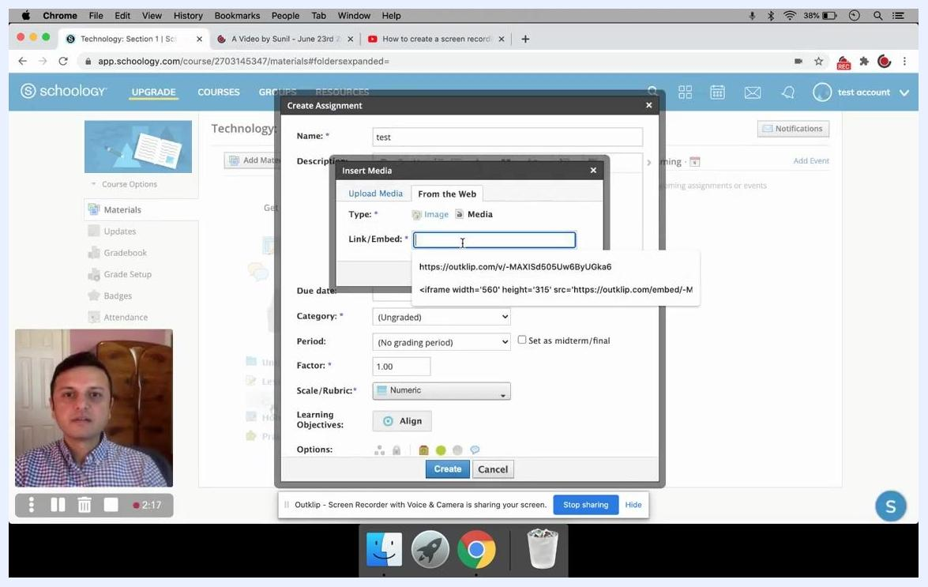
The Schoology assignment page titled "test" showing the embedded Outklip video player.

Step 12: Check an embedded YouTube video
- Click the new assignment (for example, "test 2") to open it.
- Confirm that the YouTube video appears and plays directly within Schoology.
The Schoology assignment page titled "test 2" showing the embedded YouTube video player.

Summary
You can add a video to a Schoology assignment by uploading a file of up to 100 MB or by pasting an embed link for larger or externally hosted videos. Embedding is preferable to posting a link because students can watch the video without leaving Schoology. This improves accessibility and streamlines the learning experience.
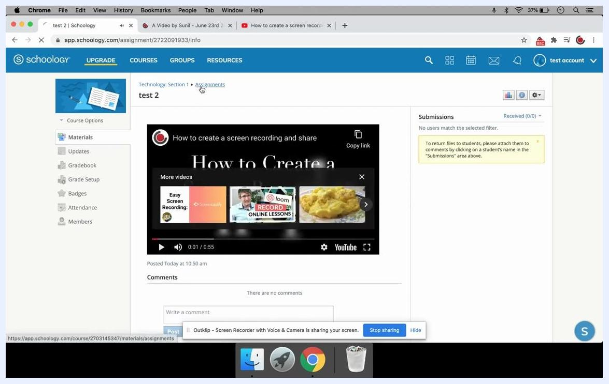
A Schoology course page showing both embedded videos available for direct viewing.

What's next
- Add embedded videos to other assignments in your course.
- Fill in optional fields such as Due Date, Category, and Learning Objectives to complete your assignments.

