How to create a group in Schoology
This guide shows you how to create a group in Schoology, set its privacy and access, and manage it after it exists. It also covers how to join an existing group with an access code or by browsing available groups. You can use groups for clubs, advising, sports, and other purposes that fit your school.

Prerequisites
- A Schoology account that you can log in to.
- An access code from the group administrator, if you want to join a group that way.

Join an existing group

Step 1. Open your Schoology home page
Log in to your Schoology account and go to the home page. The home page displays the Recent Activity feed, the navigation menus, and your upcoming events.
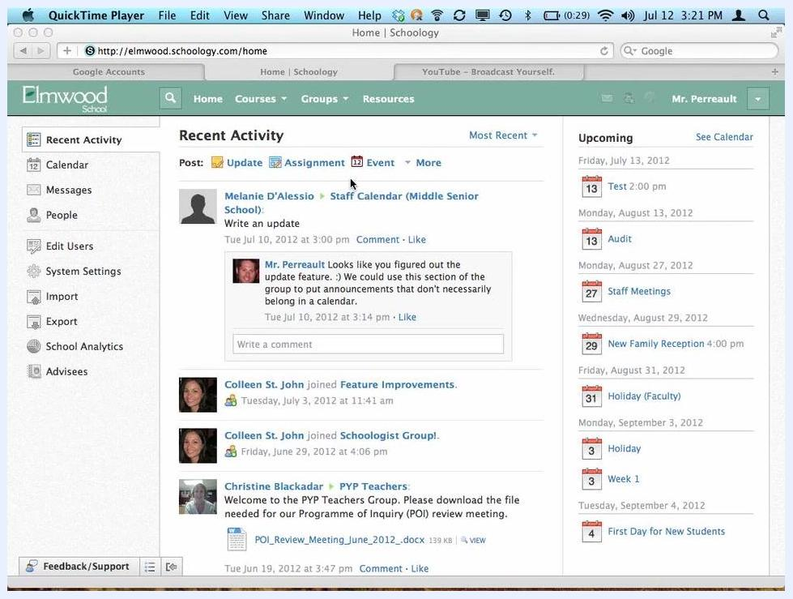
Schoology home page showing the Recent Activity feed, navigation sidebar, and upcoming events

Step 2. Open the Groups menu
In the top navigation bar, click Groups. The dropdown lists the groups you already belong to. It also gives you options to create or join groups.
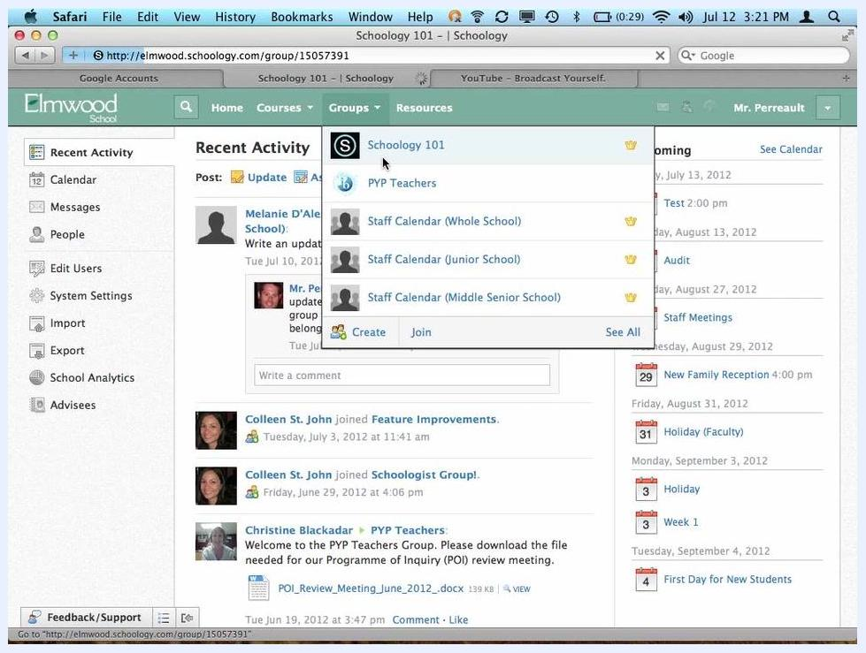
Groups dropdown menu showing existing groups and the Create, Join, and See All options

Step 3. Join a group with an access code
Get the access code from the group administrator. For example, the Schoology 101 group uses the code "84XTB-TZBQM". Then follow these steps:
- In the Groups dropdown, click Join.
- Enter the access code in the field provided.
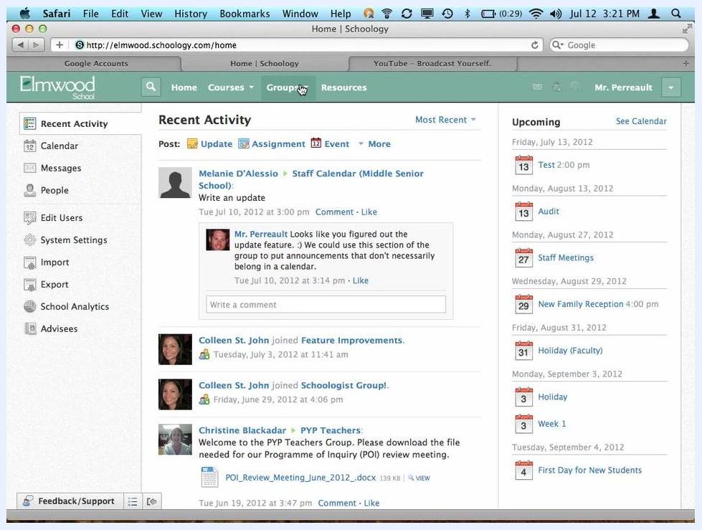
Group page showing the access code, and the Groups dropdown with the Join option

Step 4. Browse available groups and request to join
If you don't have an access code, you can browse the available groups instead:
- In the Groups dropdown, click See All.
- Browse the list of available groups, such as "Competitive Robotics" or "Elmwood Arts".
- Click a group name to view its details and request to join.
List of available groups with options to edit, add members, or join

Create a group

Step 5. Click Create in the Groups menu
To create your own group in Schoology, open the Groups dropdown and click Create.
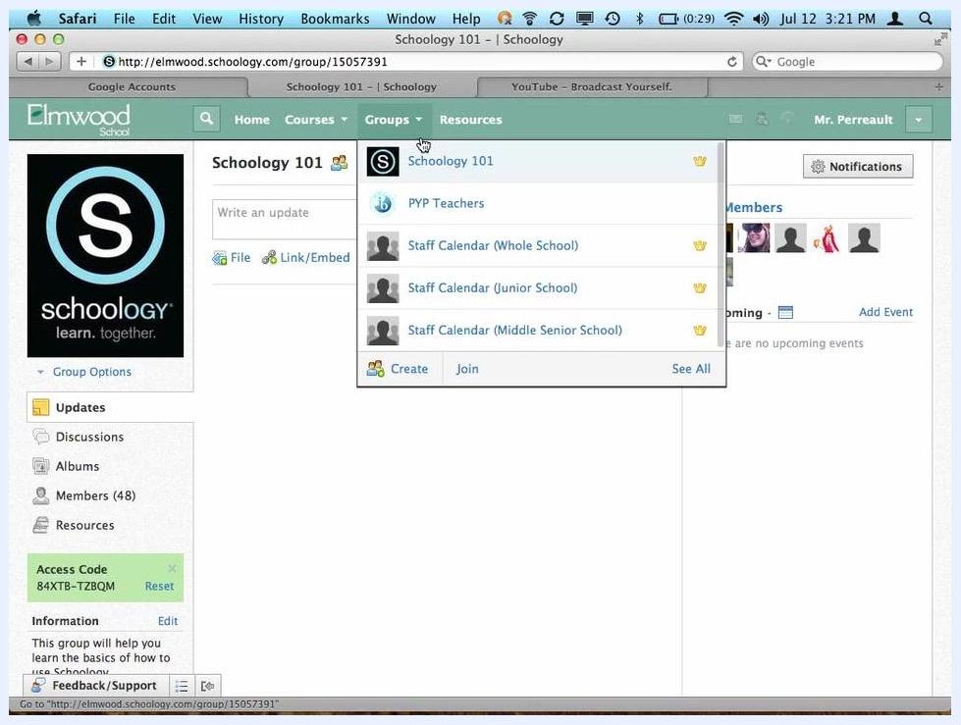
Groups dropdown with the Create option highlighted

Step 6. Fill out the group creation form
In the Create Group dialog, complete the following fields:
- Name: Enter the group name (for example, "Test").
- Description: Enter a brief description (for example, "description").
- Privacy: Select who can see the group.
- Access: Choose how people can join. Select Invite Only if you want members to be invited.
The Privacy options are:
- Everyone: The group is accessible to everyone.
- School: Only people in your school can access the group.
- Group: Only group members can see the group.
- Custom: Only invited people can see the group.
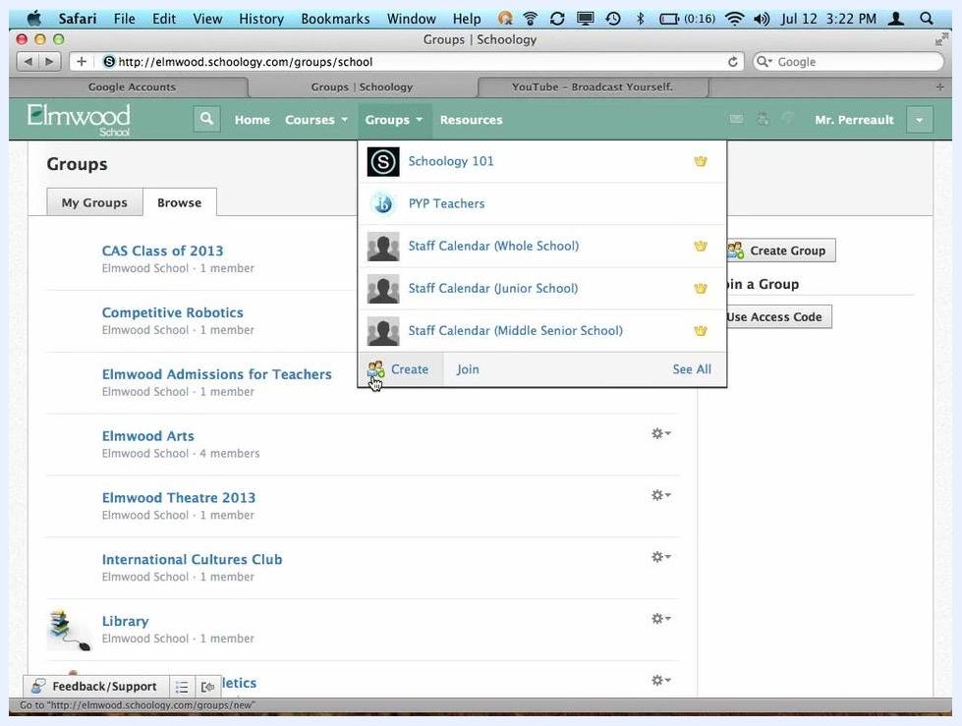
Create Group dialog with fields for Name, Description, Privacy, and Access

Step 7. Choose an Access option: Allow Requests
The Access setting controls how members join your group. The three options are:
- Invite Only: Only invited members can join.
- Allow Requests: Users can request to join, and you approve or deny their requests.
- Open: Anyone who can view the group can join without approval.
Use Allow Requests if you want people to find the group and ask to join, such as for a school club.
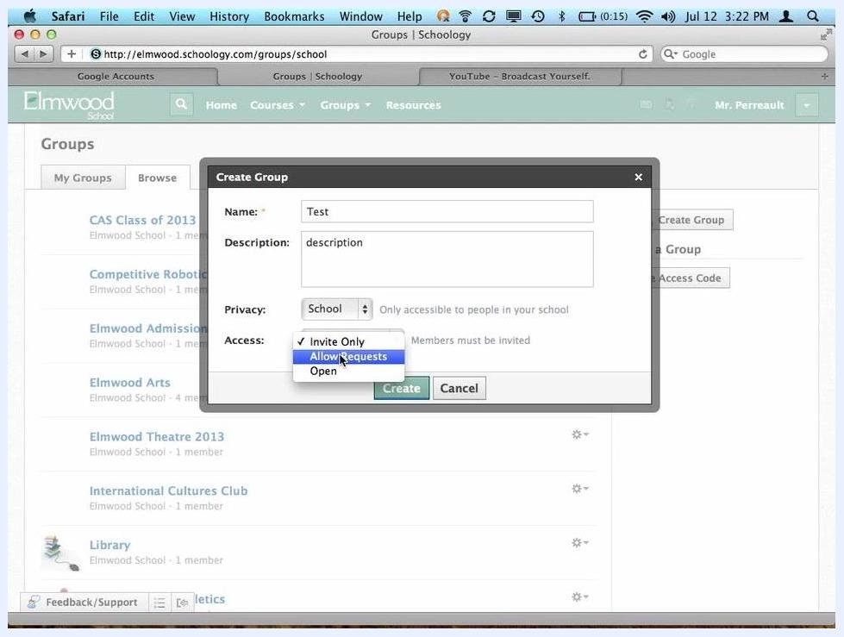
Create Group dialog with the Access dropdown open and Allow Requests highlighted

Step 8. Choose an Access option: Open
Use Open for groups that anyone in the school can join freely.
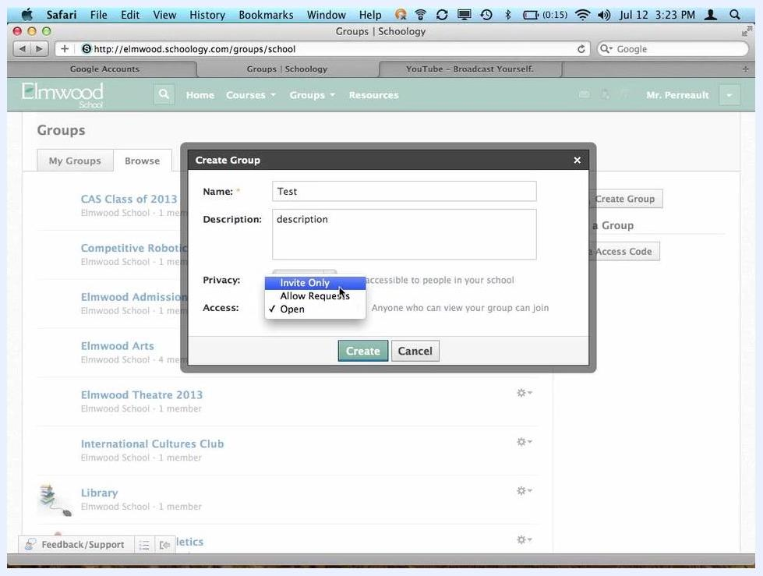
Create Group dialog with the Access dropdown open and Open highlighted

Step 9. Choose an Access option: Invite Only
Use Invite Only for private groups, such as a group where teachers organize something together.
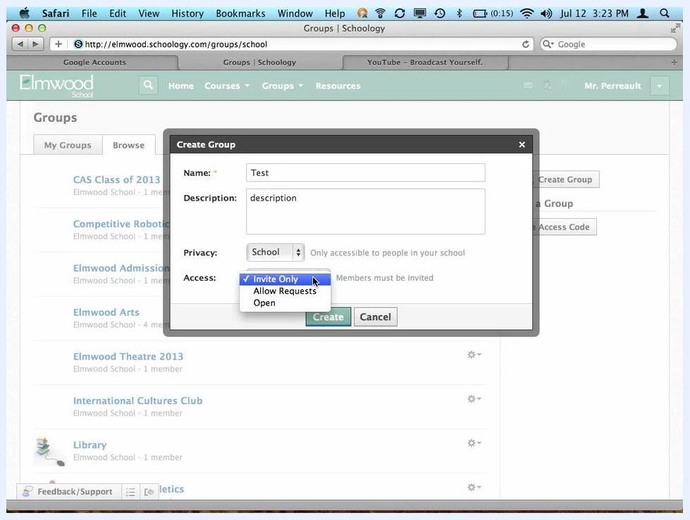
Create Group dialog with the Access dropdown open and Invite Only selected

Step 10. Click Create to finish
Click Create to finalize your new group.

Explore your new group

Step 11. Review the group homepage and sidebar
After you create the group, Schoology takes you to the group homepage. The page looks similar to a class page. You can post updates, view the group calendar, and see group members. The group access code is displayed so you can invite others.
The left sidebar gives you access to Updates, Discussions, Albums, Members, and Resources.
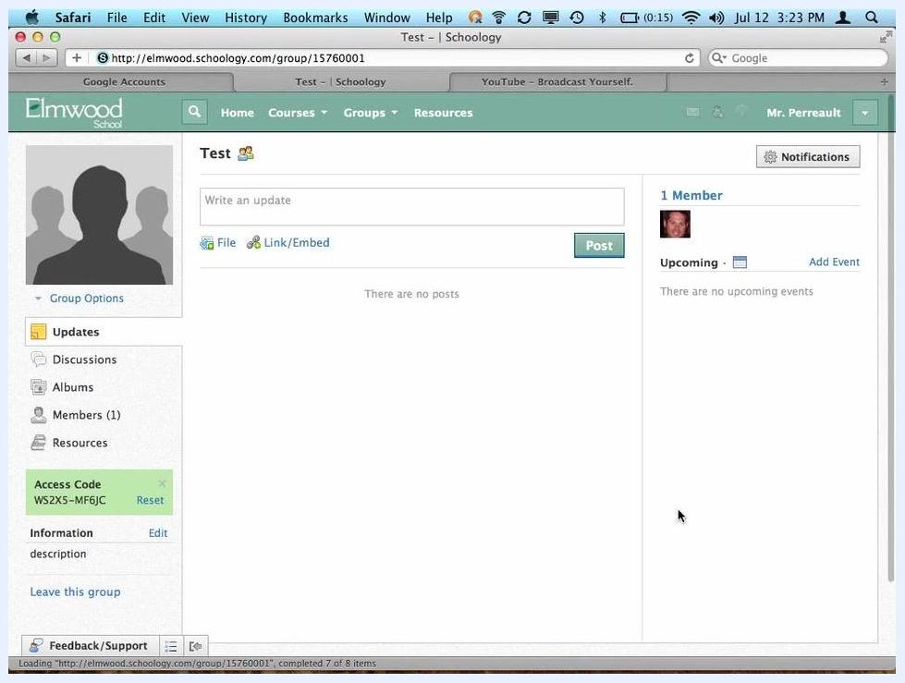
Schoology group homepage showing updates, calendar, members, and sidebar navigation

Step 12. Use the sidebar to navigate group features
Each sidebar item has a specific purpose:
- Updates: Post announcements or updates to the group.
- Discussions: Start or participate in group discussions.
- Albums: Organize and share media albums.
- Members: View and manage group members.
- Resources: Add and organize files, links, assignments, and more.
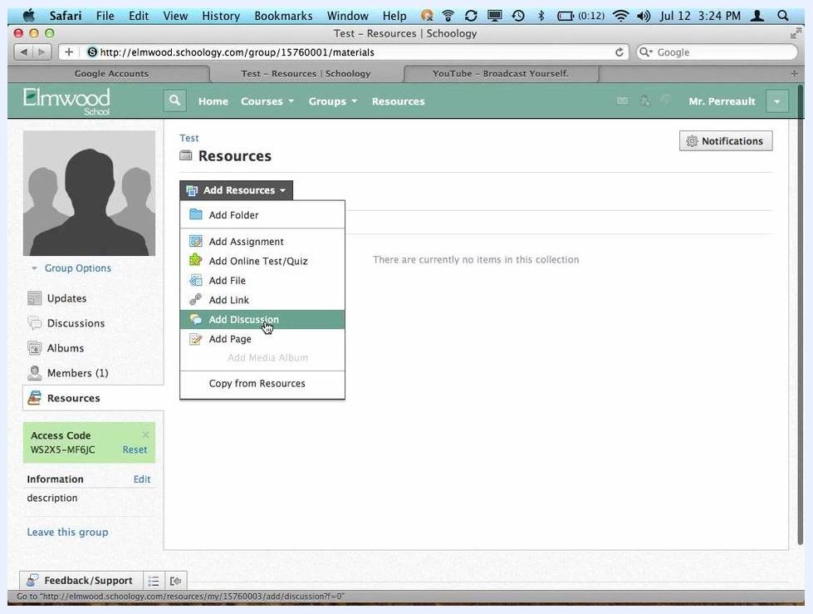
Group Discussions tab selected, showing the option to add a discussion

Step 13. Add resources to your group
Open the Resources tab and click Add Resources. You can choose from these options:
- Add Folder: Organize materials into folders.
- Add Assignment: Create assignments.
- Add Online Test/Quiz: Create tests or quizzes for reference.
- Add File or Add Link: Share files or web links.
- Add Discussion: Start a new discussion topic.
- Add Page: Create informational pages.
Resources tab open with the Add Resources menu expanded, highlighting Add Discussion
Group members can view assignments and tests that you create in a group. They cannot submit work or take tests the way they would in a class.
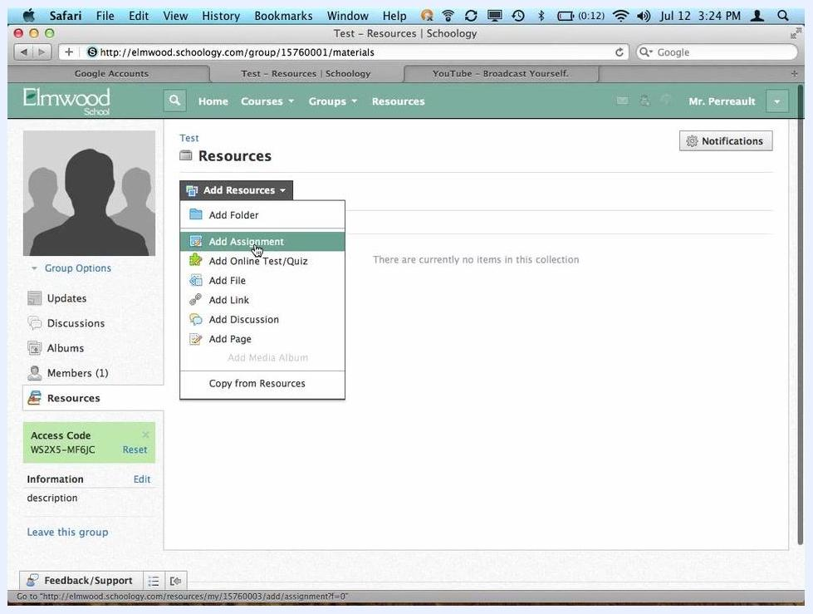
Resources tab open with the Add Resources menu expanded, highlighting Add Assignment

Step 14. Start a discussion
To start a discussion with your group or club, use the Add Discussion option under either the Discussions tab or the Resources tab.
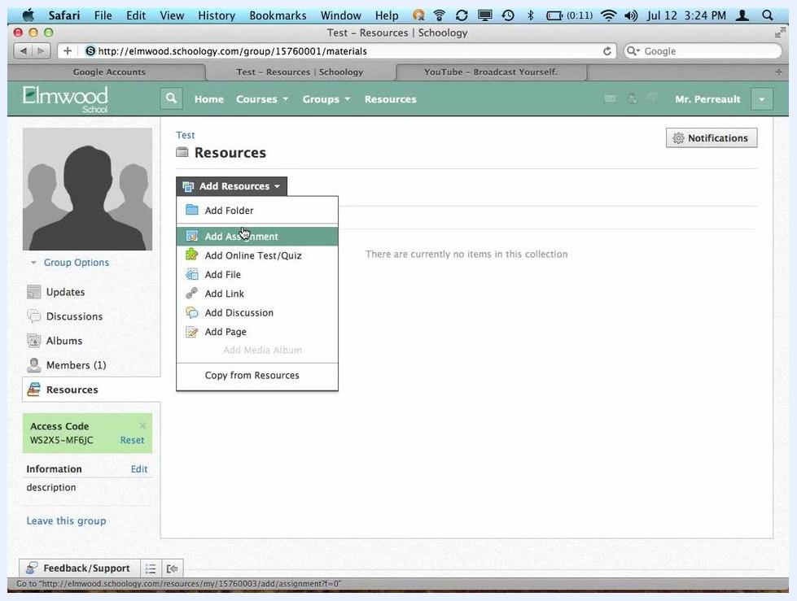
Resources tab with the Add Resources menu expanded, where you can choose Add Discussion

Edit your group

Step 15. Open Edit Info
To edit your group after you create it, click Group Options in the left sidebar and select Edit Info.

Step 16. Update the group details
In the Edit Group window, update these fields as needed:
- Name: Enter the group name (for example, "Test").
- Description: Enter a description for your group.
- Privacy: Choose who can access the group (for example, "School" for only people in your school).
- Access: Select how members can join (for example, "Allow Requests" to let people request to join).
- Category: Open the dropdown and select a category for your group, such as "General", "Advising Groups", or "Sports Groups".
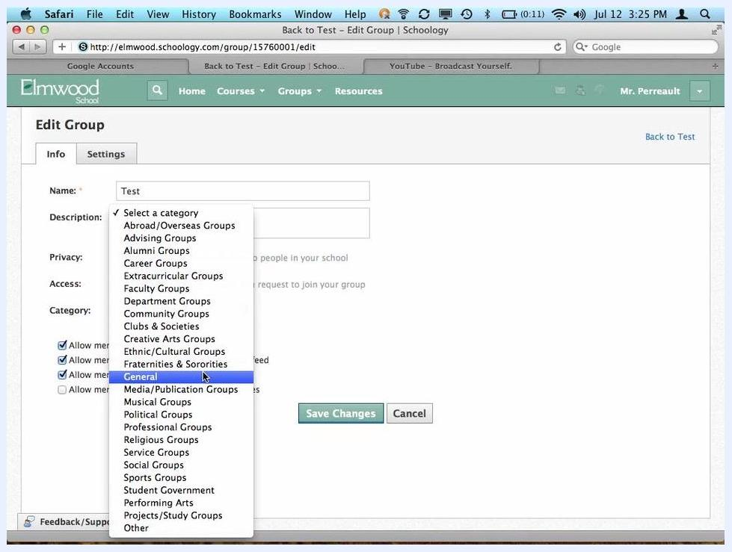
Edit Group window with fields for Name, Description, Privacy, Access, and Category, and member permission checkboxes

Step 17. Adjust member permissions
Check or uncheck the following options based on your group's needs:
- Allow members to post on group feed
- Allow members to post comments on group feed
- Allow members to create group discussions
- Allow members to post files/links to resources
Edit Group window with the member permission checkboxes highlighted

Step 18. Save your changes
Click Save Changes to apply your updates.

Control group privacy by component

Step 19. Open the Privacy settings
To control who can see different parts of your group, go to the Settings tab and select Privacy.

Step 20. Set visibility for each component
On the Group Privacy Settings screen, set visibility for each part of the group:
- Group Profile: Choose who can see the group profile: "Everyone", "Schoology Users", "School", "Group", or "No One".
- Updates, Calendar, Materials, Roster, Discussion Board: Set visibility for each item separately, for example only "School" or only "Group" members.
For example, you can let the whole school see the group profile, but allow only group members to see the updates, calendar, materials, roster, and discussion board.
Group Privacy Settings screen with visibility options for Group Profile, Updates, Calendar, Materials, Roster, and Discussion Board

Step 21. Save your privacy settings
Click Save Changes. A confirmation message, "Your changes have been saved.", appears at the top of the screen.
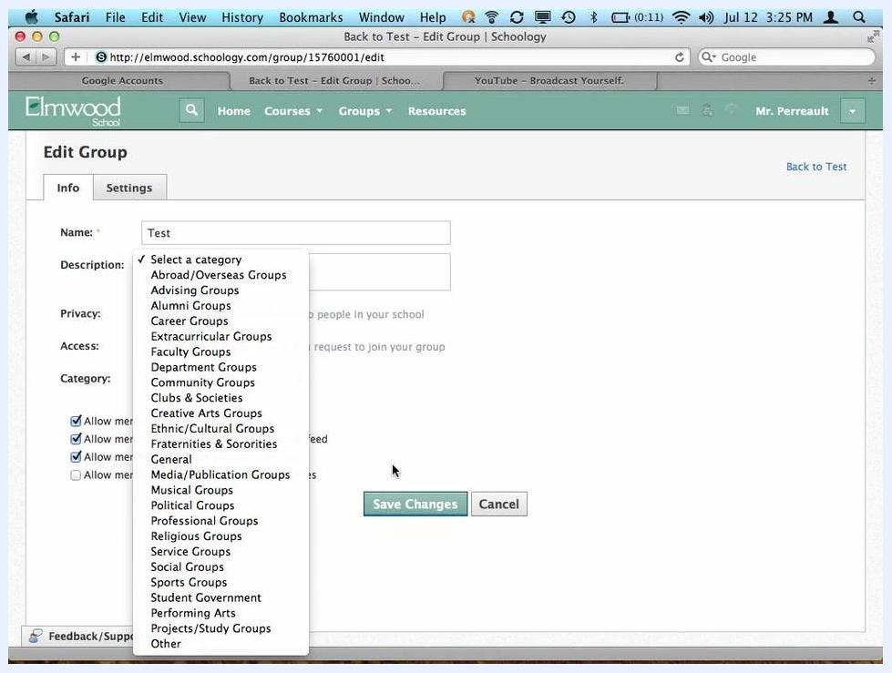
Group Privacy Settings screen with the confirmation message "Your changes have been saved."

Summary
You now know how to create a group in Schoology, choose its privacy and access settings, and add resources and discussions. You can also join existing groups, edit group details, set member permissions, and control the visibility of each group component. This flexibility lets you use groups for clubs, advising, social, or sports groups that suit your school's needs.

