How to create a banner in Schoology
If you want to learn how to create a banner in Schoology, this guide covers the whole process. You design a custom banner in Google Drawings, then add it to your course as a pinned announcement at the top of the page. The banner can include graphics, text, and links to important sections such as "Schedule," "This Week," "Contact Info," and "How-To Videos."
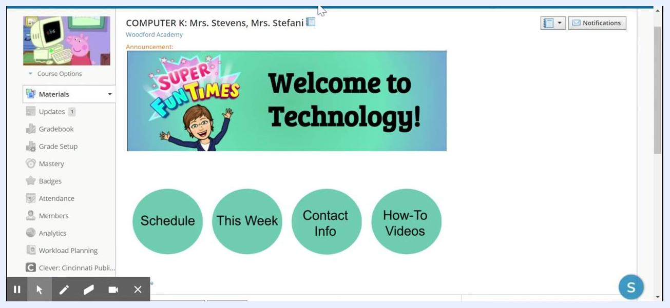
Schoology course page with a colorful banner reading "Welcome to Technology!" and four green circular buttons labeled "Schedule," "This Week," "Contact Info," and "How-To Videos"

Prerequisites
Before you start, make sure you have:
- A Schoology course where you want to display the banner
- A web browser to open Google Drawings at drawing.google.com
- Optional: a Bitmoji or another image to include in the banner

Part 1: Design the banner in Google Drawings

Step 1: Open Google Drawings
Enter https://drawing.google.com in your browser. A blank canvas opens, ready for editing.
The image below shows an example Schoology page with a banner and navigation buttons, similar to what you are building.
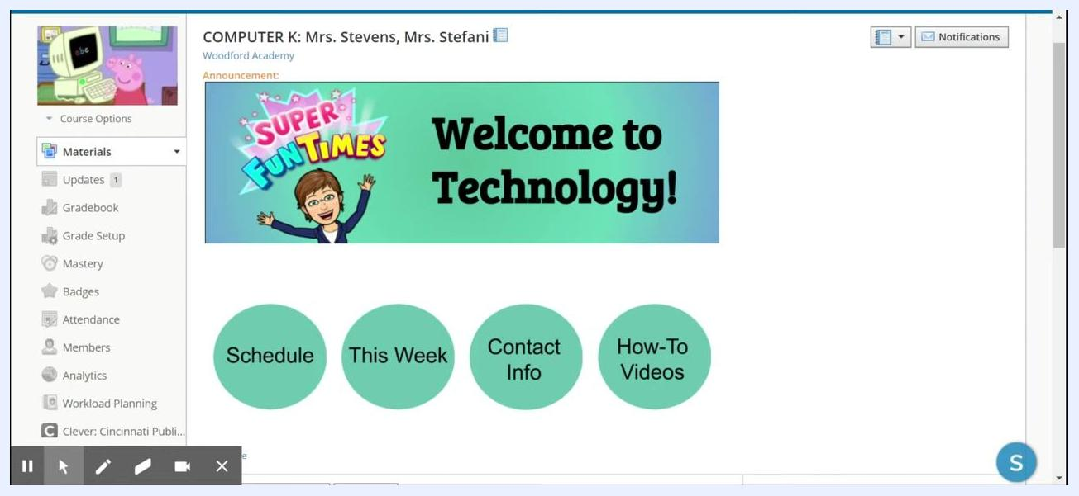
Example Schoology course page with a banner and navigation buttons

Step 2: Set the banner size
- In Google Drawings, click the File menu in the top left corner.
- Select Page setup from the dropdown menu.
Google Drawings with the File menu open and Page setup highlighted
- In the Page setup dialog, choose Custom and enter the dimensions 8 x 2 inches.
- Click Apply to set the canvas to the banner size.

Step 3: Draw the banner background
- Click the Shape tool in the toolbar.
- Select Shapes > Rectangle from the dropdown.
- Draw a rectangle that covers the entire canvas.
Google Drawings with the Shapes menu open, showing various shape options

Step 4: Choose a background color
With the rectangle selected, click the Fill color tool in the toolbar. Choose any color you like. You can select a solid color or a gradient.
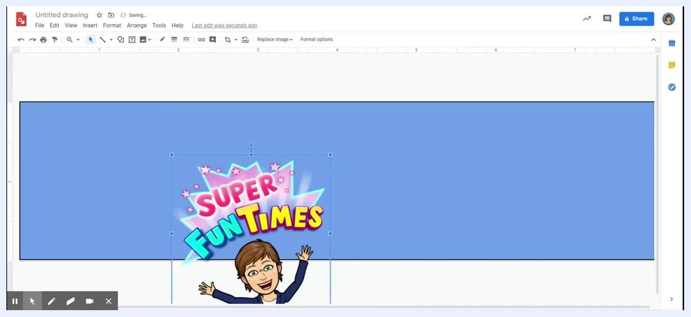
Google Drawings with a large blue rectangle covering the canvas and the color palette open

Step 5: Add graphics (optional)
To include a Bitmoji or other image, use the Bitmoji extension or drag and drop your image onto the canvas. Then resize and position the image as you want.
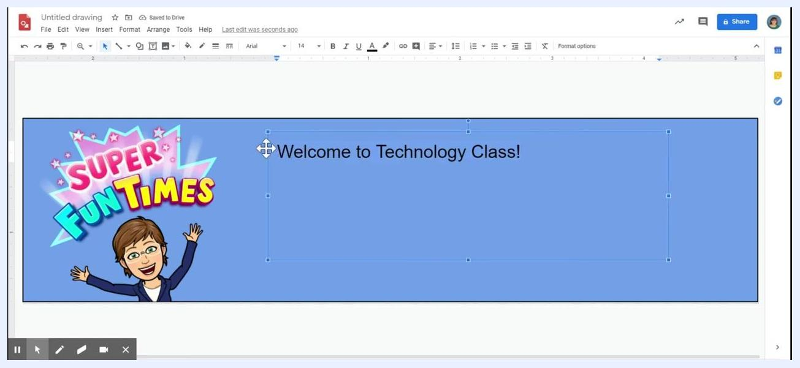
Google Drawings with a Bitmoji image and a "SUPER FUN TIMES" graphic placed on the left side of the banner

Step 6: Insert and format text
- Click the Text box tool in the toolbar.
- Draw a text box on the banner and type your message, such as "Welcome to Technology Class!"
- Format the text as you would in a word processor.
You can change the font style (for example, Arial), adjust the font size (for example, 36 pt), and center or align the text as needed.
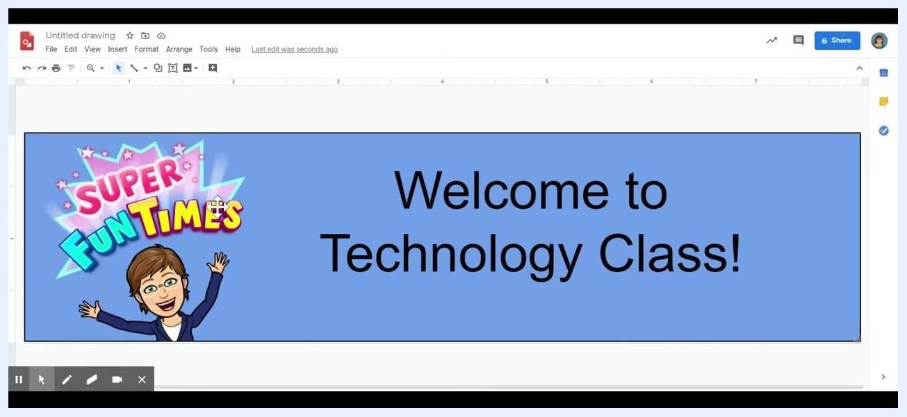
Google Drawings with a text box being edited, containing the text "Welcome to Technology Class!"

Step 7: Finalize and download the banner
- Make any final adjustments to the layout, colors, and text.
- Go to the File menu.
- Select Download, then choose PNG image (.png) to save your banner.
Google Drawings with the completed banner: a "SUPER FUN TIMES" graphic and "Welcome to Technology Class!" text on a blue background

Part 2: Add the banner to your Schoology course

Step 8: Open your course
From the Schoology dashboard, click the course where you want to add the banner. For example, click "COMPUTER 3: Mrs. Couch, Mrs. Saddler" in the list of courses.
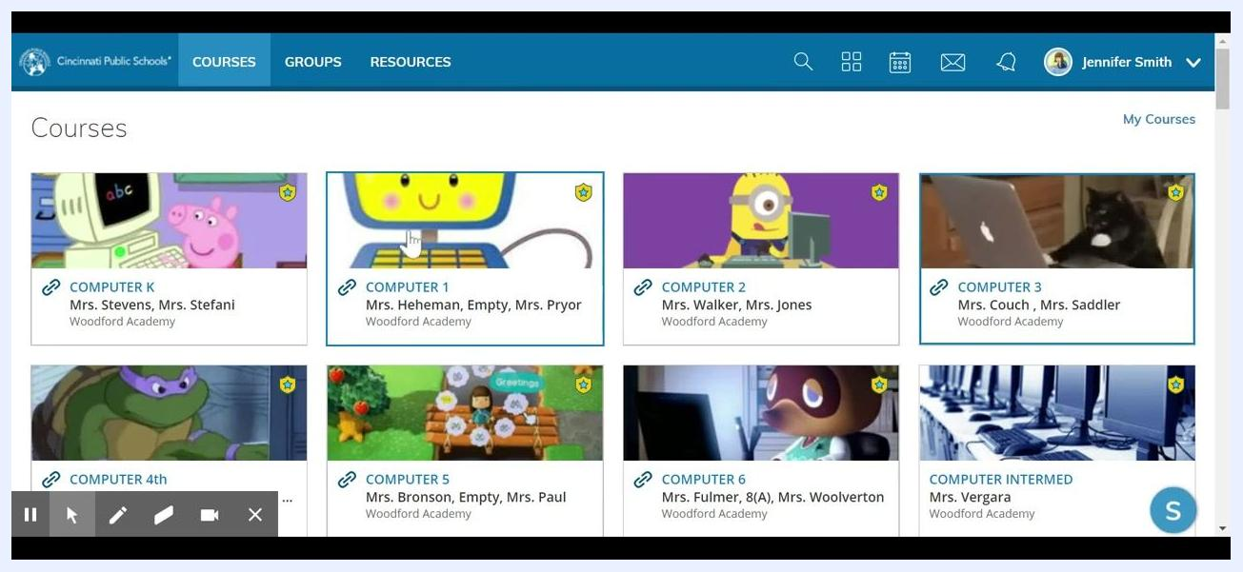
Schoology dashboard showing multiple courses, with the cursor selecting COMPUTER 3: Mrs. Couch, Mrs. Saddler

Step 9: Add a new page to Materials
- In your course, click the Add Materials button.
- From the dropdown menu, select Add Page.
Schoology course page with the Add Materials menu open, highlighting the Add Page option

Step 10: Insert the banner image
- In the new page editor, click the Insert Content button. It is usually shown as an image or media icon.
- Select Image or Insert Media.
- In the Insert Media dialog, click Attach File under the Upload Media tab.
- Locate and select the banner image file you saved, such as the PNG file from Google Drawings.
Insert Media dialog open in Schoology, with the Attach File button highlighted

Step 11: Add a page title and create the page
- Enter a title in the Page Title field, for example "banner".
- Make sure your banner image appears in the content area.
- Check any required boxes at the bottom of the page, such as "Display on Course Page" or similar, if available.
- Click Create to save the page.
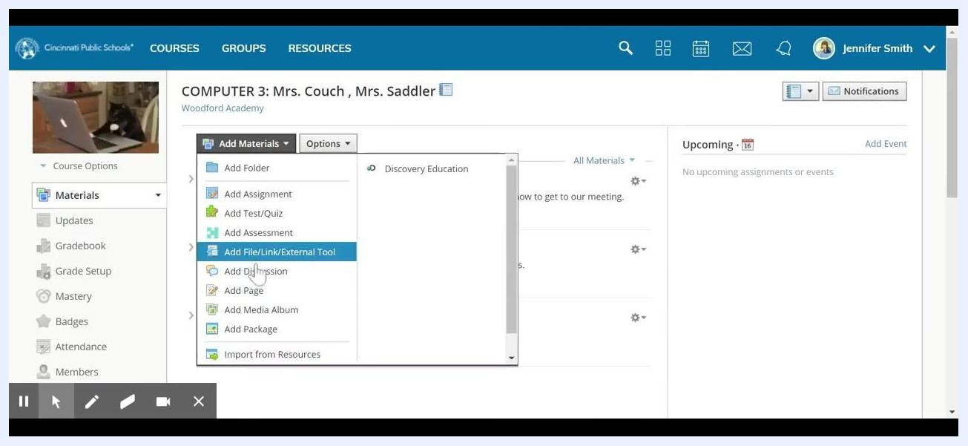
Schoology page editor with the banner image inserted and "banner" entered as the page title

Step 12: Copy the banner image
- Find the new page in your Materials list.
- Click the gear icon next to the page and select Edit.
- In the editor, select the banner image and copy it. Right-click and select Copy, or press Ctrl+C.
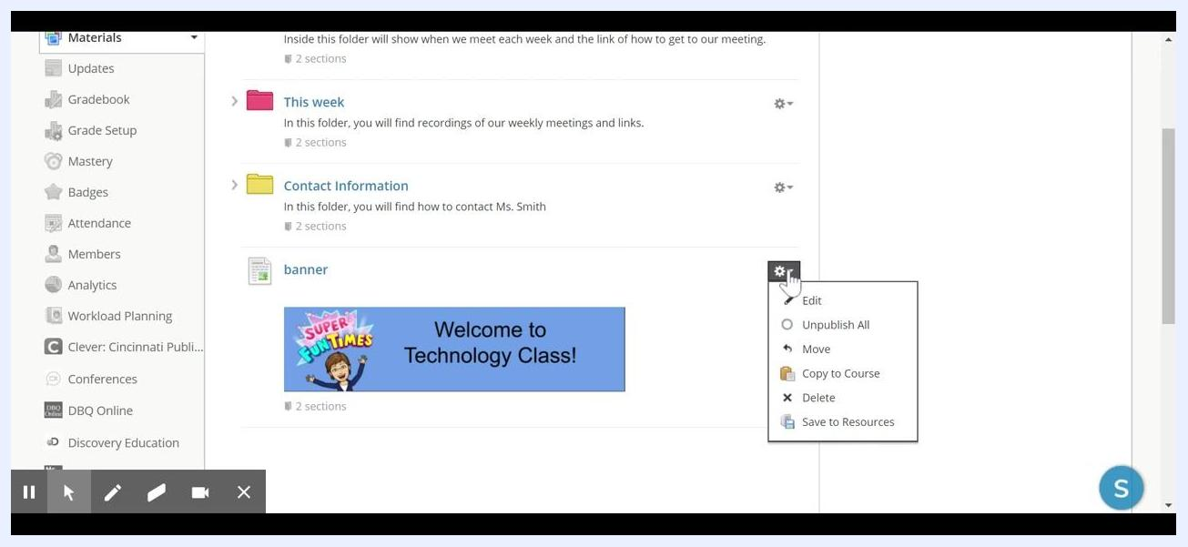
Schoology Materials list with the gear icon menu open for the banner page, showing the Edit option

Step 13: Paste the banner into an update and pin it
- Go to the Updates section in your course menu.
- Create a new update or announcement.
- Paste the copied banner image into the content area with Ctrl+V, or right-click and select Paste.
- If needed, click and drag the image corners to resize the banner.
- Click the bell icon to pin the announcement to the top of the page.
- Click Post to publish the update.
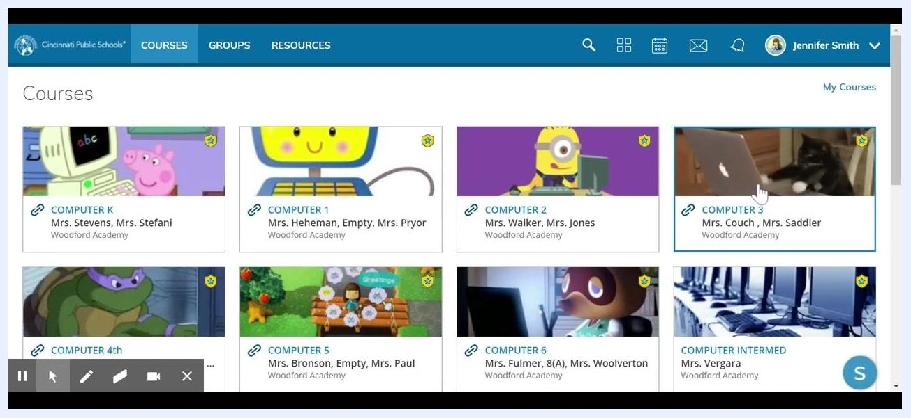
Schoology Updates section with the banner image pasted and the bell icon checked before posting

Step 14: Verify the banner placement
Return to your course page and confirm that the banner appears at the top as an announcement.
Schoology course page with the custom banner "Welcome to Technology Class!" displayed at the top as an announcement

Summary
You now know how to create a banner in Schoology. You designed an 8 x 2 inch banner in Google Drawings and downloaded it as a PNG. You then added it to a course page, copied it into a pinned update, and confirmed it appears at the top of your course. Your students now see a welcoming, organized introduction when they open the course.

