How to archive a course in Schoology and send it to the next semester or year
This guide shows you how to archive a course in Schoology by saving it to your personal resources. You can then add the saved content to a new or existing course for the next semester or year. The process copies your course materials, content, and grades to your resource library, and you can transfer everything at once instead of moving files one by one.

Prerequisites
- Access to the course you want to archive.
- Access to the Resources tab in the top navigation bar.
- A destination course, if you plan to reuse the content right away.

Save the course to resources

Step 1: Go to the course you want to archive
Log in and find the course in your course list. This guide uses "Computer Programming 2: 8(A)" as an example. Make sure you are on the main course page.
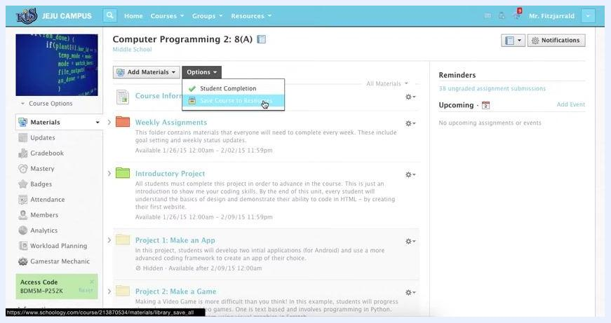
Main course page showing the course title, the navigation sidebar, and the materials list

Step 2: Open the Materials tab
In the left sidebar, click Materials. Confirm that the materials list appears in the main section.
Materials tab selected, showing course materials such as Weekly Assignments, Introductory Project, and Projects

Step 3: Open the Options menu and choose Save Course to Resources
At the top of the materials list, click Options. A dropdown menu appears with two actions: Student Completion and Save Course to Resources. Click Save Course to Resources.
Options dropdown open with Save Course to Resources highlighted

Step 4: Choose where to save the archived course
The Save Course to Resources dialog appears. Under Collection, select Home to save the course to your personal resources.
Avoid Group Resources and School Resources unless you want to share the course with those groups. You can also use the Folder and Save as fields to organize or rename the saved course.
Save Course to Resources dialog showing collection options including Home, Group Resources, and School Resources

Step 5: Submit the save
Click Submit. The system begins transferring all course materials, content, and grades to your resource library. A notification bar at the top tells you a large operation is being executed.
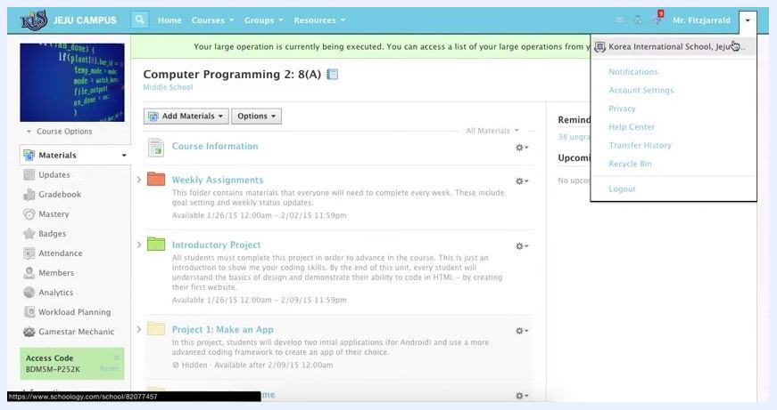
Notification bar at the top indicating a large operation is being executed, with course materials visible

Check the transfer progress

Step 6: Open Transfer History
To monitor the transfer, click the dropdown arrow next to your name in the upper right corner. Select Transfer History.
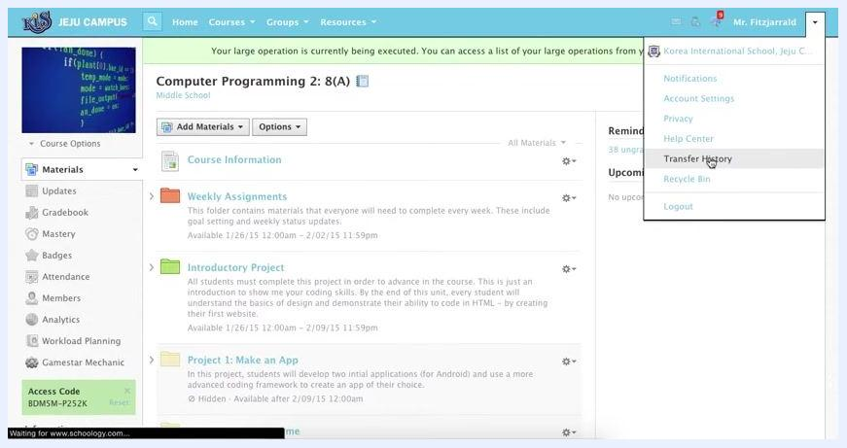
User dropdown menu open with Transfer History highlighted

Find your archived course in personal resources

Step 7: Open your Personal resources
When the transfer is complete, click Resources in the top navigation bar. Select Personal from the dropdown menu. Then locate the folder named after your course, for example "Computer Programming 2: 8(A)".
Resources tab open with a dropdown showing Personal, Public, Group, and Apps options

Step 8: Verify the archived course folder
Navigate to your Home directory under Personal resources. Confirm that the archived course folder appears in the list alongside other folders, such as "Example Lesson Folder," "Schoology Training," and "Technology." Make sure the folder is visible and accessible for future use.
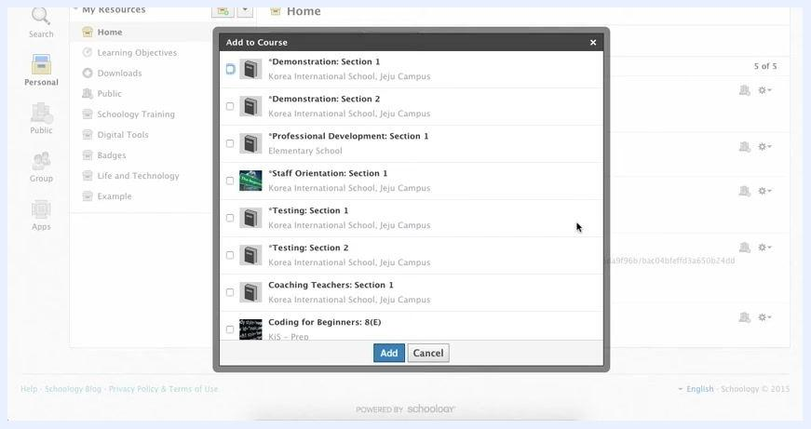
Home directory in Personal resources showing the archived course folder among other folders

Add the archived content to a new course

Step 9: Open Add to Course for the archived folder
You can move all materials from the archived folder into a new or existing course. Click the sprocket (settings) icon next to the folder, for example "Computer Programming 2: 8(A)". Then select Add to Course from the dropdown menu.
This transfers all contents at once, so you don't need to move individual files. The Add to Course dialog appears and lists all available courses.
Add to Course dialog showing a list of available courses to transfer content into

Step 10: Select the destination course and add the content
In the Add to Course dialog, review the list of available courses, such as "Demonstration: Section 1," "Professional Development: Section 1," "Testing: Section 1," and "Coding for Beginners: 8(E)." Select the checkbox next to each course you want to transfer the content into. Then click the blue Add button.
The system archives everything into the selected course or courses and your resources, so you keep a copy even if you leave the institution.
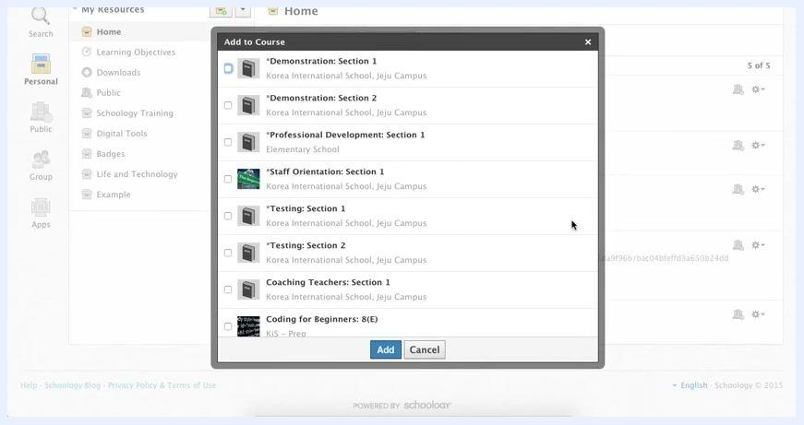
Add to Course dialog with courses listed and the Add and Cancel buttons visible

Step 11: Wait for the transfer to finish
Wait while the system processes the transfer. All materials from the selected folder are copied into the chosen course or courses. The entire folder and its contents move at once, and your resources remain archived for future access or export.

Summary
You now know how to archive a course in Schoology: save it to your personal resources, confirm the folder, and add its content to another course. Always check that you are saving to your personal collection unless you intend to share the course with a group or the entire school.

What's next
- Use Transfer History to confirm that a transfer has finished.
- Reopen your archived folder in Personal resources whenever you need the content for a future semester or year.
- Use Add to Course to reuse the archived content in any additional course.

