How to Process a Goods Receipt in SAP Using MIGO
This guide walks you through the complete Goods Receipt (GR) process in SAP, from understanding the concept to posting the document and verifying the resulting material and accounting documents. Goods Receipt is the process of confirming that materials ordered in a purchase order have been received at a plant or warehouse.

Prerequisites
Before you begin, make sure you have the following information ready:
- Purchase Order (PO) Number: e.g., 4500017231
- Vendor name: e.g., ABC Vendor / C.E.B. BERLIN
- Material code: e.g., 100-100
- Quantity ordered: e.g., 10 pieces
- Plant code: e.g., 1000
- Access to the SAP Easy Access screen

Understanding the goods receipt process
A Goods Receipt confirms that materials ordered on a purchase order have arrived at the specified plant or warehouse. In a typical scenario:
- The company raises a purchase order with a vendor.
- The vendor dispatches the ordered material to the plant.
- Upon arrival, plant personnel check the quality and quantity of the received goods.
- After verification, plant personnel create a Goods Receipt Note (GRN) in SAP.
- The GRN confirms that the materials listed in the purchase order have been received at the specified plant.
For reference, this guide uses the following example data:
- PO Number: 4500017231
- Vendor: ABC Vendor
- Material: 100-100
- Quantity: 10 pcs
- Plant: 1000
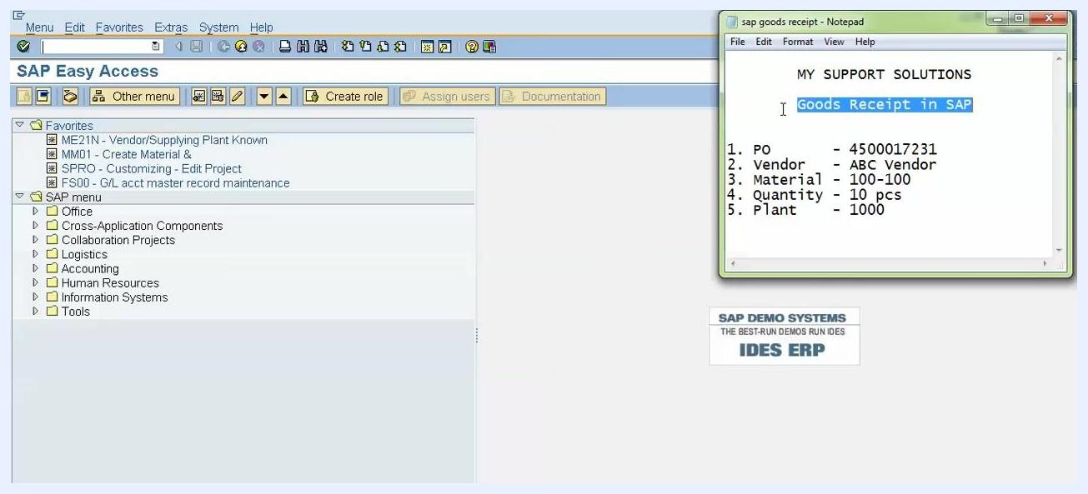
SAP Easy Access screen with a Notepad displaying "MY SUPPORT SOLUTIONS", "Goods Receipt in SAP," and the example PO details: 1. PO – 4500017231, 2. Vendor – ABC Vendor, 3. Material – 100-100, 4. Quantity – 10 pcs, 5. Plant – 1000. The SAP Easy Access menu is visible on the left, with folders for Office, Logistics, Accounting, and others.
Once the GRN is created, SAP automatically generates two documents:
- Material Document: Records the movement of materials.
- Accounting Document: Records the financial impact of the goods receipt.

Step 1: Open the SAP Easy Access screen
Make sure you are on the SAP Easy Access screen and have your purchase order details on hand for reference.
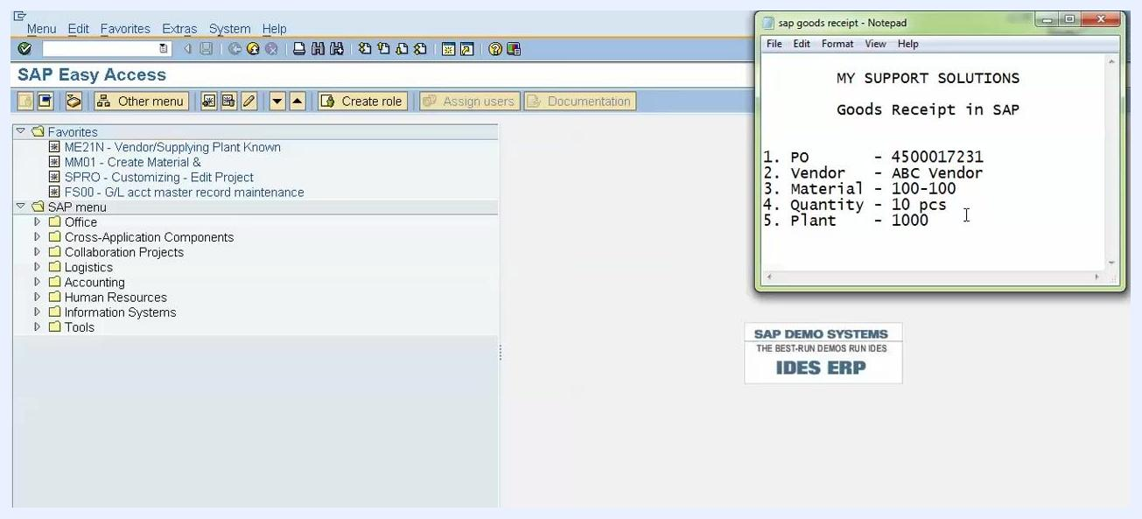
SAP Easy Access screen with a Notepad showing the purchase order details for reference.

Step 2: Start the goods receipt transaction
Enter transaction code MIGO in the command field on the SAP Easy Access screen and press Enter to begin the goods receipt process.

Step 3: Select goods receipt against the purchase order
On the MIGO screen, configure the following:
- Action: A01 Goods Receipt
- Reference Document: R01 Purchase Order
Enter your Purchase Order Number (e.g., 4500017231) in the corresponding field, and confirm that the Movement Type is set to 101 (Goods Receipt for Purchase Order). Movement Type 101 is the standard type used for goods receipt against a purchase order.
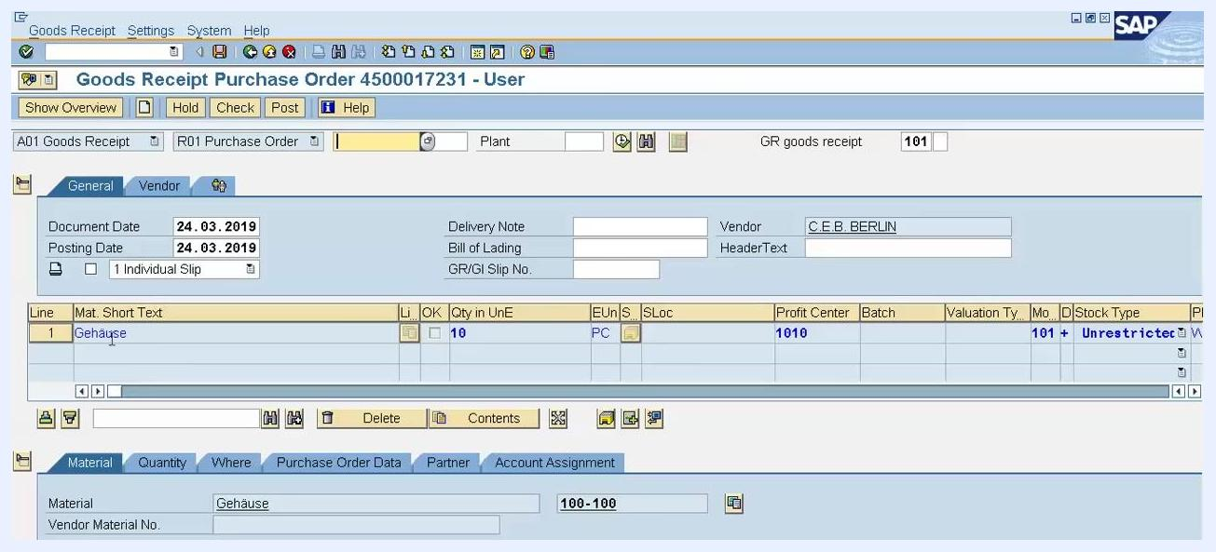
MIGO screen with the Goods Receipt action selected, Purchase Order set as the reference, PO number 4500017231 entered, and Movement Type 101 configured.

Step 4: Review the displayed purchase order contents
Press Enter after entering the purchase order number. SAP displays the contents of the purchase order, including:
- Material: 100-100 (Short Text: Gehäuse)
- Quantity: 10 (in PC – pieces)
- Vendor: C.E.B. BERLIN (per system master data)
- Profit Center: 1010
- Stock Type: Unrestricted
- Movement Type: 101
- Document Date: 24.03.2019
- Posting Date: 24.03.2019
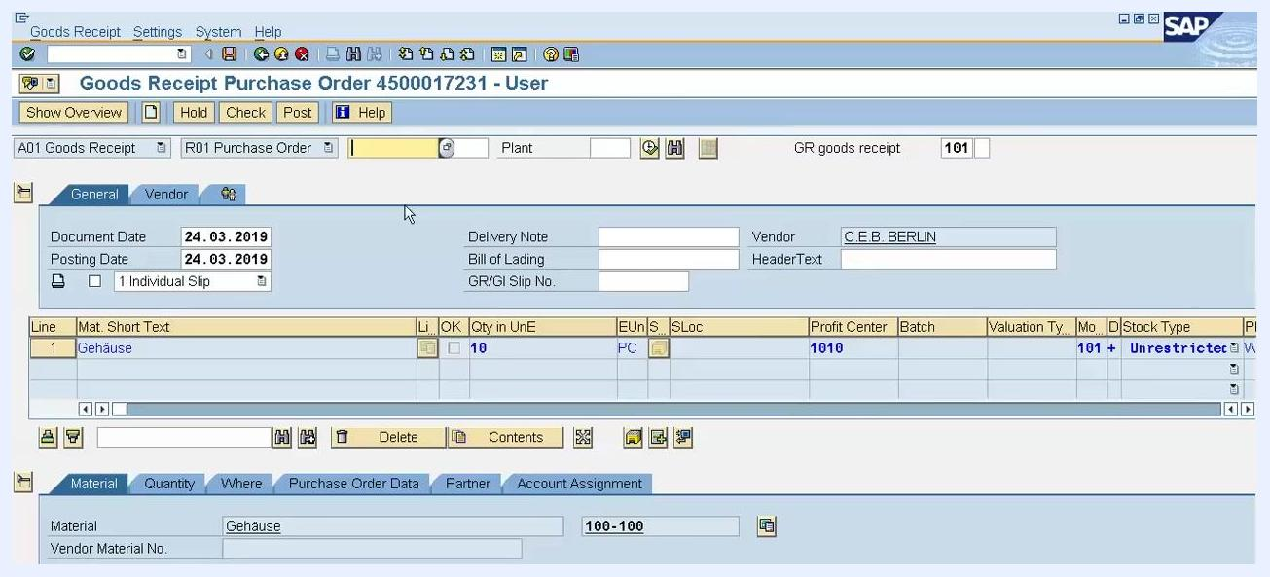
MIGO screen showing purchase order details: Material 100-100, Quantity 10, Vendor C.E.B. BERLIN, Profit Center 1010, Stock Type Unrestricted, Movement Type 101, and Document/Posting Date 24.03.2019.

Step 5: Enter delivery note and shipment references
In the Delivery Note field, enter the vendor's delivery challan or note number as provided with the shipment.
Depending on the vendor and your local requirements, you can also fill in these optional fields:
- Bill of Lading: For import (foreign) vendors, enter the Bill of Lading document number. For domestic vendors, enter the LR (Lorry Receipt) number or docket number.
- GR/GI Slip No.: Enter the Goods Receipt/Goods Issue slip number if required by your country's regulations. This field is mandatory only in certain countries.
- Header Text: Add additional notes if your organization requires them.
The vendor name (e.g., C.E.B. BERLIN) and other PO details remain visible for reference.
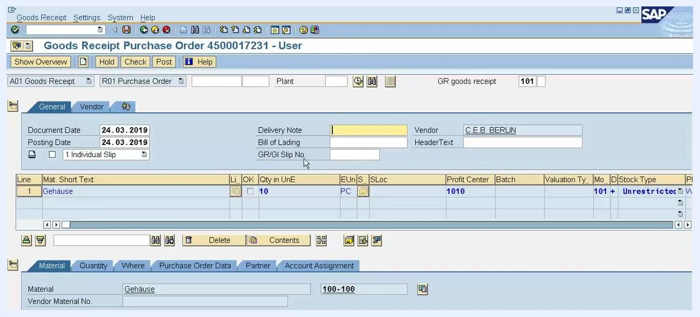
SAP MIGO screen showing the Delivery Note, Bill of Lading, and GR/GI Slip No. fields, along with vendor details.

Step 6: Review and adjust the received quantity
Click the Quantity tab at the bottom of the screen. In the Qty in Unit of Entry field, enter the actual quantity received:
- If you received the full quantity as per the PO (e.g., 10 PC), leave the value unchanged.
- If you received a different quantity (e.g., 9 PC), update the field accordingly.
You can also update the Qty in SKU and Qty in Delivery Note fields if required.
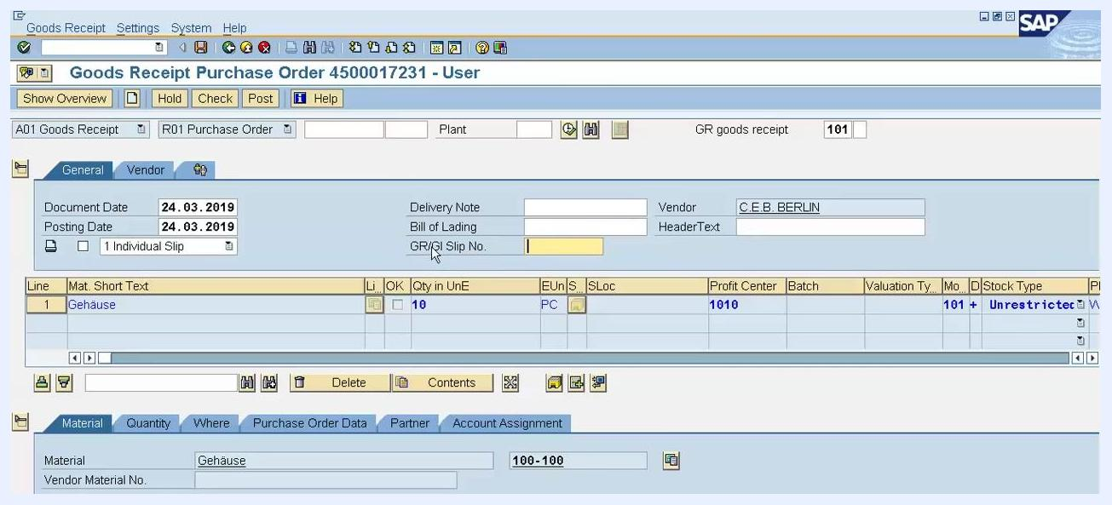
SAP MIGO screen with the Quantity tab open, showing the Qty in Unit of Entry and Qty in SKU fields.

Step 7: Specify the storage location and goods recipient
Click the Where tab. In the Storage Location field, enter the code for the physical location where the material will be stored within your plant:
- If the storage location was already specified in the purchase order, this field may be pre-filled.
- If not, enter it manually (e.g., S10).
In the Goods recipient field, enter the name or code of the person or department receiving the goods (e.g., S30). Confirm that the Plant field is correctly set (e.g., Werk Hamburg, code 1000), and that Movement Type is 101 with Stock type set to Unrestricted use.
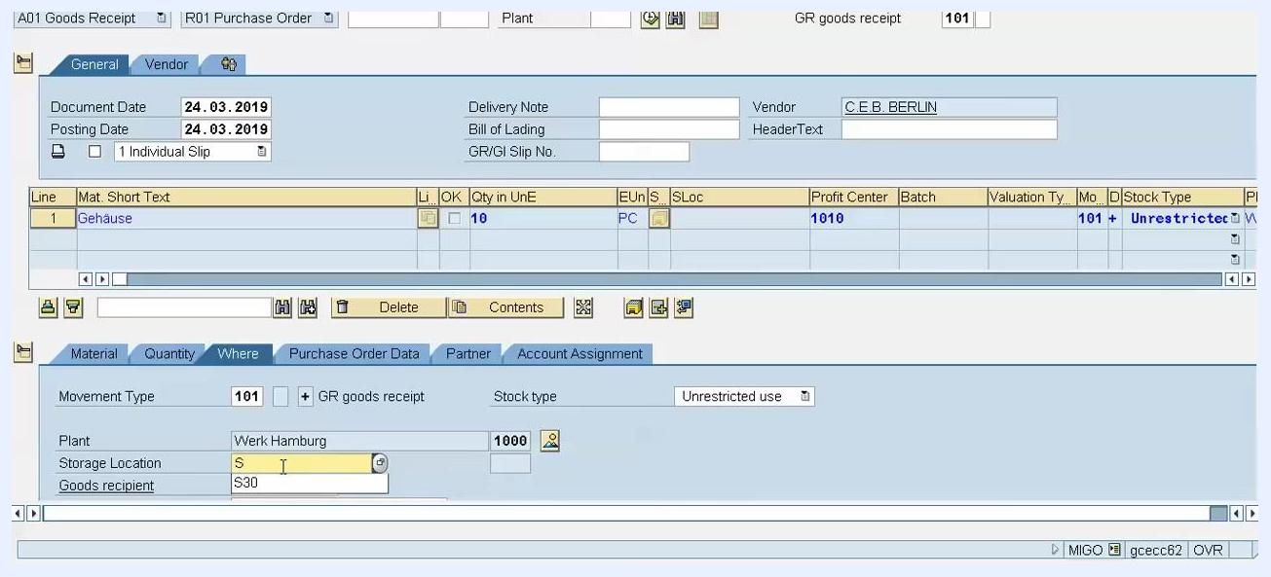
SAP MIGO screen with the Where tab open, showing Storage Location (S10), Goods recipient (S30), Plant (Werk Hamburg, 1000), Movement Type (101), and Stock type (Unrestricted use).

Step 8: Verify the storage location entry
Review the Storage Location field in the Where tab:
- If the storage location (e.g., S30) is already specified in the purchase order, you do not need to re-enter it.
- If the field is empty and your process requires it, enter the appropriate storage location code.
Confirm that the Plant field is set to Werk Hamburg with code 1000, Movement Type is 101, and Stock type is Unrestricted use. Double-check all entries for accuracy before proceeding.
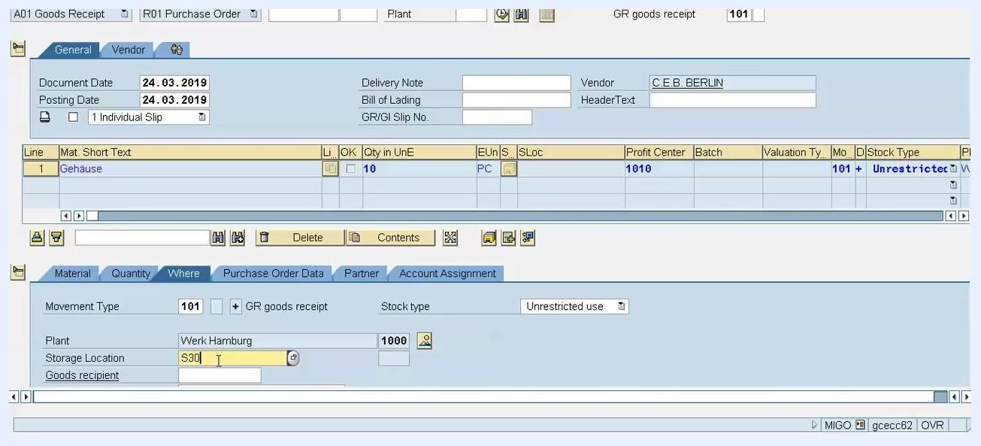
SAP MIGO "Where" tab showing the Storage Location field set to S30, an empty Goods recipient field, Plant set to Werk Hamburg (1000), Movement Type 101, and Stock type Unrestricted use.

Step 9: Enter the goods recipient name
In the Where tab, locate the Goods recipient field and enter the name of the person who will receive or unload the goods — typically the individual responsible for handling the delivery within the company. Leave the field blank if not specified, or enter the appropriate name per your company's process.
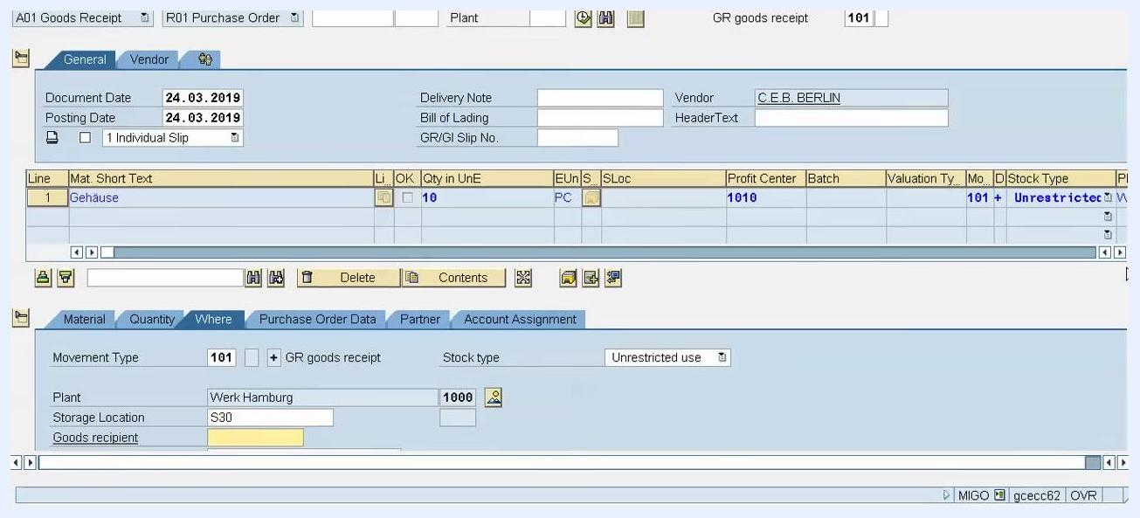
SAP screen showing the Goods recipient field highlighted in the Where tab, along with the Plant, Storage Location, and Stock type fields.

Step 10: Verify and set the stock type
The Stock type field defaults to Unrestricted use, meaning the goods are available for immediate use or sale. If required, click the dropdown in the Stock type field to select a different option:
- Unrestricted use
- Quality inspection
- Blocked stock
Choose the stock type that matches your requirements.
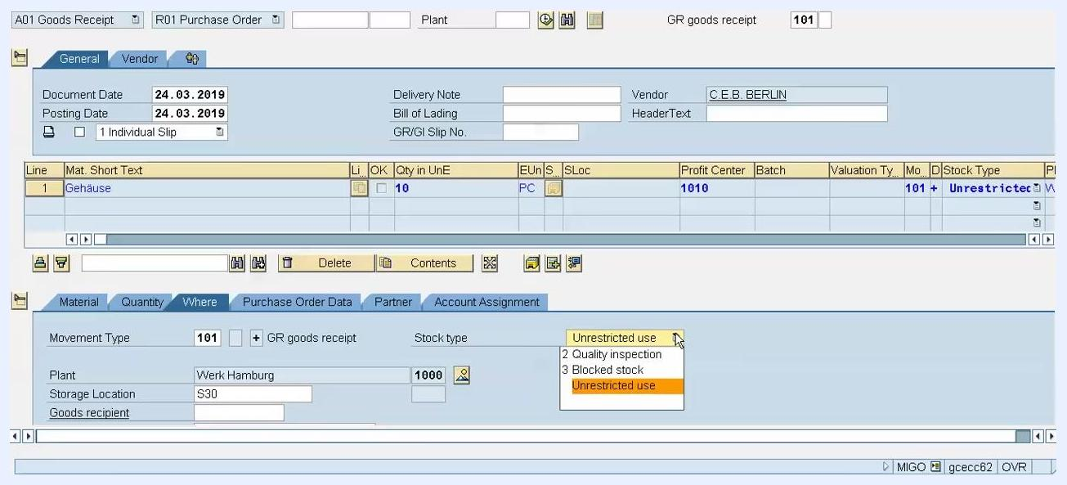
Dropdown menu for the Stock type field showing the options: Unrestricted use, Quality inspection, and Blocked stock.

Step 11: Set a valid storage location
In the Where tab, locate the Storage Location field and enter the correct storage location code. If you enter an invalid code (e.g., S30), SAP displays a message such as: "No hits were found for storage location S30 in plant 1000." Use the dropdown to select a valid storage location, such as 0001.
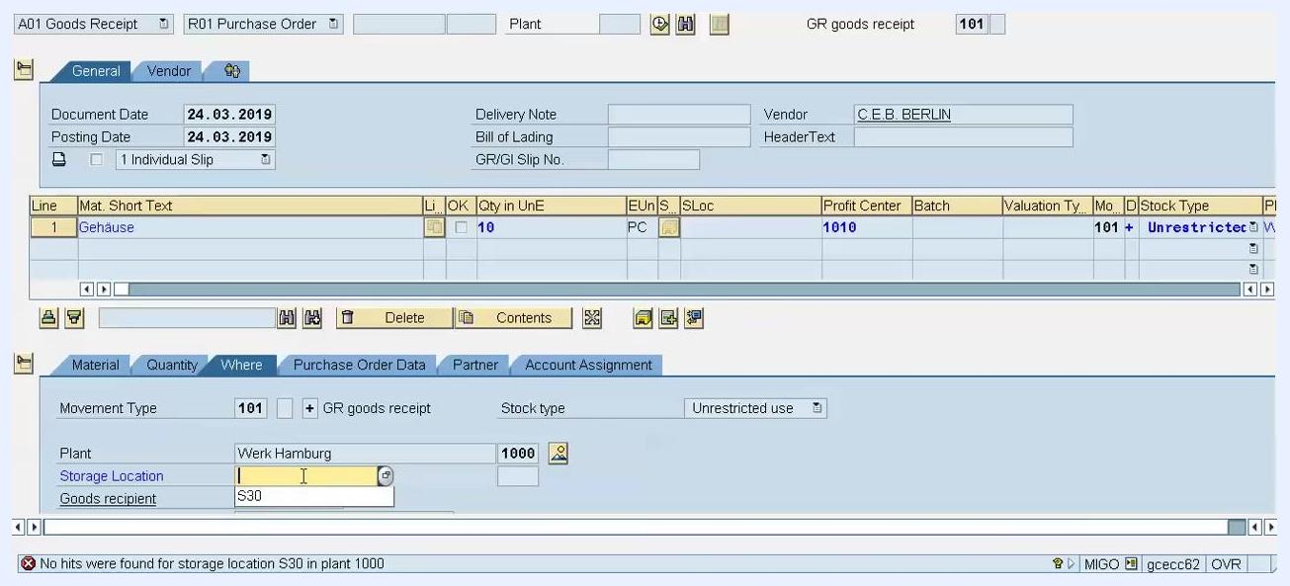
Storage Location field being edited, with a dropdown showing options S30 and 0001, and a warning message about an invalid storage location.

Step 12: Review and adjust the goods receipt quantity
Switch to the Quantity tab and enter the actual quantity received in the Qty in Unit of Entry and Qty in SKU fields. For example, if the purchase order was for 10 pieces but only 9 were received, enter "9" in both fields. SAP will treat the purchase order as still open for the remaining quantity unless you mark the delivery as complete.
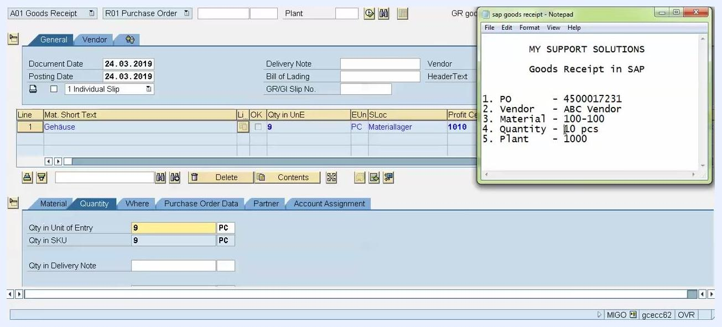
Quantity tab showing Qty in Unit of Entry and Qty in SKU both set to 9 PC, with the rest of the SAP interface visible.

Step 13: Set the delivery completed indicator (if applicable)
Go to the Purchase Order Data tab and locate the Delivery Completed indicator. If you want SAP to treat the purchase order as fully received — even though the quantity received is less than ordered — set this indicator. This prevents the system from expecting further goods receipts for this order.

Step 14: Review the purchase order data
In the Purchase Order Data tab, confirm the following:
- The Purchase Order field shows the correct PO number: 4500017231.
- The Del. Completed Ind. field is set to 2 Set, indicating the delivery is considered complete even though the full quantity was not received.
- The Item Category is Standard.
- The Qty in UnE (Quantity in Unit of Entry) is 9.
- The SLoc (Storage Location) is Materiallager, and the Profit Center is 1010.
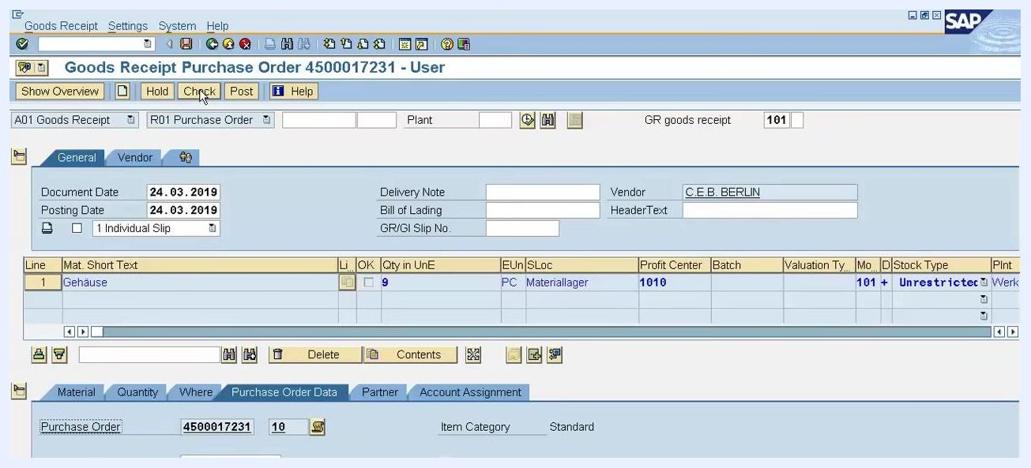
SAP screen showing the Purchase Order Data tab with PO number 4500017231, Del. Completed Ind. set to 2 Set, and quantity fields filled in.

Step 15: Confirm the item is marked OK
In the item overview section, make sure the checkbox under the OK column is selected for the relevant line item. This indicates the item is ready for processing. If it is not already checked, click the checkbox to select it.

Step 16: Validate the document
Click the Check button at the top of the screen. This prompts SAP to validate the entered data and display any warnings or informational messages.
SAP screen with the cursor on the Check button, the item OK flag checked, and all relevant fields filled in.

Step 17: Review system messages
After clicking Check, a Display logs window appears with important messages:
- Deficit of PU Ordered quantity 1 PC: Indicates that the purchase order was for 10 pieces, but only 9 are being received.
- The item will be flagged 'delivery completed': Confirms that SAP will treat the order as complete despite the shortfall.
Carefully read these messages to understand any discrepancies or warnings before proceeding.
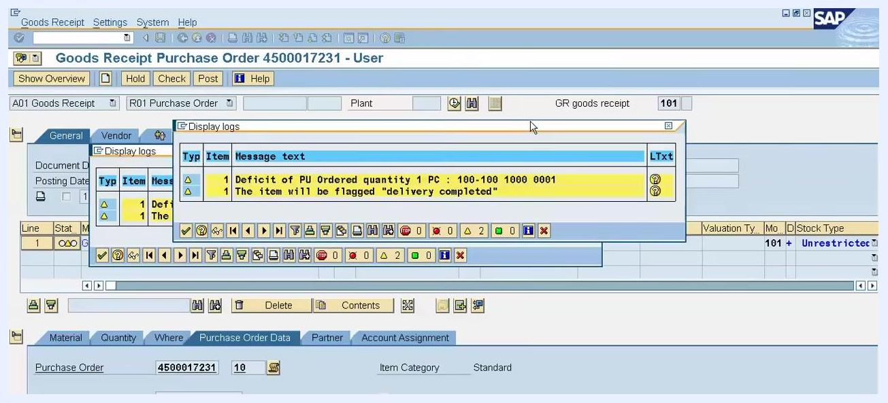
Display logs window showing the messages: "Deficit of PU Ordered quantity 1 PC" and "The item will be flagged delivery completed."
If the messages are informational and require no further action, close the Display logs window to proceed.

Step 18: Post the goods receipt document
Once all data is verified and warnings are acknowledged, click the Post button at the top of the screen. This finalizes the goods receipt and triggers SAP to generate the necessary documents.
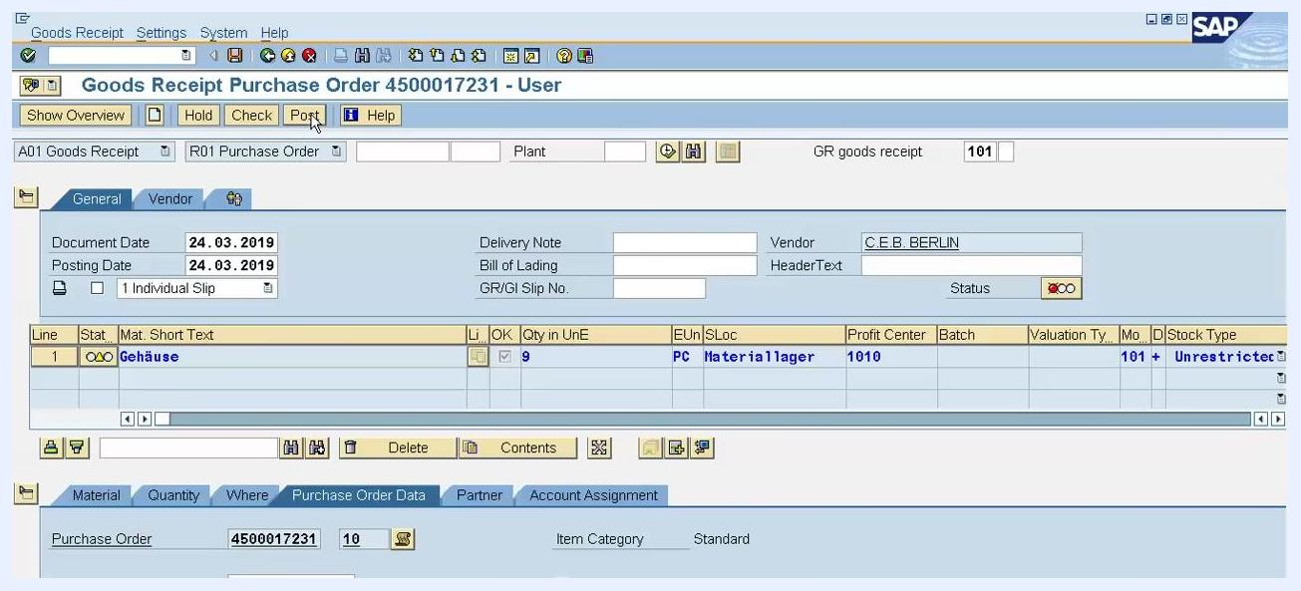
SAP screen with the cursor on the Post button, ready to finalize the goods receipt.
Upon posting, SAP creates two types of documents:
- Material Document: Records the physical movement of goods into inventory.
- Accounting Document: Records the financial impact of the goods receipt in the company's accounts.

Step 19: Verify the posted goods receipt screen
After posting, SAP returns to the main Goods Receipt Purchase Order screen, displaying the purchase order number (4500017231), vendor (C.E.B. BERLIN), and item details (Material: Gehäuse, Quantity: 9 PC, Storage Location: Materiallager, Profit Center: 1010). The Purchase Order Data tab remains visible, confirming the Del. Completed Ind. is set to 2 Set.
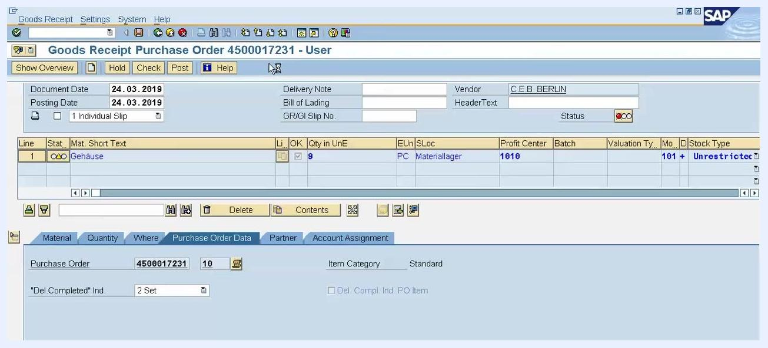
SAP Goods Receipt screen showing PO 4500017231, vendor C.E.B. BERLIN, item Gehäuse, quantity 9 PC, and the delivery completed indicator set.

Step 20: Access the material document
SAP automatically displays the Display Material Document screen for the newly created material document (e.g., 3000000). This screen shows the material (Gehäuse), quantity (9 PC), storage location (Materiallager), profit center (1010), document year (2019), and movement type (101 – Unrestricted).

Step 21: View the associated accounting documents
Click the FI Documents button to view the financial documents linked to the material document. A pop-up window titled Documents in Accounting appears, listing all related accounting entries, such as:
- 0000110001: Accounting document
- 0000328071: Profit center document
- 1000329808: Special purpose ledger
Each document is categorized by its object type text for easy identification.
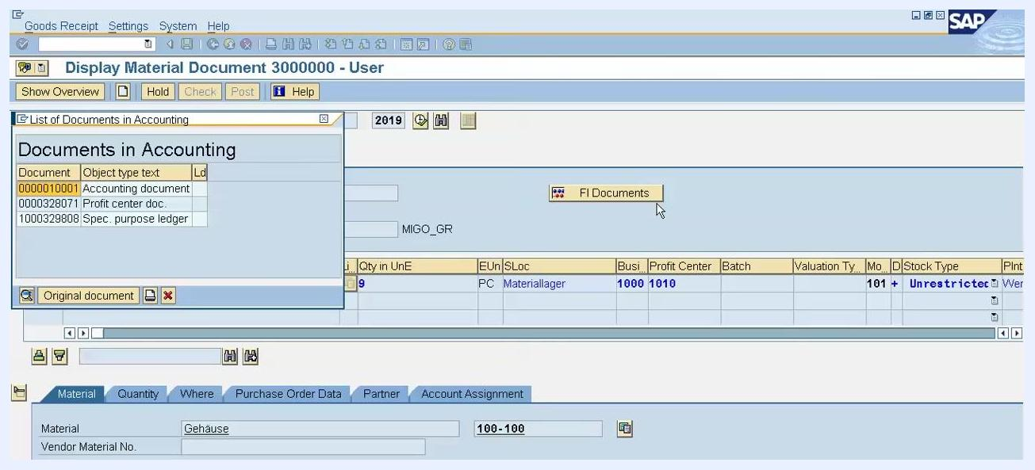
SAP Display Material Document screen with the Documents in Accounting pop-up showing the accounting document, profit center document, and special purpose ledger.
Ensure that all expected documents (material and accounting) appear in the list. If needed, click any document number to view its details or the original document for further verification.

Summary
By following these steps, you have:
- Understood the purpose and flow of the Goods Receipt process in SAP.
- Used transaction code MIGO to process a goods receipt against a purchase order.
- Entered delivery references, adjusted received quantities, and specified storage locations.
- Validated and posted the goods receipt document.
- Verified that both the Material Document and Accounting Document were generated correctly.
This confirms that the goods receipt has been successfully posted and all related documents have been generated in SAP, ensuring both inventory and financial records are up to date.

