How to Maintain the TVARVC Table in SAP
The TVARVC table lets you store dynamic variables in SAP instead of hard-coding values directly into your ABAP programs. This guide explains how to maintain the TVARVC table in SAP so you can trigger specific logic for different company codes or other criteria without changing any program code.

Why use dynamic variables
Storing values in the TVARVC table gives your programs flexibility. Instead of writing logic tied to a fixed value, you reference a variable that can be updated independently of the code.
For example, if you built a requirement for Germany and later need the same logic applied to France, you simply update the table entry rather than modifying the underlying program.
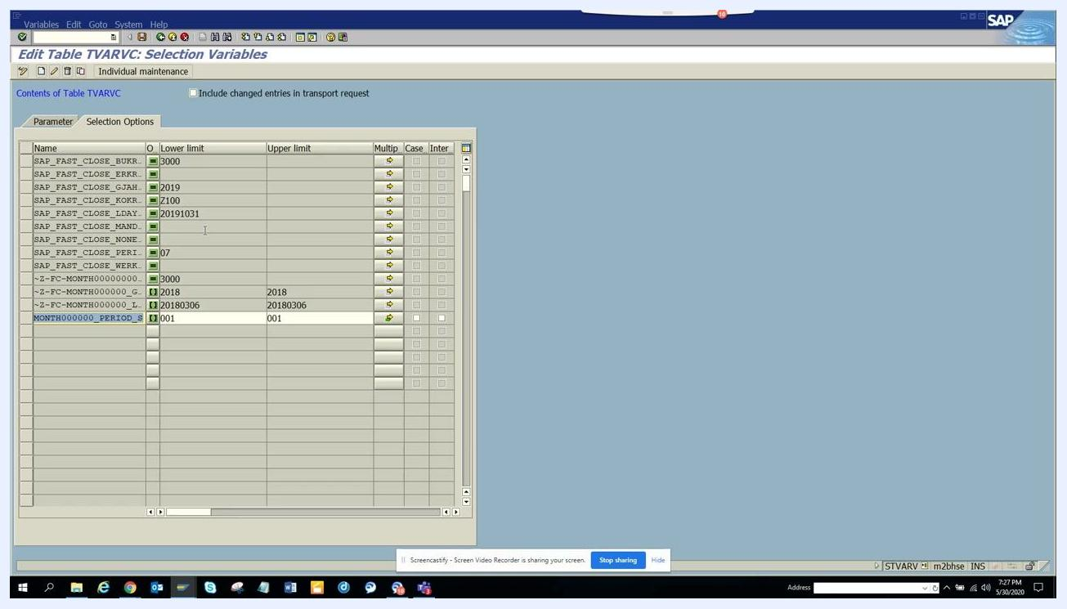
Edit Table TVARVC: Selection Variables screen showing multiple entries, illustrating the flexibility of dynamic variables.

Prerequisites
- Access to an SAP system with a valid login.
- Authorization to maintain the TVARVC table.

Step 1: Access the SAP Easy Access screen
Launch SAP and log in to your system. Confirm you are on the SAP Easy Access screen, which is typically labeled "Purchasing" or with the name of your relevant module.
The left pane displays your Favorites and SAP Menu folders, ready for you to enter a transaction.
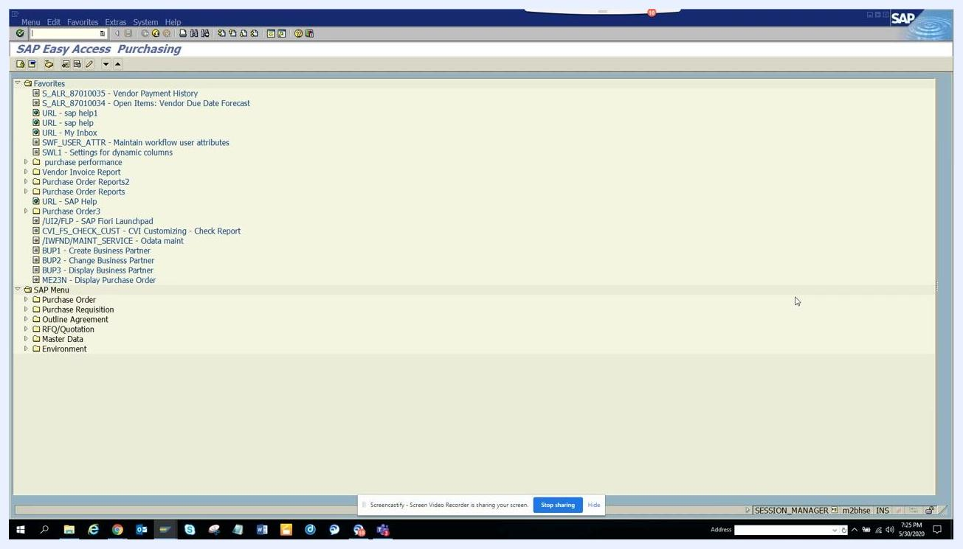
SAP Easy Access screen showing the Favorites and SAP Menu panes, with no transaction entered yet.

Step 2: Enter the TVARVC table maintenance transaction
In the command field at the top of the screen, type STVARV and press Enter.
If you enter an incorrect transaction code (for example, STVARVB), SAP displays an error message at the bottom of the screen reading "Transaction STVARVB does not exist." Double-check your entry and try again.
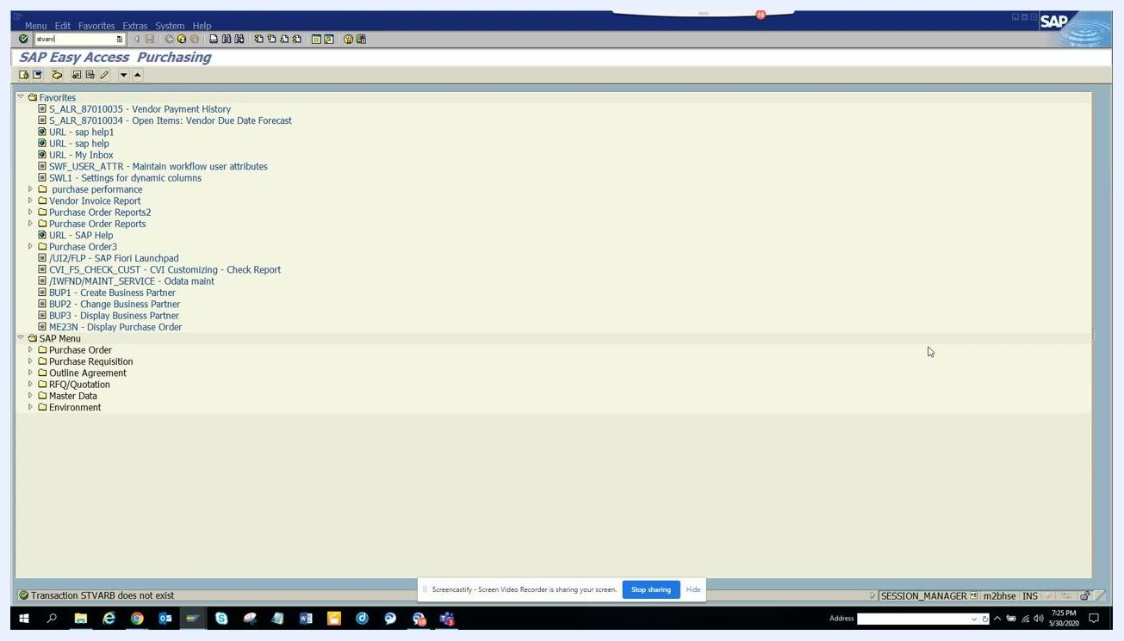
Command field with "stvarv" entered, showing an error message at the bottom for an invalid transaction code.

Step 3: View and edit Table TVARVC: Selection Variables
Once the correct transaction loads, the Edit Table TVARVC: Selection Variables screen appears. You will see two tabs: Parameter and Selection Options.
The table lists existing entries in columns for Name, Value (Val.), and Case.
To create a new parameter:
- Click the Create button (or press F5).
- In the Name column, enter your parameter, for example z_fi_comp.
- In the Val. column, enter the corresponding value, for example 0001.
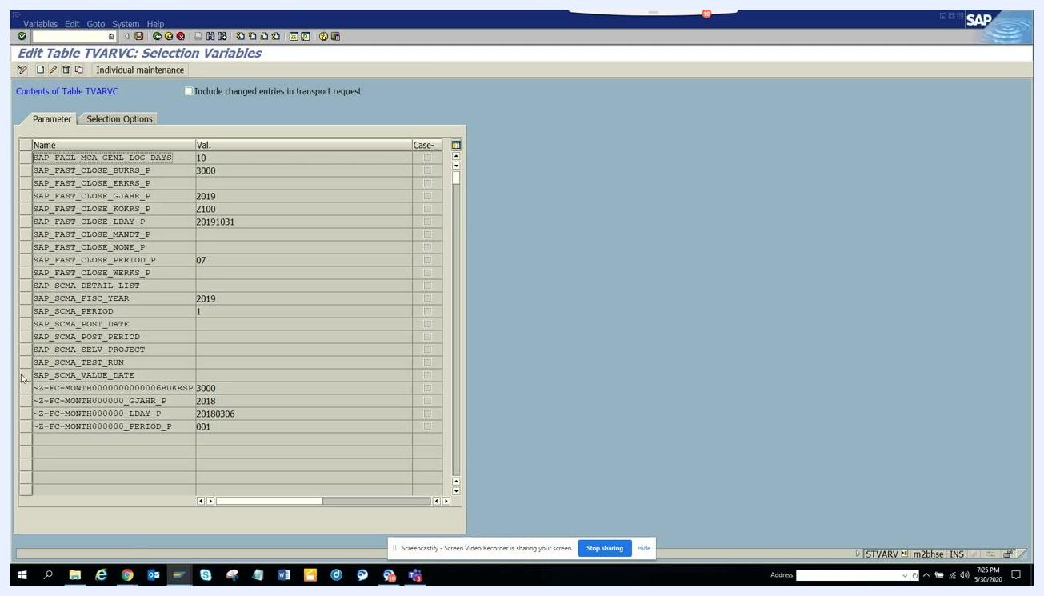
Edit Table TVARVC: Selection Variables screen showing parameter entries and the create action.

Step 4: Save the new parameter entry
After entering the new parameter and its value, click the Save icon in the toolbar.
Your new entry — for example, z_fi_comp with value 0001 — now appears in the list of parameters.
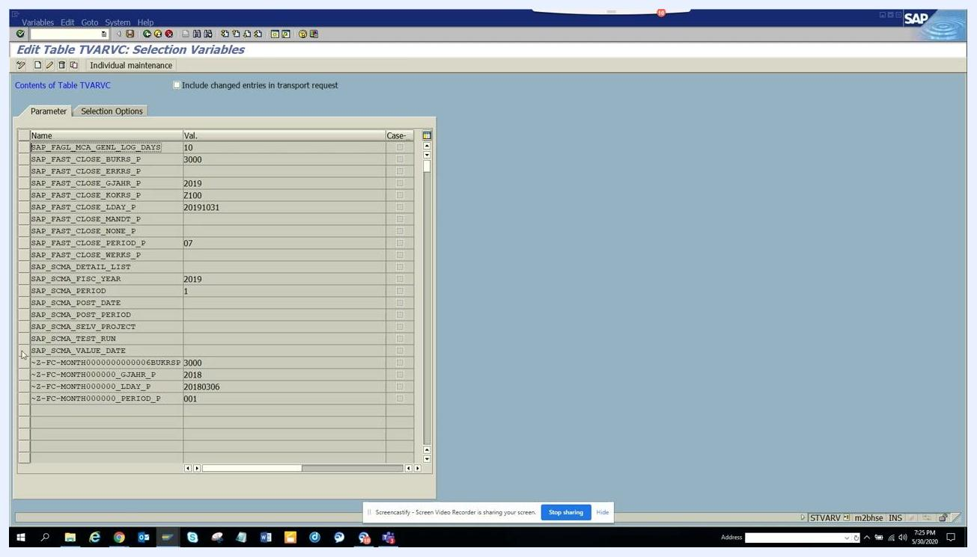
New parameter "z_fi_comp" with value "0001" entered in the table.

Step 5: Switch to the Selection Options tab
Click the Selection Options tab to view or edit selection option entries. This tab lets you create or modify entries using lower and upper limits.
To create a new selection option:
- Click the Create button.
- Enter the required values in the Lower limit and Upper limit columns.
To edit an existing entry, click on the desired row to select it for modification.
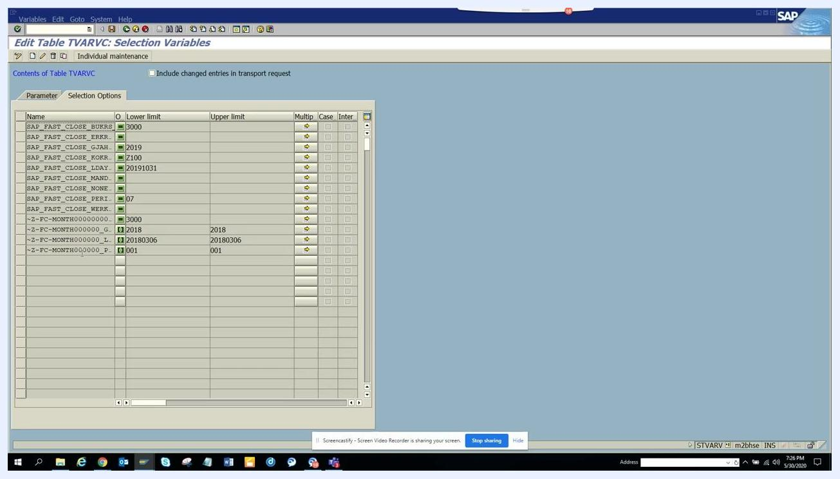
Selection Options tab showing lower and upper limit columns, existing entries, and available create/edit actions.

Step 6: Change or display entries
To toggle between display and change modes, click the Display <-> Change button, or press Ctrl+F1.
Select the entry you wish to modify and make the necessary changes. Once finished, save your changes to complete the update.
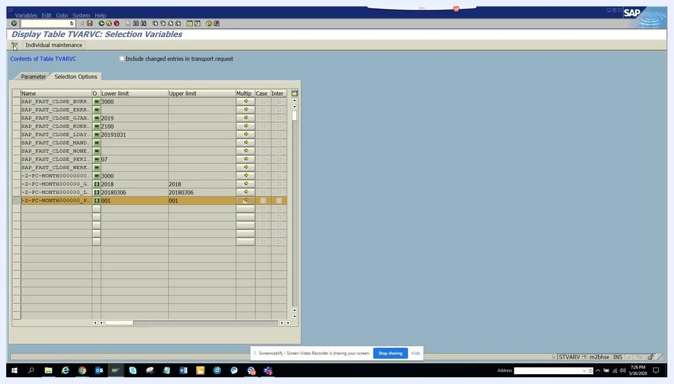
Display Table TVARVC: Selection Variables screen with an entry selected and the display/change toggle highlighted.

Summary
You have now learned how to maintain the TVARVC table in SAP by accessing the STVARV transaction, creating and saving new parameters, working with selection options, and toggling between display and change modes. Using dynamic variables this way keeps your ABAP programs flexible and reduces the need for direct code changes when business requirements expand to new company codes or criteria.

