How to Determine Pricing Procedure in SAP SD
When creating a sales order in SAP SD, the system must automatically determine a pricing procedure based on the sales area, customer, and document type. If this configuration is incomplete, you will see the error "No pricing procedure could be determined" and will be unable to proceed with the order. This guide walks you through how to determine pricing procedure in SAP SD — from identifying the error in a sales order, through configuring customer and document pricing procedures in the Implementation Guide, to verifying the result with the pricing analysis tool.

Prerequisites
- Access to the SAP GUI with authorization to create sales orders (transaction VA01) and display customer master records (transaction XD03).
- Access to the SAP Customizing Implementation Guide (transaction SPRO) with authorization to maintain pricing configuration.
- A customer master record and sales area data already set up (this guide uses Customer 491000, Sales Organization 1000, Distribution Channel 10, Division 10).
- Condition records maintained for relevant condition types (for example, via transaction VK11).

Part 1: Identify the pricing procedure error in a sales order

Step 1: Access the SAP Easy Access main menu
Launch the SAP GUI and wait for the SAP Easy Access screen to appear. The main menu displays folders such as Office, Logistics, Accounting, Human Resources, Information Systems, Tools, and WebClient UI Framework.
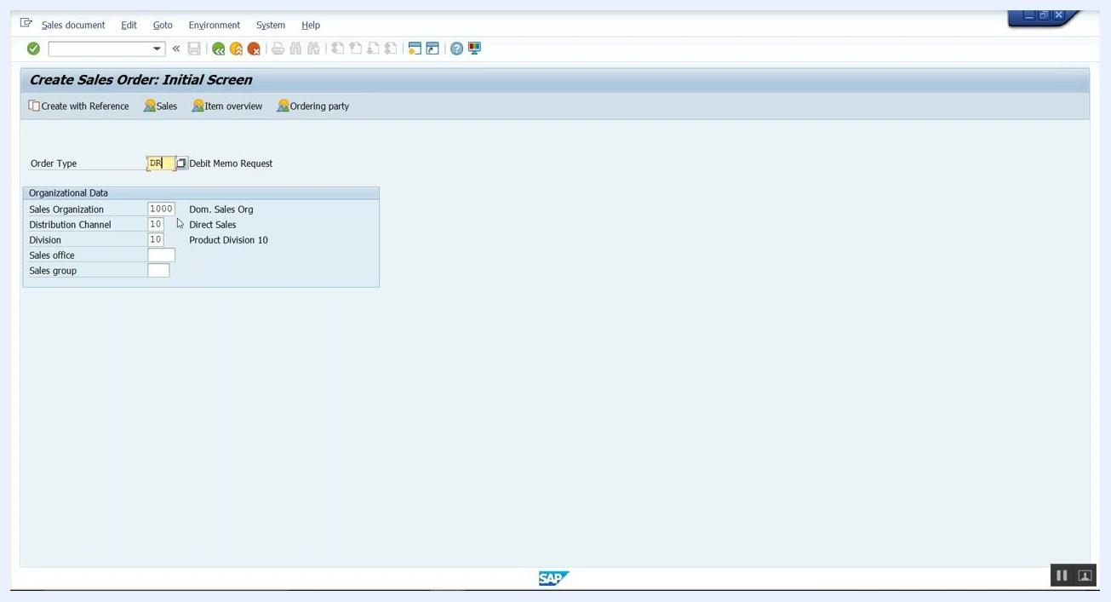
SAP Easy Access main menu with navigation folders visible

Step 2: Open the sales order transaction
In the command field at the top of the screen, enter transaction code VA01 (used to create a sales order), then press Enter.
Command field being used to enter transaction code at the SAP Easy Access screen

Step 3: Select order type and enter organizational data
On the Create Sales Order: Initial Screen, set the Order Type to DR (Debit Memo Request) and enter the following organizational data:
- Sales Organization: 1000 (Dom. Sales Org)
- Distribution Channel: 10 (Direct Sales)
- Division: 10 (Product Division 10)
Leave Sales office and Sales group blank unless your scenario requires them, and confirm that the data matches the required sales area. Press Enter to continue.
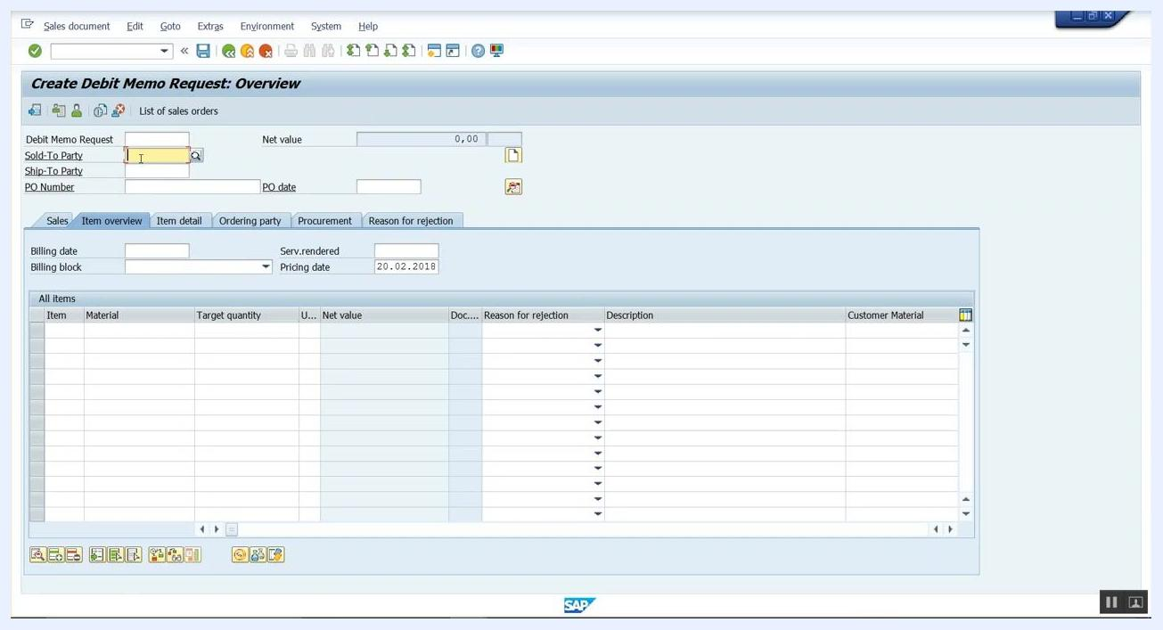
Create Sales Order: Initial Screen with Order Type DR and organizational data filled in

Step 4: Enter the customer
On the Create Debit Memo Request: Overview screen, enter the Sold-To Party customer number — for example, 491000 — in the Sold-To Party field. Fill in any other required fields, such as Ship-To Party, PO Number, or PO Date, as needed for your scenario.
Create Debit Memo Request: Overview screen with Sold-To Party field being filled

Step 5: Confirm the pricing procedure error
After entering the customer number, press Enter. If the pricing configuration is incomplete, the system displays the message "No pricing procedure could be determined" at the bottom of the screen. This indicates that pricing procedure determination has failed for the entered sales area and document type combination.
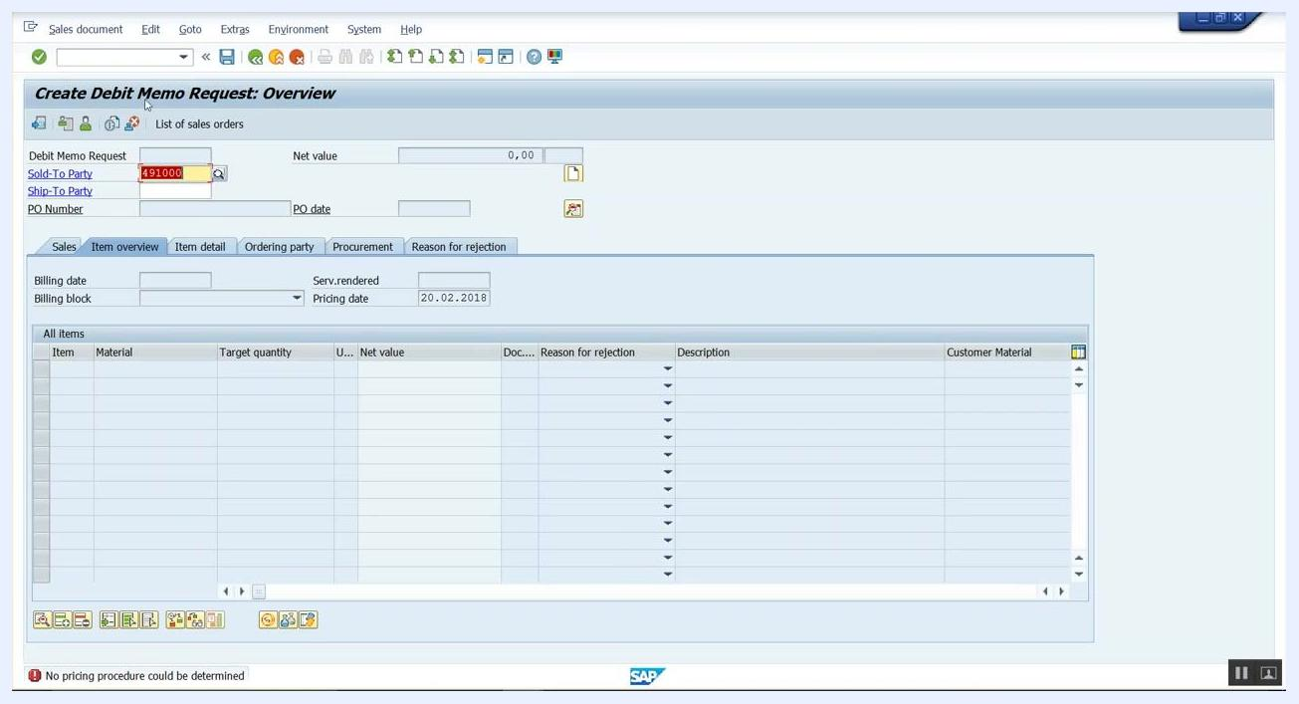
Create Debit Memo Request: Overview screen showing error message "No pricing procedure could be determined"

Part 2: Configure pricing control in the Implementation Guide

Step 6: Access the Implementation Guide and navigate to Pricing
Open the SAP Customizing Implementation Guide (transaction SPRO) and select SAP Reference IMG. In the hierarchical menu, expand the following path:
- Sales and Distribution > Basic Functions > Pricing
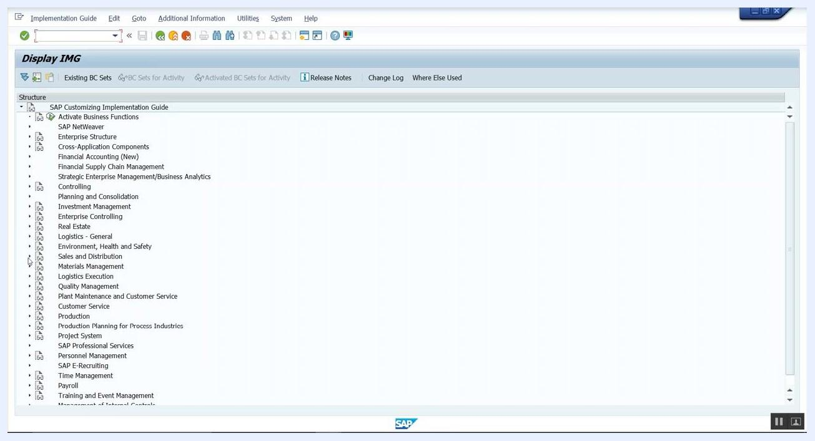
SAP IMG main structure with Sales and Distribution > Basic Functions > Pricing highlighted

Step 7: Open Pricing Control
Under the Pricing node, select Pricing Control. This area contains the major configuration options for pricing, including condition tables, condition types, access sequences, and pricing procedures.
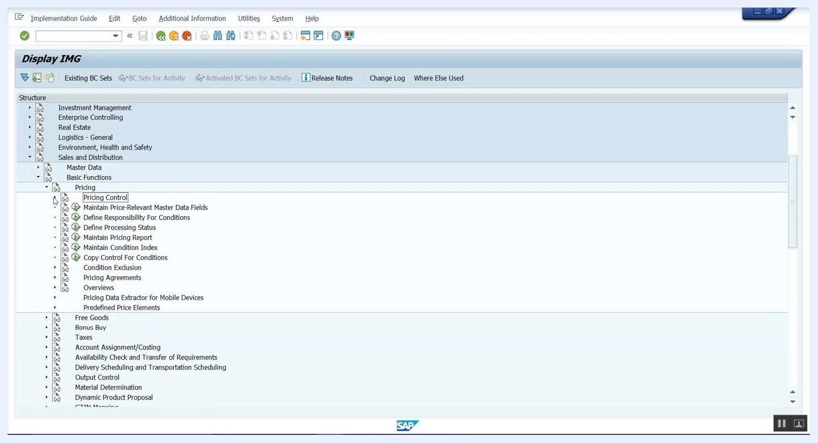
SAP IMG with Pricing Control and related configuration options visible

Step 8: Open Define And Assign Pricing Procedures
In the Pricing Control area, select Define And Assign Pricing Procedures. This section lets you define new pricing procedures and assign them to the relevant sales areas and document types.
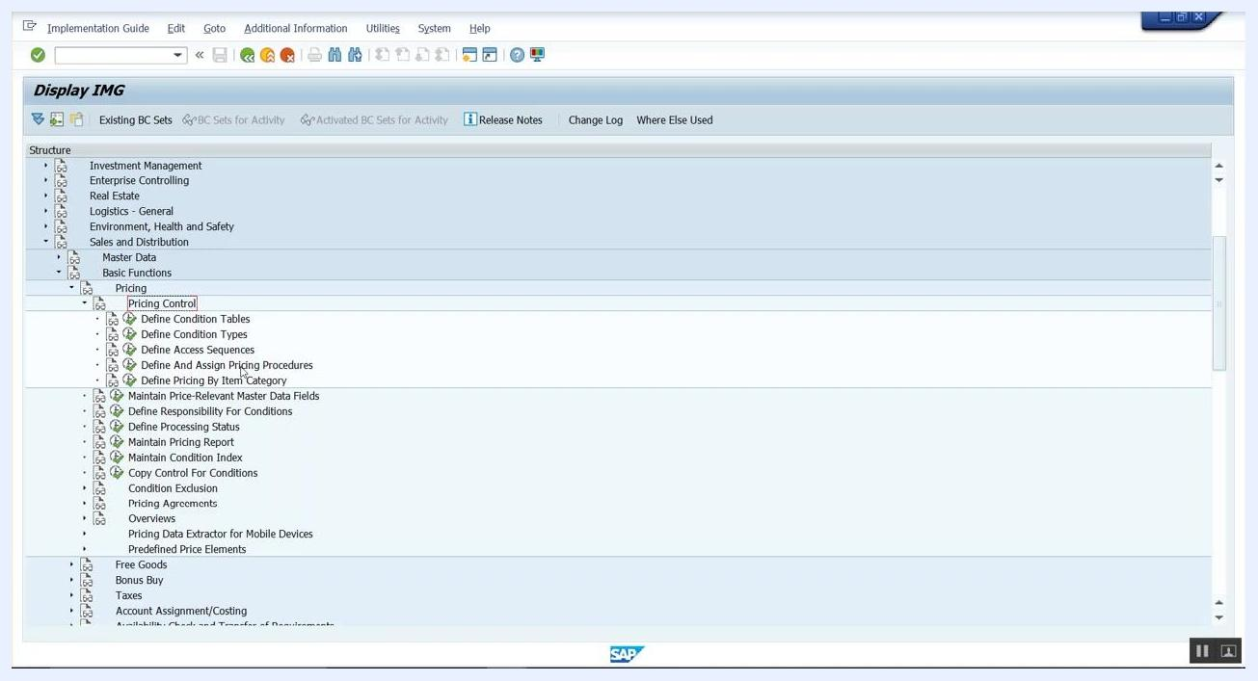
SAP IMG with Define And Assign Pricing Procedures highlighted

Step 9: Select the Maintain pricing procedures activity
A dialog box lists the available activities. Select Maintain pricing procedures from the list, then click Choose to proceed. Related activities in this dialog include defining customer and document pricing procedures, assigning procedures to order types, and checking settings.
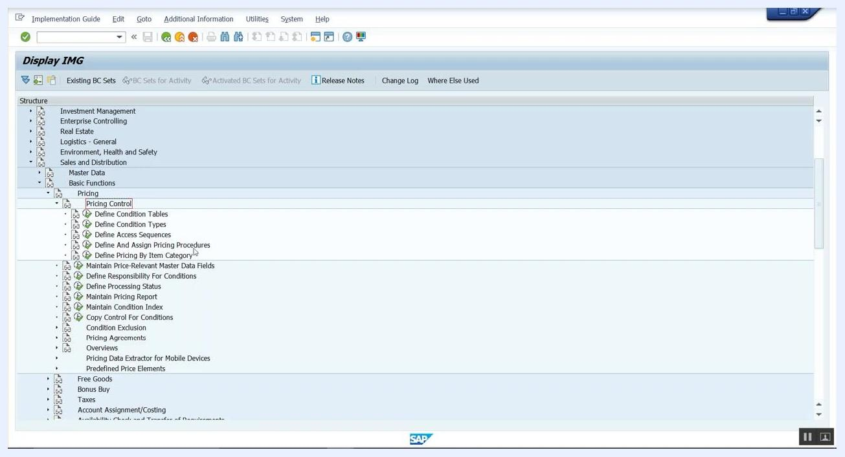
SAP Select Activity dialog with Maintain pricing procedures highlighted

Step 10: Review the standard pricing procedure
On the Change View 'Procedures': Overview screen, confirm that a standard pricing procedure is available for use. In this example, procedure RVAA01 is selected. Verify that it contains all the condition types required for your pricing needs.
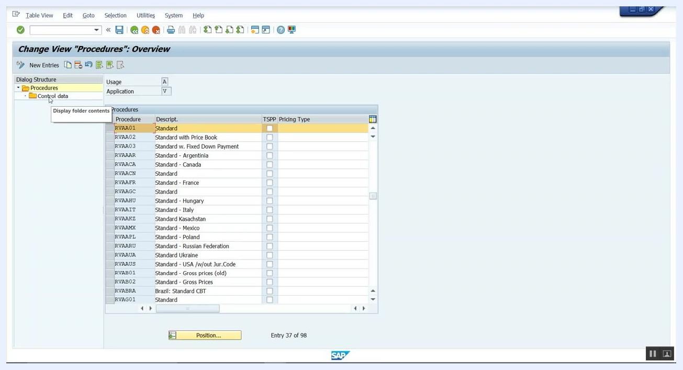
SAP "Change View 'Procedures': Overview" screen showing the list of pricing procedures, with RVAA01 (Standard) highlighted

Part 3: Define and assign the customer pricing procedure

Step 11: Open Define customer pricing procedure
In the SAP IMG Select Activity dialog, choose Define customer pricing procedure. This section lets you view and manage the different customer pricing procedures available in the system.
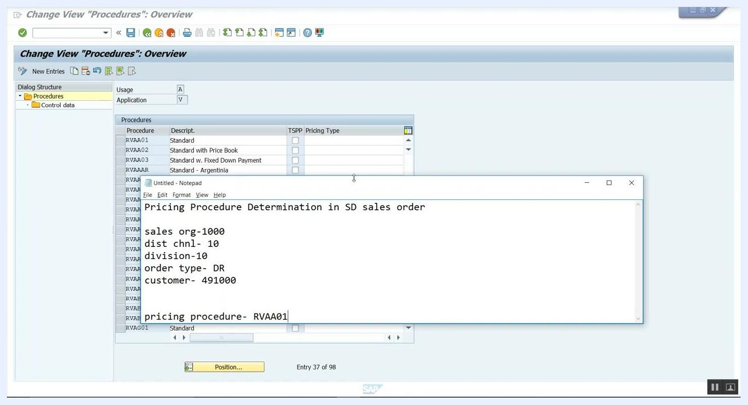
SAP IMG "Select Activity" dialog with "Define customer pricing procedure" highlighted

Step 12: Review available customer pricing procedures
Examine the list of existing customer pricing procedures, which may include:
- Standard
- Stand Incl Sales Tax
- Refund
- GTM Standard
Different customers often require different pricing calculations, so customer pricing procedures let you tailor pricing logic to specific customers or customer groups. Decide which procedure is appropriate, or create a new one if needed.
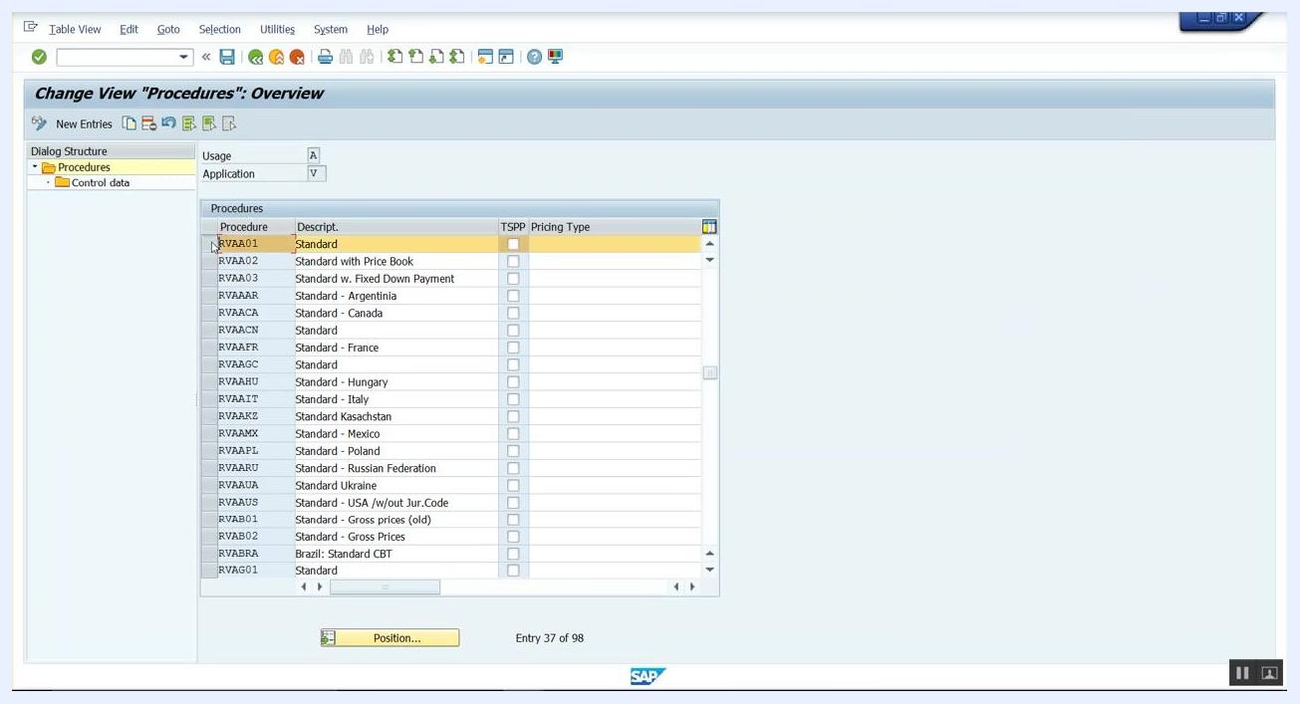
SAP "Change View 'Customer Pricing Procedures': Overview" screen showing list of customer pricing procedures

Step 13: Open the customer master record
Open the customer master record using transaction code XD03 (Display Customer) and enter the following:
- Customer: 491000
- Sales Organization: 1000
- Distribution Channel: 10
- Division: 10
Click Customer's sales areas... to proceed.
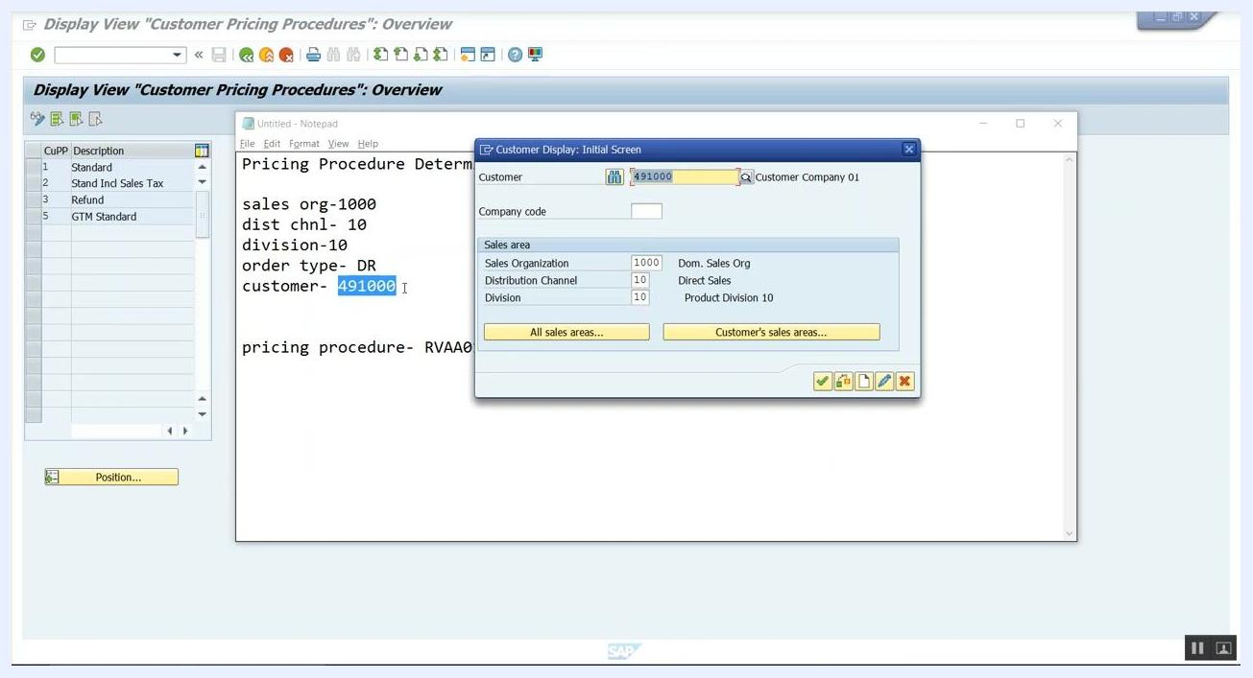
SAP "Customer Display: Initial Screen" with Customer 491000 and sales area data entered

Step 14: Verify the assigned customer pricing procedure
In the customer master, confirm that the correct customer pricing procedure is assigned. Update it if necessary so that it matches your configuration (for example, set to "Standard"), then save your changes.

Step 15: Review the customer's sales area data
On the Display Customer: Sales Area Data screen, confirm the following fields:
- Customer: 491000 (Customer Company 01, Hamburg)
- Sales Org: 1000
- Distr. Channel: 10
- Division: 10
Under Pricing/Statistics, note the Price group (01 – Bulk buyer) and Cust.pric.proc. (1 – Standard). This is the first value needed for determining the customer pricing procedure.
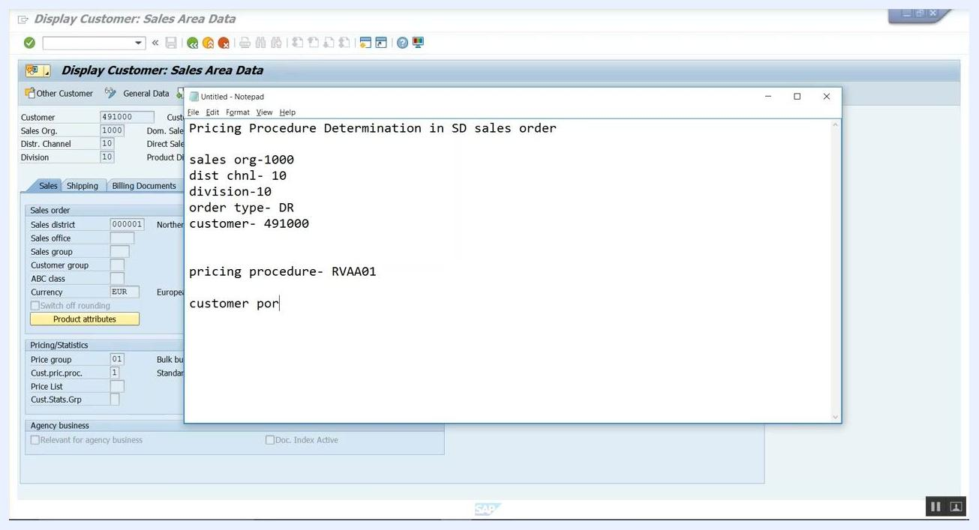
Display Customer: Sales Area Data with Cust.pric.proc. 1 and Price group 01

Part 4: Define and assign the document pricing procedure

Step 16: Review document pricing procedure activities
In the IMG Select Activity dialog, confirm that the following activities are available:
- Maintain pricing procedures
- Define customer pricing procedure
- Define document pricing procedure
- Assign document pricing procedures to order types
- Assign document pricing procedures to billing types
- Define Pricing Procedure Determination
- Check Settings for Pricing Procedures
Select the activity relevant to defining or assigning document pricing procedures.
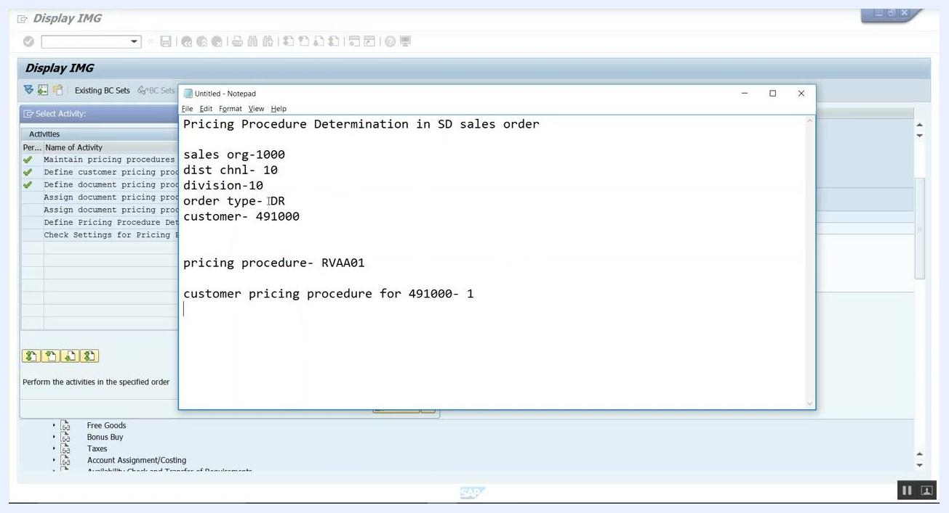
SAP IMG 'Select Activity' dialog with pricing procedure activities listed

Step 17: Confirm the document pricing procedure for the order type
On the Change View 'Sales Document Types: Document Pricing Procedures': Overview screen, review the list of sales document types and their associated document pricing procedures. Locate the DR (Debit Memo Request) entry and confirm that its document pricing procedure is set to A – Standard.
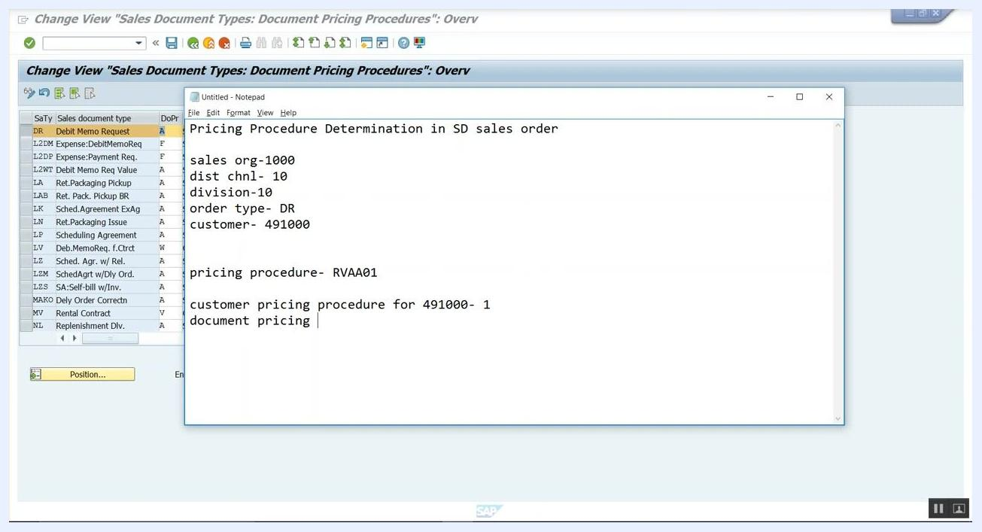
Change View 'Sales Document Types: Document Pricing Procedures': Overview with DR (Debit Memo Request) and procedure A Standard highlighted

Part 5: Define the pricing procedure determination entry

Step 18: Open Define Pricing Procedure Determination
In the IMG Select Activity dialog, confirm the list of available activities (Maintain pricing procedures, Define customer pricing procedure, Define document pricing procedure, Assign document pricing procedures to order types, Assign document pricing procedures to billing types, Define Pricing Procedure Determination, Check Settings for Pricing Procedures), and select Define Pricing Procedure Determination to proceed.
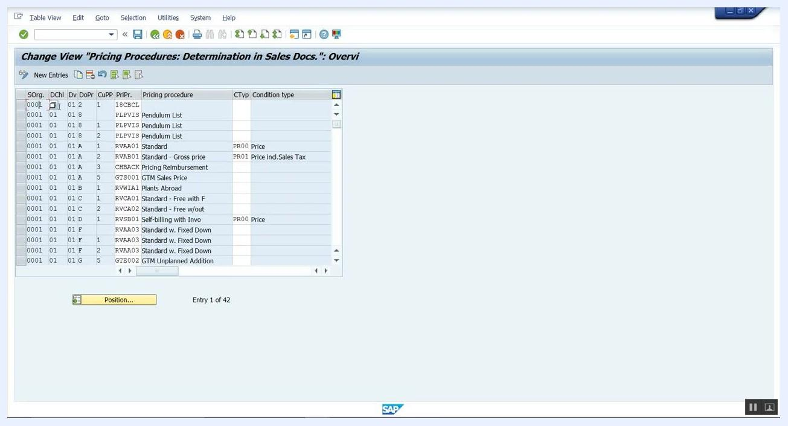
SAP IMG 'Select Activity' dialog with 'Define Pricing Procedure Determination' highlighted as the next step

Step 19: Review the pricing procedure determination overview
On the Change View 'Pricing Procedures: Determination in Sales Docs.': Overview screen, review the existing entries. The table shows columns for Sales Org. (SOrg.), Distribution Channel (DChl), Division (Dv), Document Pricing Procedure (DoPr), Customer Pricing Procedure (CuPP), Pricing Procedure (PrPr), and related condition types. Locate the relevant entry for your configuration, or prepare to add a new one.

Step 20: Prepare the values for a new entry
If your combination does not already exist, click New Entries to add a new row. Have the following values ready:
- Sales org: 1000
- Distribution channel: 10
- Division: 10
- Document pricing procedure: A
- Customer pricing procedure: 1
- Pricing procedure: RVAA01
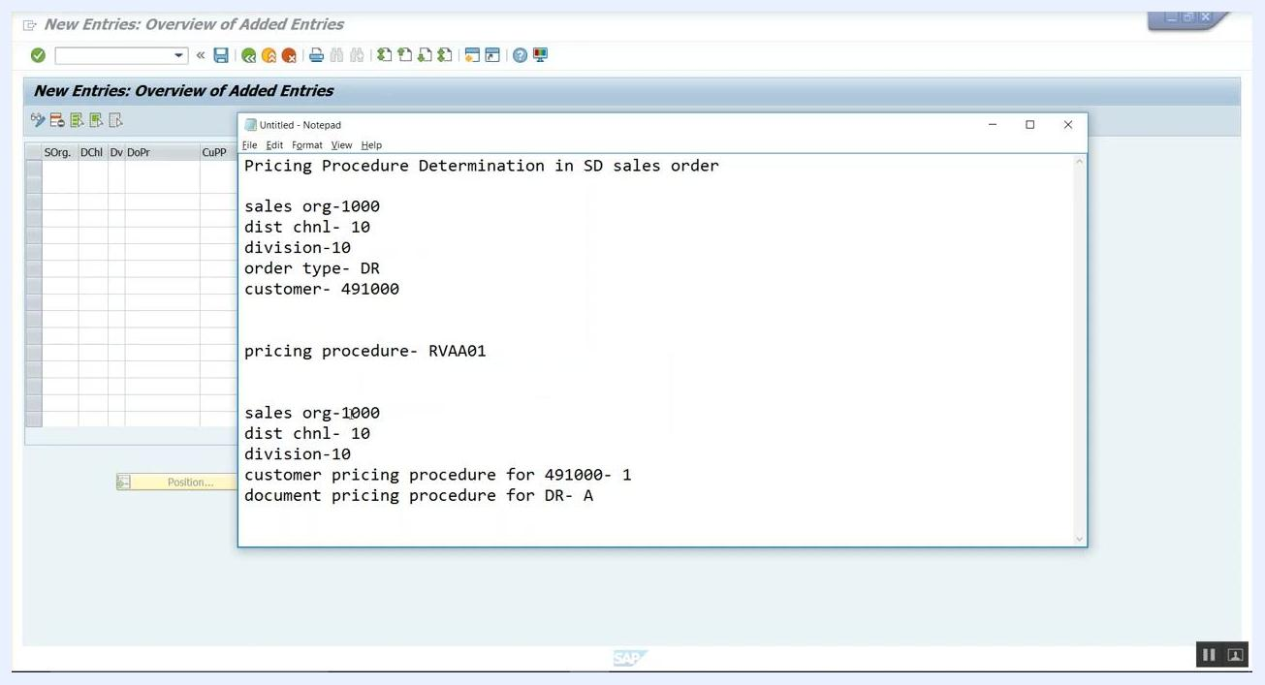
Notepad with all required values for pricing procedure determination entry

Step 21: Enter the new pricing procedure determination
On the New Entries: Overview of Added Entries screen, input the following values and confirm they match your documentation:
- SOrg.: 1000
- DChl: 10
- Dv: 10
- DoPr: A
- CuPP: 1
Then set the Pricing procedure field to RVAA01.
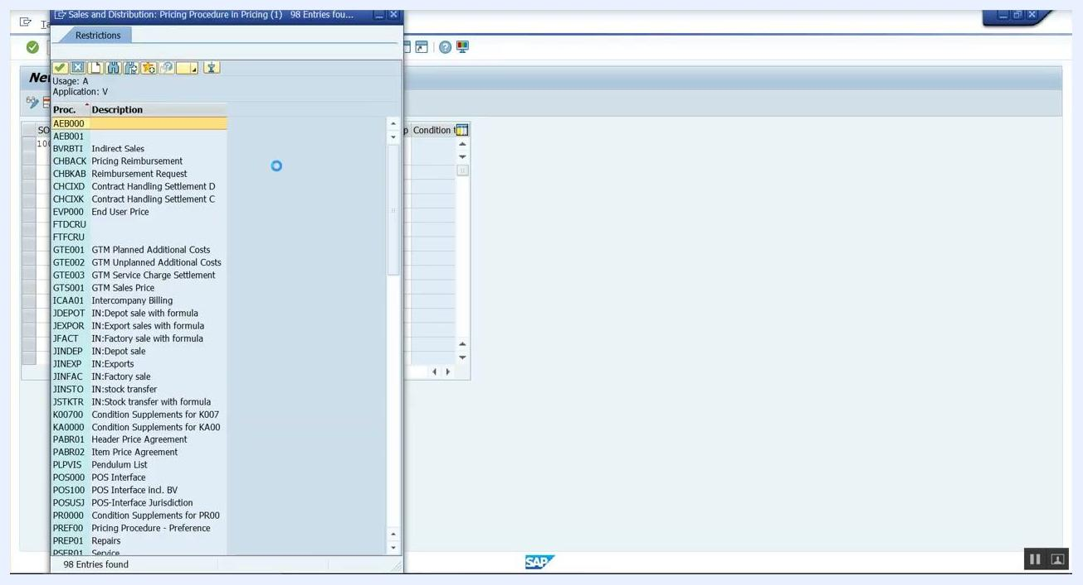
SAP entry screen with notepad showing values for new pricing procedure determination

Step 22: Select the pricing procedure from the list
If prompted, open the list of available pricing procedures, locate RVAA01 (Standard), and select it. Confirm that the selection matches your documentation.
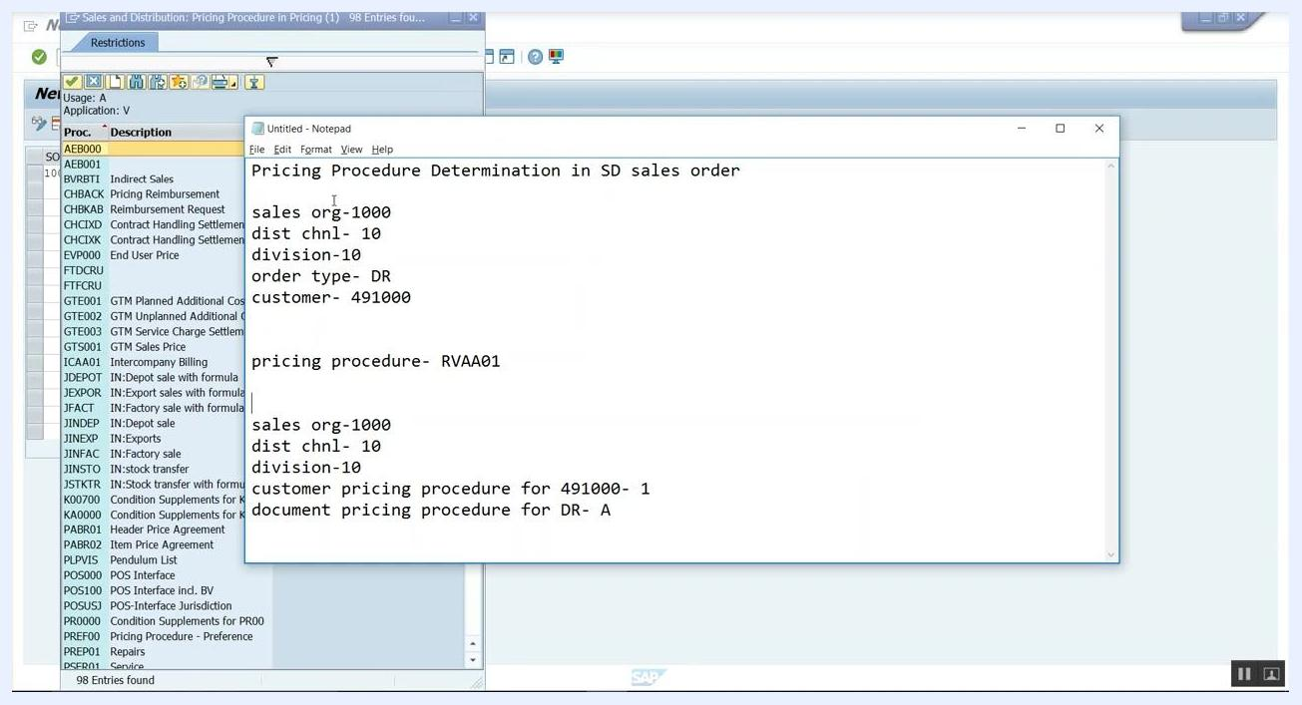
SAP pricing procedure selection dialog with list of available procedures

Step 23: Save the entry with a customizing request
After entering all required values, save your entry. If prompted, enter a customizing request — for example, Request: ZQHK900014, Short Description: ZQH Customizing for Testing — then confirm the request to proceed.
Prompt for customizing request with request number and description

Step 24: Verify that the data was saved
Check for a confirmation message, such as "Data was saved," at the bottom of the screen, and confirm that your new entry appears in the overview table. Once this entry is in place, the correct pricing procedure (RVAA01) will be automatically determined for this sales area, order type, and customer combination.

Part 6: Verify the pricing procedure in a new sales order

Step 25: Enter the debit memo request header data
On the Create Debit Memo Request: Overview screen, enter:
- Sold-To Party: 491000
- Ship-To Party: 491000
- PO Number: po-01
- Billing date: 20.02.2018
- Pricing date: 20.02.2018
Select the customer from the dropdown if needed.
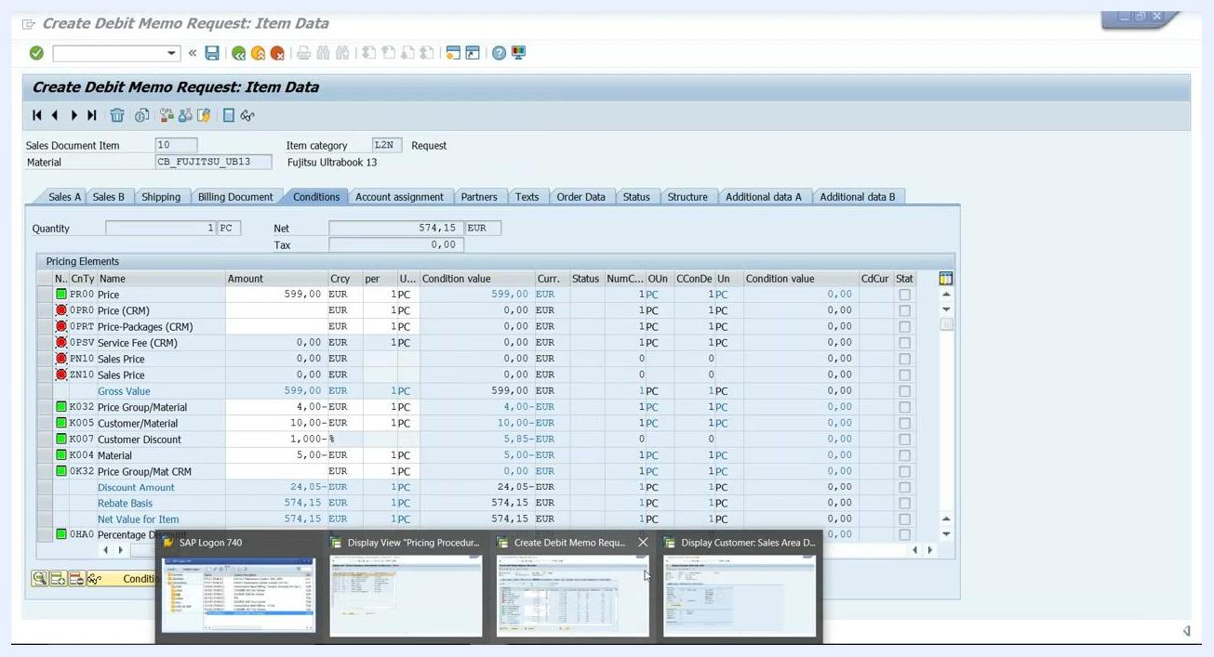
SAP "Create Debit Memo Request: Overview" screen with Sold-To Party dropdown open, showing customer 491000 selected.

Step 26: Enter the material and quantity
In the "All items" section, select the material CB_FUJITSU_UB13 from the dropdown and enter the target quantity as 1 PC. Confirm that the net value is calculated automatically.
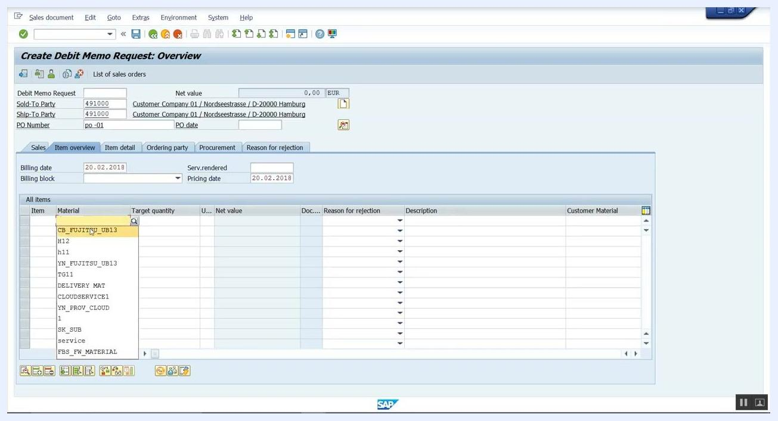
SAP "Create Debit Memo Request: Overview" screen with material CB_FUJITSU_UB13 selected and target quantity field active.

Step 27: Review the item details and pricing
Verify that the item details are populated correctly:
- Material: CB_FUJITSU_UB13
- Target quantity: 1 PC
- Net value: 574,15 EUR
- Description: Fujitsu Ultrabook 13
Confirm that all relevant fields are filled and that the pricing matches the condition records maintained in VK11.
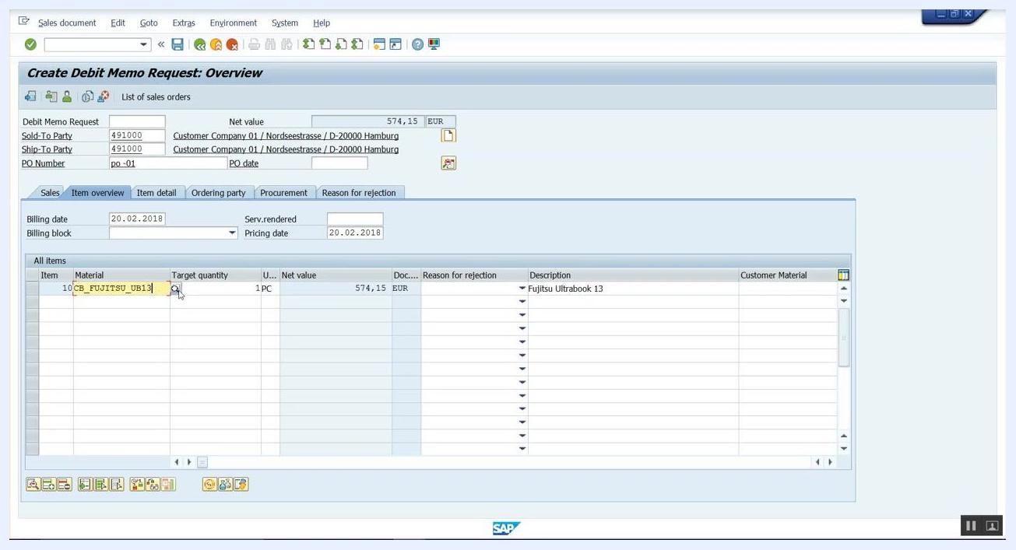
SAP "Create Debit Memo Request: Overview" screen showing item details for CB_FUJITSU_UB13, including net value and description.

Part 7: Analyze the pricing procedure determination

Step 28: Open the pricing analysis
On the Create Debit Memo Request: Item Data screen, go to the Conditions tab and review the pricing elements for item CB_FUJITSU_UB13 (Fujitsu Ultrabook 13):
- PR00 (Gross Value): 599,00 EUR
- K032 (Price Group/Material): -4,00 EUR
- K005 (Customer/Material): -10,00 EUR
- K007 (Customer Discount): -5,85 EUR
- K004 (Material): 0,00 EUR
- Net Value for Item: 574,15 EUR
- MWST (Output Tax): 0,00 EUR
- SKTO (Cash Discount): 0,00 EUR
- VRPRS (Internal price): 1.200,00 EUR
- Profit Margin: 625,85 EUR
Confirm that the net value and discounts are calculated as expected, then click the Analysis button at the bottom of the screen to open the pricing analysis for this item.
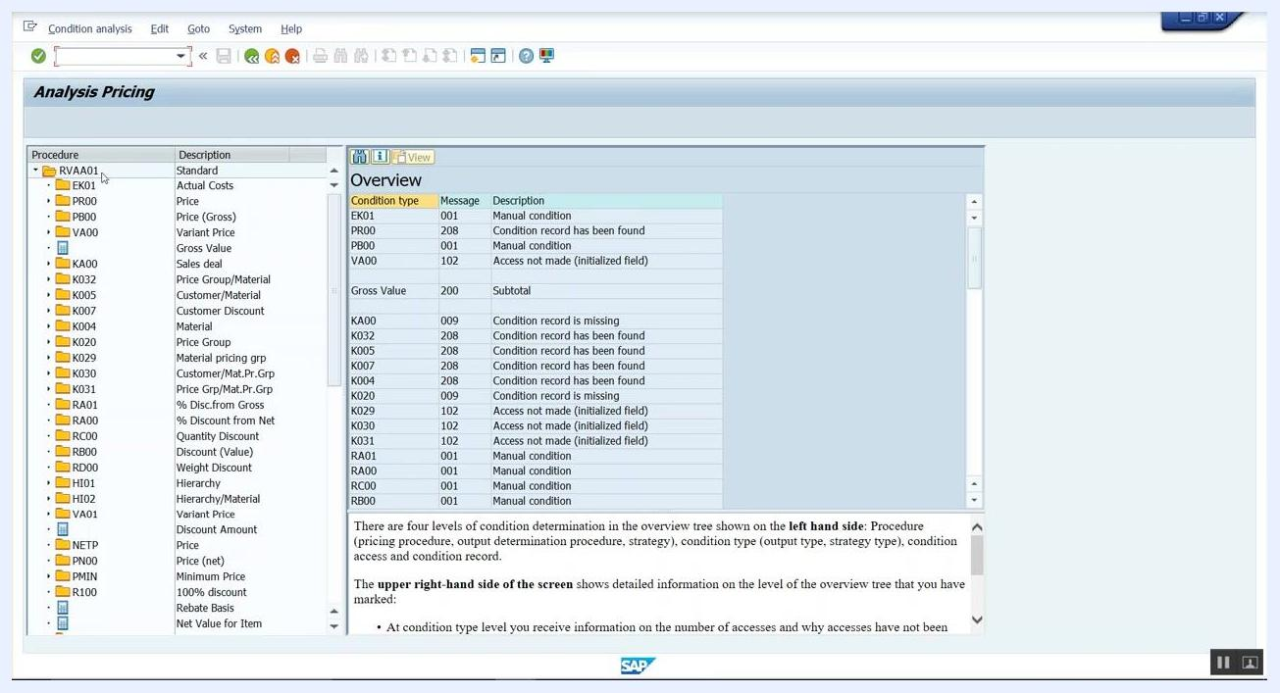
SAP "Create Debit Memo Request: Item Data" screen, Conditions tab, showing detailed pricing elements, amounts, and the cursor pointing to the "Analysis" button.

Step 29: Interpret the pricing procedure determination results
In the Analysis Pricing window, the pricing procedure tree on the left shows procedure RVAA01 (Standard) selected, listing all condition types (PR00, K032, K005, K007, K004, and others) under this procedure. The right pane ("Overview") shows the status for each condition type, for example:
- EK01: Manual condition
- PR00: Condition record has been found
- PB00: Manual condition
- VA00: Access not made (initialized field)
- KA00: Subtotal
- K032: Condition record has been found
- K005: Condition record has been found
- K007: Condition record has been found
- K004: Condition record is missing
- K029: Access not made (initialized field)
Use the following interpretation to review each status:
- "Condition record has been found" means the system found a valid condition record for that type.
- "Condition record is missing" or "Access not made" means no valid record was found, or the field was not initialized.
- "Manual condition" means the value was entered manually.
Review the Overview section to confirm the pricing setup or to troubleshoot any discrepancies.

Step 30: Close the pricing analysis
Once you have reviewed the analysis and confirmed the correct determination of pricing elements, close the Analysis Pricing window. The session ends with a confirmation or closing message.
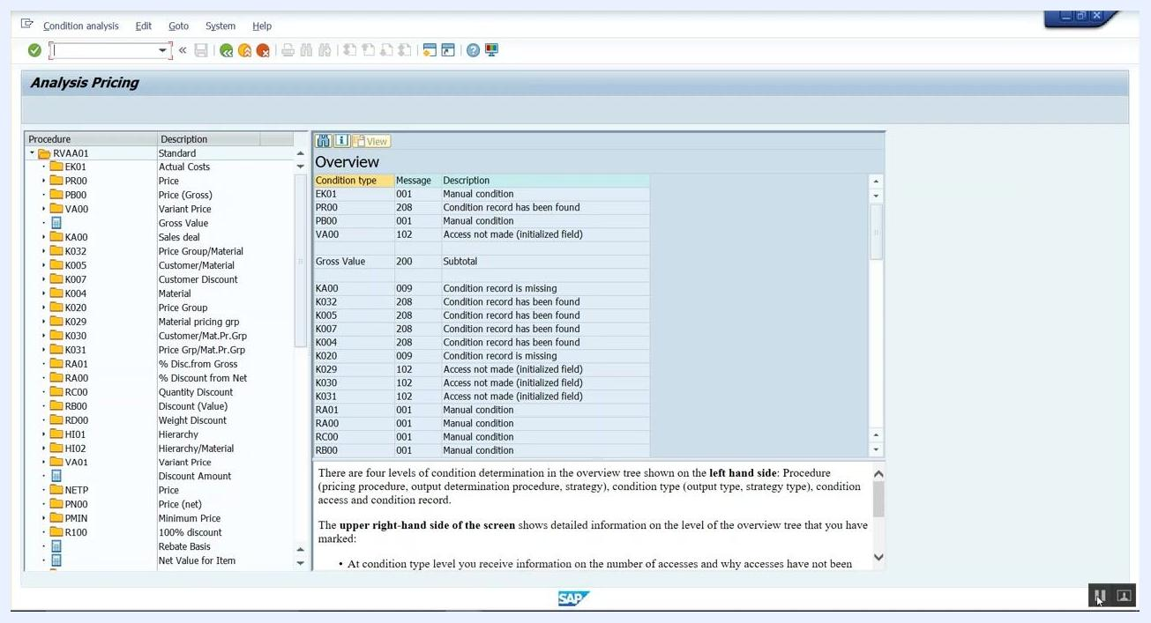
SAP "Analysis Pricing" window, unchanged, showing the end of the analysis session.

Summary
You have learned how to determine pricing procedure in SAP SD by identifying a missing pricing procedure error, navigating the Implementation Guide path Sales and Distribution > Basic Functions > Pricing > Pricing Control > Define And Assign Pricing Procedures, and configuring the customer pricing procedure, document pricing procedure, and pricing procedure determination entry (Sales org 1000, Distribution channel 10, Division 10, Document pricing procedure A, Customer pricing procedure 1, Pricing procedure RVAA01). You then verified the configuration by creating a debit memo request and using the pricing analysis tool to confirm that each condition type was correctly determined.

What's next
With the pricing procedure determination configured and verified, you can create further sales documents for this sales area, customer, and order type combination, confident that the system will automatically apply the correct pricing procedure. If you encounter missing condition records (such as the K004 status shown in the analysis), review and maintain the relevant condition records using transaction VK11.

