How to Create a T-Code for a Report in SAP ABAP
Transaction codes act as shortcuts that let users open applications or programs quickly in SAP, without needing to remember or type the full program name. This guide walks you through how to create a T-code for a report in SAP ABAP, link it to your custom report program, and verify that it works correctly.

Prerequisites
- A custom ABAP program that starts with the REPORT keyword (an executable report with a selection screen).
- Access to transaction SE93 in your SAP system.
- Authorization to save objects under a local package ($TMP) or a transport-enabled package.

Step 1: Verify your program type
Before creating a transaction code, confirm that your ABAP program is the right type.
- Open your ABAP program in the editor and check the first line.
- If the first word is REPORT, your program is an executable report with a selection screen.
- For example, the program ZPRG4_CLASSICAL_REPORT_2_TABLE starts with REPORT zprg4_classical_report_2_table., confirming it is a report program.
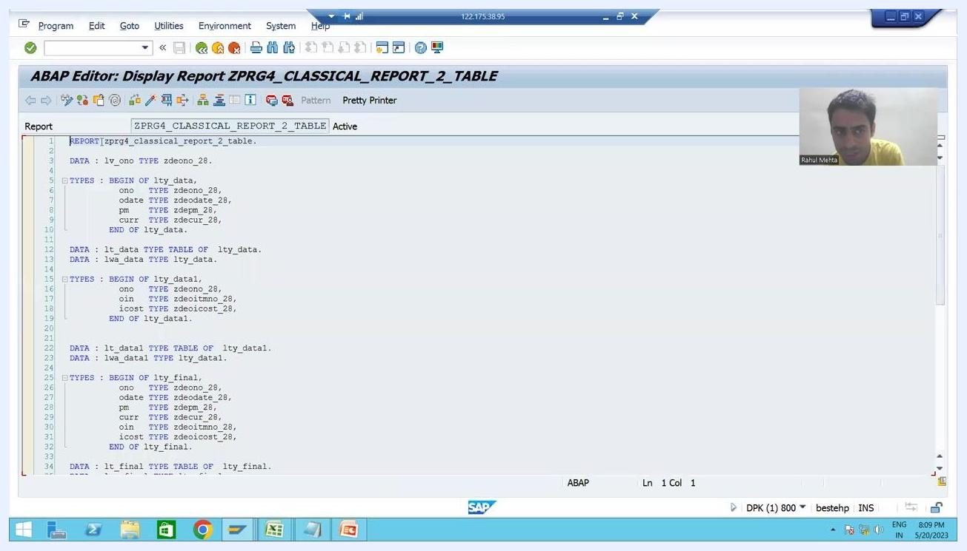
SAP ABAP editor showing the program "ZPRG4_CLASSICAL_REPORT_2_TABLE" with the first line "REPORT zprg4_classical_report_2_table."

Step 2: Understand why you need a transaction code
Customers often find it difficult to remember program names, and they do not want to manually enter the program name or click the execute button every time. They expect a direct shortcut—a transaction code—that takes them straight to the program screen. Creating a transaction code for your custom ABAP program solves this by giving end users an easily accessible shortcut.
The transaction code used to create a new transaction code is SE93. The Maintain Transaction screen in SE93 is where you define this shortcut.
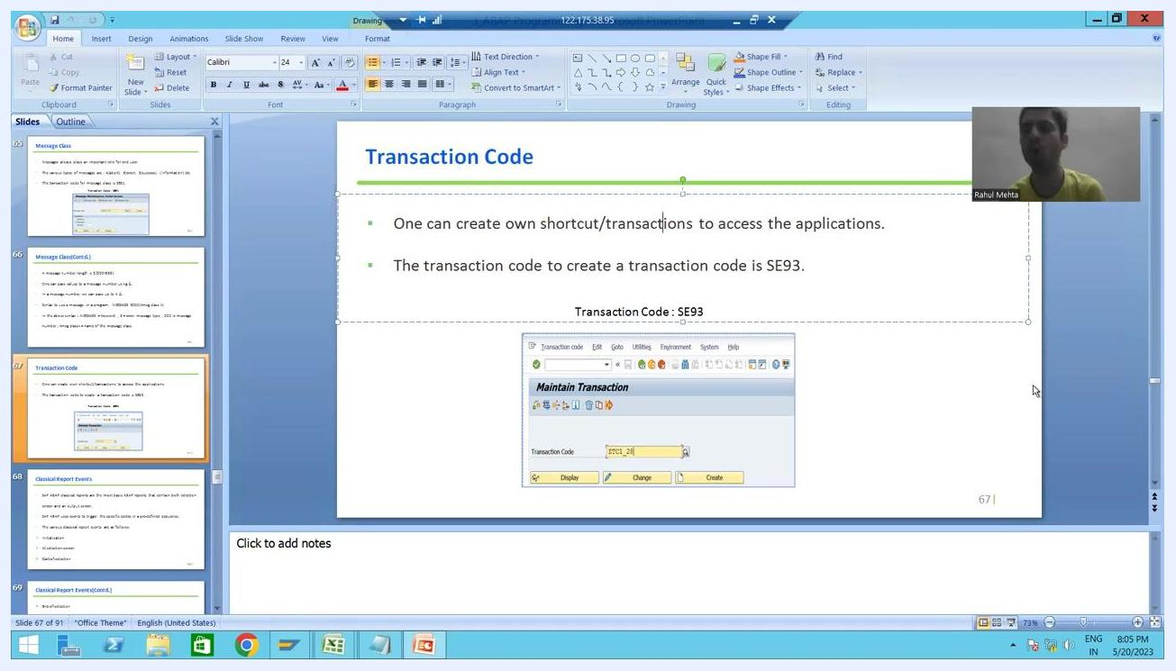
PowerPoint slide titled "Transaction Code," explaining that you can create your own shortcut to access applications, with transaction code SE93 and a sample "Maintain Transaction" screen.

Step 3: Navigate to transaction SE93
Open the Maintain Transaction screen where you will define your new shortcut.
- In the SAP GUI command field, enter /nSE93 and press Enter.
- This opens the Maintain Transaction screen.
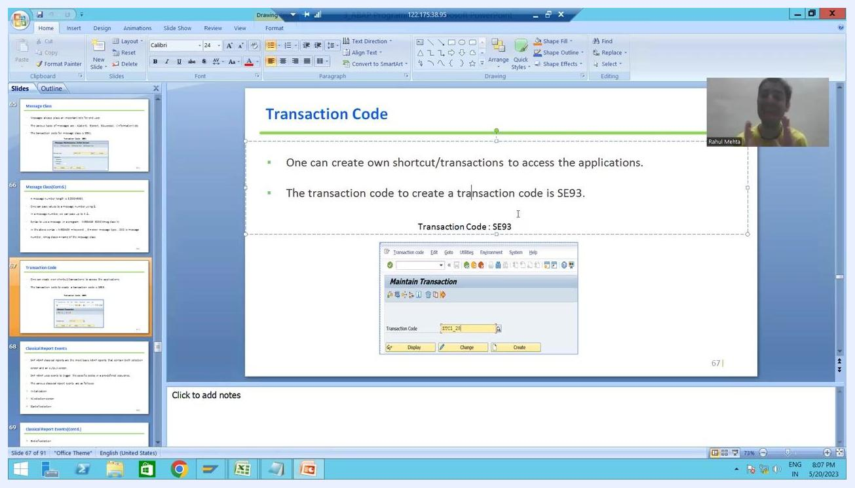
SAP ABAP editor initial screen with the command "/nSE93" entered in the command field, with the program "ZPRG4_CLASSICAL_REPORT_2_TABLE" visible.

Step 4: Enter a new transaction code
On the Maintain Transaction screen, define the custom code you want to use.
- Click in the Transaction Code field.
- Enter a new transaction code, for example ZORD.
- Use a short code that starts with Z or Y (or 5 on some systems) to indicate that it is a custom transaction.
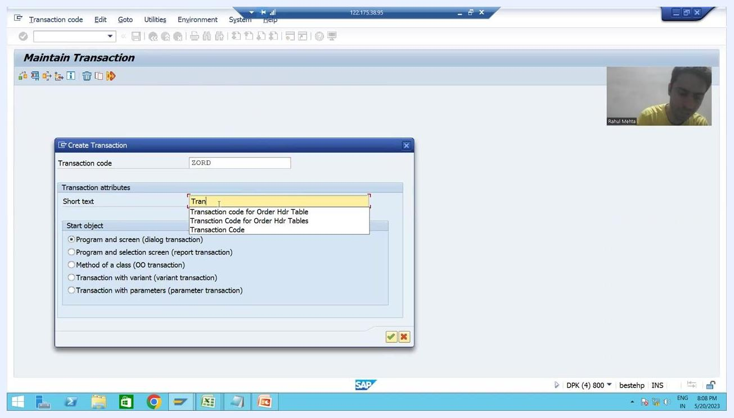
SAP Maintain Transaction screen with "ZORD" entered in the Transaction Code field, and a dropdown showing other custom transaction codes starting with Z.

Step 5: Create the transaction code
Click the Create button to start defining the new transaction code.

Step 6: Choose the start object
In the Create Transaction dialog, enter the attributes for your new transaction and select the correct start object.
- Confirm the Transaction code field shows your chosen code (for example, ZORD).
- In the Short text field, enter a description such as Transaction Code.
- Under Start object, select the option that matches your program type. For a report program with a selection screen, choose Program and selection screen (report transaction).
Create Transaction dialog with "ZORD" as the transaction code, a short text being entered, and the Start object options visible.
The Start object options available are:
- Program and screen (dialog transaction) — used for module pool or dialog programming.
- Program and selection screen (report transaction) — used for executable report programs that start with REPORT and have a selection or input screen.
- Method of a class (OO transaction)
- Transaction with variant (variant transaction)
- Transaction with parameters (parameter transaction) — used for table maintenance views, such as those created via SM30.
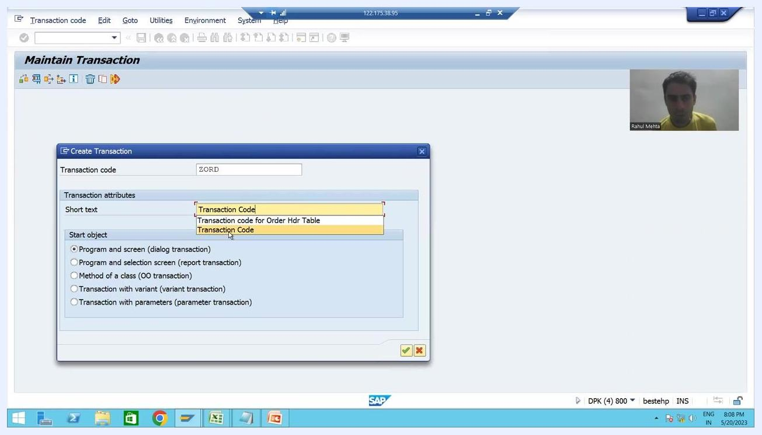
Create Transaction dialog in SAP with "ZORD" as the transaction code, "Transaction Code" in the short text field, and all five Start object radio buttons visible.
For an ABAP report program like the one in this guide, select Program and selection screen (report transaction).

Step 7: Confirm and proceed
Click the green checkmark button (OK) at the bottom right of the dialog to proceed. The system automatically assigns a selection screen number.

Step 8: Review the selection screen details
The Create Report Transaction screen displays the details assigned to your transaction code.
- Transaction code: ZORD
- Transaction text: Transaction Code
- Selection screen: 1000 (filled in automatically)
- Under Classification, ensure Professional User Transaction is selected.
The selection screen number (1000) links the transaction code to the input screen of your report program. It is assigned automatically when you choose Program and selection screen as the start object.
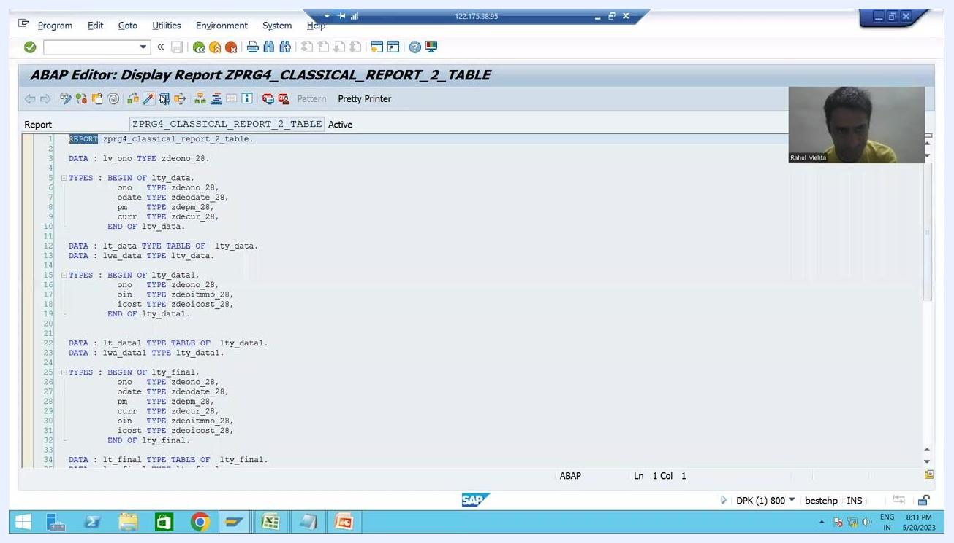
Create Report Transaction screen showing transaction code ZORD, selection screen 1000, and classification options.

Step 9: Confirm the program name
When prompted, make sure the correct program name (for example, ZPRG4_CLASSICAL_REPORT_2_TABLE) is passed in the relevant SAP dialogs or fields. This ensures the transaction code executes the intended report.

Step 10: Select all GUI support options
In the Create Report Transaction screen, locate the GUI support section and select all three options:
- SAPGUI for HTML
- SAPGUI for Java
- SAPGUI for Windows
Selecting all three ensures the transaction code can be executed from any supported SAP GUI interface, giving you maximum compatibility across different customer environments.
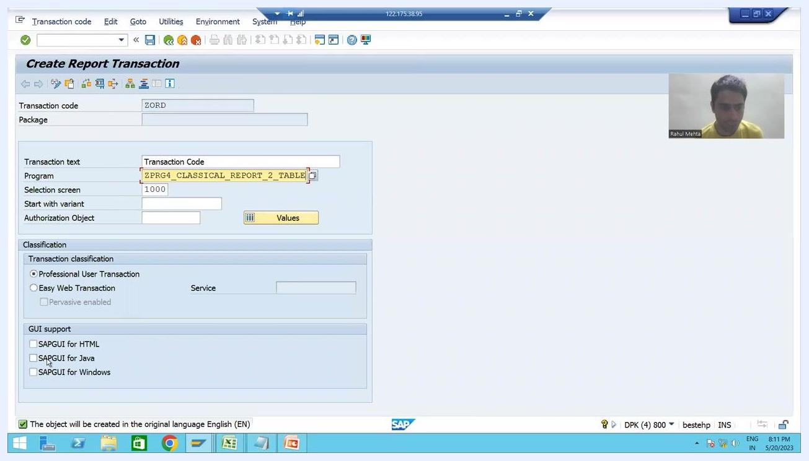
Create Report Transaction screen with all three GUI support checkboxes selected, transaction code ZORD, and program ZPRG4_CLASSICAL_REPORT_2_TABLE.

Step 11: Save the transaction code
Save your transaction code configuration and assign it to a package.
- Click the save icon (floppy disk) or use the corresponding menu option.
- In the Create Object Directory Entry dialog, enter $TMP in the Package field to save it as a local object not intended for transport.
- Confirm or enter the responsible user in the Person Responsible field (for example, USER1).
- Review the Original System and Original language fields.
- Click Local Object to save the transaction code.
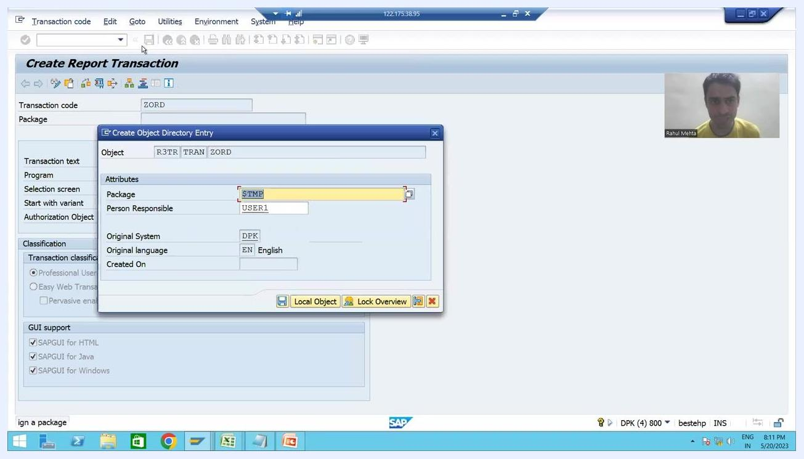
Create Object Directory Entry dialog with package $TMP, person responsible USER1, and the Local Object button highlighted.

Step 12: Verify the transaction code was created
After saving, the Change Report Transaction screen appears. Confirm the following details:
- Transaction code: ZORD
- Package: $TMP
- Program: ZPRG4_CLASSICAL_REPORT_2_TABLE
- Selection screen: 1000
- All three GUI support options are checked.
A confirmation message at the bottom of the screen states: "Transaction code ZORD saved."
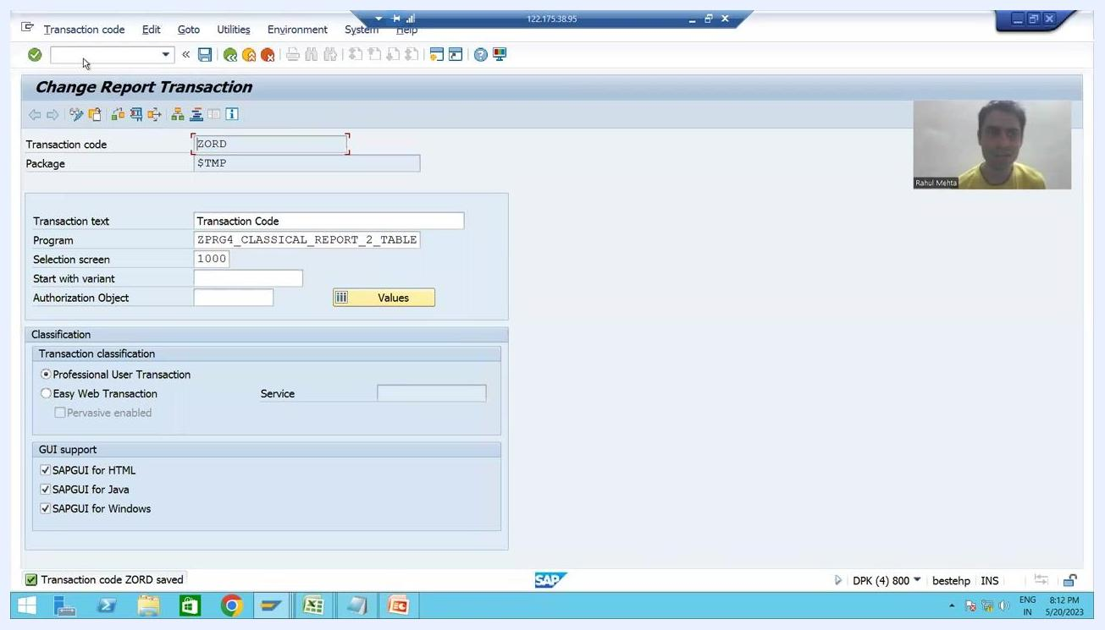
Change Report Transaction screen confirming transaction code ZORD saved, all GUI support options checked, and correct program and selection screen.

Step 13: Test the transaction code
Verify that your new T-code launches the report as expected.
- In the SAP command field, enter /nZORD and press Enter.
- This executes the transaction and launches the associated report program.
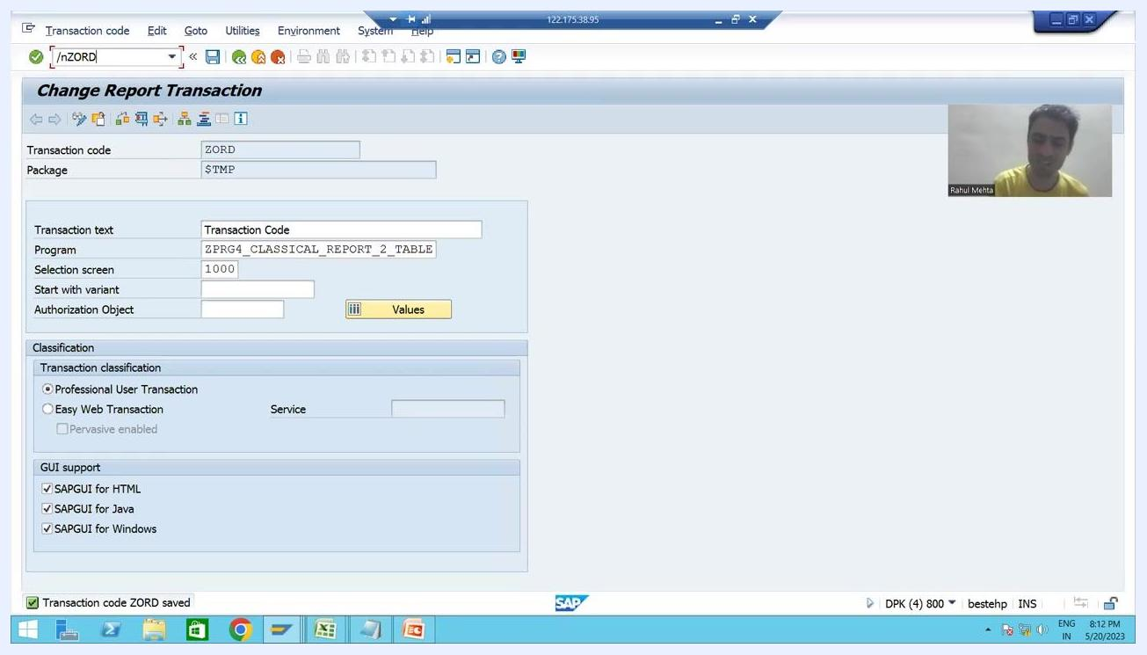
SAP command field with "/nZORD" entered, ready to execute the transaction code.

Step 14: Verify program execution
Confirm that the report runs and displays the expected output.
- In this example, the report displays order details from the order header and order item tables.
- The output includes columns for order numbers, item numbers, dates, types, amounts, and currency (INR).
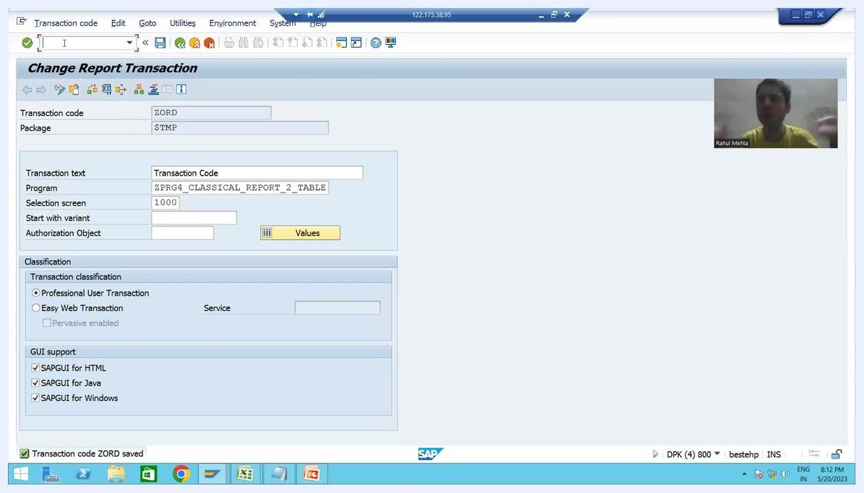
Report output screen displaying order details from the order header and order item tables.

Step 15: Share the transaction code with the customer
Provide the transaction code (ZORD) to the customer and explain that they should use it to run the program, since it is easier to remember and use than the full program name. The customer does not need to run the program directly—they only need to enter the transaction code.

Summary
- Always use a custom prefix (Z, Y, or 5) for new transaction codes.
- Provide a meaningful short text so the transaction is easy to identify.
- Select the correct start object based on your program type—most custom reports use Program and selection screen (report transaction).
- It is the technical team's responsibility to deliver the transaction code together with the program.
By following these steps, you have created a transaction code for your executable report, linked it to the correct selection screen, and verified the configuration in SAP. The selection screen number (1000) is assigned automatically when you choose Program and selection screen, streamlining the process of connecting your report to a transaction code.

