How to Create a Storage Location in SAP
When you manage incoming or outgoing inventory in SAP, you need a way to track exactly where materials are stored within a plant. This guide explains how to create a storage location in SAP, assign it a unique identifier, and attach a specific address and responsible contact to it using the SAP Customizing Implementation Guide (IMG).

Background: shipments, plants, and storage locations
Before creating a storage location, it helps to understand how SAP organizes inventory at a higher level.
Shipment details. When you ship inventory, SAP prompts you to enter relevant shipment information, including:
- Wrapping material used
- Stuffing material used
- Weight of each product
- Total weight of the shipment
SAP also asks you to specify the plant where you want to store the material.
Plants. A plant represents your physical location or factory. Plants vary widely in size, from about 50,000 square feet to 10–15 acres or more. When prompted, you select the plant in which you want to store the incoming material.
Why storage locations matter. To manage inventory efficiently within a large plant, you divide the plant into multiple sections. Each section is called a storage location in SAP. Storage locations let you track exactly where products are stored and make retrieval and placement simpler. For each plant, you define storage locations with unique identifiers (for example, 001, 002, and so on). You can create hundreds or thousands of storage locations as needed, and assign each incoming product to a specific one for precise tracking.

Prerequisites
- Access to the SAP Customizing Implementation Guide (IMG)
- Your plant number (for example, RPLN)
- Authorization to maintain storage locations and storage location addresses

Step 1: Navigate to Maintain Storage Location
In the SAP IMG, expand the following path:
Enterprise Structure > Definition > Materials Management
Click Maintain storage location. This opens the screen where you manage storage locations for your selected plant.
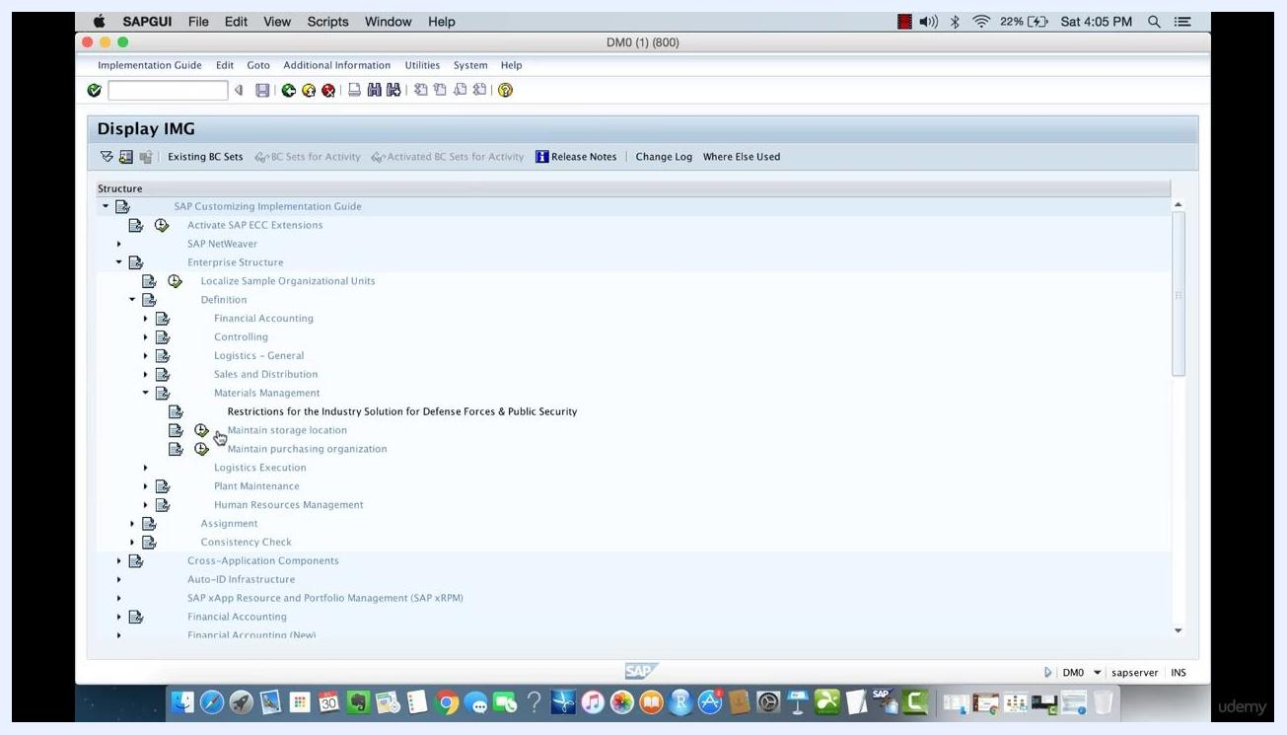
SAP IMG screen with "Maintain storage location" highlighted under Materials Management, showing the navigation structure and available options.

Step 2: Enter your plant number
On the "Change View 'Storage locations': Overview" screen, enter your plant number in the Plant field (for example, RPLN). This displays all existing storage locations for the selected plant. If no storage locations have been created yet, the list appears empty.

Step 3: Create a new storage location
Click New Entries at the top of the screen. In the new row, enter:
- SLoc: 001
- Description: First Loc.
Press Enter to confirm the entry.
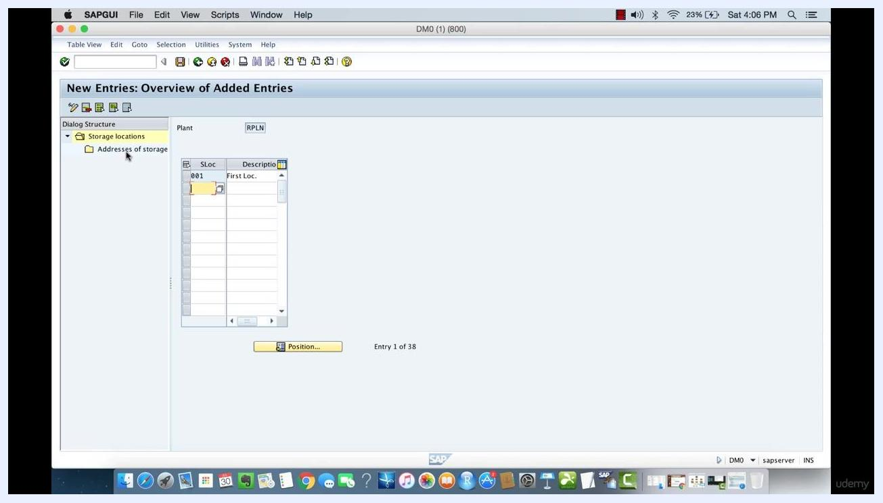
SAP screen showing the creation of a new storage location with SLoc "001" and Description "First Loc." for plant RPLN.

Step 4: Assign a specific address to the storage location
Select the newly created storage location (001). In the left navigation pane, double-click Addresses of storage locations to open the address assignment screen for that storage location.
Click New Entries to add a new address entry, then enter LW1 in the No. field (representing "Left Wing 1" or a similar internal address code).
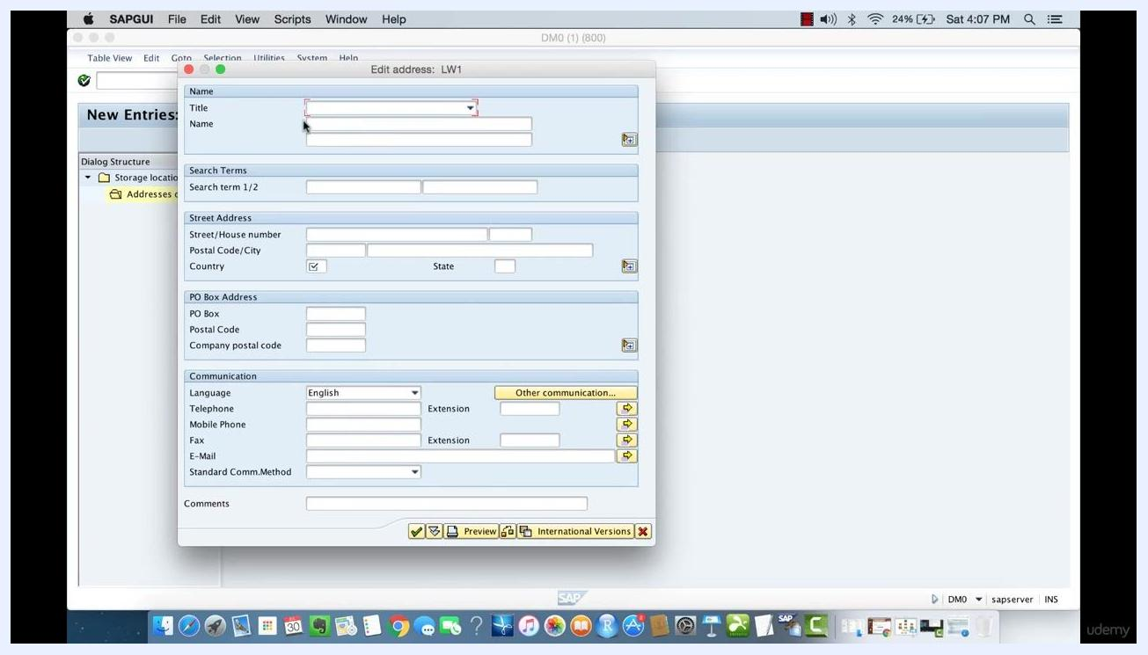
SAP screen for adding a new address entry to storage location 001, with the "New Entries" button highlighted and the No. field ready for input.

Step 5: Complete the required address fields
In the "Edit address: LW1" pop-up, fill in the following fields:
- Title: Mr.
- Name: Jorge Stewart
- Search term 1/2: Location 001 and storage loc 001
- Country: US
You do not need to complete any other fields unless your organization requires them.
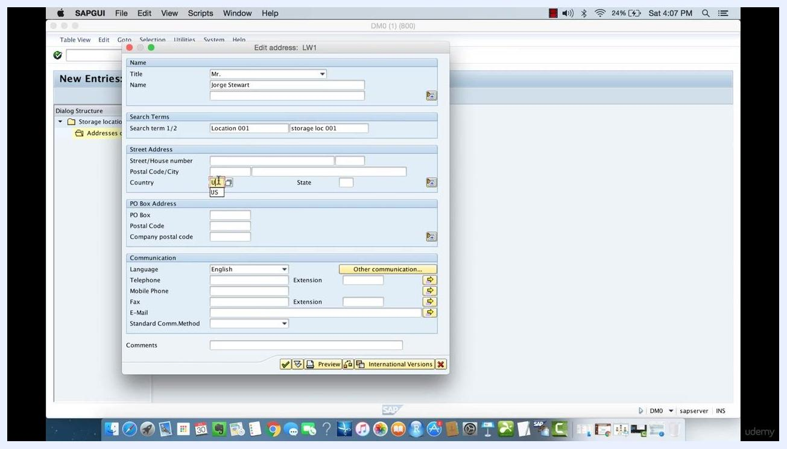
SAP "Edit address: LW1" pop-up with Title "Mr.", Name "Jorge Stewart", search terms "Location 001" and "storage loc 001", and Country "US" filled in. Other fields are visible but not required.

Step 6: Finalize the address entry
Click the Save icon (diskette) to confirm the address entry. If a warning appears, such as "The use of the last 10 characters in field SORT1 is restricted," review the message, then click New entry or the checkmark button to acknowledge it and proceed.
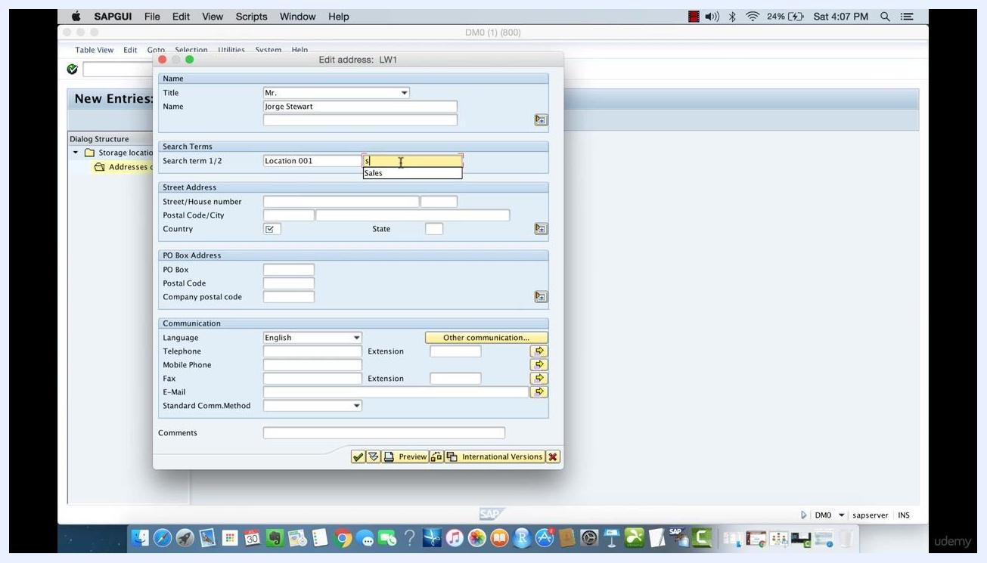
SAP warning dialog about the SORT1 field character limit, with the "New entry" button highlighted.

Step 7: Verify the address assignment
After saving, you return to the "Overview of Added Entries" screen. Confirm that your new address (LW1) is listed for storage location 001 under plant RPLN. The status bar should display "Data was saved."
SAP "Overview of Added Entries" screen showing Plant "RPLN", Stor. Location "001", and address No. "LW1" listed, with the status bar reading "Data was saved."

What's next
With your storage location created and its address assigned, you can repeat this process to define additional storage locations within the same plant, each with its own unique identifier and address. This allows you to track inventory precisely across every section of your plant.

