Creating a Sales Order in SAP Using VA01
This guide walks you through the complete process of creating a Scrap Sales Order in SAP using transaction code VA01. You will learn how to open the transaction, enter organizational data, add customer and shipping details, enter material and pricing information, review the document for completeness, and save the order. The guide also covers how to check the document flow and identifies the standard transaction codes used in the broader order-to-cash process.

Prerequisites
- Access to SAP GUI with a valid user account (e.g., "User Menu for RAHUL.SAHU").
- Authorization to use transaction codes VA01 (Create Sales Order), VA02 (Change Sales Order), and related SD transactions.
- Familiarity with your organization's sales organization, distribution channel, division, customer codes, and material codes.

Opening the sales order transaction

- Open the SAP Easy Access menu.
- Launch the SAP GUI and log in to your user account.
- Confirm you are on the SAP Easy Access - User Menu screen and that your user name is displayed (e.g., "User Menu for RAHUL.SAHU").
- Familiarize yourself with the navigation pane on the left, which contains folders such as "sd", "sales report", "production planning", "mm", and "FI".
- Note the Favorites section for quick access to frequently used transactions.

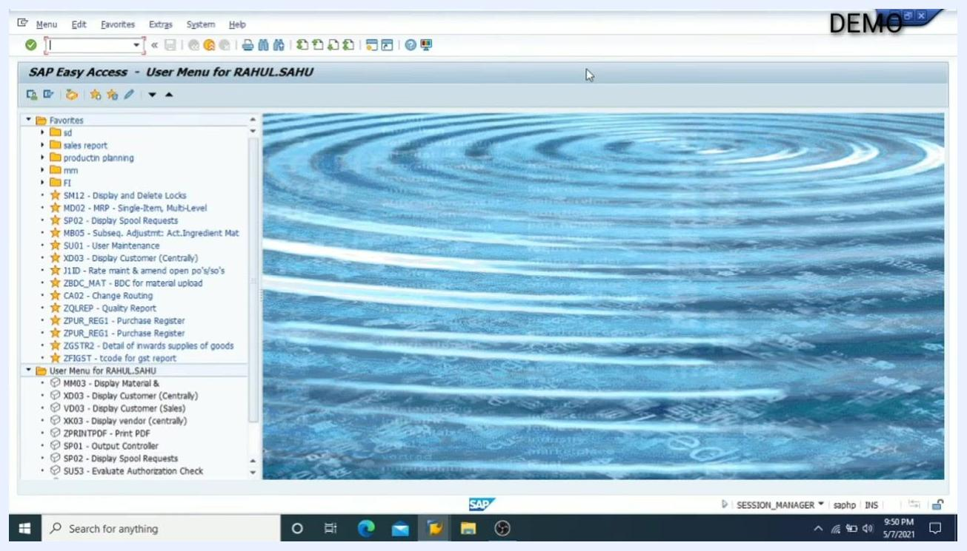
SAP Easy Access screen showing the user menu, navigation pane with folders, and Favorites section

- Navigate to the SD (Sales and Distribution) folder.
- In the navigation pane, locate and expand the sd folder under Favorites.
- This folder contains various SD-related transaction codes, including VA01 for creating sales orders.

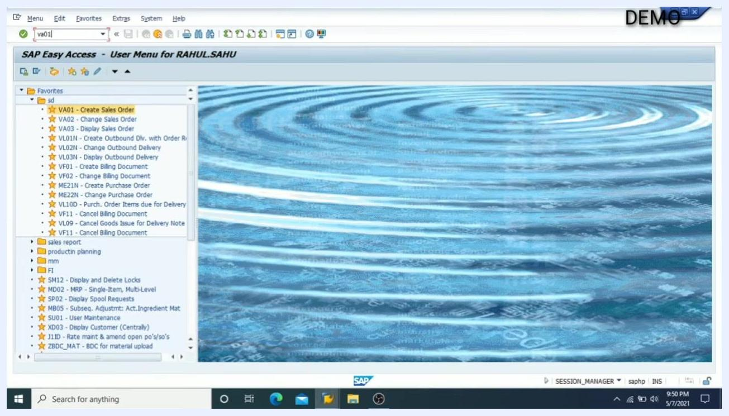
SAP Easy Access screen with the 'sd' folder expanded, showing VA01 - Create Sales Order and other SD transactions

- Start the sales order creation process.
- In the command field at the top, enter the transaction code VA01.
- Press Enter to open the Create Sales Document screen.
- The screen displays fields for Order Type and Organizational Data (Sales Organization, Distribution Channel, Division, Sales Office, Sales Group).

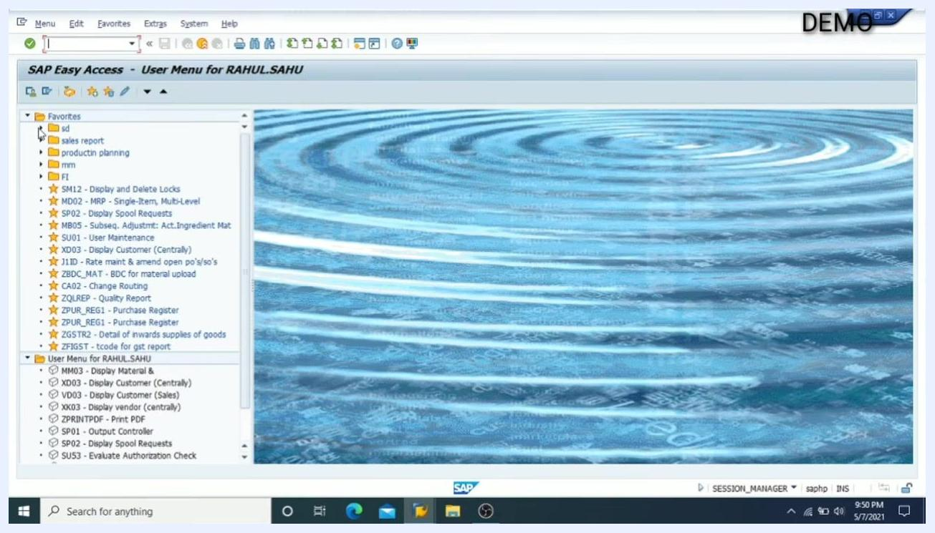
Create Sales Document screen with fields for Order Type, Sales Organization, Distribution Channel, Division, Sales Office, and Sales Group

- Select the order type.
- Click the search icon (or dropdown) next to the Order Type field to open the list of available sales document types.
- Review the list and select the appropriate order type for your transaction. For example, select "ZSCR" if that is your required order type.
- The list may contain standard and custom order types (e.g., DMRP, CR, GOR, ZSCR, etc.).

Sales document type selection window showing a list of order types and descriptions

- Enter organizational data.
- In the Sales Organization field, enter the code for your company's sales organization (e.g., 2100).
- In the Distribution Channel field, enter the appropriate channel code (e.g., 70).
- In the Division field, enter the division code (e.g., 90).
- If required, fill in the Sales Office and Sales Group fields.
- Use the search icon next to each field if you need to look up valid entries.

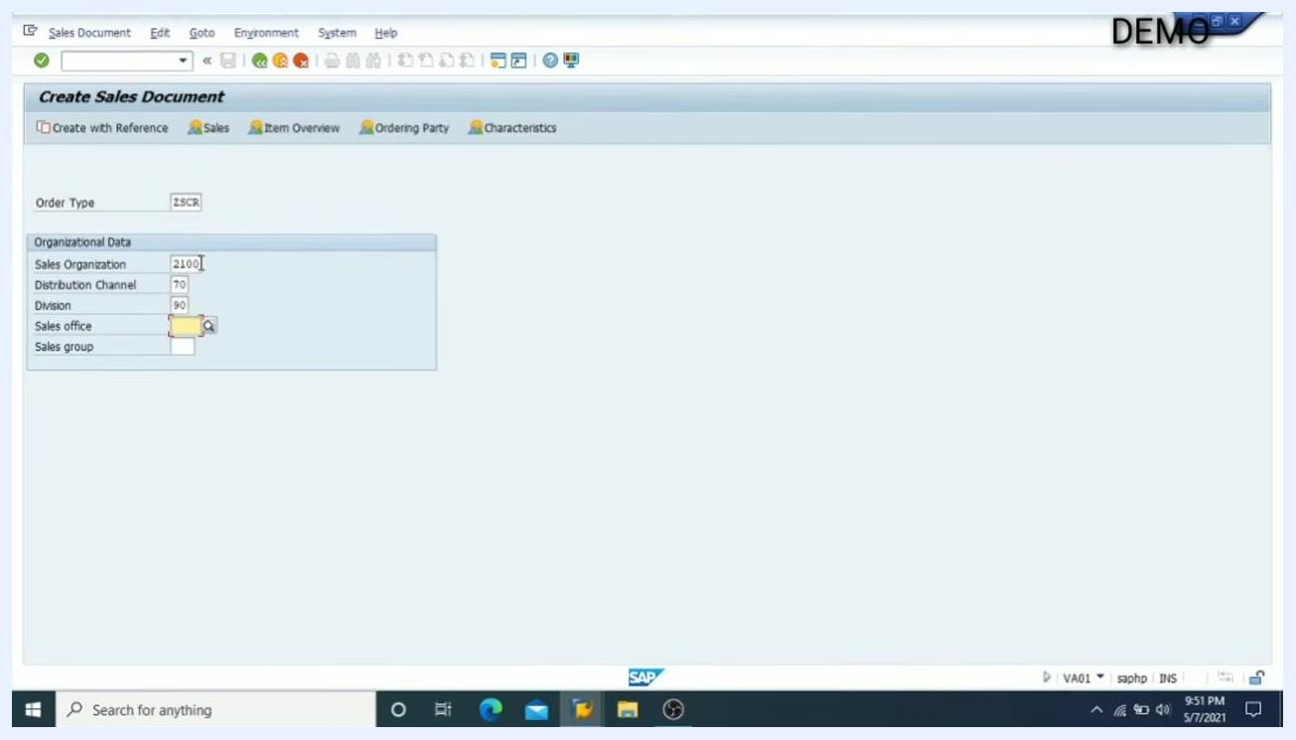
Create Sales Document screen with Order Type ZSCR, Sales Organization 2100, Distribution Channel 70, and Division 90 filled in
Key values used in this example:
- Order Type: ZSCR
- Sales Organization: 2100
- Distribution Channel: 70
- Division: 90

Entering customer, reference, payment, and shipping information

- Skip optional fields.
- Note that the Sales Office and Sales Group fields are optional and not mandatory for order creation.
- You may leave these fields blank unless your process specifically requires them.

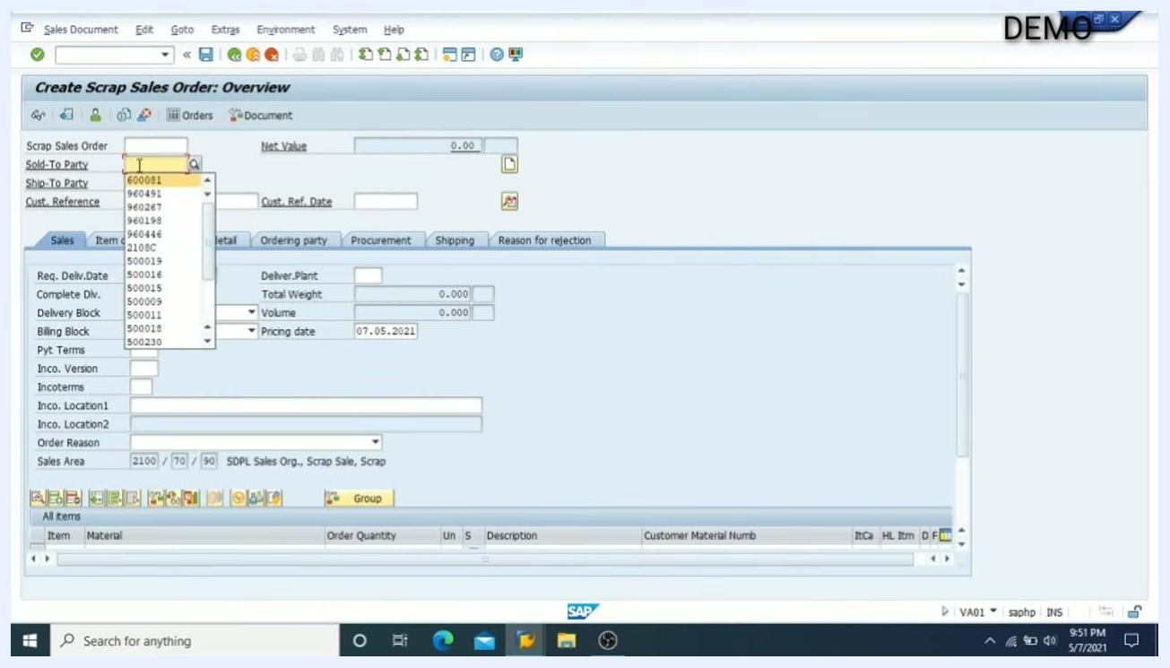
Create Sales Document screen with Sales Office and Sales Group fields highlighted as optional

- Enter the Sold-To Party (customer).
- In the Sold-To Party field, enter the customer code for the party placing the order.
- Use the dropdown or search icon to select from available customers. For example, select customer code 600081.

Create Scrap Sales Order: Overview screen with the Sold-To Party dropdown open, showing customer codes

- Enter the customer reference and reference date.
- In the Cust. Reference field, enter the reference for the order (e.g., "by mail" if the order was received via email).
- In the Cust. Ref. Date field, enter the date of the reference. For example, enter 07.05.2021 for May 7, 2021.

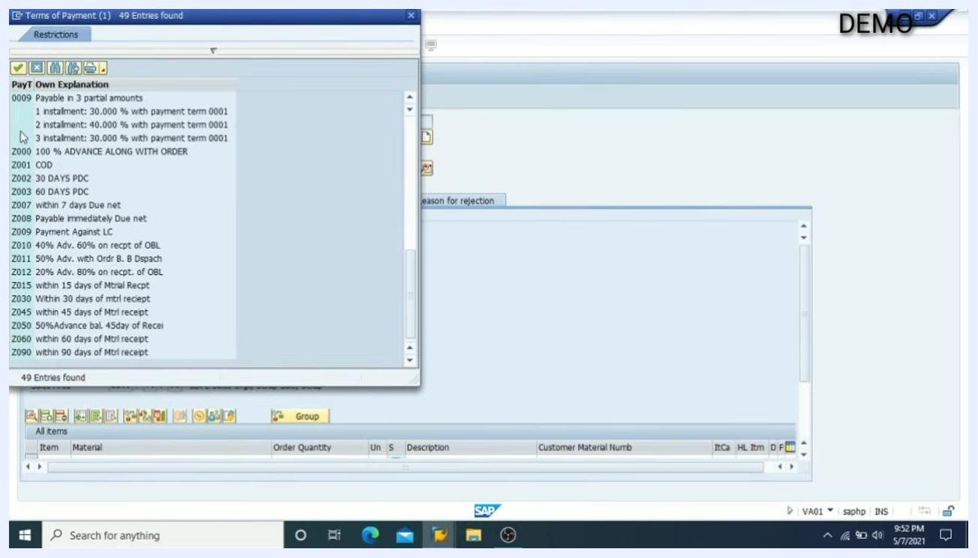
Create Scrap Sales Order: Overview screen with Cust. Reference 'by mail' and Cust. Ref. Date '07.05.2021'

- Specify payment terms.
- In the Pyt Terms field, select the appropriate payment terms for the order.
- Use the search icon to view available payment terms. For example, select Z090 for "within 90 days of Mtrl receipt".

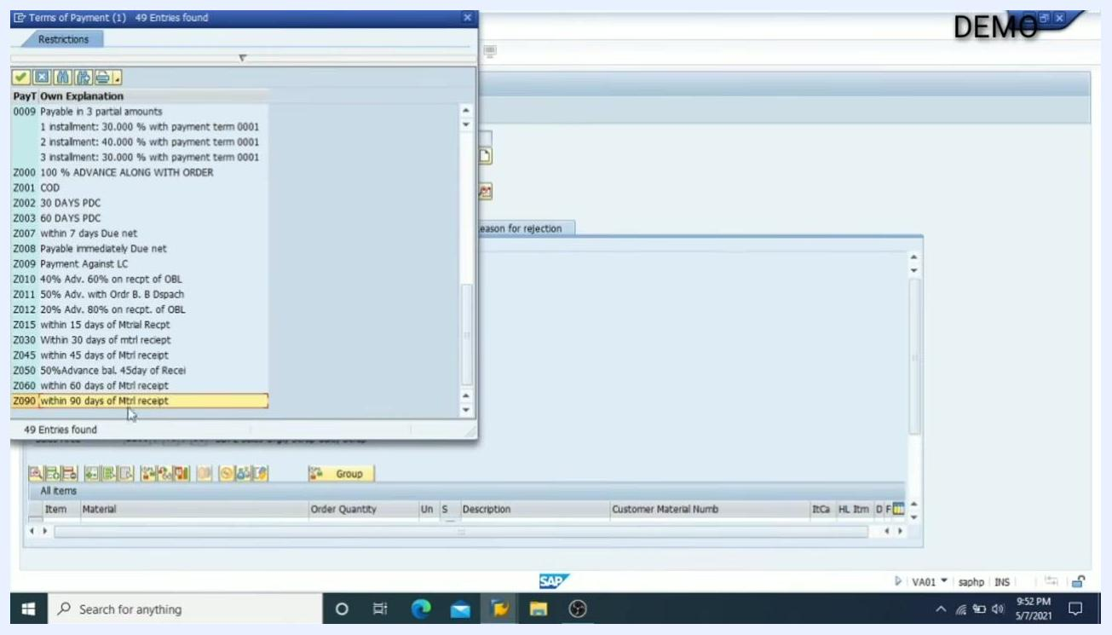
Terms of Payment selection window with Z090 'within 90 days of Mtrl receipt' highlighted

- Select Incoterms.
- In the Incoterms field, specify the delivery and payment terms agreed with the customer.
- Use the search icon to view available Incoterms. For example, select CFR for "Costs and freight".

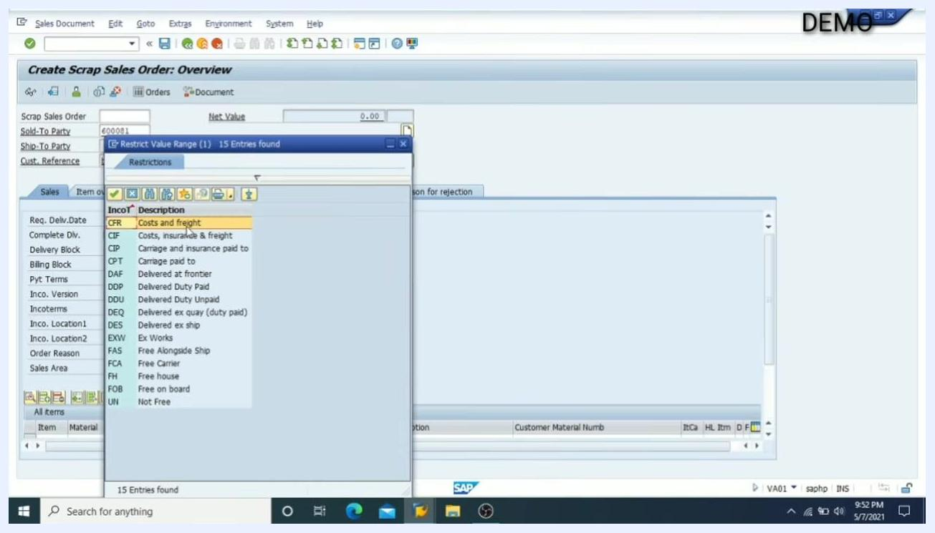
Incoterms selection window with CFR 'Costs and freight' highlighted

- Enter the shipping location.
- In the Inco. Location1 field, enter the location where goods will be shipped. For example, enter Bhopal.
- Confirm that all entered values are correct and match your order requirements.

- Review the entered data.
- Ensure the following fields are filled as per the example:
- Sold-To Party: 600081 (e.g., RAJESH JAAT / Bhopal)
- Ship-To Party: 600081 (e.g., RAJESH JAAT / Bhopal)
- Cust. Reference: by mail
- Cust. Ref. Date: 07.05.2021
- Pyt Terms: Z090 (within 90 days of Mtrl receipt)
- Incoterms: CFR (Costs and freight)
- Inco. Location1: Bhopal

Create Scrap Sales Order: Overview screen with all fields filled, including Sold-To Party, Ship-To Party, Cust. Reference, Cust. Ref. Date, Pyt Terms, Incoterms, and Inco. Location1
Key values used in this example:
- Sold-To Party / Ship-To Party: 600081 (RAJESH JAAT / Bhopal)
- Cust. Reference: by mail
- Cust. Ref. Date: 07.05.2021
- Payment Terms: Z090 (within 90 days of Mtrl receipt)
- Incoterms: CFR (Costs and freight)
- Shipping Location: Bhopal

Entering material, quantity, plant, and pricing

- Switch to the Item overview for easier data entry.
- Click on the Item overview tab to expand the view and make it easier to enter material details.
- This step helps avoid repeatedly using dropdowns for each field.

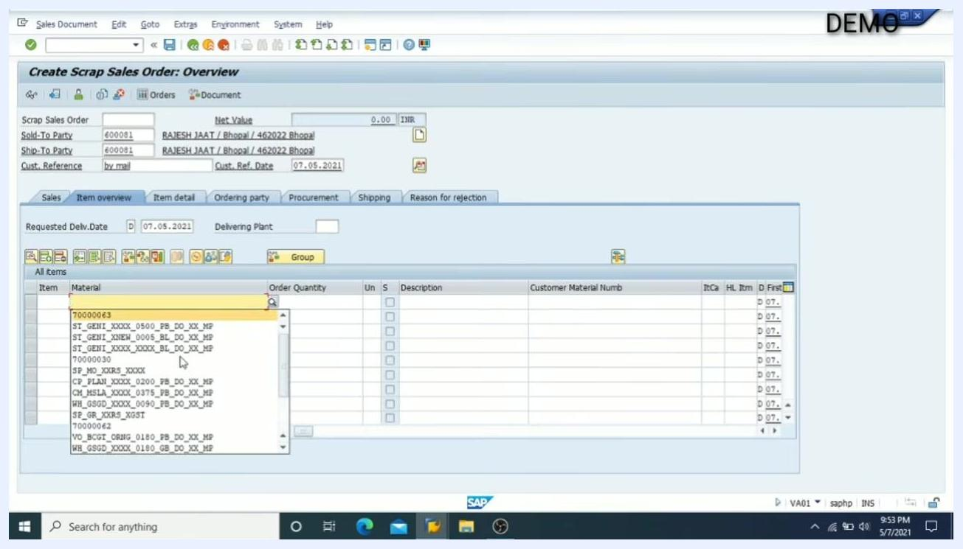
Create Scrap Sales Order: Overview screen with the Item overview tab selected, ready for material entry

- Select the material.
- In the Material column, click the dropdown to view available materials.
- Select the required material code from the list. For example, choose 70000063.

Material dropdown open in Item overview, showing available material codes

- Enter the order quantity.
- In the Order Quantity column, enter the required quantity for the selected material. For example, enter 10 KG.

- Specify the plant.
- In the Plnt (Plant) column, enter or select the plant code where the material will be processed or shipped from.
- If the plant does not auto-populate, use the dropdown to select the correct plant. For example, select 2001.

Material, quantity, and plant fields being filled in Item overview

- Review the entered material data.
- Ensure the following fields are filled:
- Material: 70000063
- Order Quantity: 10 KG
- Description: (e.g., Iron W...)
- Plnt: 2001
- First date: 07.05.2021

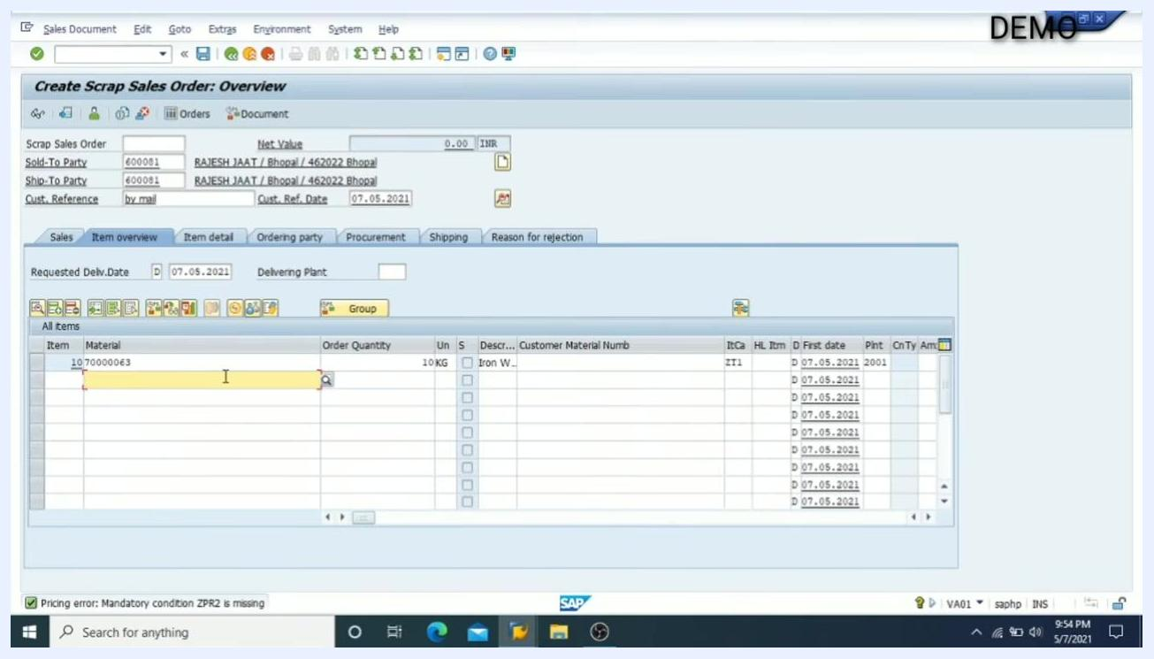
Item overview with material, quantity, and plant entered

- Check for pricing errors.
- After entering material, quantity, and plant, check for any pricing errors at the bottom of the screen.
- If you see a message such as "Pricing error: Mandatory condition ZPR2 is missing," proceed to manually enter the price.

- Enter the price manually in the Conditions tab.
- Double-click on the material line to open the item details.
- Go to the Conditions tab.
- In the ZPR2 (Basic Price: Scrap) row, enter the price per unit. For example, enter 100.00 INR per KG.

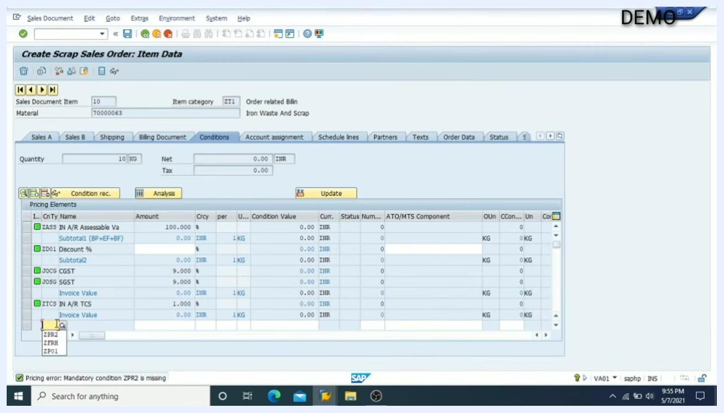
Conditions tab open with the ZPR2 price field ready for manual entry

- Verify the pricing calculation.
- Confirm that the system calculates the total value based on the entered price and quantity.
- For example, with a price of 100 INR and quantity of 10 KG, the condition value should be 1,000.00 INR.
- Review the breakdown of taxes and totals:
- CGST: 90.00 INR
- SGST: 90.00 INR
- Invoice Value (after tax): 1,180.00 INR
- TCS (1%): 11.00 INR
- Final Invoice Value: 1,191.80 INR

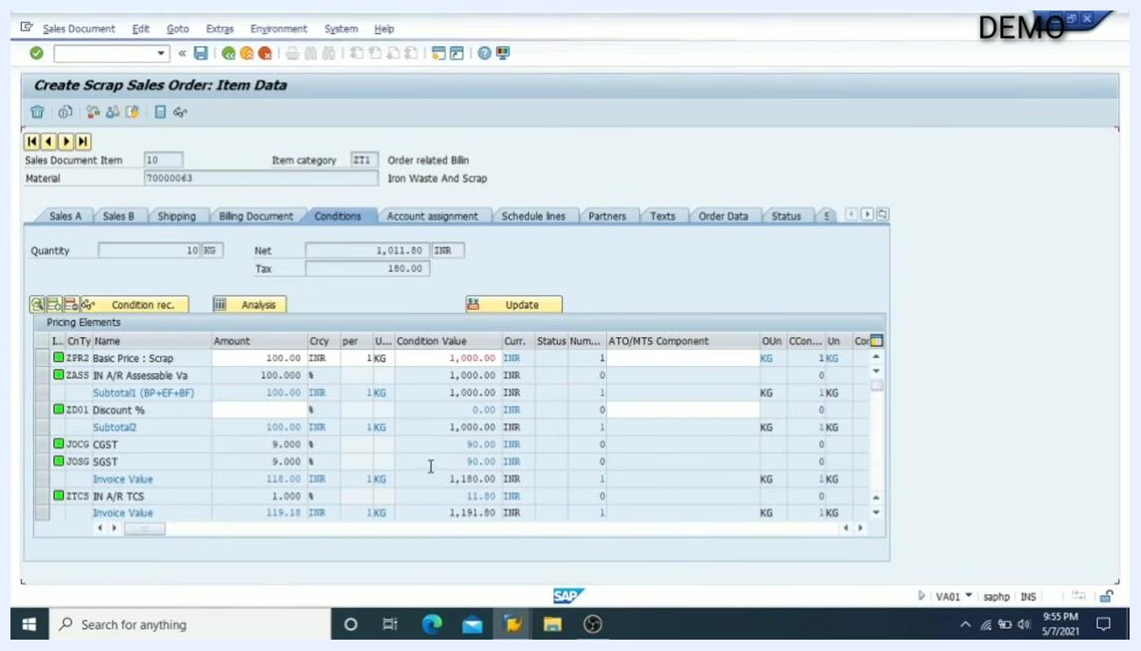
Conditions tab showing the full pricing breakdown, including taxes and final invoice value
Key data entered in this example:
- Material: 70000063
- Order Quantity: 10 KG
- Plant: 2001
- Unit Price (ZPR2): 100.00 INR
- CGST/SGST: 90.00 INR each
- TCS (1%): 11.00 INR
- Final Invoice Value: 1,191.80 INR

Reviewing header details and completing the document

- Open the header details.
- Click the Display header details icon in the Create Scrap Sales Order: Overview screen.
- The screen shows fields such as Sold-To Party (600081), Ship-To Party (600081), Customer Reference (by mail), and Customer Reference Date (07.05.2021).
- The item overview lists Material 70000063, Order Quantity 10KG, Description "Iron W...", and other item details.

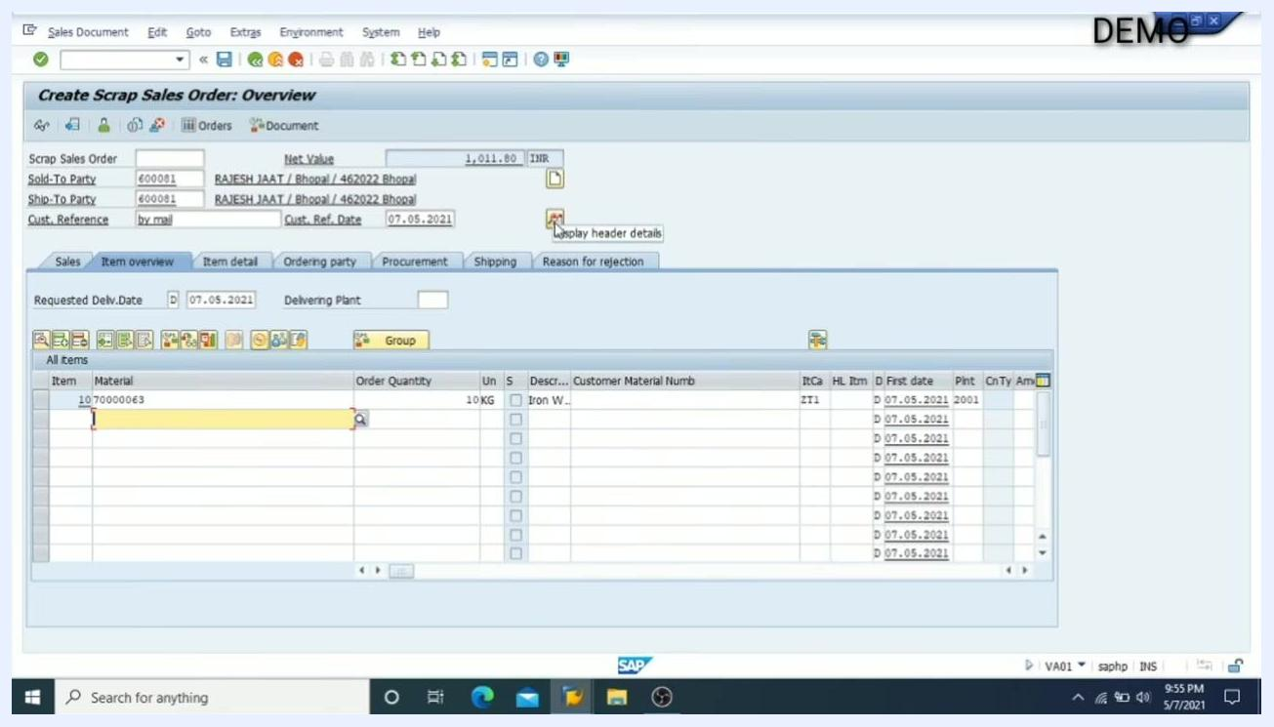
Create Scrap Sales Order: Overview screen with cursor on the 'Display header details' icon, showing order and item details

- Access the header Conditions.
- Click on the Conditions tab or button to view or edit pricing and condition details for the sales order.
- The cursor is shown hovering over the Display header details icon, preparing to access condition information.

Create Scrap Sales Order: Overview screen, cursor on 'Display header details', preparing to access conditions

- Check for errors.
- Review all entered data for completeness and correctness.
- Ensure all mandatory fields are filled.
- The screen continues to display the item overview and order details.

- Check the Incompletion Log.
- Click on Edit in the top menu, then select Incompletion Log (or press Ctrl+F8) to check for any missing or incomplete data in the sales order.
- The dropdown menu under Edit shows options like Display Range, Additional Functions, Batch Determination, and Incompletion Log.

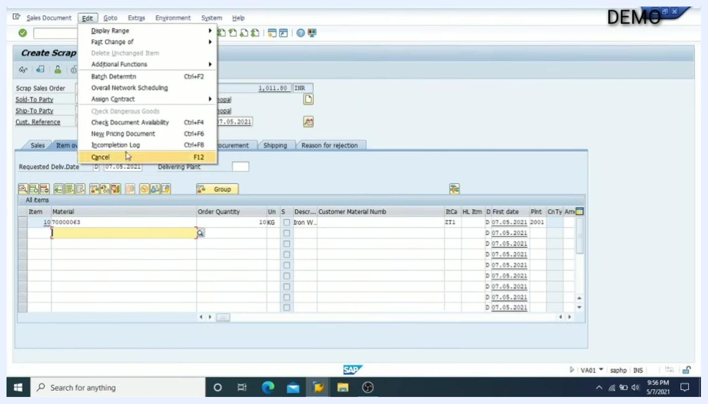
Edit menu open with 'Incompletion Log' highlighted, showing options for checking document completeness

- Enter required values for missing data.
- In the Create Scrap Sales Order: Item Data screen, under the Shipping tab, enter Net Weight = 1 and Gross Weight = 1.
- The Ship-to party is 600081 (RAJESH JAAT / Bhopal / 462022 Bhopal).
- Delivery Priority is set to 1 (High).

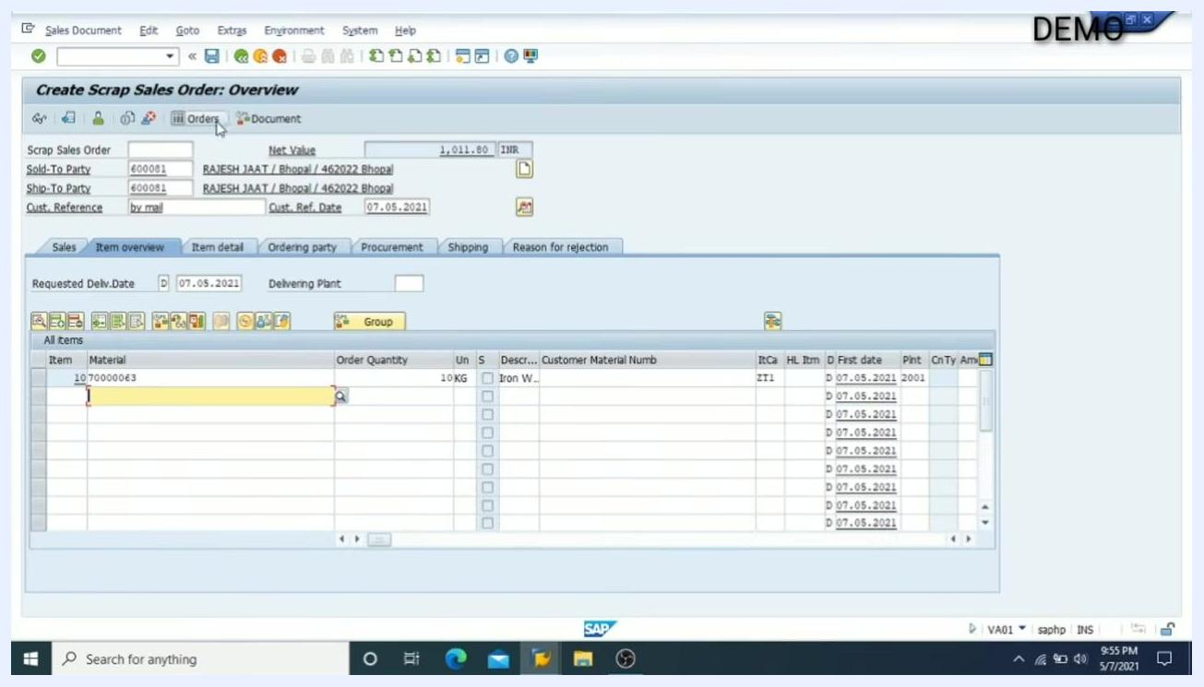
Item Data screen with Net Weight and Gross Weight fields set to 1, showing shipping and delivery details

- Enter the AID by customer reference.
- In the Create Scrap Sales Order: Overview screen, ensure the Sold-To Party field is set to 600081 and the customer reference is entered as required.

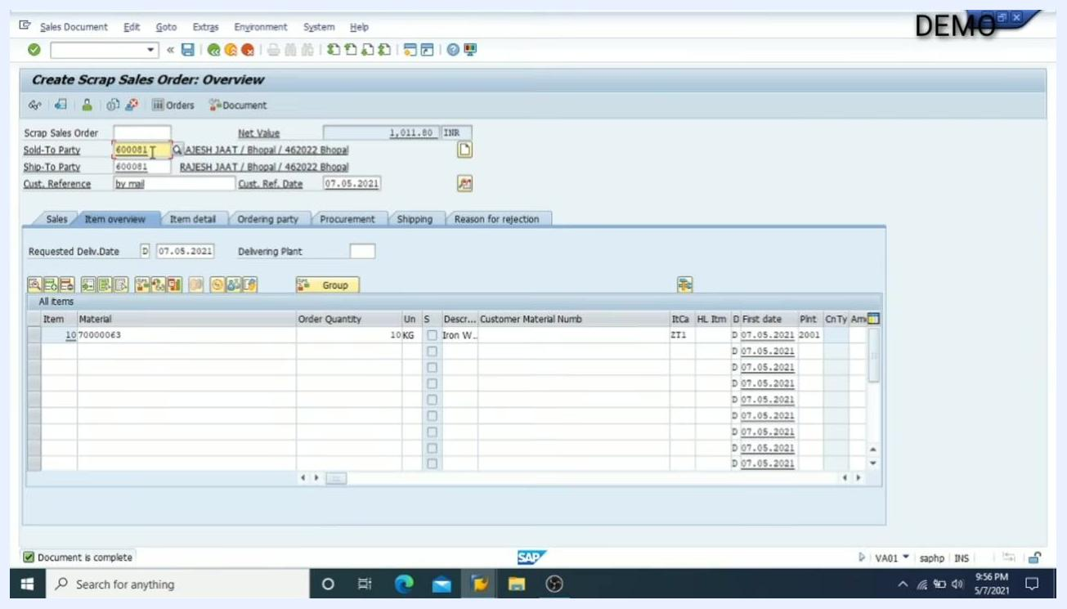
Overview screen with Sold-To Party 600081 and customer reference fields highlighted

- Review the header Conditions tab.
- The Create Scrap Sales Order: Header Data screen displays tabs for Sales, Shipping, Billing Document, Payment Cards, Accounting, Conditions, etc.
- Under Conditions, review the pricing elements such as Basic Price (ZFR2), Assessable Value (ZASS), Discount %, CGST, SGST, TCS, and Invoice Value.
- Net value is 1,011.80 INR, Tax is 180.00 INR, and Invoice Value is 1,191.80 INR.

Header Data screen with the 'Conditions' tab open, showing detailed pricing elements and amounts

- Check the remaining header tabs.
- You can similarly click on the Sales tab to view sales details, Billing Document for billing information, and Payment Cards for payment terms.

- Return to the Overview screen.
- Go back to the Overview screen to review all entered data and ensure everything is correct.

- Confirm the document is complete.
- At the bottom left of the screen, a message "Document is complete" is displayed, indicating all required fields have been filled and the order is ready for processing.

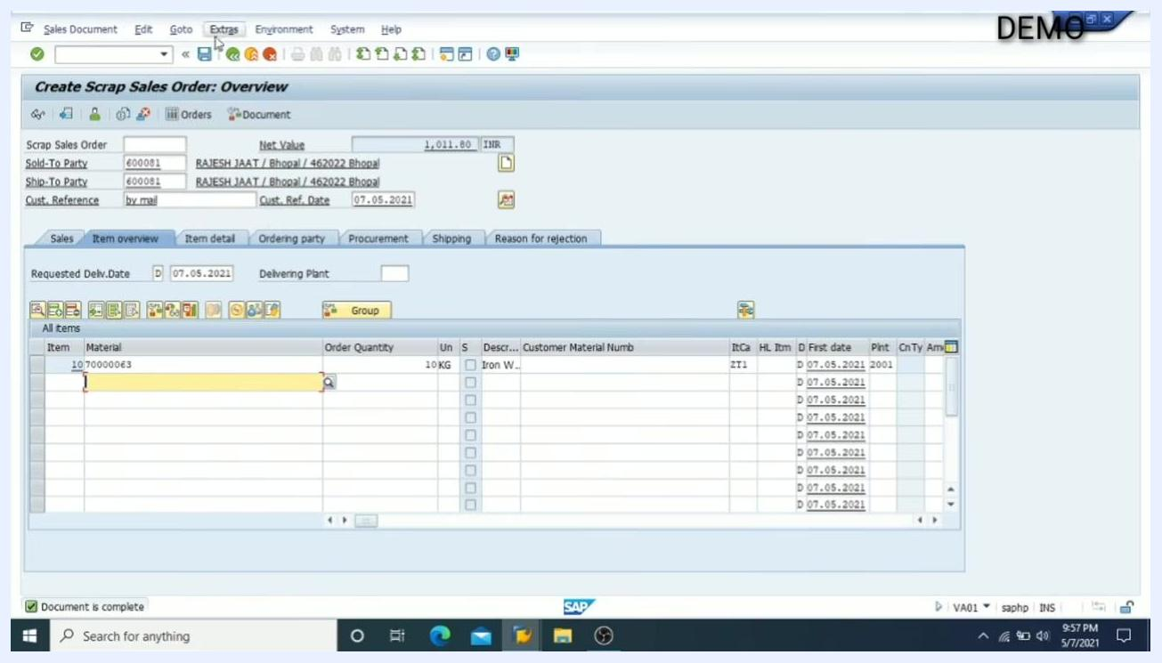
Overview screen with the 'Document is complete' message at the bottom, confirming successful entry

Saving and reviewing the sales order

- Save the completed Scrap Sales Order.
- In the Create Scrap Sales Order: Overview screen, ensure all required fields are filled and the message "Document is complete" is visible at the bottom.
- Click the Save icon (floppy disk) in the toolbar at the top of the SAP window to save your invoice.
- The screen displays details such as Sold-To Party (600081), Ship-To Party (600081), Customer Reference (by mail), Customer Reference Date (07.05.2021), Material (70000063), Order Quantity (10KG), and Description ("Iron W...").

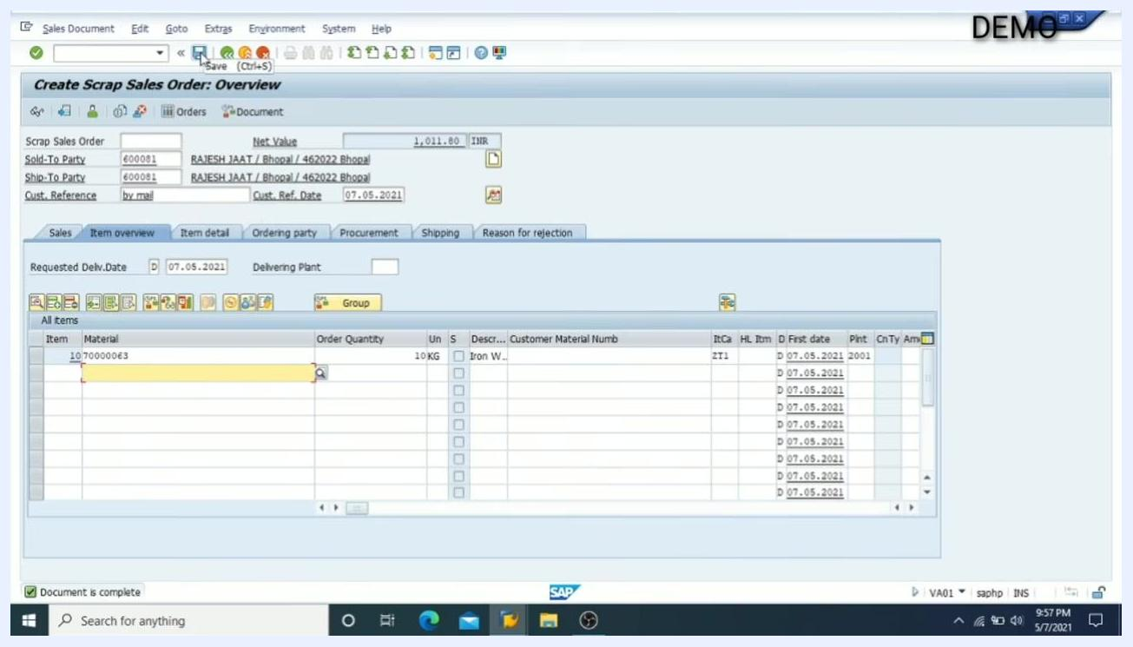
Create Scrap Sales Order: Overview screen with all order details filled and the Save icon highlighted, ready to save the invoice

- Change an existing sales order if needed.
- Return to the SAP Easy Access menu.
- In the Favorites section, locate and select VA02 - Change Sales Order to modify an existing sales order.
- The user menu is labeled "User Menu for RAHUL.SAHU" and displays a list of frequently used transaction codes such as VA01, VA02, VA03, VL01N, VL02N, VF01, etc.

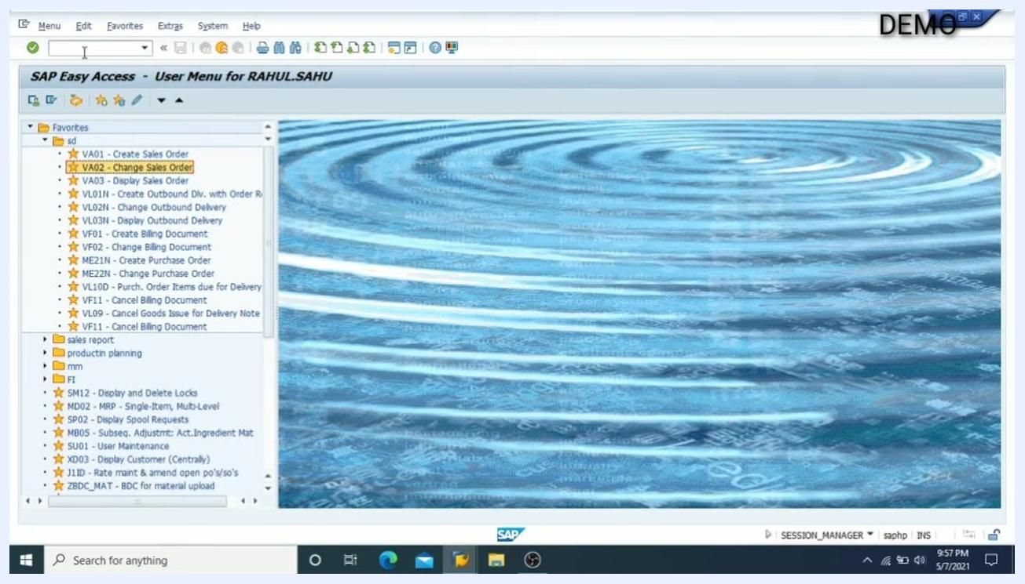
SAP Easy Access menu with 'VA02 - Change Sales Order' highlighted in the Favorites list

- Review for possible mistakes.
- Double-check all fields and values in your sales order for accuracy before proceeding.

- Check the document flow for your order.
- In the Change Sales Document screen, enter your order number (e.g., 8016003179) in the Order field.
- Click the Display Document Flow icon (Shift+F5) to view the flow of documents related to your sales order.
- The screen also allows you to search by Purchase Order No., Sold-to party, Delivery, Billing Document, WBS Element, or Material.

Change Sales Document screen with the order number entered and the 'Display Document Flow' icon highlighted

- Open the sales order for review.
- After clicking to display the document flow, the sales order details will open.
- The Change Scrap Sales Order: Overview screen displays all header and item details for the order number entered.
- Review fields such as Net Value (1,011.80 INR), Sold-To Party (600081), Ship-To Party (600081), Customer Reference (by mail), Customer Reference Date (07.05.2021), Material (70000063), Order Quantity (10KG), and Description ("Iron Waste And Scrap").

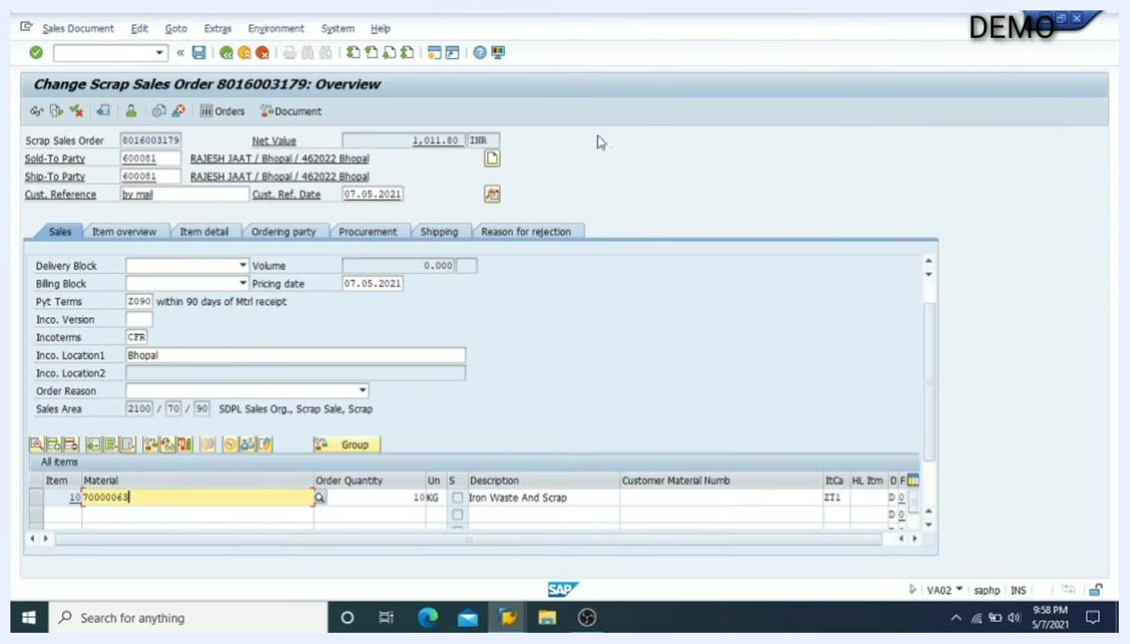
Change Scrap Sales Order: Overview screen with all order details visible for review

- View or edit item details.
- In the item overview section, double-click the material number (e.g., 70000063) to access detailed information about the item.

- Review pricing and condition details.
- In the Conditions tab, verify all pricing elements such as Basic Price, Discounts, Taxes (CGST, SGST), and Invoice Value.
- The screen displays condition values (e.g., 1,000.00 INR, 90.00 INR, 1,180.00 INR, 1,191.80 INR) and their respective units (KG).
- Click Update if any changes are made.

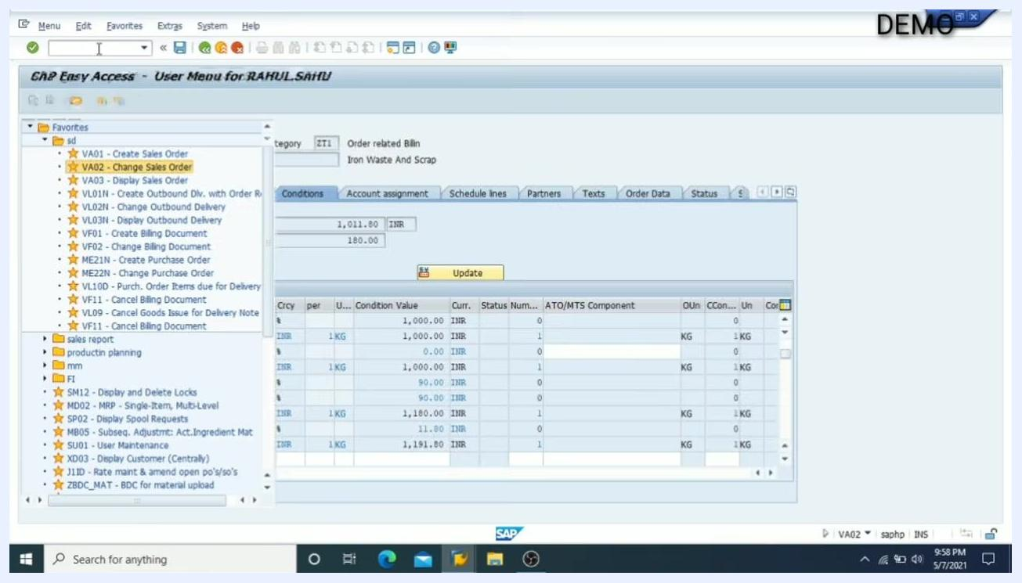
Conditions tab open in Change Sales Order, showing detailed pricing and tax breakdowns

- Keep the key fields in mind.
- Customer, material, quantity, and plant are very important fields in an order.
- Always ensure these fields are correctly filled to avoid errors.

Key transaction codes for order processing

- Understand the standard SAP transaction codes.
- VL01N: Create Outbound Delivery with Order Reference (used for delivery creation)
- VL02N: Change Outbound Delivery (used for Post Goods Issue, PGI)
- VF01: Create Billing Document (used for invoice creation)
- These transaction codes are visible in the Favorites list and are essential for the sales order process.

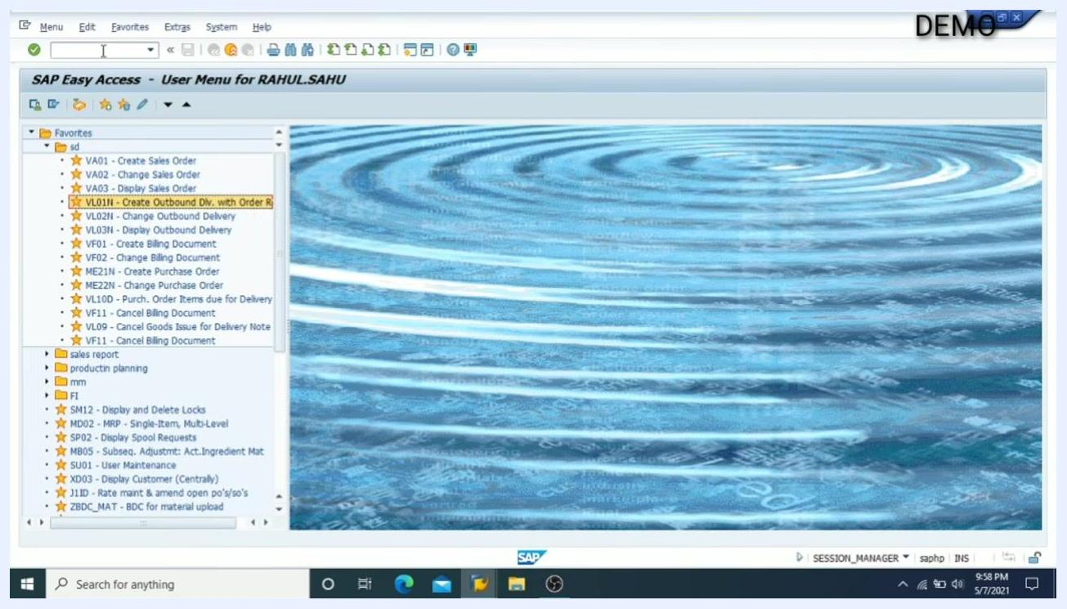
SAP Easy Access menu with VL01N, VL02N, and VF01 transaction codes highlighted in the Favorites list

- Note the standard transaction codes for sales order processing.
- These are the standard transaction codes used in SAP for sales order, delivery, PGI, and billing processes.

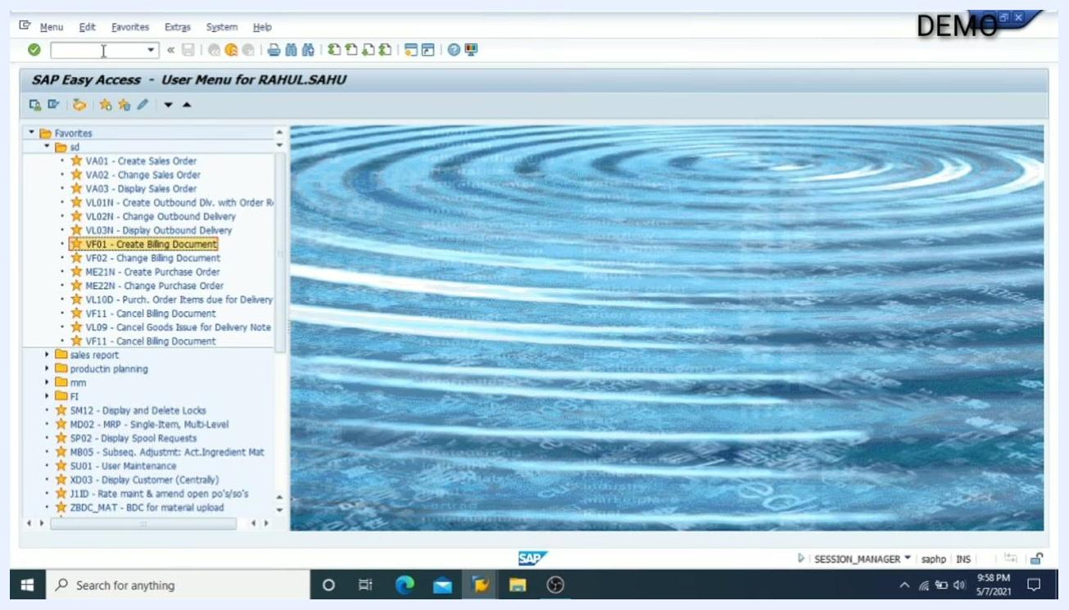
SAP Easy Access menu with standard transaction codes for sales and billing processes

Returning to the main menu

- Return to the SAP Easy Access main menu.
- After completing all sales order processing steps, ensure you are back at the SAP Easy Access screen.
- The screen displays "SAP Easy Access – User Menu for RAHUL.SAHU" at the top.
- The Favorites panel on the left lists frequently used transaction codes, including:
- VA01 – Create Sales Order
- VA02 – Change Sales Order
- VA03 – Display Sales Order
- VL01N – Create Outbound Dlv. with Order Ref.
- VL02N – Change Outbound Delivery
- VL03N – Display Outbound Delivery
- VF01 – Create Billing Document
- VF02 – Change Billing Document
- ME21N – Create Purchase Order
- ME22N – Change Purchase Order
- VL10D – Purch. Order Items due for Delivery
- VL09 – Cancel Goods Issue for Delivery Note
- VF11 – Cancel Billing Document
- Additional folders for "sales report," "production planning," "mm," and "FI" are visible.
- The background features a blue ripple water effect, and the system is marked as "DEMO" in the upper right corner.
- The Windows taskbar at the bottom shows the SAP application icon, browser, file explorer, and other standard Windows elements.
- No actions are being performed; the system is idle and ready for the next user input.

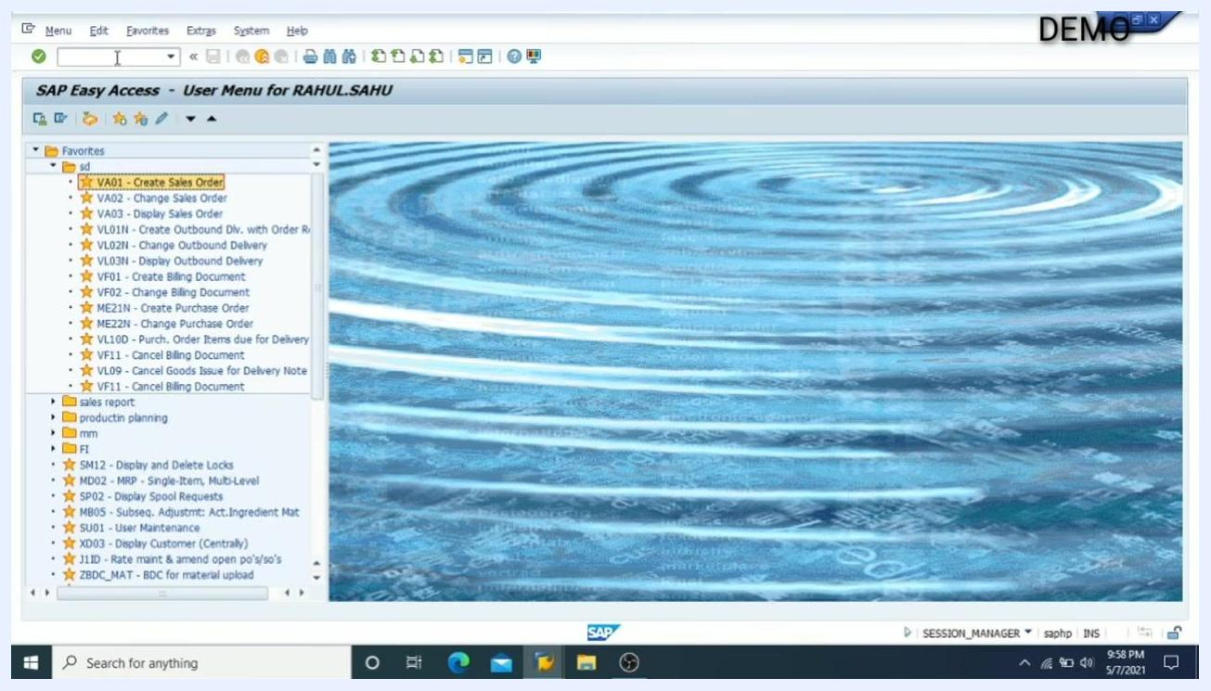
SAP Easy Access main menu with the Favorites panel and blue ripple background, system idle and ready for next input

- Seek further assistance if needed.
- If you have any questions or encounter issues, you are encouraged to seek help or clarification via the comments section of the tutorial or support channel.

- Support the tutorial if it was helpful.
- If you found the guide or video useful, show your support by liking the content and subscribing to the channel for more tutorials.
- The SAP Easy Access screen remains unchanged, confirming the end of the process.

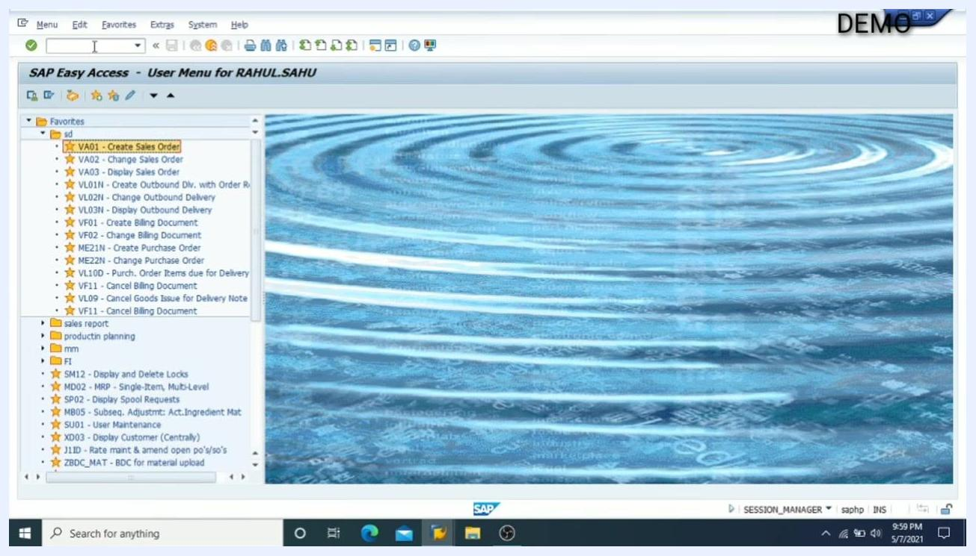
SAP Easy Access main menu with the Favorites panel and blue ripple background, system idle and ready for next input

What's next
By following these steps, you have successfully created, checked, completed, saved, and reviewed a Scrap Sales Order in SAP, and you understand the key transaction codes and fields required for efficient order processing. From here, you can proceed to the next stages of the order-to-cash process using VL01N to create an outbound delivery, VL02N to post goods issue, and VF01 to create the billing document. For any further questions, use the available support channels, and consider supporting the content creator if you found this guide helpful.

