How to Create a New Material Type in SAP MM
This guide explains how to create a new material type in SAP MM by copying an existing raw material type, and how to edit an existing material type afterward. You will use transaction codes OMS2 and OMH2 to access the material types overview and configure your custom material type.

Prerequisites
- Access to the SAP Easy Access screen with authorization to use transaction codes OMS2 and OMH2.
- Knowledge of the material type code and description you want to create (for example, ZZR3).

Creating a new material type

1. Open the material types overview
Launch the SAP Easy Access screen. In the command field at the top, enter oms2 and press Enter. The SAP Menu and Favorites folders appear on the left side of the screen.
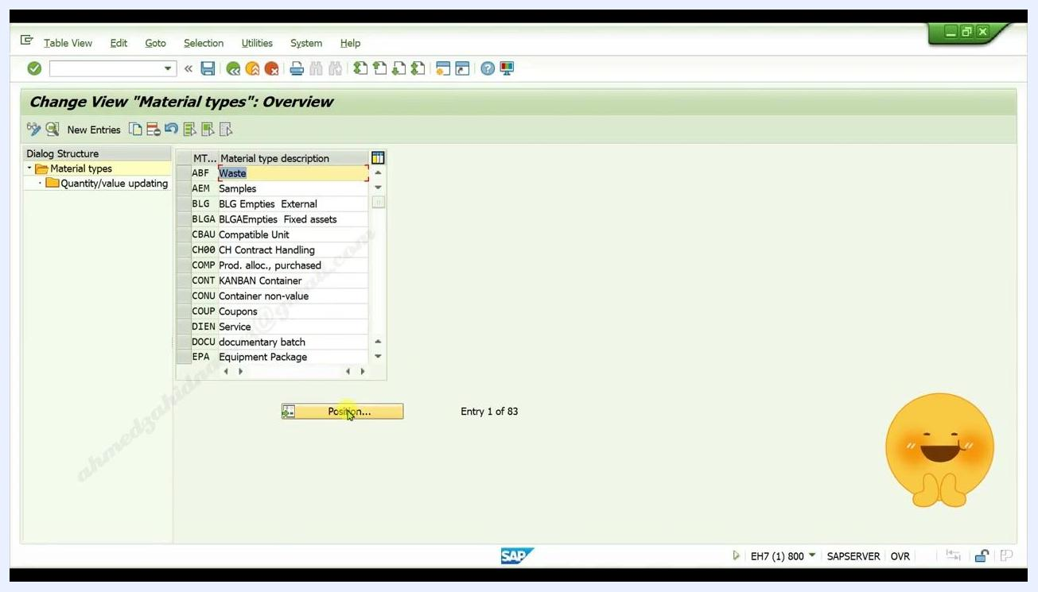
SAP Easy Access screen with 'oms2' entered in the command field, SAP Menu tree visible
The Change View "Material types": Overview screen opens, displaying a list of existing material types and their descriptions. Click the Position... button if you want to quickly find a specific material type.
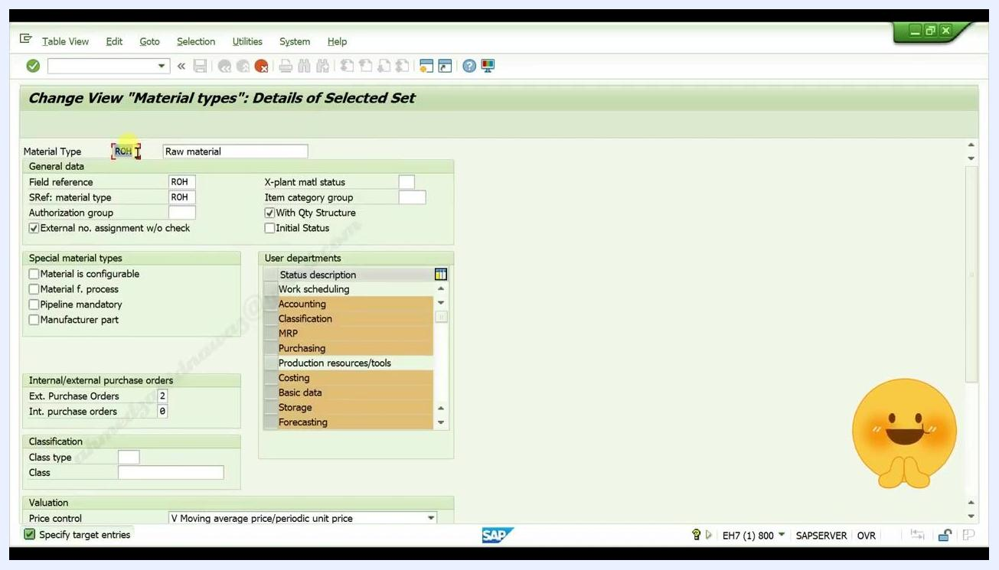
Material types overview list with the Position button highlighted

2. Select the raw material line
Scroll through the list and select the line where:
- MT is ROH
- Material type description is Raw material
This highlights the raw material type entry.
ROH Raw material line selected in the material types overview list

3. Copy the material type
Click the Copy as icon to open the details screen for copying the material type.

4. Enter your own material type code
In the Material Type field, replace ROH with your own code, for example zzr3. The Raw material description remains unchanged for now.
Material Type field being edited with the new code 'zzr3' entered

5. Enter your own description
In the Material type description field, enter your custom description, for example ZZR3 Raw material.
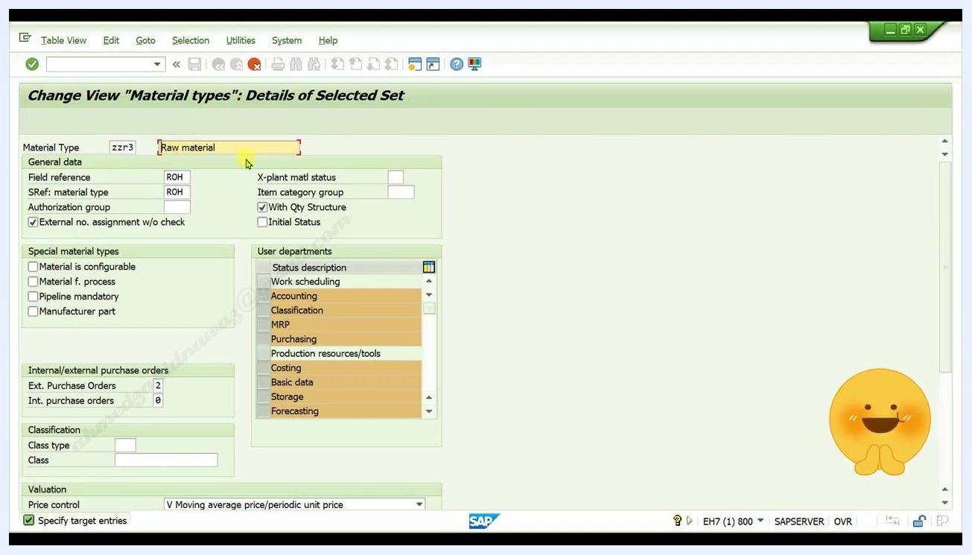
Material type code 'zzr3' with description being edited

6. Confirm your entries
Press Enter to confirm the new code and description. The fields update to reflect your entries.
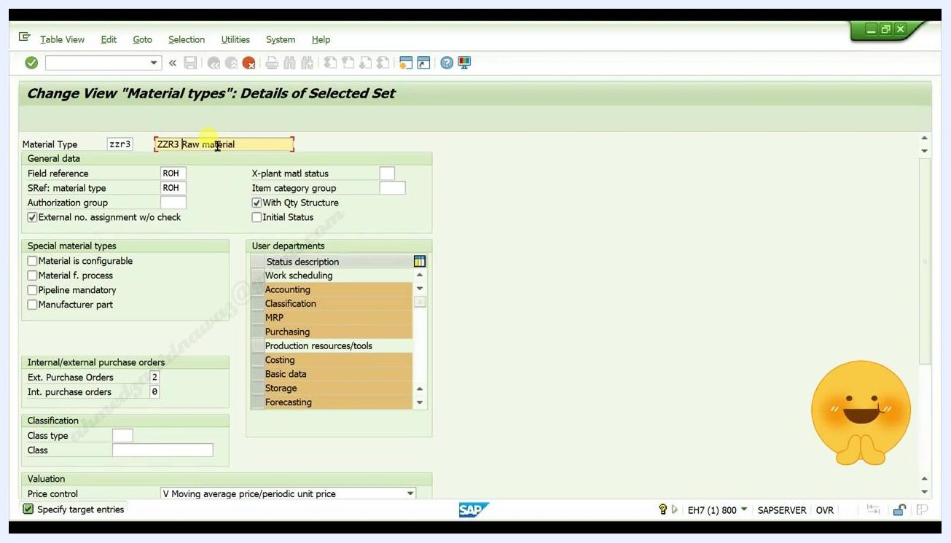
Material type and description fields updated to 'ZZR3' and 'ZZR3 Raw material'

7. Save the new material type
Click the Save button (disk icon) in the toolbar. If prompted, click Continue to confirm any warnings. A message appears at the bottom left of the screen confirming: "Data was saved."
Overview list showing the new material type 'ZZR3 ZZR3 Raw material' with the 'Data was saved' message

Editing an existing material type

8. Open the material types overview
Launch the SAP Easy Access screen. In the command field at the top, enter omh2 and press Enter. The SAP Menu and Favorites folders appear on the left side of the screen.
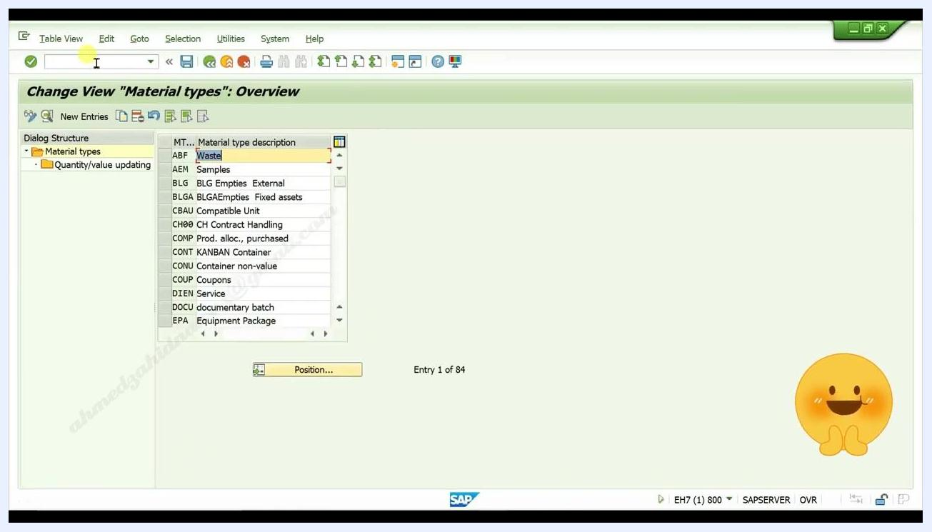
SAP Easy Access screen with the command field ready for input, SAP Menu tree visible
The Change View "Material types": Overview screen opens, displaying the list of existing material types and descriptions, with the Position... button available below the list.

9. Find your material type
Click the Position... button. In the dialog that appears, enter the material type code you created earlier (for example, ZZR3), and press Enter to navigate directly to it in the list.
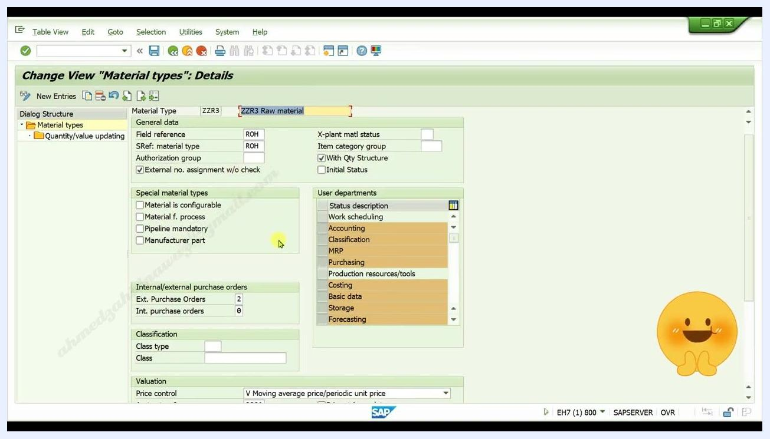
Position button being clicked in the material types overview

10. Select and open your material type
Locate your material type (for example, ZZR3) in the list, then double-click the entry to open its details.
Material types overview with entries visible, ready for selection

11. Edit the material type details
The Change View "Material types": Details screen opens. Here, you can edit any of the following fields as needed:
- Material Type (for example, ZZR3)
- Material type description (for example, ZZR3 Raw material)
- Field reference, SRef: material type, Authorization group
- Special material types (checkboxes for configurable, process, pipeline, manufacturer part)
- Internal/external purchase orders
- Classification (Class type, Class)
- Valuation (Price control, etc.)
- User departments (Work scheduling, Accounting, Classification, MRP, Purchasing, etc.)
Make the necessary changes to your material type details.
Material type details screen for ZZR3 Raw material with editable fields visible

12. Save your changes
After editing, click the Save button (disk icon) in the toolbar. A confirmation message appears at the bottom left: "Data already saved."
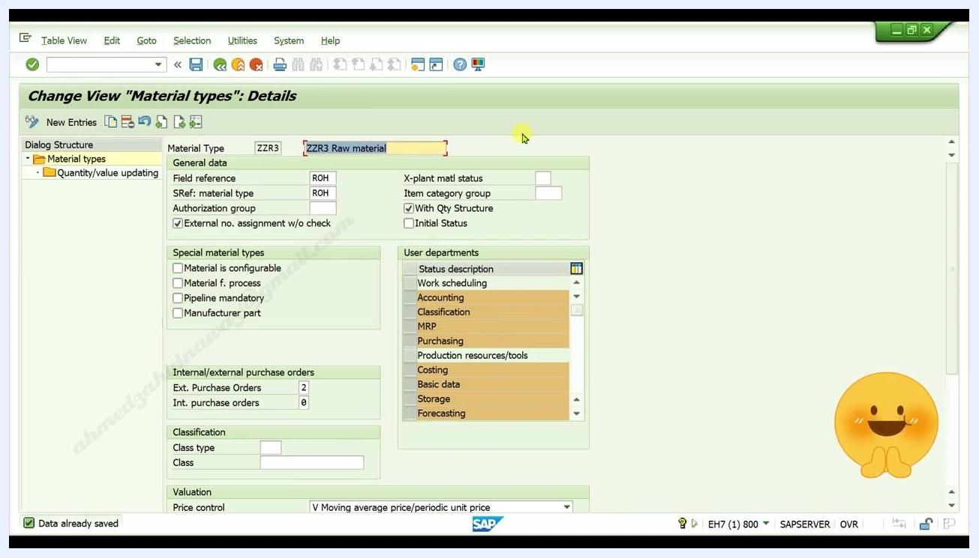
Material type details screen showing the 'Data already saved' message

Summary
By following these steps, you can create a new material type in SAP MM by copying an existing raw material type, and efficiently locate and edit the details of your custom material type whenever needed.

