How to Create a Dynamic ALV Report in SAP ABAP
This guide walks you through how to create a dynamic ALV report in SAP ABAP that can accept any table name at runtime, determine its structure, fetch data, and display the results in an ALV grid. By the end of this guide, you will have a flexible table viewer that works with any table in your SAP system.

Prerequisites
- Access to the ABAP editor in your SAP system.
- Basic familiarity with ABAP syntax and the SAP data dictionary.

Step 1: Start a new ABAP report
Open the ABAP editor and create a new report named zms_p_test01. Enter the following declaration at the top of your report:

REPORT zms_p_test01.
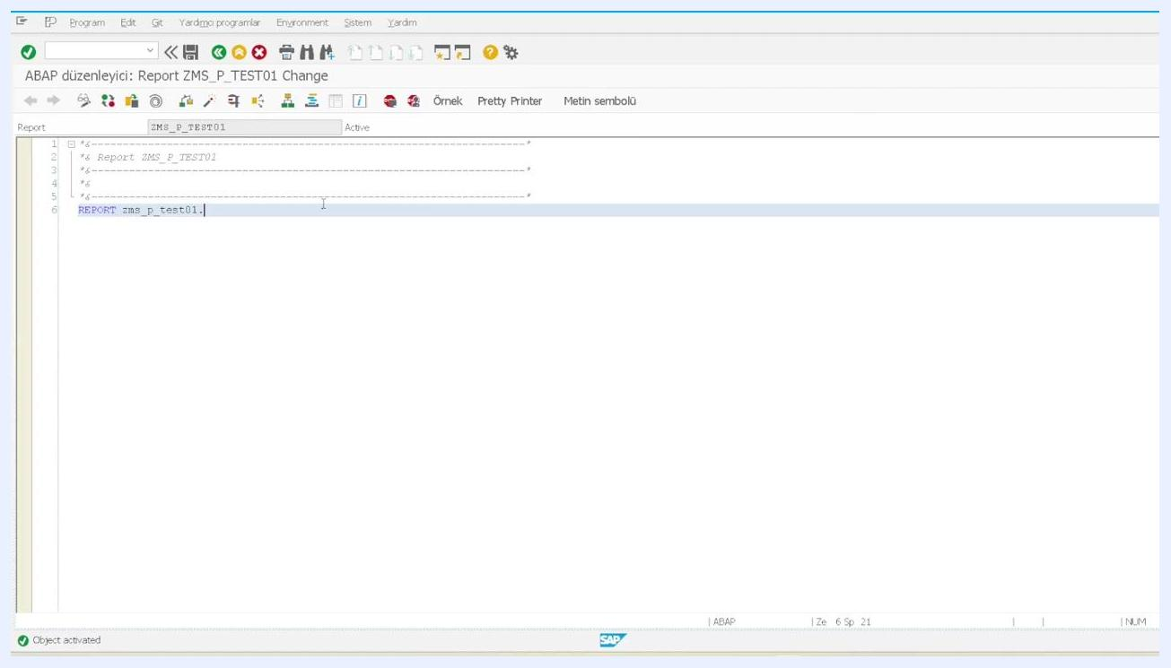
ABAP editor showing the initial report declaration: REPORT zms_p_test01.

Step 2: Define a parameter for table name input
Add a parameter to the selection screen so users can enter the name of the table they want to view. Define the parameter as obligatory and of type tabname:

PARAMETERS : p_tabn TYPE tabname OBLIGATORY.
This parameter accepts any table name, such as echo or wubac.
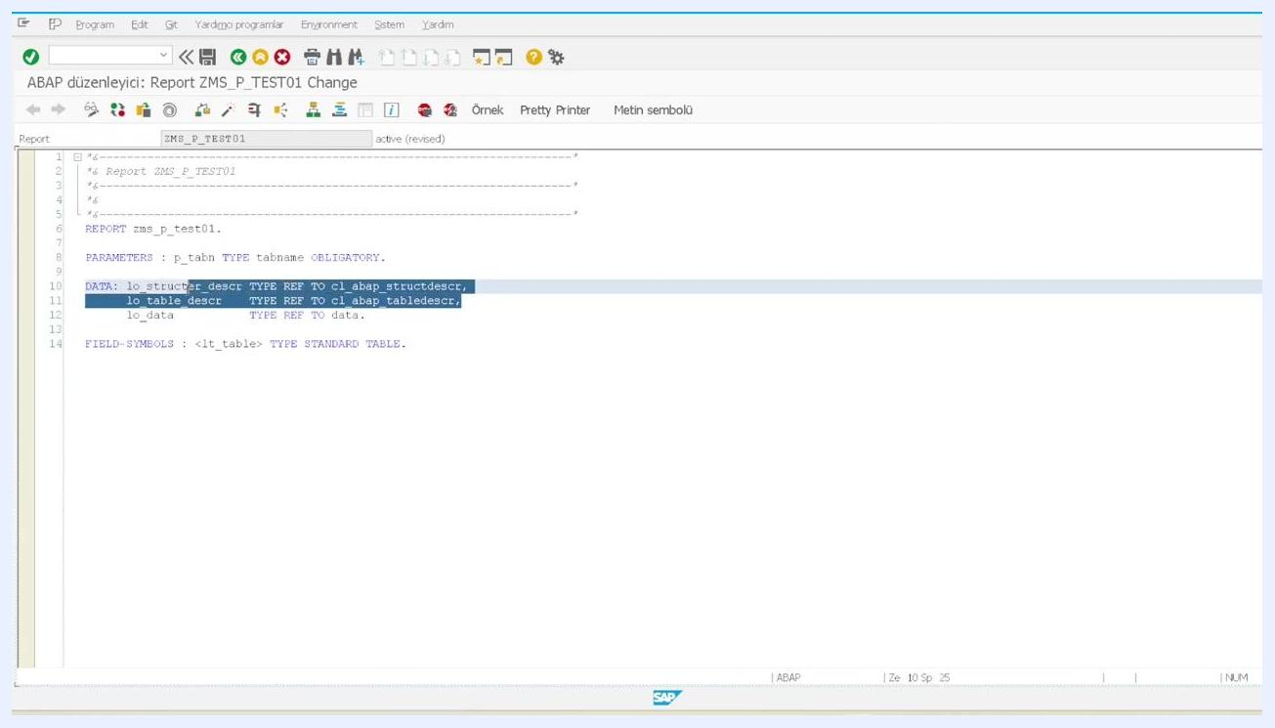
Parameter definition for table name input: PARAMETERS : p_tabn TYPE tabname OBLIGATORY.

Step 3: Declare data objects for dynamic table handling
Define the data references needed to handle dynamic table structures at runtime:
- lo_structer_descr holds the structure definition.
- lo_table_descr holds the table definition.
- lo_data is the reference for the dynamic internal table.
You also need a field symbol to act as the dynamic internal table:

DATA: lo_structer_descr TYPE REF TO cl_abap_structdescr,
lo_table_descr TYPE REF TO cl_abap_tabledescr,
lo_data TYPE REF TO data.
FIELD-SYMBOLS: <lt_table> TYPE STANDARD TABLE.
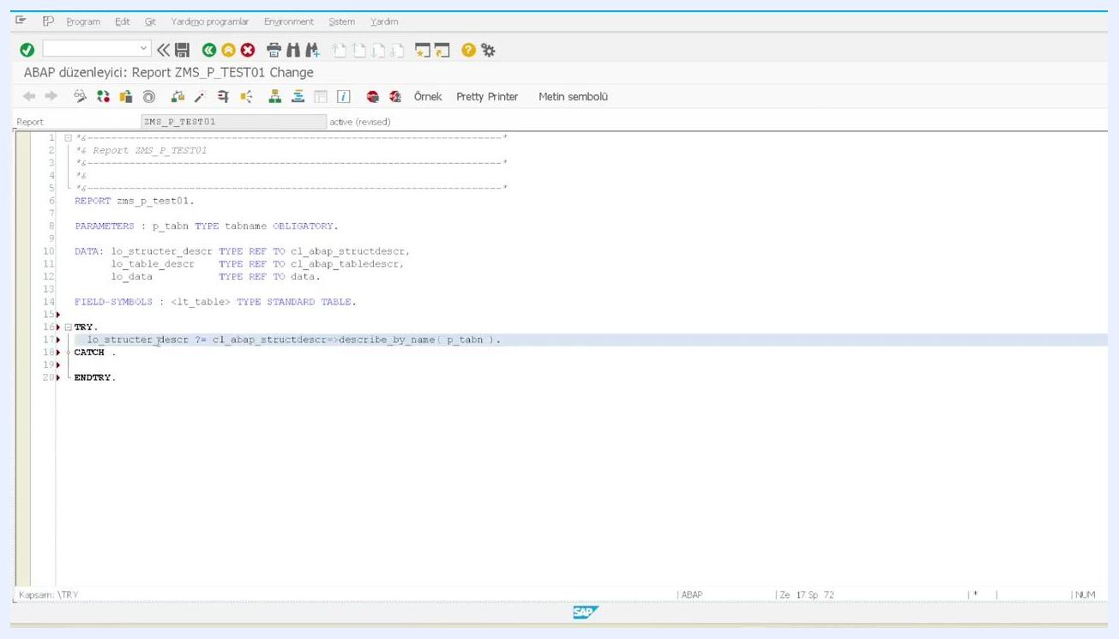
Data and field symbol declarations for dynamic table handling.

Step 4: Create the dynamic internal table

Determine the table structure at runtime
Use a TRY-CATCH block to safely determine the structure of the table entered by the user. Call cl_abap_structdescr=>describe_by_name( p_tabn ) to retrieve the structure, then call cl_abap_tabledescr=>create( lo_structer_descr ) to create a table description:

TRY.
lo_structer_descr ?= cl_abap_structdescr=>describe_by_name( p_tabn ).
lo_table_descr = cl_abap_tabledescr=>create( lo_structer_descr ).
TRY block with structure and table description logic.

Create a data object based on the table template
Dynamically create a data object for the internal table using the table description handle, then assign that data object to the field symbol <lt_table>:

CREATE DATA lo_data TYPE HANDLE lo_table_descr.
ASSIGN lo_data->* TO <lt_table>.
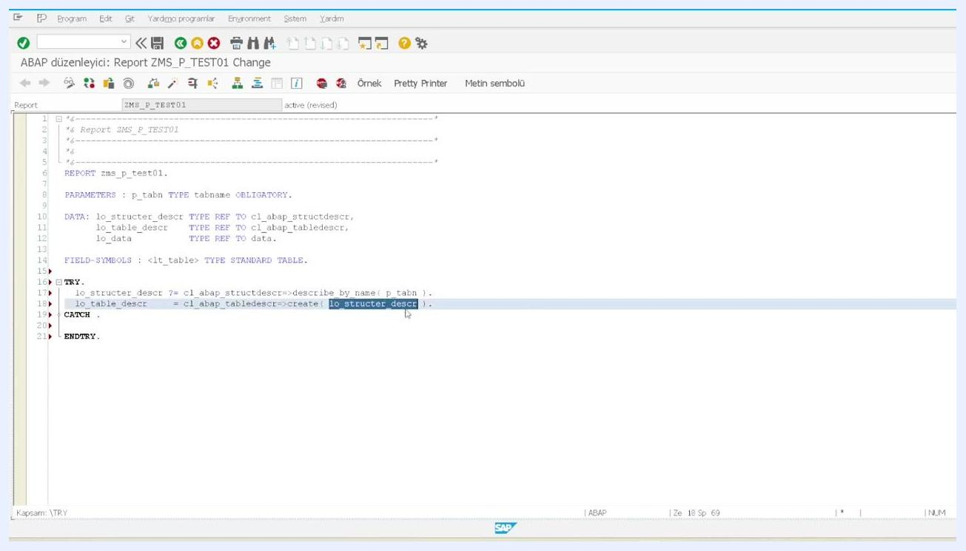
Data object creation and assignment to the field symbol.

Complete error handling for table structure creation
Add a CATCH block to handle cases where the entered table name does not exist, and display an error message if the structure cannot be created:

CATCH cx_sy_struct_creation.
MESSAGE 'Tablo Bulunamadı' TYPE 'E'.
ENDTRY.
This ensures the program fails gracefully if the user enters an invalid table name.
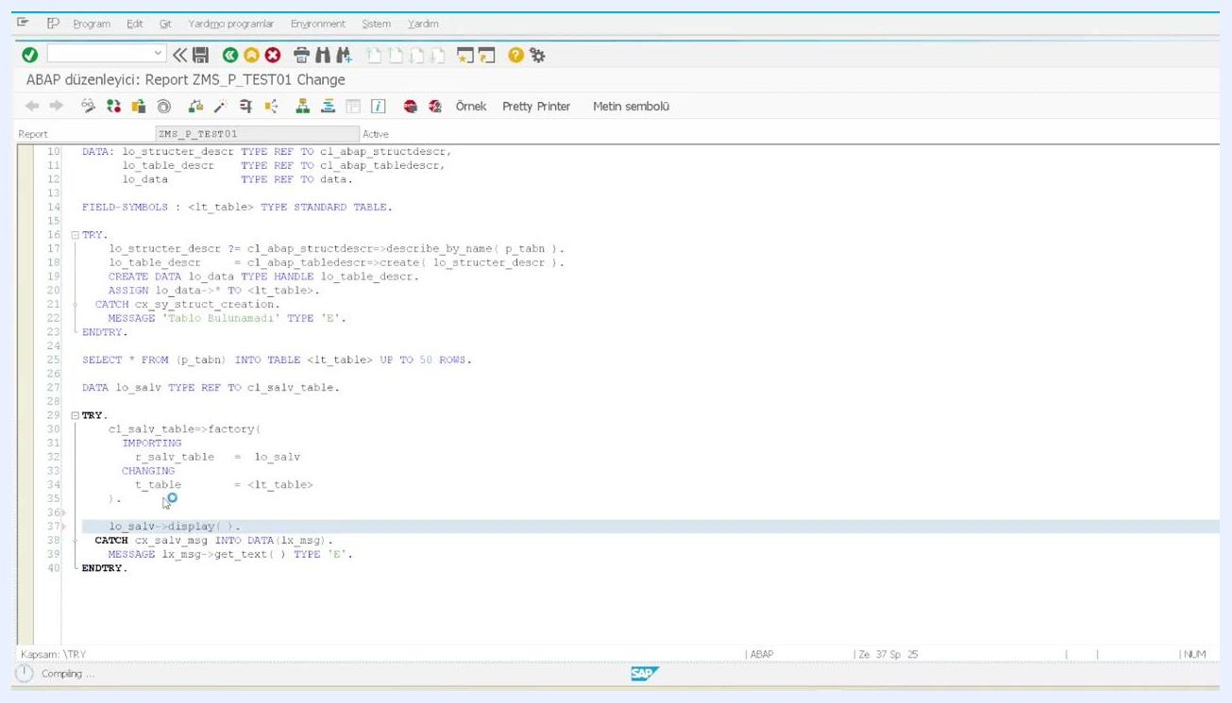
ABAP editor showing the completed TRY-CATCH-ENDTRY block for structure creation, with error message handling.

Step 5: Fetch the first 50 rows from the specified table
Use a dynamic SQL SELECT statement to retrieve up to 50 rows from the table specified by the user input (p_tabn). Store the results in the dynamically created internal table <lt_table>:

SELECT * FROM (p_tabn) INTO TABLE <lt_table> UP TO 50 ROWS.
This step prepares the data for display.
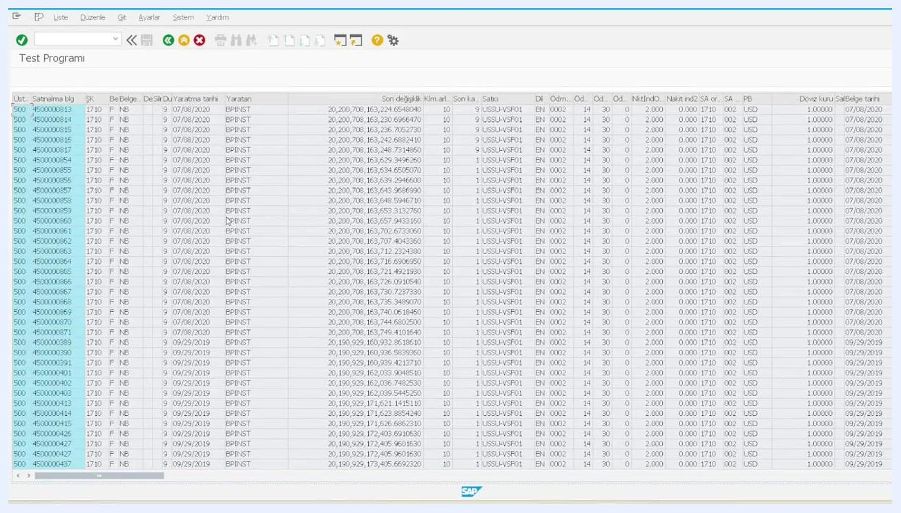
ABAP editor showing the SELECT statement fetching up to 50 rows into the dynamic internal table.

Step 6: Prepare the ALV display
Declare a reference variable for the ALV table:

DATA lo_salv TYPE REF TO cl_salv_table.
Use a TRY-CATCH block to safely create and display the ALV table:

TRY.
cl_salv_table=>factory(
IMPORTING r_salv_table = lo_salv
CHANGING t_table = <lt_table>
).
lo_salv->display( ).
CATCH cx_salv_msg INTO DATA(lx_msg).
MESSAGE lx_msg->get_text( ) TYPE 'E'.
ENDTRY.
This code initializes the ALV viewer and displays the fetched data.
ABAP editor showing the ALV display logic with TRY-CATCH error handling.

Step 7: Run the program and view results
Activate and execute the report. Enter a valid table name (for example, ECHO) in the selection screen, then press F8 to run the program. The first 50 rows from the specified table appear in an ALV grid.
ALV grid displaying the first 50 rows of the selected table, with columns and data visible.

Step 8: Debug the dynamic table creation and data fetch
Set a breakpoint in the code to inspect the dynamic table creation and data fetching process, then run the program in debug mode. Observe the structure and contents of the dynamic internal table (<lt_table>) and the related references (lo_structer_descr, lo_table_descr).
Confirm that the structure is created from the table name, the table is created from the structure, and the data is fetched correctly.
ABAP debugger showing the dynamic structure and table references, along with the internal table variable.
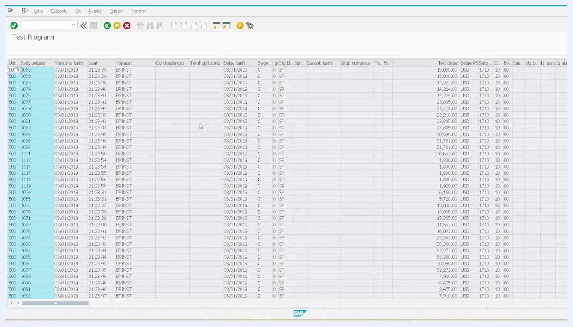
ABAP debugger showing the internal table <lt_table> filled with 50 rows, along with the table name parameter.

Step 9: Verify ALV output for different tables
Test the program with different table names (for example, VUBAC). Each time, the ALV grid displays the first 50 rows of the specified table, confirming the dynamic nature of the solution.
ALV grid displaying the first 50 rows of a different table, with columns and data visible.

Summary
By following these steps, you have learned how to create a dynamic ALV report in SAP ABAP that:
- Accepts any table name at runtime.
- Determines its structure automatically.
- Fetches the first 50 rows of data.
- Displays the results in an ALV grid.
- Handles errors gracefully.
- Supports debugging for verification.
You can now use this report as a flexible table viewer for any table in your SAP system.

