How to Create a Customer in SAP S/4HANA Using Business Partner
This guide walks you through how to create a customer in SAP S/4HANA using the Business Partner (BP) transaction. In S/4HANA, both customers and vendors are created through the Business Partner transaction, replacing the older customer creation method. If you try to use the legacy transaction, the system displays a warning message because it is now obsolete. A business partner can represent a customer, a vendor, or any other partner in your business, so there is no need to create separate records for companies that act as both a customer and a vendor.

Prerequisites
- Access to the SAP GUI with authorization for transaction code BP.
- Knowledge of your organization's sales area data: Sales Organization, Distribution Channel, and Division.
- The correct reconciliation account number, or access to your FI (Financial Accounting) consultant to obtain it.
- Company code information for the customer you are creating.

Step 1: Open the Business Partner transaction
Open the SAP GUI and enter transaction code /nBP in the command field, then press Enter. This opens the Business Partner screen where you create and manage customer and vendor records.
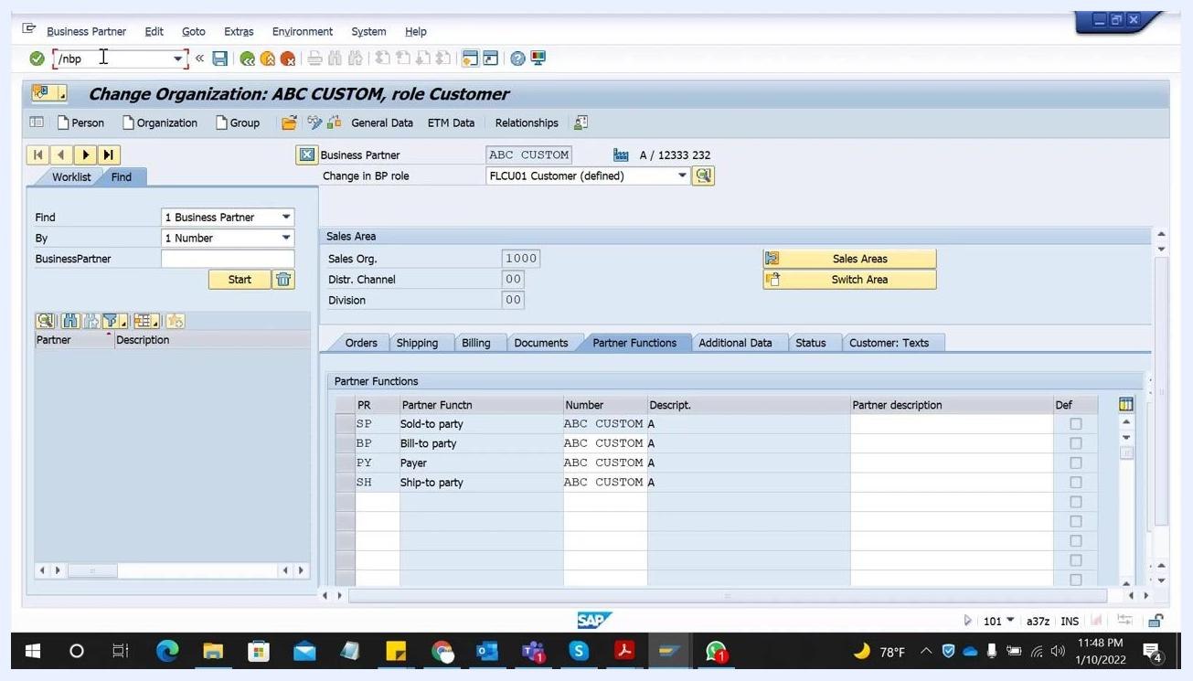
SAP GUI showing the Business Partner transaction screen with the command field containing '/nbp', and the "Change Organization: ABC CUSTOM, role Customer" window open. Tabs for Orders, Shipping, Billing, Documents, Partner Functions, Additional Data, Status, and Customer: Texts are visible. The Partner Functions tab is selected, displaying roles such as Sold-to party, Bill-to party, Payer, and Ship-to party, all assigned to 'ABC CUSTOM A'.
As a reference, the Partner Functions tab shows the roles assigned to a completed business partner record, including Sold-to party, Bill-to party, Payer, and Ship-to party, all linked to the same business partner.

Step 2: Select the number assignment type
From the BP screen, select the option to create organization data, then choose the Grouping that determines how the business partner number is assigned:
- 0002 External Number Assignment – choose this option if you want to provide your own customer number.
- 0001 Internal Number Assignment – choose this option if you want SAP to assign the number automatically.
If you select external assignment, you must provide the customer number manually.
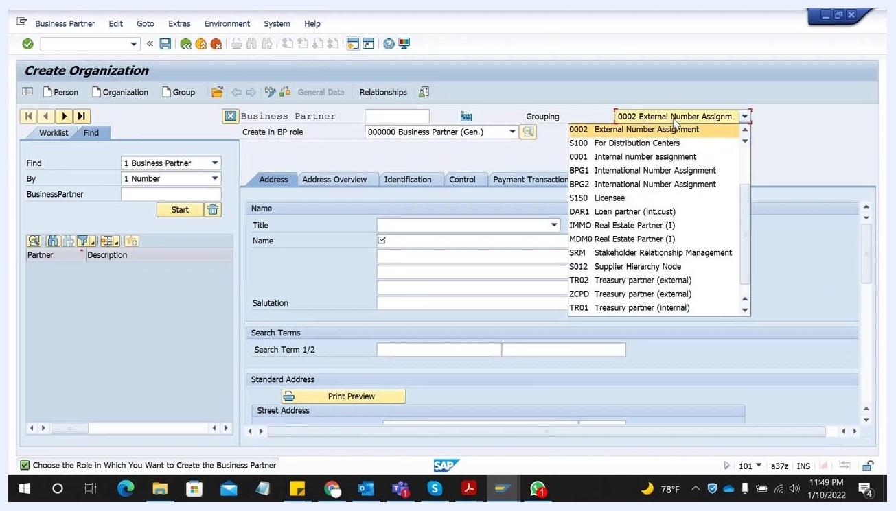
SAP GUI showing the "Create Organization" screen with the "Grouping" dropdown expanded, highlighting "0002 External Number Assignment" and other options.

Step 3: Select the business partner role
In the Create in BP role dropdown, scroll down and select FLCU01 Customer. This ensures the business partner is created with customer-specific data.
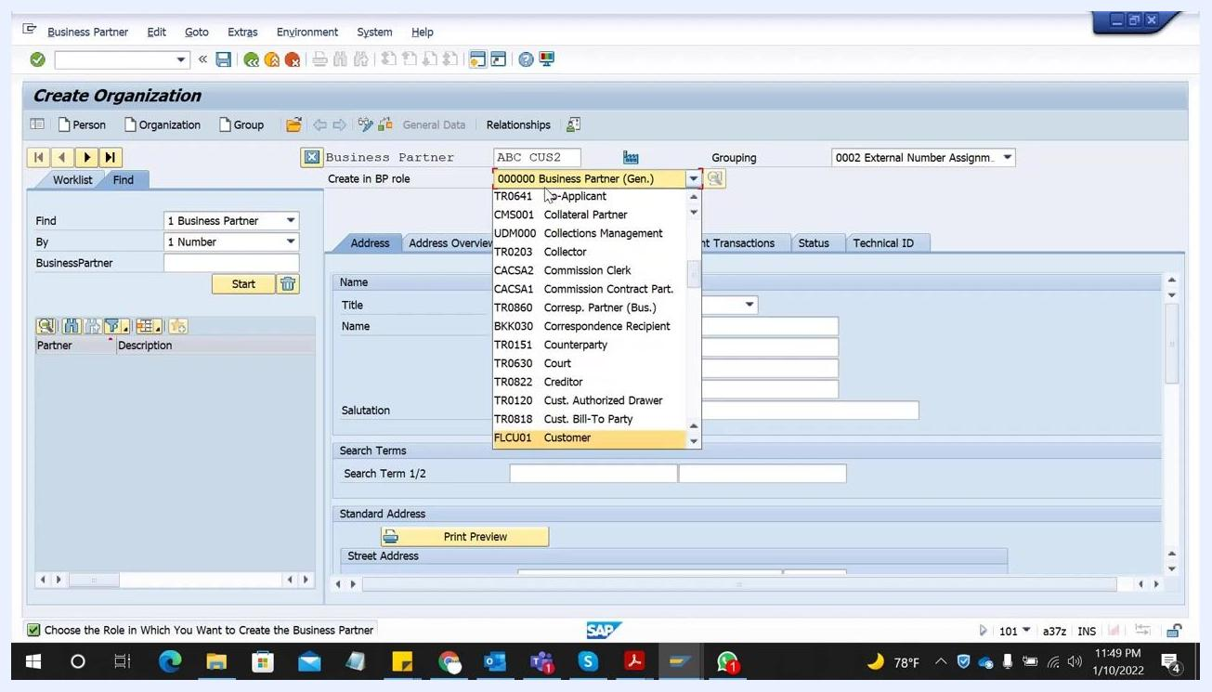
SAP GUI showing the "Create Organization" screen with the "Create in BP role" dropdown expanded, highlighting "FLCU01 Customer" among other roles.

Step 4: Confirm the role change prompt
If you attempt to switch roles before saving, the system prompts you to choose between creating the business partner directly in the new role or saving it first in the general role. Click Create to proceed directly with the customer role. Note that data already entered is not saved during this creation prompt.
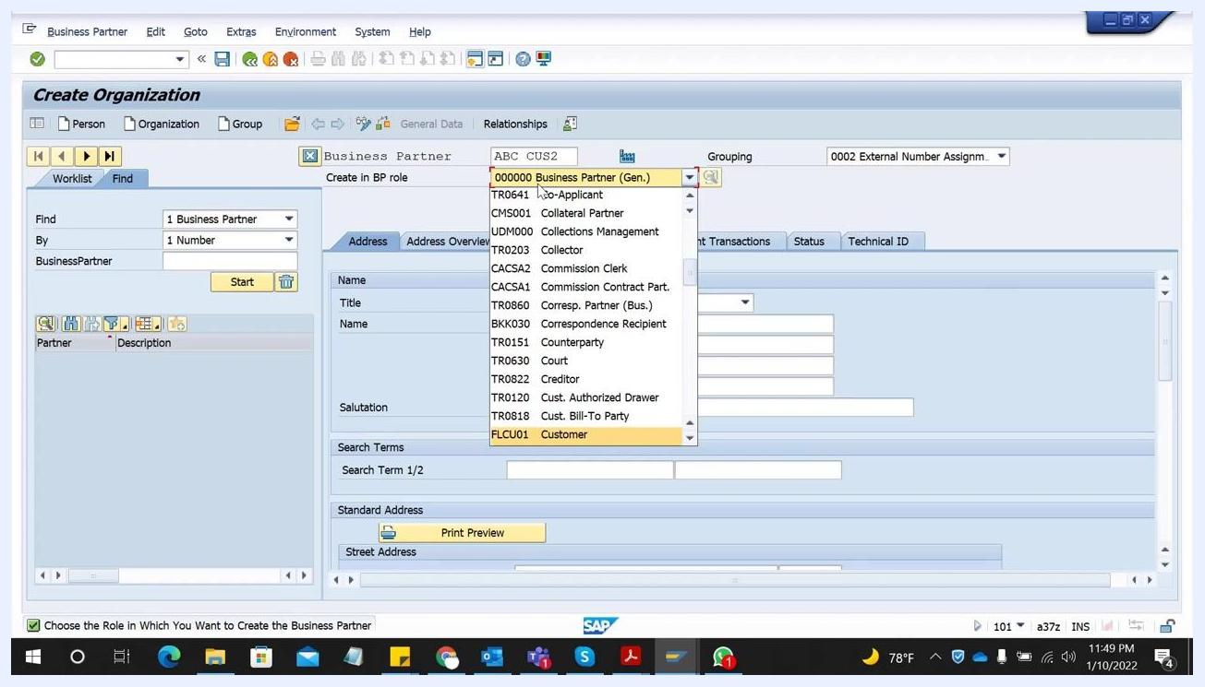
SAP GUI showing a prompt: "Do you want to create business partner ABC CUS2 in BP role 'FI Customer' or do you want to save it first in BP role 'Business Partner (Gen.)' and then change it? Data already entered is not saved during creation." The "Create" button is selected.

Step 5: Enter basic company information
In the Address tab, fill in the following fields:
- Title – select the appropriate title, e.g., 0003 Company.
- Name – enter the company name, e.g., ABC PVT LTD.
- Search Term – enter a term to help you find the customer later, e.g., ABC.
These fields help you uniquely identify and search for the customer later in the system.
SAP GUI showing the "Create Organization: Role FI Customer" screen with the "Title" set to "0003 Company", "Name" as "ABC PVT LTD", and "Search Term" as "ABC".

Step 6: Enter address details
In the Standard Address section, provide the street, postal code, city, and country:
- Street/House number – e.g., 3rd Name, 101.
- Postal Code/City – e.g., 21333, Dortmund.
- Country – e.g., DE for Germany.
Only fill in the fields you know; the rest remain optional unless your system marks them as mandatory.
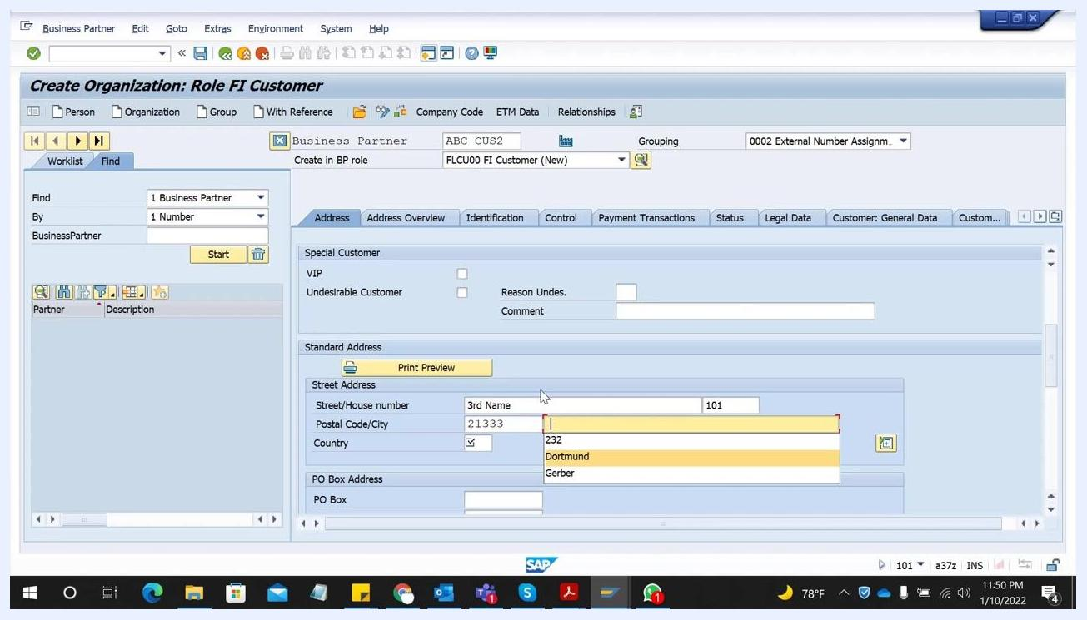
SAP GUI showing the "Standard Address" section with "Street/House number" as "3rd Name" and "101", "Postal Code/City" as "21333" and "Dortmund", and "Country" as "DE".

Step 7: Enter communication details
Scroll down to the Communication section and set the Language field, which is mandatory (for example, EN for English). You can also enter telephone, mobile phone, fax, and email if this information is available, but these fields are optional.
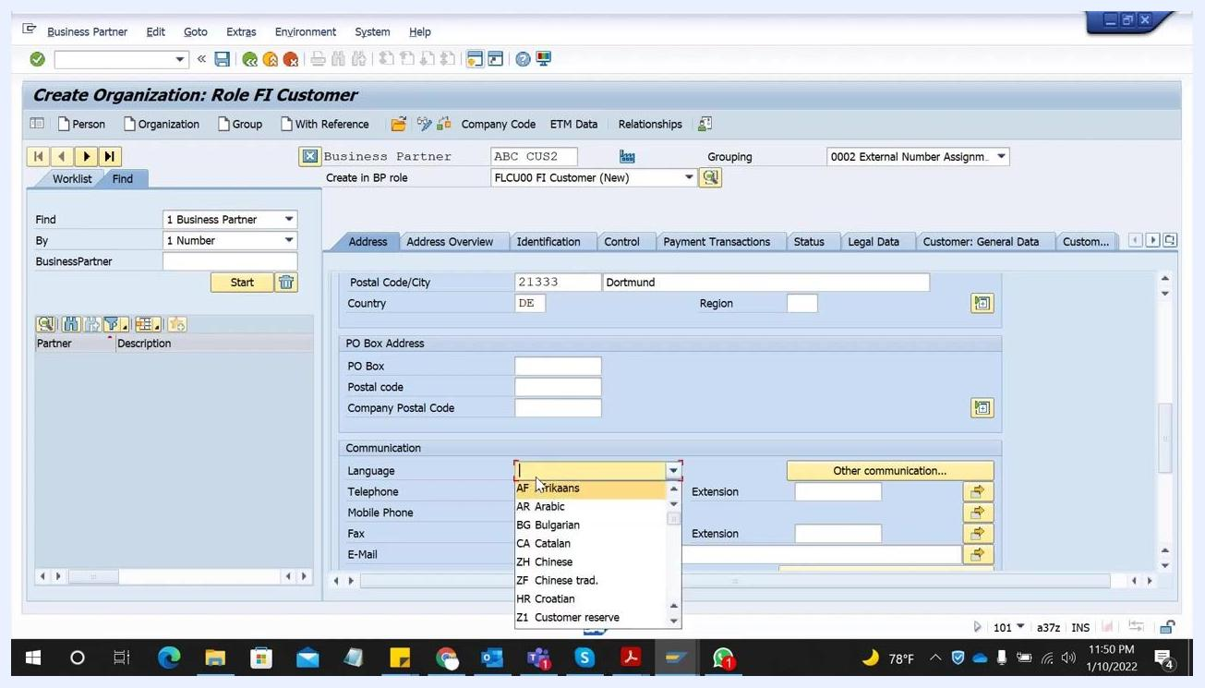
SAP GUI showing the "Communication" section with the "Language" dropdown expanded, ready to select "EN" for English.

Step 8: Complete additional address and communication fields
Review the Address tab for further optional fields, and fill them in if applicable:
- Time zone – e.g., CET.
- Transportation Zone – enter if applicable.
- Structure Group – enter if applicable.
- PO Box Address – fill in if the customer uses a PO box.
You can also add mobile phone, telephone, fax, and email in the Communication section. Only the Language field remains mandatory.
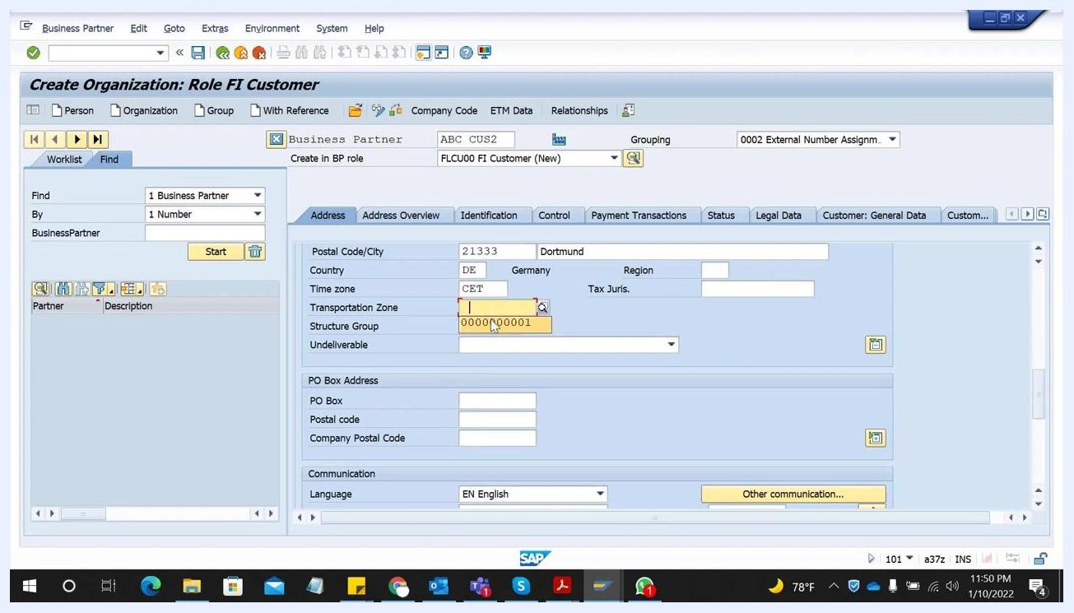
SAP GUI showing the "Address" tab with optional fields like Time zone, Transportation Zone, Structure Group, and PO Box Address, as well as the Communication section.

Step 9: Extend the business partner to a company code
Navigate to the Company Code tab to extend the business partner to a specific company code. Click the Company Codes button if you need to select from available codes, then enter your company code, e.g., 1000. The company code name (for example, FHWS Solutions) appears next to the code you entered.
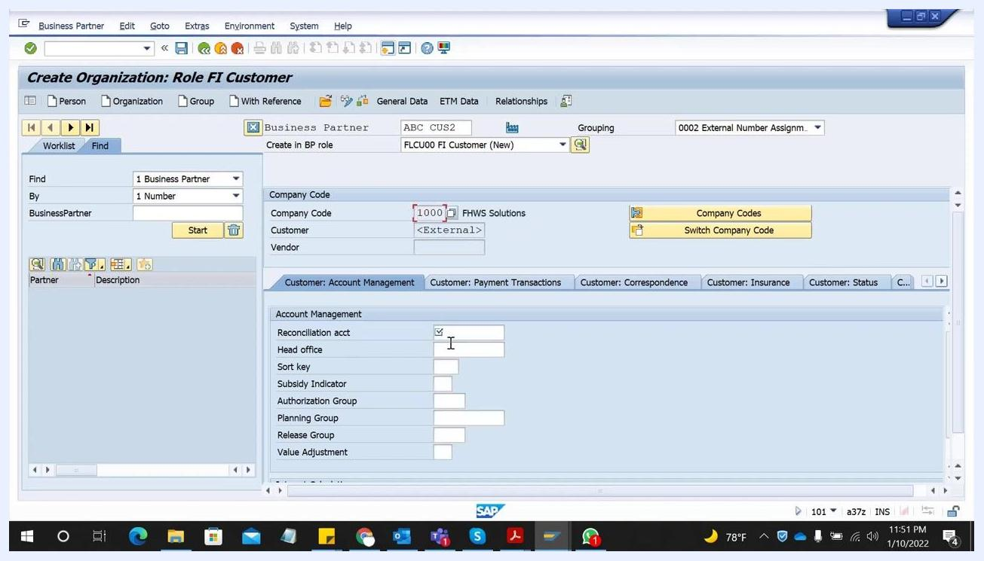
SAP GUI showing the "Company Code" tab with "Company Code" field being filled with 1000 and the company name displayed.

Step 10: Enter the reconciliation account
In the Customer: Account Management section, enter the Reconciliation acct number, e.g., 240000. If you do not know the correct reconciliation account, consult your FI consultant, since this account is critical for financial postings and month-end bank reconciliations.
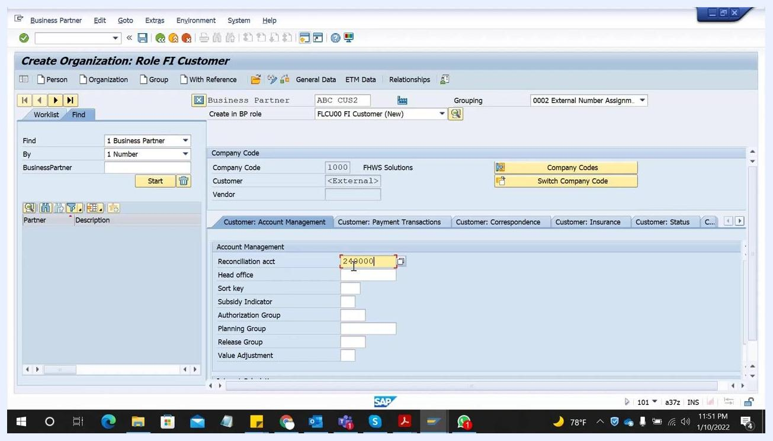
SAP GUI showing the "Customer: Account Management" section with "Reconciliation acct" filled as 240000.

Step 11: Enter additional account management data (optional)
You can complete other fields in the Account Management section if your process requires them:
- Head office – enter if applicable.
- Sort key – e.g., 001.
- Subsidy Indicator, Authorization Group, Planning Group, Release Group, Value Adjustment – enter if needed.
These fields are not mandatory but can be filled in when the information is available.
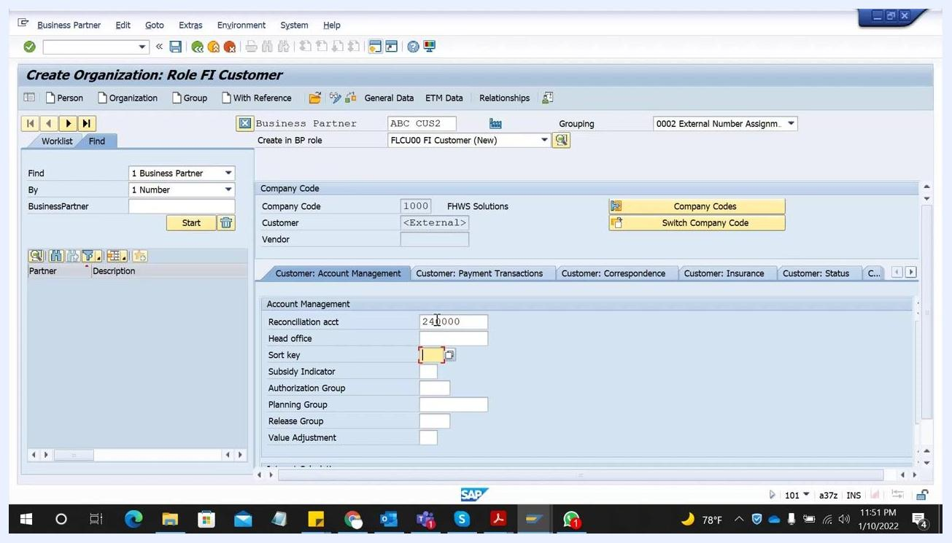
SAP GUI showing "Sort key" field being filled with 001 in the "Customer: Account Management" section.

Step 12: Enter payment transaction data
Switch to the Customer: Payment Transactions tab and enter the Payment Terms, e.g., 0001. You can also complete related fields such as Credit Memo Payment Term, Tolerance Group, B/Ex. Charges Terms, Check Cashing Time, Known/Negotiat.Leave, and Record Payment History, as required by your organization.
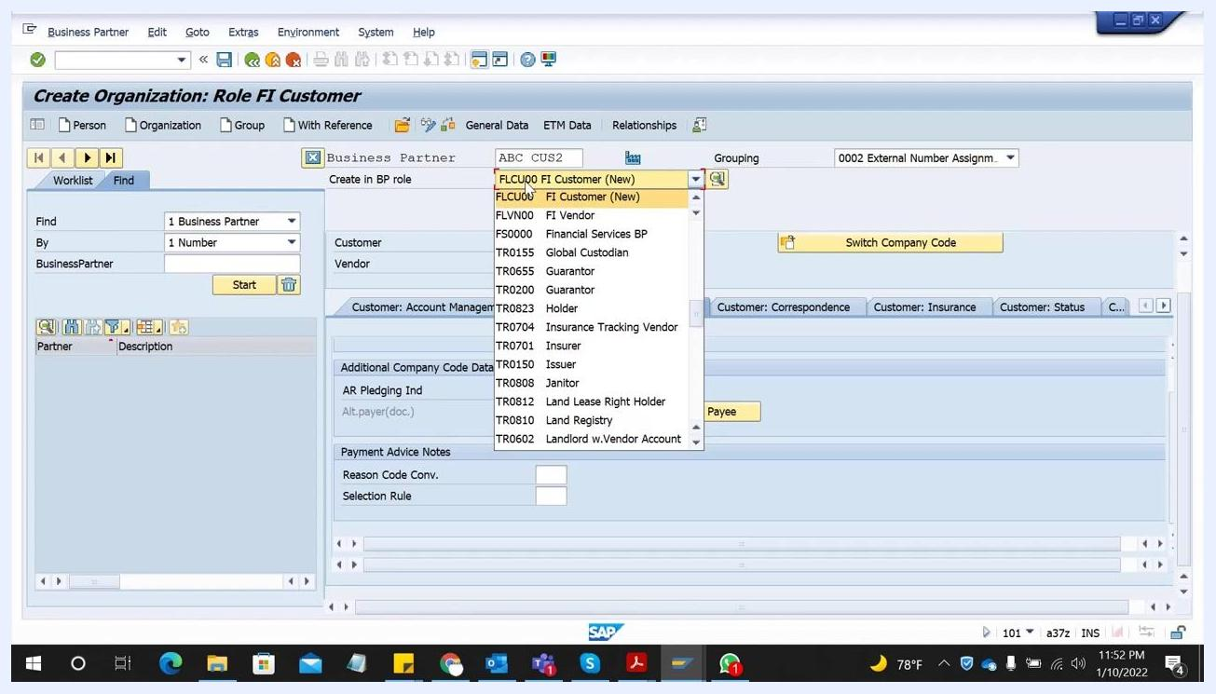
SAP GUI showing the "Customer: Payment Transactions" tab with "Payment Terms" set to 0001.

Step 13: Review additional company code data
If needed, review or complete fields under Additional Company Code Data and Payment Advice Notes, such as AR Pledging Indicator, Alternative Payer, Reason Code Conversion, and Selection Rule. This step is optional and depends on your organization's requirements.

Step 14: Confirm the business partner role before saving
Before saving, make sure you are in the correct BP role. Use the dropdown in the Create in BP role field to confirm or switch roles as needed, for example to FLCU00 FI Customer (New). The dropdown also lists other roles such as FI Vendor.
SAP GUI showing the BP role dropdown expanded with various roles such as FLCU00 FI Customer (New), FI Vendor, and others.

Step 15: Save the customer master record
Once all required and relevant optional fields are complete, click the Save button (green checkmark or disk icon) at the top of the screen. This creates the customer master record in SAP S/4HANA, extended to the specified company code with all the data you entered. Check the confirmation message at the bottom of the screen to verify the save was successful, and consult your FI consultant for any company-specific requirements you are unsure about.
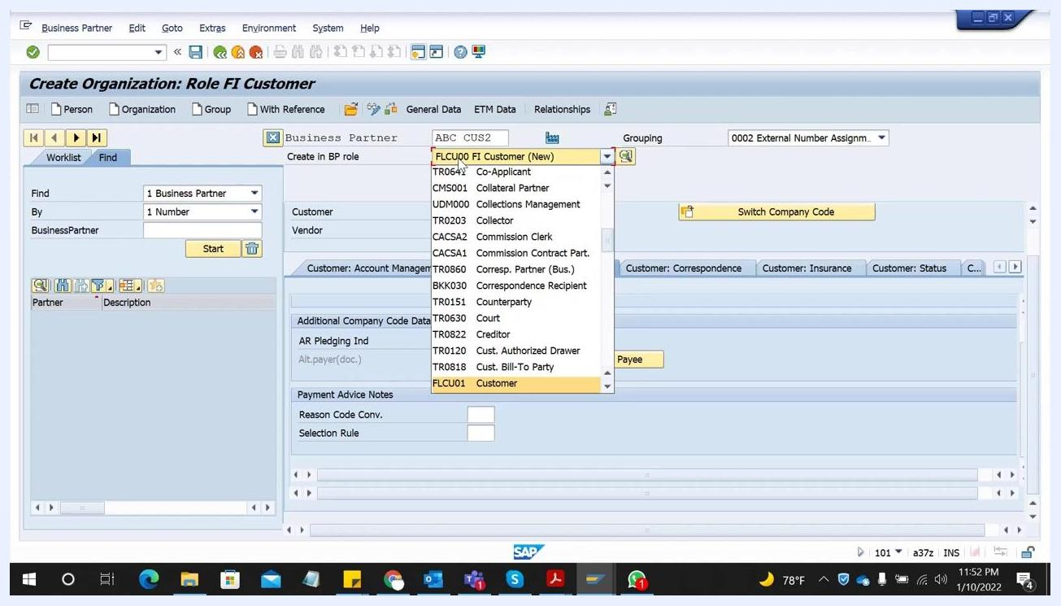
SAP GUI showing the "Create Organization: Role FI Customer" screen with the BP role dropdown expanded, highlighting "FLCU00 FI Customer (New)" and the Save button visible at the top.

Step 16: Respond to the role change prompt for the customer role
To extend the business partner to the sales-relevant Customer role, the system prompts:
"Do you want to create business partner ABC CUS2 in BP role 'Customer' or do you want to save it first in BP role 'FI Customer' and then change it? Data already entered is not saved during creation."
Click Create to proceed with creating the business partner directly in the Customer role, or choose Save or Cancel as needed.
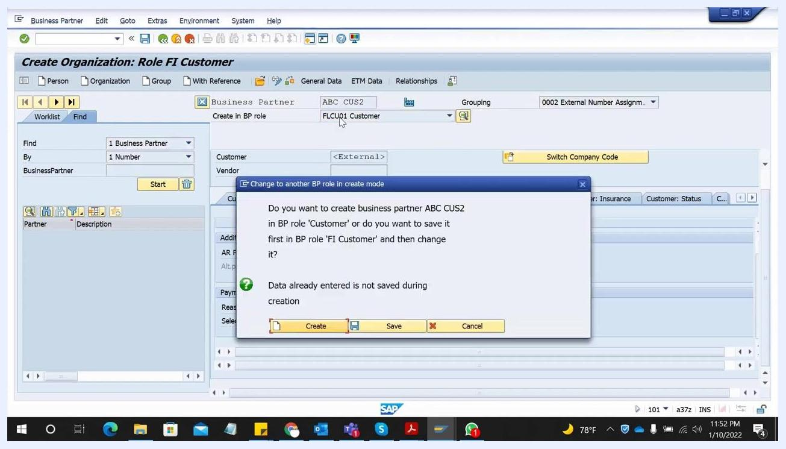
SAP screen with a modal dialog prompting to create a business partner in the 'Customer' role, with options Create, Save, Cancel

Step 17: Verify the business partner details in the customer role
After confirming, verify that the business partner has been created in the new role. The screen displays:
- Title: "Change Organization: ABC CUS2, new role Customer"
- Business Partner: ABC CUS2
- Name: ABC PVT LTD CO
- Search Term 1/2: 1234
- Special Customer: VIP
SAP screen showing the business partner details in the new customer role, with fields for name, search terms, and special customer status

Step 18: Navigate to Sales and Distribution
Click the Sales and Distribution tab at the top of the screen. This tab lets you enter the sales-specific data required to complete the customer role extension.

Step 19: Enter sales area data
In the Sales Area section, enter your sales organization, distribution channel, and division, then press Enter to proceed:
- Sales Org.: 1000 (FHWS Sales SW)
- Distr. Channel: 00 (Stand.distr.channel)
- Division: 00 (Cross-divisional)
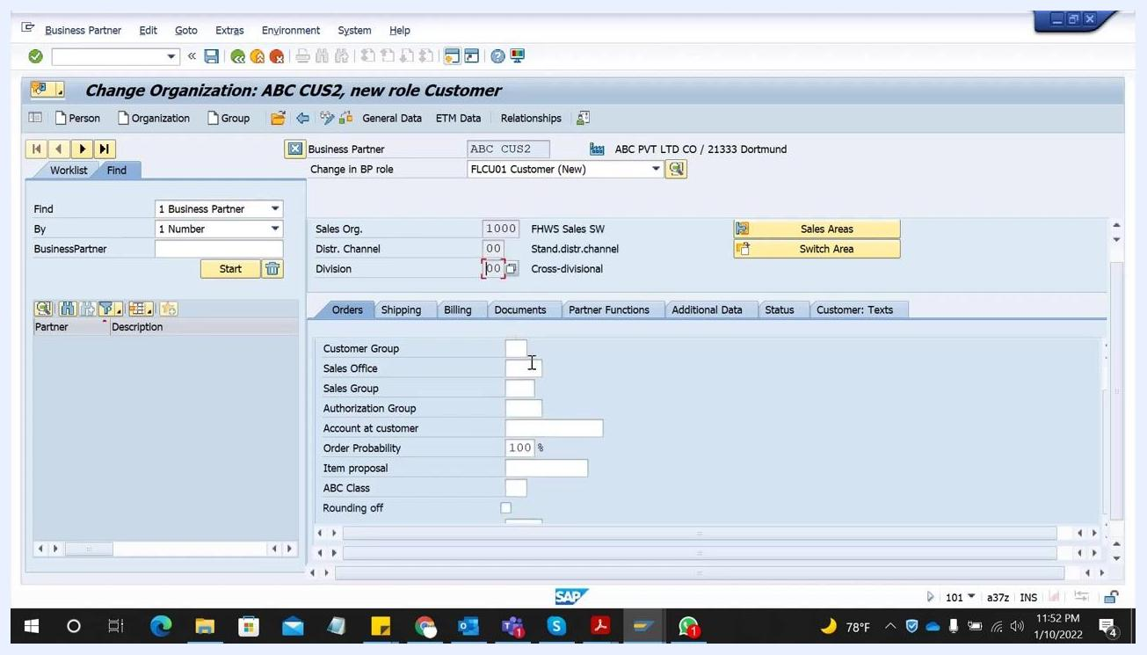
SAP screen with Sales Org, Distr. Channel, and Division fields filled in, and the Orders tab active

Step 20: Fill in order data
In the Orders tab, enter or verify the following:
- Order Probability: 100%
- Currency: EUR (European Euro) – this is a mandatory field.
- Customer Pricing Procedure: enter as required.
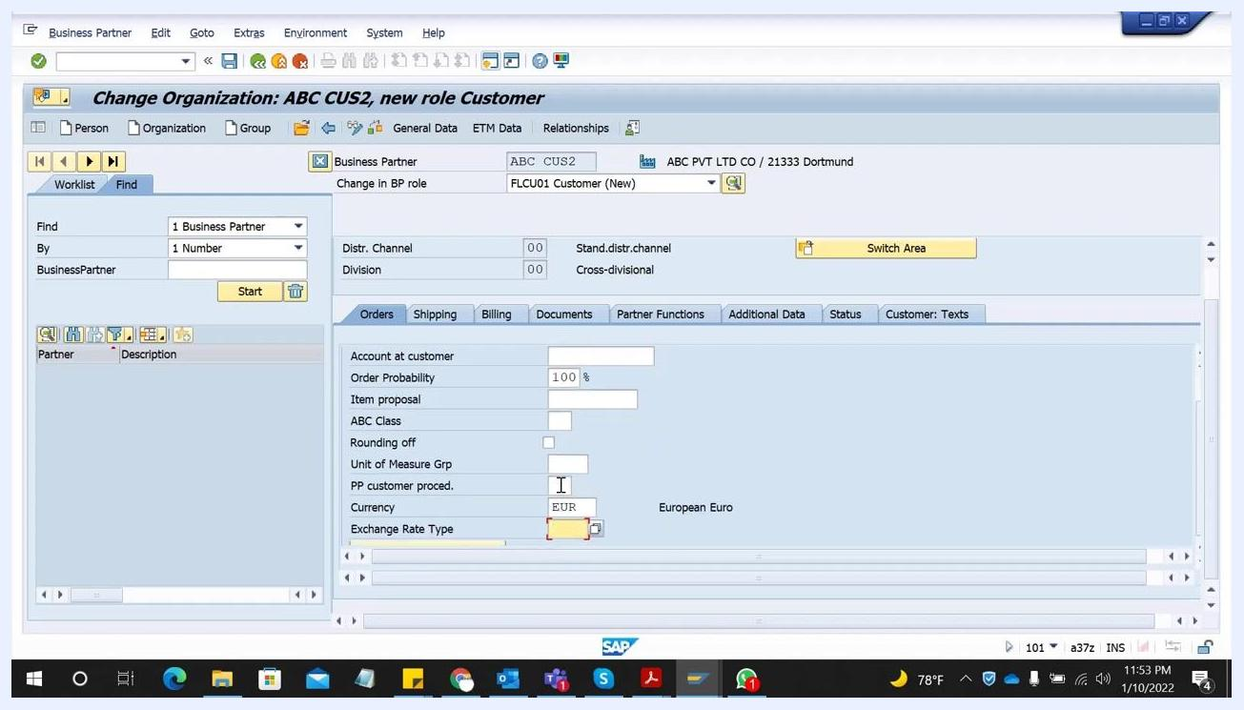
SAP screen showing the Orders tab with fields for order probability, currency (EUR), and other order-related data

Step 21: Enter shipping and delivery data
Switch to the Shipping tab and enter:
- Delivering Plant: 1000
- Shipping Conditions: enter as required.
- Max. Part. Deliveries: enter as required.
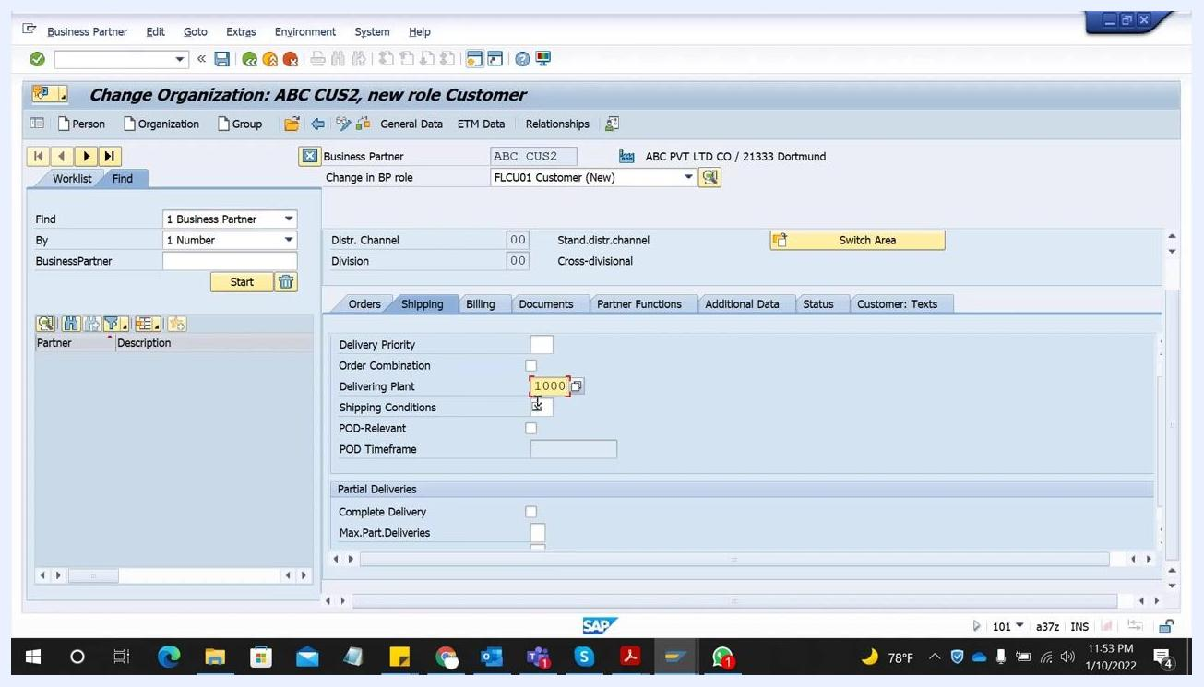
SAP screen showing the Shipping tab with Delivering Plant set to 1000 and other shipping-related fields

Step 22: Enter billing and payment terms
Go to the Billing tab, and under Delivery and Payment Terms, enter:
- Incoterms Version: FH
- Incoterms Location 1: Miami
- Payment Terms: 0002
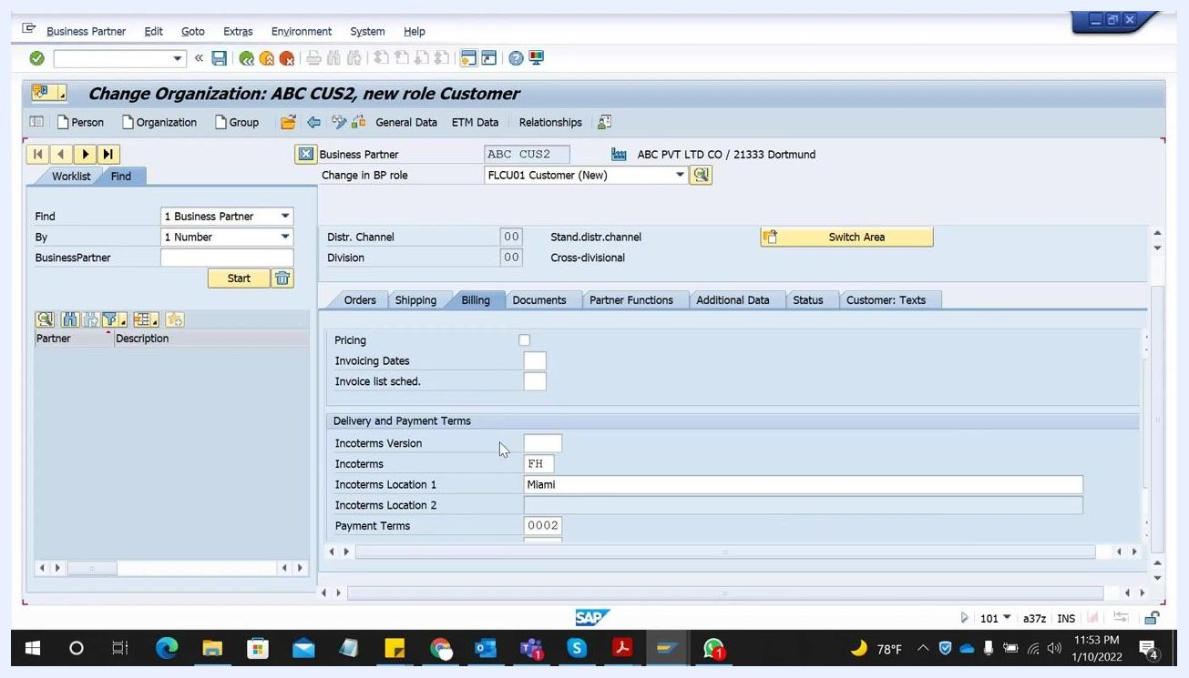
SAP screen showing the Billing tab with Incoterms Version FH, Incoterms Location 1 Miami, and Payment Terms 0002

Step 23: Review mandatory data across tabs
Check that all mandatory fields are filled in across the Orders, Shipping, and Billing tabs. Depending on your system configuration, additional views or data may be required before you can save.
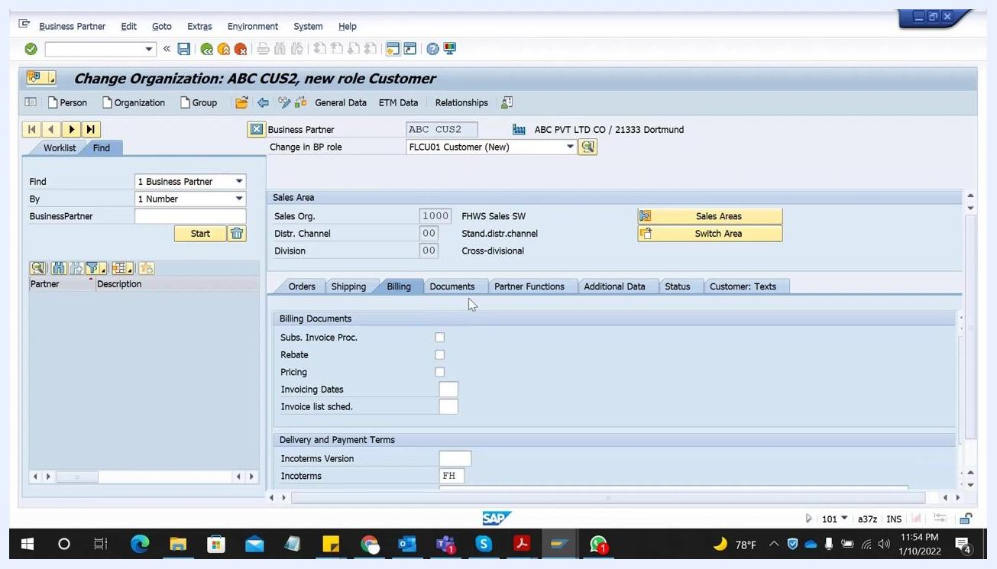
SAP screen showing the Billing tab with all required fields filled, and navigation tabs for other data views

Step 24: Use field help for detailed descriptions
If you are unsure about a specific field, such as Invoicing Dates in the Billing tab, click the field and press F1 on your keyboard. A help window opens with a long description and guidance for that field, which is useful for understanding mandatory fields or special data requirements.
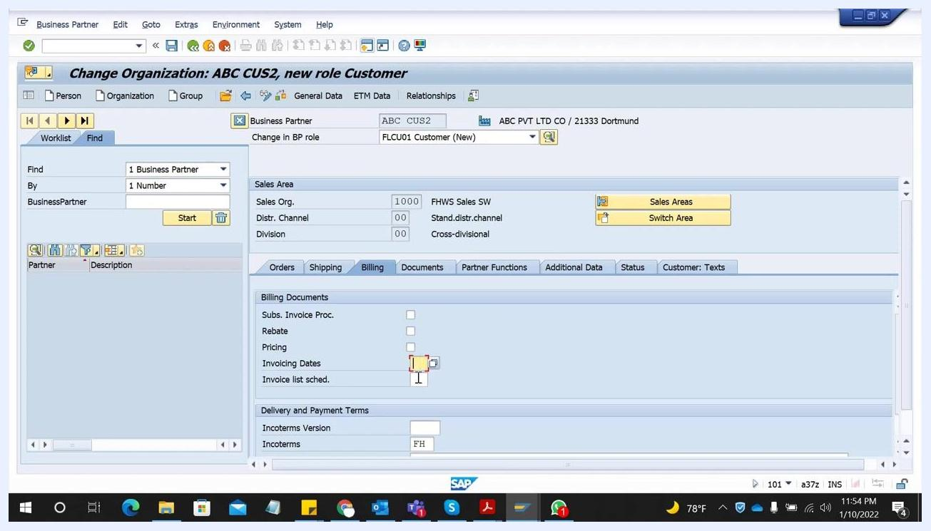
SAP screen showing the Billing tab with the "Invoicing Dates" field selected, ready for F1 help to be invoked

Step 25: Save the customer data
Once all required fields are completed and verified, click the Save icon (floppy disk) in the SAP toolbar at the top of the screen. Wait for the confirmation message at the bottom of the screen indicating that your changes have been saved.
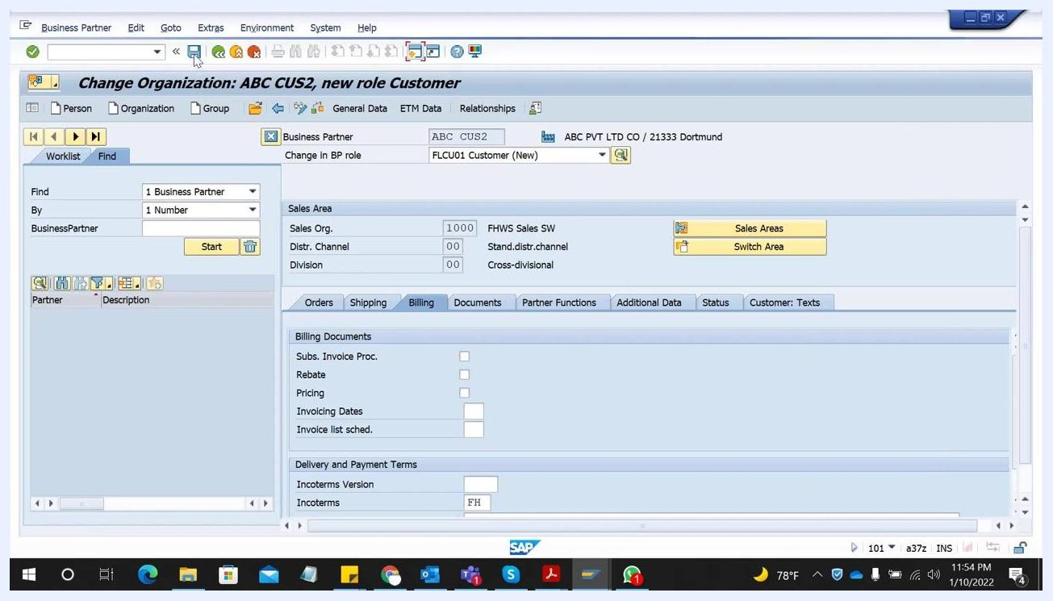
SAP screen with the Save icon being clicked in the toolbar, and all customer data filled in the Billing tab

Step 26: Search for the customer to verify creation
To confirm the customer has been created and is available in the system, enter the customer number (e.g., ABC CUS2) or a known search term (e.g., 1234) in the search field, then click Start to run the search.
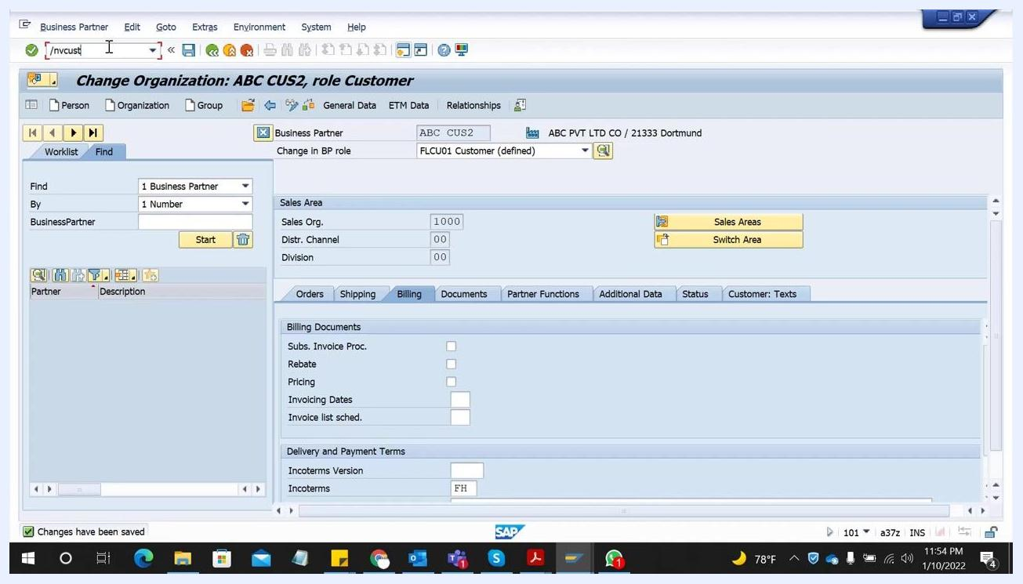
SAP screen showing the command field with "/nvcust" and the customer number ABC CUS2 entered, ready to search

Step 27: Review the customer list
The Customer List screen displays detailed information for the customer(s) found, including customer number, name, address, sales organization, distribution channel, division, and other relevant data. Confirm that your newly created customer (e.g., ABC CUS2) appears with all expected details.
SAP Customer List screen showing ABC CUS2 with all associated details such as name, city, search term, and sales data

What's next
After confirming the customer record in the Customer List, your business partner is fully extended to the customer role with all required organizational, address, company code, financial, and sales and distribution data. You can now use this customer in SAP Sales and Distribution processes. Remember to use F1 field-level help whenever you need clarification on a specific field, and consult your FI consultant for any company-specific requirements, such as reconciliation accounts, that you are unsure about.

