How to Create a Company Code in SAP MM
This guide explains how to create a company code in SAP MM by copying an existing company code. Copying an existing company code lets you reuse its configuration settings, saving you from entering every setting manually when setting up a new entity in your SAP system.

Prerequisites
- Access to the SAP GUI with valid login credentials.
- Authorization to access the SAP Customizing Implementation Guide (transaction SPRO).
- The source company code you intend to copy from (for example, 0001).

Access the customizing implementation guide

1. Start SAP Easy Access
Launch the SAP GUI and log in to your SAP system. On the SAP Easy Access screen, confirm that the workspace and navigation panel are visible before proceeding.
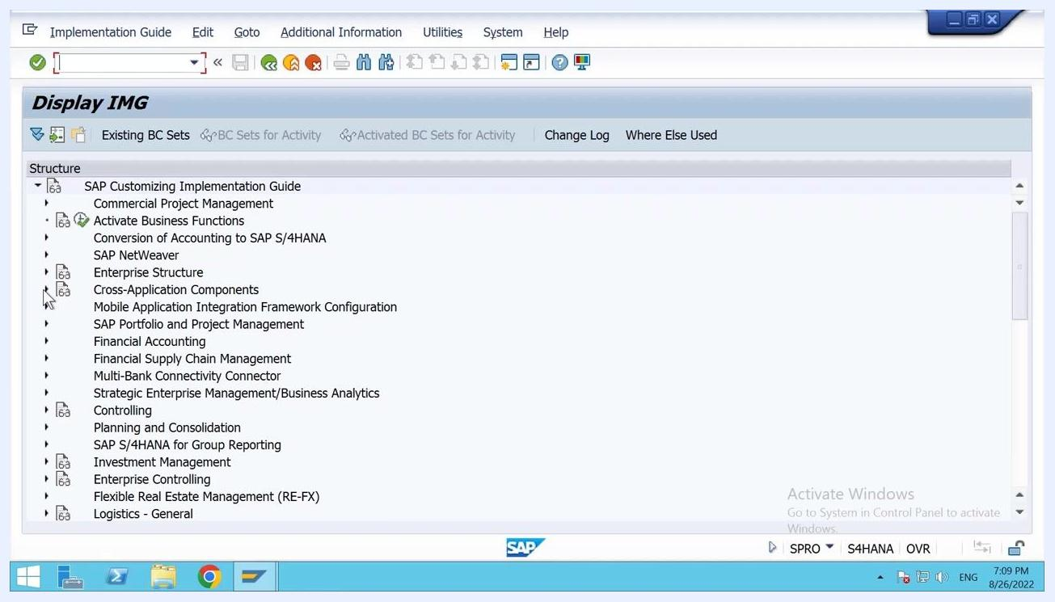
SAP Easy Access screen with navigation panel visible

2. Navigate to SPRO
In the command field, enter SPRO and press Enter. This opens the SAP Customizing Implementation Guide, confirmed by the "Start of application: Customizing - Edit Project" message at the bottom of the screen.
SAP Easy Access screen with navigation to SPRO and the application start message at the bottom

3. Open the company code editing option
In the Display IMG window, expand the following menu path: SAP Customizing Implementation Guide > Enterprise Structure > Definition > Financial Accounting. Locate and select Edit, Copy, Delete, Check Company Code.
Display IMG screen showing the expanded menu path to Edit, Copy, Delete, Check Company Code

Copy an existing company code

4. Select the copy company code option
In the Change View "Company Code": Details of Selected Set window, click the option to copy an existing company code. Enter the source company code (for example, 0001) and the new company code (for example, REL1), then proceed.

5. Enter the new company code details
On the details screen, fill in the following fields:
- Company Code: REL1
- Company Name: Reliance 1
- City: Enter the city, for example Hyderabad
- Country: IN (India)
- Currency: INR (Indian Rupee)
- Language: EN (English)
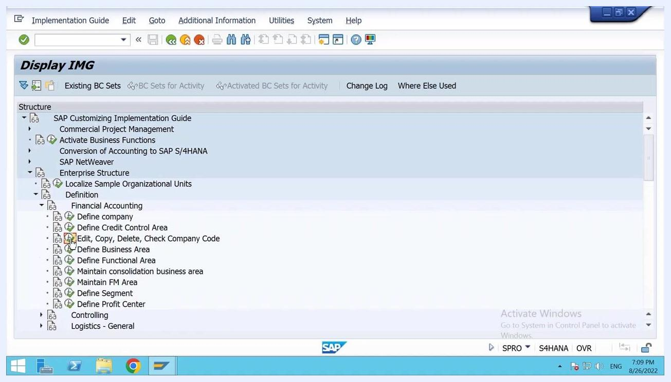
Change View Company Code details screen with Company Code REL1 and the Company Name field being edited

6. Enter the address details
In the Edit Address dialog for the new company code, complete the following fields:
- Title: Select Company
- Name: Enter Reliance 1
- Search Term: Enter a short term, for example Relax
- Country: Select IN for India
- Region: Enter Telangana
- PO Box Number: Enter as required
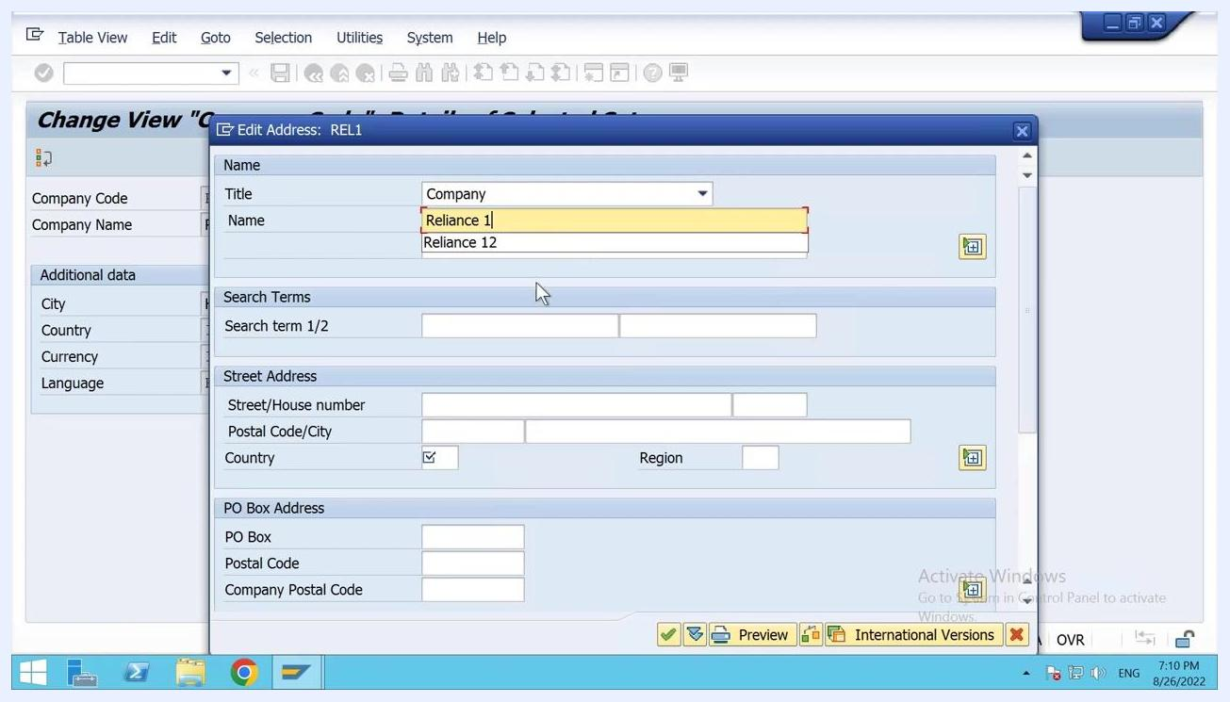
Edit Address dialog for REL1 with Title set to Company and Name set to Reliance 1

7. Save the new company code
After entering all required details, click the save icon (diskette) to save the new company code. Confirm any prompts that appear to complete the process.

8. Verify the company code was created
Confirm that the new company code (for example, REL1) appears in the overview list, and that the company name (for example, Reliance 1) is displayed correctly.
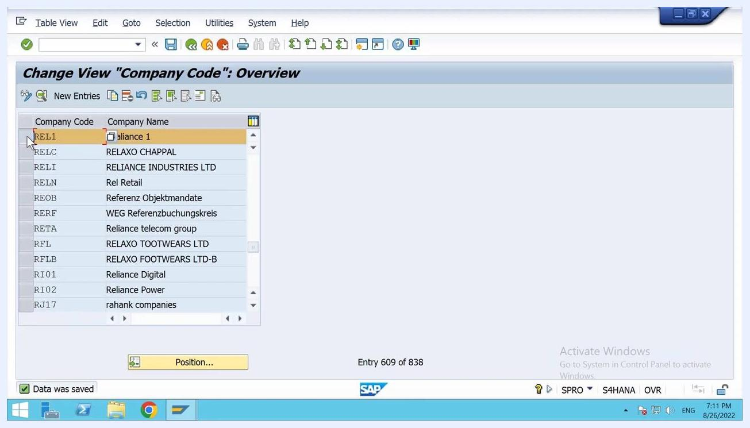
Change View Company Code overview screen showing REL1 (Reliance 1) in the list of company codes

Copy tables and complete the configuration

9. Start the table copy process
Begin the process to copy tables from the existing company code (for example, 0001) to the new company code (REL1). Click Continue when prompted.

10. Confirm the organizational object copy
When prompted "Do you want the org. complete object?", select Yes to copy the complete organizational object.
Organizational object Company code screen with the complete object prompt and Yes selected

11. Respond to the G/L account data prompt
When asked "Do you want to copy the G/L account company code data?", select No if you do not want to copy the G/L accounts from the source company code.
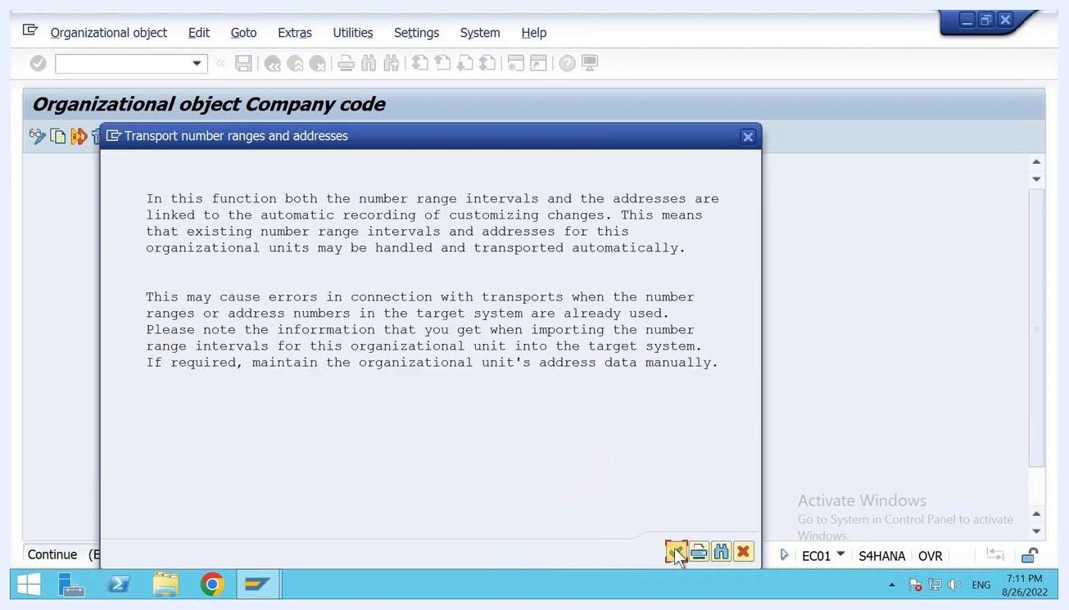
G/L accounts in company code REL1 prompt with the copy question and No selected

12. Respond to the controlling area assignment prompt
When prompted "Do you want to copy the assignment to the controlling area?", select No if you do not want to copy this assignment.
Controlling Area Assignment prompt with No selected

13. Review the transport information
Read the information regarding the transport of number ranges and addresses, then click Continue to proceed.
Transport number ranges and addresses information dialog with Continue button highlighted

14. Decline the number range transport
When prompted "Do you really want to transport number ranges?", select No. This ensures that number ranges are not transported, since some tables will be updated in the background.
Number range management messages prompt with No selected

15. Confirm the customizing request
When prompted for a customizing request, verify the request number (for example, S4HK903703) and the short description (for example, SAP MM MADE EASY). Click the green checkmark to confirm and continue.
Customizing request dialog with request number S4HK903703 and short description SAP MM MADE EASY

16. Confirm the final number range prompt
If prompted again with "Do you really want to transport number ranges?" for the new company code (for example, REL1), select No.
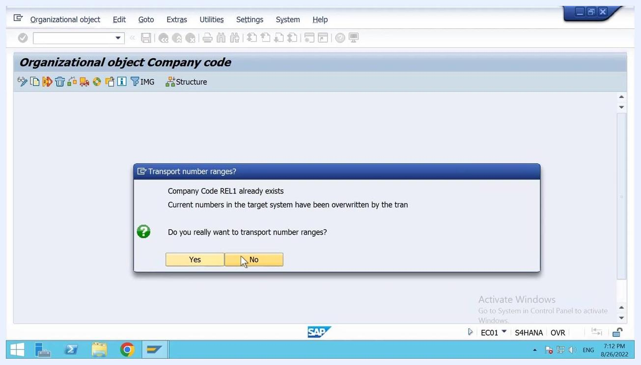
Transport number ranges prompt with No selected for the new company code

Summary
You have now learned how to create a company code in SAP MM by copying an existing one. By following these steps, you copied the source company code's configuration, entered the new company code's details and address, and responded to each table-copy prompt, resulting in a fully configured new company code (REL1) ready for use.

