How to configure a pricing procedure in SAP SD
Configuring a pricing procedure in SAP SD involves defining condition tables, access sequences, and condition types before assembling them into a procedure that the system uses to calculate prices on sales documents. This guide walks through the complete process in SAP SD, from building the pricing building blocks to validating the configuration with a sales order, delivery, and billing document.

Prerequisites
Before you begin, make sure you have access to the following transaction codes in your SAP GUI:
- V/03 – Define condition table
- V/07 – Define access sequence
- V/06 – Define condition type
- VK11 – Create condition records
- VA01 – Create sales order
- VL01N – Create outbound delivery
- VF01 – Create billing document

Overview of the configuration steps
A complete pricing procedure setup in SAP SD follows these main stages:
- Define Condition Table
- Define Access Sequence
- Define Condition Type
- Define Pricing Procedure
- Document Pricing Procedure
- Customer Pricing Procedure
- Pricing Procedure Determination
- Condition Record Creation (transaction code VK11)

Define the condition table

1. Open the condition table transaction
Use transaction code V/03 to begin defining a condition table.
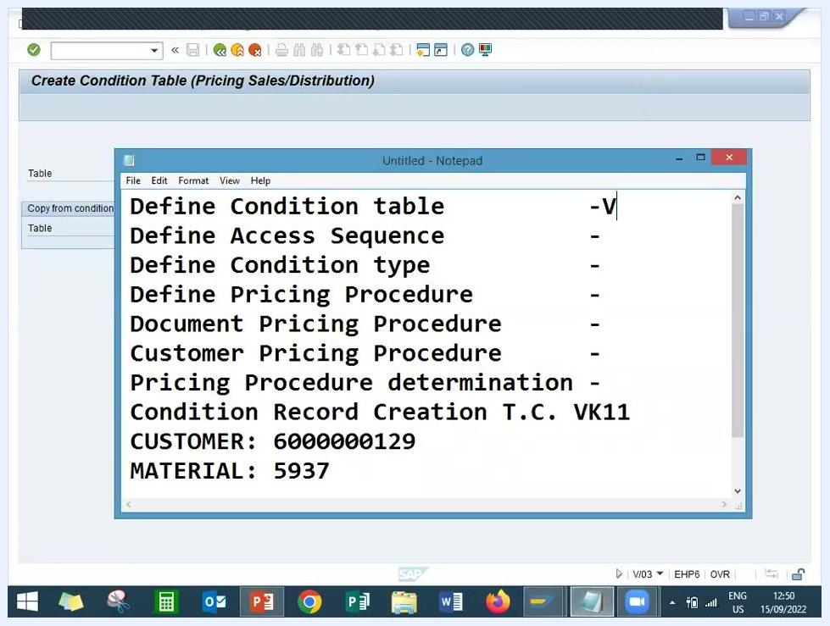
SAP window with a notepad listing the configuration steps, customer, and material numbers, alongside transaction code V/03 used to define the condition table

2. Create the condition table
On the Create Condition Table (Pricing Sales/Distribution) screen:
- Enter a table number above 500 (for example, 625 or 626).
- Use the Page Up and Page Down keys to browse available table numbers.
- Make sure With validity period and With release status are checked.
On the Create Condition Table (Pricing Sales/Distribution): Field Overview screen, select the fields required for your condition table:
- Select Sales Organization from the field catalog and move it to the Selected Fields section.
- Select Distribution Channel and move it to the Selected Fields section.
- Select Customer and move it to the Selected Fields section.
- Select Material and move it to the Selected Fields section.
- Confirm the table number is set to 626.
- Confirm that both With validity period and With release status remain checked.
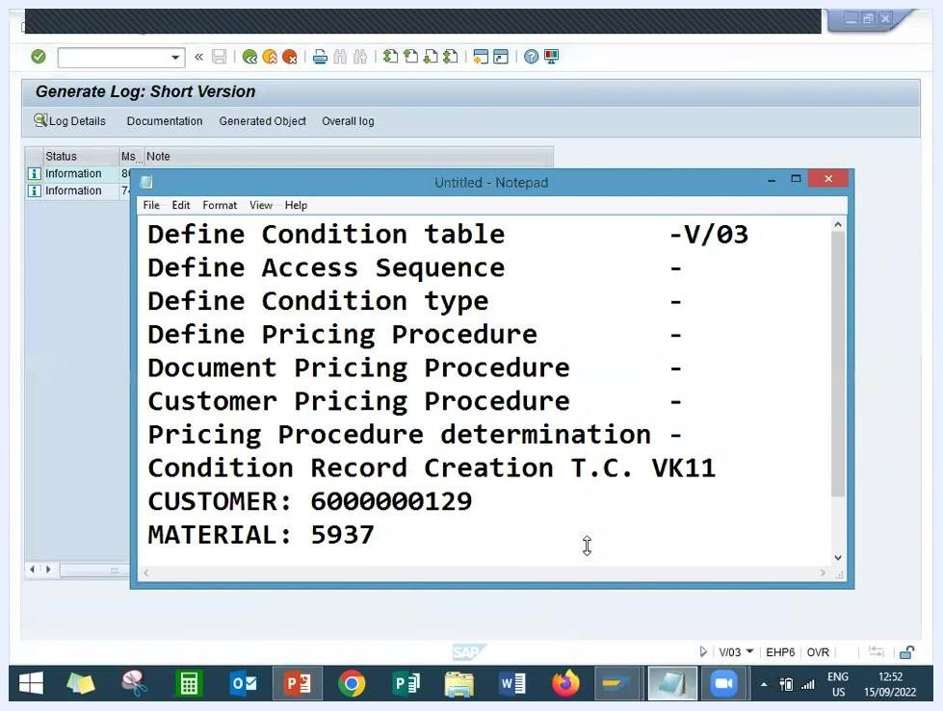
SAP screen showing all four selected fields — Sales Organization, Distribution Channel, Customer, and Material — in condition table 626

3. Generate the condition table
Click the Generate button (or press Shift+F4) to create the condition table and wait for the system to process it.
Generate button highlighted on the SAP "Create Condition Table" screen, with all fields selected
Review the generation log to confirm success. Look for messages such as "Table A626 has been saved" and "Reports and screens for table A626 marked for generation." Note that your condition table number is 626.
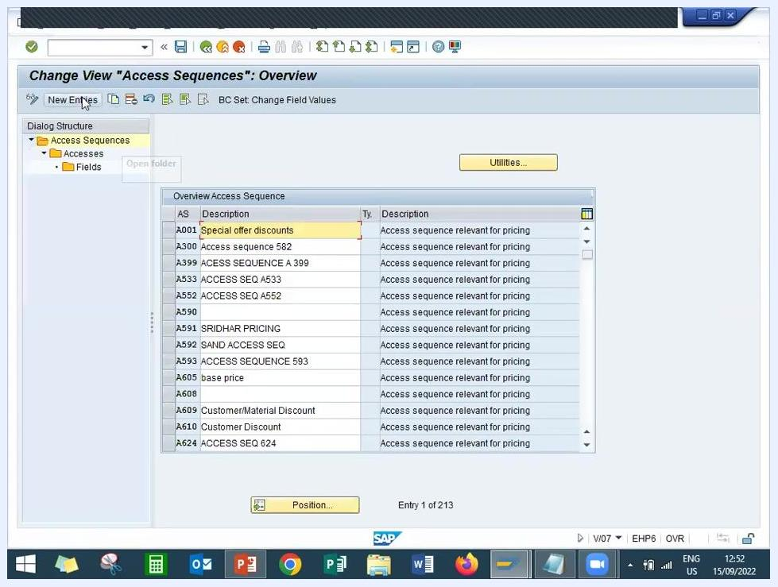
SAP generation log confirming that table A626 has been saved, with a notepad showing the step summary and table number

Define the access sequence

4. Open the access sequence configuration
Return to the main configuration menu and navigate to the Access Sequence configuration section. Use transaction code V/07 to define a new access sequence, then click New Entries to create one.
SAP "Change View 'Access Sequences': Overview" screen with the New Entries button highlighted

5. Enter and finalize the access sequence
Enter the following details for the new access sequence:
- Access Sequence: A626
- Description: a relevant description, for example "Access sequence for table 626"
- Transaction Code: B-07
Confirm the entry in your tracking notes.
Notepad showing access sequence A626 being added, with the SAP screen visible in the background
Confirm that access sequence A626 is created and associated with table 626:
- Press Enter when prompted to confirm your entries.
- Double-click the relevant line item to review the fields.
- Press Enter again to proceed.
- Save your changes to generate the access sequence.
- Press F3 to return to the previous menu.
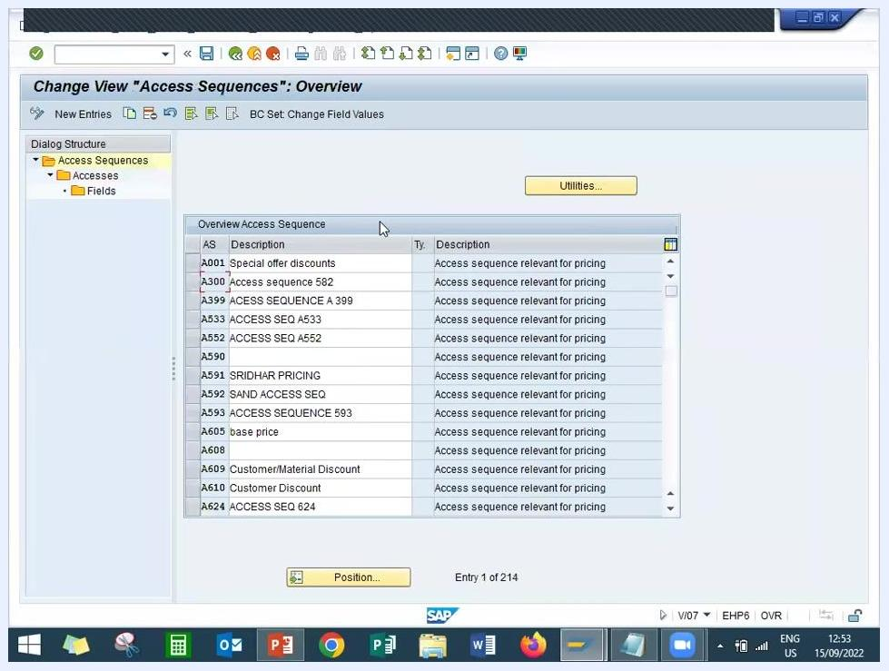
SAP "Fields: Overview" screen showing Access Sequence A626, Table 626, and all selected fields: Sales Organization, Distribution Channel, Sold-to Party, Pricing Ref. Material, Release Status, and Processing Status

Define the condition type

6. Open condition type definition
Go to the Condition Types definition section using transaction code V/06, then select the Conditions: Condition Types overview from the SAP menu.
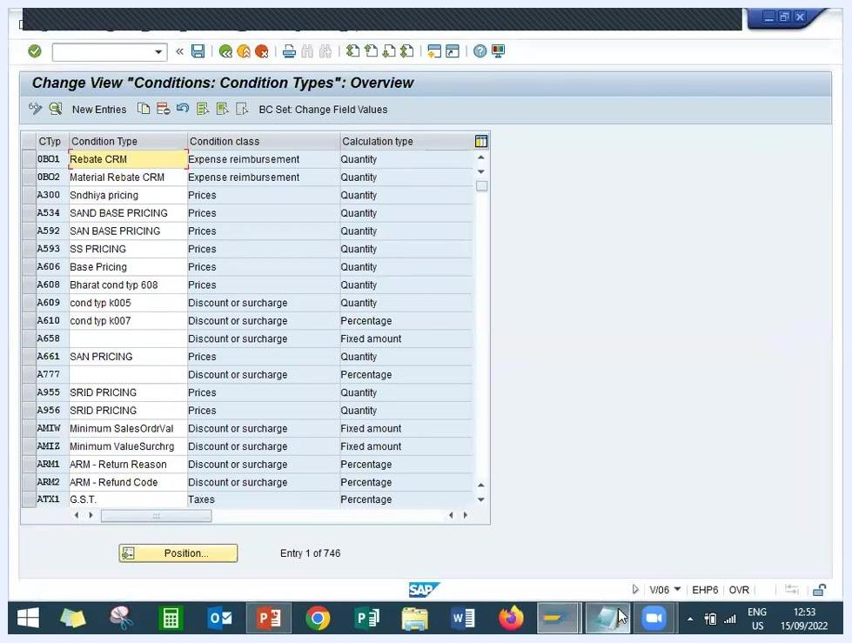
SAP "Conditions: Condition Types: Overview" screen with a list of condition types, including PR00 highlighted

7. Copy the standard condition type PR00
Find PR00 (Base Pricing) in the list and select it as the template for your new condition type. Click Copy As (or press F6) to create a new condition type based on PR00.
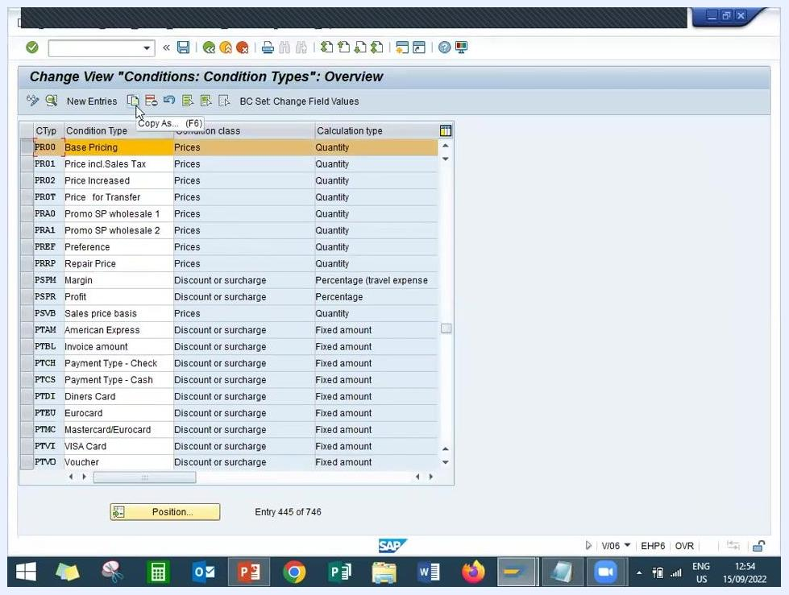
SAP "Conditions: Condition Types: Overview" screen with PR00 (Base Pricing) highlighted and the Copy As button selected

8. Create the new condition type Z626
In the copy dialog, enter:
- Condition Type: Z626
- Description: Base Pricing LEARN2W (or as required)
- Access Sequence: A626
Confirm and save. Verify that Z626 now appears in the list of condition types with the correct description and access sequence.
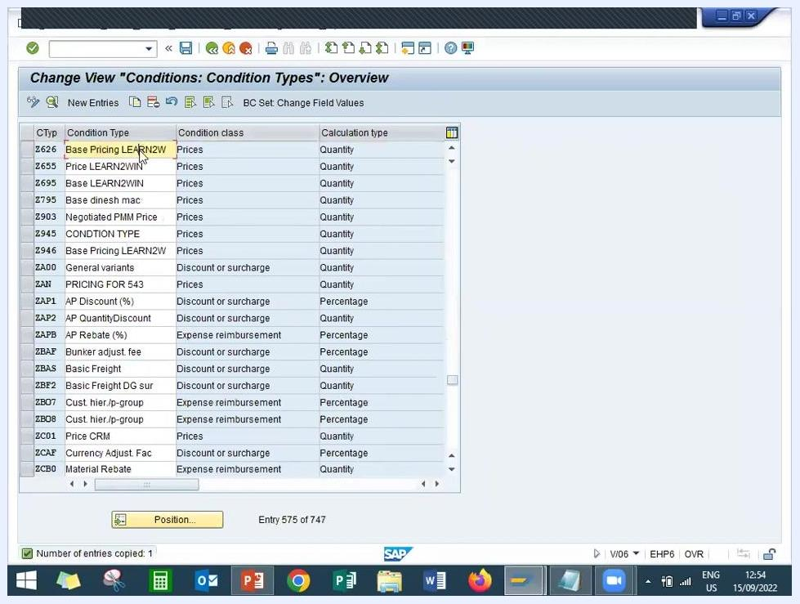
SAP "Conditions: Condition Types: Overview" screen showing the new condition type Z626 (Base Pricing LEARN2W) created and listed

9. Verify the condition type configuration
On the Change View "Conditions: Condition Types": Details screen, confirm that the following fields are populated:
- Cond. type: Z626
- Description: Base Pricing LEARN2W
- Access seq.: A626
Double-check that access sequence A626 is correctly assigned to condition type Z626, and confirm that all previous steps are complete before proceeding to pricing procedure configuration.

Create and assign the pricing procedure

10. Open the procedures overview
Navigate to the Change View 'Procedures': Overview screen. You will see a list of existing pricing procedures. Click New Entries at the top left to create a new pricing procedure.
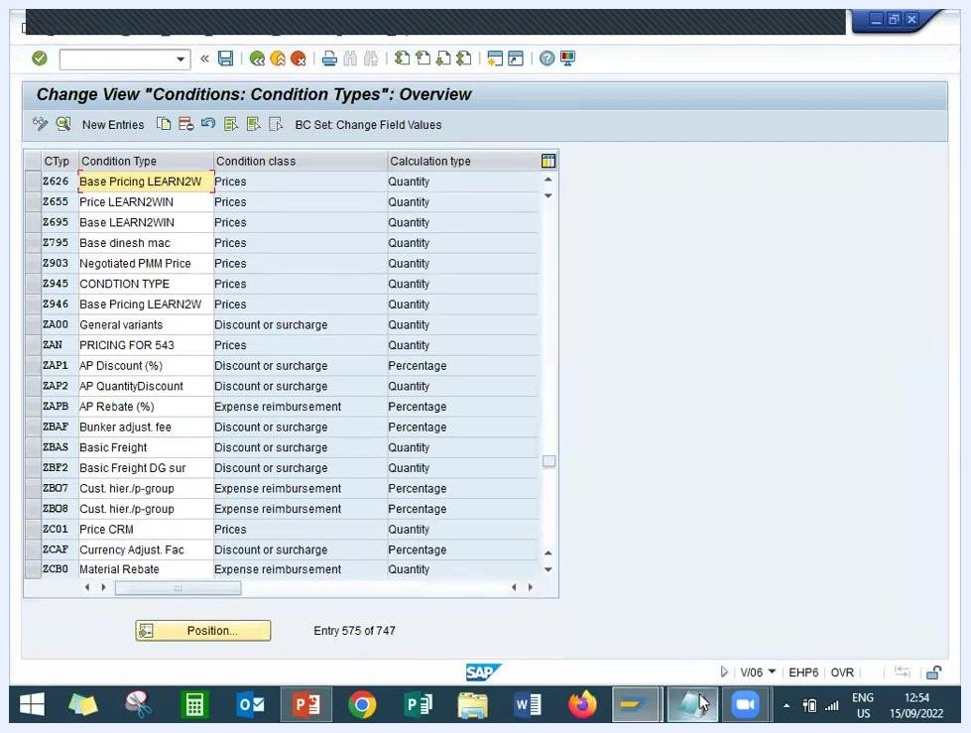
SAP screen showing the Procedures Overview with the New Entries button highlighted, listing existing procedure codes and descriptions

11. Create a new pricing procedure
On the new entry screen, enter:
- Procedure: Z626ZZ
- Description: PRICING PROCEDURE LEARN2WIN
This sets up the new pricing procedure for further configuration.

12. Assign the condition type to the pricing procedure
On the New Entries: Overview of Added Entries screen, assign the condition type:
- Step: 1
- Counter: 0
- CType: Z626
- Description: Base Pricing LEARN2W
Additional columns such as From, To, Manual, Reqt, Subtotal, Requirement, Calculation Type, Base Type, and Account Key are available for further configuration.
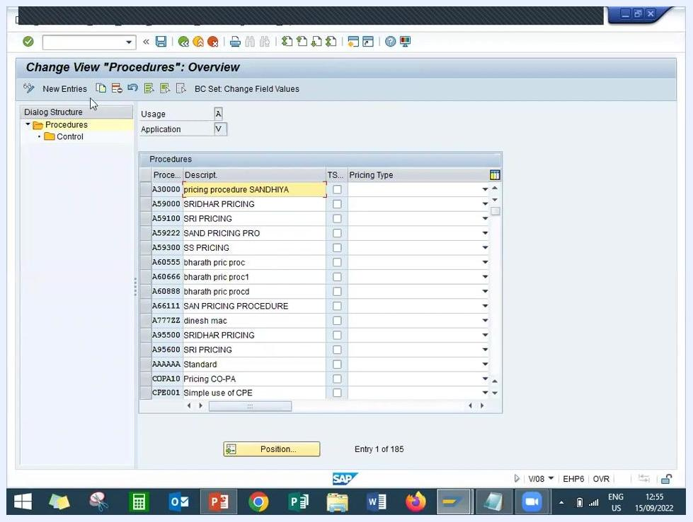
SAP screen showing the assignment of condition type Z626 to the new pricing procedure Z626ZZ, with step, counter, condition type, and description columns
Press Enter to validate the entries. The system updates the screen to confirm the assignment of Z626 Base Pricing LEARN2W. Ensure the Reqt field is set to 2 and the BasTy field is set to ERL.
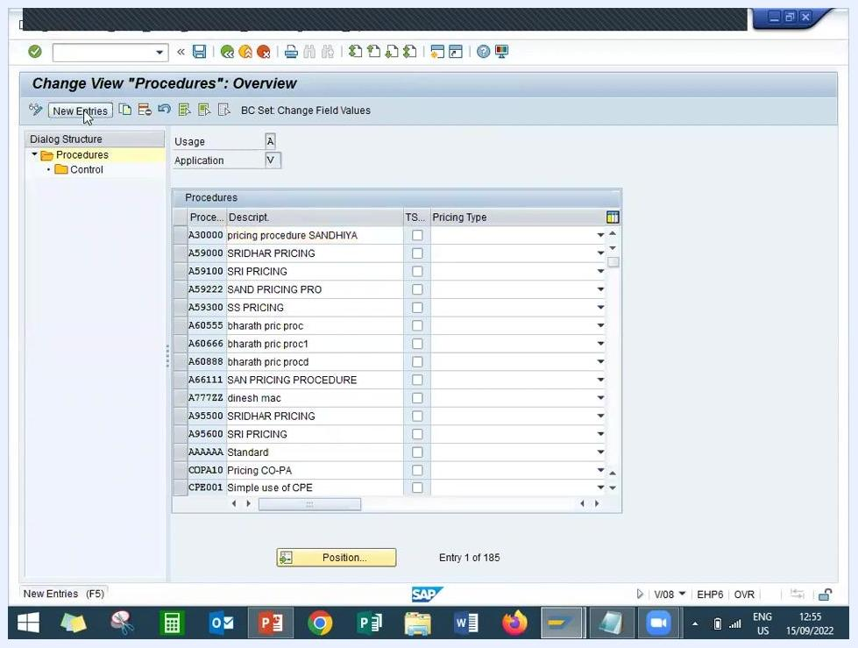
SAP screen showing the confirmed assignment of Z626 Base Pricing LEARN2W to the pricing procedure, with Reqt = 2 and BasTy = ERL

13. Save the pricing procedure
Click the Save icon (or press Ctrl+S) and wait for the confirmation message indicating the entries were saved successfully.
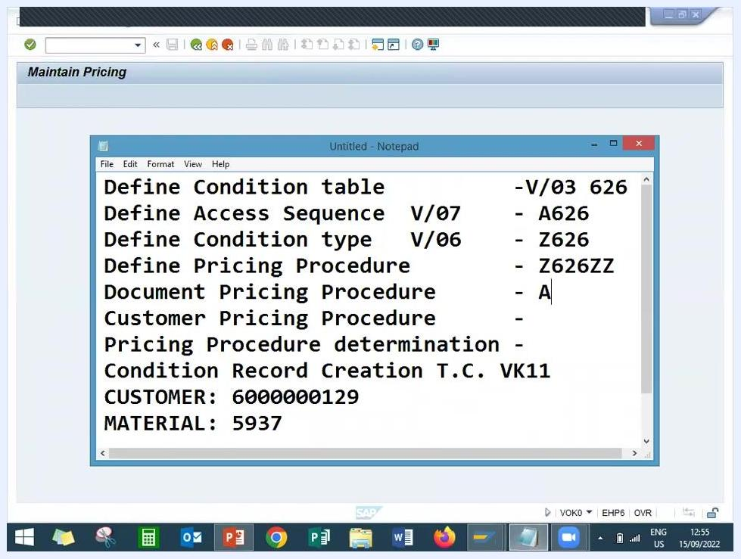
SAP screen showing the saved pricing procedure with the Save icon highlighted and the entry for Z626 Base Pricing LEARN2W confirmed

Set up pricing procedure determination

14. Use standard document and customer pricing procedures
Use the existing standard values rather than creating new entries:
- Document Pricing Procedure: A
- Customer Pricing Procedure: 1
Navigate to the Change View 'Pricing Procedures: Determination in Sales Docs.': Overview screen. This screen lists all existing pricing procedure assignments by sales organization, distribution channel, division, document pricing procedure, and customer pricing procedure. Use the Position... button at the bottom to quickly locate specific entries.
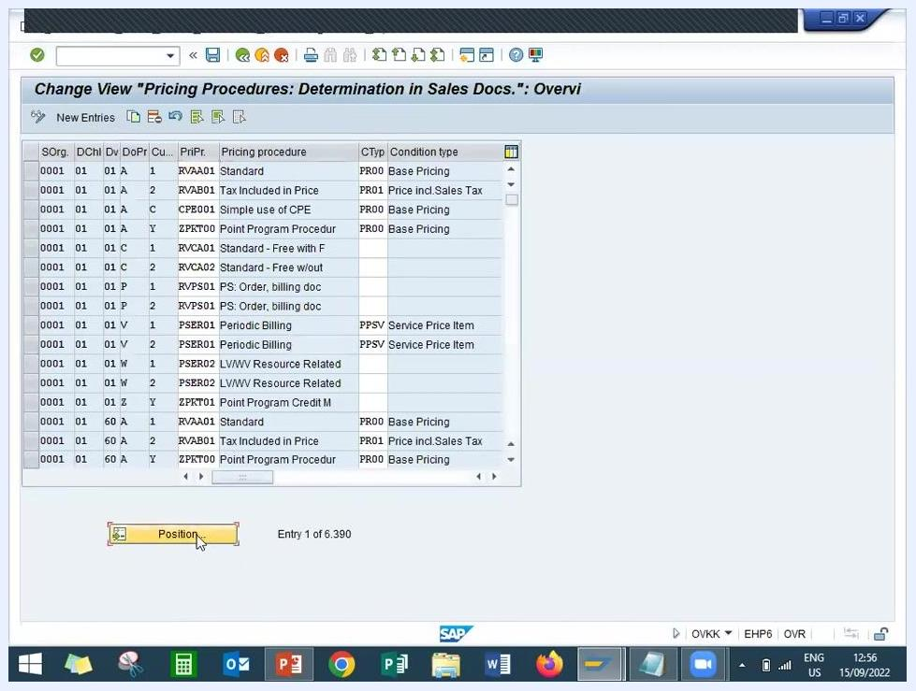
SAP screen showing the overview of pricing procedure determination in sales documents, with a list of assignments and the Position button

15. Search for the new pricing procedure assignment
Use Position... or scroll to locate the entry for your new pricing procedure, and confirm it matches:
- Sales Organization: LD01
- Distribution Channel: LD
- Division: LD
- Document Pricing Procedure: A
- Customer Pricing Procedure: 1
- Pricing Procedure: Z626ZZ
- Condition Type: Z626
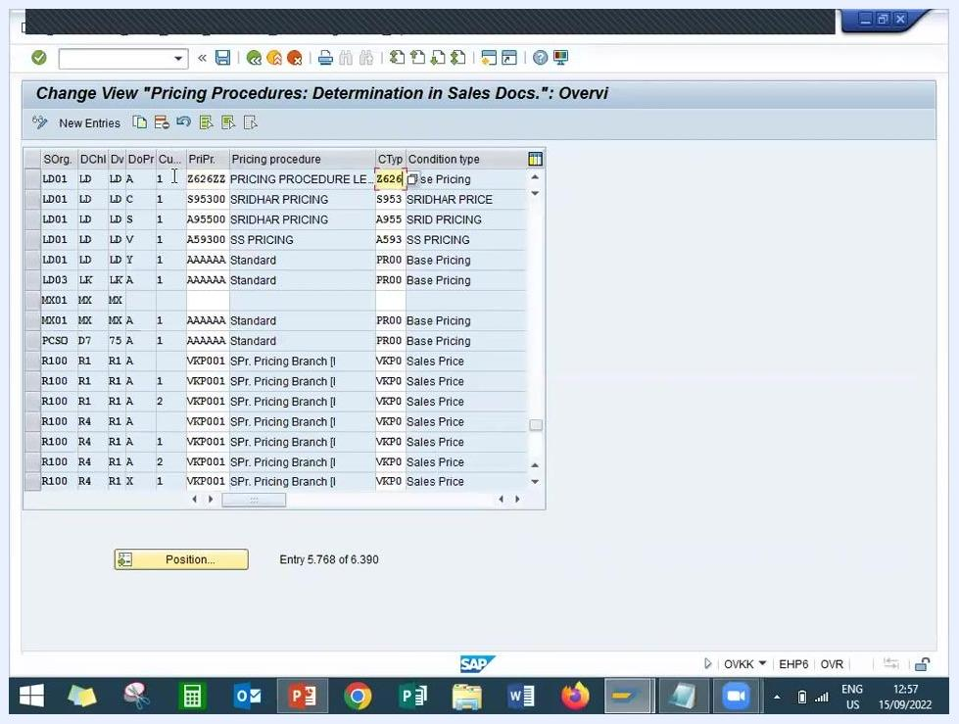
SAP screen with the entry for pricing procedure Z626ZZ and condition type Z626 highlighted under sales organization LD01, distribution channel LD, division LD, document pricing procedure A, and customer pricing procedure 1

Create the condition record

16. Prepare for condition record creation
Note the values needed for the VK11 transaction:
- Condition Type: Z626
- Customer: 6000000129
- Material: 5937

17. Open the Create Condition Records screen
Navigate to the Create Condition Records screen. The screen displays tabs for Condition Information and Key Combination.
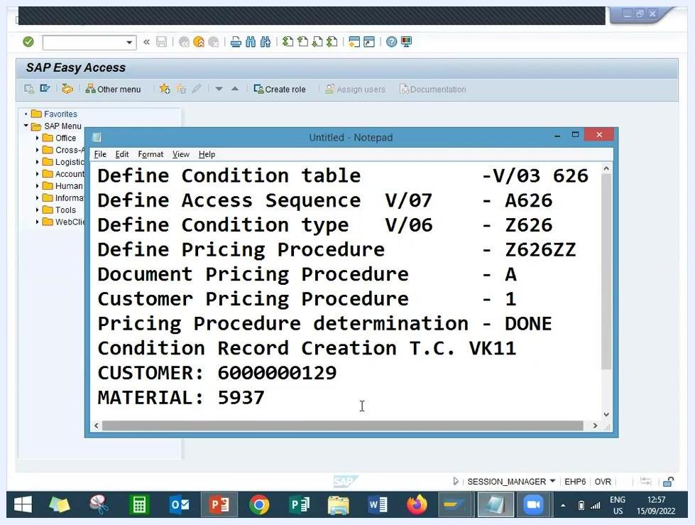
SAP Create Condition Records screen with a notepad open showing all required values for condition record creation

18. Enter condition record details
On the Create Base Pricing LEARN2W Condition (Z626): Fast Entry screen, enter:
- Sales Organization: LD01
- Distribution Channel: LD
- Customer: 6000000129 (GHJ INDS)
- Material: 5937
- Description: Streering wheels kiger
- Amount: 15,500.00 INR per 1 EA
- Validity: From 15.09.2022 to 31.12.9999
This screen sets the price at which the material will be sold to the customer.
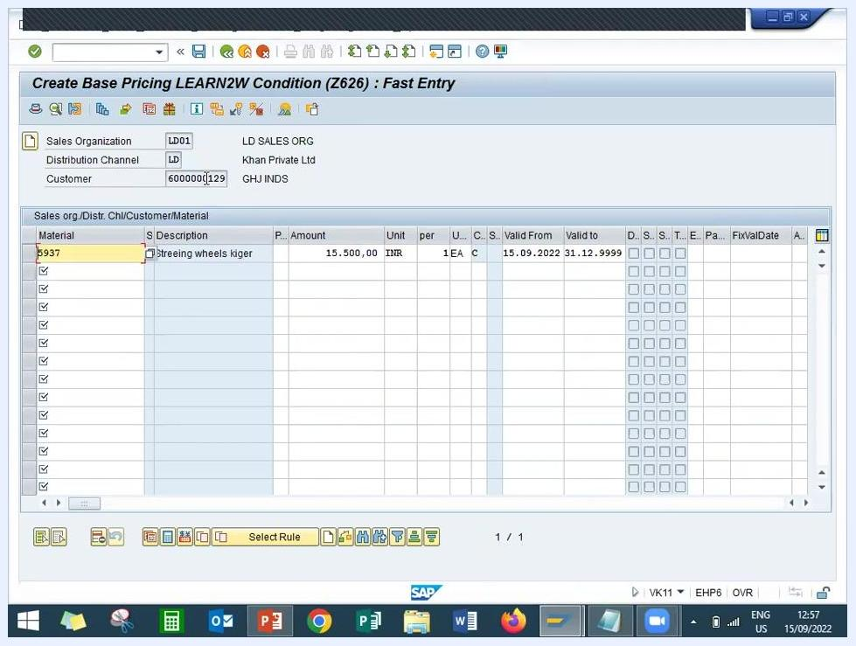
SAP VK11 screen showing the condition record entry for material 5937, customer 6000000129, price 15,500.00 INR, and validity dates

19. Save the condition record
Click the save icon (diskette) to store the condition record. Confirm that the record is saved by checking for a confirmation message at the bottom of the screen; the entry fields will clear once the save is successful.
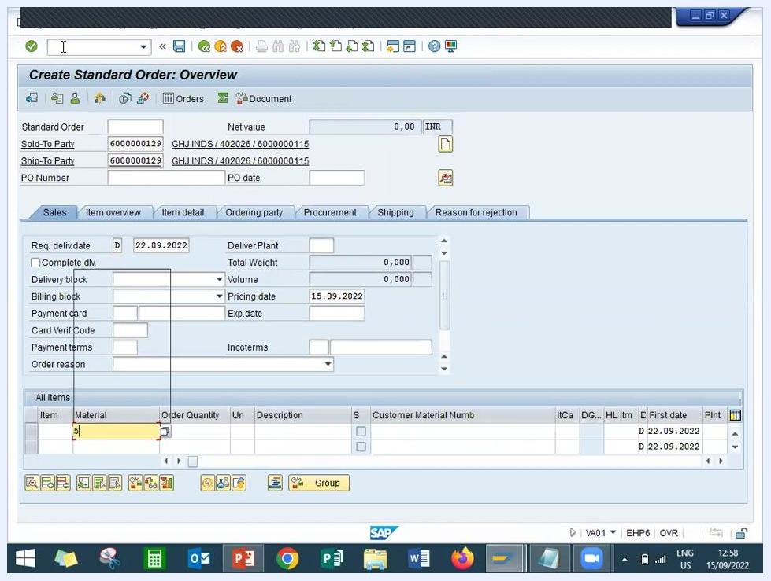
SAP VK11 screen after saving, with the confirmation message "Condition records saved" shown at the bottom

Validate the configuration with a sales order

20. Start sales order creation
In the command field at the top, enter /nVA01 and press Enter to open the Create Standard Order: Overview screen.
SAP VK11 screen with the command field showing /nVA01, ready to create a sales order

21. Enter sales order header data
On the Create Standard Order: Overview screen, fill in:
- Sold-To Party: 6000000129 (GHJ INDS)
- Ship-To Party: 6000000129 (GHJ INDS)
- Pricing Date: 15.09.2022
- Required Delivery Date: 22.09.2022
In the All items section, begin entering the material number.
SAP Create Standard Order: Overview screen with header fields completed and material entry in progress

22. Enter material and order details
In the All items section, enter:
- Material: 5937
- Order Quantity: 1 EA
- Description: Streering wheels kiger
If configured correctly, the system automatically pulls in the price from the condition record.

23. Specify payment terms and incoterms
On the Sales tab, enter:
- Payment Terms: 0001 (select from the dropdown)
- Incoterms: CFR
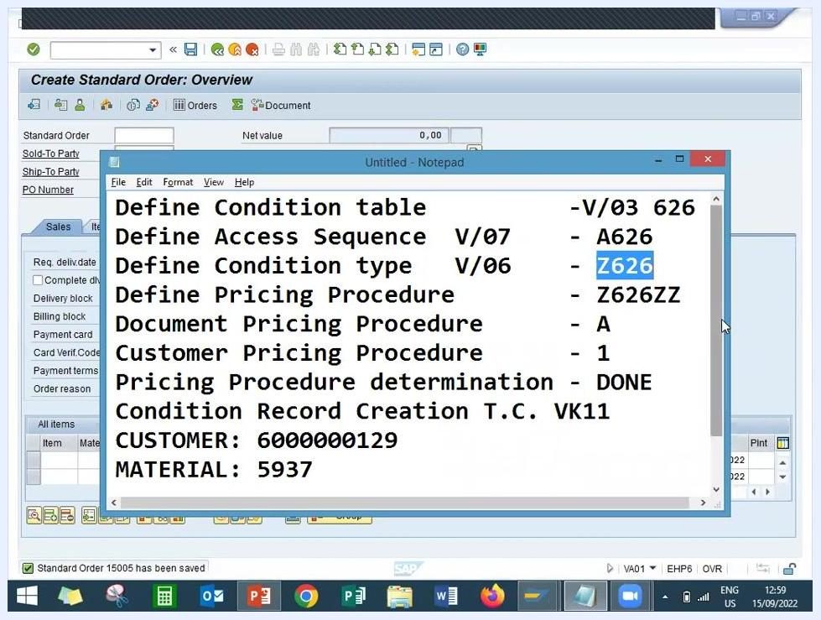
SAP Create Standard Order: Overview screen with payment terms 0001 and incoterms CFR entered, and item details filled in

24. Save the sales order
Click the save icon to create the sales order. Wait for the confirmation message at the bottom of the screen (for example, "Standard Order 15005 has been saved") and note the generated sales order number for reference.
SAP Create Standard Order: Overview screen with the notepad showing a checklist and confirmation that order 15005 has been saved

Confirm pricing through goods receipt, delivery, and billing

25. Perform a goods receipt for the material
On the Goods Receipt Other - mms screen, General tab, enter:
- Document Date: 15.09.2022
- Posting Date: 15.09.2022
- Material Short Text: Streering wheels kiger
- Quantity: 100
- Unit: EA
- Storage Location: FERT
- Movement Type: 561 (GI entry of st. bals)
- Plant: LD PLANT
- Stock Type: Unrestricted use
- Plant Code: LD01
Save the goods receipt document.
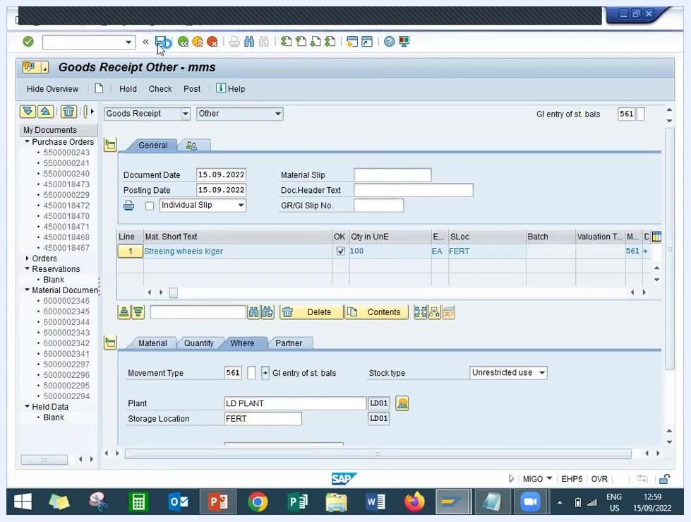
Goods Receipt Other screen with all fields filled in for the material receipt, including movement type 561, plant LD01, and quantity 100 for "Streering wheels kiger"

26. Navigate to outbound delivery creation
Return to the SAP Easy Access menu and prepare to create an outbound delivery using transaction code VL01N.
SAP Easy Access screen showing the navigation path to create an outbound delivery

27. Create the outbound delivery
On the Create Outbound Delivery with Order Reference screen, enter:
- Shipping Point: LD01
- Sales Order: 150005
- Material: 5937
On the Delivery Create: Overview screen, verify:
- Ship-to party: 6000000129
- Document Date: 15.09.2022
- Pick Date/Time: 22.09.2022
- Material: 5937
- Plant: LD01
- Storage Location: LD01
- Delivery Quantity: 1 EA
- Picked Quantity: 1 EA
- Description: Streering wheels kiger
Make sure the item shows as "Fully picked" and that no WM transfer order is required.
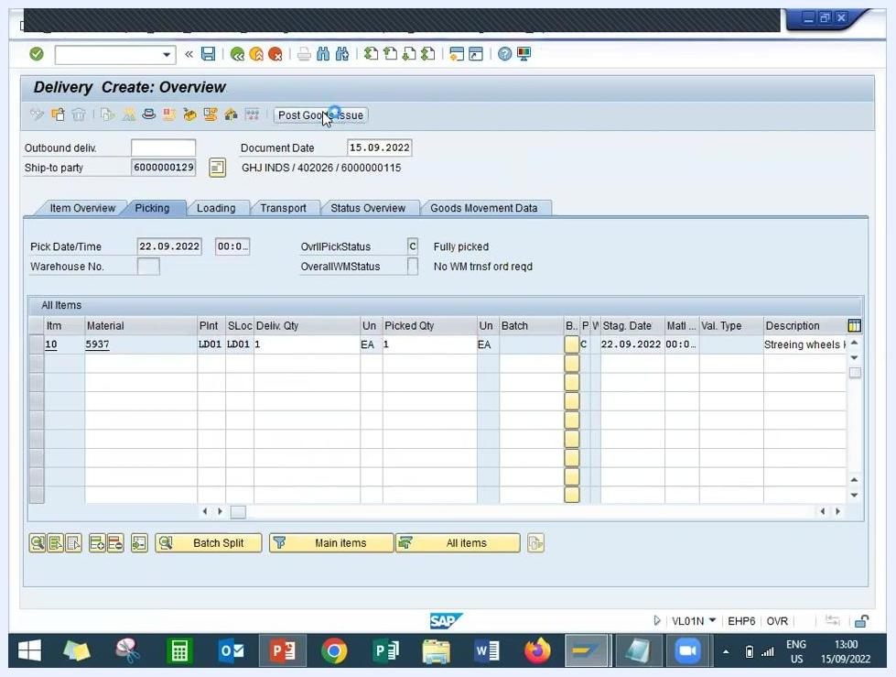
Delivery Create Overview screen with all delivery and picking details filled in, ready for Post Goods Issue

28. Post goods issue
Click Post Goods Issue to complete the outbound delivery process, and confirm that the goods issue is posted successfully.
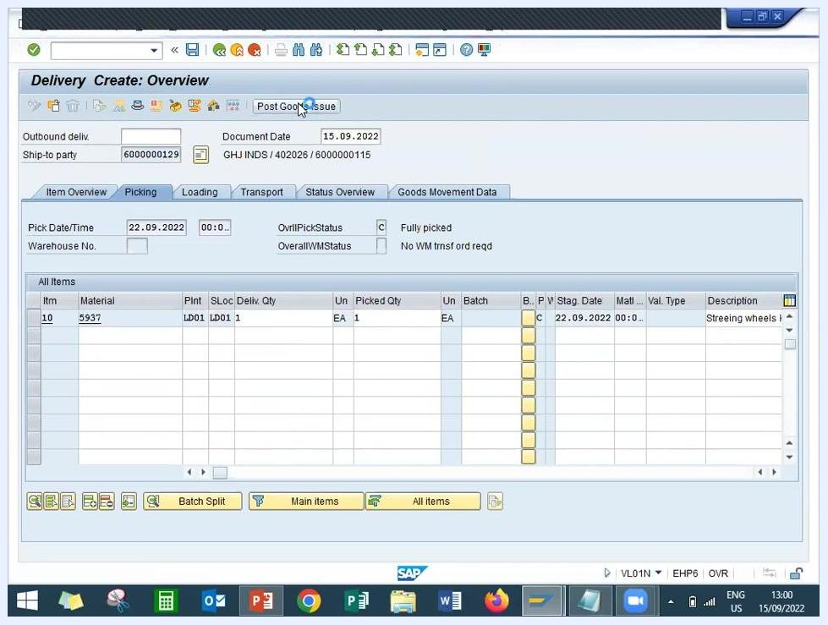
Delivery Create Overview screen with the Post Goods Issue button highlighted

29. Create the billing document
Return to the SAP Easy Access menu and enter transaction code VF01 to create a billing document.
SAP Easy Access screen with transaction code VF01 entered for billing document creation

30. Review and confirm the billing document
On the Invoice (F2) Create: Overview of Billing Items screen, review:
- Invoice: S000000001
- Payer: 6000000129
- Billing Date: 16.09.2022
- Description: Streering wheels kiger
- Billed Quantity: 1 EA
- Material: 5937
- Net Value: 15,500.00 INR
- Tax Amount: 0.00
Verify all details for accuracy before confirming the billing document.
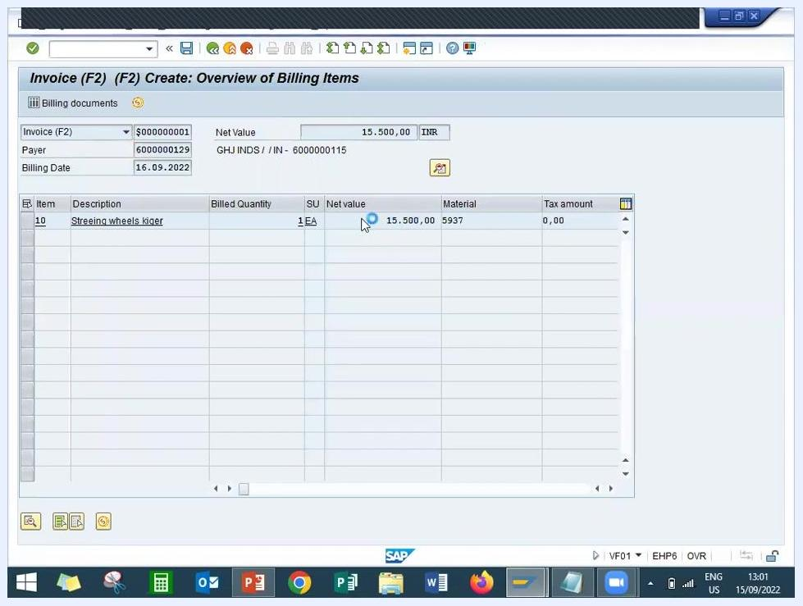
Invoice (F2) Create: Overview of Billing Items screen showing the net value, billed quantity, and material details

Summary
By completing these steps, you have configured a pricing procedure in SAP SD — from the condition table, access sequence, and condition type through to the pricing procedure assignment and determination — and validated it end-to-end by creating a condition record, a sales order, a goods receipt, an outbound delivery, and a billing document. The net value on the invoice confirms that the new pricing procedure correctly determined the price for the sales transaction.

