How to Delete a Receipt in SAP Concur
This guide explains how to delete a receipt in SAP Concur when the wrong receipt has been matched to a company card charge. This situation can occur due to user error or because billing details changed after the receipt was attached. The steps below walk you through reviewing, detaching, and re-attaching receipts so your expense report reflects the correct documentation before you submit it.
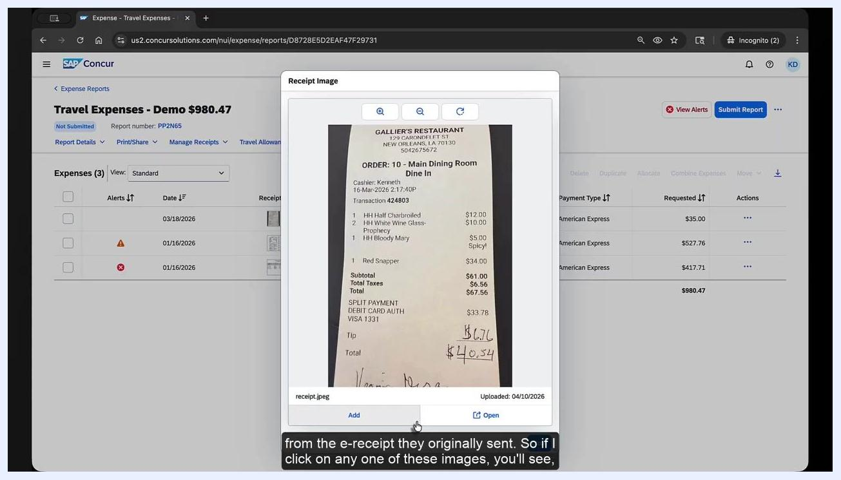
Receipt pop-up displaying a scanned restaurant receipt over the SAP Concur expense report, with no option to remove the receipt.
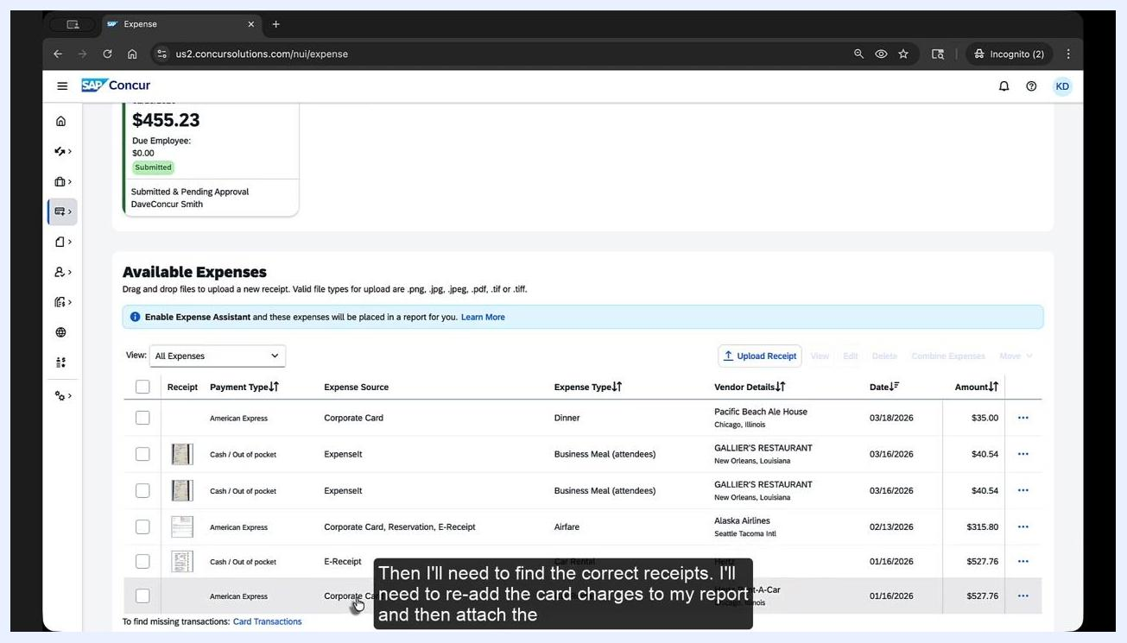
Presenter in front of a "Kevin's Corner" street sign, with a blue box displaying "community.concur.com" and "username: KevinD" for SAP Concur Community support.

Before you begin
Understanding how receipts reach SAP Concur helps you troubleshoot mismatches:
- Expense It Feature: You take a picture of a receipt, and the system analyzes it, uploads it to Available Expenses, and matches it to the corresponding credit card charge.
- E-Receipts from Vendors: Vendors such as car rental agencies, hotels, and airlines send e-receipts directly, which are automatically matched to company card charges.
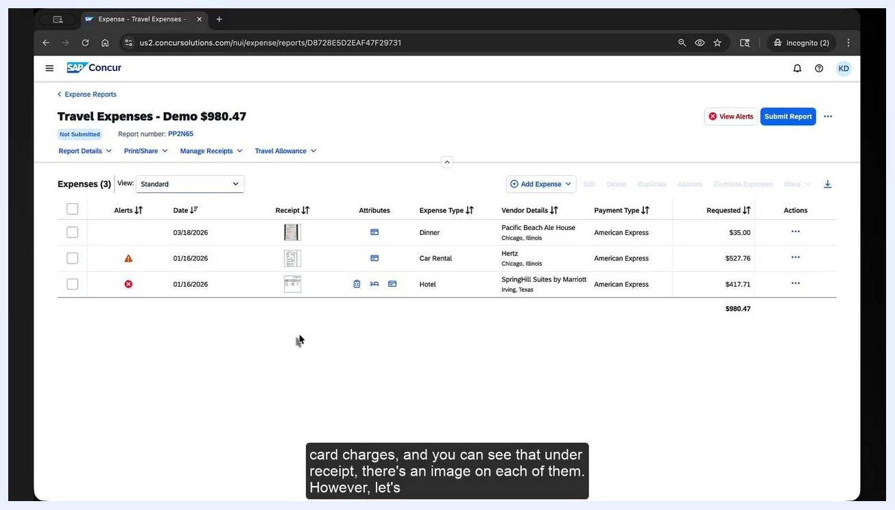
SAP Concur expense report listing Dinner, Car Rental, and Hotel charges, each showing a receipt icon in the Receipt column alongside columns for Alerts, Date, Attributes, Expense Type, Vendor Details, Payment Type, Requested, and Actions.
Before making changes, confirm the expense report has not been submitted yet, since you will be editing expense items directly.

Step 1: Review the expense report and its attached receipts
Open your expense report and check each company card charge for an attached receipt. In the example report, three charges each display a receipt image in the Receipt column: a Dinner charge, a Car Rental charge, and a Hotel charge, all paid with American Express.
Available Expenses screen showing Dinner, Car Rental, and Airfare card charges ready to be added back to a report, with options to upload receipts and select expenses.
The presence of a receipt image confirms that a receipt or e-receipt has already been matched to that line item. If any of these receipts appear incorrect, you will need to detach them before attaching the right one.

Step 2: Confirm that receipts cannot be removed while attached to the report
Click the receipt image in the Receipt column for the expense in question. A pop-up window opens showing the scanned image or photo for a physical receipt, or the electronic receipt for an e-receipt sent by a vendor.
In either case, no remove option is available in this pop-up. This confirms that receipts and e-receipts cannot be detached directly from within an active expense report.

Step 3: Delete the expense items from the report
To detach a receipt, you must first remove the expense item itself from the report:
- Select the checkboxes next to the expenses you want to detach receipts from, such as Dinner and Car Rental.
- Click Delete at the top of the expense list.
- Review the confirmation dialog, which explains that expenses will be permanently deleted, while expenses from outside sources that cannot be deleted—such as e-receipts or corporate card transactions—will be moved to Available Expenses.
- Click Delete Expenses to confirm.
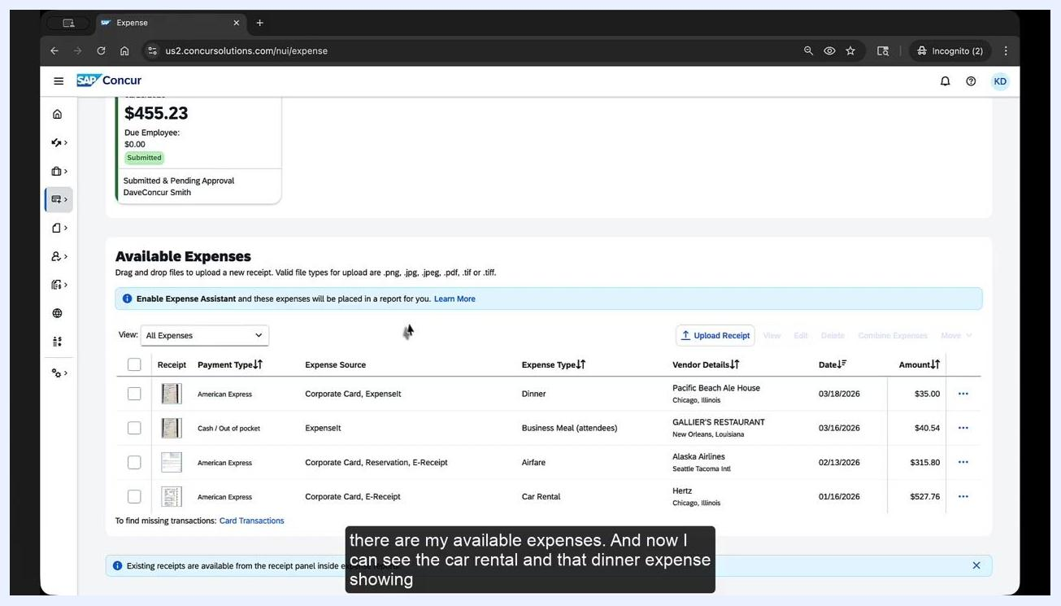
SAP Concur expense report with two expenses selected and a confirmation dialog explaining that e-receipts and card transactions will move to Available Expenses instead of being permanently deleted.

Step 4: Locate the expenses in Available Expenses
After deletion, the selected expenses no longer appear in the report. Navigate to the Available Expenses section to find them.
Each expense now appears with its source listed, such as "Corporate Card, ExpenseIt" or "Corporate Card, E-Receipt," confirming that the card transaction and the receipt have been moved there together.

Step 5: Separate the receipt from the company card charge
For each expense with an incorrectly matched receipt, you need to split the combined sources:
- Click the expense source link, such as "Corporate Card, ExpenseIt" for Dinner or "Corporate Card, E-Receipt" for Car Rental.
- In the Expense Sources window that appears, review the combined sources listed for the expense.
- Click Separate Expenses.
- If prompted, confirm by clicking Separate again.
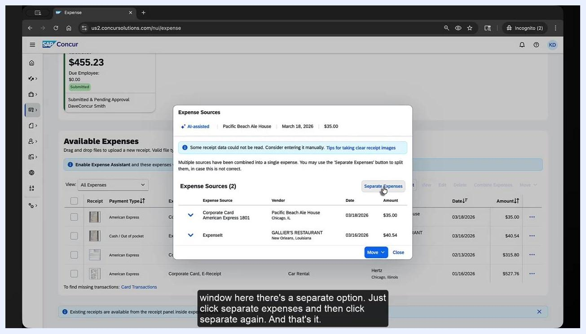
Expense Sources dialog showing Corporate Card and ExpenseIt listed as two sources for a Dinner expense, with the Separate Expenses button highlighted.
Repeat this process for every expense that has an incorrectly matched receipt or e-receipt.
Once separated, the card charge and the receipt become individual items in Available Expenses, letting you correctly match or remove receipts as needed.

Step 6: Re-add the card charge and attach the correct receipt
With the sources separated, you can now rebuild the expense correctly:
- In Available Expenses, identify each card charge by its Payment Type (for example, "American Express"), Expense Source (for example, "Corporate Card"), Expense Type (for example, "Dinner" or "Car Rental"), and Vendor Details (for example, "Pacific Beach Ale House" or "Hertz Rent-A-Car").
- Select the checkbox next to each card charge you want to add back to your report.
- Click Add to Report (the button label may vary slightly depending on your SAP Concur configuration).
- Once the expense is back in your report, click Upload Receipt or the receipt icon next to the expense.
- Attach the correct receipt image or file.
- Verify that the correct receipt is now matched to the appropriate card charge.
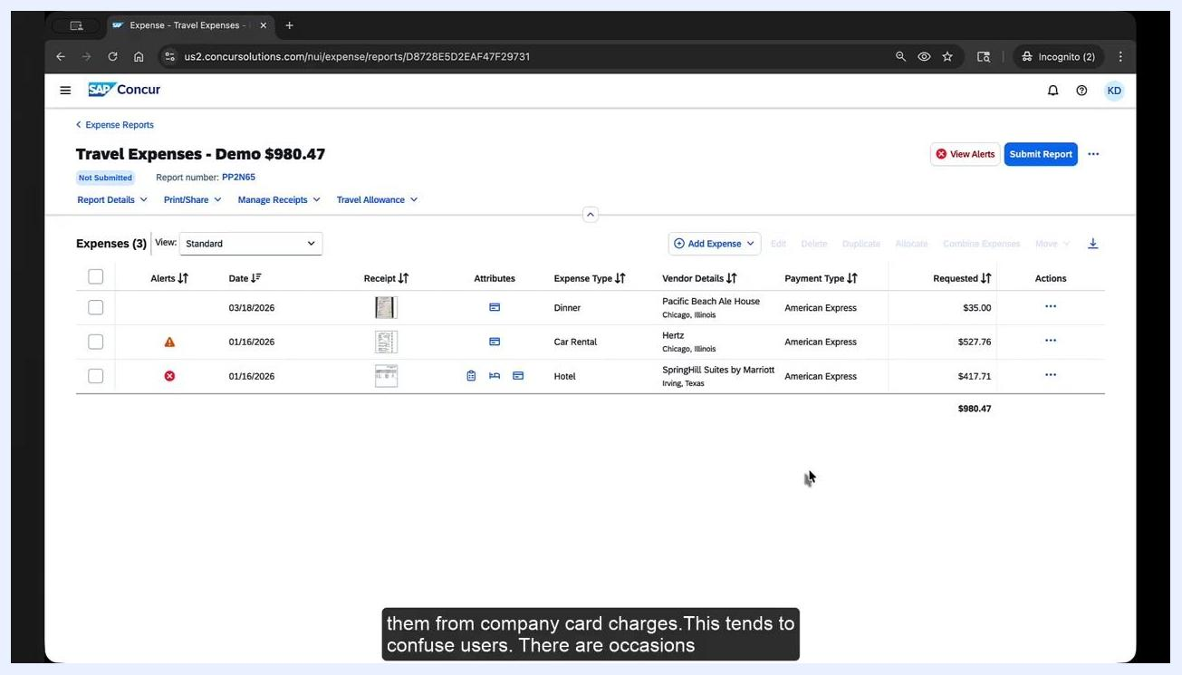
A presenter stands in front of a background with a street sign reading "Kevin's Corner." A blue overlay displays: "Kevin Dorsey, Director, SAP Concur Community Management & Engagement." Subtitle at the bottom reads: "Welcome back to Kevin's Corner. Today's topic was suggested by two members of the SAP Concur"
Available Expenses screen showing the Dinner and Car Rental expenses with their payment type, source, and vendor details.

What's next
After attaching the correct receipts to each card charge, review the full report once more to confirm accuracy, then submit it for approval as usual.
If you have further questions, visit the SAP Concur Community at community.concur.com, where you can search existing answers or post your own question.

