How to create a user defined object (UDO) in SAP Business One
User-defined objects (UDOs) are custom documents or forms that capture information the standard SAP Business One modules don't cover. For example, if your business manages vehicles and SAP Business One has no vehicle management module, you can build one yourself.
This guide shows you how to create a user defined object (UDO) in SAP Business One. You create the tables and fields, register the object with the wizard, adjust its form, and enter test data. The example is a vehicle object built on a parent table named VMST and a child table named VMST_CHILD.

Prerequisites
Before you register a UDO, you must complete two things:
- Create user-defined tables.
- Create user-defined fields within those tables.
Steps 1 to 11 cover both prerequisites.

Create the user-defined tables

Step 1: Open User-Defined Tables – Setup
Open SAP Business One and make sure you are on the main cockpit screen.
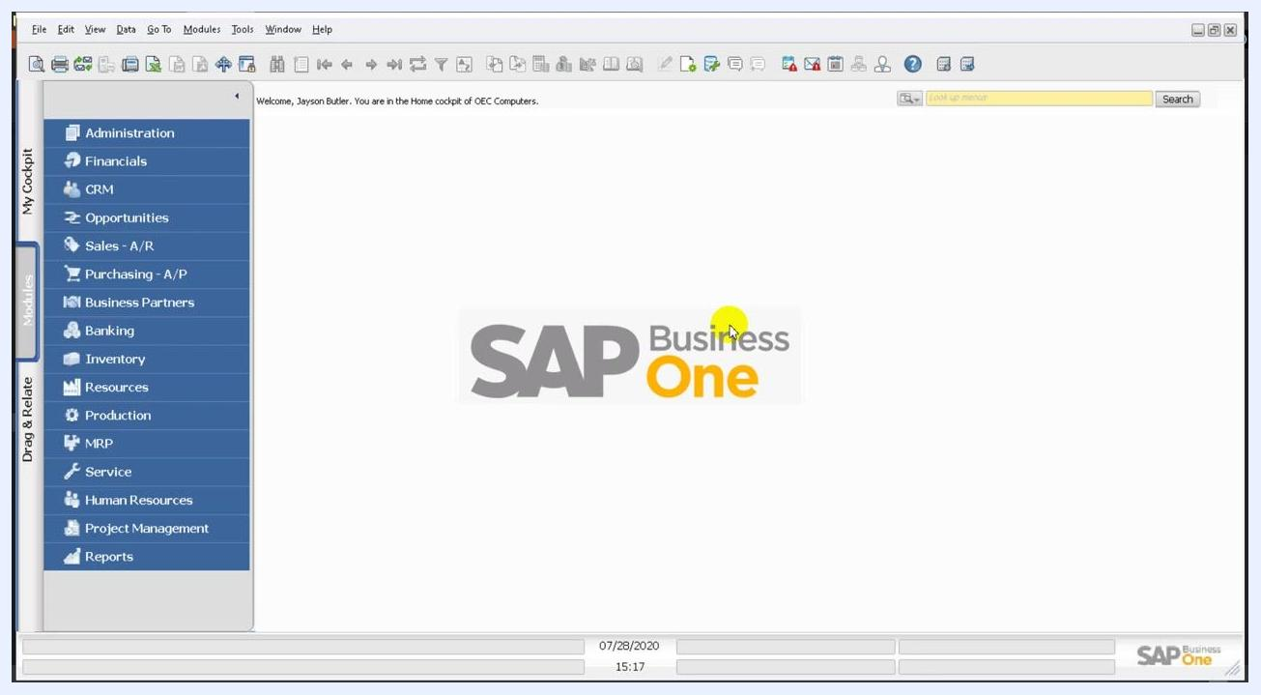
SAP Business One main cockpit with the navigation panel and logo

Step 2: Select the setup window from the Tools menu
In the menu bar, go to Tools > Customization Tools > User-Defined Tables – Setup. The User-Defined Tables – Setup window opens.
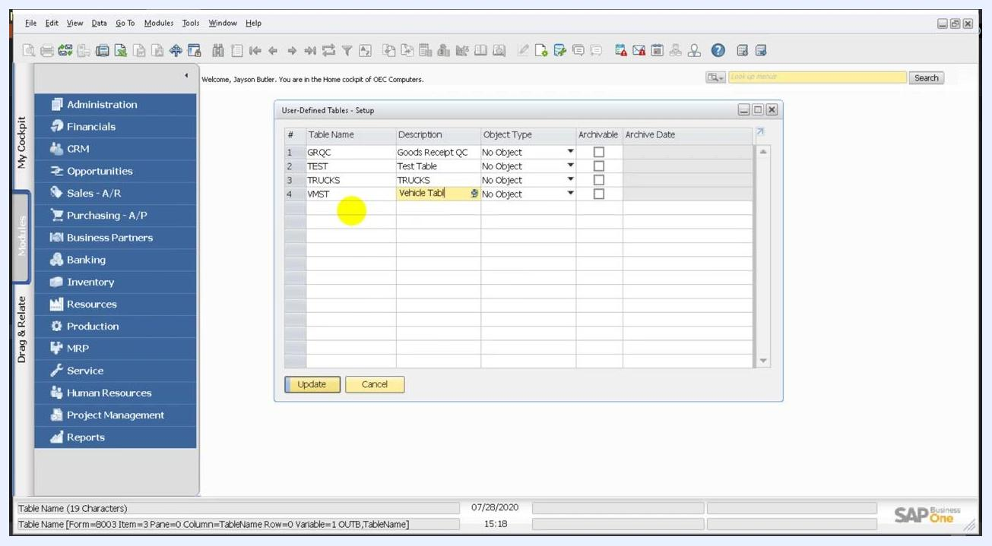
Tools menu open with Customization Tools highlighted and User-Defined Tables – Setup selected

Step 3: Add the parent table
In the User-Defined Tables – Setup window, add a new row and enter the following values:
- Table Name: VMST
- Description: Vehicle Table
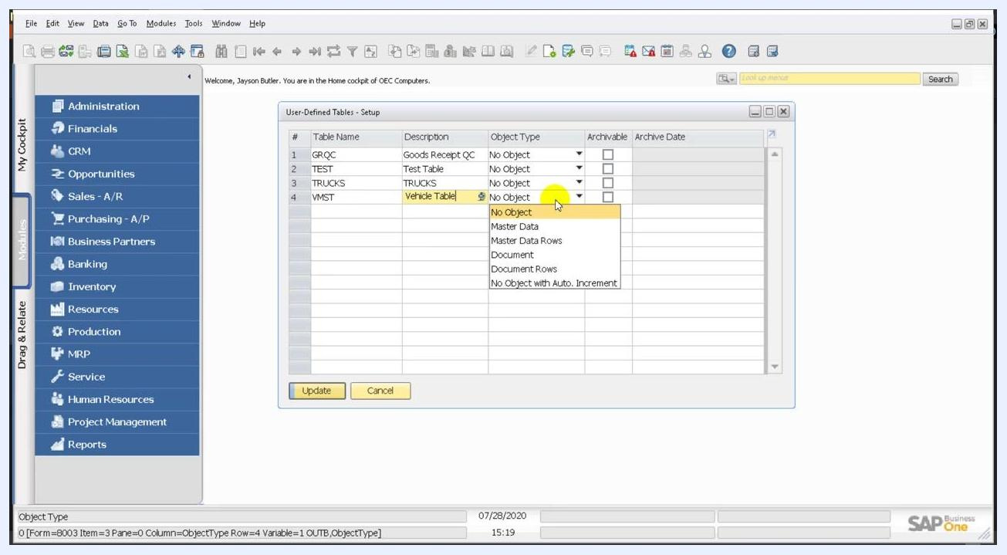
User-Defined Tables – Setup window with a new row: Table Name VMST and Description Vehicle Table

Step 4: Set the object type
Click the dropdown in the Object Type column of the VMST row. The available options are "Master Data", "Master Data Rows", "Document", and "Document Rows". Choose the option that fits your use case.
In this example, VMST is the main document table, so it must end up with the object type Document. The child table you create next uses Document Rows.
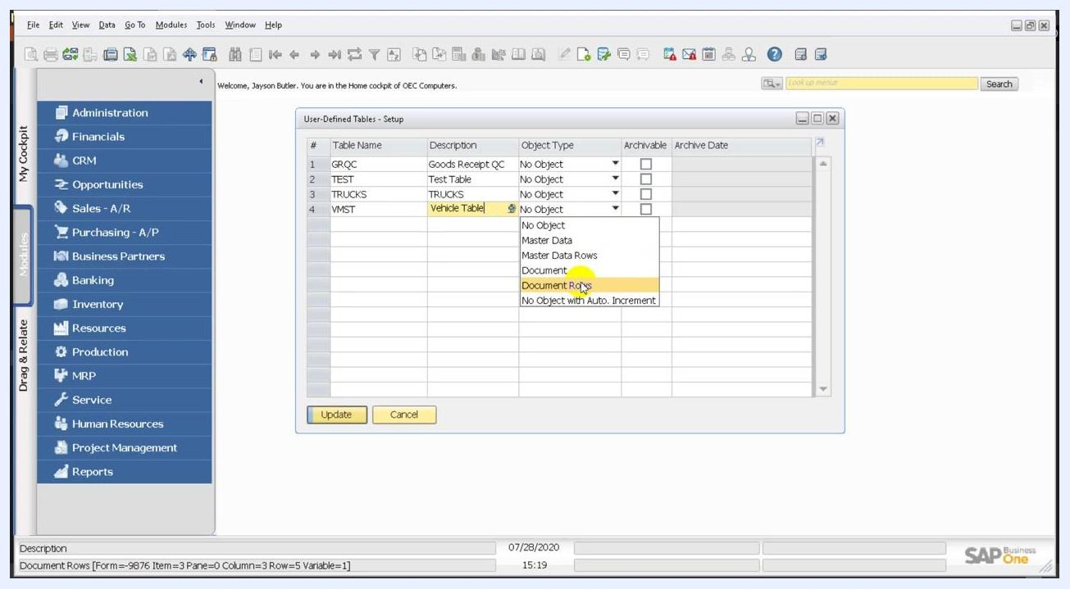
Object Type dropdown open in the User-Defined Tables – Setup window, with Document Rows highlighted

Step 5: Save the table and add the child table
Click Update or OK to save the new user-defined table. Then add a second row for the child table:
- Table Name: VMST_CHILD
- Description: Vehicle child Table
- Object Type: Document Rows (select it from the dropdown)
Click OK or Update to save the child table.
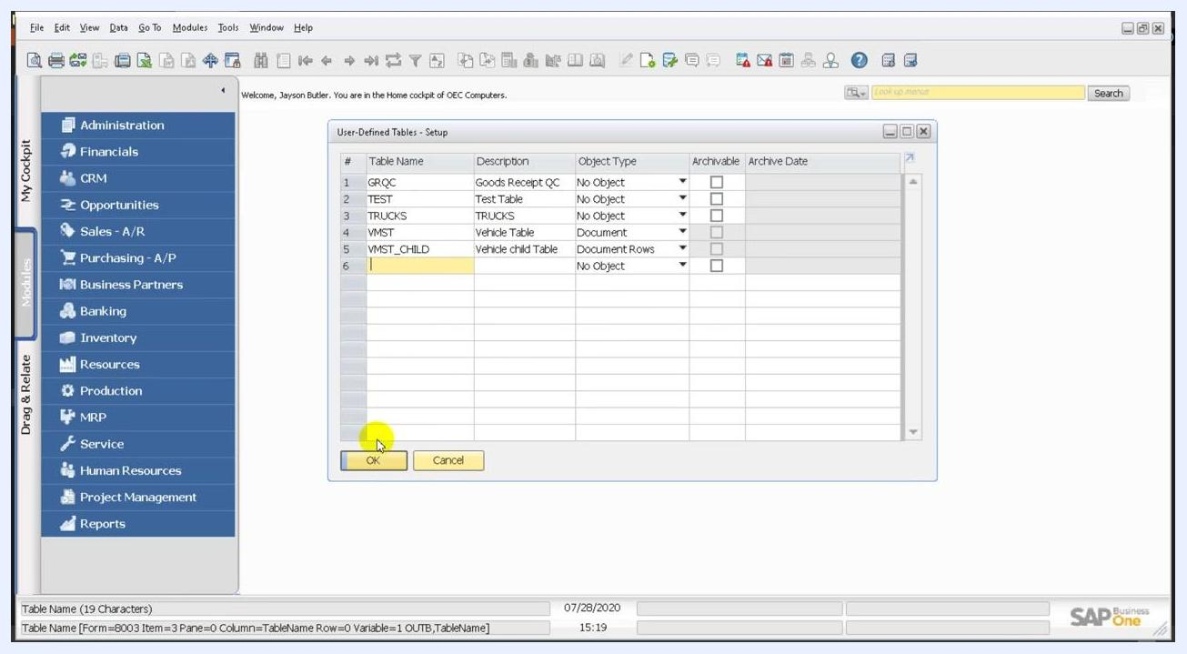
User-Defined Tables – Setup window showing VMST as Document and VMST_CHILD as Document Rows, ready to save
Confirm that you now have two tables:
- VMST (Vehicle Table) with Object Type Document
- VMST_CHILD (Vehicle child Table) with Object Type Document Rows

Create the user-defined fields

Step 6: Open User-Defined Fields – Management
In the top menu, select Tools > Customization Tools > User-Defined Fields – Management.
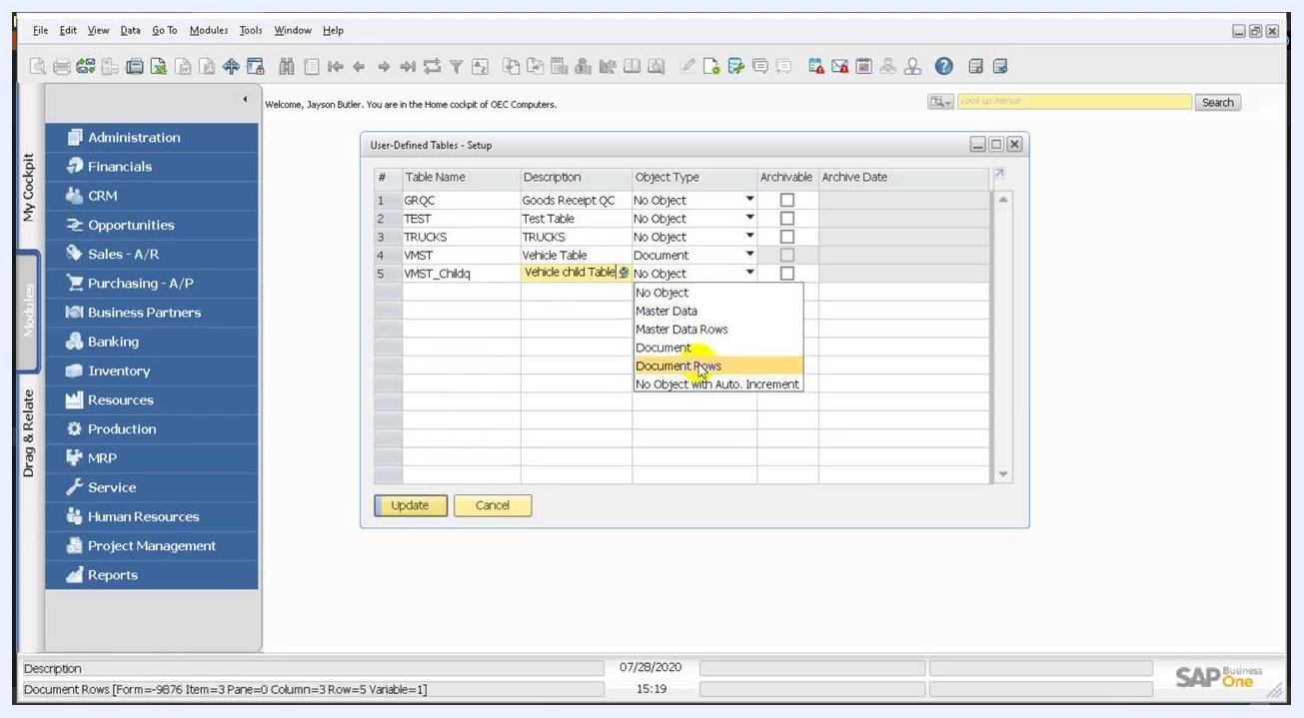
Tools menu open with Customization Tools highlighted and User-Defined Fields – Management selected

Step 7: Add the Name field to the parent table
In the User-Defined Fields – Management window, expand the User Tables section and select Vehicle Table. Click Add to open the Field Data dialog, and enter these values:
- Title: Name
- Description: Name
- Type: Alphanumeric
- Length: 10
Leave the other options at their defaults, then click Add to create the field.
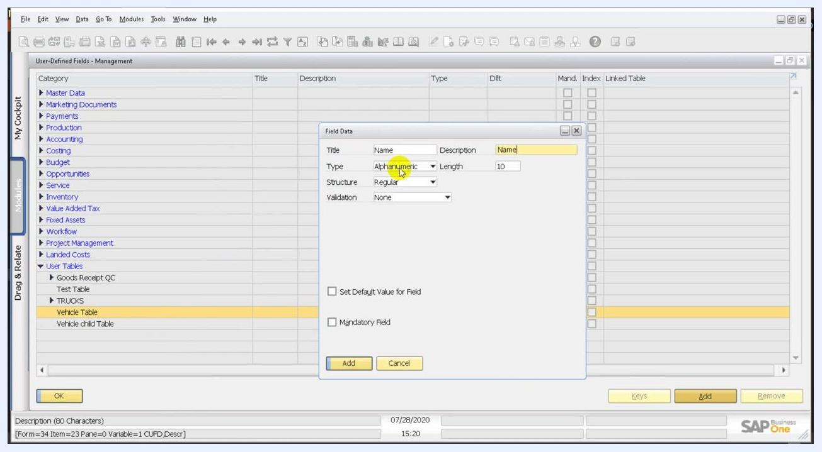
Field Data dialog for adding the Name field to Vehicle Table, Type Alphanumeric, Length 10

Step 8: Add the Date field to the parent table
Click Add again and enter these values:
- Title: Date
- Description: Date
- Type: Date/Time (select it from the dropdown)
- Length: 10 (default)
Click Add to create the field.
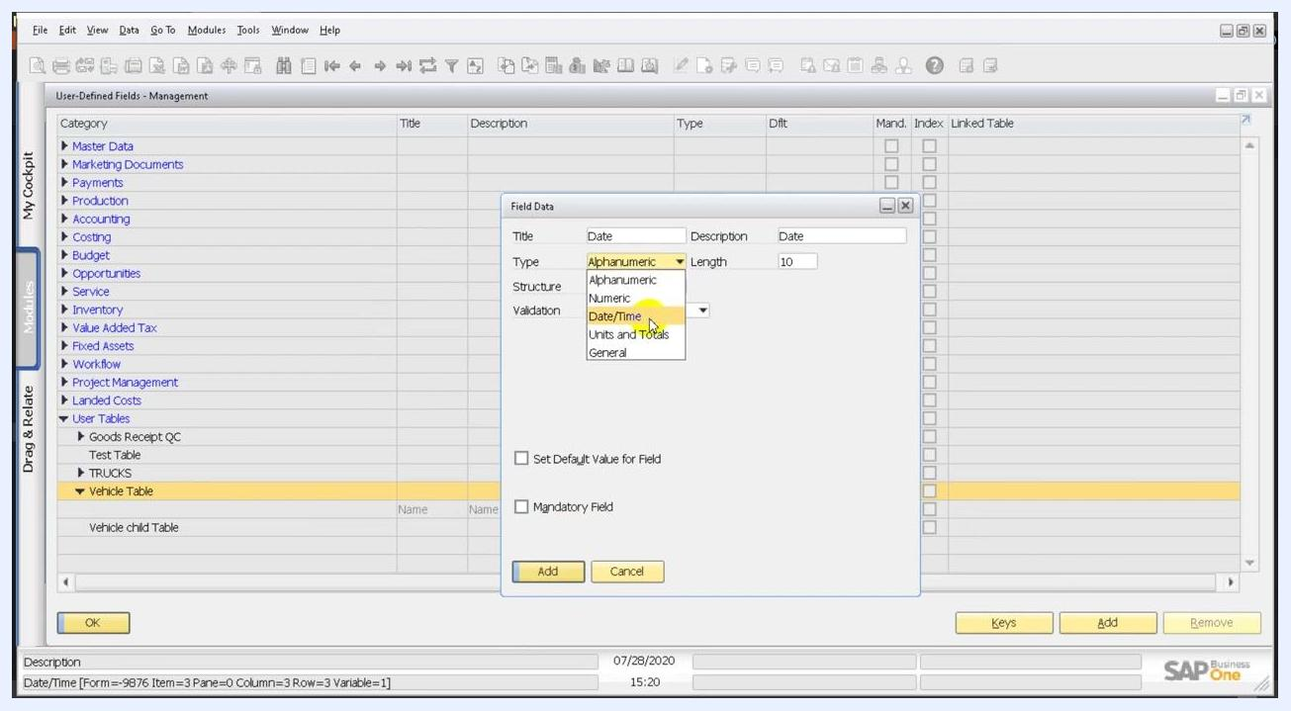
Field Data dialog for adding the Date field to Vehicle Table, Type Date/Time

Step 9: Add the VehicleCode field to the child table
Under User Tables, select Vehicle child Table. Click Add to open the Field Data dialog, and enter these values:
- Title: VehicleCode
- Description: Leave blank or enter a value as needed.
- Type: Alphanumeric
- Length: 10
Click Add to create the field.
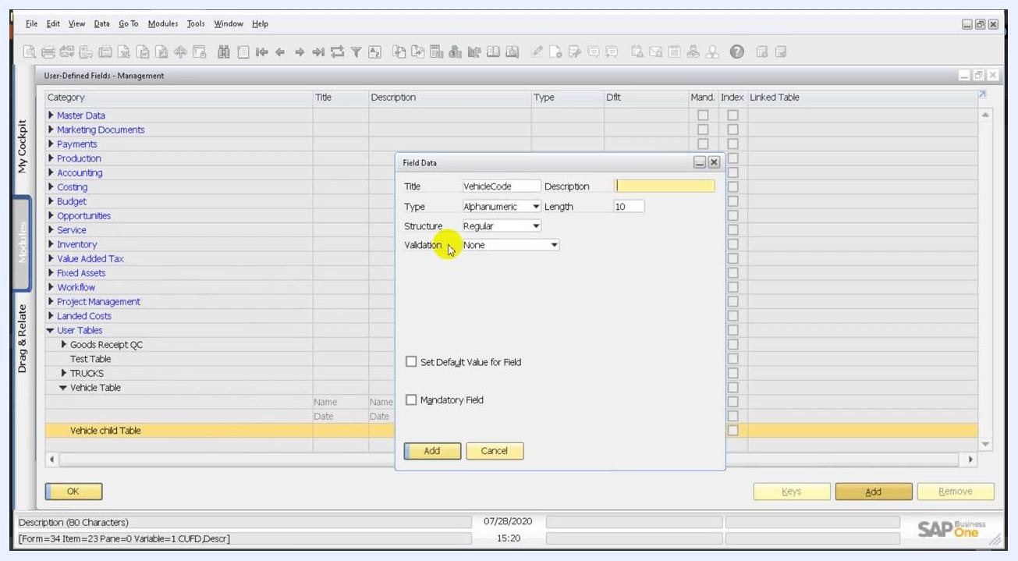
Field Data dialog for adding the VehicleCode field to Vehicle child Table, Type Alphanumeric, Length 10

Step 10: Add the Description field to the child table
Add a second field to Vehicle child Table. In the Field Data dialog, enter these values:
- Title: Description
- Description: Description
- Type: Alphanumeric
- Length: 20
- Structure: Regular
- Validation: None
If you need them, you can select Set Default Value for Field or Mandatory Field. Click Add to create the field.
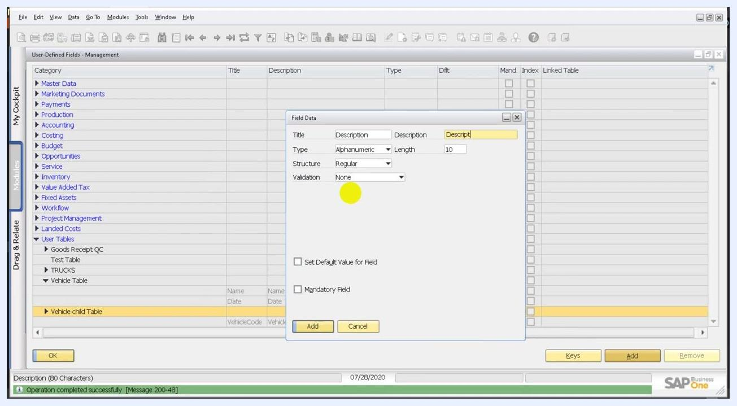
Field Data dialog for adding the Description field to Vehicle child Table, Type Alphanumeric, Length 20

Step 11: Verify the child table fields
Confirm that Vehicle child Table now lists both fields:
- Description (Alphanumeric, 20)
- VehicleCode (Alphanumeric, 10)
Also check that the status bar displays "Operation completed successfully".
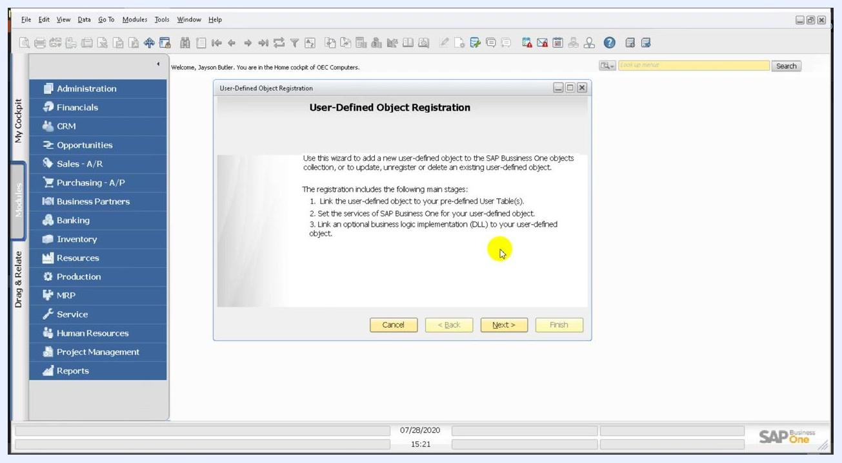
User-Defined Fields – Management window listing the Description and VehicleCode fields under Vehicle child Table
If SAP Business One shows a message about a database structure modification, read it. It says: "The database structure has been modified. In order to resume the process, all open windows will be closed. Do you want to continue adding the user-defined field?" Click Yes to proceed or No to cancel the operation.
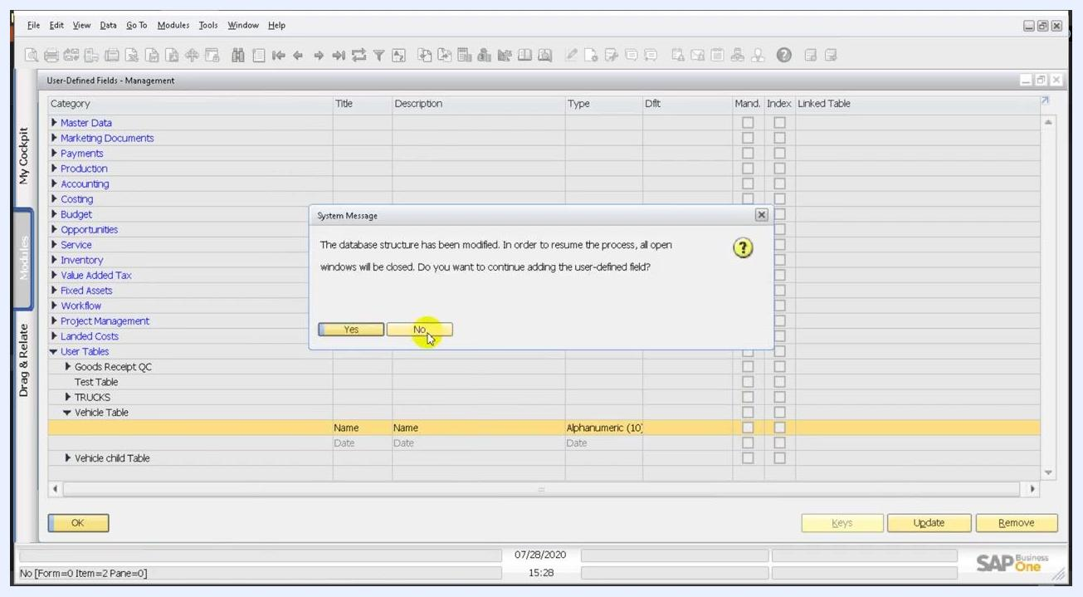
System message over the User-Defined Fields – Management window asking whether to continue adding the field after a database structure modification, with Yes and No options and No highlighted

Register the user-defined object

Step 12: Open the Object Registration Wizard
In the top menu, select Tools > Customization Tools > Object Registration Wizard.
Tools menu open with Customization Tools highlighted, ready to select Object Registration Wizard

Step 13: Review the wizard introduction
The User-Defined Object Registration window opens with an introduction. It outlines three tasks:
- Link the user-defined object to your pre-defined user table or tables.
- Set SAP Business One services for your user-defined object.
- Optionally, link a business logic implementation (DLL).
Click Next to proceed.
User-Defined Object Registration wizard introduction screen

Step 14: Select the registration mode
Choose Add a New Object. The other options are Update an existing object, Unregister an existing object, and Delete an existing object. Click Next to continue.
Registration mode screen with Add a New Object selected

Step 15: Define the basic settings
In the Defining Basic Settings window, enter these values:
- Unique ID: VMSD
- Name: VMSD
- Type: Select Document from the dropdown.
You choose the Table Name in the next step. At this stage, only Master Data and Document are available as object types.
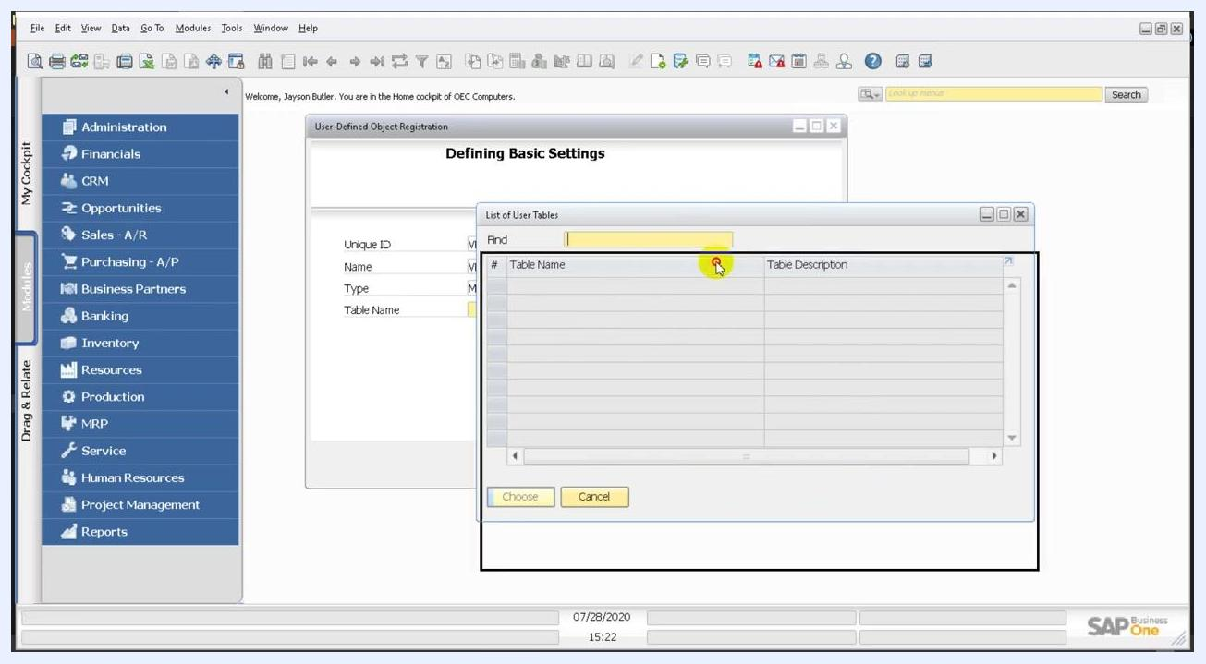
Defining Basic Settings dialog with the Unique ID and Name fields and the Type dropdown showing Master Data and Document

Step 16: Open the list of user tables
Click the lookup button next to Table Name to open the List of User Tables dialog. The list depends on the type you selected:
- If you select Master Data, the list is empty because you haven't created any master data tables.
- If you select Document, the list shows the available document tables.
List of User Tables dialog showing no available tables for the Master Data type

Step 17: Select the main document table
With Document as the type, find the table with these details in the List of User Tables dialog:
- Table Name: VMST
- Table Description: Vehicle Table
Select only the main document table, VMST. Do not select the rows table or any child table at this stage. Click Choose to confirm.
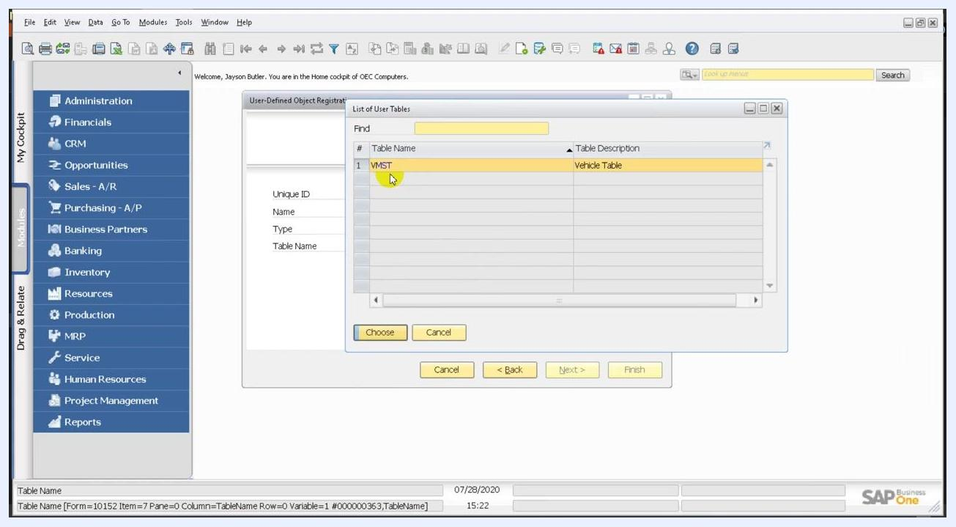
List of User Tables dialog with VMST (Vehicle Table) selected as the main document table

Set services and UI settings

Step 18: Choose the services
In the Setting Services window, review the list of services available for the object. Set the checkboxes as follows:
- Add: Checked (mandatory)
- Delete: Checked
- Find: Checked (lets users search for records)
- Update: Unchecked
- Cancel: Unchecked
- Close: Unchecked
- Log: Unchecked
- Manage Series: Unchecked
- Year Transfer: Unchecked
- Data Archive (Requires Implementation DLL): Unchecked
- Approve: Unchecked
Leave the settings as they are unless you need specific changes, then click Next >.
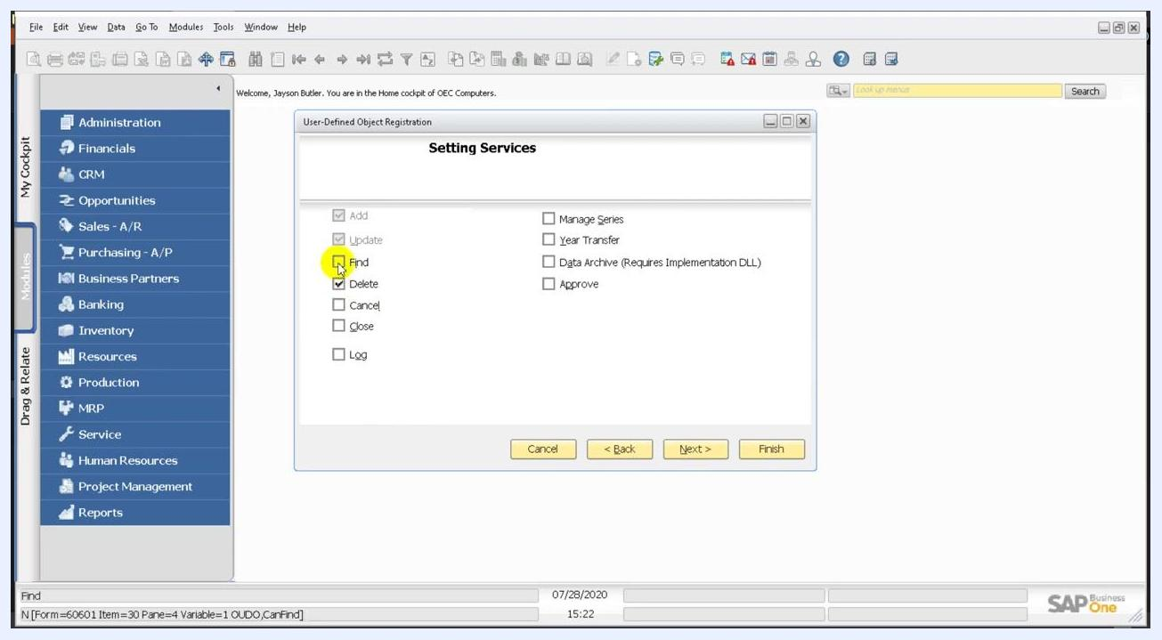
Setting Services window with the Add, Delete, and Find options checked

Step 19: Configure the UI settings
In the UI Settings window, make sure Default Form is checked and select Header Line Style as the form style.
To add the object as a menu item, check Menu Item and enter VMST in the Menu Caption field. Leave Parent Menu ID, Position, and Menu UID blank for now.
To assign the object to a specific module, click the ... button next to Parent Menu ID.
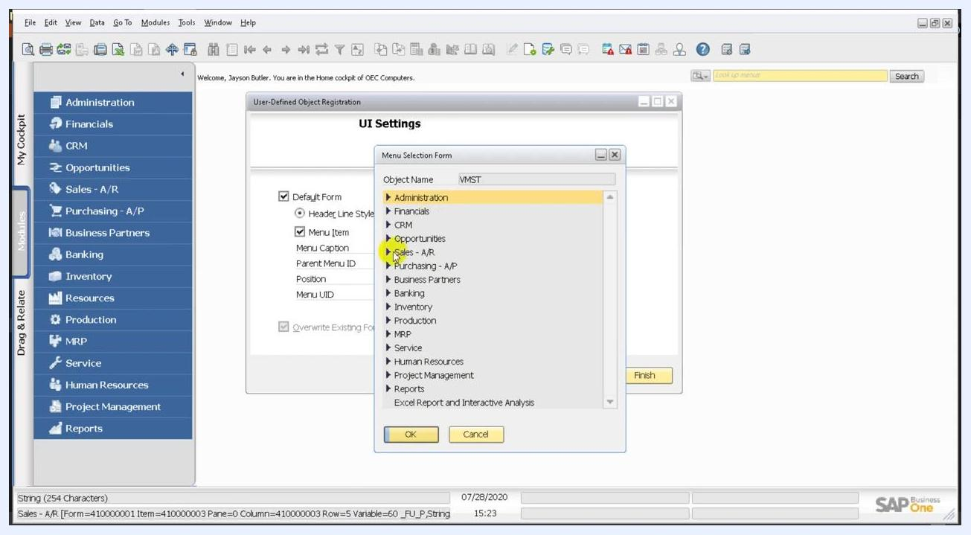
UI Settings window with Menu Item checked and the Menu Caption field ready for input

Step 20: Assign the object to a module
In the Menu Selection Form dialog, browse the list of modules and select the one you want, for example Inventory. Click OK to confirm.
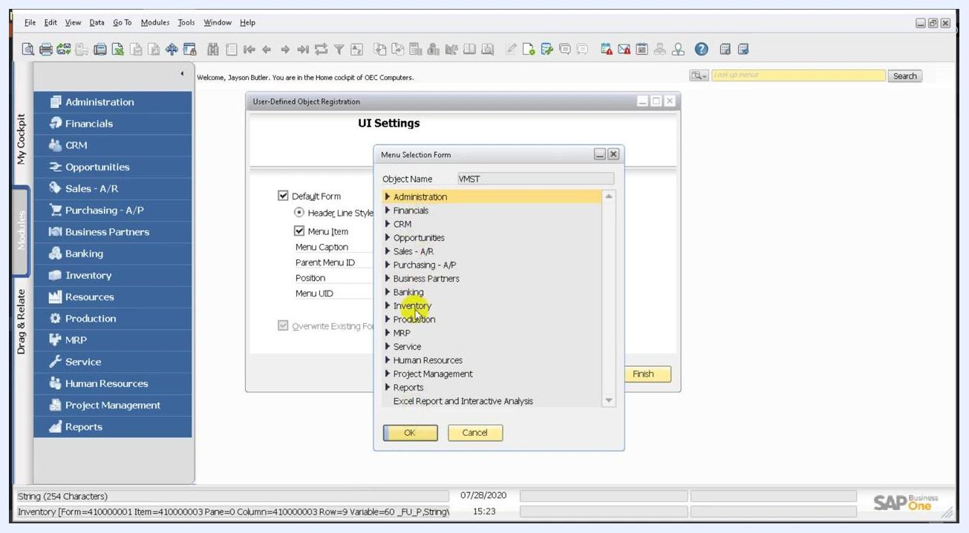
Menu Selection Form dialog with the Inventory module highlighted
Back in UI Settings, check the following:
- Parent Menu ID now shows the ID of the module you selected, for example Inventory.
- Menu UID is set to VMST.
If needed, adjust Position or Place at Bottom. Then click Next >.

Set the Find and form fields

Step 21: Choose the fields for Find
In the Setting the fields for Find window, review the available columns. Check the boxes for the columns you want users to search by. Columns in the list include:
- DocEntry
- DocNum
- Period
- Instance
- Series
- Handwritten
- Canceled
Use the up and down arrows to reorder the columns. Optionally, check View Checked Columns Only to filter the list. Click Next > to continue.
Setting the fields for Find window with columns such as DocEntry, DocNum, Period, Instance, Series, Handwritten, and Canceled, some checked

Step 22: Recognize the U_ prefix
SAP Business One automatically prefixes every user-defined field you create with U_. This prefix distinguishes user-defined fields from system fields. For example, the fields appear in the Find window as U_Name and U_Date.
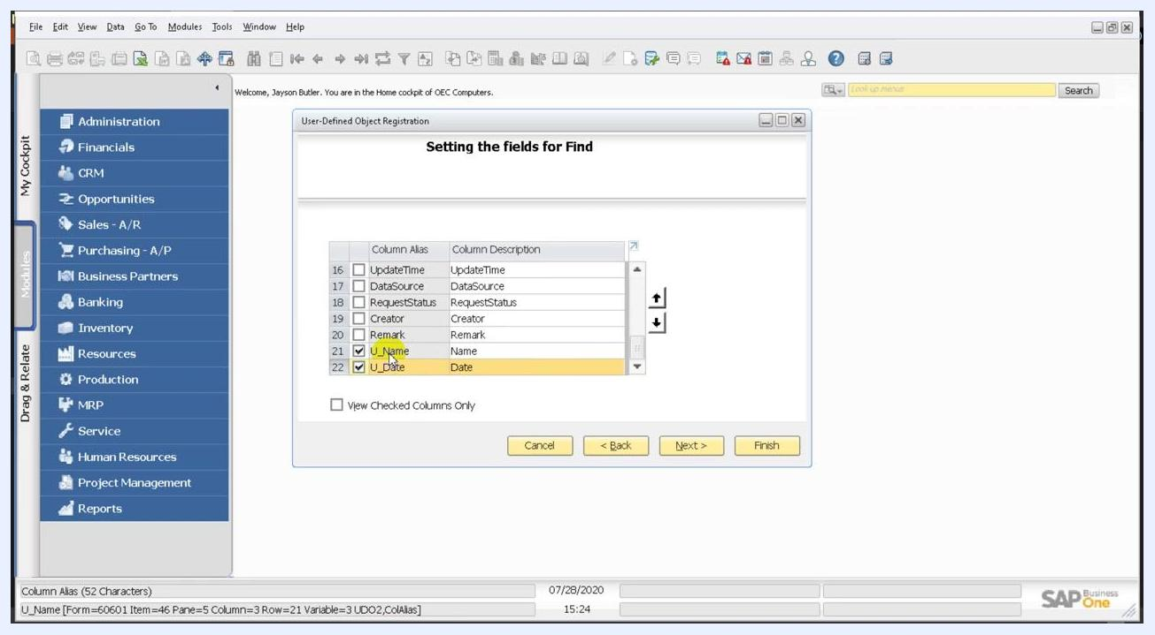
Setting the fields for Find window showing the user-defined fields U_Name and U_Date, both checked

Step 23: Verify your user-defined fields in the Find list
Scroll the list to confirm that the fields you created are present. Besides U_Name and U_Date, the window shows columns such as UpdateTime, DataSource, RequestStatus, Creator, and Remark. Only fields with the U_ prefix are user-defined.
In this example, U_Name is checked, so users can search by it, and U_Date is unchecked.
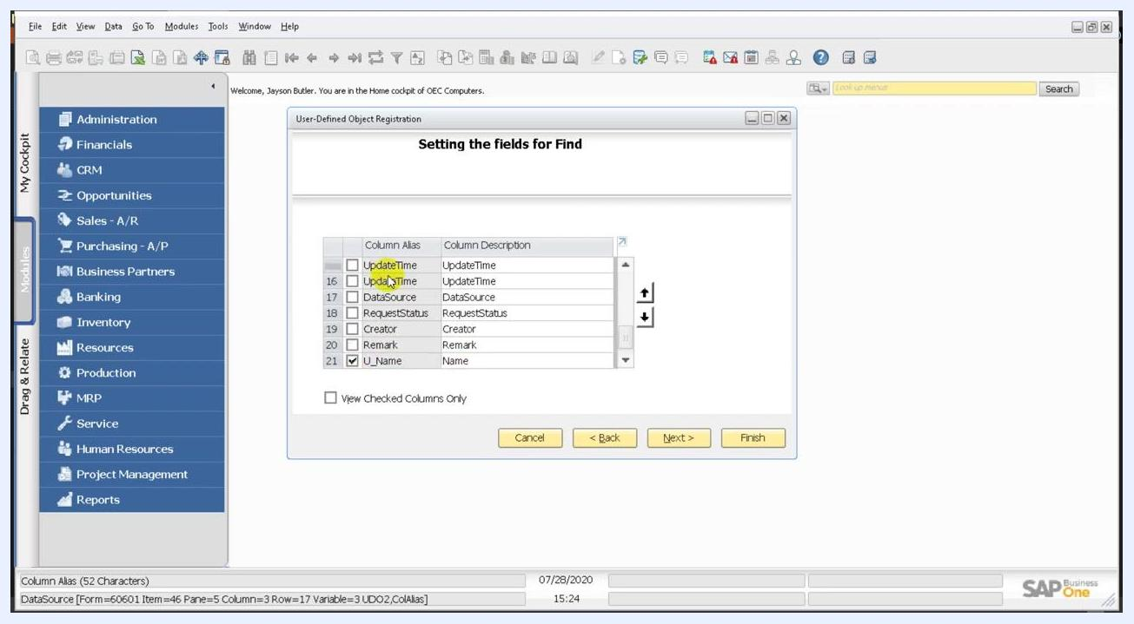
Setting the fields for Find window with U_Name checked and U_Date unchecked

Step 24: Set the fields for the default form
Click Next > to open the Setting fields for default form window. Here you select which fields are visible and editable on the default form of your object.
The list includes columns such as DocEntry, DocNum, Period, Instance, Series, and Handwritten. By default, only DocEntry is checked as visible.
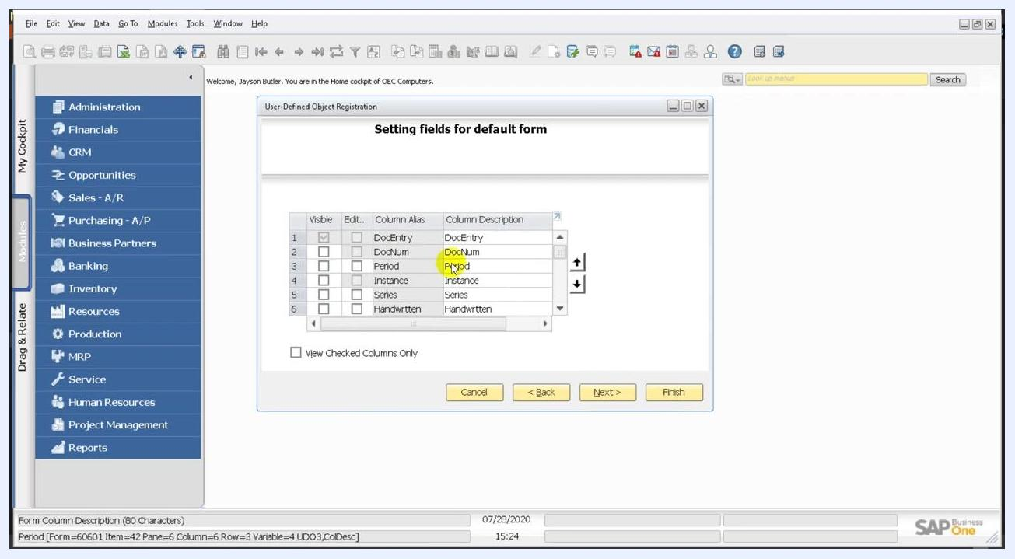
Setting fields for default form window with DocEntry checked as visible

Step 25: Review the additional default form fields
Scroll through the list to review more fields: Status, CreateDate, CreateTime, UpdateDate, UpdateTime, and DataSource. None is checked as visible or editable by default. Check any of them if you want them to appear on the form.
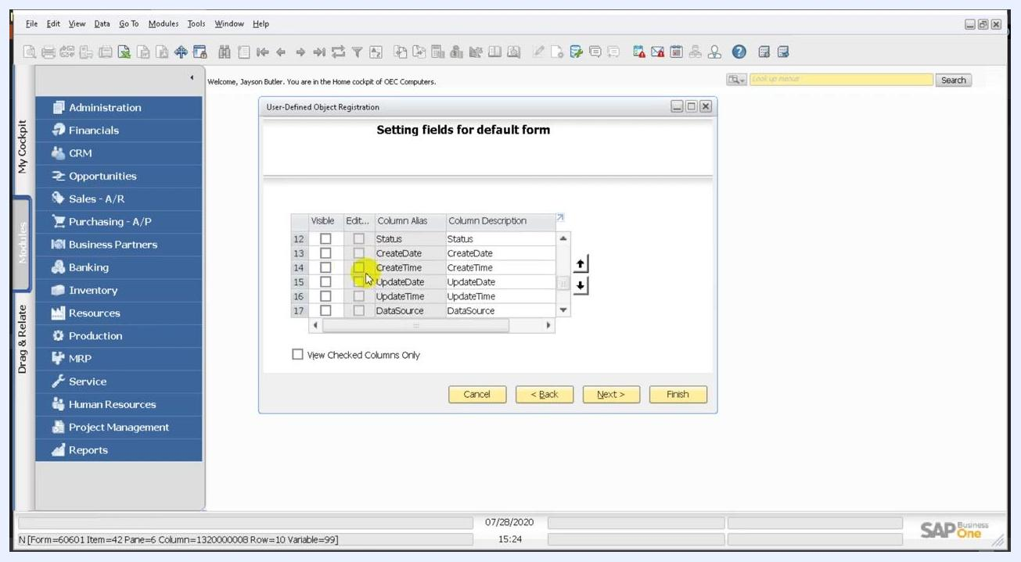
Setting fields for default form window showing Status, CreateDate, CreateTime, UpdateDate, UpdateTime, and DataSource, none checked

Step 26: Link the child table
In the Linking child user tables window, review the list of available child tables. The table VMST_CHILD with the description "Vehicle child Table" is listed. Check the box next to VMST_CHILD to link it to your main object, then click Next >.
Linking child user tables window with VMST_CHILD checked and the Next button highlighted

Step 27: Set the fields for the child table form
In the Setting fields for a child table default form window, select which fields are visible and editable for the child table. VMST_CHILD includes columns such as DocEntry, LineId, VisOrder, Object, LogInst, U_VehicleCode, and U_Description.
Check U_VehicleCode (Vehicle Code) and U_Description (Description) to make them visible and editable on the child table form.
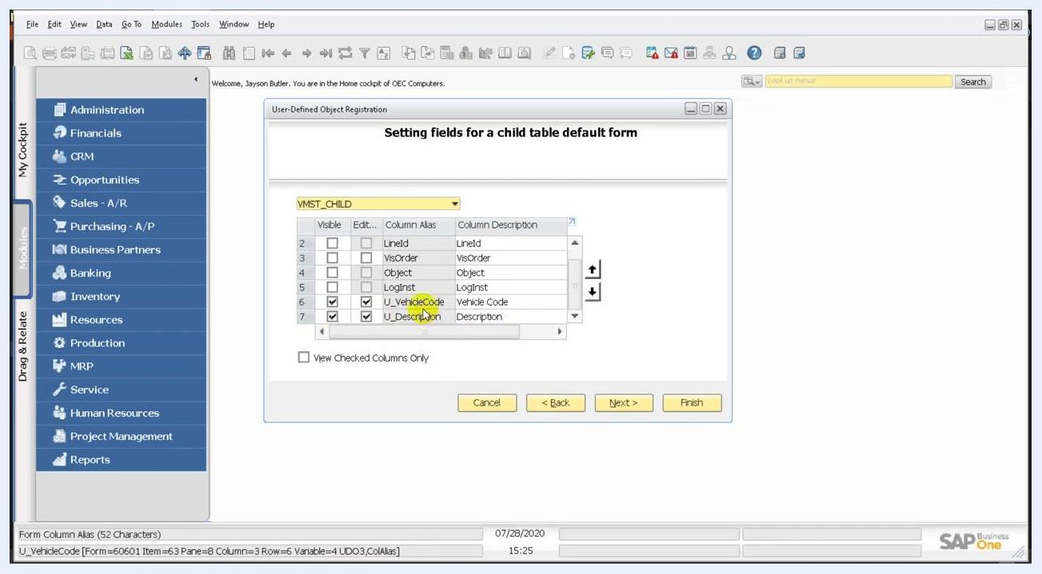
Setting fields for a child table default form window with U_VehicleCode and U_Description checked

Step 28: Review the generated form
After you finish the field selection, the system displays the generated form for your user-defined object. It includes:
- DocEntry (disabled)
- Date
- Name
- A table for entering Vehicle Code and Description
The Add and Cancel buttons appear at the bottom of the form.
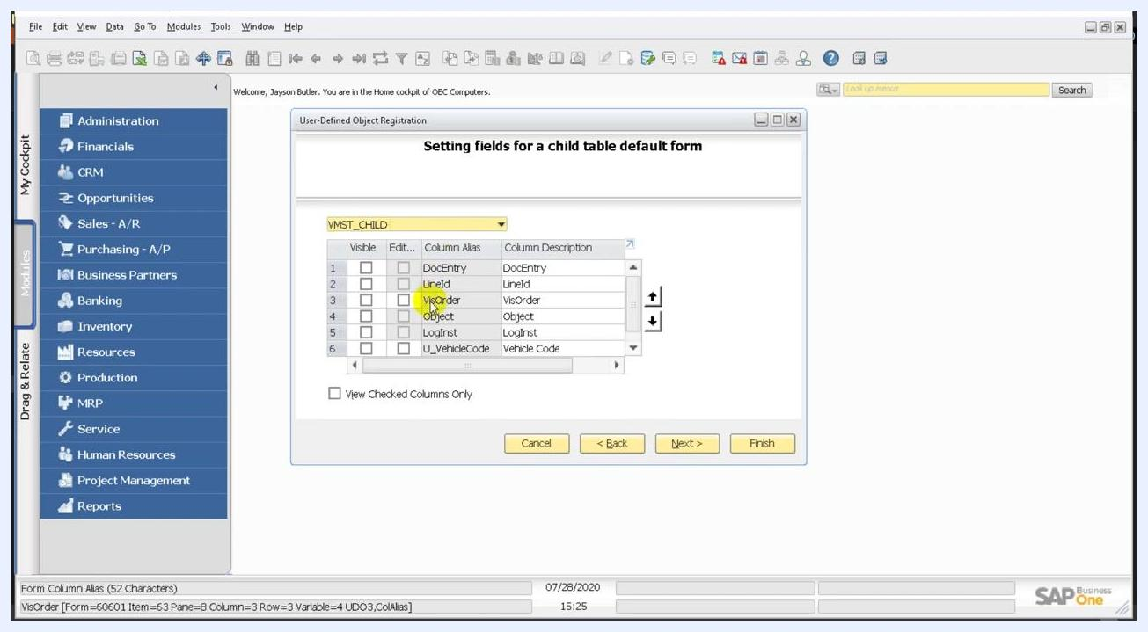
Generated user-defined object form with DocEntry (disabled), Date, Name, and a table for Vehicle Code and Description

Customize the form with Edit UI Form

Step 29: Open the form settings
To control which table columns are visible, select Tools > Edit UI Form. The Form Settings - VMST window opens.
On the Table Format tab, the table columns are listed: #, Vehicle Code, and Description. Check or uncheck the boxes in the Visible and Active columns to control which fields are shown and editable. In this example, all three columns are visible and active.
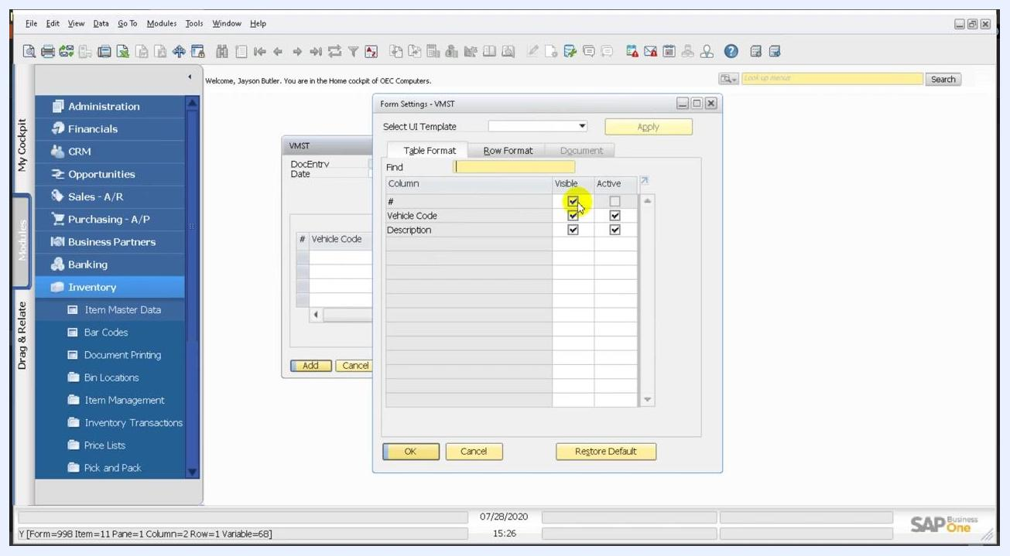
Form Settings - VMST window with the #, Vehicle Code, and Description columns all set as visible and active

Step 30: Apply and save the changes
After you adjust column visibility and activity, click OK or Apply to save your changes. You can also use the window controls to close the dialog. The changes immediately affect the layout of the VMST form.
Form Settings - VMST window with all columns visible and active, ready to apply changes

Step 31: Use UI Edit Mode for further customization
The VMST form now appears in UI Edit Mode. Right-click any field, such as Date or Name, to open a context menu. The options are Save, Leave UI Edit Mode, Restore Default, Add Tab, Remove Tab, and Rename Tab.
These options let you customize the form layout further. The status bar at the bottom confirms "UI changes saved successfully."
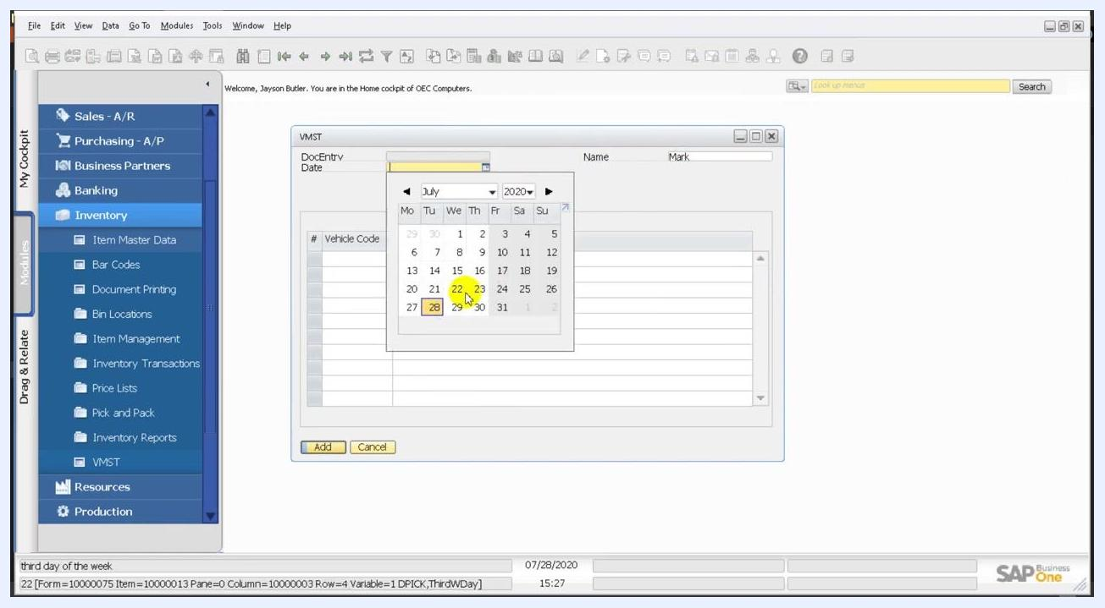
VMST form in UI Edit Mode with the right-click context menu open, showing Save, Leave UI Edit Mode, Restore Default, Add Tab, Remove Tab, and Rename Tab

Step 32: Return to the standard form view
Exit UI Edit Mode to return to the standard VMST form view. The form reflects the changes you made. The DocEntry, Date, and Name fields appear at the top, with the table for Vehicle Code and Description below.
VMST form in standard view after UI customization, showing DocEntry, Date, Name, and the table

Enter and update data

Step 33: Set the date
Click the Date field to open the date picker, then select a date from the calendar. In this example, July 28, 2020 is chosen. The selected date fills the Date field on the form.
VMST form with the date picker open and July 28, 2020 selected

Step 34: Enter data in the table
In the table section, enter these values:
- Vehicle Code: 0001
- Description: Truck
The row is highlighted while you enter data. The form then displays the entered data, ready for further actions such as adding or saving the record.
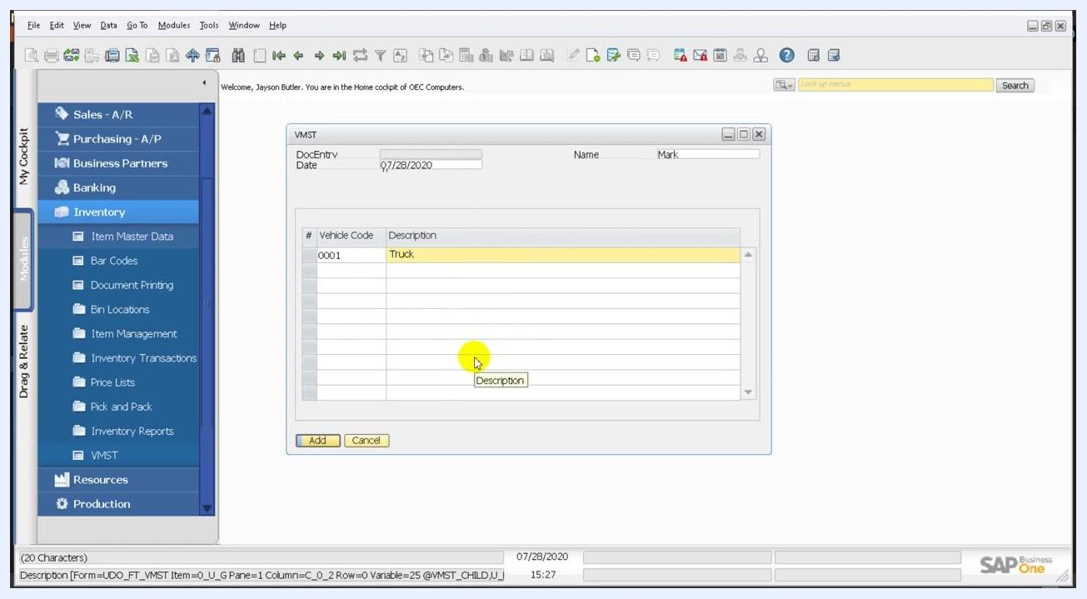
VMST form with Vehicle Code 0001 and Description Truck entered in the table

Step 35: Edit the Name field
Click the Name field and change the value to Mark Hamilton. If an error appears after you edit, review the data and field settings to make sure they meet SAP Business One requirements.
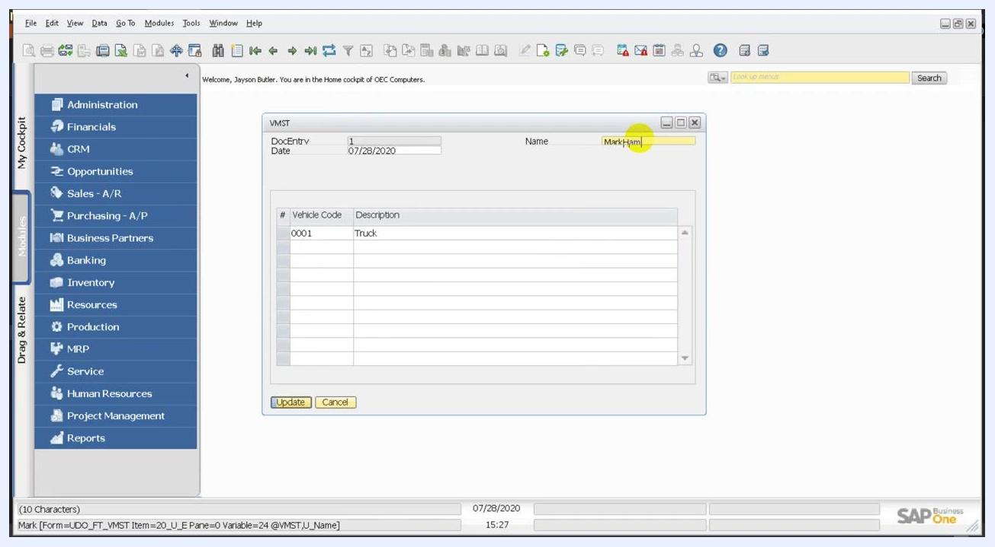
VMST form with the Name field being edited to Mark Hamilton, showing DocEntry, Date, and the table with Vehicle Code 0001 and Description Truck

Step 36: Verify the record
Return to the VMST form and select the last record in the VMST table. Confirm that the Name field is updated (for example, "Mark Hamilton"). Also confirm that the table shows the correct vehicle information: Vehicle Code 0001 and Description Truck.
VMST form showing DocEntry 1, Date 07/28/2020, Name Mark, and a table with Vehicle Code 0001 and Description Truck, with the OK and Cancel buttons visible

Step 37: Test the update function
Click Update to save your changes. Make sure the navigation menu and form fields reflect the updated data.
VMST form with the Name field set to Mark Hamilton, Vehicle Code 0001, and Description Truck, with the Update and Cancel buttons visible

What's next
After you create your UDO, you can reopen Tools > Edit UI Form to refine the layout. You can also return to the Object Registration Wizard to update the object later.

Summary
You created a user defined object (UDO) in SAP Business One by completing these tasks:
- Created the parent table VMST and the child table VMST_CHILD.
- Added the user-defined fields Name and Date to the parent table.
- Added VehicleCode and Description to the child table.
- Registered the object with the Object Registration Wizard.
- Enabled the mandatory services and configured the UI settings.
- Assigned the object to the Inventory module with a menu caption.
- Chose the Find fields and the default form fields for the parent and child tables.
- Customized the form with Edit UI Form and UI Edit Mode.
- Entered sample data and updated a record.

