How to create a lightweight add-on in SAP Business One
This guide explains how to create a lightweight add-on in SAP Business One by using the Extension Package Application. You prepare your compiled source code, enter the extension details, select the 32-bit and 64-bit executables, and package everything into a ZIP file.

Prerequisites
Before you begin, make sure you have the following:
- SAP Business One SDK installed
- Visual Studio installed
- Add-on source code that is ready and compiled for both 32-bit and 64-bit configurations
- A build output path that matches your intended deployment directory

Steps

1. Open Visual Studio and prepare your source code
Open Visual Studio and load your add-on project. In this example, the project is named "ExtPack", and the configuration is set to Debug and x64.
Confirm that the build output path matches your intended deployment directory.
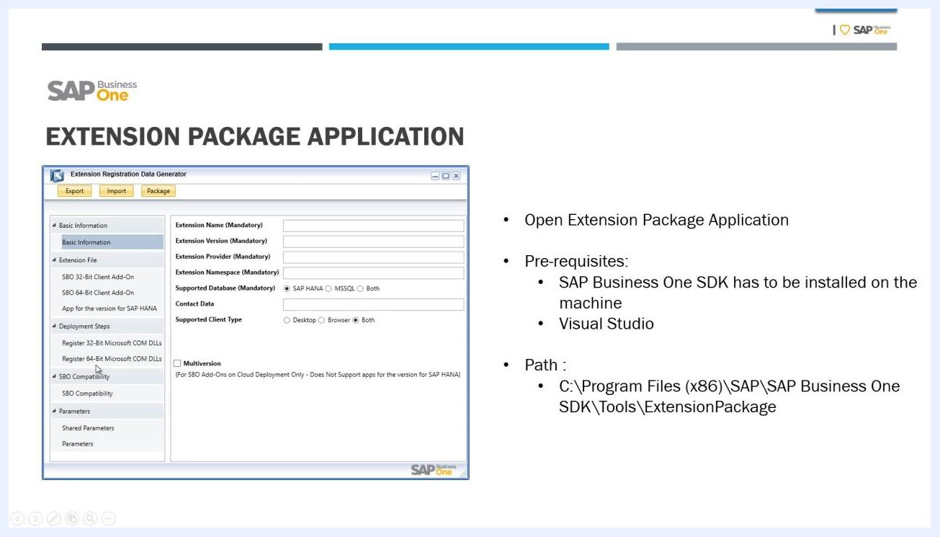
Visual Studio with the ExtPack project open, the configuration set to Debug and x64, and the build output visible

2. Launch the Extension Package Application as administrator
Go to the following directory on your machine:
C:\Program Files (x86)\SAP\SAP Business One SDK\Tools\ExtensionPackage
Right-click the Extension Package Application executable and select Run as administrator. The Extension Registration Data Generator window opens.
Extension Registration Data Generator window with the prerequisites and the application path

3. Enter the basic extension information
Fill in the mandatory fields:
- Extension Name: Enter the name of your add-on.
- Extension Version: Enter the version.
- Extension Provider: Enter the vendor or provider name.
- Extension Namespace: Enter the namespace.
- Supported Database: Select SAP HANA, MSSQL, or Both.
- Contact Data: Enter your contact information.
- Supported Client Type: Select Desktop, Browser, or Both.
This example uses the following values:
- Extension Name: Demo
- Extension Version: 1.0.0
- Extension Provider: Own
- Extension Namespace: Own
- Supported Database: SAP HANA
- Contact Data: Own
- Supported Client Type: Both
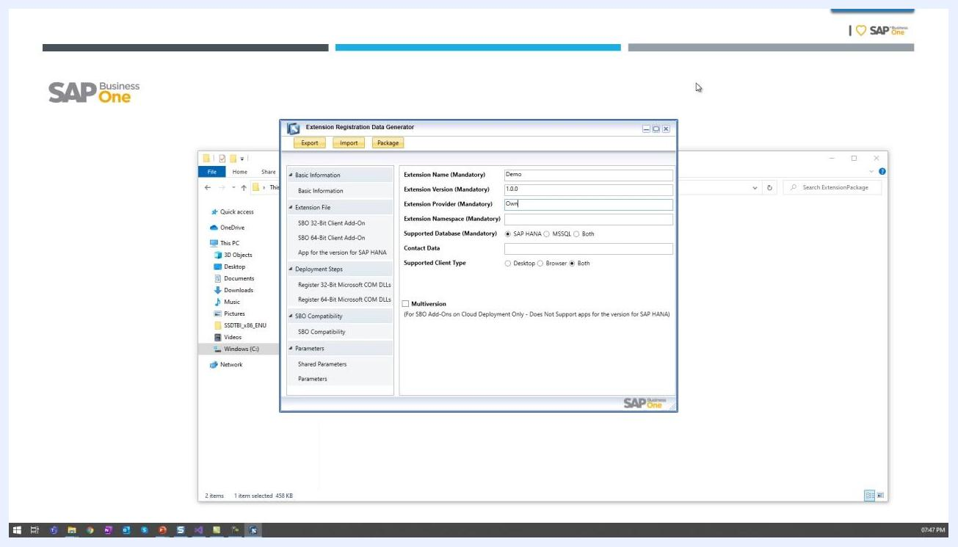
Extension Registration Data Generator with the fields filled in: Demo, 1.0.0, Own, Own, SAP HANA, Own, and Both

4. Select the 32-bit add-on executable
In the SBO 32-Bit Client Add-On section, click to open the file dialog. Go to your compiled 32-bit executable, for example in the x86 folder under your project's bin directory.
Select the .exe file for your add-on. If it applies to your add-on, select the option for non-required files.
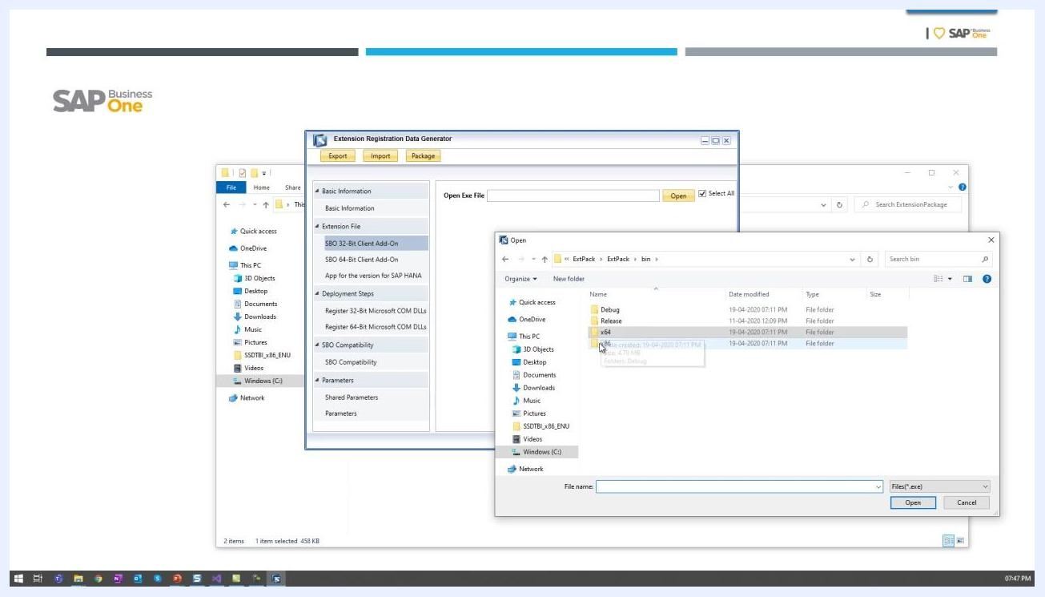
File dialog open in the x86 folder to select the 32-bit add-on executable

5. Select the 64-bit add-on executable
Repeat the process for the 64-bit version:
- Go to the SBO 64-Bit Client Add-On section.
- Open the file dialog and go to the x64 folder under your project's bin directory.
- Select the 64-bit .exe file for your add-on.

6. Start packaging your add-on
After you select both executables, click the Package button at the top of the Extension Registration Data Generator window. A file dialog opens so you can choose the location and filename for the packaged add-on.
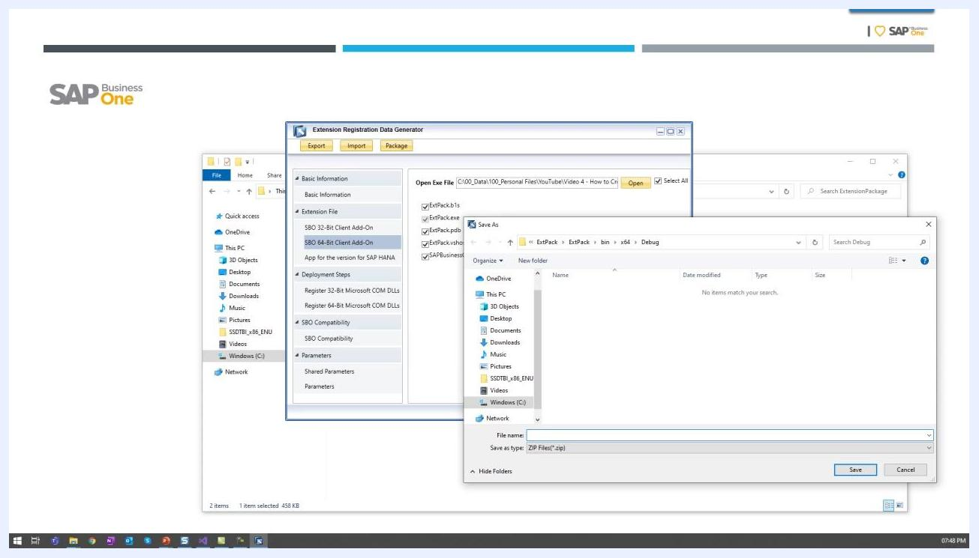
Extension Registration Data Generator with the Package button and the file dialog open for choosing a save location

7. Specify the package save location and name
In the Save As dialog, complete these actions:
- Go to the folder where you want to save the package.
- Enter a filename for your package, for example Demo.
- Make sure the file type is set to ZIP Files (*.zip).
- Click Save.
Save As dialog with the filename Demo and the ZIP file type, ready to save

8. Confirm that packaging succeeded
When packaging finishes, a confirmation dialog appears with this message:
You have successfully packaged your add-on at: [path]\Demo_1.0.0.zip
Click OK to close the dialog.

Summary
You have now learned how to create a lightweight add-on in SAP Business One. You entered the basic extension information, selected the 32-bit and 64-bit executables, and packaged the add-on as a ZIP file.
The application may offer further steps, such as configuring deployment steps, compatibility, and parameters. Complete them as your add-on requires, and then deploy the extension according to your organizational requirements.

